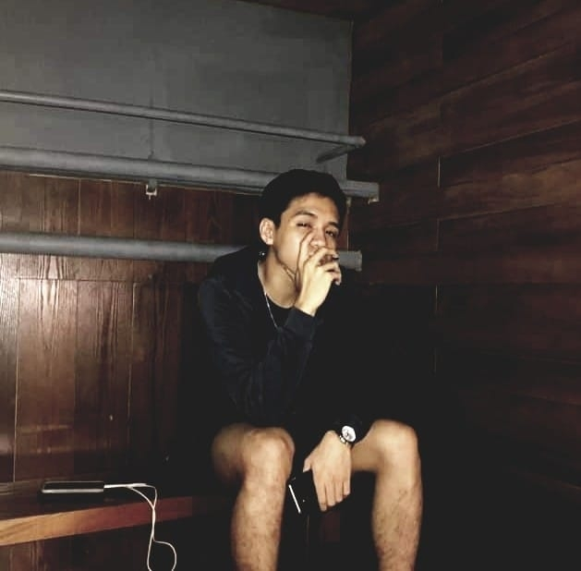
timothy aidan g. lopez
Lot 7 Block 29 Mondego St. Villa de Toledo
Brgy. Balibago, Santa Rosa City, Laguna 4026
(049) 302 9556
+639088132738
aidanlopez15@gmail.com

EDUCATION

2018- de la salle university
Bachelor of Science degree in Industrial Engineering.

2016-2018 DE LA SALLE UNIVERSITY LAGUNA CAMPUS
Senior High School Diploma, June 2018.

2012-2016 CARITAS DON BOSCO SCHOOL
High School Diploma, March 2016.

CO-CURRICULAR ACTIVITIES

2017-2018 STAGE HAND, DEAR EVAN HANSEN PLAY
Assisted in making of props. Part of setting up the scenes.

2016-2018 MEMBER, DLSU BASKETBALL TEAM B AREA MEET

2014-2015 MEMBER, CDBS BASKETBALL TEAM B AREA MEET

SEMINARS ATTENDED

November 2018 med for you seminar
Yuchengco Bldg., De La Salle University

RESEARCH PAPERS PREPARED

March 2018 URBAN AGRICULTURE: CONTAINER GARDENING AS A LIVELIHOOD TO SUSTAIN RESOURCES FOR SUBURBAN COMMUNITIES
Propose a structural model of an original greenhouse container garden to maximize the area at smaller locations and also in order to enhance its mobility.

timothy aidan g. lopez
page 2

PERSONAL BACKGROUND

Fluent in English and Filipino. Knowledgeable in Microsoft programs. Adaptable, goal-oriented and quality oriented.

REFERENCES

AIMEE JOSPHINE G. LOPEZ
Toyota employee
+639989609022
Lot 7 Block 29 Mondego St. Villa de Toledo
Brgy. Balibago, Santa Rosa City, Laguna 4026

TOMASITO T. LOPEZ JR.
Toyota employee
+639285209880
Lot 7 Block 29 Mondego St. Villa de Toledo
Brgy. Balibago, Santa Rosa City, Laguna 4026

