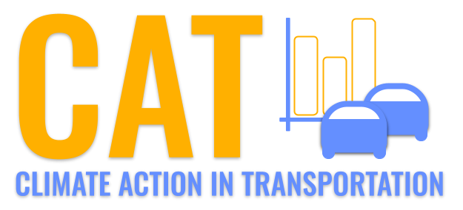
Carbon Emissions in Tompkins County, 2020
Made with CAT REPORTER by Gao Labs @ Cornell University.
New Research Sheds Light on the Impact of Vehicle Emissions on CO2 Equivalent and Light Trucks, Cars/ Bikes, Heavy Trucks, Combo Trucks, Buses. Estimates from the Climate Action in Transportation (CAT) Dashboard from Cornell University are empowering communities with vital data for a healthier and more sustainable environment.

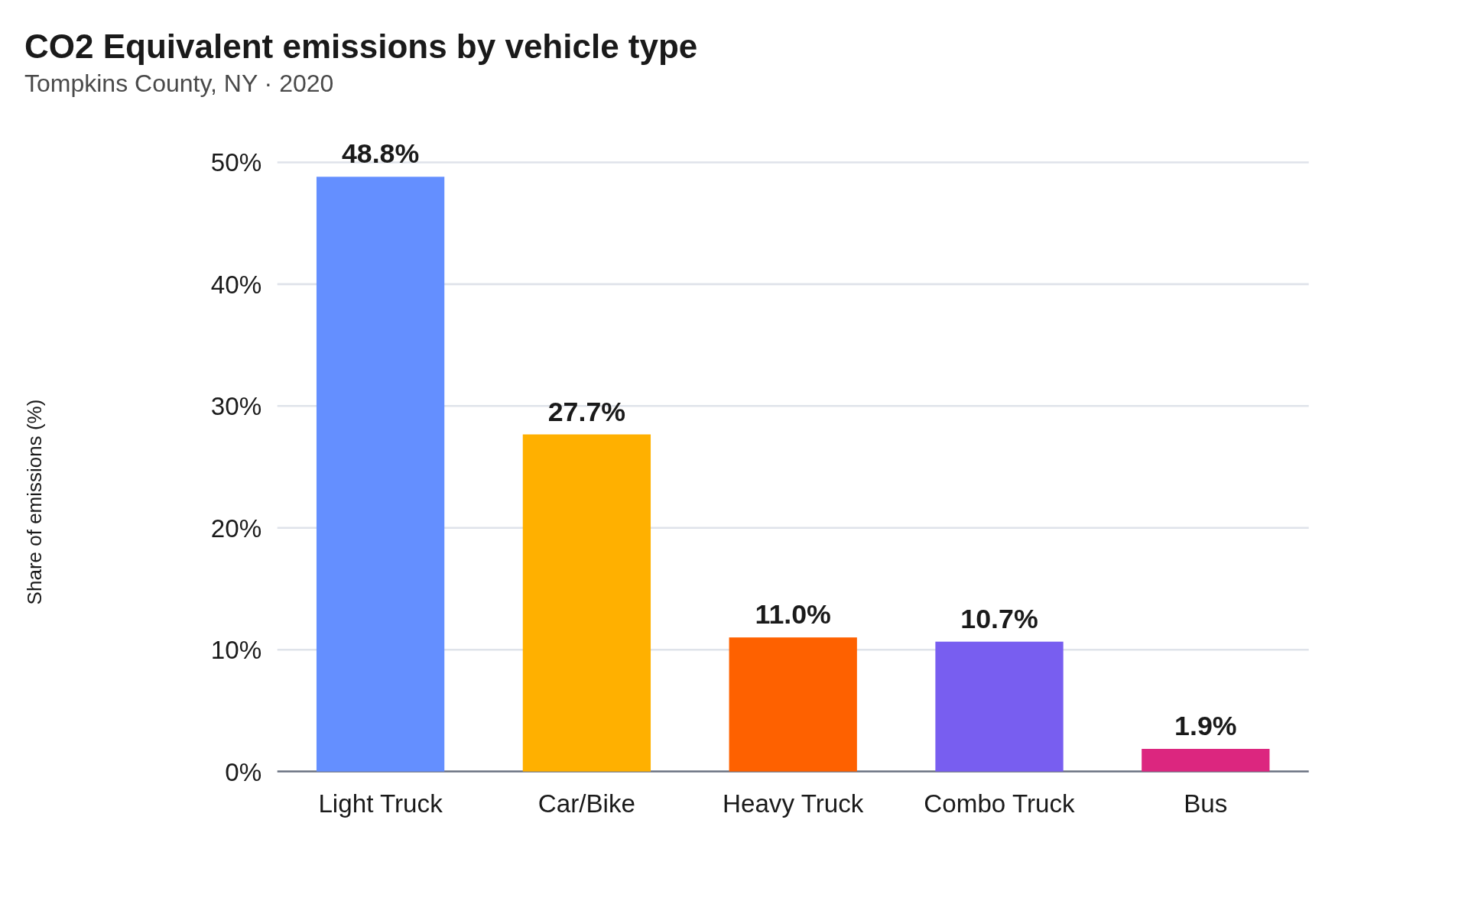

1. Light Trucks Take the Lead: Light Trucks are the primary culprits, accounting for a staggering 48.8% of total emissions. This indicates that they are either more abundant in number, have higher emission rates, or both.
2. Cars/ Bikes, Still a Concern: Surprisingly, combined emissions from cars/ bikes come in second at 27.7%. This demonstrates the collective impact of smaller vehicles in the region.
3. Heavy Trucks, Combo Trucks, and Buses: Heavy trucks contribute 11.0% of the CO2 Equivalent emissions, followed by combo trucks at 10.7%. Buses represent a mere 1.9%.

In conclusion, while each vehicle type plays a role in the overall carbon emissions of Tompkins County, efforts to reduce emissions might be most effective if they initially focus on light trucks and cars/ bikes. It provides a clear picture of where interventions could be targeted for a greener future.
Contact Information:
Department Name, Organization Name
Street Address, City, State
Email: name@thing.com

