**PhySci/MiMG/CaSB M178**

**Homework 4**

**Due: 10/31/23 at 12:00PM PDT**

**Notes:** This homework involves performing simulations of the caspase cascade we’ve been discussing in the last two class meetings. In the same post on Bruinlearn where you obtained this document, you will also find a file called “HW4_template.ipynb” that contains a template Jupyter notebook that you can use as a starting point to complete the questions below. Please modify this notebook and use it as the starting point for answering the following problems.

To submit your homework, please answer the questions below. Note that you will have to paste in several graphs that you generate using the Jupyter notebook. After completing the questions, **save this document as a PDF and upload it to Gradescope**. You **must also upload the Jupyter notebook to Bruinlearn** using this assignment page. You can upload your Jupyter file (which should be a .ipynb file). Make sure you upload your Jupyter notebook by the due date/time (10/31/23 at 12:00PM PDT).

**Problems**

In class, we talked about the caspase cascade. We initially considered a simple model in which the amount of caspase 8 in the model was fixed. Caspase 8 cleaves pro-caspase 3 to generate the active caspase 3 species. In this problem we will extend the model to include the saturation of caspase 8. To do this, we will need to model the formation of the complex of caspase 8 and pro-caspase 3.

$$C8+proC3\underset{→}{k_a} C8proC3$$

$$C8proC3\underset{→}{k_d}C8+proC3$$

As in the model from class we still have the conversion of pro-caspase 3 to caspase 3 via caspase 8, as well as the synthesis of pro-caspase 3, and the degradation of pro-caspase and caspase 3:

$$C8proC3\underset{→}{k_{c}} C8+C3$$

$$\underset{→}{Q} proC3$$

$$proC3\underset{→}{δ}$$

$$C3\underset{→}{δ}$$

$$C8proC3\underset{→}{δ}C8$$

We do not model the activation, synthesis, nor degradation of caspase 8 here.

**1) (20 points)** First write down the change equations for this new caspase model. MAKE SURE that you write down equations not just for C8 and the C8proC3 complex, but ALL the species.

C8_prime = -k_a*C8*proC3 +k_d*C8proC3 +k_c*C8proC3 +delta*C8proC3

proC3_prime = -k_a*C8*proC3 +k_d*C8proC3 + Q -delta*proC3

C8proC3_prime = +k_a*C8*proC3 -k_d*C8proC3 -k_c*C8proC3 -delta*C8proC3

C3_prime = +k_c*C8proC3 -delta*C3

**In the section of code called “initial caspase model” implement the change equations to reflect the new model. Make sure you implement all the equations written above!**

In the next section of code, “INITIAL CONCENTRATIONS & PARAMETERS”, the values we will use for simulation are set, except the value of Q, the synthesis of rate of pro-caspase 3.

To calculate Q, first imagine there was no caspase 8 in the cell, and so no pro-caspase 3 can be converted to active caspase 3. Note that we have set the pro-caspase initial concentration (called proC3_0) to a certain value. Now, we want to set the value of Q so that the amount of proC3 would not change over time in this case where there is no caspase 8 in the cell. In other words, we want the amount of caspase 3 to already be at steady state.

We can write down an equation for Q so that we guarantee that the steady state will always just be proC3_0. Write that equation below. NOTE: you should not use the current *numerical value* of proC3_0 in this equation. You should just use variables (like delta, proC3_0, etc.) in your equation.

Q = delta*proC3

**Enter your expression for the value of Q in the code.**

Finally in the section of code called “STEADY-STATE responses of initial caspase model”, we will vary the initial concentration of C8 and plot the resulting steady state concentration of C3 divided by the initial concentration of proC3. Note that the current initial concentration of proC3 is set to 1 and the initial concentration of C8 will be varied from 0 to 0.01. **Run this section of code and paste the resulting graph below:**

This model is similar PTM cycle models explored in HW1. Relate the species and reactions from our caspase model to the PTM model with synthesis and degradation. Which species/reactions from the PTM model do not have analogous species/reactions in the caspase model?

In PTM, the unmodified protein would be analogous to proC3 in the caspase model. In PTM, the modified protein would relate to C3 in the caspase model. The kinase facilitating phosphorylation in PTM is analogous to C8 in the caspase model. The enzyme-substrate complex in PTM is analogous to the C8proC3 complex in the caspase model. The degradation rate *δ* is also common in both models and applies to all species. There is also similar formation/dissociation: Similar to PTM, the caspase model involves the enzyme and substrate binding and unbinding.

However, there is no degradation rate for C8 in the caspase model, but there is a degradation rate of the kinase in the PTM model.

There’s also no reverse conversion of C3 to proC3, once proC3 is cleaved it cannot convert back to C3 in the caspase model, but in the PTM a phosphorylated protein can be dephosphorylated.

In HW 1, we explored the effect of saturation on the steady state amount of modified substrate as a function of initial kinase concentration by changing the initial concentration of substrate. **Increase the initial concentration of the substrate species in the caspase model at least twice to explore the effect of saturation. Make sure you increase the concentration *significantly*. Rerun the code and the paste your resulting graphs.** How do the results compare to HW1? Can you explain why differences emerge, if any?

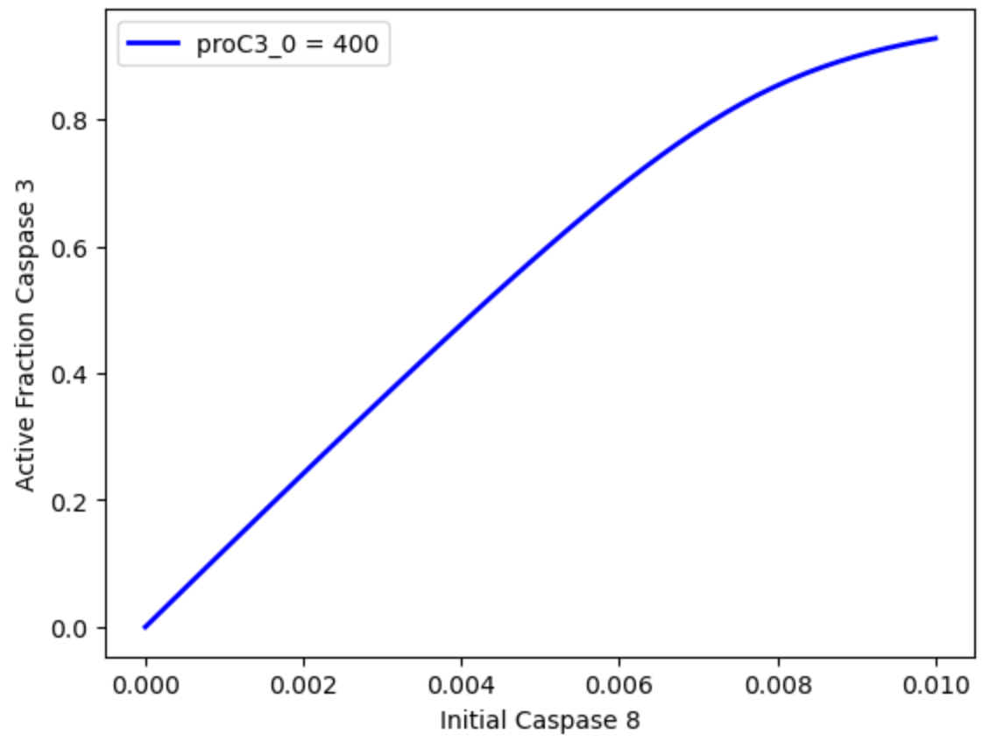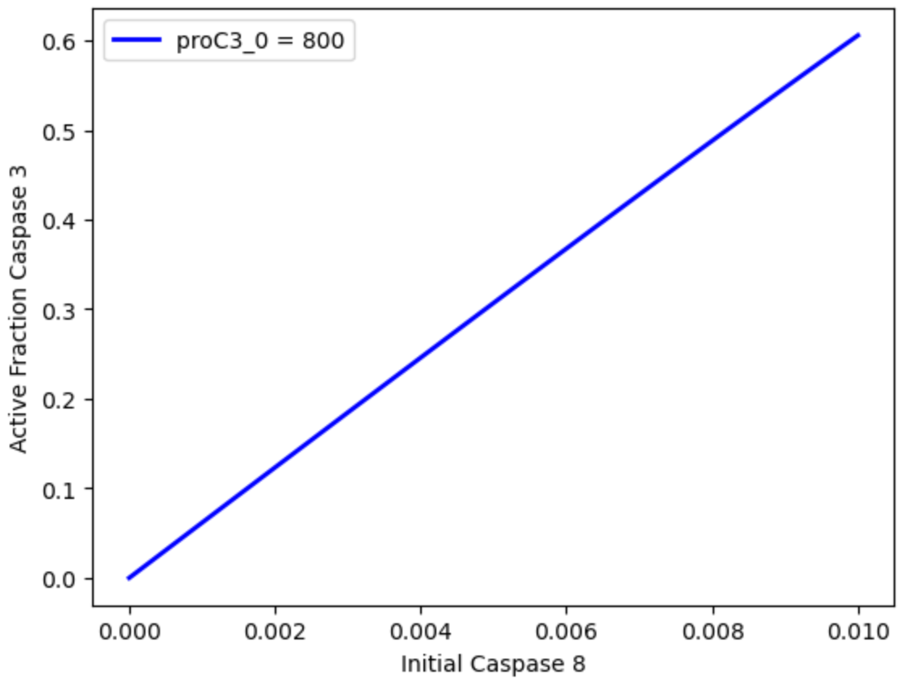

When the initial concentration of Caspase 8 increases significantly, the curve of the active fraction of pro-caspase-3 graph becomes less curved and more linear. When the initial Caspase 8 concentration increases up to a certain point, the graph is a complete straight line and additional initial concentration of Caspase 8 doesn’t affect the shape. This is different from what we found in HW1 in the PTM model where the saturation produced a sigmoidal curve and the change in S*/S_T was small for low values of r and increased up until steady state as r increased. This could be that the caspase has no reverse mechanism like how there is dephosphorylation of kinases in the PTM model. C3 only decreases through degradation.

**2) (20 points)** Next, we will implement a version of the caspase model that includes a receptor activating pro-caspase 8, FLIP binding at the receptor, and positive feedback by caspase 3 in the section “simple caspase model with feedback and FLIP”.

In this model we will have the following species: proC8, C8, proC3, C3, R (receptor), F (FLIP), and RF (receptor-FLIP complex). Write the change equations for this model that satisfy the below description and **add these to the section of code.**

1. proC8 and proC3 are synthesized at rate QC8 and QC3 respectively (zeroth order reaction).
2. proC8, C8, proC3, and C3 are all degraded at rate delta (first order reaction).
3. proC8 binds R at rate k_ba and generates C8 (second order reaction). Note that, in contrast to the model in question 1, we are not forming an R-C8 *complex*; rather, R interacts with proC8 and generates active C8 all in one step.
4. proC3 binds C8 at rate k_a and generates C3 (second order reaction). As in step “c” above, we do not form a complex here.
5. C3 binds proC8 at rate k_a and generates C8 (second order reaction). As in step “c” above, we do not form a complex here.
6. F binds R at rate kp to generate RF (second order reaction). Note that, in this case, F and R *are* forming an explicit complex (RF).
7. RF dissociates into F and R at rate km (first order reaction) .

Write your change equations here:

proC8prime = +QC8 -delta*proC8 -k_ba*proC8*R -k_a*C3*proC8

C8prime = -delta*C8 +k_ba*proC8*R +k_a*C3*proC8

proC3prime = +QC3 -delta*proC3 -k_a*proC3*C8

C3prime = -delta*C3 +k_a*proC3*C8

Rprime = -kp*R*F +km*RF

Fprime = -kp*R*F +km*RF

RFprime = +kp*R*F -km*RF

Which reaction in the above list implements a positive feedback mechanism? Write that specific reaction again below:

C3 + proC8 —> C8 (at rate k_a)

or k_a*proC8*C3

C3 binds proC8 at rate k_a and generates C8. Increase in C3 leads to increase in C8 which further catalyzes activation of proC3 to C3.

We will once again explore steady state responses of the model in the section “STEADY-STATE responses of feedback + FLIP model”. In particular we want to simulate how varying the concentration of initial active receptors affects the downstream activation of caspase 3.

Note we once again first define initial conditions and parameter values. All caspases exist only in their non-active state at the beginning of the simulation and the concentration of FLIP is set equal to that of the caspases. The rate of activation of pro-caspase 8 is slower to mimic the "basal" activity of proC8 cross-activation when bound to the receptor (without feedback).

Run this section of code and paste the resulting graph. If complete activation of C3 leads to cell death, how does the fate of the cell vary with receptor concentration? Is this result reasonable for a cell? Why or why not?

If complete activation of C3 leads to cell death, a high sensitivity to receptor concentration would be unreasonable for a cell. This is because being too sensitive to receptor concentrations would lead to unnecessary cell death a lot of the time. A more moderated or threshold-based response would be more reasonable to prevent unintended apoptosis.

Let’s now see if we can suppress activation of the caspase cascade by modifying parameters values from reactions involving FLIP. **Modify the values of kp and km and rerun this section of code until the plot generated differs from the previous result. Try making the binding affinity stronger; to do this, you should increase kp or decrease km. Note that you may encounter errors or numerical artifacts if your kp or km values are too large or too small; if you see strange behavior, try modifying these numbers again. Try *three* different values. Paste this final graphs here:**

kp=10000, km=0.01

kp=90000, km=0.001

kp=130000, km=0.001

Did your changes make any difference for the behavior of the system?

Yes, there is now a binary and switch-like behavior. There is full activation of Caspase-3 only when there is a minimum initial receptor concentration otherwise there is near 0 fraction of active caspase 3 for all three separate changes I made in the system.

Proteins cannot bind to each other arbitrarily fast, nor can they have arbitrarily strong binding affinities. A good rule of thumb is that association rates (kp values) are typically less than ${10}^{2} μM^{-1}s^{-1}$ for protein interactions, and KD values are typically larger than ${10}^{-4} μM$. Based on these rough ranges, are the parameter values that gave you different behavior above biophysically reasonable as a model for cell death?

The parameter values I gave were not biophysically reasonable as a model for cell death. My kp values ranged from 1.0*104 to 1.3*105 and were above the typical upper limit of 102 *μM-1 s*-1. My KD values ranged from 0.01 to 0.001 andd were also smaller than the typical lower limit of ${10}^{-4} μM$.

**3) (20 points)** Underneath the section where you plotted the steady state responses for the FLIP model, there is a section called “STEADY-STATE responses of feedback + irreversible FLIP model”. In this section, we will now assume that binding of FLIP to the receptor is ***irreversible***. We will implement this using the same model as before (“caspase_FLIP_model”) and modifying a single parameter value.

What parameter value do we change to simulate *irreversible* binding of FLIP to the receptor? What value do we set it to?

km represents the dissociation rate of the RF complex back to R and F so we set it to 0 to make the binding irreversible.

**Implement this change into this section of model code under the “#parameters” section.**

The remaining parameters are will remain unaltered to keep them in a biologically reasonable range. Does irreversible FLIP binding alone alter C3 activation? To answer this question, go BACK to the “STEADY-STATE responses of feedback + FLIP model” code above, make this change to the one parameter you identified above, and re-run the code. Does anything change?

Irreversible FLIP binding alone does not alter C3 activation because the graph does not appear to change when only km is altered.

We will now assume that FLIP is bound to the receptor prior to the start of the simulation. If the total amount of FLIP (F_tot) is greater than or equal to the total amount of receptors (R_tot), than all receptors are initialized to the receptor-FLIP complex (RF_0 = R_tot), R_0 = 0, and F_0 is equal to amount of FLIP in excess of R_tot. If F_tot is less than R_tot, than all FLIP is initialized to the receptor-FLIP complex (RF_0 = F_tot), F_0 = 0, and R_0 is equal to amount of receptors in excess of FLIP.

**Implement these rules for the initial conditions utilizing the if/then statement inside of the for loop. Run the section of code and paste the resulting graph.**

Explain in your own words what is happening in the model as the total receptor concentration surpasses the total FLIP concentration.

When the total receptor concentration surpasses the total FLIP concentration, there is a sharp increase in active cascade 3. Above a certain threshold, C3 gets activated there is positive feedback that leads to full activation of caspase 3, which promotes apoptosis since the receptors are not all neutralized by FLIP.

In this model, how does FLIP concentration control C3 activation as a function of receptor concentration?

FLIP controls C3 activation by binding to receptors and forming the RF complex. If FLIP concentration is high, fewer receptors are available to interact with proC8, thereby limiting the activation of C8 and, subsequently, C3 so C3 won’t be active if FLIP concentration is high. As receptor concentration increases, the impact of a constant FLIP concentration diminishes, allowing more C3 activation. This results in a switch-like behavior in the system.

Is the modeled behavior a reasonable for the cell? Why or why not? Do you think that the *assumptions* we need to make here are reasonable?

The modeled behavior seems reasonable for the cell. It shows a safeguard mechanism (FLIP) that controls the cell's move toward apoptosis and ensures that the cell’s decision to undergo apoptosis is final. There is no in-between, which could result in partial cell death and cause cell damage. The assumptions are reasonable since signals in the body can control the amount of FLIP and

receptor concentrations when deciding whether or not to undergo apoptosis.