**PhySci/MiMG/CaSB M178**

**Homework 8**

**Due: 11/30/23 at 12:00PM PDT**

**Notes:** This homework involves performing simulations of the history-dependent signaling systems we’ve been discussing in the last two class meetings. In the same folder on BruinLearn where you obtained this document, you will also find a file called “HW8_template.ipynb” that contains a template Jupyter notebook that you can use as a starting point to complete the questions below. Please modify this notebook and use it as the starting point for answering the following problems.

To submit your homework, please answer the questions below. Note that you will have to paste in several graphs that you generate using the Jupyter notebook. After completing the questions, **save this document as a PDF and upload it to Gradescope**. You **must also upload the Jupyter notebook to BruinLearn**; to do so, navigate to the “Homework” section on the left-hand side of the course BruinLearn website. There you will see an assignment entitled “Homework 8 Jupyter submission.” You can upload your Jupyter file (which should be a .ipynb file). Make sure you upload your Jupyter notebook by the due date/time (11/30/23 at 12:00PM PDT).

**Problems**

In class, we have talked about the NFkB signaling pathway that mediates inflammatory responses. We mentioned the following incoherent feedforward loop:

In the first model for this homework, we will explore the effect of this motif on inflammatory responses following repetitive activation of NFΚB (p65:p50).

We will start with the simple model of gene expression that we had from Homework 7. In our model, the input NFkB (p65:p50), binds to the promoter region of a gene and converts it from an inactive to active state. In this active state, transcription can occur, initiating an inflammatory response program. Hence in our investigation, we will take the amount of active promoter as a proxy measure for the degree of inflammatory response, the output of our model. Let *NFKB* denote the input signal, whose value can change over time.

One of the effects of activation of the promoter with NFKB is the synthesis of p50:p50 dimer. Much like in Homework 6, this synthesis takes time and hence this is a “delayed reaction”. Hence in the model, the amount of p50:p50 dimer produced at time *t* is dependent on the amount of active promoter present at time *t*-τ, where τ is the delay variable (i.e. the amount of time required for protein synthesis).

Finally, p50:p50 dimer inhibits the conversion of the inactive promoter site to its active form. To include this in the model, the effective rate of activation of the promoter region is a function of the abundance of both NFKB and p50:p50 dimer, as well as their binding affinities for the promoter region. We include this information in a Hill Equation:

*H_n* and *H_p* describe the proportion of binding sites that are occupied by NFKB and p50:p50 dimer respectively. Since p50:p50 dimer binding is inhibitory, the proportion of unbound sites (*1- H_p(t)*), determines the rate of promoter activation. Hence if is the maximum rate of promoter activation, the effective rate dependent onNFKB and p50:p50 is given by the product

In summary we have the following reactions:

|  |  |
| --- | --- |
| **Reactions** | **Description** |
|  | Activation of the promoter region |
|  | Deactivation of the promoter region |
|  | Synthesis of p50:p50 dimer (delayed reaction) |
|  | Degradation of p50:p50 dimer |

**1. (20 points)** First write down the change equations for the model described above. For the p50 synthesis term, make sure to write it in terms of the delayed variable, pr_a_tau.

**pr’ = -k_a*H*pr +k_d*pr_a**

**pr_a = +k_a*H*pr -k_d*pr_a**

**p50’ = -k_deg*p50 + k_syn*pr_a_tau**

**In the section of code called “NFkB-p50 model” implement the change equations to simulate the model.** Note how the code defines the value of the delayed variable, pr_a_tau, and the Hill Equation (H); use these values in your implementation. Once you have defined your model equations, run the cell containing the model code as well as the following cell titled “delay helper functions”. These functions are used to look up the old values of delayed variables as needed by the model.

Now we will simulate the model in the section of code called “Simulation of NFKB-p50:p50 model”. In this section, we have defined our initial conditions and default parameter values which are also listed below for your reference.

|  |  |
| --- | --- |
| **Parameter** | **Value** |
| Kd1 | 0.1 |
| Kd2 | 0.1 |
| k_a | 0.2 min-1 |
| k_d | 0.05 min-1 |
| k_syn | 0.05 min-1 |
| k_deg | 0.01 min-1 |
| tau | 25 min |

Below the initial conditions and parameter definitions is a section called “NFkB activation”. For the simulations in this homework, the profile of activation for all model inputs will be a box function (identical to that of IKK activation from HW 6 and TF from HW 7). Unlike the prior homeworks, we have the possibility of two successive activations. The first activation period is referred to priming and the second activation period is called the challenge. Hence to describe the temporal dynamics ofNFkB, we have to specify a first on time and off time (NFKB_on1_time, and NFKB_off1_time) and a second on time and off time time (NFKB_on2_time, and NFKB_off2_time). We assume the amplitude of both activations are equivalent (NFkB_amplitude). By default, NFKB_on1_time = 0, NFKB_off1_time = 60, NFkB_amplitude = 1, and there is no challenge (the remaining activation parameters are set to zero).

**Run the section of code for “Simulation of NFKB-p50:p50 model” and the section of code for “Checking Model Implementation”.** Check to see that the values on the right (from simulation of your model implementation) match the values on the left (from simulation of the correct model implementation). If the values don’t match to the first few decimal places, double check your change equations and code before proceeding.

**Run the section of code called “Plot Dynamics” and paste your graph here.** Can you identify from the “model output” (bottom) plot the value of tau? How about the value of NFKB_off1_time?

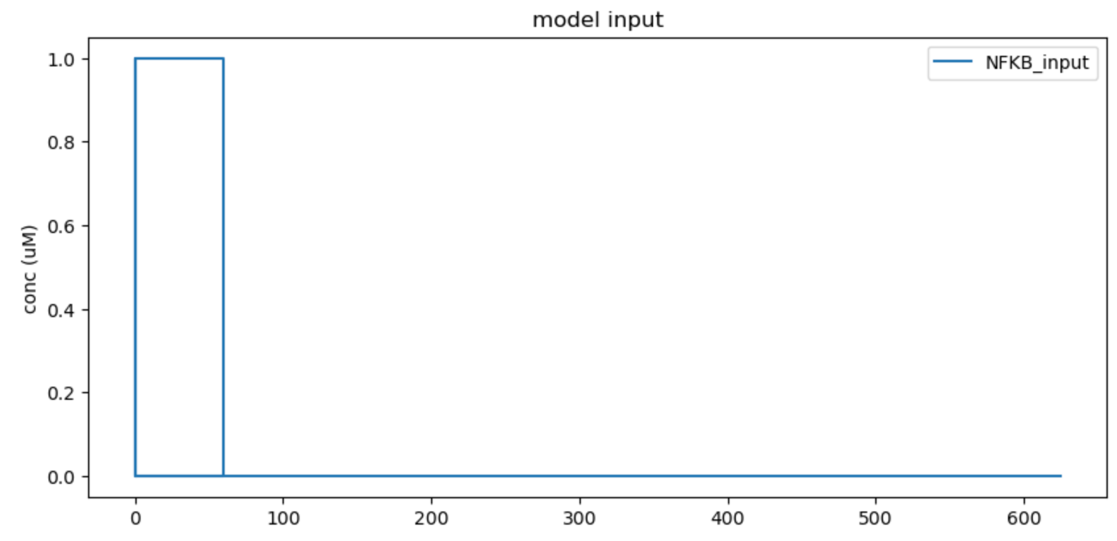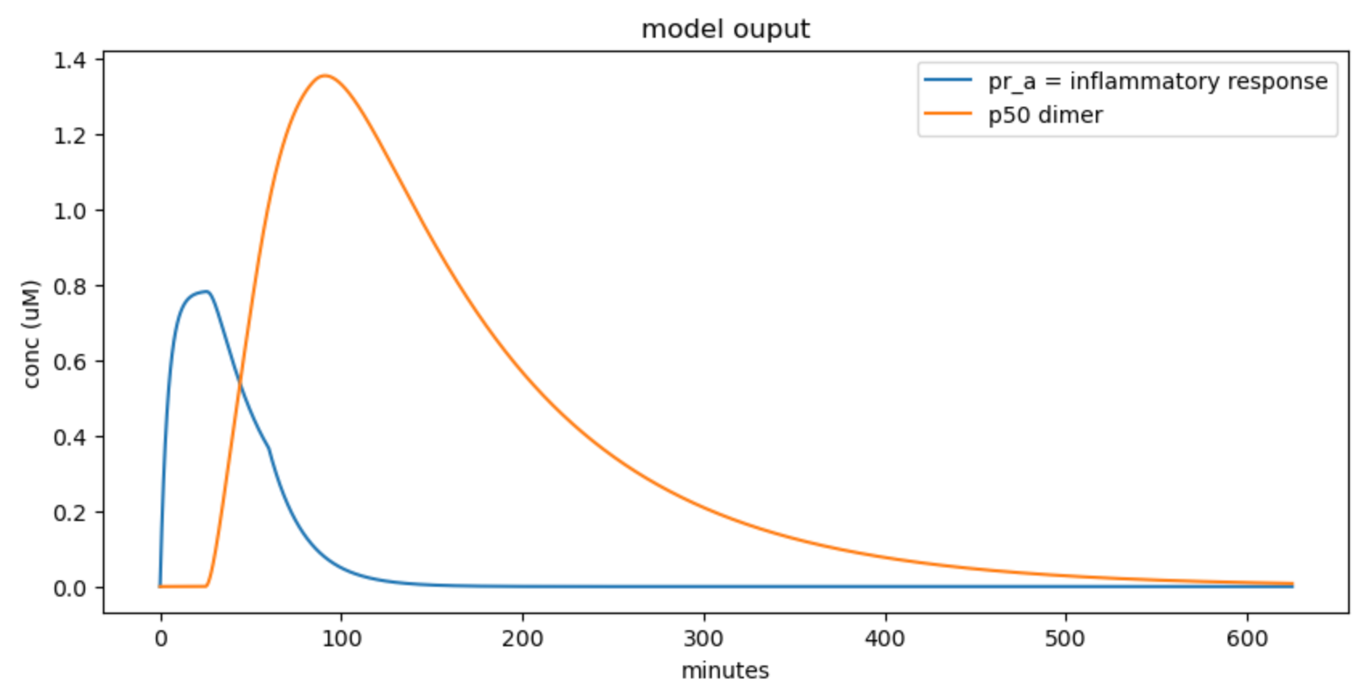

The value of tau appears to be 25 minutes because the inflammatory response doesn’t begin until 25 minutes after the p50 dimer. At t=25min, the pr_a concentration begins increasing from 0 concentration. The value of NFKB_off1_time can also be determined by looking at the “hitch” in the curve as the inflammatory response decline. At t=60min, the decline of pr_a goes from a linear shape to a curved shape, which indicates the NFKB_off1_time.

We will know add a challenge activation. **Modify “Simulation of NFKB-p50:p50 model” such that NFKB_on2_time = 120 and NFKB_off2_time = 180. Rerun the simulation and plotting cell. Paste your resulting graph here.** Describe the profile of inflammatory response over time. Is the response to the challenge activation different from the priming activation? If so, why?

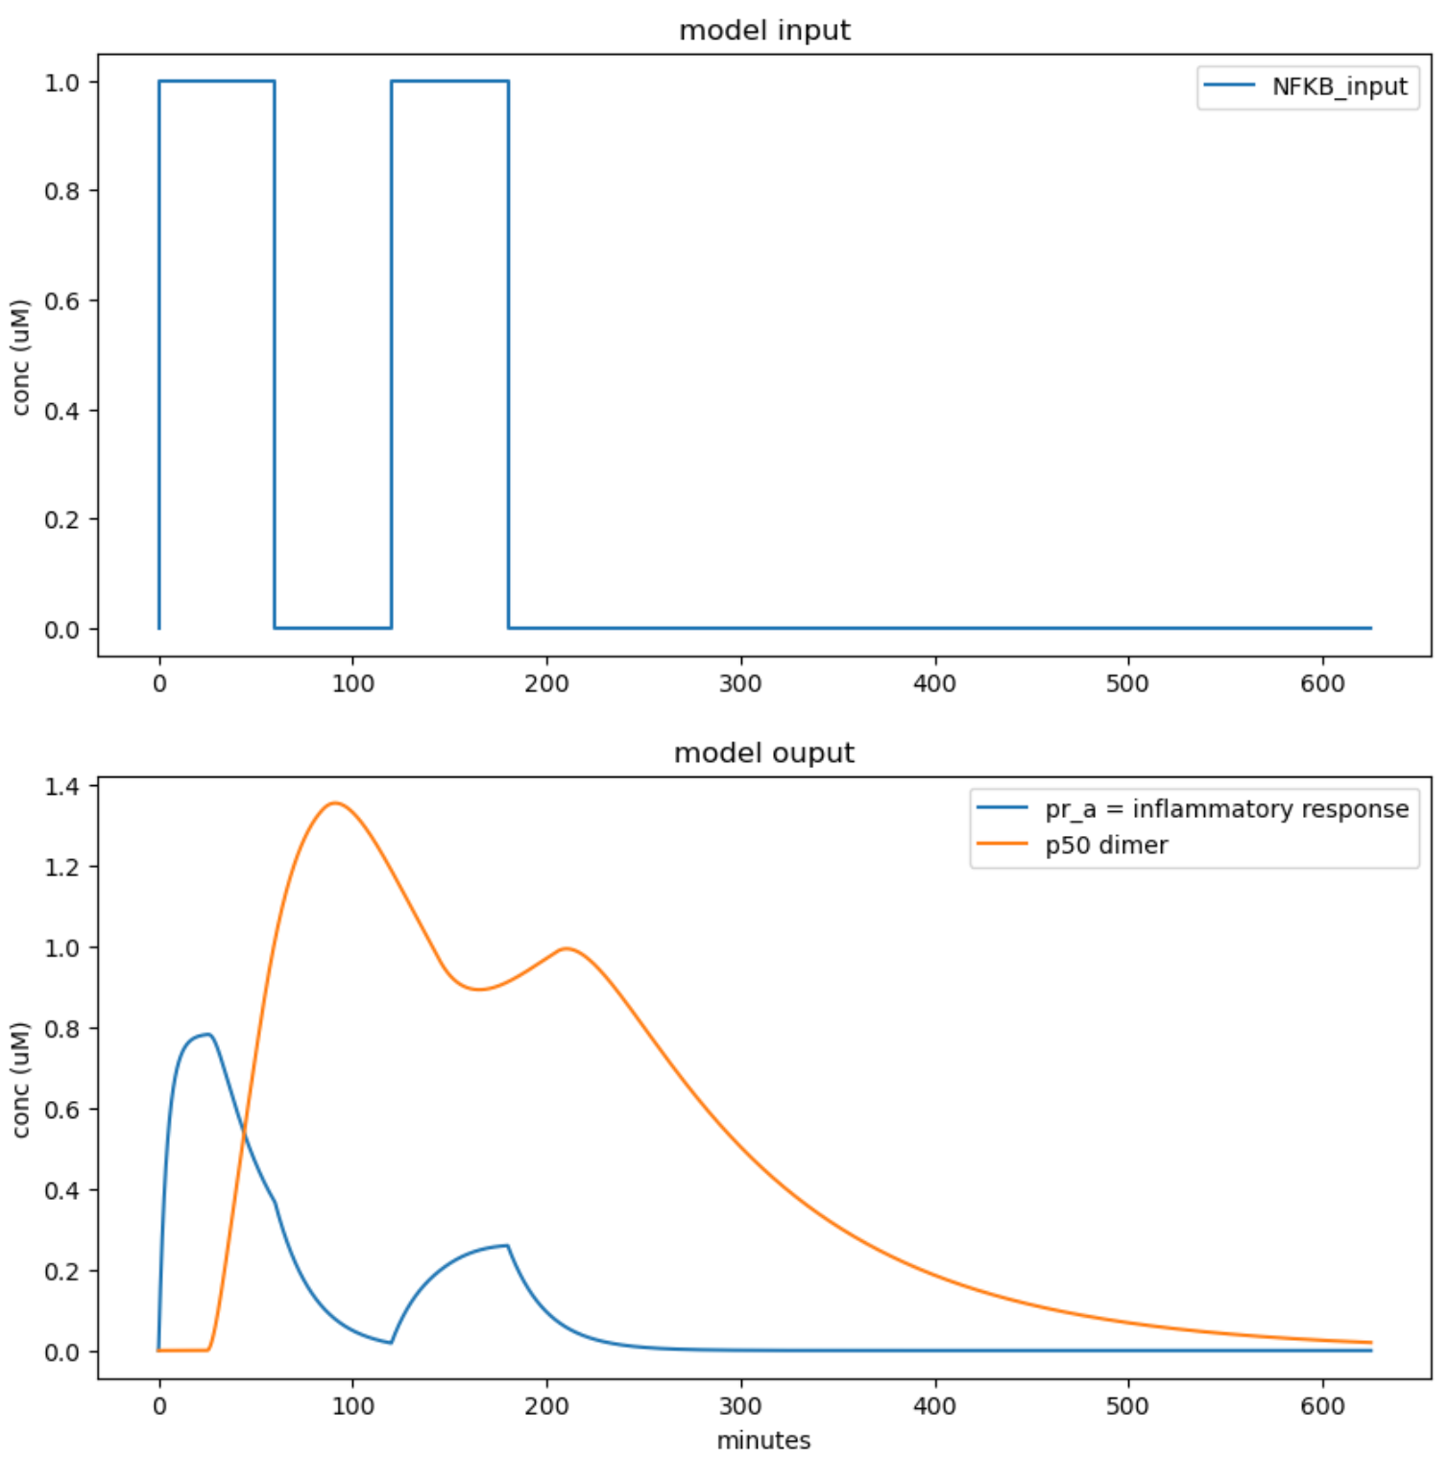

Here, there are two spikes in NFKB input, suggesting two distinct stimuli or activations spaced out over time as shown in the increase in inflammatory response that occurs twice, one that begins at t=0 minutes and the second that begins at t=120 minutes. There is a rapid increase following the first NFKB input spike, which peaks shortly after but then gradually decreasing toward the baseline concentration before a second spike occurs. The second challenging activation response to NFKB input is diminished compared to the first peak and also appears to increase more gradually. There is also still a time delay where the pr_a inflammatory response concentration increases first, then the p50 dimer concentration follows shortly after. The challenge activation response is differently because there was still a high concentration of p50 dimer causing the inflammatory response to be smaller.

**Modify “Simulation of NFKB-p50:p50 model” such that NFKB_on2_time = 360 and NFKB_off2_time = 420. Rerun the simulation and plotting cell. Paste your resulting graph here.** Describe the profile of inflammatory response over time. Is the response to the challenge activation more or less like the priming activation compared to the previous simulation? Why?

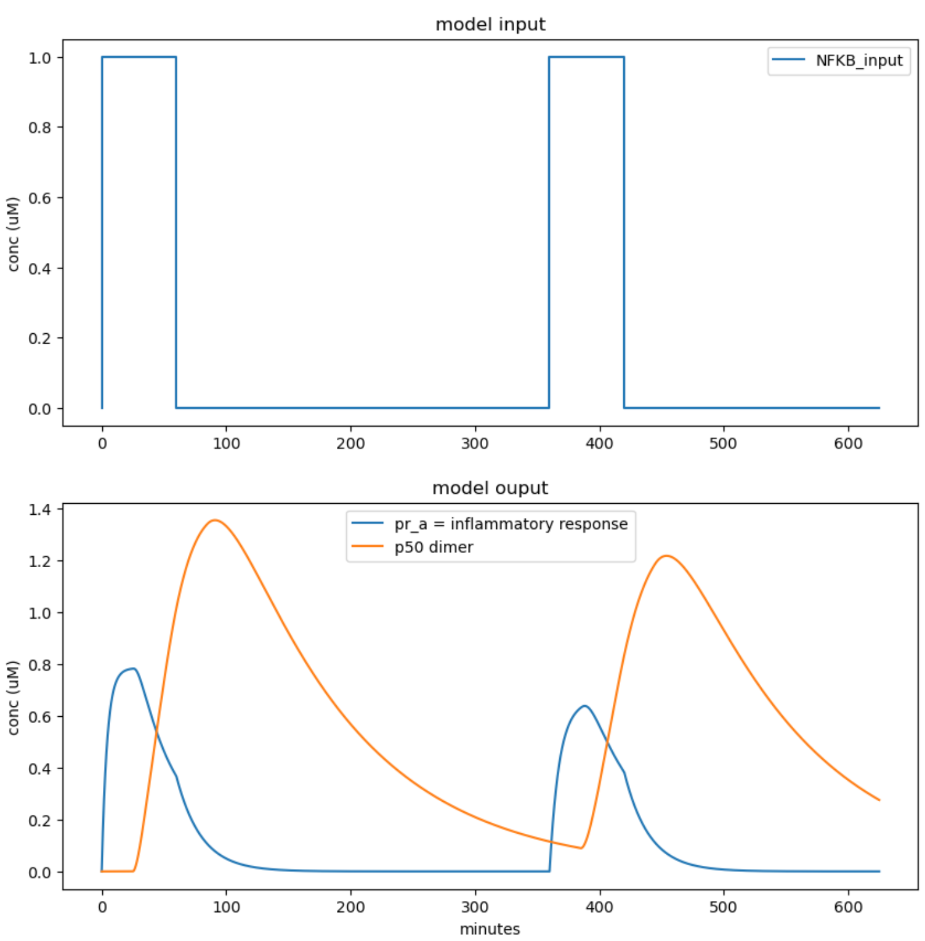

There is a larger time gap between the two NFKB inputs. The peak of pr_a inflammatory response and p50 dimer concentration in the challenge activation appears to be slightly lower than the priming activation but still has the same overall shape. Again, there is a rapid increase in pr_a inflammatory response followed by p50 dimer, then both responses gradually decline to baseline levels until a second peak occurs. In the second peak, the pr_a inflammatory response increases rapidly followed by p50 dimer until both gradually decline to baseline levels. The response to the challenge activation here is different than the previous challenge activation because there are two distinct peaks this time and each one is similar in peak concentration for both pr_a inflammatory response and p50 dimer. This could occur because the system could have become less response to a stimulus after the initial exposure in the previous simulation since there’s less time between stimulus activation, whereas in this simulation there’s a larger time interval gap, allowing the system to reset and recover. This is likely because there is less p50 dimer when the challenge activation initiated, causing a similar response to the priming activation.

**Reset “Simulation of NFKB-p50:p50 model” such that NFKB_on2_time = 120 and NFKB_off2_time = 180. Modify the value of k_deg until the response to challenge activation looks more like the response to the priming activation. Paste your resulting graph and state the value of k_deg you used.**

k_deg = 0.10

**How does k_deg control the priming effect?**

k_deg controls the availability of the p50 dimer in the system or the degradation rate of p50 dimer. If k_deg is high, p50 dimer is rapidly degraded after forming, which could lead to a reduced priming effect because the dimer wouldn’t persist long enough to have sustained signaling necessary for priming the response to subsequent stimuli. If k_deg is low, the dimer would be more stable and persist longer, allowing the system to maintain activation of downstream inflammatory pathways for an extended duration, which could lead to a system remaining prepared for re-exposure to the stimulus.

**2. (20 points)** In class we also talked about the Interferon signaling pathway and responses to viral pathogens. This past week we focused on the positive feedback loops present in the pathway:

We will first focus on simulating the portion of the pathway on the right-hand side of this schematic. For this model, the input is interferon, IFN. It stimulates the conversion of ISGF3 into its active form, ISGF3*. ISGF3* activates an antiviral gene response program, and hence we will use it as the output measure from our model. Finally, ISGF3* stimulates the production of more ISGF3. The induced production of ISGF3 is proportional to fraction of ISGF3* bound DNA binding-sites, and we once again use a Hill term to describe this. Additionally, this synthesis is also a delayed reaction, so we use the value of ISGF3* at time *t*-τ (ISGF3*_tau) to calculate the value of the Hill term at time *t*.

Finally, if *k1_syn* represents the basal synthesis rate of ISGF3, the total synthesis rate including that from ISGF3* stimulation is given by *k1_syn * (1 +H(t)).*

In summary we have the following reaction:

|  |  |
| --- | --- |
| **Reactions** | **Description** |
|  | ISGF3 synthesis |
|  | ISGF3 degradation |
|  | ISGF3* degradation |
|  | IFN mediated activation of ISGF3 |
|  | Deactivation of ISGF3 |

First write down the change equations for the model described above. For the ISGF3 synthesis term, make sure to write it in terms of Hill term.

**ISGF3’ = +k1_syn*(1+H) -k1_deg*ISGF3 -k_a*ISGF3*IFN +k_d*ISGF3p**

**ISGF3p’ = -k2_deg*ISGF3p +k_a*ISGF3*IFN -k_d*ISGF3p**

**In the section of code called “simple IFN model” implement the change equations to simulate the model.** Note how the code defines the value of the delayed variable, ISGF3p_tau and uses it in the calculation of the Hill Term (H). Make sure to use the value of H in your implementation. Once you have defined your model equations, run the cell containing the model code as well as the following cell titled “delay helper functions”. These functions are used to look up the old values of delayed variables as needed by the model.

Now we will simulate the model in the section of code called “Simulation of simple IFN model”. In this section, we have defined our initial conditions and default parameter values which are also listed below for your reference.

|  |  |
| --- | --- |
| **Parameter** | **Value** |
| k1_syn | 0.1 nM*min-1 |
| k1_deg | 0.01 min-1 |
| k2_deg | 0.01 min-1 |
| k_a | 0.2 nM-1min-1 |
| k_d | 0.05 min-1 |
| Kd | 0.1 |
| tau | 25 min |

Below the initial conditions and parameter definitions is a section called “IFN activation”. The definitions are much like that for NFKB activation in problem 1. By default, IFN_on1_time = 0, IFN_off1_time = 10, IFN_amplitude = 1, and there is no challenge (the remaining activation parameters are set to zero).

**Run the section of code for “Simulation of simple IFN model” and the section of code for “Checking Model Implementation”.** Check to see that the values on the right (from simulation of your model implementation) match the values on the left (from simulation of the correct model implementation). If the values don’t match to the first few decimal places, double check your change equations and code before proceeding.

**Run the section of code called “Plot Dynamics” and paste your graph here.** Can you explain the shape of the trajectories in the “model output” (bottom) plot? Does the model return to its initial steady state?

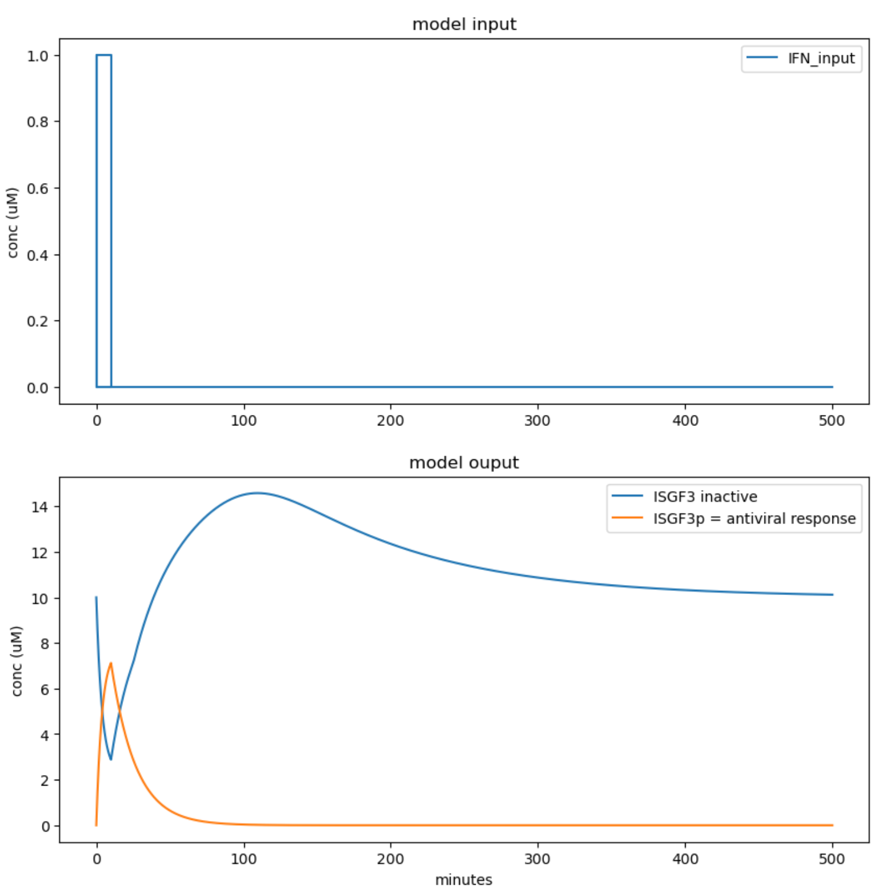

There is a sharp decrease in ISGF3 inactive concentration corresponding with a sharp increase in ISGF3p concentration as the transient IFN input occurs. Then, the ISG3 inactive concentration increases again above its baseline level, but then rebounds to baseline level over time. At the same time, ISGF3p gradually decreases to baseline level after the transient signal is gone. The model does eventually return to its initial steady state. You can see that the initial concentration of ISGF3 inactive was 10 (microM), and in the long-run after the ISGF3p antiviral response has decayed to 0, the concentration of ISGF3 was at the same value of 10 microM.

We will know add a challenge activation. **Modify “Simulation of simple IFN model” such that IFN_on2_time = 100 and IFN_off2_time = 110. Rerun the simulation and plotting cell. Paste your resulting graph here.** Describe the profile of antiviral response over time. Is the response to the challenge activation different from the priming activation? Why or why not?

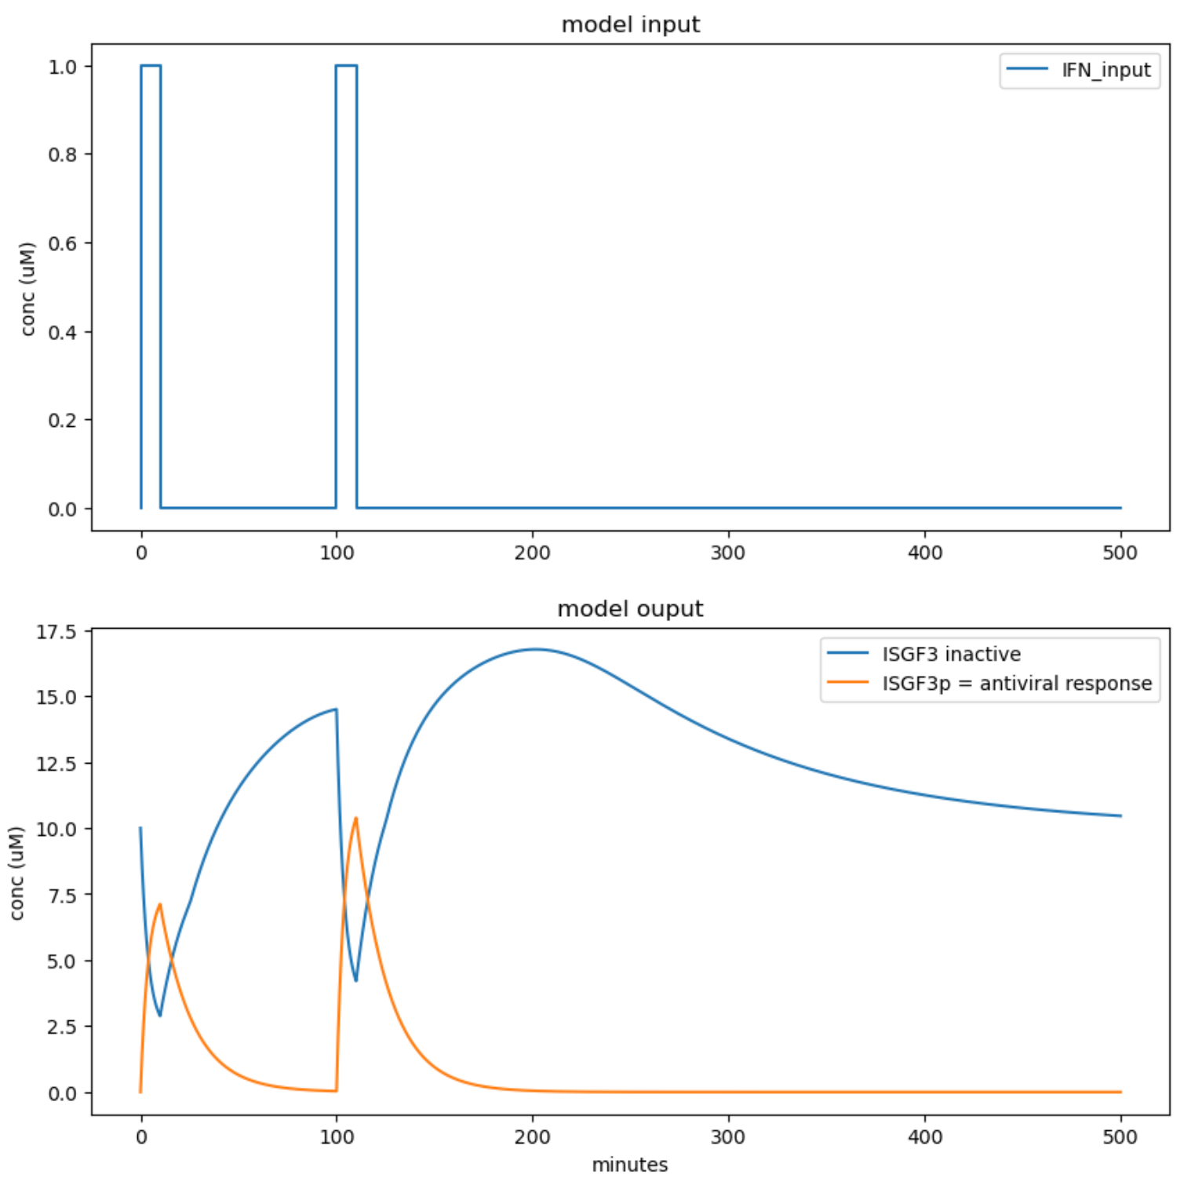

Initially, the ISGF3 inactive curve shows a sharp increase in the first IFN input, indicating an immediate activation of the pathway, followed by a decline once the input disappears. This is mirrored by the ISGF3p curve, representing the antiviral response, which spikes at the same time the ISGF3 inactive reaches its trough.

In the second IFN input, both ISGF3 inactive and ISGF3p responses are higher compared to the first input in that the peak of the ISGF3p antiviral response concentration and trough of the ISGF3 inactive concentration are both higher in the challenging activation than the priming activation. There is also a larger difference between the peak of ISGF3p and the trough of ISGF3 inactive. The higher ISGF3p antiviral response concentration is likely due to the priming of the first input, which leads to a more efficient antiviral response upon re-exposure. The prior activation allowed for an immune memory effect where there is now a heightened state of readiness leading to a more robust response to the subsequent stimulus.

**Now modify “Simulation of simple IFN model” such that IFN_on2_time = 450 and IFN_off2_time = 460. Rerun the simulation and plotting cell. Paste your resulting graph here.**

Describe the profile of antiviral response over time. Is the response to the challenge activation different from the priming activation? Why or why not?

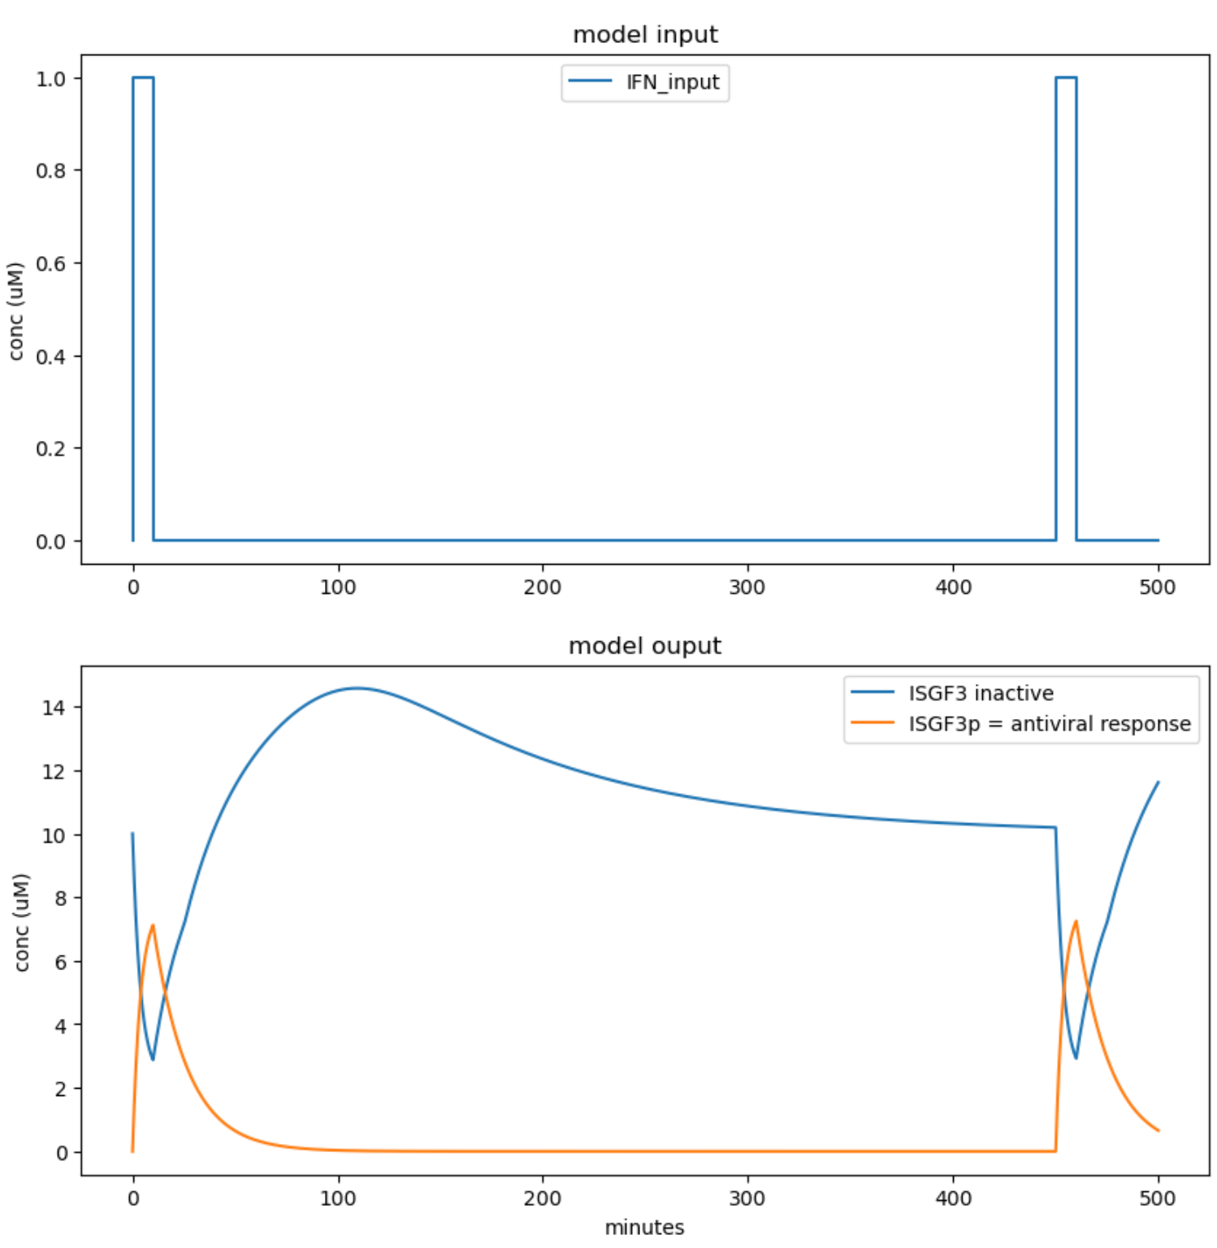

The ISGF3p curve initially sharply peaks after the first IFN input, then falls back to baseline before the second IFN input occurs. The ISGF3 inactive concentration also initially sharply declines after the first IFN input, then gradually increases and peaks before gradually declining to rebound to baseline level before the second IFN input occurs. During the second IFN input, the dynamics appear to be nearly identical to the first IFN input where the ISGF3 inactive concentration decreases to the same trough value in the challenging activation and the ISGF3p concentration increases to the same peak value in the challenging activation. This could be because there is a larger time interval gap between the two IFN inputs, resulting in the system reverting to its pre-stimulation state by the time the second IFN input occurs.

**Set back IFN_on2_time = IFN_off2_time = 0 in the section “Simulation of simple IFN model”.** We will now explore the effect of lengthening the priming activation. **Modify “Simulation of simple IFN model” such that IFN_on21_time = 0 and IFN_off1_time = 100. Rerun the simulation and plotting cell. Paste your resulting graph here.**

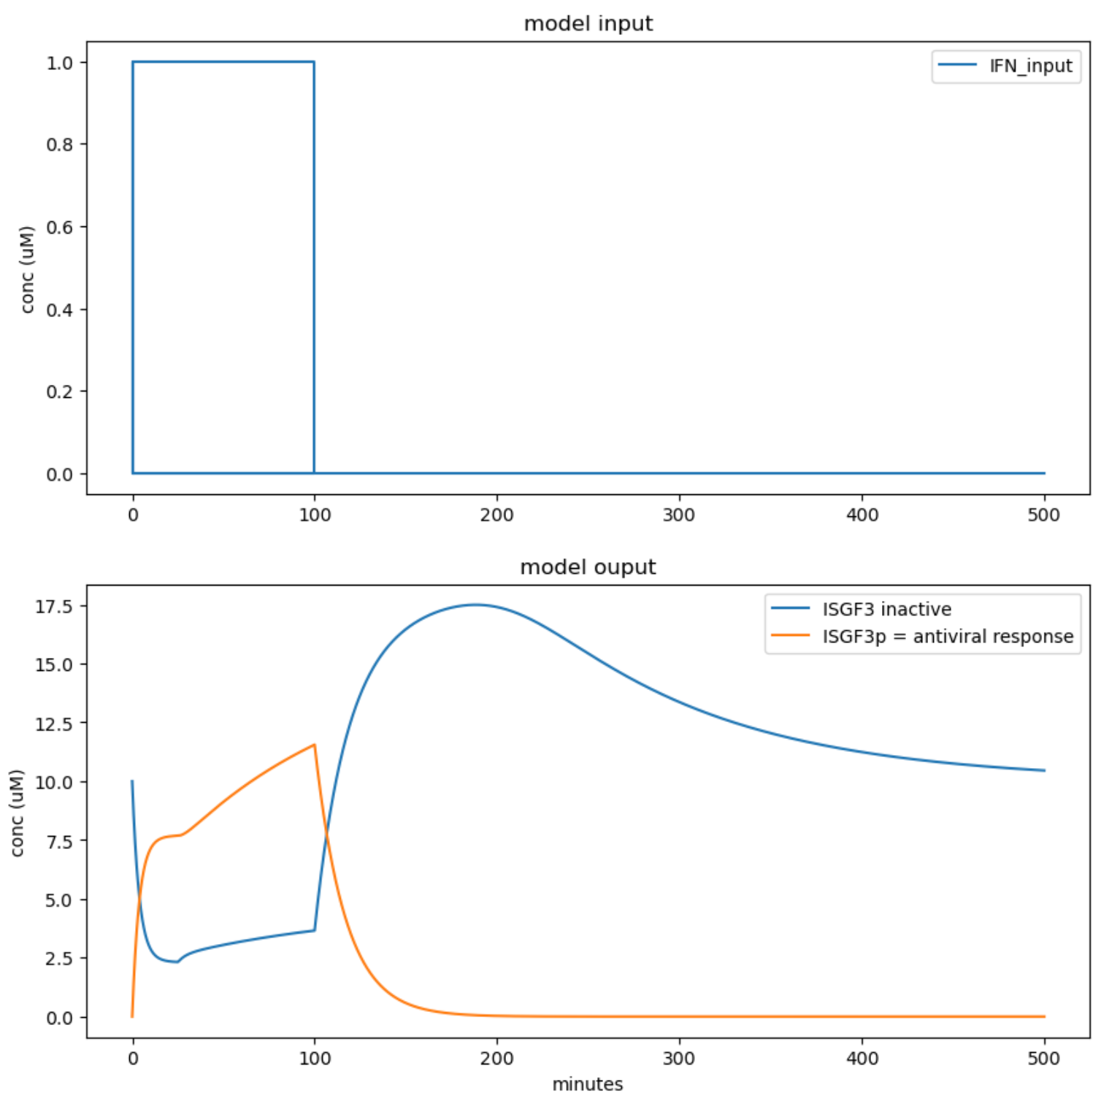

How does the antiviral response differ from that with only a single 10-minute IFN activation? Why is there difference in the shape of the response?

Here, there’s a sharp initial increase in ISGF3p concentration followed by a relatively linear continuous increase up until 100 minutes. For ISGF3 inactive concentration, the concentration rapidly decreases, but then slowly and gradually increases up until 100 minutes. After 100 minutes, the ISGF3p concentration decreases relatively quickly to baseline level while ISGF3 inactive concentration increases relatively quickly to its peak concentration level before gradually decreasing to baseline level in the long run. There could be a difference in the shape of the response because a longer stimulus duration could initiate additional regulatory processes or signaling molecules could accumulate, which might not occur with a shorter stimulus. This could lead to a more complex response that has multiple phases of activation and deactivation, as opposed to a single transient peak following a short-lived stimulus.

**3. (20 points)** We will now simulate the complete IFN model depicted in the above illustration. We now also have a virus, V, that stimulates the conversion of IRF3/7 to its active form IRF3/7*. IRF3/7* and IRF1 (which is always active) stimulates the production of IFN. Finally, ISGF3* stimulates the synthesis of ISGF3, IRF3/7, and IRF1 (IRF1 unlike the other species has no basal production).

In summary we have the following reaction:

|  |  |
| --- | --- |
| **Reactions** | **Description** |
|  | ISGF3 synthesis |
|  | IRF3/7 synthesis |
|  | IRF1 synthesis |
|  | ISGF3 degradation |
|  | ISGF3* degradation |
|  | IRF3/7 degradation |
|  | IRF3/7* degradation |
|  | IRF1 degradation |
|  | IFN mediated activation of ISGF3 |
|  | Deactivation of ISGF3 |
|  | Viral mediated activation of IRF3/7 |
|  | Deactivation of IRF3/7* |
|  | IFN synthesis |
|  | IFN degradation |

The Hill term, *H*, is the same as it was as problem 2, containing the delayed value of ISGF3*. We additionally have the Hill term, *HOR*, to describe the effective synthesis rate of IFN which can be stimulated by IRF3/7* or IRF1:

We use the Hill equation from Homework 7 to describe a logical “OR” gate and use the delayed values of IRF3/7* and IRF1 to account for the time it takes to synthesis a protein.

First write down the change equations for the model described above, only for the species listed below. Make sure to include the Hill terms in the synthesis terms.

**IRF3/7’ = +k3_syn*(1+H) -k3_deg*IRF37 -k_a2*V*IRF37 +k_d2*IRF37p**

**IRF3/7p’ = -k4_deg*IRF37p +k_a2*V*IRF37 -k_d2*IRF37p**

**IRF1’ = +k5_syn*H -k5_deg*IRF1**

**IFN’ = -k_a1*IFN*ISGF3 +k_a1*IFN*ISGF3 +k6_syn*H_or -k6_deg*IFN**

**In the section of code called “complete IFN model” implement the change equations to simulate the model.** Also include your equations for ISGF3 and ISGF3* from problem 2. Note how the code defines the value of the delayed variables and uses it in the calculations of the Hill Terms. Make sure to use the values of H and H_or in your implementation. Once you have defined your model equations, run the cell containing the model code as well as the following cell titled “delay helper functions”. These functions are used to look up the old values of delayed variables as needed by the model.

Now we will simulate the model in the section of code called “Simulation of complete IFN model”. In this section, we have defined our initial conditions and default parameter values which are also listed below for your reference (numerical subscripts are eliminated for brevity).

|  |  |
| --- | --- |
| **Parameter** | **Value** |
| k_syn | 0.1 nM*min-1 |
| k_deg | 0.01 min-1 |
| k_a | 0.2 nM-1min-1 |
| k_d | 0.05 min-1 |
| Kd | 0.1 |
| tau | 25 min |

Below the initial conditions and parameter definitions is a section called “viral activation”. The definitions are again much like NFKB and IFN from the previous problems. By default, V_on1_time = 0, V_off1_time = 10, V_amplitude = 1, and there is no challenge (the remaining activation parameters are set to zero).

**Run the section of code for “Simulation of complete IFN model” and the section of code for “Checking Model Implementation”.** Check to see that the values on the right (from simulation of your model implementation) match the values on the left (from simulation of the correct model implementation). If the values don’t match to the first few decimal places, double check your change equations and code before proceeding.

**Run the section of code called “Plot Dynamics” and paste your graph here.** Can you explain the shape of the trajectories in the “model output” (bottom) plot? Does the model return to its initial steady state?

Initially, the IRF3/7* active concentration is the only component that increases, but then it declines to baseline level after the virus input ceases. As the IRF3/7* decreases, the ISGF3p active concentration and IFN concentration both increase with the ISGF3p active concentration increasing sharply while the IFN concentration increases gradually. Then, the IRF1 active concentration increases sometime after. The ISGF3p active concentration, IFN, and IRF1 active concentration remain elevated after the virus input is no longer present, suggesting a sustained response to the viral presence and a maintenance of an antiviral defense. So, the model does not return to its initial steady state. Only IRF3/7* active concentration returns to its baseline level of 0 concentration. The shape makes sense because IRF3/7* active are interferons that help lead to IFN production. Then, IFN concentration increasing shortly after makes sense because they are produced to respond to viral infections and activate other immune cells. ISGF3p active concentration increasing makes sense because it will induce a broad antiviral state. Then, IRF1 active concentration increasing needs to occur because of its response to increasing IFN concentration and possibly ISGF3p concentration (indirectly).

We will know add a challenge activation. **Modify “Simulation of complete IFN model” such that V_on2_time = 450 and V_off2_time = 460. Rerun the simulation and plotting cell. Paste your resulting graph here.** Is the response to the challenge activation different from the priming activation? Why or why not?

The response to the challenge activation different from the response to the priming activation. After the first virus input, the system initiates an antiviral response characterized by a rapid but transient activation of IRF3/7, followed by a more prolonged production of IFN and ISGF3p, and subsequent activation of IRF1. However, in the response to the challenge activation, only the IRF3/7* activation increases, while the ISGF3p active, IRF1 active, and IFN concentration don’t change whatsoever from their new baseline levels. This lack of further increase in IFN, ISGF3p, and IRF1 could indicate a saturation effect where the maximum response capacity has been reached, or that a feedback mechanism is maintaining these components at steady-state levels necessary for an effective antiviral defense. So, the system's sustained antiviral state after the initial activation allows it to maintain a response without the need for further increases upon re-exposure to the virus.

Suppose instead the timing of the challenge activation was further delayed (i.e. V_on2_time = 1000, V_off2_time = 1010). Predict what the response of ISF3/7* would look like to the challenge.

I predict that the response of ISF3/7* will be elevated or quicker compared to the first response. I believe that memory of the initial stimulus will remain so when there’s subsequent stimuli, the system is already in a heightened antiviral state indefinitely, similarly to what we saw when the challenge activation occurred at t=450 minutes in the previous question. The IRF3/7* activation will likely peak higher in concentration before gradually decreasing to baseline level.

How is the priming in this model different from that in the previous two problems? Can you think of scenarios where these different types of “memory” could be useful to a cell?

In the previous two problems, the system’s response to a second stimulus was diminished after a short time interval, indicating a short-term adaptation or tolerance rather than an enhanced memory response. This could be useful when a cell is exposed to frequent, non-lethal stimuli and needs to avoid an overreaction that could cause unnecessary inflammation. It could also be beneficial in changing environments where a cell needs to respond to varied stimuli rather than being a prolonged heightened state that might interfere with the cell’s ability to adapt to new challenges.

In the current model with a delayed second stimulus, there is a long-term memory within the cell, which allows for an enhanced response after the initial priming response. This could be useful for long-term immunity like with vaccinations against a specific pathogen that could be commonly present.