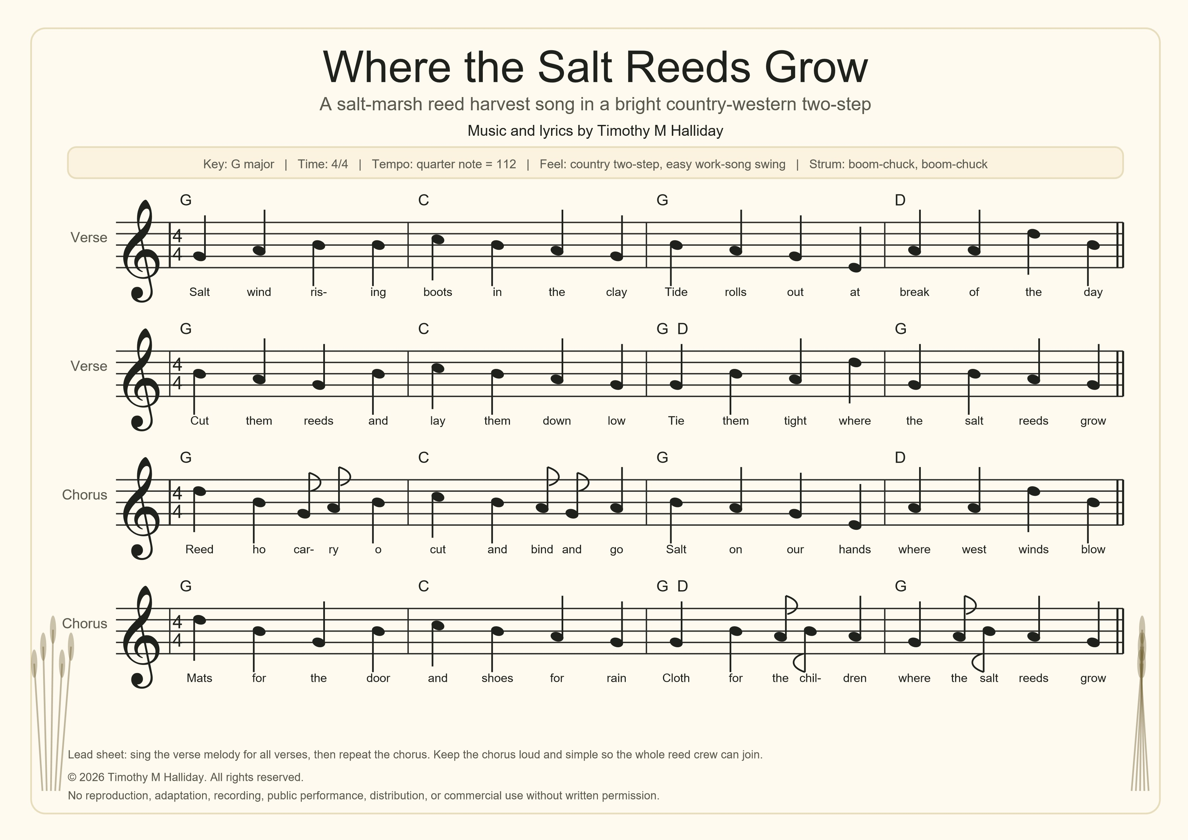
Where the Salt Reeds Grow
Full lyric and chord sheet
Verse 1
G
Salt wind rising, boots in the clay,
C
Tide rolls out at the break of day.
G
Cut them reeds and lay them down low,
D G
Tie them tight where the salt reeds grow.
Chorus
G
Reed-ho, carry-o, cut and bind and go,
C
Salt on our hands where the west winds blow.
G
Mats for the doorway and shoes for the rain,
D G
Cloth for the children when the cold comes again.
G
Reed-ho, carry-o, swing and go,
D G
Everybody singing where the salt reeds grow.
Verse 2
G
Grandmothers humming by the old salt run,
C
Brown reeds shining in the morning sun.
G
Hands make clothing, hands make shoes,
D G
Hands make a mat for the door we choose.
Verse 3
G
Rain on the brim and a gull on the mast,
C
Sing it once slow, then sing it fast.
G
If the day grows heavy, let the rhythm roll,
D G
Salt marsh work puts gold in the soul.
Call and response bridge
G
Caller: Who makes the mat?
D
Crew: The reed and the hand.
G
Caller: Who makes the shoe?
D G
Crew: The marsh and the land.
C
Caller: Who keeps us singing?
D G
Crew: The tide and the band.
Harvest singing note
Best sung in a steady walking beat: one cut, one lift, one bind, one carry. The chorus is deliberately simple so every worker can join without rehearsal.
Optional ending: repeat “Everybody singing where the salt reeds grow” three times, softer each time, then finish on G.
© 2026 Timothy M Halliday. All rights reserved.
No reproduction, adaptation, recording, public performance, distribution, or commercial use without written permission.

