Some-Name Syndication Software

T&M SoftWare

System Overview

T&M Software

Syndication & Racing Club Software Overview

 T&M SoftWare

Some street name • Second Name

Town Name, County eircode

Phone 203.555.0167 • Fax 203.555.0168

Table of Contents

Abstract……………………………………………………………...1

Introduction 1

Real World Syndicates & Racing Clubs 1

Players 1

Types of arrangements 1

Types of arrangements 1

How to Change the Headers and Footers 1

How to Create a Numbered Paragraph 1

How to Save Time in the Future 1

How to Create a Document 1

More Template Tips 1

Index 1

ABSTRACT

This document aims to provide an overview of the Syndication Software System, its value to its customer base and how it generates sales.

Syndication is a common theme in all walks of the sporting and commercial life as can be seen in the syndication of the thoroughbred horse (racehorse, stallion, mare and even foal), Greyhounds, Motor Sport and Showjumping. In these syndicates there are common structures and elements e.g. Owners, syndicate members, timelines, agreements and so on which SomeNameSoftware rationalizes to bring owners and potential members together to create not only Syndicates as we currently understand them but enables the creation of virtual Syndicates which would be unique to an individual member. It not only provides agreements with timelines, reward and payment schemes and facilitates information sharing, it also allows members to trade in syndicate ‘interests’ which have a value which varies line with the success of the Syndicate itself.

INTRODUCTION

Syndicates in various forms have always existed but in a world of distributed wealth, where it’s less likely for any individual to be either capable or willing to fund all the risk for any initiative, syndicates and clubs are becoming an increasingly common vehicle with which to share risk and broaden opportunity.

The origin of this system has come from the authors experience in the horse racing breeding industry. In short:

1. Most breeders want to sell most if not all of their stock. This works well if the breeder has produced a colt of good conformation, born in the first quarter of the year that is by a popular commercial stallion or has a particularly well bred, good looking filly available. In other words, a commercially viable proposition. This being farming/ bloodstock, that isn’t always going to be the case and will leave a breeder with some extensive costs and only limited opportunities to make a viable sale. There are many reasons for this, a lot of which lie at the lack of competition between Sales companies and the imbalance in power that that can bring.
2. Some breeders will want to keep valued, well-bred offspring as potential replacements of successful broodmares approaching retirement.

In either case, the breeder needs to add value to the stock they’ve decided not to sell at the sales. They need to do this in order to generate a sale later on in the horses career or to add value as a broodmare. In the case of bloodstock, that’s to enter them into training with a view to racing. This involves risk. It’s a high risk, high return industry and in the modern climate, very few individuals want to take on that level of risk when the most likely outcome is not that of high return. To address this, the owner/ breeder will need to spread the risk by putting together a syndicate or racing club. This needs contacts, access to people who have an interest in horseracing or the horseracing experience and may be from any number of sources:

* Personal associations. This can be limited to those who can afford the minimum investment usually required in the current syndication model. This is less so for the racing club model.
* Direct industry association. Other breeders, trainers, previous customers.
* Indirect industry association e.g. Trainers or bloodstock agents who themselves have their own customer base.

A good number of the above can be difficult to draw upon more than once, especially in the event of a previous unsuccessful experience so as a dependable model for decision making, setting up syndicates/ racing clubs on one’s own can have a limited future.

So the idea came about for an application which is a repository of syndicates and racing clubs, which could be searched for and subscribed to by anybody who was interested and agreed to the terms of that syndicate/ racing club. Of course, once one starts thinking about this, the application doesn’t need to be solely for the horse industry. Syndicates/ Clubs can apply to many different ‘investment’ sets, greyhounds, football, cycling teams and so on. The concepts are the same, the ‘investments’ vary in name and only slightly if at all in function.

It is the purpose of this system to

1. Identify and automate most if not all of those existing characteristics and behaviours and make available to
   1. anybody who wants to make an investment available:
      1. As a syndicate or a club
      2. To a syndicate or club
   2. anybody who wants to find and join a syndicate or club
2. Provide additional value which is currently not possible in the traditional syndicate/ racing club model. So:
   1. Introduce and support concepts of:
      * 1. Virtual Syndicates
        2. Configurable Investment member quantity.
           1. No minimal limit investment for members
        3. No max number on syndicate/ club numbers
        4. ‘Interests’. Tradable increments of any syndicate or club for the lifetime of that syndicate/ club.
   2. A supporting app to share progress information, support for multimedia updates
3. Support external standalone syndication and club web sites by making the core application software available via a Cloud based API.

This document will describe

* How each of the areas will work from a functional perspective.
* What is Core functionality and that which is Syndicate Type/ Club Type specific
* Added value
* Architecture

Chapter

1

Existing Syndicates and Clubs

# Real World Traditional - Attributes and Behaviours

Commercial syndicates or clubs offer individuals who wish to join them, the opportunity to get involved in the ownership experience for a set fee. In many cases this set fee is a monthly or annual charge that includes all extras, meaning members won't run the risk of under budgeting or surprise expenses building up.  There are many types:

1. **Syndicates:** These tend to involve some kind of upfront investment in the horse be that in the form of ownership or as a share of the costs with a return relative to the ‘share’.
   1. **Ownership**. The members share the cost of the purchase according to the percentage share they contribute. The percentage is usually fixed e.g. 5%, 10%, 15% and so on. All further expenses (training fees, Vet bills, out of season livery, registrations etc) and profits (prize money, resale) would be shared according to that share. Members usually avail of all the lifestyle experiences of a traditional owner i.e. visits to trainer, racecourse attendance, information on progress etc. etc.
      1. **Comment**: While the risk is certainly significantly less than for sole ownership, there is still an amount of initial investment required which in the case of a failure, could be lost. Additionally, there’s no limit on the additional expenses which could be incurred. However, given the cost of training is similar irrespective of the value of the horse, one key benefit is to allow potential members an opportunity to get involved in a higher value proposition albeit at a lower percentage.
   2. **Leasing/ loans**. The membership lease or loan the horse for a pre-determined period of its racing career where after it’s returned to the owner. Costs during the racing career would be shared in line with a percentage stake in the syndicate. Returns in terms of prize money are in line with the stake.
      1. **Comment**: No upfront investment so significantly less risk than the ownership model, however in the event of a successful racehorses, while there’d be a return in line with that success from prizemoney, there would be no sale revenue. Additionally, in the event of fixed term leases, the horse may be returned to the owner before the racing career is over and all racing benefits realised. Members usually have access to all or some of the lifestyle experiences involved in owning a racehorse available to them.
2. **Racing Club**. Racing Clubs tend to (but not always) decouple the stakeholder relationship between the members and the horses and involve a membership fee which entitles the individual to membership of the club rather than any fixed return on a horse’s performance. Horses may come and go but the club continues. The membership fee can vary depending on the capacity of the club to manage numbers and the quality of racing the club is targeting (and therefore quality of horses). The value to the member is largely around the racing experience determined by the logistics of a large horse base rather than any return in investment. However some clubs may pay out a dividend at the end of a pre-determined cycle (one, two or three years).

So the purpose of the Syndication Software is to facilitate all the features described above and this document will use the real world example of a racehorse to make things clearer. It will also attempt to identify where this may not apply to others when applicable.

System Software

# Landing Page

On landing at the application, the user should be able to:

1. View available Syndicates.
2. View available stand alone investments (e.g. racehorse). These would be available to add to one’s own Syndidate.

# Account creation.

Before anybody can use the System, they will need to have a login and Account, activities such as:

1. Create an Account
2. Login
3. Once the account has been created and logged into, there should be the usual account viewing and management activities.
   1. View account details.
   2. Edit details, primary owner, address, payment details, password etc..
   3. Add funds, withdraw funds, issue payments (Weatherbys??)

In additon to the above, the user should be able to:

1. View available Syndicates.
2. View available stand alone investments (e.g. racehorse). These would be available to add to one’s own Syndidate.

# Syndicates And Investments

Those who have an Investment (racehorse) and want to create a syndicate can do one of three things:

1. Create a Syndicate from scratch and add the Investment (e.g. racehorse) to it.
2. Add the Investment (racehorse) to an existing Syndicate for which they’re responsible.
3. Make the horse available as an Investment to be part of another Syndicate. This would be the case if the person has no desire to have the administrative responsibility of managing a Syndicate but has something of value others Syndicate administrators would want to invest in.

## **Creating a Syndicate**

A Syndicate is an Umbrella structure which ‘contains’ one or more Investments. A Syndicate it self can be an Investment. It has the following attributes some of which will dictate how the Syndicate behaves:

1. Name (May need interaction with organising authority here e.g. Weatherbys).
2. Administrator – may be more than one but there should be one account.
3. Type – Ownership/ Lease/ Loan/ Club
4. Lifespan
   1. Number of Months Or
   2. Start and end dates
5. Status – Open (to new members) or Closed (to new members)
6. Gross Initial Investment – 0 to infinity
7. Monthly subscription (bills are paid monthly) amount
8. Access Status - Public, Private, Group. Should be able to make available to:
   1. All (Public)
   2. Nobody but the creator (Private)
   3. A selected group (Group)
      1. Group names – (email addresses or account names)
9. List of Investements.
   1. May have one or more Investments
   2. May have one or more Syndicates within
10. List of Members
11. Some kind of contractual T&C’s which need to be agreed to.

### **A Simple Syndicate.**

A simple Syndicate ‘contains’ one Investment, which, in our running example, would be a single horse.

So to create a Syndicate, the account holder must select the relevant *Create Syndicate* menu option and fill in all those fields listed above and save it.

Once the Syndicate has been created, it will exist as a seperate, stand alone micro web site specific to the Syndicate itself. It will have it’s own:

1. Url
2. Log in access
3. Look and Feel

So now we have two ‘views’:

1. The Syndicate with it’s view of its Members, Administrators and Investments.
2. The Core Application which has the Syndicate listed amongst it’s ‘many’ others.

*Question: Where does the ‘selling’ happen? i.e. We have created our Syndicate, how do we ‘sell’ it to others to obtain Members? Advertise the Investment? Is it in the Syndicate View (1. above) or the Core Application view?*

Now the Syndicate exists it should be available for viewing according to it’s Access Status from within the ‘Core Application’. Potential Members can then Subscribe (see later).

A Syndicate can exist without Investments but it’s non functioning until Investsments are added. This may be the case while a Syndicate creator is building a Portfolio before creating the relevant Investments. Similar to a Crowd Funding exercise, building a fund before making the purchases and creating the Investment(s).

For the Syndicate to be functioning, an Investment must be added, see below.

### **Slightly More Complex Syndicates**

A single Syndicate can ‘contain’ more than one Investment each of which may have diferent Investment attributes however, it’s usual for a Syndicate to be consistent, i.e. Ownership or Lease or Club.

A Syndicate can also contain other Syndicates again, these would normally be consistent with the parent Type i.e. Ownership or Lease or Club.

It’s not too difficult to imaging then, that we could have Syndicates containing Syndicates which in turn contain other Syndicates. What should start to become clear then, is that an Investment can belong to more than one Syndicate. All the Investment ‘cares’ about is that it is sufficiently funded.

### **A Virtual Syndicate.**

A Virtual Syndicate is one where an individual creates a Syndicate, adds Investments and or other Syndicates but doesn’t look for additional Membership. In other words, creates a pool of Investments they want to have an Interest in and is prepared to fund that. Funding is simply a matter of declaring how much a Member wants to contribute to an Investment. This could be anything from a very small percentage to all of it. Remember, the Investme will decide whether it can be Active which is usually but not always predicated on sufficient funding.

## **Creating an Investment**

An Investment is the most basic unit of investment. However while it can exist on it’s own, it cannot function without being part of a Syndicate. It has the following attributes:

1. Name
2. Investment Type – Ownership/ Lease
   1. Investment Value
   2. Loan/ lease fee
   3. Loan/ lease term
3. Total Monthly requirement. This is the amount of monthly funding required to render the Investment ‘Active’. This could be some or all of the monthly costs covered. The Investment owner may render an Investement Active without sufficient external funding but may be willing to cover the remainder themselves.
4. Minimum Complement – the point at which sufficient funding has been reached to make the Investment Active. True/ False.
5. Date for Minimum complement. The date for which a Minimum Complement needs to be reached for the Investment to work. In the case of a racehorse, this would be enter training or pre-training.
6. Access Status – Public, Private, Group. Where:
   1. Public – visible and available to all
   2. Private – visible to creator only
   3. Group – a named group (account names or email addresses).

To create an Investment, the account holder must select the relevant *Create Investment* menu option and fill in all those fields listed above and save it.

**Adding An Investment to a Syndicate**

Ok so we now have a number of views:

1. A List of Account holder Syndicates (0, 1.. many)
2. A List of Investments and Syndicates (not account holders) with relevant Access Status.
3. A view showing the attributes of any Syndicate or Investment. This view may be both:
   1. A pop up when hovering over the relevant Syndicate/ Investment.
   2. A ‘real’ view when the Syndicate/ View is clicked into.

To add to a Syndicate, only those Investments (Investments or Syndicates) with the correct Investment Type will show as available. Some examples:

|  |  |
| --- | --- |
| **Account owner Syndicate Type** | **Available Investments** |
| Ownership | Ownership  Lease/ Loan |
| Loan/ Lease | Lease/ Loan  Club (applies to Syndicates only) |
| Club | Lease/ Loan  Club (applies to Syndicates only. |

Adding an Investment can take the form of either:

1. Dragging an Investment from the Available List to the Account holder Syndicate or
2. Via a menu item, Add Investment

## **Subscribing To A Syndicate**

So we now have a Syndicate with Investments. For it to be complete, the Syndicate will need Members. A pre requisite for subscribing is that the potential member will need to be an Account holder (see earlier for creating an Account). Subscribing to a Syndicate can be done from a number of ‘Views’.

### **The Syndicate View**

Once created, a Syndicate will have it’s own micro website. To non subscribers there will be one view available, that of the Overview or Sales view of the Syndicate. This allows potential subscribers to view the details of the Investments (racehorses), the cost of subscription, monthly commitment any ‘offers’ which the administor may have, Terms And Conditions and so on. Cruicially, on this page, a button to ‘Subscribe to Syndicate’ will be present to allow the potential Subscriber to become a Member. This button takes the potential member to a ‘Subscribe’ View.

### **The Core Application List of Syndicates View**

In addition to having a micro website, the Syndicate will exist in a list of Syndicates maintained by the Core Application.

Hovering above any Syndicate in the list should present a high level overview of the Syndicate costs, initial investment and monthly commitment. By clicking on the Syndicate of interest the potential member is taken to the Syndicate View described above.

## **The Subscribe View**

This is where the actual commitment to subscribe to a Syndicate takes place. Activities such as:

1. Review Syndicate Details.
2. Ensure sufficient funds are in Account.
3. Make initial investment if required.
4. Select Monthly commitment (if possible)
5. Review and accept Terms and Conditions.
6. Click Subscribe

Once funds have been confirmed (*Question: Do we do a Credit Check here?*) the new Syndicate is taken to the *Welcome to <somename>Syndicate View* where the Member can view further Syndicate specific information, performance reviews, video updates, upcoming events, additional information etc.

## **An ‘Active’ Syndicate**

So we now have a Syndicate with Investments and Members. So how does it work:

### *Making ‘Active’*

While the Syndicate is being created and Membership is being developed. Aside from any initial payments, the first and subsequent monthly commitments wouldn’t be due until the Syndicate has been made ‘Active’ (see attributes of a Syndicate above). This would be determined by two things:

1. Sufficient membership has been accrued to support funding. This would be determined entirely by the Syndicate Administrator(s).
2. When does it become ‘Active’?
   1. When do funds be deposited?
   2. How do funds get issued?
3. Can the Syndicate change it’s membership during the period of it being ‘Active’?
   1. Members leaving/ subscribing

To Do’s:

1. Identify user types to review and discuss desirability of application. (put this in an Appendix) e.g.
   1. Breeders
      1. looking to syndicate a filly to be retained as a broodmare
      2. looking to syndicate a yearling not suitable for sales. (racehorse v’s saleshorse)
   2. Larger Breeders/ Studs looking for capital investment for potential stallions
   3. Pinhookers looking to spread the risk.
   4. Racing enthusiats looking for a small interest in one or more small ventures
   5. etc, etc..
2. Creating seperate Web page (like facebook) when syndicate formed. This is done.
3. Proof of ownership
4. Clarify the list of User Views:
   1. Syndicate Administrators View
   2. Account Holders View
   3. Investment owners View
   4. Members View
5. Create workflows for each process.
   1. Creating an Investment
   2. Creating a Syndicate
   3. Adding an Investment to a Syndicate
   4. Subscribing to a Syndicate
   5. Activating a Syndicate
   6. Lifecycle of a Syndicate
   7. Account Managment:
      1. Security of managing funds? How to ensure funds don’t get swiped. Retain funds until proof of ownership secured.
      2. Monthly Payment Cycle
      3. Withdrawing Funds
      4. Adding Funds
      5. Insufficient Funds
      6. Credit Checking?
   8. Responsibilities of an Investment owner.
   9. Rating of Investments by Syndicate Adminstrators. Similar to that of ebay, airbnb etc. etc.

# Personas

For the purposes of understanding the software being designed, the following personas (most of which have already been mentioned in this document) should guide various use cases from a user and system perspective

|  |  |
| --- | --- |
| **Persona** | **Description** |
| Owner | For the initial use case, this would be a breeder who would like to make their racehorse available to a group of people under defined conditions for the purposes of training and racing the horse. Moving forward, this would be the legal owner of any investment or syndicate opportunity |
| Syndicate Member | An individual who signs up to a syndicate and is willing to contribute a payment and/or a series of payments to be part of syndicate. They will enjoy the benefits of racehorse ownership defined by the conditions of the syndicate. The will receice access to updates relating to their investment etc |
| Syndicate Manager | This may well overlap with the “Owner” persona but would be responsible to defining what a syndicate actual consists of (investments), it’s running costs, entitlements of members. In addition, they would act as a primary contact for both members and information contributors |
| Information Contributor | An information contributor is a stakeholder in the racehorse and who provides useful information to the syndicate. This could be the trainer, jockey, stable lad, HRI (for race entries) etc. The information contributor should be motivated to be active. |
| System Administrator | The system will need funtionality to manage and monitor what is happening in the system. An ability to understanding the status of all syndicates/investments and user enagement is critical. Taking action on misuse etc |
| System/R2D2 | The system/r2d2 persona is basically a catch all for the work which the system should do based on interaction from an end user. This woud include sending emails automatically based on certain events (registration, payment due, info updates) to taking payments etc. This will be a wide and expanding persona. |
| **More....** |  |

# High Level Architecture

An initial high level architecture to support a potentially large scale application with the scope to grow on demand is ideally suited to a cloud based environment using cloud based services (databases, email, security, hosting, event buses, payments, content management).

In addition, a flexible mobile solution needs to support the majority of stakeholder interactions.

Services should be stateless/RESTful to facilitate scaling easily. Microservices would also be worth considering as a means of dividing functionality and ramping up where needed.

|  |  |  |
| --- | --- | --- |
| **Technology** | **Proposal** | **Notes** |
| Database | MySQL | Relational important to capature transactional data. MongoDB may also be a consideration here based on it scalable attributes – not sure how easy this is with MySQL. |
| Services / Middle Layer | Spring Boot | Provide REST based service using Spring Boot. Seems to be robust and well support for services and database connectivity. Also can add easily to Docker containers for scalability as required. |
| Mobile | Ionic | Write once in Typescript and wrap in Android, IOS, Windows Mobile container |
| Platform | Amazon AWS | Comprehensive set of services for hosting web applications. Allows for managment of VM or containers (Docker), content management through S3. Have their own relational databases, email services etc. |
| Payments | Stripe | Developer centred payment solution – alledgedly very easy to integrate and use. |
| Communications (Email) | Amazon SES | See above |

This diagram is a placeholder for a more concrete version in the future. AWS would be the main platform. EC2 instances would hold Spring Boot services (possibly in Docker containers) instead of Node shown here. S3 would be used for content storage. Database would potentially be MySQL. Security etc is handled by the services around AWS VPC which is nice.

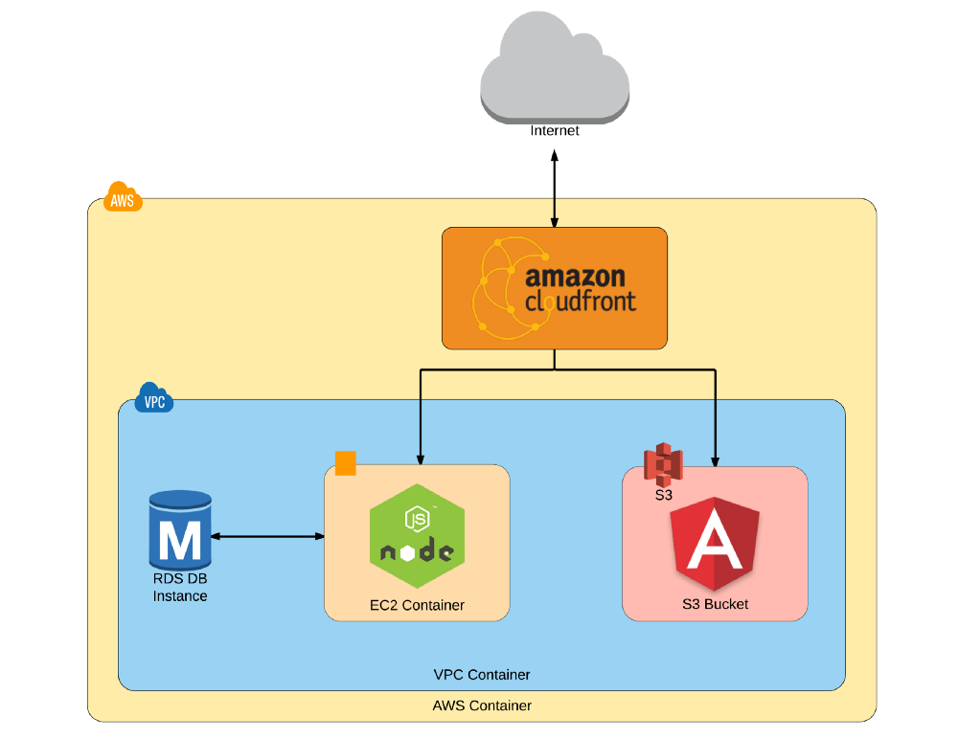

Finance

# Charges and making money

This section is in place to determine how to the system will be profitable and how it will make money.

**Thoughts:**

|  |  |
| --- | --- |
| **Means of making money** | **Who Pays** |
| Membership fee for joining syndicate | Syndicate Member |
| Fee for listing a horse, possibly % based | Owner/Breeder |
| Commission per financial transaction | All stakeholders if buying/selling/trading shares etc |
|  |  |

# Scenarios

Scenario 1: very simple and may be too simple but a starting point

|  |  |  |  |
| --- | --- | --- | --- |
|  |  | Chargable activities | Earnings |
| Value of horse (defined by owner/breeder) | 20,000 |  |  |
| Cost of training fees (8 months training fees, vet, entries etc) | 20,000 |  |  |
| Proposed cost to syndicate of 10 people over 8 months | 25,000 |  |  |
|  |  | Owner lists horse | 100 |
|  |  | 10 people join syndicate @ 50e joining fee | 500 |
|  |  | Commission per transaction – 3% of 25000 | 750 |
|  |  |  |  |
|  |  | **Total** | **1350** |

# Appendix A

# Some Concepts:

|  |  |
| --- | --- |
| **Concept** | **Description** |
| Syndicate |  |
| Investment |  |
| Member |  |
|  |  |

# Index

background, 1

border, 3

bullet, 1

caption, 2

color, 2

drawing, 2

drop cap, 1

footer, 3

frame, 3

graphic, 2

group, 2

header, 3

Help, 3

link, 4

margins, 2

normal view, 1

number, 4

picture, 2, 3, 4

print, 1

re-size, 3

section break, 2

shading, 1

style, 1, 2, 3, 4

symbol, 1

Table of Contents, 3

template, 4

ungroup, 2

Wingdin