Computer Communications and Networks (COMN)
2019/20, Semester 2

Assignment Part 2 Results Sheet

Forename and Surname: | Timothy Murphy
Matriculation Number: | S1732368

Question 1 – Experimentation with Go-Back-N. For each value of window size, run the experiments for 5 times and write down average throughput.

 | Average throughput (Kilobytes per second)
Window Size | Delay = 5ms | Delay = 25ms | Delay = 100ms
1 | 46.21 | 9.83 | 2.49
2 | 84.61 | 18.09 | 4.79
4 | 153.89 | 35.47 | 9.55
8 | 281.26 | 68.10 | 19.05
16 | 391.89 | 133.87 | 37.83
32 | 449.17 | 230.76 | 67.12
64 | 491.76 | 282.41 | 103.84
128 | 490.11 | 276.39 | 118.20
256 | 469.17 | 264.68 | 116.67

Create a graph as shown below using the results from the above table:
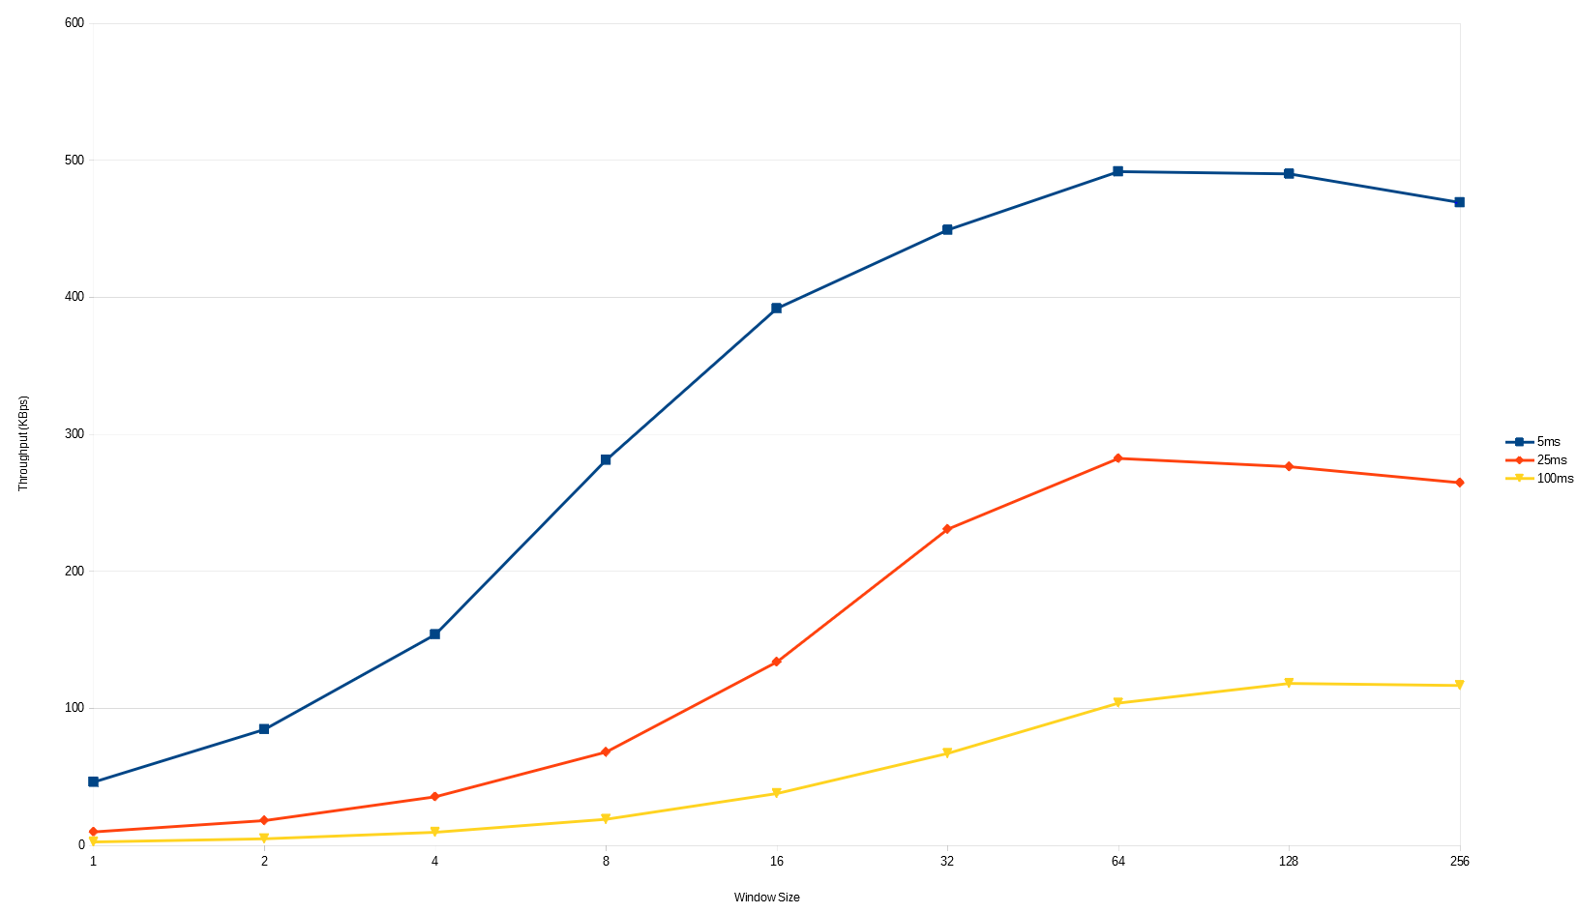

Question 2 – Discuss your results from Question 1.

Window size and delay both influence throughput. Increasing the delay will lower throughput and increasing window size increases throughput. But there does reach a point, for each delay, where increasing the window size decreases throughput; this is presumably because the receiver becomes overwhelmed by the number of packets it is receiving and cannot process them all in a timely manner. As the delay gets larger, the point at which increasing the window size starts decreasing throughput is increased; likely because the receiver has more time to process the packets because of the increased delay. A timeout value of 25ms was used for 5ms delay, as it was the optimal value from the previous part. I used the same value for the other two delays, as to get a fairer read of how adjusting delay affects throughput.

Question 3 – Experimentation with Selective Repeat. For each value of window size, run the experiments for 5 times and write down average throughput.

 | Average throughput (Kilobytes per second)
Window Size | Delay = 25ms
1 | 9.85
2 | 19.63
4 | 38.93
8 | 76.03
16 | 150.17
32 | 229.68

Question 4 - Compare the throughput obtained when using “Selective Repeat” with the corresponding results you got from the “Go Back N” experiment and explain the reasons behind any differences.

Both Selective Repeat and Go Back N see increased throughput as window size is increased, although we do not see a drop off with Selective Repeat. The results from Selective Repeat are a bit faster than that of Go Back N; this is likely because less packets are redundantly resent to the receiver, as only the timed out packets that have not been ACKed are resent, while Go Back N would resend all packets after the timed out packet even though the receiver may have already received them.

Question 5 – Experimentation with iperf. For each value of window size, run the experiments for 5 times and write down average throughput.

 | Average throughput (Kilobytes per second)
Window Size (KB) | Delay = 25ms
1 | 12.93
2 | 17.07
4 | 33.37
8 | 61.50
16 | 87.98
32 | 94.60

Question 6 - Compare the throughput obtained when using “Selective Repeat” and “Go Back N” with the corresponding results you got from the iperf experiment and explain the reasons behind any differences.

Iperf gets faster with a bigger window size, similar to SR and GBN. Selective Repeat and Go Back N are significantly faster than that of iperf, likely because SR and GBN are UDP while iperf is TCP. TCP includes checks for data corruption, which would increase the processing time per packet, as they each must be checked, dropping throughput. TCP also holds back on sending too many packets at once, to avoid congestion of the pipe, which would also decrease throughput.

