Course 5 Project 1

Tim Lambert

August 19, 2017

## R Markdown

It is now possible to collect a large amount of data about personal movement using activity monitoring devices such as a Fitbit, Nike Fuelband, or Jawbone Up. The mean and median steps are below along with a histogram of the number of steps.

##   
## Attaching package: 'dplyr'

## The following objects are masked from 'package:stats':  
##   
## filter, lag

## The following objects are masked from 'package:base':  
##   
## intersect, setdiff, setequal, union

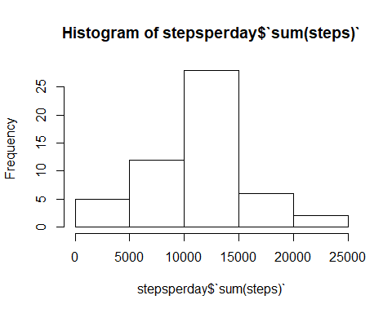

## [1] 10766.19

## [1] 10765

## Plot of Steps Per Interval during the day.

When we replace all NA values with the average for the particular day, the mean, median, and histogram do not change.

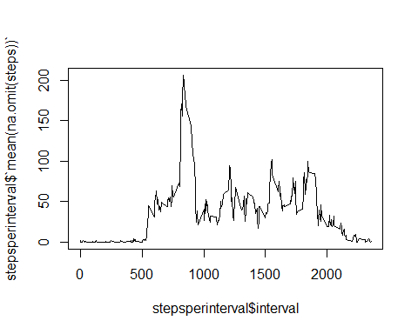

## Joining, by = "interval"

## [1] 10766.19

## [1] 10766.19

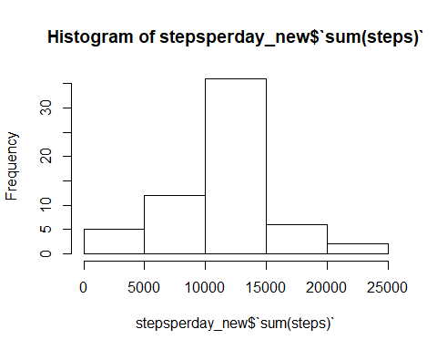

## Compare Weekend vs. Weekday

