BIN381: Business Intelligence 381
Project Milestone 3: Modelling, Evaluation and Deployment
Socioeconomic Development & Household Well-being in South Africa (SDHSA)
A household food-insecurity screening model and its R/Shiny deployment
Group P1
Group member | Role in Milestone 3
Alexander Solomon | Person A: modelling strategy and implementation (Task 1)
Rudi Jan du Plessis | Person B: technical evaluation and business interpretation (Tasks 2 and 3); report compiler
Timothy Wubbeling | Person C: deployment, monitoring and ethics (Task 4 and the ethics part of Task 3)

Belgium Campus iTversity, Bachelor of Computing
Submitted: 6 October 2026
Code, data and notebooks: github.com/timothywubbeling/BIN381 (private repository)

Contents
Introduction 3
Task 1: Modelling Strategy and Implementation 3
1.1 Analytical question and task type 3
1.2 Data, split and predictors 3
1.3 Leakage control 4
1.4 Candidate techniques and assumptions 4
1.5 Preprocessing recipes 5
1.6 Resampling, class imbalance and tuning 5
1.7 Final models 6
1.8 Binary screening model 6
1.9 Hand-offs and reproducibility 6
Task 2: Technical Model Evaluation and Comparison 8
2.1 Evaluation design 8
2.2 Three-tier results 9
2.3 Screening performance and decision threshold 10
2.4 Calibration 11
2.5 Generalisation, overfitting and uncertainty 12
2.6 Evaluation matrix and final model selection 12
Task 3: Interpretation and Business Evaluation 15
3.1 What drives the predictions 15
3.2 Hypotheses H1–H6 16
3.3 Business objectives and success criteria 17
3.4 Performance across subgroups 18
3.5 Limitations 19
3.6 Deployment recommendation 19
3.7 Ethics, fairness and responsible AI 20
Task 4: Deployment and Monitoring Strategy 24
4.1 Deployment objective, users and conditions 24
4.2 Deployment tool evaluation 25
4.3 The deployed component 26
4.4 Path for new data: validate, clean, preprocess, score 29
4.5 Operational workflow, roles and versions 30
4.6 Monitoring plan 31
4.7 Retraining and retirement 32
4.8 Repository and reproducibility 33
Insights and Recommendations 34
Key insights 34
Recommendations for the institute 34
Conclusion 35
Acknowledgement of AI Use 35
References 36

Introduction
Milestone 1 framed the decision problem for a Department of Social Development-type policy institute: which household conditions are associated with food insecurity, and which households should be prioritised for support when budgets are limited. Milestone 2 turned seven household-level files of the Stats SA General Household Survey 2024 into a clean, integrated analytical dataset of 20,940 households, engineered the predictors behind hypotheses H1–H6, built the Food Insecurity (FI) Score target from eight food-access items, and fixed a stratified 70/30 train/test split.
This milestone covers CRISP-DM's last three phases. Task 1 (modelling) builds and tunes three candidate classifiers in reproducible tidymodels workflows. Task 2 (evaluation) compares them with metrics suited to a 69/31 class imbalance, chooses a referral threshold and selects the final model. Task 3 (interpretation) explains what drives the predictions, tests H1–H6 and the Milestone 1 business objectives, and evaluates ethics and fairness. Task 4 (deployment) puts the selected model into an R/Shiny screening tool, with a validation path for new data, a monitoring plan and retraining and retirement triggers.
Every number in this report comes from the notebooks in the repository. notebook/BIN 381 Milestone 3 - Full Notebook (Group P1).Rmd runs Tasks 1 to 4 end to end from a clean R session, with package versions pinned by renv.

Task 1: Modelling Strategy and Implementation
Alexander Solomon - Group P1

1.1 Analytical question and task type
Business Objective 2 asks for South African households to be classified into food-insecurity vulnerability tiers, in a form a non-technical stakeholder can interpret, so that limited support can be targeted at the households most in need. The analytical question is therefore: given a household's income and how it has changed, its size, its settlement type and its access to electricity, sanitation and grants, how likely is it to be food insecure? This is a supervised classification task.
The primary target is Vulnerability_Tier, derived in Milestone 2 from the FI Score (the number of the eight food-access items answered 'yes'): food secure (FI = 0, 69.45% of training households), food insecure (FI 1–3, 10.55%) and severely food insecure (FI of 4 or more, 20.00%). Food_Insecure_Binary (any food insecurity, 30.55%) was kept from Milestone 2 as the documented fallback in case the thin middle tier proved hard to separate.

1.2 Data, split and predictors
Modelling starts from the Milestone 2 modelling dataset: the 20,925 of the 20,940 integrated households that have a valid FI Score. Milestone 2's stratified 70/30 split (seed 381) is reused unchanged rather than re-created: 14,646 training and 6,279 test households, with the same tier mix in both (69.45/10.55/20.00 and 69.44/10.56/20.00). The test set was not used in any modelling decision. The eight predictors were engineered in Milestone 2 from the H1–H6 hypotheses and are reused as they are (Table 1.1).
Table 1.1 Predictors and the hypotheses they test
Predictor | Source | Form in the model | Hypothesis
ComparativeIncomeCode | D09 | Ordered factor 1–5: income compared with a year ago (1 = much higher … 5 = much lower) | H1
GeoTypeCode | D07 | Factor: urban, traditional/tribal, farms | H2
HouseholdSize | D07 | Count, 1 to 25 | H3
Income_Log | D07 | log1p(total monthly household income) | H1, H3
Income_PerCapita | D07 | Income ÷ household size | H3
ElectricityAccessCode | D06 | Factor: yes, no | H4
SocialGrantRecipients | D09 | Count, 0 to 16 | H5
MainToiletCode | D05 | Factor, GHS codes 1–12 (rare codes pooled) | H6

GeoTypeCode has three levels in the data dictionary (urban, traditional/tribal, farms); the binary urban/rural coding assumed in Milestone 2's original encoding table was corrected before modelling.

1.3 Leakage control
The FI Score is built from the eight food-access items, so those items must never be predictors. The notebook lists 16 leakage columns: the eight items, the two older hunger questions, the four 'number of days' follow-up questions, the FI Score itself and its count of answered items. It asserts in code (stopifnot) that none of them is in the predictor set and that none survives into the modelling data, and Person B re-checked this before evaluation. All preprocessing that learns from the data (imputation values, pooling of rare categories, scaling) sits inside tidymodels recipes, so it is re-estimated within every cross-validation fold and never sees the test set (Kuhn & Silge, 2022).

1.4 Candidate techniques and assumptions
Three candidates were built, one more than the brief's minimum, so that the comparison covers the trade-off between interpretability and performance (Table 1.2).
Table 1.2 Candidate techniques, their role and their assumptions
Technique (engine) | Role | Assumptions and how they were handled
Regularised multinomial logistic regression (glmnet; Friedman, Hastie & Tibshirani, 2010) | Interpretable baseline: coefficients relate directly to H1–H6 | Linear in the log-odds: income enters as log1p(income), which removes its strong right skew. Low multicollinearity: regressing ComparativeIncomeCode on the two income features gives R² = 0.064, a variance inflation factor of 1.07, far below the usual concern level of 5. The penalty is scale-sensitive, so predictors are dummy-encoded and normalised.
Decision tree (rpart; Therneau & Atkinson, 2026) | Readable rules for interpretation | No distributional assumptions and no scaling. Trees are unstable (small changes in the data change the splits), so the tree is treated as an interpretability option, not the performance candidate.
Random forest (ranger; Breiman, 2001; Wright & Ziegler, 2017) | Performance benchmark | No scaling or encoding needed; averaging 500 trees reduces the single tree's instability. Harder to interpret, so any gain in performance has to be weighed against that.

1.5 Preprocessing recipes
Each technique family gets its own recipe. The linear recipe imputes missing numeric predictors with the training median and factors with the training mode, pools toilet codes used by fewer than 2% of households into an 'other' level, guards against factor levels not seen in training (step_novel), dummy-encodes factors, drops zero-variance columns and normalises numeric predictors. The tree recipe applies the same imputation, pooling and unseen-level guard, but no dummies or scaling, because trees split on factors and raw values directly.

1.6 Resampling, class imbalance and tuning
Models were tuned with 5-fold cross-validation on the training set, stratified on the tier so that every fold keeps the 69/11/20 mix (folds of 2,928 to 2,930 households). Class imbalance is handled in two places: stratified folds keep each tier represented in every fold, and the final referral decision uses a threshold chosen for recall (Section 2.3) instead of the most probable tier. Frequency-inverse class weights (food secure 0.48, food insecure 3.16, severely food insecure 1.67) were tested as the alternative: the tuned multinomial logistic regression was refitted on the same five folds with and without them (notebook section 1.14, Table 1.3). Weighting raised middle-tier recall from 0.0% to 25.6% and severe-tier recall from 25.8% to 58.7%, but cut food-secure recall from 95.5% to 59.7% and badly worsened calibration (Brier score 0.205 against 0.289), while ranking improved only slightly (AUC 0.669 against 0.680). Even with weights, three in four middle-tier households were still missed. Because the app shows probabilities, the unweighted models were kept, and imbalance is handled at the decision threshold instead (Section 2.3).
Table 1.3 Class weights compared with plain stratification (multinomial logistic regression, 5-fold CV, data/modelling/class_weight_comparison.csv)
Setting | ROC-AUC (H-T) | Balanced accuracy | Accuracy | Brier | Recall: secure | Recall: insecure | Recall: severe
Stratified folds only (used) | 0.669 | 0.562 | 0.715 | 0.205 | 95.5% | 0.0% | 25.8%
Stratified folds + class weights | 0.680 | 0.623 | 0.559 | 0.289 | 59.7% | 25.6% | 58.7%

Grids used space-filling designs, which cover each parameter space with few candidates (Table 1.4). Hyperparameters were selected on cross-validated ROC-AUC (the Hand-Till multiclass version for the three-tier models), the metric agreed on Day 1; accuracy and balanced accuracy were tracked alongside because a 69% majority class makes accuracy alone misleading. The seed 381 is set before every random step.
Table 1.4 Tuning design and selected hyperparameters
Model | Tuned parameters | Candidates | Selected values
Multinomial logistic (glmnet) | penalty, mixture | 12 | penalty 8.1 × 10⁻¹⁰, mixture 0.18
Decision tree (rpart) | cost_complexity, tree_depth, min_n | 12 | cost_complexity 1 × 10⁻¹⁰, depth 11, min_n 19
Random forest (ranger) | mtry (2–8), min_n; 500 trees | 10 | mtry 2, min_n 31
Binary logistic (glmnet) | penalty, mixture | 8 | penalty 1.9 × 10⁻⁶, mixture 1 (lasso)

1.7 Final models
Each workflow was finalised with its selected hyperparameters and refitted on the full training set. Table 1.5 is the model parameter table.
Table 1.5 Model parameter table (5-fold stratified CV, seed 381)
Model | Target | CV ROC-AUC, three tiers (mean ± SD) | CV ROC-AUC, screening | Fit time | Saved workflow (data/modelling/)
Multinomial logistic (glmnet) | Three tiers | 0.669 ± 0.007 | 0.734 | 0.8 s | final_workflow_logistic.rds
Decision tree (rpart) | Three tiers | 0.658 ± 0.010 | 0.721 | 0.4 s | final_workflow_tree.rds
Random forest (ranger) | Three tiers | 0.673 ± 0.005 | 0.739 | 7.7 s | final_workflow_forest.rds
Binary logistic (glmnet) | Any food insecurity | – | 0.733 ± 0.010 | 0.5 s | final_workflow_binary.rds (deployed)

1.8 Binary screening model
The Shiny app returns one at-risk probability per household, so a fourth model was fitted on Food_Insecure_Binary with the same eight predictors, the linear recipe and its own tuning (eight candidates, 5-fold stratified cross-validation, seed 381). Its outcome levels are labelled so that the predicted probability column is .pred_insecure, the column the app reads. The three-tier models remained the primary candidates for evaluation; Section 2 shows why the binary screen was the model finally deployed.

1.9 Hand-offs and reproducibility
- To Person B: test-set and cross-validated predictions for every model (data/modelling/test_predictions_for_personB.csv, cv_predictions_for_personB.csv), so that cross-validation and test performance can be compared.
- To Person C: the fitted workflows and an input schema giving each predictor's name, type, valid range and missing-value handling (input_schema_for_personC.csv).
- Reproducibility: tidymodels workflows (recipes, parsnip, rsample, tune), the seed 381 throughout and package versions pinned with renv. Re-running Task 1 from a clean session reproduces every saved prediction and the parameter table exactly (Section 4.8).

Task 2: Technical Model Evaluation and Comparison
Rudi Jan du Plessis - Group P1

2.1 Evaluation design
All results in Tasks 2 and 3 come from notebook/BIN 381 Milestone 3 Person B - Evaluation and Interpretation.Rmd. It starts from Person A's hand-off and does not refit or retune any model. Before any metric was computed, the notebook checked three things. Every model was scored on the same 6,279 test households. These are exactly the households in M2_test.rds. Train and test together give the 20,925-household modelling population. The test set's class mix (69.44% / 10.56% / 20.00%) matches the training set to within 0.01 percentage points, so the stratified Milestone 2 split held.
The Shiny app uses Person A's binary fallback model (any food insecurity vs food secure), not the three-tier models. That model was therefore evaluated as a fourth candidate on the same test households, using its saved workflow. The file the app loads (models/final_workflow.rds) was confirmed to give identical predictions, so this evaluation describes the model that is actually deployed.
Metric choice. 69.45% of households are food secure, so a model that labels every household "Food secure" reaches 69.4% accuracy while finding no one in need. Accuracy is reported only for reference. The comparison rests on metrics that the majority class cannot carry (Table 2.1).
Table 2.1 Evaluation metrics and their justification
Metric | Why it is used
Per-class recall and specificity | Shows whether the two food-insecure tiers are found at all.
Macro recall (balanced accuracy), macro F1 | Weights each tier equally, so the 69% majority cannot carry the score.
Severe-as-secure rate | Share of severely food-insecure households predicted food secure: the costliest error, because those households are never referred.
Hand-Till multiclass ROC-AUC (Hand & Till, 2001) | Threshold-free ranking quality across all three tiers; the metric Person A tuned on.
Macro PR-AUC | More informative than ROC-AUC when the classes of interest are small (Saito & Rehmsmeier, 2015).
Brier score and calibration plot (Brier, 1950) | The app shows a probability to an official, so the probability must be trustworthy, not just the ranking.

The app answers one practical question: should this household be referred for follow-up? Each three-tier model was therefore also evaluated as a screen. Its at-risk probability, P(Food insecure) + P(Severely food insecure), is compared with the binary model's probability of any food insecurity.

2.2 Three-tier results
Table 2.2 Test-set performance on the three-tier target (n = 6,279; class = most probable tier)
Model | Accuracy | Macro recall | Recall: secure | Recall: insecure | Recall: severe | Severe as secure | ROC-AUC (H-T) | PR-AUC (macro) | Brier
Random forest (ranger) | 0.718 | 0.412 | 95.3% | 0.3% | 28.0% | 71.7% | 0.681 | 0.491 | 0.203
Multinomial logistic (glmnet) | 0.715 | 0.405 | 95.4% | 0.0% | 26.2% | 73.8% | 0.667 | 0.483 | 0.205
Decision tree (rpart) | 0.697 | 0.420 | 90.7% | 3.2% | 32.2% | 65.1% | 0.660 | 0.468 | 0.213
Always "Food secure" | 0.694 | 0.333 | 100% | 0.0% | 0.0% | 100% | 0.500 | – | –

All three models rank households better than chance (Hand-Till AUC 0.66–0.68). When each household is assigned its most probable tier, however, the middle tier is almost never predicted. Food-insecure recall is 0.0% for the logistic model, 0.3% for the forest and 3.2% for the tree. Between 65% and 74% of severely food-insecure households are labelled food secure (Figure 2.1). With these eight predictors, the thin middle tier (FI_Score 1–3, 10.55% of households) cannot be separated from its neighbours. That is the condition Milestone 2 named for falling back to the binary target, so the binary screen is evaluated as the operational model from here on.
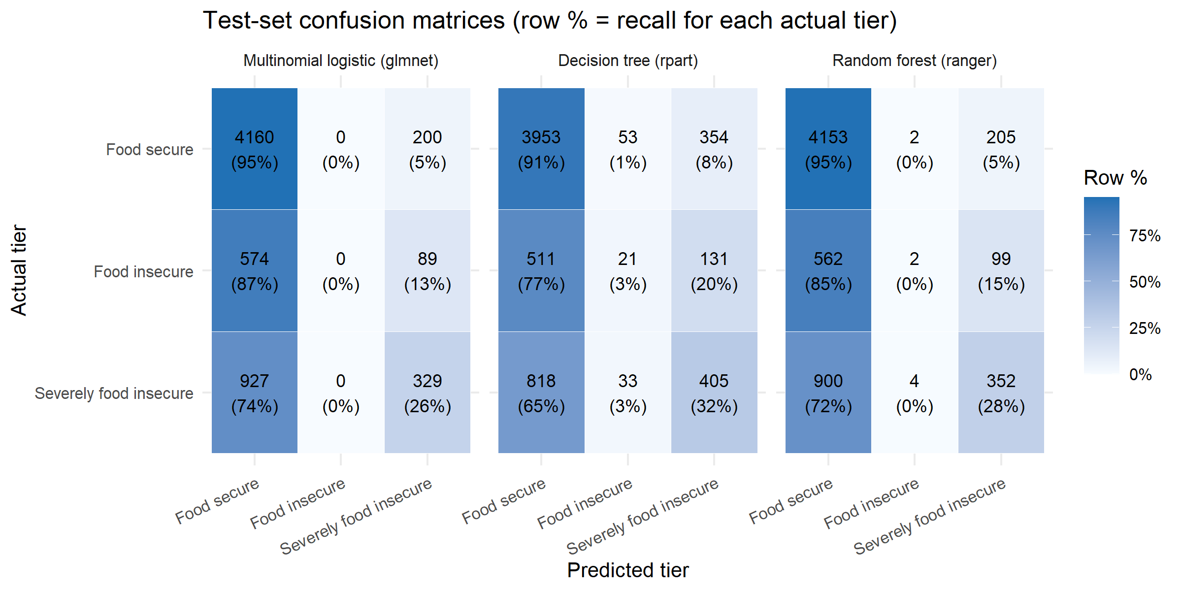
Figure 2.1 Test-set confusion matrices for the three-tier models (row % = recall for each actual tier)

2.3 Screening performance and decision threshold
Table 2.3 Screening performance: any food insecurity vs food secure (PR-AUC of a random model = 0.306)
Model | CV ROC-AUC | Test ROC-AUC | Test PR-AUC | Test Brier
Random forest (ranger) | 0.739 | 0.745 | 0.571 | 0.177
Binary logistic (glmnet) | 0.733 | 0.736 | 0.550 | 0.180
Multinomial logistic (glmnet) | 0.734 | 0.736 | 0.549 | 0.180
Decision tree (rpart) | 0.721 | 0.727 | 0.527 | 0.187

Used as a screen, the models are closer together and clearly better than chance: the test ROC-AUC runs from 0.727 to 0.745, and the PR-AUC of 0.53–0.57 is well above the 0.31 a random ranking would give.
Threshold. A default cut-off of 0.5 refers only 15% of households and finds just 31% of those at risk, so a lower threshold is needed. The threshold was chosen on the cross-validation predictions only, so the test result remains an honest estimate. Both rules considered reflect that a missed food-insecure household costs more than a false alarm.
- F2-optimal (recall weighted twice as heavily as precision; van Rijsbergen, 1979): threshold 0.14. It refers 84% of all households at a precision of 35%, barely above the 31% base rate. A screen that refers almost everyone does not prioritise anything, so this rule was rejected.
- At least 80% recall at the fewest referrals: threshold 0.24. Chosen.
Table 2.4 Binary model on the test set at each threshold rule
Rule (fixed on CV) | Threshold | Recall | Precision | Specificity | Households referred
80% recall (chosen) | 0.24 | 80.7% | 41.9% | 50.7% | 58.9%
F2-optimal (rejected) | 0.14 | 95.9% | 35.0% | 21.6% | 83.8%
Default 0.5 | 0.50 | 31.1% | 62.4% | 91.8% | 15.2%

At the chosen threshold, the deployed model finds 80.7% of at-risk test households and 85.7% of severely food-insecure ones, while referring 58.9% of households. 41.9% of referred households are genuinely at risk, which is 1.37 times the base rate. Figure 2.2 shows the trade-off behind the choice.
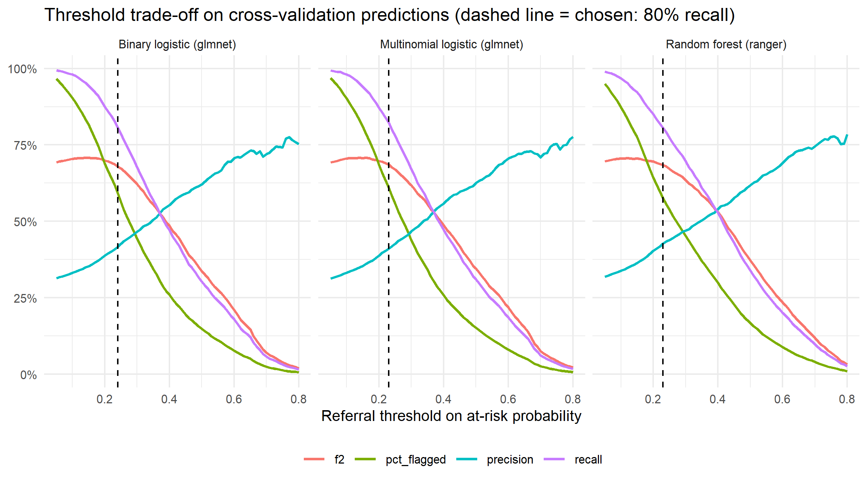
Figure 2.2 Recall, precision, share referred and F2 by threshold, on cross-validation predictions (dashed = chosen)

2.4 Calibration
Because the app displays a probability, it must be calibrated. Three models have an expected calibration error of about one percentage point (logistic 0.010, binary 0.012, forest 0.012), so a displayed 40% can be read as roughly 40%. The decision tree is the exception (0.040): its leaf probabilities are coarse, and its Brier score is the worst (0.187 against 0.177–0.180).
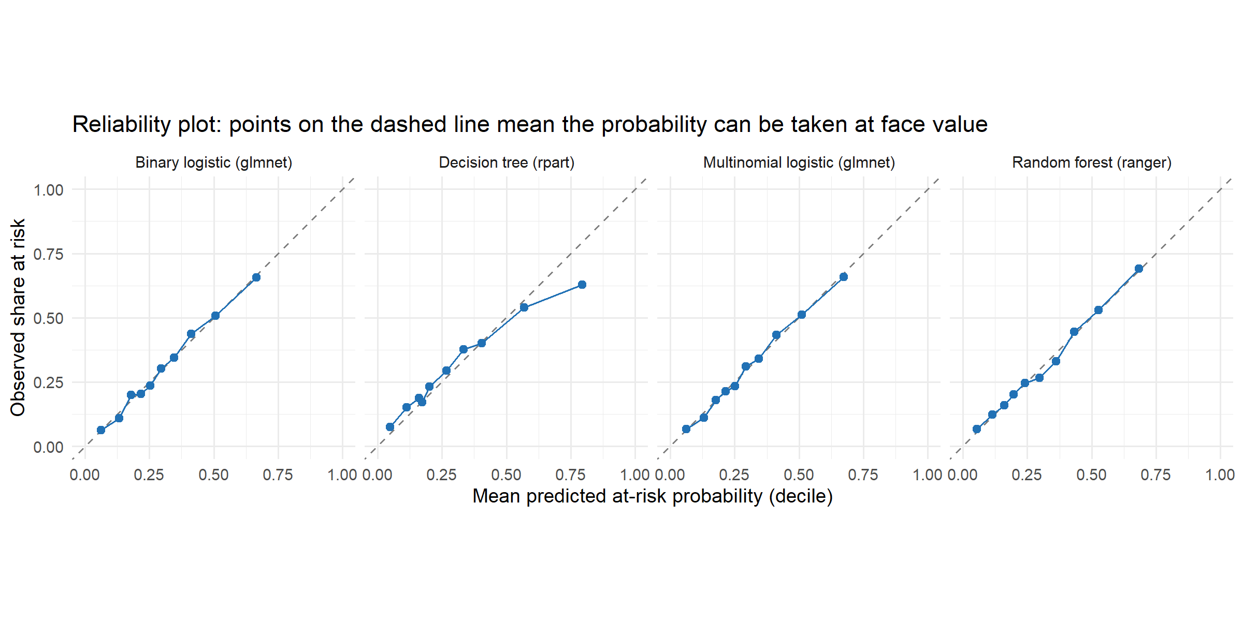
Figure 2.3 Reliability of the at-risk probability on the test set (deciles; dashed line = perfect calibration)

2.5 Generalisation, overfitting and uncertainty
Table 2.5 Cross-validation against test, and training fit (Hand-Till AUC; ∗binary AUC for the binary model)
Model | 5-fold CV AUC (mean ± SD) | Test AUC | Test − CV | Test 95% bootstrap CI | Train − test AUC
Random forest (ranger) | 0.673 ± 0.005 | 0.681 | +0.007 | 0.669–0.691 | 0.177
Multinomial logistic (glmnet) | 0.669 ± 0.007 | 0.667 | -0.002 | 0.656–0.678 | 0.006
Decision tree (rpart) | 0.658 ± 0.010 | 0.660 | +0.002 | 0.649–0.672 | 0.072
Binary logistic (glmnet) | 0.733 ± 0.010∗ | 0.736∗ | +0.002 | – | -0.001

Cross-validation and test results agree to within 0.008 for every model, so the tuned settings generalise and the test set is not unusual. The training-set fit tells a different story for the tree-based models. The forest scores 0.18 higher on its own training data than on the test set, and the tree 0.07 higher, so both memorise detail that does not carry over. For a random forest this is expected (Breiman, 2001) and harmless here, because its CV-to-test gap is small. It does show, however, that the forest's extra capacity buys little real signal. The two logistic models show no overfitting.
The test set was bootstrapped 1,000 times (Efron & Tibshirani, 1993), with the same resamples for every model, so that each difference between two models gets its own interval. On the three-tier task, the forest beats the logistic model by 0.014 AUC (95% CI 0.006 to 0.022): small, but real. The logistic model and the tree cannot be told apart (-0.004 to 0.017). As screens, the forest beats the binary model by 0.009 (0.002 to 0.016). The binary and multinomial logistic models rank households identically (difference 0.0002).

2.6 Evaluation matrix and final model selection
All four candidates are compared on the screening task, because that is the decision the app supports and the only measure on which the binary and three-tier models can be compared directly. Each criterion is scored from 5 (best) down to a floor of 1. A model loses points for its distance from the best model, at a fixed rate per criterion, so differences too small to matter cost almost nothing.
Table 2.6 Evaluation matrix – evidence (test set, each model at its own 80%-recall threshold)
Model | Test AUC | Threshold | Recall | Precision | Referred | Brier | ECE | CV−test gap / CV SD | Fit time
Binary logistic (glmnet) | 0.736 | 0.24 | 80.7% | 41.9% | 58.9% | 0.180 | 0.012 | 0.002 / 0.010 | 0.5 s
Random forest (ranger) | 0.745 | 0.23 | 79.9% | 42.8% | 57.1% | 0.177 | 0.012 | 0.006 / 0.006 | 7.7 s
Multinomial logistic (glmnet) | 0.736 | 0.23 | 82.4% | 41.0% | 61.4% | 0.180 | 0.010 | 0.002 / 0.007 | 0.8 s
Decision tree (rpart) | 0.727 | 0.19 | 79.9% | 42.2% | 57.9% | 0.187 | 0.040 | 0.006 / 0.008 | 0.4 s

Table 2.7 Scoring rules
Criterion (weight) | Evidence | Points lost
Discrimination (25%) | Test screening ROC-AUC | 1 per 0.01 below the best
Referral efficiency (15%) | Precision at the chosen threshold | 1 per 0.01 below the best
Calibration (15%) | Test Brier score | 1 per 0.005 above the best
Robustness (10%) | CV−test AUC gap + fold SD | 1 per 0.005 above the best
Interpretability (20%) | Can an official see why a household was flagged? | 5 = one odds ratio per factor; 4 = readable but more complex (per-tier coefficients, depth-11 tree); 2 = black box needing post-hoc explanation
Deployment fit (15%) | Matches the app: one probability, fast, small file | 5 = built for the app's interface; 3 = app must collapse three tiers

Table 2.8 Evaluation matrix – scores and weighted decision, with two alternative weightings
Model | Discrim. | Effic. | Calib. | Robust. | Interp. | Deploy | Weighted | Equal wts | Perf. only
Binary logistic (glmnet) | 4.1 | 4.1 | 4.3 | 4.3 | 5.0 | 5.0 | 4.46 | 4.47 | 4.20
Random forest (ranger) | 5.0 | 5.0 | 5.0 | 4.4 | 2.0 | 3.0 | 4.04 | 4.07 | 4.85
Multinomial logistic (glmnet) | 4.1 | 3.3 | 4.3 | 5.0 | 4.0 | 3.0 | 3.92 | 3.95 | 4.18
Decision tree (rpart) | 3.2 | 4.4 | 3.1 | 4.1 | 4.0 | 3.0 | 3.58 | 3.63 | 3.70

Decision: the binary logistic regression (glmnet) at a referral threshold of 0.24. It ranks first under the chosen weights (4.46) and under equal weights.
The best scorer was not chosen. The random forest has the highest discrimination (screening AUC 0.745 against 0.736) and would win if only performance counted (4.85 against 4.20). The bootstrap shows its advantage is real but small. At the same 80% recall, its precision is 42.8% against 41.9%, roughly one fewer unnecessary referral per hundred referrals. Against that, the forest cannot give an official a stable reason for a referral, needs post-hoc explanation, takes 16 times longer to fit, and its saved workflow is five times larger. The binary model gives one odds ratio per factor, is as well calibrated, shows no overfitting and matches the app's interface. The multinomial logistic model ranks households identically for screening, so deploying the simpler binary model loses nothing. The three-tier models are not deployed because they cannot detect the middle tier.

Task 3: Interpretation and Business Evaluation
Rudi Jan du Plessis - Group P1

3.1 What drives the predictions
Two complementary views were used. Permutation importance (Breiman, 2001) shuffles one predictor at a time on the test set and records the loss in AUC, so it shows what each model actually relies on. Odds ratios come from an unpenalised logistic regression of any food insecurity on the training set. Person A's tuned penalty was effectively zero (8.1 × 10⁻¹⁰), so these match the deployed model while adding confidence intervals. Income_PerCapita is left out of the odds-ratio model on purpose: total income and household size are already in it, and per-capita income is their ratio, so keeping it would make the household-size coefficient meaningless. Partial-dependence plots (Friedman, 2001) show the shape of each relationship. All of these are associations, not causes.
Table 3.1 Permutation importance: drop in test ROC-AUC when the predictor is shuffled (5 repeats)
Predictor | Binary logistic | Multinomial logistic | Random forest
ComparativeIncomeCode | 0.082 | 0.053 | 0.058
Income_PerCapita | 0.033 | 0.044 | 0.054
SocialGrantRecipients | 0.029 | 0.018 | 0.014
Income_Log | 0.021 | 0.022 | 0.026
ElectricityAccessCode | 0.006 | 0.005 | 0.005
GeoTypeCode | 0.003 | 0.003 | 0.003
MainToiletCode | 0.001 | -0.000 | 0.009
HouseholdSize | -0.000 | 0.003 | 0.002

The ranking is consistent across all three models. Year-on-year income change (ComparativeIncomeCode) matters most, followed by the two income measures and the number of grant recipients. Electricity access and settlement type add a little. Household size and toilet type add almost nothing once income is known, even though both are associated with food insecurity on their own.
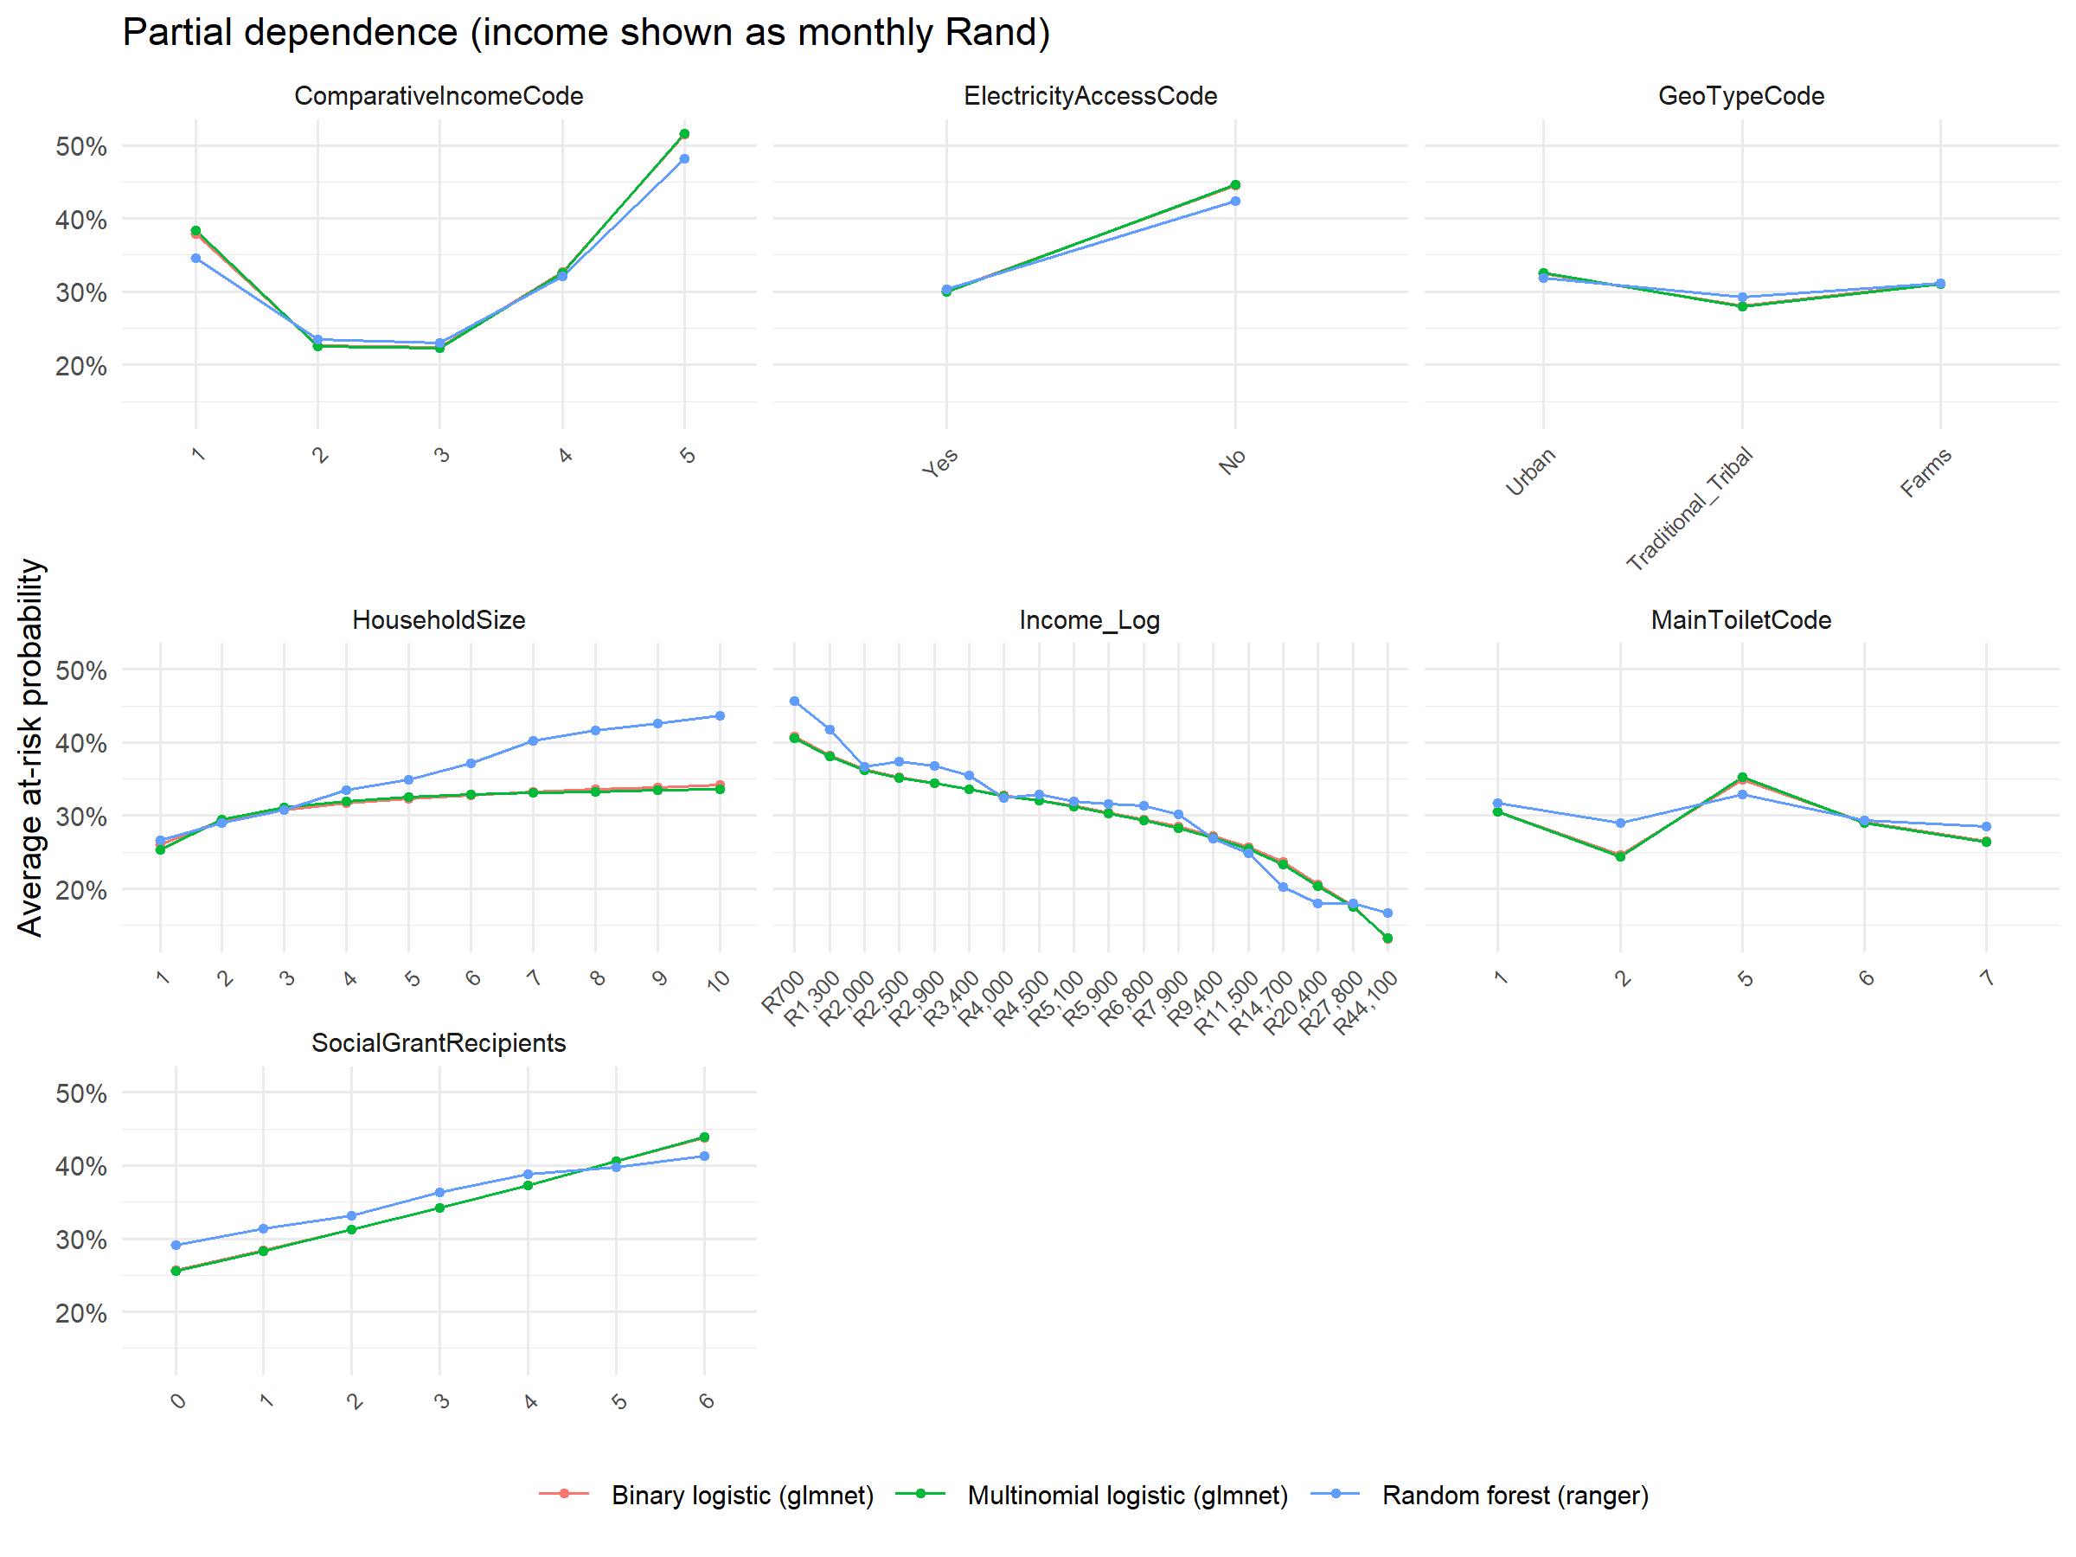
Figure 3.1 Partial dependence of the at-risk probability on each predictor (income and household size are varied together with per-capita income)

3.2 Hypotheses H1–H6
Table 3.2 Hypothesis verdicts (raw rates on all 20,925 households; odds ratios with 95% CI)
Hypothesis (Milestone 1) | Evidence | Verdict
H1 Lower ComparativeIncomeCode → higher food insecurity | The variable records income compared with a year ago (1 = much higher … 5 = much lower). Food insecurity is 58.3% when income is much lower, against 18.4–21.2% for codes 2–3. Odds ratio vs code 1: 2.05 (1.62–2.59). It is the strongest predictor in every model. But households whose income is much higher (code 1, n = 592) also show 34.8%, so the relationship is U-shaped. | Supported for falling income; the relationship is not linear
H2 Rural (Traditional/Tribal) households more food insecure after controlling for income | Raw rates: 34.8% Traditional/Tribal vs 28.5% Urban. After adjusting for income, electricity, grants and the other predictors, the odds ratio is 0.76 (0.66–0.87); Farms 0.89 (0.70–1.11). | Not supported: the raw rural gap is explained by income and services
H3 Larger households more food insecure at fixed income | Odds ratio 1.04 (1.01–1.07) per extra member (p = 0.008). Raw rates rise from 26.8% (1–2 people) to 42.6% (7+). Most of the effect runs through per-capita income (importance rank 2); the direct effect is small. | Supported (weak direct effect)
H4 No electricity → higher food insecurity | 47.0% without electricity vs 29.7% with; odds ratio 2.07 (1.73–2.48). Only 5% of households lack electricity, so it carries limited weight in prediction. | Supported
H5 Grant receipt → lower food insecurity | The opposite holds: 37.6% with grant recipients vs 20.6% without; odds ratio 1.20 (1.16–1.24) per recipient. Grants are means-tested, so they go to poorer households; a single cross-section cannot show their protective effect. | Not supported (reversed): reflects who is targeted, not that grants cause food insecurity
H6 Toilet type is a significant predictor (chronic-poverty proxy) | Code 5, the second-largest group (4,191 households), shows 40.9% vs 27.2% for code 1; odds ratio 1.31 (1.13–1.52). Its permutation importance is near zero in the logistic models. | Partly supported: significant association, little predictive value beyond income

3.3 Business objectives and success criteria
Table 3.3 Results against the Milestone 1 business objectives
Milestone 1 objective and success criterion | Result | Status
BO1: a ranked list of the top 5–8 indicators associated with food insecurity, with p < 0.05 and an effect size, reproducible in R | Eight predictors ranked by permutation importance (Table 3.1), with odds ratios and 95% CIs (Table 3.2). Every predictor in the odds-ratio model has at least one level significant at p < 0.05 (per-capita income enters through income and household size). Fully reproducible from the notebook. | Met
BO2: an interpretable classification model, built without leakage, evaluated on held-out data against a defined performance threshold | No leakage (asserted in Person A's code and re-checked). Evaluated once on the untouched 30% test set. The binary model gives one odds ratio per factor. Screening AUC 0.736; recall 80.7% at 58.9% referred. The three-tier model cannot detect the middle tier, so the documented binary fallback is used. | Partly met: met for the binary screen, not for three tiers. [CHECK: compare with the threshold set in the Milestone 2 report]
BO3: self-service Power BI exploration by province and household characteristic | Due in Milestone 4; not assessed here. | Not assessed in M3

3.4 Performance across subgroups
The table below shows how the deployed model performs for different kinds of household, at threshold 0.24. Person C's fairness section builds on it. The groups match R/fairness_check.R, and the intervals are 95% Wilson intervals (Wilson, 1927).
Table 3.4 Subgroup performance on the test set (overall recall 80.7%; full table incl. all provinces in data/evaluation/subgroup_performance.csv)
Group | Level | Test households | At risk | Recall (95% CI) | Precision | Referred | Gap (points)
Settlement | Urban | 4,056 | 1131 | 77% (74%–79%) | 39% | 54% | -4
Settlement | Traditional/Tribal | 2,026 | 726 | 87% (85%–90%) | 46% | 68% | +7
Settlement | Farms | 197 | 62 | 76% (64%–85%) | 43% | 55% | -5
Income | < R2,500 | 1,635 | 738 | 94% (92%–96%) | 49% | 87% | +13
Income | R2,500-5,000 | 1,386 | 512 | 82% (79%–85%) | 40% | 76% | +2
Income | R5,000-11,500 | 1,620 | 455 | 75% (71%–79%) | 37% | 58% | -6
Income | > R11,500 | 1,500 | 189 | 39% (32%–46%) | 31% | 16% | -42
Grants | Receives grants | 3,683 | 1389 | 88% (86%–90%) | 43% | 77% | +7
Grants | No grants | 2,596 | 530 | 62% (57%–66%) | 37% | 34% | -19
Household size | 1-2 | 2,785 | 748 | 76% (72%–79%) | 40% | 51% | -5
Household size | 7+ | 570 | 245 | 96% (93%–98%) | 49% | 84% | +15
Province | Eastern Cape | 788 | 347 | 89% (86%–92%) | 55% | 71% | +9
Province | Gauteng | 1,678 | 469 | 71% (67%–75%) | 37% | 54% | -10
Province | Western Cape | 591 | 148 | 71% (63%–78%) | 42% | 42% | -10

The model finds food insecurity where it coincides with low income and grant receipt. It misses households that are food insecure despite looking better off. Recall is 94% for households earning under R2,500 but 39% above R11,500. It is 62% for households without grants and about 71% in Gauteng and the Western Cape. The income and grant gaps exceed the 10-point tolerance in R/fairness_check.R. A "lower risk" result must therefore never be read as clearance for these groups. Survey weighting (HouseholdWeight) changes the picture only slightly: weighted prevalence is 28.8% against 30.6% unweighted, and weighted recall is 78.3%.

3.5 Limitations
- Modest discrimination. A screening AUC of 0.74 means many false referrals: 58% of referred households are food secure. The eight predictors describe resources, not food access itself.
- One cross-sectional survey wave (GHS 2024). The results show associations, not causes. The reversed grant effect (H5) is the clearest case where cause and targeting cannot be separated.
- Self-reported food-insecurity items. The target inherits recall and social-desirability bias (Milestone 1 risk register).
- Thin middle tier. The three-tier target is not usable with these predictors; only the binary screen is deployable.
- Excluded data. D11 (a separate survey) and the person-level files D01–D03 (the Milestone 2 decision) are not used. 15 households with no valid food-insecurity answers are excluded as unscorable.
- Unweighted training. The model was trained on the sample, not survey-weighted; the weighted check above shows a small effect.
- Small subgroups. Farms (197 test households, 62 at risk) and the smaller provinces have wide intervals, so their gaps cannot be judged precisely.
- A policy choice in the threshold. The 80% recall floor should be confirmed with the stakeholder against actual follow-up capacity.

3.6 Deployment recommendation
Deploy with conditions. The binary logistic model at threshold 0.24 is fit for one purpose: prioritising households for follow-up by trained officials. It finds about four in five at-risk households (86% of the severely food insecure) while referring 59% of households, and its probabilities are well calibrated. It is not accurate enough to decide anything about a household on its own. Conditions for Person C's deployment plan:
- Screening only. Use it to prioritise outreach. Never use it to approve, refuse or withdraw a grant, service or support.
- Human review. Every referral is reviewed by an official. A "lower risk" result is not clearance, especially for higher-income and no-grant households and in Gauteng and the Western Cape, where recall is 39–71%.
- Show the probability and the reasons, not only the label, together with the plain-language caveat.
- Monitoring baseline. Recall 80.7%, precision 41.9%, 58.9% referred, AUC 0.736, Brier 0.180 (data/evaluation/monitoring_baseline.csv). Investigate if recall on followed-up households falls below 70.7% (10 points under baseline), or if the referral rate drifts far from 59%.
- Consistency. The app must reproduce the notebook's probabilities exactly (R/check_app_matches_model.R) before it is used.
- Review the threshold with the stakeholder against actual follow-up capacity, and retrain when a new GHS wave is released.

3.7 Ethics, fairness and responsible AI
Timothy Wubbeling - Group P1
Ethical issues were identified at each stage of Milestone 3 rather than added at the end: in the choice of target and predictors (Task 1), in the choice of metric and threshold (Task 2), and in how the model is put in front of users (Task 4). Each issue is recorded in the register below with its risk, the mitigation adopted and the owner. Fairness builds on the subgroup results in Section 3.4, and privacy is assessed against the Protection of Personal Information Act 4 of 2013 (POPIA). The issues are considered in the South African context the brief asks for: a national survey whose geography, services and incomes still carry the imprint of apartheid spatial planning.

3.7.1 Ethics and fairness register
Table 3.5 Ethics and fairness register (owners: A = Alexander Solomon, B = Rudi Jan du Plessis, C = Timothy Wubbeling)
# | Issue | Risk | Mitigation | Owner
1 | Proxy discrimination | Settlement type, income and toilet type follow apartheid-era spatial patterns (traditional/tribal areas largely coincide with former homelands), so they can stand in for race, which is not a predictor. | Race excluded from the model. Recall by settlement type and province is within the 10-point tolerance (Section 3.7.2). Flags only ever add support. Every higher-risk result is reviewed by an official. | B, C
2 | Missed households that do not look poor | Recall is 0.39 above R11,500 a month and 0.62 for households with no grant recipients, so their food insecurity is more often missed. | Limit shown in the app's About tab; 'Lower risk' is not treated as clearance; random audit sample of lower-risk households (Section 4.6); subgroup recall re-checked at every GHS release. | B, C
3 | Use for eligibility decisions | A score is used on its own to refuse or withdraw a grant, service or support. | Usage limits in the About tab; a caveat on every result and download; sign-in only; no decision based solely on the model (POPIA s71). | C
4 | Over-reliance (automation bias) | Officials accept scores without checking them. | Probability, main factors and data warnings shown with every result; every higher-risk result reviewed; unscored rows go to manual assessment. | C
5 | Stigmatising labels | A family is labelled 'food insecure' by a model. | The app says 'Higher risk: refer for review'; no labels are stored; reporting is framed around conditions, not identity groups. | C
6 | Privacy (POPIA) | Personal information of real households is exposed or kept. | In-memory processing, nothing stored; HouseholdID never shown or returned; seven fields only; totals-only monitoring log; South African hosting behind sign-in (Section 3.7.3). | C
7 | Association read as cause | Grant receipt is associated with higher risk (H5 reversed, Section 3.2). Read causally, this could deprioritise grant households. | 'Associated with' wording in the app and report; the About tab explains that factors are associations. | B, C
8 | Representation gaps | D01–D03 and D11 excluded; SalaryEarnersInHousehold unusable (Milestone 2), so working-poor households are under-described; 451 refused incomes are unlikely to be random; 15 households with no valid food-insecurity answers could not be scored and are excluded. | Stated in the app and in the limitations (Section 3.5); missing-income rate monitored (Section 4.6). | A, C
9 | Self-reported outcome | Food-insecurity items carry recall and social-desirability bias; FI Score of 1 or more is a chosen cut-off. | Stated as a limitation; target documented; three-tier framing evaluated alongside the binary screen (Section 2.2). | A, B
10 | Small subgroups | Farm households: 197 in the test set, 62 at risk. | 95% Wilson intervals reported (0.64–0.85); no parity claim for small groups. | B
11 | Survey weights | Unweighted model output is misread as national prevalence. | Outputs are screening results only; weighted check in Section 3.4 shows a small effect (recall 0.783 weighted against 0.807). | B
12 | Model drift and inflation | The model reads income in Rand: a simulated 25% nominal income rise, with real circumstances unchanged, cut the share flagged from 59.8% to 51.9%. | Drift monitoring and retraining triggers (Sections 4.6 and 4.7). | C

3.7.2 Fairness evaluation
Criterion. Fairness is assessed with equal opportunity (Hardt, Price & Srebro, 2016): among households that really are food insecure, the screen should find a similar share in every group, so recall (and the false-negative rate) should be similar across groups. This matches the business objective, because a missed food-insecure household is the costliest error (Section 2.3).
Tolerance and uncertainty. Before the results were examined, the tolerance was set at 10 percentage points from the overall test recall of 0.807. Recall is reported with 95% Wilson intervals (Wilson, 1927), because a wide interval means a group is too small to judge. The groups are settlement type, income band, household-size band, grant receipt and province. Section 3.4 gives the full results (all groups and provinces are in data/evaluation/subgroup_performance.csv); they were recomputed independently with R/fairness_check.R and match exactly. Table 3.6 summarises them against the tolerance.
Table 3.6 Groups against the 10-point recall tolerance (test set, threshold 0.24)
Variable | Group | Households | At risk | Recall (95% CI) | Gap vs 0.807 | Within tolerance
Settlement type | Urban, traditional/tribal, farms | 6,279 | 1,919 | 0.758 to 0.875 | −0.049 to +0.067 | Yes
Province | All nine | 6,279 | 1,919 | 0.708 (Gauteng) to 0.893 (Eastern Cape) | −0.099 to +0.086 | Yes
Monthly income | < R2,500 | 1,635 | 738 | 0.940 (0.921–0.955) | +0.133 | No
Monthly income | > R11,500 | 1,500 | 189 | 0.392 (0.325–0.463) | −0.416 | No
Household size | 7 or more | 570 | 245 | 0.959 (0.927–0.978) | +0.152 | No
Grant receipt | No grant recipients | 2,596 | 530 | 0.617 (0.575–0.657) | −0.190 | No

Findings. Settlement type and all nine provinces are within the tolerance, so on these data the model does not treat urban, traditional/tribal and farm households, or provinces, materially differently. The farm interval is wide (0.64–0.85), so this is an absence of evidence of a gap rather than proof of parity. Four groups fall outside the tolerance, and they point in one direction. The screen finds more of the at-risk households among the poorest and the largest households, and far fewer among households earning more than R11,500 a month and households with no grant recipients: food-insecure households that do not look poor on these inputs are the ones the model misses. This follows from the model's reliance on income and grant receipt (Section 3.1) and from the representation gaps in the register: the data cannot see debt, irregular income or other pressures that leave a nominally better-off household without food.
Mitigations. Lowering the threshold only for the affected groups was considered and rejected, because it would make the referral rule depend on income band and grant status in a way that is hard to explain and to justify to the people affected. Instead:
- the limitation is shown to users in the app's About tab with the actual recall values, and a 'Lower risk' result is never treated as clearance;
- a small random audit sample of lower-risk households is followed up every month (Section 4.6), which measures the households the model misses rather than only confirming the ones it flags;
- subgroup recall is re-estimated at every GHS release with the same groups and tolerance, and a persistent gap is a retraining trigger (Section 4.7);
- the model remains a prioritisation aid with human review, so a missed household can still be referred through the normal channels.

3.7.3 Privacy and POPIA
The model was built on de-identified survey data, but in deployment the tool would process information about real, identifiable households, which is personal information under POPIA. The design was checked against the relevant sections of the Act (Table 3.7).
Table 3.7 Privacy-by-design features mapped to POPIA (Republic of South Africa, 2013)
POPIA section | Requirement | How the tool complies
s10 Minimality | Process only what is adequate, relevant and not excessive | Seven inputs only; no names, addresses or ID numbers
s13 Purpose specification | Collect for a specific, defined purpose | Purpose stated in the About tab: screening for follow-up only
s14 Retention | Do not keep records longer than necessary | Uploads processed in memory and not saved; only per-upload totals logged
s19 Security safeguards | Secure the integrity and confidentiality of information | Sign-in required; HouseholdID never displayed or returned; hosted in South Africa
s26 Special personal information | Restrictions on processing race or ethnic origin | Race is not an input; proxy effects monitored (register item 1)
s55 Information Officer | Duties of the responsible party's Information Officer | The institute's Information Officer approves the purpose and fields (Table 4.6)
s71 Automated decision-making | No decision with legal or significant effect based solely on automated profiling | Every higher-risk result reviewed by an official; not an eligibility test
s72 Transborder information flows | Limits on sending personal information outside South Africa | Hosted in South Africa, not on an offshore free tier (Section 4.2)

3.7.4 Responsible use
- Association, not cause. The factors shown in the app and the odds ratios in Section 3.2 describe associations in one survey wave; grant receipt is associated with higher risk because grants are targeted at poorer households.
- Geography in context. Settlement type and services reflect historical spatial inequality; the appropriate use of these signals is to direct more support to under-served areas, never to ration it.
- Moderate accuracy. About 6 in 10 referrals are not at risk (precision 0.419), so the tool's value is in ordering limited follow-up capacity, not in judging individual households.

Task 4: Deployment and Monitoring Strategy
Timothy Wubbeling - Group P1
This task covers CRISP-DM's deployment phase (Chapman et al., 2000): planning the deployment, planning monitoring and maintenance, and the deployed R/Shiny component itself (app/ in the repository).

4.1 Deployment objective, users and conditions
Users. As defined in Milestone 1, the primary users are analysts and programme officials at a national Department of Social Development-type policy institute, responsible for targeting social support and infrastructure investment. Secondary users are provincial and local government planning units and NGOs running food-relief programmes.
Decision supported. Which households to prioritise for follow-up and programme referral when resources are limited (Business Objective 2). Decisions not supported: approving, refusing or withdrawing any grant, service or support; any decision made without a person reviewing it; estimating national prevalence, which needs the survey weights.
Model and recommendation. The deployed model is the binary logistic regression selected in Section 2.6, at a referral threshold of 0.24 (models/final_workflow.rds, version binary-glmnet-v1). Section 3.6 recommends deploying it with conditions. Table 4.1 shows how this deployment plan meets each condition, plus the privacy conditions added in Section 3.7.
Table 4.1 How the deployment meets the conditions in Section 3.6
Condition | How the deployment meets it | Section
Screening only | Usage limits in the About tab; a caveat on every result and every download; described as a prioritisation aid, not an eligibility test | 4.3
Human review; 'lower risk' is not clearance | Every higher-risk result and every unscored row is reviewed by an official; the weaker recall for higher-income and no-grant households is shown in the app; monthly audit sample of lower-risk households | 4.5, 4.6
Show the probability and the reasons, with the caveat | Every result shows the probability against the threshold, the three main contributing factors and a plain-language caveat | 4.3
Monitoring baseline | Baselines from monitoring_baseline.csv: recall alert below 0.707; referral share alert outside 58.9% ± 10 points; drift checked on every upload | 4.6
Consistency with the notebook | R/check_app_matches_model.R: the app reproduces the evaluated probabilities for all 6,279 test households (largest difference 0) | 4.4
Threshold review and retraining | Threshold reviewed against real follow-up capacity; retraining triggers include each new GHS release | 4.6, 4.7
Privacy (added in Section 3.7) | Sign-in, South African hosting, no stored uploads, HouseholdID never shown | 4.2, 4.3

4.2 Deployment tool evaluation
Five options were compared on six criteria, weighted by their importance for this use case. A score of 5 means the option fully meets the criterion.
Table 4.2 Evaluation criteria and weights
Criterion | Weight | What a 5 means
R-native fit | 20% | Runs the saved tidymodels workflow directly, with no rewrite in another language
Scoring interactivity | 20% | Single-household form, CSV upload, instant results and download
Access control | 20% | Only named, signed-in users can reach it (needed for household data under POPIA)
Hosting cost | 15% | Free or very cheap for a public-sector institute
Reproducibility | 15% | Deployed from the repository with pinned package versions (renv)
Team skills | 10% | Group P1 can build and maintain it now

Table 4.3 Weighted scores (0.20 × R fit + 0.20 × interactivity + 0.20 × access + 0.15 × cost + 0.15 × reproducibility + 0.10 × skills)
Option | R fit | Interactive | Access | Cost | Reproducible | Skills | Weighted
Shiny on Posit Connect or an institute-run Shiny Server | 5 | 5 | 5 | 2 | 4 | 4 | 4.30
Shiny on shinyapps.io | 5 | 5 | 2 | 4 | 4 | 4 | 4.00
Quarto dashboard (static) | 4 | 2 | 3 | 5 | 5 | 4 | 3.70
plumber API | 4 | 2 | 3 | 3 | 4 | 2 | 3.05
Power BI with an R visual | 2 | 2 | 5 | 3 | 2 | 4 | 2.95

- Shiny on Posit Connect or an institute-run server: native R, full interactivity, named-user sign-in and deployment from the repository; the cost is a licence or a server.
- shinyapps.io: the quickest to publish and cheap, but its free plan has no sign-in and it is hosted outside South Africa, which raises POPIA s19 and s72; suitable for a demonstration with fake data only.
- Quarto dashboard: excellent for reproducible reporting, but static unless a Shiny server is added, so it cannot score an uploaded file.
- plumber API: useful if another system needs scores, but it has no user interface and is new to the team.
- Power BI with an R visual: strong access control and already used for the Business Objective 3 dashboards, but it cannot run a household-scoring workflow with uploads and row-level validation messages.
Recommendation. Shiny is the deployment tool. It is the only option that runs the team's saved tidymodels workflow natively while supporting single-household entry and CSV batch scoring with row-level validation messages (Chang et al., 2026; Wickham, 2021). For this milestone the app is built and demonstrated locally from the repository. For operational use it should be hosted on Posit Connect or an institute-run Shiny Server with named-user sign-in, inside South Africa. Power BI remains the tool for aggregate, province-level exploration (Business Objective 3); the Shiny tool complements it by scoring individual households (Business Objective 2).

4.3 The deployed component
The R/Shiny app (app/app.R, with helper modules in app/R/) has three tabs. Score one household takes the seven inputs, with 'Unknown' allowed for each and an 'income refused' option, and returns the risk band, the probability against the threshold, the three main contributing factors and a plain-language caveat (Figure 4.1). Batch upload (CSV) scores a whole file, shows summary counts, a results table and a table of every data problem found, and offers the results as a download (Figure 4.2). About and limits states the intended use, the model version, the threshold and the known limits, including the subgroup results; it works as a simple model card (Mitchell et al., 2019) (Figure 4.3).
Table 4.4 Inputs and outputs of the deployed app
Inputs (7) | Outputs
Income compared with a year ago (1 much higher … 5 much lower)  Settlement type (urban, traditional/tribal, farms)  Household size  Total monthly household income (Rand)  Electricity access  Number of social-grant recipients  Main toilet facility (12 GHS 2024 types) | Status: ok, scored with warning, or not scored  Risk band: 'Higher risk: refer for review' or 'Lower risk'  Probability of food insecurity  Top three contributing factors  Caveat and model version on every result and download  Issues table: one line per data problem, with the action taken

Explaining a result. For each household, each input in turn is replaced by the typical training value (the median for counts and income, the most common code for categories) and the household is re-scored; the change in probability is that input's contribution, and the three largest are shown. A rural household of six whose income has fallen sharply, with no electricity and R1,200 a month, scores 0.80, with 'income compared with a year ago' (+31 points) and 'electricity access' (+14 points) as the main factors; an urban household of two earning R30,000 a month scores 0.07. The method works for any model type, but it changes one input at a time (no interactions), depends on the chosen baseline and shows association, not cause, as the app states.
Privacy by design. Uploads are processed in memory and not written to disk. HouseholdID, if present, is used only to detect duplicates and is never displayed or returned; results keep the upload's row order so they can be matched back in the user's own system. The monitoring log stores per-upload totals only.
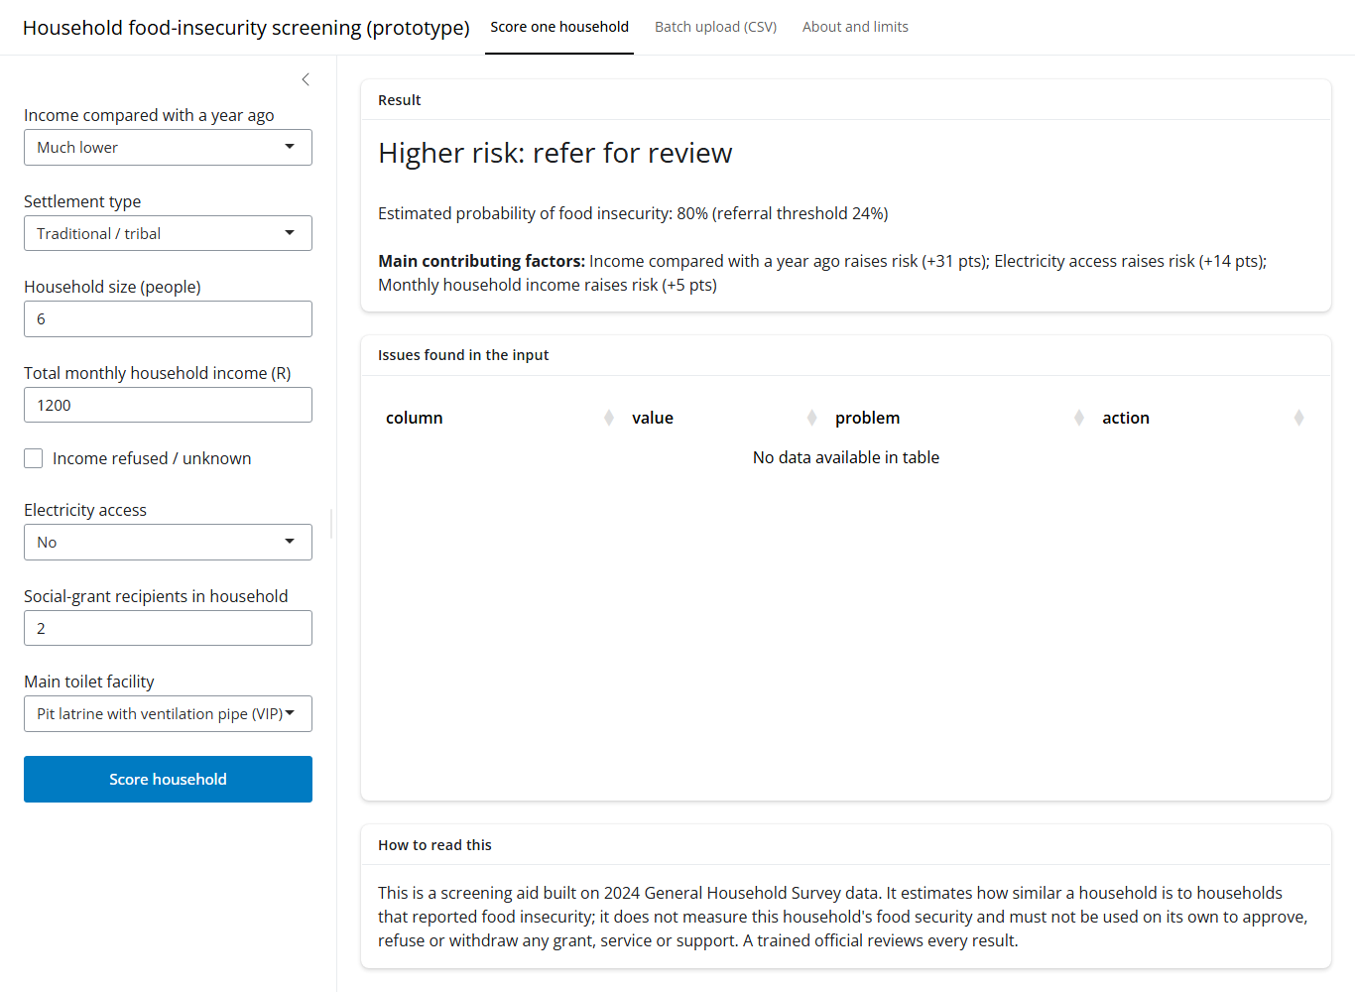
Figure 4.1 Scoring a single household: risk band, probability against the 24% threshold, main factors and caveat
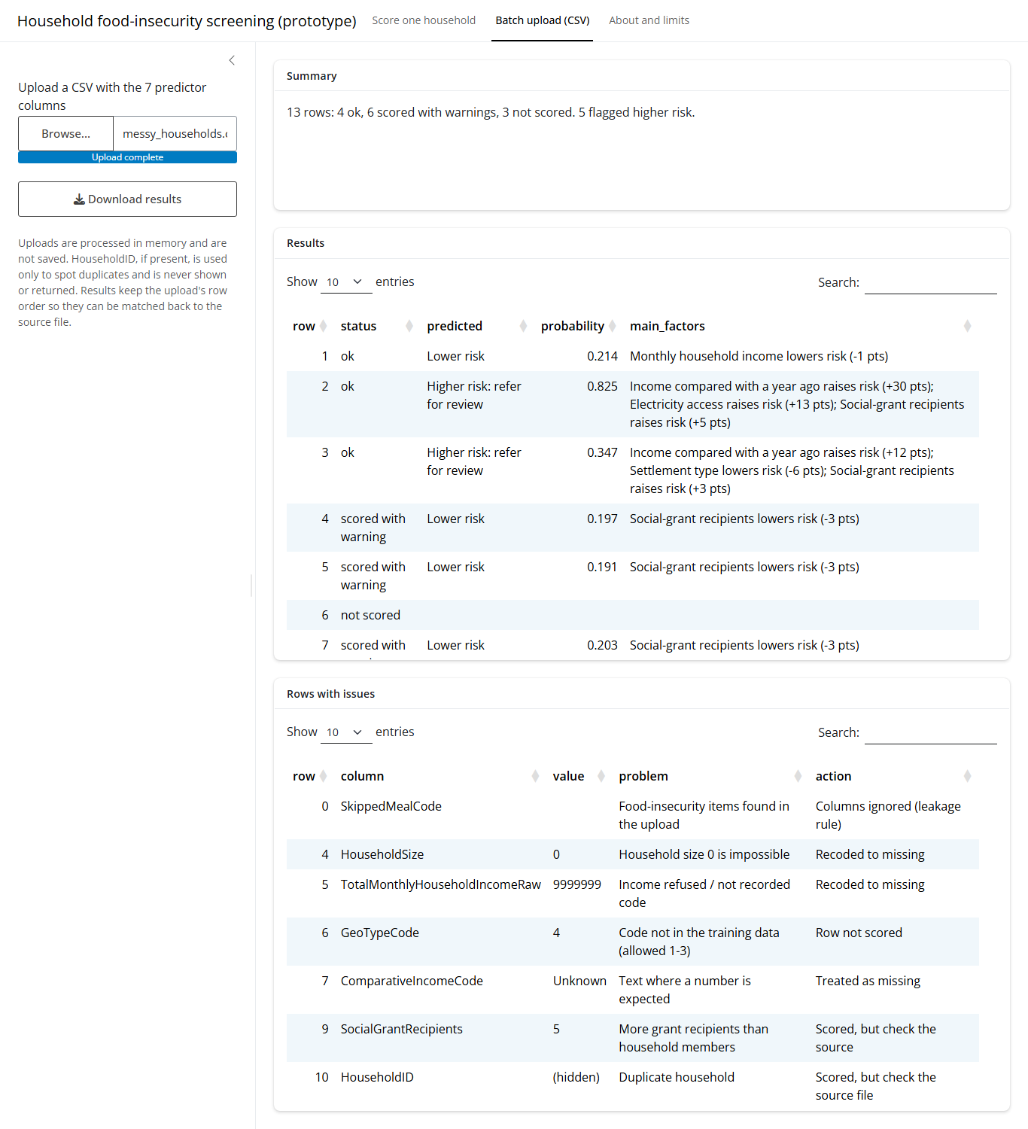
Figure 4.2 Batch upload of the messy test file: summary, results and the issues table (sentinel codes, an unseen code, a text value, an impossible value, a duplicate ID and the leakage guard)
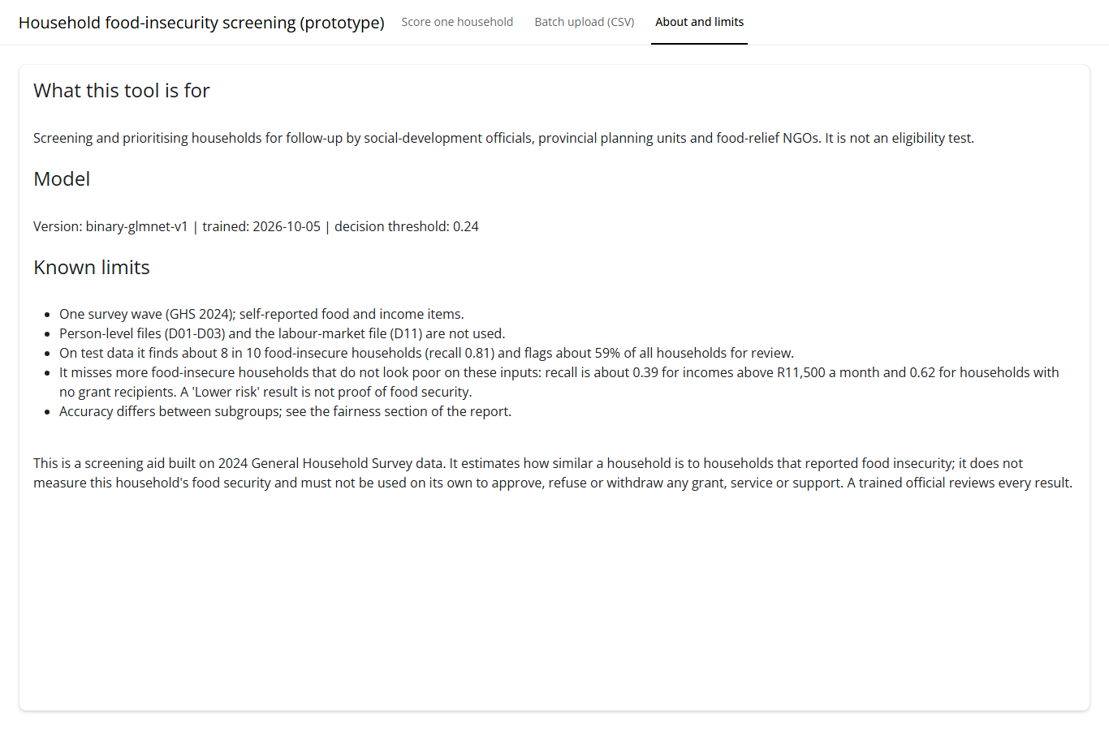
Figure 4.3 The About and limits tab: intended use, model version, threshold and known limits

4.4 Path for new data: validate, clean, preprocess, score
- Validate (app/R/validate.R). The seven inputs must be present, or the upload stops with a message naming the missing columns. Every column is read as text, so 18-digit HouseholdIDs stay exact (the precision defect found in Milestone 2) and placeholders such as 'Unknown' produce a message instead of an error. The 16 leakage columns listed in Task 1 (the food-insecurity items, the hunger follow-ups and the FI Score) are ignored if an upload contains them, because they define the target. Other columns that are not model inputs, such as ExpenditureBand (valid codes 1–14 in Milestone 2), are not used. Duplicate IDs are flagged.
- Clean. The Milestone 2 rules are applied column by column (Table 4.5). Sentinel codes and text placeholders become missing; codes never seen in training, negative or fractional counts and rows with more than two missing inputs are not scored and are listed for manual assessment; values above the training range are scored with a warning.
- Preprocess (to_model_input() in app/R/score.R). Validated raw codes are converted into the model's features exactly as in Task 1: labelled factors, Income_Log = log1p(income) and Income_PerCapita = income / household size. The saved workflow's recipe then imputes, encodes and scales with values learned on the training data only.
- Score. The probability of food insecurity, 'Higher risk: refer for review' at or above the threshold of 0.24, and the three main contributing factors.
Table 4.5 Cleaning rules applied to new data (reused from the Milestone 2 sentinel map)
Input | Recoded to missing | Valid | Otherwise
Income compared with a year ago | 9 (unspecified) | codes 1–5 | not scored (unseen code)
Settlement type | – | codes 1–3 | not scored
Household size | 0 (impossible, rejected as a size) | 1 to 25 (8 and 9 are valid sizes) | below 1 or fractional: not scored; above 25: warning
Monthly household income | 9 999 999 to 9 999 999 999 (refused) | 0 or more (R0 is valid) | negative: not scored; above R1,460,000: warning
Electricity access | 9 (unspecified) | codes 1–2 | not scored
Social-grant recipients | 99 (unspecified) | 0 to 16 | more recipients than household members: warning
Main toilet facility | 99 (unspecified) | codes 1–12 | not scored

Testing. An automated test (tests/test_validation.R) runs 13 deliberately messy rows through the path and checks every rule: all checks pass, giving 4 rows ok, 6 scored with warnings and 3 not scored (Figure 4.2). To prove that the app and the evaluation agree, all 6,279 test households were scored through the app's own path and compared with the evaluated predictions (R/check_app_matches_model.R): the largest difference in probability was exactly 0, no household was refused, and recall (0.807) and the share referred (58.9%) match Section 2.3. A batch of 5,000 households, including the explanations, is scored in about 1.1 to 1.4 seconds on a standard laptop.

4.5 Operational workflow, roles and versions
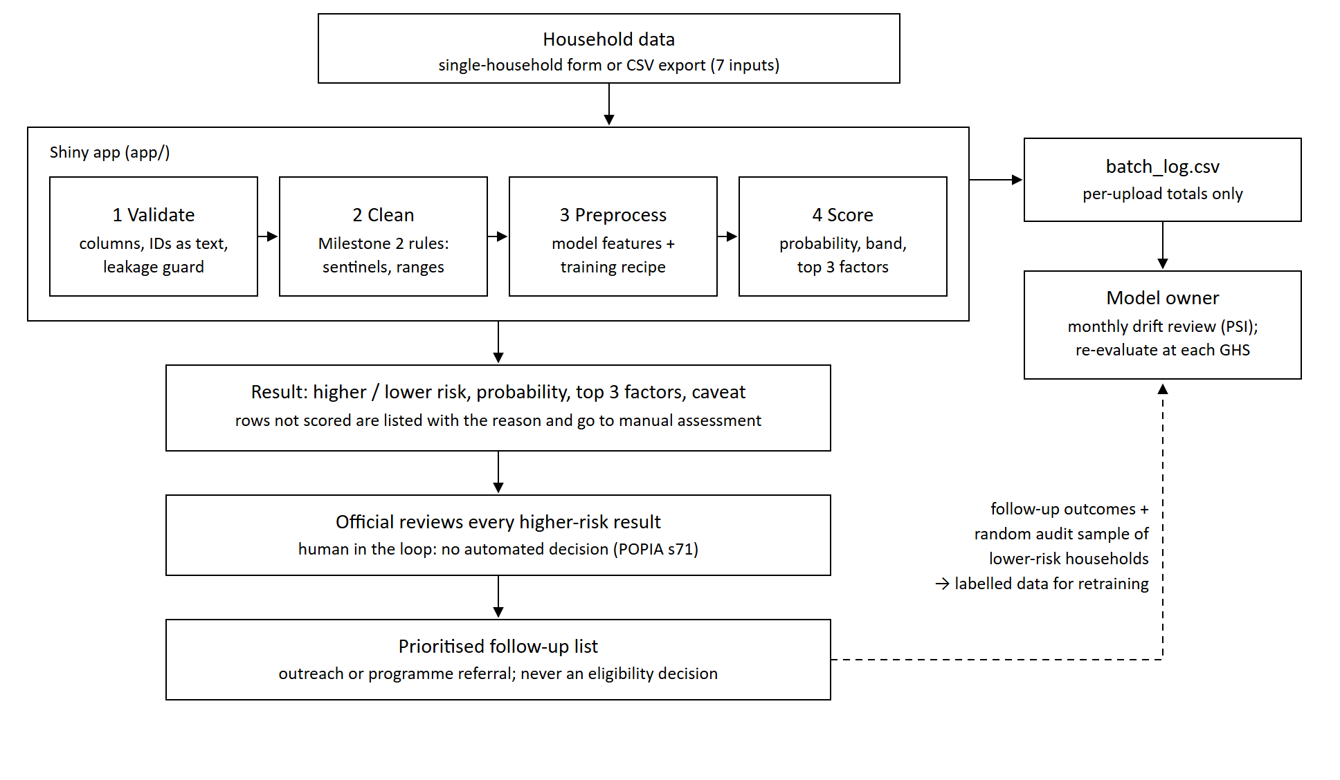
Figure 4.4 Operational workflow of the screening tool: from data entry through the app to human review, with the monitoring and retraining loop
Table 4.6 Roles in operation
Role | Who (in a real deployment) | Responsibilities
Model owner | Analytics unit at the institute | Monthly monitoring review; retraining; signing off new versions; keeping the previous version for rollback
App administrator | IT or analytics | Hosting, user accounts and sign-in, package updates, backups
Reviewing official | Programme officials | Review every higher-risk result and every row that was not scored; record the decision and the reason
Information Officer | The institute's POPIA Information Officer (s55) | Approve the purpose and the data fields; handle data-subject requests and security incidents

Versions and rollback. Every result and download carries the model version (binary-glmnet-v1), and models/CHANGELOG.md records each version with its threshold and test results. The app is deployed from the repository with the package versions pinned in renv.lock, so the server runs the same code and packages as the notebook. The previous model file is kept, so rolling back means changing one path.

4.6 Monitoring plan
The outcome is only observed when Statistics South Africa releases a new General Household Survey, roughly once a year, so the model's accuracy cannot be measured continuously. Monitoring therefore has two layers. Between releases, every upload writes one row of totals to monitoring/batch_log.csv: the rows not scored, the missing-income rate, the share flagged and the Population Stability Index (PSI) for income, settlement type and household size. No household-level data is stored, which keeps monitoring consistent with the privacy design. At each release, recall, calibration and subgroup recall are re-estimated against the Section 2 baselines.
PSI compares the distribution of an input in a new batch with the training data, bin by bin: below 0.10 is stable, 0.10 to 0.25 calls for a closer look and above 0.25 indicates a significant shift (Siddiqi, 2006). It is left blank for batches under 200 rows, where bin shares are too noisy.
Table 4.7 Monitoring signals and alert thresholds (baseline: data/evaluation/monitoring_baseline.csv)
Signal | Measure | Baseline | Alert when | Action | When
Input drift | PSI for income, settlement type, household size | 0 | 0.10–0.25 watch; above 0.25 act | Investigate the source; review for retraining if sustained for two months | Every upload; reviewed monthly
Missing income | % of rows with income missing or refused | 2.2% (451 of 20,940) | above 5% | Check the source form or export | Every upload
Rows not scored | % of rows refused by validation | 0% of test rows | above 5% | Check codes and format; look for a changed questionnaire | Every upload
Output shift | % flagged higher risk | 58.9% | ±10 points | Check input drift; review the threshold | Monthly
Performance | Recall for at-risk households; Brier score | 0.807; 0.180 | recall below 0.707; Brier clearly worse | Retrain; recalibrate if only the Brier score worsens | Each GHS release
Fairness | Recall by subgroup (Table 3.4) | Table 3.4 | gap above 10 points | Threshold review, extra review for the group, report it | Each GHS release

Drift test. The monitoring summary was computed for 1,000 randomly chosen test households as they are, and for the same households after a simulated shift: incomes 25% higher (about five years of inflation) and a third of urban households recorded as traditional/tribal (Table 4.8).
Table 4.8 Monitoring summary for a normal and a shifted batch
Batch (1,000 households) | PSI income | PSI settlement | PSI size | % flagged | Alert
Test households as they are | 0.013 | 0.002 | 0.001 | 59.8% | stable
Simulated shift | 0.087 | 0.191 | 0.001 | 51.9% | watch (settlement type)

The unshifted batch is stable and its share flagged (59.8%) is close to the 58.9% baseline, while the settlement-type shift is caught at the 'watch' level. The test also shows why monitoring matters for this model: raising nominal incomes by 25% left real circumstances unchanged, yet cut the share flagged by 7.9 points, because the model reads income in Rand. Without retraining, inflation alone would slowly make the screen miss more households.
Labelled data between releases. Officials record the outcome of each follow-up, which provides new labels. Because only flagged households are followed up, these labels can never reveal the households the model misses (a feedback loop), so a small random audit sample of lower-risk households is also followed up every month. Governance: monthly, the model owner runs R/review_monitoring.R on the batch log and records the outcome; at each GHS release the full evaluation is repeated on the new data; every model change gets a new version, a change-log entry and an updated README.

4.7 Retraining and retirement
Retrain when any of the following happens: a new GHS release (planned, yearly); labelled follow-up and audit data reaches a useful size; PSI above 0.25 on a key input for two consecutive monthly reviews; recall below 0.707 or a subgroup gap above 10 points at a release; or a rise in rows not scored, showing that survey codes or questions have changed.
Retire the model when the business objective changes (for example, the institute adopts a different vulnerability measure), when performance still fails after retraining, when the data source or questions are discontinued, when a fairness gap cannot be mitigated, or when a legal or policy change rules out this kind of profiling.

4.8 Repository and reproducibility
The repository (github.com/timothywubbeling/BIN381, private) contains the preparation, modelling and deployment code. Its README gives the steps to reproduce everything: clone, open BIN381-P1.Rproj, run renv::restore() to install the pinned packages, knit the notebooks, run the two checks and launch the app with shiny::runApp("app"). The full Milestone 3 notebook runs Tasks 1 to 4 in order from a clean session. A full re-run took 15 minutes and reproduced every model and evaluation output (only the recorded training times differ, and the re-fitted final model gives identical predictions); the Milestone 2 cleaning notebook reproduces the cleaned files byte for byte.

Insights and Recommendations
This section draws the findings of Tasks 2 and 3 together for the stakeholder, the social-development policy institute defined in Milestone 1. All findings are associations in one survey wave, not causes.

Key insights
- A recent fall in income is the strongest warning sign. 58.3% of households whose income is much lower than a year ago are food insecure, against 18–21% for codes 2 and 3 (odds ratio 2.05 against code 1). It is the most important predictor in every model (Sections 3.1–3.2).
- Income per person matters more than household size itself. Food insecurity rises from 26.8% in households of one or two people to 42.6% in households of seven or more, but most of that effect runs through per-capita income; the direct effect of size is small (odds ratio 1.04).
- Grant households remain at high risk. 37.6% of households with grant recipients are food insecure, against 20.6% without (odds ratio 1.20 per recipient). Grants reach poorer households, but in this cross-section they do not lift them clear of food insecurity.
- Electricity and sanitation mark deprivation. 47.0% of households without electricity are food insecure, against 29.7% with it (odds ratio 2.07); households using a pit latrine with a ventilation pipe (code 5) show 40.9%, against 27.2% for flush toilets on public sewerage (code 1). Both add little predictive value once income is known.
- The rural gap is an income-and-services gap. Traditional/tribal households are more often food insecure (34.8% against 28.5% in urban areas), but once income and services are accounted for their odds are lower (0.76), so the difference reflects resources rather than place.
- Food insecurity is concentrated in a few provinces. Weighted to the population, 28.3% of households are at risk nationally, rising to 43.0% in the Eastern Cape, 40.5% in the Northern Cape, 37.1% in North West and 35.5% in Mpumalanga, against 13.1% in Limpopo and 24.3% in the Western Cape (data/powerbi/powerbi_reconciliation.csv).
- Some food insecurity is hidden from the model. It finds 94% of at-risk households earning under R2,500 a month but only 39% of those earning over R11,500, and 62% of those without grant recipients (Sections 3.4 and 3.7).
- The middle tier cannot be told apart with these data. Mild-to-moderate food insecurity (FI Score 1–3) is missed even when class weights force the model to look for it (Table 1.3), so a binary screen is the realistic tool.

Recommendations for the institute
- Use the screening tool to prioritise outreach, not to decide eligibility, under the conditions in Sections 3.6 and 4.1: an official reviews every referral, and the tool runs behind sign-in on South African hosting.
- Ask about recent income change at every intake. It is the strongest and cheapest signal; a household reporting a sharp fall should trigger follow-up even before other information is collected.
- Treat grant households as a group to check, not a group to deprioritise. Coordinating food-relief outreach with grant registers would reach many of the households most at risk.
- Direct food-relief and basic-services budgets first to the Eastern Cape, Northern Cape, North West and Mpumalanga, and drill down by settlement type, income band and grant receipt within each province in the Milestone 4 Power BI dashboard.
- Do not read 'lower risk' as clearance. Keep self-referral channels open and run the monthly audit sample of lower-risk households, especially among higher-income and no-grant households, where the model is weakest.
- Agree the referral threshold with programme managers. At 0.24 the tool refers 59% of households; if follow-up capacity is smaller, the threshold should be raised knowingly, accepting lower recall.
- Improve the data for the next model: per-person income and employment (D01–D03), debts and local food prices, plus recorded follow-up outcomes, and re-evaluate the model at every new GHS release.

Conclusion
Milestone 3 turned the Milestone 2 dataset into a validated screening model and a working deployment. Three candidate classifiers were tuned with stratified cross-validation (Task 1). With these eight predictors the three-tier target could not separate the thin middle tier, so the documented binary fallback, a lasso logistic regression at a referral threshold of 0.24, was selected over a marginally stronger random forest for its interpretability, calibration and fit with the app (Task 2). It finds 80.7% of at-risk test households, and 85.7% of the severely food insecure, while referring 58.9% of households. Falling income, low per-capita income, no electricity and larger households are associated with higher risk (H1, H3 and H4 supported; H6 partly), grant receipt is associated with higher rather than lower risk because grants are targeted, and the rural gap disappears once income and services are controlled for (Task 3). The model is deployed with conditions as an R/Shiny screening tool that validates new data with the Milestone 2 rules, reproduces the evaluation exactly, explains each result and keeps an official in the loop, with monitoring and fairness safeguards for the households it is weakest on (Tasks 3 and 4). Milestone 4 will deliver the Power BI dashboard for Business Objective 3 and the final report.

Acknowledgement of AI Use
Generative AI was used in this milestone. Timothy Wubbeling (Person C) used Claude (Anthropic), through the Claude desktop application, as a coding and writing assistant. It was used to plan the Person C tasks; to give guidance on the draft and debug the R code for the Shiny app (input validation, scoring and explanations, drift monitoring), the consistency and fairness checks and the Person C and merged notebooks; to set up the repository and fix the package environment; to guide Timothy on how to create the draft of the deployment, monitoring and ethics sections, and the workflow diagram. All AI-assisted code was run and tested on the project data, and every reported number was checked against the notebooks' outputs. Rudi du Plessis (Tasks 2 and 3) used Claude (Anthropic) as a coding and writing assistant. It was used to plan the Person B tasks; to draft and debug R code in the evaluation notebook and helped draft the text of the Task 2 and Task 3 sections. The author reviewed and approved all analysis decisions, including the choice of metrics, the threshold rule and the final model. Every number, table and figure in these sections was generated by running the notebook on the team's data. The text was checked against those outputs before submission. Responsibility for the content rests with the author. [Alexander: add your own AI use here, or state that none was used.] The group takes full responsibility for the submitted work. Each use is recorded in the group's Ethics and Responsible AI Usage Log.

References
Breiman, L. (2001). Random forests. Machine Learning, 45(1), 5–32.
Brier, G. W. (1950). Verification of forecasts expressed in terms of probability. Monthly Weather Review, 78(1), 1–3.
Chang, W., Cheng, J., Allaire, J., Sievert, C., Schloerke, B., Aden-Buie, G., Xie, Y., Allen, J., McPherson, J., Dipert, A., & Borges, B. (2026). shiny: Web application framework for R (R package version 1.14.0). https://shiny.posit.co/
Chapman, P., Clinton, J., Kerber, R., Khabaza, T., Reinartz, T., Shearer, C., & Wirth, R. (2000). CRISP-DM 1.0: Step-by-step data mining guide. SPSS.
Efron, B., & Tibshirani, R. J. (1993). An introduction to the bootstrap. Chapman & Hall.
Friedman, J. H. (2001). Greedy function approximation: A gradient boosting machine. The Annals of Statistics, 29(5), 1189–1232.
Friedman, J., Hastie, T., & Tibshirani, R. (2010). Regularization paths for generalized linear models via coordinate descent. Journal of Statistical Software, 33(1), 1–22. https://doi.org/10.18637/jss.v033.i01
Hand, D. J., & Till, R. J. (2001). A simple generalisation of the area under the ROC curve for multiple class classification problems. Machine Learning, 45(2), 171–186.
Hardt, M., Price, E., & Srebro, N. (2016). Equality of opportunity in supervised learning. Advances in Neural Information Processing Systems, 29.
Kuhn, M., & Silge, J. (2022). Tidy modeling with R. O'Reilly Media.
Kuhn, M., & Wickham, H. (2020). Tidymodels: A collection of packages for modeling and machine learning using tidyverse principles. https://www.tidymodels.org
Mitchell, M., Wu, S., Zaldivar, A., Barnes, P., Vasserman, L., Hutchinson, B., Spitzer, E., Raji, I. D., & Gebru, T. (2019). Model cards for model reporting. In Proceedings of the Conference on Fairness, Accountability, and Transparency (pp. 220–229).
Posit. (2026). Posit Connect and shinyapps.io [Product pages]. Retrieved 6 October 2026, from https://posit.co/products/enterprise/connect/ and https://www.shinyapps.io/
R Core Team. (2026). R: A language and environment for statistical computing. R Foundation for Statistical Computing. https://www.R-project.org/
Republic of South Africa. (2013). Protection of Personal Information Act 4 of 2013. Government Gazette.
Saito, T., & Rehmsmeier, M. (2015). The precision-recall plot is more informative than the ROC plot when evaluating binary classifiers on imbalanced datasets. PLoS ONE, 10(3), e0118432.
Siddiqi, N. (2006). Credit risk scorecards: Developing and implementing intelligent credit scoring. Wiley.
Statistics South Africa. (2026). General Household Survey 2024 [Data set]. Statistics South Africa. https://isibaloweb.statssa.gov.za/
Therneau, T., & Atkinson, B. (2026). rpart: Recursive partitioning and regression trees (R package version 4.1.27). https://doi.org/10.32614/CRAN.package.rpart
Ushey, K., & Wickham, H. (2026). renv: Project environments (R package version 1.3.0). https://rstudio.github.io/renv/
van Rijsbergen, C. J. (1979). Information retrieval (2nd ed.). Butterworths.
Wickham, H. (2021). Mastering Shiny. O'Reilly Media.
Wilson, E. B. (1927). Probable inference, the law of succession, and statistical inference. Journal of the American Statistical Association, 22(158), 209–212.
Wright, M. N., & Ziegler, A. (2017). ranger: A fast implementation of random forests for high dimensional data in C++ and R. Journal of Statistical Software, 77(1), 1–17. https://doi.org/10.18637/jss.v077.i01

