
BIN 381 Milestone 4
Group P1

Alexander Solomon (601638)
Timothy Wubbeling (602543)
Rudi Jan du Plessis (601342)

Table of Contents
- Business problem and approach 2
1.1 The Problem 2
1.2 How we followed CRISP-DM 2
- Data strategy, integration and preparation 3
2.1 Data selected 3
2.2 Cleaning decisions that changed the result 3
2.3 Integration 4
2.4 Target, predictors and data split 5
- Modelling 5
3.1 Framing 5
3.2 Techniques and preprocessing 6
3.3 Validation and tuning 6
3.4 The change to a binary model 7
3.5 Reproducibility 7
References 8

Business problem and approach

The Problem
Households that cannot reliably get enough food are hard to find when support budgets are limited. We worked as analysts for a policy institute of the Department of Social Development type, which must decide which households to prioritise for follow-up and referral. Our evidence is the Stats SA General Household Survey (GHS) 2024, which records 20,940 households and asks eight questions about running out of food, skipping meals and going hungry (Statistics South Africa, 2026).
The project had three business objectives, set in Milestone 1:
- BO1. Identify and rank the five to eight household indicators most associated with food insecurity, with p < 0.05 and an effect size.
- BO2. Build an interpretable classification model, without leakage, that is evaluated on held-out data and can be used to prioritise households.
- BO3. Give decision-makers self-service exploration by province and household characteristic, delivered as a Power BI dashboard (Section 5).
We linked these to six hypotheses about what puts a household at risk: falling income (H1), settlement type (H2), large households and low income per person (H3), no electricity (H4), social grant receipt (H5) and poor sanitation (H6). Section 4 reports which were supported.

1.2 How we followed CRISP-DM
We followed the CRISP-DM phases in order (Chapman et al., 2000) and went back when the evidence required it. Table 1 shows where each phase occurred and the most important decision in each.
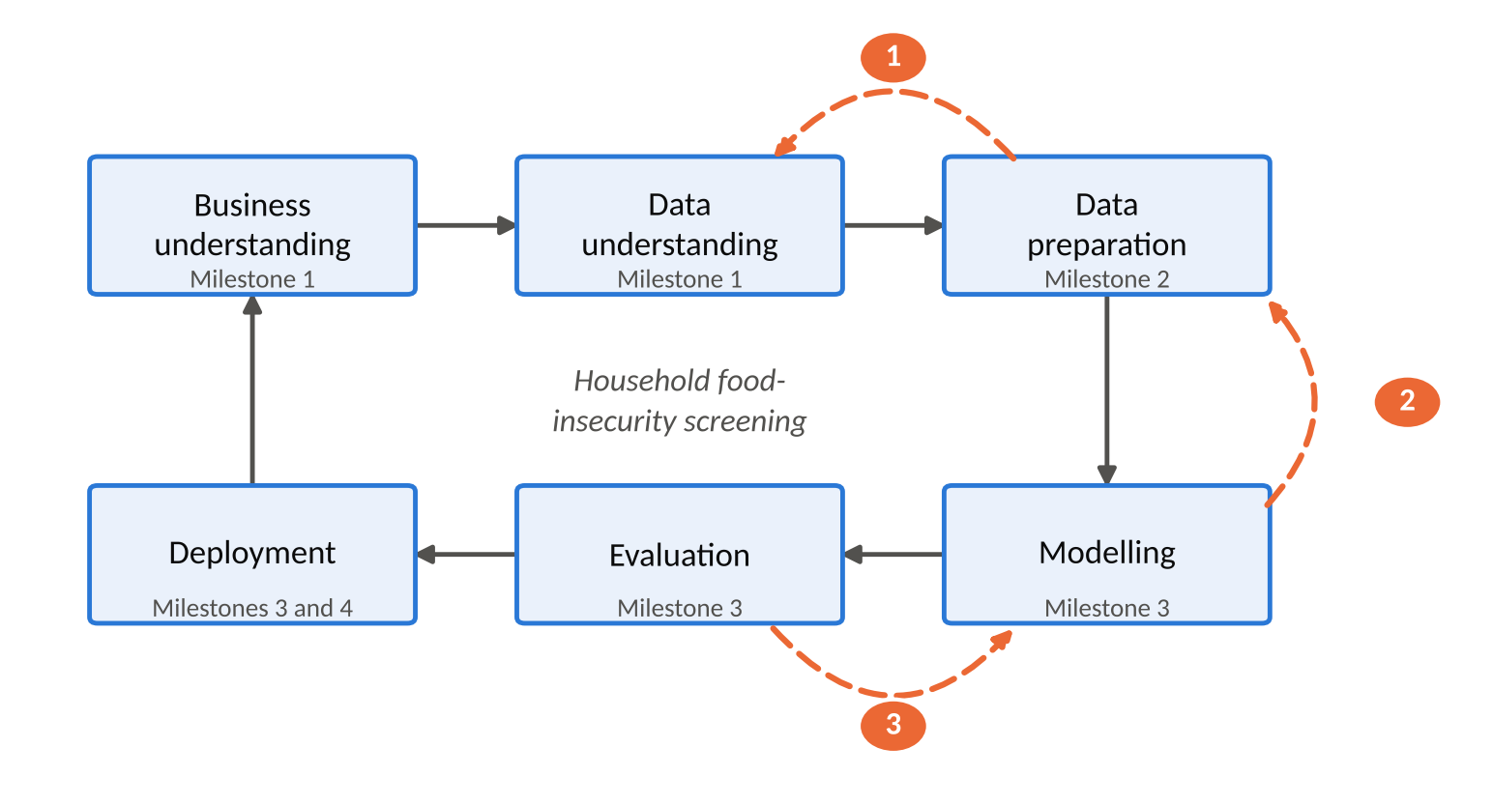
Figure 1 CRISP-DM phases followed in this project. Dashed arrows mark decisions that were revised: (1) duplicate IDs reported in Milestone 1 were a data-type artefact, found in Milestone 2; (2) settlement type recoded to three levels before modelling; (3) three-tier target replaced by the binary fallback for deployment.
Table 1 CRISP-DM phases, where they were done and the main decision in each
Phase | Milestone | Main Decision
Business and data understanding | 1 | Framed the problem as targeting limited support; explored all 11 GHS files; set BO1 to BO3 and H1 to H6.
Data preparation | 2 | Kept seven household-level files, repaired keys and duplicates, built the food-insecurity target and the predictors, and fixed one stratified train/test split.
Modelling | 3 | Tuned three classifiers with stratified cross-validation, then added a binary model when the three-tier target proved too hard.
Evaluation | 3 | Judged models on imbalance-aware metrics and chose a referral threshold of 0.24 on the training data only.
Deployment | 3 and 4 | Released an R/Shiny screening tool with validation, monitoring and retraining triggers, and a Power BI dashboard for exploration.

Three times the later work changed an earlier decision. Milestone 1 reported 256 to 272 duplicate household IDs per file, but in Milestone 2 we found this came from reading 18-digit IDs as numbers (Section 2.2). The urban/rural coding of settlement type assumed in Milestone 2 was corrected to the three levels in the data dictionary before modelling. For deployment, we replaced the three-tier target set in Milestone 2 with the binary fallback we documented in advance (Section 3.4).

Data strategy, integration and preparation

Data selected
The GHS 2024 comes as eleven files, D01 to D11. We analysed households, so one row is one household, and the key is HouseholdID. Seven household-level files were kept: dwelling conditions (D04), basic services (D05), energy (D06), household well-being (D07, which holds the food-insecurity items and acts as the anchor), connectivity (D08), household resources (D09) and mobility (D10). D08 was not in the Milestone 1 core set. We added it because it is household-level, joins without mismatch, and digital exclusion is a recognised dimension of deprivation.
Three files were left out on purpose. D01 to D03 are person-level (about 70,450 rows against 20,940 households), so using them would force an extra aggregation choice for every variable, and none of H1 to H6 needs a person-level variable. D11 (labour market) comes from a different survey with a different sampling universe and has no household IDs in common with the GHS.

Cleaning decisions that changed the result
We cleaned each file before joining and logged every treatment (data/clean/qa_log_personC.csv). Table 2 lists the decisions that had a real effect on the final dataset.
Table 2 Main cleaning decisions and their effect
Problem | Decision | Effect
18-digit HouseholdID read as a number loses its last digits (R holds only 15 to 16 digits exactly) | Read every ID as text. | The "256 to 272 duplicates per file" in Milestone 1 disappeared. It was an artefact of rounding, not of the survey.
Exact duplicate rows in D04, D07 and D09 | Kept the first copy after checking every duplicate was a full row copy. | 20,956, 20,955 and 20,955 rows became 20,940 in each file. No information was lost.
Province typed as padded or mixed-case text (up to 31 variants in one file) | Rebuilt the label from the clean numeric province code. | Nine provinces in every file.
Refused, "unspecified" and "not recorded" codes (9, 99, 9999999 and text tokens) | Recoded to missing instead of treating them as real answers. | For example, 451 households have no usable income. They are imputed later inside the model recipe, using training data only.
Household size of 0 | Recoded to missing. Sizes 8 and 9 were kept as valid. | Removes an impossible value without discarding real large households.
Two D09 columns that look like counts but are not (salary earners, total grant recipients) | Excluded from the dataset. | Avoids feeding amounts and sentinels into a count predictor.

Integration
We joined D07 with the other six files one at a time, using guarded one-to-one joins that stop if a household would be dropped or duplicated. This mattered. Fifteen households in D05 carried placeholder keys ("UNMATCHED_…") instead of real IDs, so a plain inner join would have lost them without any warning. Because all files list households in the same order, we matched each placeholder to the ID at the same row position in D07, and then confirmed it with the household's province, settlement type and survey weight. Both checks agreed for all 15, so the keys were restored and the join went ahead.
The result is 20,940 households with no loss or duplication at any step. We tested it three ways: every source value survives the join unchanged (compared column by column with no tolerance), the descriptors that were dropped from the other files agree with the integrated values for all matched households, and the provincial household counts equal those in D07. These checks stop the notebook if they fail. The dictionary (data/integrated/BIN381_M2_Data_Dictionary.csv) records the source file and treatment of every column.
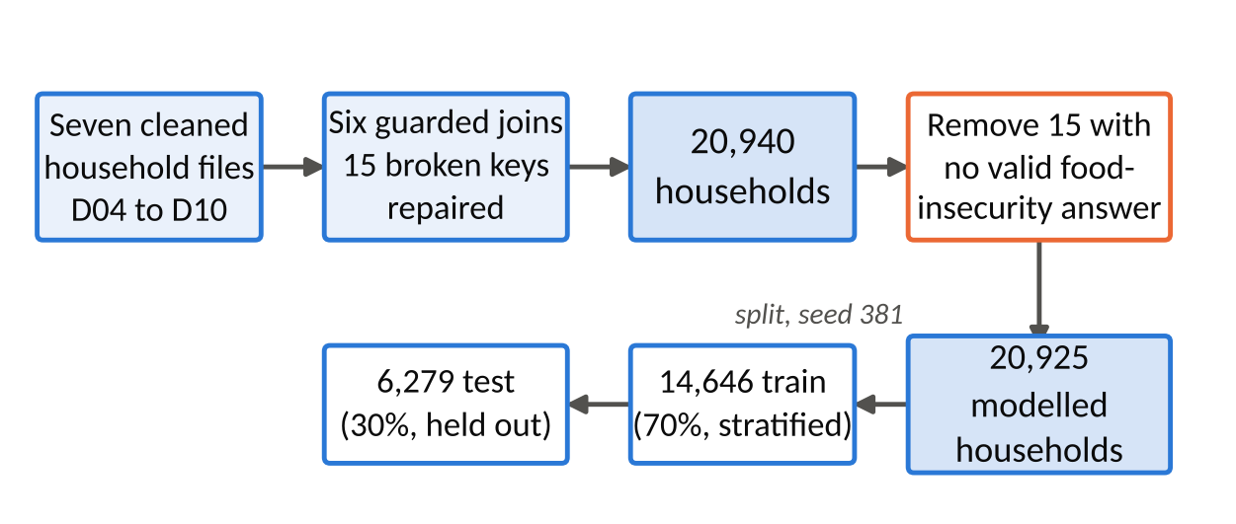
Figure 2 From the cleaned files to the modelling split

Target, predictors and data split
Target. The Food Insecurity (FI) Score counts the "yes" answers to the eight food-access items (0 to 8). An answer of "don't know/refused" is missing, not "no", because it is no evidence of food security. Fifteen households have no valid answer, so they cannot be scored and were set aside, leaving 20,925 modelled households. We grouped the score into three tiers: food secure (FI = 0, 69.45% of training households), food insecure (FI 1 to 3, 10.55%) and severely food insecure (FI of 4 or more, 20.00%). Any food insecurity (FI of 1 or more, 30.55%) was kept as a binary fallback.
Predictors. Each of the eight predictors comes from a hypothesis: income compared with a year ago (H1), settlement type (H2), household size and income per person (H3, with log income also used for H1), electricity access (H4), number of grant recipients (H5) and main toilet type (H6). Income is log-transformed because it is strongly right-skewed.
Leakage. The FI Score is built from the eight items, so they cannot also be predictors. We excluded 16 columns: the eight items, two older hunger questions, four "number of days" follow-ups, the FI Score and its count of answered items. The notebook asserts that none is in the predictor set or in the modelling data.
Split. A stratified 70/30 split on the tier (seed 381) gave 14,646 training and 6,279 test households, with the same tier mix in both. The test set was not used for any modelling decision.

Modelling

Framing
This is a supervised classification problem: given a household's income, size, settlement type and access to services and grants, how likely is it to be food insecure? We started with the three-tier target because BO2 asks for vulnerability tiers, and we wrote down in advance that we would fall back to the binary target if the thin middle tier (10.55%) could not be separated.

Techniques and preprocessing
We built three candidates, one more than the minimum, to cover the trade-off between interpretability and performance. Regularised multinomial logistic regression (glmnet; Friedman, Hastie and Tibshirani, 2010) is the interpretable baseline whose coefficients map onto H1 to H6. It assumes a linear relationship on the log-odds scale and low multicollinearity. We handled the first by log-transforming income and checked the second: income compared with a year ago, regressed on the two income features, gives R² = 0.064 and a variance inflation factor of 1.07, far below the usual concern level of 5. A decision tree (rpart; Therneau and Atkinson, 2026) gives readable rules, but is unstable, so we used it for interpretation and not as the performance candidate. A random forest (ranger; Breiman, 2001; Wright and Ziegler, 2017) of 500 trees is the performance benchmark, at the cost of being harder to interpret.
Each family has its own preprocessing recipe. Missing numbers are filled with the training median and missing categories with the training mode, rare toilet codes (under 2% of households) are pooled, and unseen categories are guarded against. The logistic model also gets dummy encoding and scaling, because its penalty is scale-sensitive. All this sits inside tidymodels workflows, so it is re-learned inside every cross-validation fold and never sees the test set (Kuhn and Silge, 2022).

3.3 Validation and tuning
We tuned each model with 5-fold cross-validation on the training set, stratified on the tier so that every fold keeps the 69/11/20 mix. Candidates came from space-filling grids of 8 to 12 settings, and the selection metric was cross-validated ROC-AUC (the Hand and Till, 2001, version for three classes), which the majority class cannot inflate. Accuracy is misleading here because predicting "food secure" for everyone scores 69%.
We also tested class weights as an alternative way to handle imbalance. They raised recall for the severe tier from 25.8% to 58.7% but cut recall for food-secure households from 95.5% to 59.7% and worsened calibration (Brier score 0.289 against 0.205). The app reports a probability, so we kept the unweighted models and handled imbalance at the decision threshold instead (Section 4).
Table 3 Final models and their cross-validated performance (seed 381)
Model | Selected settings | CV ROC-AUC, three tiers | CV ROC-AUC, screening
Multinomial logistic (glmnet) | penalty 8.1 × 10⁻¹⁰, mixture 0.18 | 0.669 ± 0.007 | 0.734
Decision tree (rpart) | cost complexity 1 × 10⁻¹⁰, depth 11, min_n 19 | 0.658 ± 0.010 | 0.721
Random forest (ranger) | mtry 2, min_n 31, 500 trees | 0.673 ± 0.005 | 0.739
Binary logistic (glmnet) | penalty 1.9 × 10⁻⁶, mixture 1 (lasso) | not applicable | 0.733 ± 0.010
Screening AUC is the ability to separate food-secure from food-insecure households, from the sum of the two insecure-tier probabilities.

3.4 The change to a binary model
All three three-tier models rank households better than chance (cross-validated AUC 0.66 to 0.67), but on the test set none of them recall more than 3.2% of middle-tier households (the forest 0.3%; Section 4), and the differences between them are small. With these eight predictors, the middle tier cannot be separated from its neighbours, which is the condition we set in advance for the fallback. The Shiny app also returns one probability per household, which suits a two-class model. We therefore fitted a fourth model, a lasso logistic regression on any food insecurity, with the same predictors and recipe. Section 4 compares it with the others on the test set and explains why it was deployed.

3.5 Reproducibility
The seed 381 is set before every random step, and package versions are pinned with renv (R 4.6.1, 225 packages; Ushey and Wickham, 2026). Running the modelling notebook from a clean session reproduces every saved prediction and the parameter table exactly. The fitted workflows, the predictions and an input schema (names, types, valid ranges) were handed to Rudi for evaluation and to Timothy for deployment.

Evaluation and key findings
All four candidates were tuned with stratified five-fold cross-validation on the training set and then scored once on the untouched 30% test set (6,279 households, 1,919 of them food insecure). Because the three-tier target could not separate the thin middle tier — no three-tier model recalls more than 3.2% of mildly-to-moderately insecure households, and the best-ranking one manages 0.3% — the deployable question was reframed as a binary screen: is this household at risk of any food insecurity? Models are therefore compared on how well they rank households by risk, not on accuracy, which the 69% food-secure majority would flatter.
Table 4 Screening performance on the test set, each model at its own 80%-recall threshold (source: data/evaluation/evaluation_matrix.csv)
Model | ROC-AUC | Threshold | Recall | Precision | Referred | Brier | ECE
Binary logistic | 0.736 | 0.24 | 80.7% | 41.9% | 58.9% | 0.180 | 0.012
Random forest | 0.745 | 0.23 | 79.9% | 42.8% | 57.1% | 0.177 | 0.012
Multinomial logistic | 0.736 | 0.23 | 82.4% | 41.0% | 61.4% | 0.180 | 0.010
Decision tree | 0.727 | 0.19 | 79.9% | 42.2% | 57.9% | 0.187 | 0.040

4.1 Why this model and this threshold
The selected model is the lasso (glmnet) binary logistic regression at a referral threshold of 0.24. The threshold was fixed on cross-validation, never on the test set, using a policy rule agreed before evaluation: find at least 80% of at-risk households at the fewest referrals. On the test set it finds 80.7% of at-risk households and 85.7% of the severely food insecure, while referring 58.9% of households at 41.9% precision. The F2-optimal threshold of 0.14 was rejected because it refers 83.8% of all households, and the default 0.5 because it misses 68.9% of at-risk households. The random forest scores marginally higher (AUC 0.745 against 0.736; bootstrap difference +0.009, 95% CI 0.002–0.016), but the logistic model was chosen for one interpretable odds ratio per factor, equally good calibration and a direct fit with the Shiny app — a gain too small to pay for the loss of explanation in a tool that must justify every referral to an official.
It generalises and it is calibrated: cross-validated AUC 0.733 against 0.736 on test (gap 0.0024, so no meaningful overfitting), Brier 0.180 and expected calibration error 0.012, so the scores are usable as probabilities and not only as a ranking. Survey-weighting the test set moves recall only from 80.7% to 78.3%.

4.2 What drives risk, and what the data says about the hypotheses
Permutation importance ranks the drivers consistently across all three models: income change vs a year ago (0.082), income per person (0.033), number of grant recipients (0.029), household income (log) (0.021). Electricity, settlement type, toilet type and household size add little once income is known. The odds ratios below come from an unpenalised logistic fit on the training data (Person A's tuned penalty was effectively zero), so they describe the deployed model while adding confidence intervals — as associations, not causes.
Table 5 Milestone 1 hypotheses against the final evidence (odds ratios with 95% CI)
Hypothesis | Evidence | Verdict
H1 Falling income raises risk | 58.3% vs 18.4–21.2% mid-scale; OR 2.05 (1.62–2.59). But code 1 (much higher) is also 34.8%. | Supported; U-shaped
H2 Rural households more at risk, income held equal | 34.8% vs 28.5% urban raw; adjusted OR 0.76 (0.66–0.87). | Not supported; the gap is income and services
H3 Larger households more at risk at fixed income | OR 1.04 (1.01–1.07) per member; raw 26.8% → 42.6%, mostly via income per person. | Supported; weak direct effect
H4 No electricity raises risk | 47.0% vs 29.7%; OR 2.07 (1.73–2.48). Only ~5% of households affected. | Supported
H5 Grant receipt lowers risk | Reversed: 37.6% vs 20.6%; OR 1.20 (1.16–1.24) per recipient. Grants are means-tested. | Not supported; targeting, not cause
H6 Toilet type is a useful poverty proxy | Code 5 (4,191 households) 40.9% vs 27.2%; OR 1.31 (1.13–1.52). Importance near zero. | Partly; little predictive value
The gaps matter more than the averages. The screen finds 94.0% of at-risk households earning under R2,500 a month but only 39.2% of those over R11,500, and 61.7% of households with no grant recipients against 88.0% of those with them. By province recall runs from 70.8% (Gauteng) to 89.3% (Eastern Cape). It is weakest exactly where food insecurity is least expected — a reason to keep self-referral open rather than trust a ‘lower risk’ result.

Recommendations
Each recommendation below starts from a number in Section 4 and names who should act. All of them assume the screening conditions in Section 5: an official reviews every referral, and the tool never decides eligibility on its own.
1. Deploy the screen for outreach triage only, and resource it for the referral rate it actually produces. At threshold 0.24 the tool refers 58.9% of households and 58.1% of those referrals turn out to be food secure. Programme managers should size follow-up capacity against that rate before go-live, or raise the threshold knowingly and accept lower recall; it is a policy choice, not a technical one. Monitoring should raise an alert if recall on followed-up households falls below 70.7%.
2. Ask every household about income change over the past year at intake. It is the single strongest predictor (AUC drop 0.082, roughly 2.5× the next variable), and 58.3% of households reporting a sharp fall are food insecure. Field staff can collect it in one question, and it should trigger follow-up on its own even before the full screen is run.
3. Treat grant-receiving households as a group to check, not a group to deprioritise. 37.6% of households with grant recipients are food insecure against 20.6% without. Social development should coordinate food-relief outreach with existing grant registers, which is the cheapest route to the households most at risk — while reading the association as evidence of targeting, not of grants causing harm.
4. Direct food-relief and basic-services budgets to the four provinces with the highest weighted risk first. Weighted to the population, 43.0% of Eastern Cape households are at risk, 40.5% in the Northern Cape, 37.1% in North West and 35.5% in Mpumalanga, against 28.3% nationally. Provincial teams can drill into settlement type, income band and grant status within each province on the dashboard.
5. Run a standing audit of ‘lower risk’ households in the groups where the model is weakest. Recall falls to 39.2% for households earning over R11,500 and 61.7% for households receiving no grants. A monthly sample of lower-risk households in those groups, reviewed by field officers, is the only way the institute will see the cases the screen misses. Keep self-referral open and never present a low score as clearance.

Limitations and future work
Modest discrimination is the central limitation. An AUC of 0.736 means the screen separates risk only moderately: at the chosen threshold 58.1% of referred households are not food insecure, and 19.3% of at-risk households are missed. The eight predictors describe a household's resources, not its access to food, and the strongest of them is a single self-reported question about income change.
The evidence is one cross-sectional wave of the General Household Survey 2024, so every result is an association rather than a cause; the reversed grant finding (H5) is the clearest case where targeting and effect cannot be separated. The target is itself a proxy built from self-reported items, which carry recall and social-desirability bias, and its three-tier version was abandoned because the middle tier is not separable with these predictors, so the tool cannot grade severity. Training used the unweighted sample (survey-weighting moves recall by 2.4 points); the person-level files D01–D03 and the D11 labour survey were excluded in Milestone 2; and small subgroups such as farms (197 test households) have intervals too wide to judge. Most importantly, the model has never been validated outside this survey: there is no external cohort and no record of what officials found when they followed up.
Future work follows from those gaps, in order of value. First, capture follow-up outcomes so the next model can be trained and validated on what was actually found rather than on a survey proxy. Second, add a second GHS wave to allow within-household change and a genuine test of whether grants protect against food insecurity. Third, bring in per-person income, employment, debt and local food prices, which the current eight predictors stand in for only crudely. Fourth, revisit severity grading once a richer target exists, and re-tune the threshold against the institute's measured follow-up capacity instead of an assumed 80% recall floor.

References
Breiman, L. (2001) 'Random forests', Machine Learning, 45(1), pp. 5–32.
Chapman, P. et al. (2000) CRISP-DM 1.0: step-by-step data mining guide. Chicago, IL: SPSS.
Friedman, J., Hastie, T. and Tibshirani, R. (2010) 'Regularisation paths for generalised linear models via coordinate descent', Journal of Statistical Software, 33(1), pp. 1–22. doi:10.18637/jss.v033.i01.
Hand, D.J. and Till, R.J. (2001) 'A simple generalisation of the area under the ROC curve for multiple class classification problems', Machine Learning, 45(2), pp. 171–186.
Kuhn, M. and Silge, J. (2022) Tidy modelling with R. Sebastopol, CA: O'Reilly Media.
Statistics South Africa (2026) General Household Survey 2024 [Dataset]. Pretoria: Statistics South Africa. Available at: https://isibaloweb.statssa.gov.za/ (Accessed: [add the date you opened it]).
Therneau, T. and Atkinson, B. (2026) rpart: recursive partitioning and regression trees. R package version 4.1.27. Available at: https://doi.org/10.32614/CRAN.package.rpart.
Ushey, K. and Wickham, H. (2026) renv: project environments. R package version 1.3.0. Available at: https://rstudio.github.io/renv/.
Wright, M.N. and Ziegler, A. (2017) 'ranger: a fast implementation of random forests for high dimensional data in C++ and R', Journal of Statistical Software, 77(1), pp. 1–17. doi:10.18637/jss.v077.i01.

Appendix A. AI usage log, Rudi Jan du Plessis (Person B)
Rudi Jan du Plessis (Person B) used Claude, a generative AI assistant made by Anthropic, through the Claude desktop application. The assistant could read and write files in the BIN381 project folder, run code there and operate Power BI Desktop on Rudi's computer, so its output was produced and tested against the project's own data rather than in isolation. Each use is listed below.
Table 6 Use of AI tools in Milestone 4, Person B
ID | Date, person, tool | Task and what the AI produced | How it was checked | Decisions and changes by the team
AI-M4-B1 | 17 Oct 2026  Rudi (B)  Claude (Anthropic) | Project audit and brief. Claude checked the state of the local repository, found that Main Dash.pbix and some raw files existed only on Rudi's computer and in no commit, and set up a separate branch for the Milestone 4 work. It read the official Milestone 4 brief and compared it with the team guideline. | Each file was checked against the full Git history. The brief was read in full against the 100-mark rubric. | The team was warned that Main Dash.pbix had no backup. The A/B/C split and the 10-page limit were confirmed before writing started.
AI-M4-B2 | 17 Oct 2026  Rudi (B)  Claude (Anthropic) | Report sections 4, 6 and 8. Claude wrote build_personB_sections.py, which reads every figure from data/evaluation/ and data/powerbi/ and generates the three sections, so no number is typed into the text by hand. | The script was re-run from a clean state and its output compared with the Milestone 3 report and the evaluation notebook. Length was checked against the 3-page budget. | Rudi reviewed and approved the findings kept, the five recommendations and the wording of the limitations.
AI-M4-B3 | 17 Oct 2026  Rudi (B)  Claude (Anthropic) | Number check. Claude wrote check_numbers.py, which recomputes the headline metrics from the dashboard export, asserts them against data/evaluation/, and fails if easily confused figures are swapped (58.9% vs 59.2% referred; 28.3% vs 28.8% weighted at risk). | Run before and after every change to the report, slides and dashboard. All assertions pass. | Adopted as the team's pre-submission check for any quoted evaluation figure.
AI-M4-B4 | 17 Oct 2026  Rudi (B)  Claude (Anthropic) | Dashboard specification. Claude wrote the hand-over guide docs/powerbi_m4_person_b_pages.md: decision questions, page layouts, DAX for the what-if measures and label columns, and a reconciliation table of expected values. It found that the CSVs imported as text under the en-ZA locale and documented the fix. | Every expected value was recomputed from powerbi_households.csv and matched against evaluation_matrix.csv. | Rudi used the guide to build the dashboard (AI-M4-B5).
AI-M4-B5 | 17 Oct 2026  Rudi (B)  No AI tool | Dashboard data model and first pages, built by Rudi. In Power BI Desktop Rudi loaded the five tables, set the import locale, added the Threshold what-if parameter, the six measures and the Driver, Factor and Direction columns (using the DAX in AI-M4-B4), and built the first version of all three pages: metric cards, threshold slicer, score chart, subgroup slicer, bars and table, driver bars and odds-ratio table. | Checked against the reconciliation table in the specification. | Own work, recorded so that AI-M4-B6 can be read accurately.
AI-M4-B6 | 17 Oct 2026  Rudi (B)  Claude (Anthropic) | Finishing the dashboard. At Rudi's request Claude operated Power BI Desktop. It rebuilt the layouts of Rudi's three pages from code with the same content, added an Overview page with the six decision questions, the what-if cards, the tolerance-band lines, the H1/H4/H5 comparison charts, and titles, navigation and footnotes on every page. Through TMDL view it added supporting measures, columns and number formats. It fixed four errors: the threshold slider had been saved at 0.00; the Threshold Value measure returned 0.24000000000000002, so the slider at 0.24 showed 80.4% recall instead of 80.7%; cards showed raw decimals; and table totals summed recall. It took the page screenshots in docs/figures/. | Every card and table was compared with data/evaluation/: 80.7% recall, 41.9% precision, 58.9% referred, ROC-AUC 0.736, 20,925 households, 28.3% weighted at risk. The what-if cards were tested at thresholds 0.14, 0.22, 0.24, 0.30 and 0.50 against the specification's verification table; all matched. | Rudi's original pages are kept as a backup. Rudi is responsible for explaining and demonstrating every visual. Timothy then merged these pages into the group dashboard (AI-M4-C1).
AI-M4-B7 | 17 Oct 2026  Rudi (B)  Claude (Anthropic) | Slides 5 to 7. Claude drafted the slides, speaker notes, the live demo script and prepared answers to likely defence questions, and later updated the demo script to the dashboard's actual page names. | Every number was checked against data/evaluation/ and the dashboard. | Draft only. Rudi presents slides 5 to 7 and is responsible for defending them.
AI-M4-B8 | 17 Oct 2026  Rudi (B)  Claude (Anthropic) | Review against the brief. Claude checked all Person B deliverables against the rubric and the team guideline and listed the gaps, including that recommendation 4 depends on the province pages of the dashboard. It also corrected an earlier draft of this log that wrongly said the AI had produced no dashboard work. | The gap list was checked against the repository contents and the brief. | Rudi decided which gaps to act on and raised the team-level ones with the group.
AI-M4-B9 | 17 Oct 2026  Rudi (B)  Claude (Anthropic) | Reflection. Claude produced a first draft of Rudi's personal reflection from the project history. | Not applicable: a personal reflection cannot be checked against data. | The submitted reflection is Rudi's responsibility; this entry records that an AI draft existed.

