COMPANY NAME
BACKBREWNER
LOGO
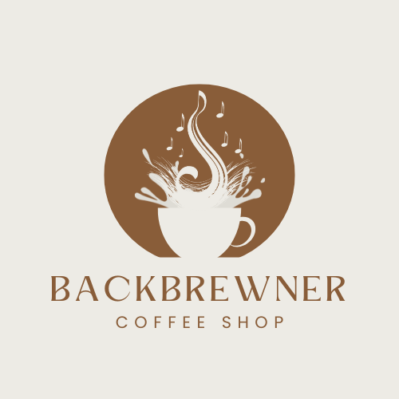

DESCRIPTION
Backbrewner Café is a chill and cozy online café concept inspired by music and self-expression. It offers a virtual space where people can explore handcrafted coffee products, learn about the café’s story, and immerse themselves in the relaxing atmosphere inspired by NIKI’s song “Backburner.” The website serves as an emotional and creative hub for coffee lovers who find comfort in both art and warmth.
MISSION
To provide a digital space where comfort, creativity, and connection blend together. Backbrewner Café aims to share the warmth of coffee culture and the emotion of music through an online platform that encourages reflection and self-expression.
VISION
To be a leading online café brand that inspires connection, creativity, and comfort — where every visitor experiences warmth, emotion, and belonging, even through a digital screen.

OBJECTIVES
- To design an interactive, user-friendly website that reflects the café’s cozy and melancholic identity.
- To promote handcrafted coffee products and merchandise online.
- To create an emotional and aesthetic digital environment inspired by music and nostalgia.
- To encourage user engagement through multimedia features such as music playlists and event updates.
- To establish an online presence that represents Backbrewner Café’s brand identity and artistic message.

PURPOSE OF THE WEBSITE
The website aims to serve as the official online platform of Backbrewner Café — introducing its concept, story, and products while offering visitors a space to connect emotionally and creatively. It bridges the café’s artistic identity with its online audience through a warm, interactive digital experience.

TARGET AUDIENCE
- Young adults (ages 16–30) who love coffee, music, and artistic experiences.
- Students and freelancers looking for online inspiration or cozy digital spaces.
- Fans of aesthetic, emotionally driven brands and lifestyle cafés.

WEBSITE GOALS
- Build brand awareness through storytelling and design.
- Provide easy navigation and an enjoyable browsing experience.
- Create emotional connection through visuals and content.

EXPECTED FEATURES
- Home Page: brief intro and featured products
- About Page: story, mission, and vision
- Menu Page: lists of drinks, meals, and products
- Events/Promotions Page: digital events or online sales

SITEMAP
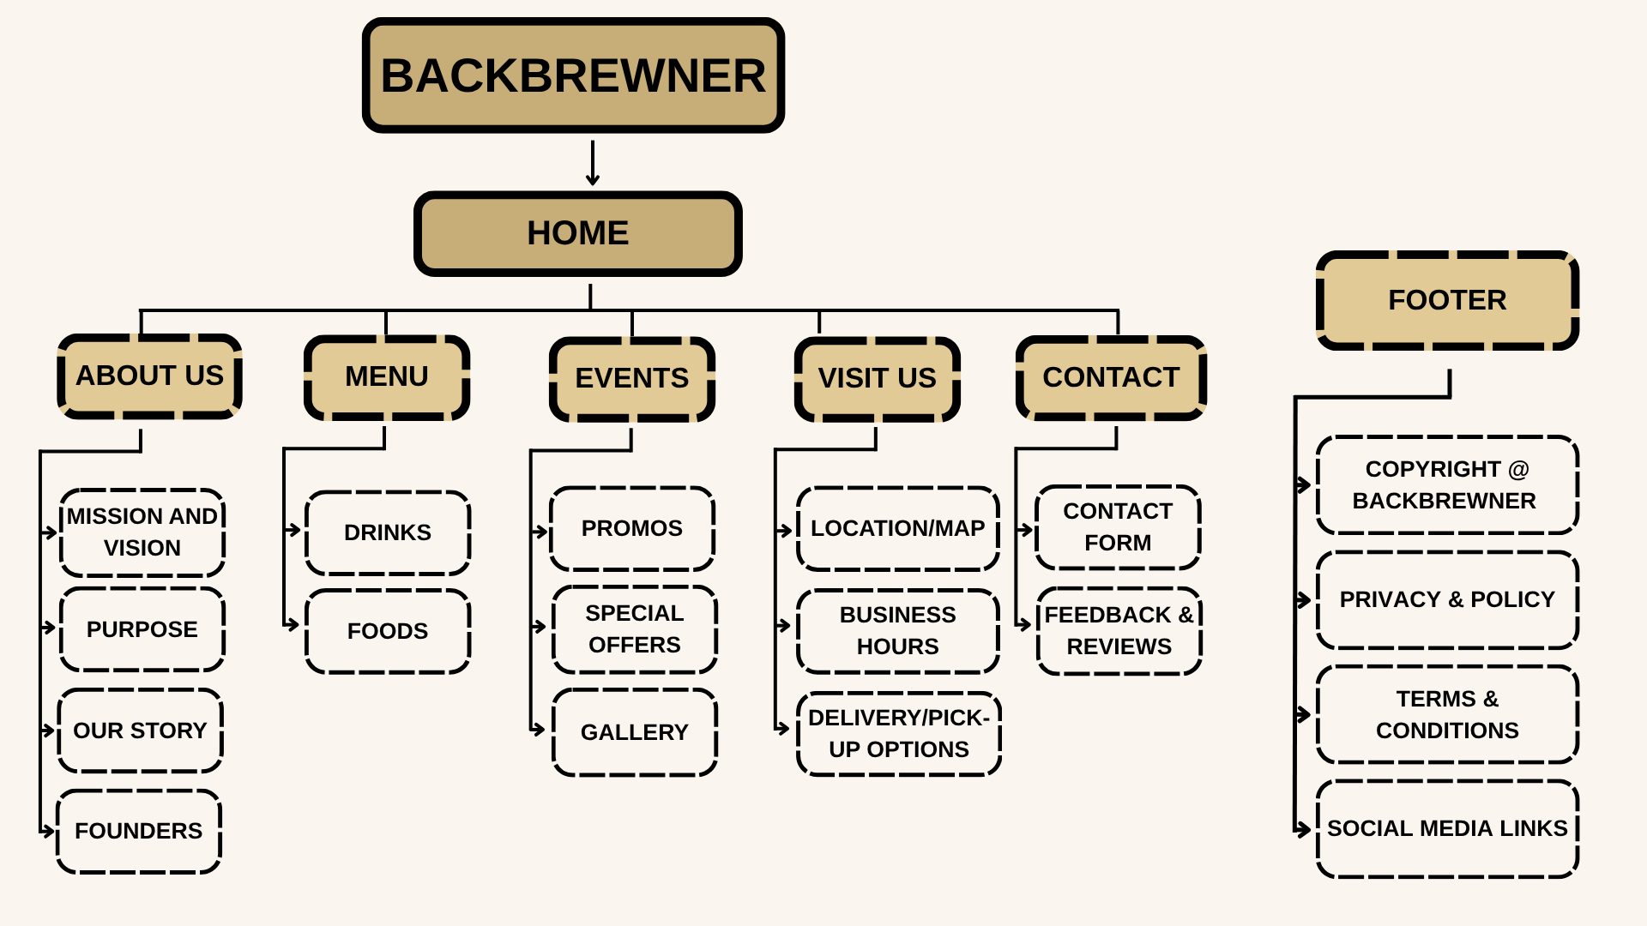

SHORT DESCRIPTION OF EACH PAGE
Home - Consists of the café’s background and a short introduction about Backbrewner Café. It welcomes visitors and gives a quick overview of what the café is all about.
About - Contains the café’s mission, vision, and inspiration behind its creation. It also shares how Backbrewner was inspired by NIKI’s song Backburner and what the café represents.
Menu - Consists of the list of drinks, pastries, and food items offered by the café. It includes best-sellers and signature blends that reflect the café’s theme.
Events - Shows the café’s latest events, activities, and special promos. This section keeps customers updated on what’s happening at Backbrewner.
Contact - Contains the café’s location, contact details, social media links, and a feedback form. It allows customers to reach out or visit the café easily.

COLOR SCHEME
- Primary: Deep Coffee Brown (#4B2E05) – warmth and comfort
- Secondary: Cream Beige (#F5E6CA) – coziness and simplicity
- Accent: Muted Blue-Gray (#8A9BA8) – emotional and melancholic tone
- Highlight: Amber (#E8B86D) – soft warmth, like light from a café lamp

TYPOGRAPHY
- Header Font: Playfair Display – elegant and nostalgic
- Body Font: Poppins or Open Sans – clean and modern for readability
- Accent Font (Taglines): Dancing Script or Great Vibes – personal and emotional touch

DESIGN JUSTIFICATION
The website’s warm color palette and soft typography evoke comfort and reflection, aligning with the emotional inspiration behind Backbrewner. The layout emphasizes storytelling, aesthetic visuals, and user comfort. Each element — from muted tones to calm spacing — is designed to make visitors feel at home, even in a digital space.

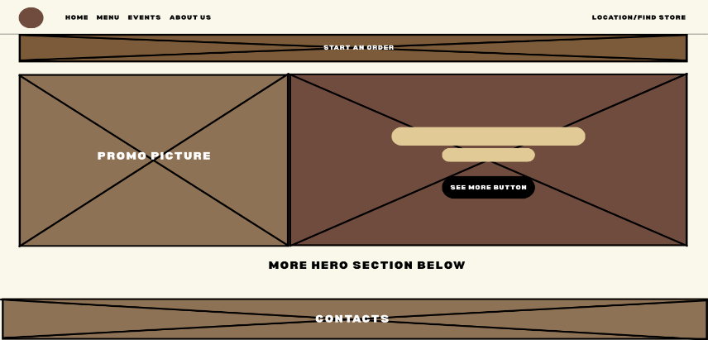
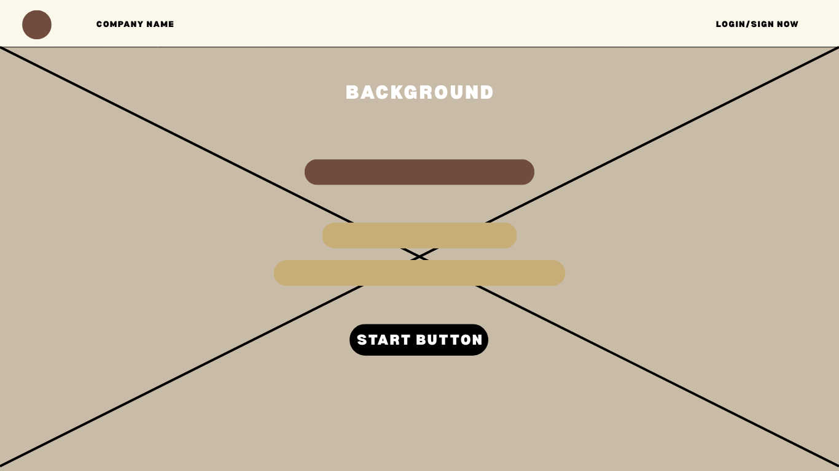
WIREFRAME IDEAS

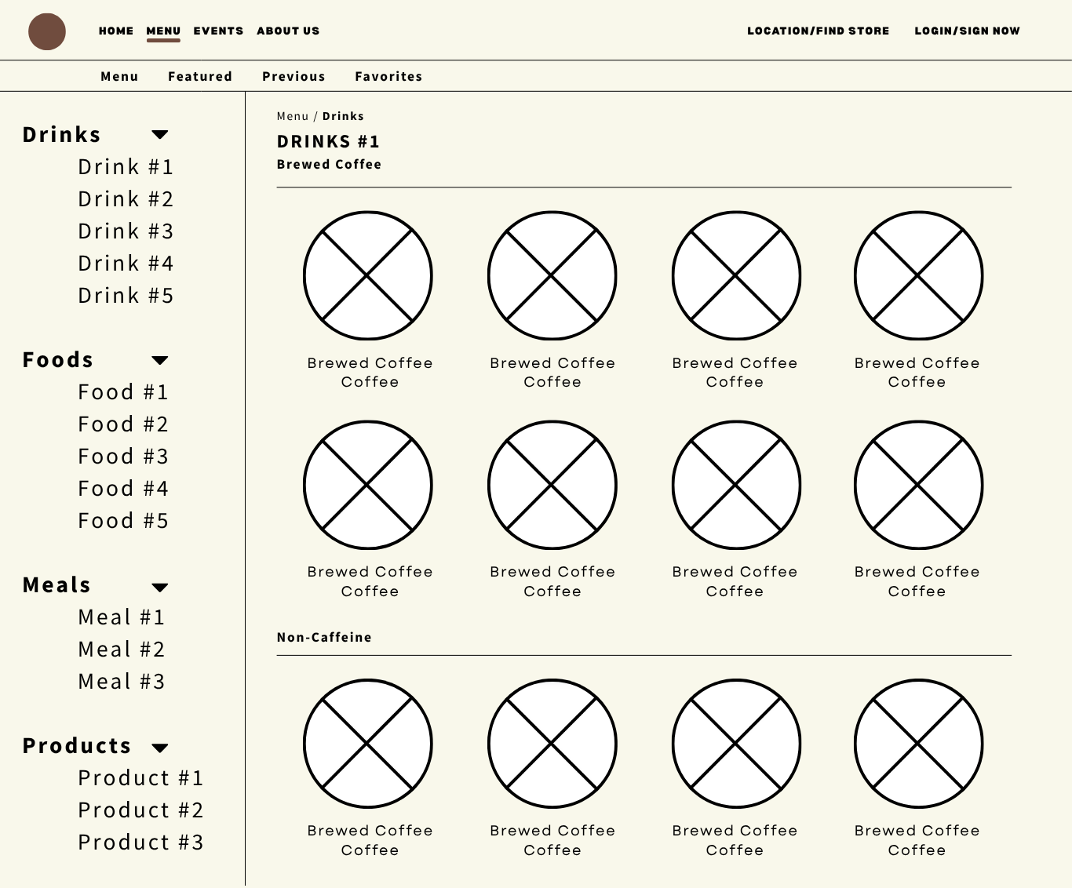

ACCESSIBILITY CONSIDERATIONS
- High text contrast for readability (dark text on light background)
- Alternative text (alt text) for images
- Keyboard navigable menus and links
- Descriptive labels for forms
- Large, readable fonts for all devices
ROLES AND RESPONSIBILITIES
MEMBER | ROLE | RESPONSIBILITIES
CAMPOMANES, JUAN MIGUEL | Web Developer | Leads the overall planning and direction of the project. Designs the website’s layout, color scheme, and logo. Ensures the project meets deadlines and aligns with the café’s brand concept.
CARUNGCONG, BENEDICT | Content Writer / Researcher | Writes and edits the website’s textual content including the company profile, mission, vision, and product descriptions. Researches design inspirations and assist in documentation.
TALAGTAG, TIMOTHY | Project Manager / Designer | Handles the website’s coding using HTML, CSS, and JavaScript. Develops the layout based on the wireframe and ensures responsiveness and accessibility. Conducts testing and revisions.
DEVELOPMENT TOOLS
- Design: Canva / Figma (for wireframes and mockups)
- Development: Visual Studio Code (HTML, CSS, JavaScript)
- Graphics: Adobe Photoshop / Canva
- Version Control: GitHub
- Testing: Google Chrome Developer Tools
GANTT CHART
Task | Description | Start Date | End Date | Duration | Person(s) Responsible
Project Planning | Brainstorm café concept and assign group roles. | Oct 7 | Oct 14 | 1 week | All Members
Sitemap Creation | Design the sitemap showing all website pages. | Oct 15 | Oct 25 | 10 days | All Members
Wireframe Design | Create the wireframe layout for each webpage. | Oct 15 | Oct 25 | 10 days | All Members
Content Development | Write page descriptions and café story. | Oct 26 | Nov 5 | 10 days | Content Writer/ Researcher
Design Phase | Design the logo. color palette, and overall website style guide | Nov 6 | Nov 15 | 10 days | Project Manager/Designer
Website Prototype | Build the sample website in HTML/CSS. | Nov 16 | Dec 5 | 3 weeks | Web Developer
Testing and Revision | Check for layout issues, links, and corrections. | Dec 6 | Dec 12 | 1 week | Web Developer/Designer
Final Report and Submission | Compile sitemap, wireframe, and final output. | Dec 13 | Dec 17 | 5 days | All Members

The Backbrewner Café website aims to strengthen the brand’s digital identity by creating a warm, interactive, and emotionally resonant online presence. Through its cozy design, engaging content, and user-friendly features, the website helps the company achieve its goal of connecting with people who seek comfort, creativity, and reflection — even in a digital space.

