ABOUT MORTALITY DATA FOR HUNGARY
By László Radnóti and Domantas Jasilionis
Last Revised: 12 April 2011

GENERAL
Before the middle of the 19th century, the collection of statistical information within the territory of Hungary was the responsibility of the statistical office of the Habsburg Empire. The first attempt to establish a national statistical office in Hungary was made in 1848. The local Statistical Department within the Ministry of Agriculture of Hungary was established in 1867 (HCSO, 2007a). The department was reorganized into the Hungarian Royal Central Statistical Office in 1887. Since the restoration of the country’s independence in 1918, the Hungarian Central Statistical Office (HCSO) has been the main governmental body collecting population data in Hungary.

Demographic data exist both in published and electronic format. Detailed information on population and vital events can be downloaded from an online database (see the link below):
http://portal.ksh.hu/portal/page?_pageid=38,119917&_dad=portal&_schema=PORTAL.

The first population census was conducted on January 1st, 1870. The next six censuses (1880, 1890, 1900, 1910, 1920, and 1930) were carried out on December 31st of the respective years. The 1941 census was conducted on January 31. The 1949, 1960, 1970, 1980, and 1990 censuses refer to January 1st. The most recent census was carried out on February 1st, 2001. The Hungarian Central Statistical Office has released census information both to the experts and the general public, in electronic form. It is also available online (see the link below):
http://www.nepszamlalas.hu

Sources of Data
Population, death, and birth count data that are used for our calculations come from the Hungarian Central Statistical Office. The reference file for Hungary provides detailed information about the sources of both the published and the unpublished data used in the Human Mortality Database (HMD).

Specific Episodes in the Demographic History of Hungary
The prohibition of abortion introduced in the early 1950s led to a sudden increase in births during 1953-1955 (Kamarás, 1996). This restriction was lifted in the second half of the 1950s.

Following a period of great improvement in general mortality (and, consequently, in life expectancy) lasting from 1945 until the mid 1960s, a specific chronic epidemiological crisis developed, culminating during the early 1990’s. The crisis is attributed to the changes brought about by the upheaval of the socio-economic (and political) regime. It was a specific one, because the mortality increase was observed mainly (although not exclusively) in the adult male population. Since 1994, life expectancy at birth has increased by a total of 4,1 years, mostly as a consequence of a decline in cardiovascular mortality. (Józan, 2008).

In October 1956, there was an armed conflict (a nationwide revolt against the Stalinist government of Hungary and its Soviet-imposed policies, lasting from October 23rd until November 10th1956) which caused numerous civilian and military deaths in Hungary. It is not clear whether all the deaths and the massive unregistered emigration after the uprising have been accounted for in the official statistics for this year. Tóth (1996) suggests that about 200,000 people left the country (legally or illegally) after the suppression of the unrest.

After the second half of the 1950s, both emigration and immigration were relatively low until 1990. During the 1990s, there were large waves of immigration from Romania (return migration of ethnic Hungarians) and the former Yugoslavia (war refugees).

TERRITORIAL COVERAGE

There were no territorial changes in Hungary during the period included in the HMD (1950-2009). Prior to 1950, however, numerous changes in boundaries took place.

DEATH COUNT DATA

Coverage and completeness
The HCSO defines death as the absence of any “sign of life (i.e. the cessation of all life-functions without the capability of revival).” The WHO definitions of a live birth and an infant death have been used for the whole period covered by the HMD.

Specific details
Since 1970, the national death statistics include all deaths that occurred in the legal resident population. Before 1970, vital statistics included deaths occurring in the present (de facto) population.

The 1956 uprising caused numerous civilian and military deaths in the country. It is not clear whether these deaths have been included in official statistics for this particular year.

POPULATION COUNT DATA

Coverage and completeness
Until 1969, the Hungarian Central Statistical Office recorded the de facto population, which refers to the population actually present at the place of enumeration at the time of the census. The de facto population does not include Hungarian citizens living abroad but does include foreign citizens staying in the country. Since 1970, the HCSO reports the resident population: the total number of persons who are registered as residents in the enumeration district (including both permanent and temporary residents), but who are not registered as temporary residents in another enumeration district.

Specific details
As noted earlier, the 1956 uprising against the Soviet Union invasion led to increases in mortality and emigration. It is not clear whether the official population estimates for 1956 fully account for these population losses.

The official population estimates are post-censal estimates. The estimates for the period 1961-2000 have been calculated based only on annual births and deaths; these data do not account for international migration. Such an approach led to notable inaccuracies in the population numbers, especially during the 1990s (for more details, see below the section entitled “Data quality issues”). International migration has been accounted for only in the most recent series of official post-censal estimates (from 2002 onwards).

The official population estimates have been used for the periods 1950-1959 and 2002-2010, while for other years (1960-2001) we calculated our own inter-censal estimates using the HMD methodology. Due to potential data quality problems, the population estimates for 1956-1959 should be used with caution.

BIRTH COUNT DATA

Coverage and Completeness
The Hungarian Central Statistical Office uses the WHO definition of a live birth: “a foetus is live-born if it gives any sign of life after birth, regardless of the length of pregnancy and the length of life after birth” (HCSO, 2007b).

Specific details
Since 1970, the national birth statistics include all live births that occurred in the legal resident population. Before 1970, vital statistics included live births occurring in the de facto population.

DATA QUALITY ISSUES

Problems with the official population estimates
The HCSO provides annual counts of deaths and population throughout the period of 1950-2006. However, for the HMD estimation of mortality surfaces, we used the official population estimates only for the periods 1950-1959 and 2002-2010.

The official population estimates are post-censal estimates. They have not been recalculated backwards based on the subsequent censuses. In addition, the official population estimates did not account for international migration during the period 1960-2001. The undercount was not significant for the 1960-1989 period (when international migration was restricted by the communist regime). However, there was a sudden increase in emigration in the late 1980s followed by waves of immigration from Romania and the former Yugoslavia in the 1990s. As a consequence, the official population estimates exhibit a drop in the total population between the pre-census year 1989 and the census year 1990 (Figure 1). Between 1999 and the census year 2000, there is a sudden increase (attributable to unregistered immigration) in the total population.

Although the official population estimates for the 1950s account for international migration, it is not clear whether these data reflect the true pattern of emigration after the suppression of the 1956 unrest.

Taking into account the aforementioned problems, we calculated our own inter-censal estimates for 1960-2001 using the HMD methodology. These newly calculated inter-censal population estimates show more plausible trends without discontinuities in total population numbers (Figure 1). However, as noted above, population estimates for 1956-1959 should be used with caution.

Figure 1. Trends in the total number of males and females. Official versus HMD population estimates, 1950-2005

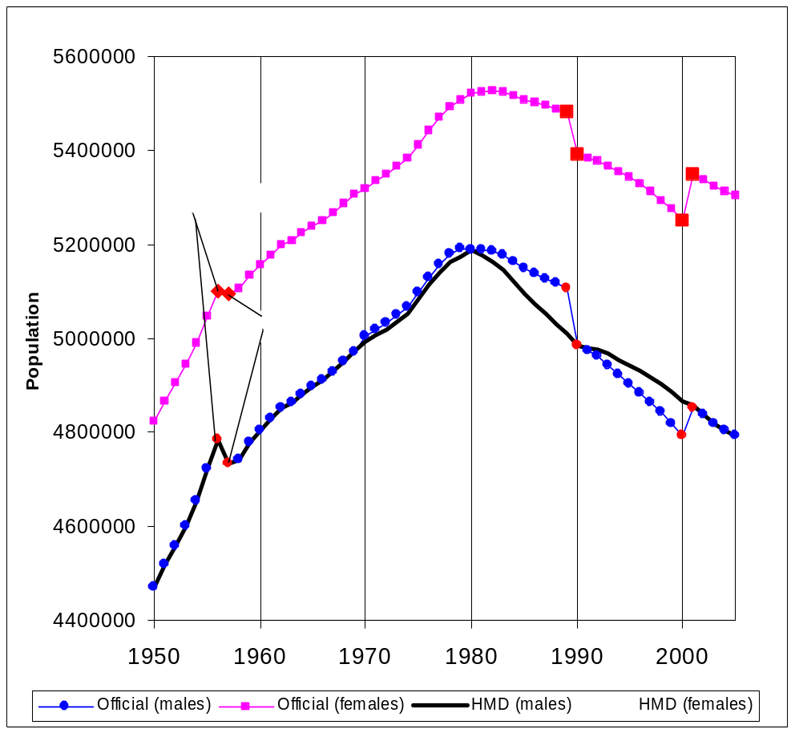

REFERENCES

Hungarian Central Statistical Office (HCSO). (2007a). Present rooted in the past. In: We are introducing the Hungarian Central Statistical Office. Retrieved 21 February 2007 (http://portal.ksh.hu/portal/page?_pageid=38,119973&_dad=portal&_schema=PORTAL).
Hungarian Central Statistical Office (HCSO). (2007b). Population, vital events. In: Methodology. Retrieved 21 February 2007 (http://portal.ksh.hu/pls/ksh/docs/eng/modsz/modsztoc.html).
Józan, P. (2008). Crisis and revival in the epidemiological development in Hungary after World War II. Published by the Hungarian Academy of Sciences, 127 p. English translation is under way.
Kamarás, F. (1996). Birth rates and fertility in Hungary. Pp. 55-88 in: Demography of contemporary Hungarian society. New York, USA: Atlantic Research and Publications, Columbia University Press.
Tóth, P.P. (1996). International migration and Hungary. Pp.139-169 in: Demography of contemporary Hungarian society. New York, USA: Atlantic Research and Publications, Columbia University Press.

APPENDIX 1:
DESCRIPTION OF DATA USED FOR LEXIS DATABASE

DEATHS
Period | Type of Data | Age grouping | Comments | RefCode(s)
1950-1989 | Annual number of deaths by sex, single year of age, and birth cohort (Lexis triangles, except for the open-ended interval) | 0, 1, 2, …, 99, 100+, UNK, TOT |  | 1
1990-2009 | Annual number of deaths by sex, single year of age, and birth cohort (Lexis triangles) | 0, 1, 2, …, 109, 110, UNK, TOT |  | 16, 17

POPULATION
Period | Type of Data | Age grouping | Comments | RefCode(s)
1950-  1959 | Annual population estimates (as of January 1st) by sex and single year of age | 0,1,…90+ | Present (de facto) population | 2
1960 | Census counts (as of January 1st) by sex and single year of age | 0, 1, …, 99, 100+, unknown | Present (de facto) population | 13
1970,  1980,  1990 | Census counts (as of January 1st) by sex and single year of age. | 0, 1, …, 99, 100+, unknown | Resident population | 13
2001 | Census counts (as of February 1) by sex and single year of age | 0, 1, …, 99, 100+, unknown | Resident population | 13
2002-2010 | Annual population estimates (as of January 1st) by sex and single year of age. | 0, 1, …, 89, 90+ | Resident population; Post-censal estimates | 6, 12, 14, 19, 20

BIRTHS

Period | Type of Data | Comments | RefCode(s)
1950-2009 | Annual counts of live births by sex |  | 3, 4, 5, 8, 15,  18

