Abstract
We explore the feasibility of smartphone-based pH measurement using a colorimetric dye indicator deposited on paper substrates for physiological screening applications, where pH-dependent absorbance changes are quantified through single-channel (red-channel) intensity measurements. Using flat-field imaging data within a radiometric modeling framework, we model and decompose the dominant noise sources associated with the smartphone-based imaging system, including illumination and geometric contributions, and show that intrinsic camera noise is not the primary limiting factor. Instead, residual variability is dominated by spatial texture and illumination stability, indicating that with appropriate control of illumination, geometry, and dye coating consistency, smartphone imaging platforms are capable of supporting the accuracy and precision required to meet UNICEF target specifications for neonatal pH screening.
- Introduction
The concentration of hydronium ions, commonly referred to as pH, in aqueous solutions plays a vital role in assessing health and quality across diverse fields, from plant growth and aquatic ecosystems to human physiology, food processing, and industrial manufacturing [1]. Broadly speaking, pH is measured using one of two prevalent technologies: electrochemical probes or pH dye-indicator paper strips. Electrochemical probes can achieve resolutions as fine as 0.001 pH units and are generally considered the gold standard in pH measurement. However, these probes come with several drawbacks: they are delicate, require regular calibration and maintenance, and are expensive and complex to operate [2]. In contrast, paper strips are coated or embedded with pH-sensitive dyes that change color depending on the solution's pH. Users then compare the color observed on the strip to a manufacturer-provided color standard or reference chart corresponding to specific pH values. While paper-based pH sensors are lauded for their cost-effectiveness, simplicity, and repeatability, their effective resolution is constrained by the observer’s just-noticeable-difference (JND) perceptual threshold, and are typically used for qualitative assessment [3].
Recently, machine-learning algorithms and AI-based image analysis have been applied to paper-based pH sensors, achieving quantitative resolutions of approximately ±0.05–0.15 pH units [4]. In these studies, the image data are usually stored as .jpeg or .png files that have undergone proprietary in-camera processing steps intended to enhance picture quality. Unfortunately, these same processing steps, such as tone mapping, white balancing, and gamma correction, alter pixel intensities from the sensor’s native linear response, thereby sacrificing accuracy for aesthetics, introducing additional noise and bias into scientific analysis. To standardize the resulting color data, most authors apply color-space transformations (e.g., RGB → HSV or L*a*b*), which reorganize color information but cannot eliminate distortions introduced by the imaging pipeline, nor those arising from camera-specific or illumination artifacts. Subsequent machine-learning models are then trained to compensate for the compounding effects of multiple sources of variability.
Our interest in this topic stems from the critical need for a low-cost, easy-to-use screening tool for neonatal hypoxic ischemic encephalopathy (HIE). HIE is a brain injury caused by oxygen deprivation around the time of birth. Without prompt intervention, it can lead to lifelong disabilities such as cerebral palsy, seizures, developmental delays, impaired motor function, learning difficulties, and even death. HIE, often referred to as birth asphyxia, is estimated to account for approximately 23% of global neonatal deaths, with the vast majority occurring in low- and middle-income countries (LMICs) [5]. A hallmark physiological response to HIE is metabolic acidosis, often reflected by a plasma pH below 7.1, indicating severe hypoxia and impaired cellular respiration. In economically developed societies with well-resourced and staffed neonatal care units, arterial cord blood gas analysis is routinely performed to assess acid-base status and screen for HIE, enabling timely therapeutic intervention. However, in low-resource settings, the tools and expertise required to perform such analyses are generally unavailable. This disparity underscores the urgent need for low-cost, scalable, and robust alternatives to conventional blood gas analysis, particularly those that can operate in resource-limited environments without sacrificing screening utility.
A paper-based pH sensor intended for physiological measurements, whether for routine acid–base assessment or high-stakes applications such as neonatal HIE screening, must satisfy both regulatory analytical standards and practical point-of-care requirements. Under the 2025 Clinical Laboratory Improvement Amendments (CLIA) proficiency testing guidelines for blood gas analysis, the total allowable error (TAE) for pH is ±0.04 pH units, establishing the benchmark for accuracy; that is, how close a measurement must be to the true value [6]. The UNICEF Target Product Profile (TPP) for neonatal diagnostic tools aligns with this requirement by specifying a target accuracy of ±0.04 pH units, but it goes further by imposing a more stringent precision requirement: repeated measurements must fall within ±0.01 pH units of each other [7].
Yet, from the aforementioned literature review, it is clear that existing ML models based on color-space transformations fall short of the required accuracy and precision. Here, we argue that much of this error originates before the machine-learning stage, specifically during data acquisition and normalization, where in-camera image processing, illumination variability, and inconsistent color correction introduce distortions that downstream models cannot fully compensate for. In this work, we use mathematical modeling to guide the optimization of the data collection and normalization. Our goal is to reduce pre-ML variability to a level where machine-learning algorithms can meet clinically meaningful performance requirements. Table 1 summarizes key target performance parameters for a paper-based pH sensor system intended for physiological measurements.
Table 1: Key Target Parameters for a paper-based physiological pH screening tool
Parameter | Target Specification | Rationale / Source
Physiological pH range | 6.9 – 7.45 | Encompasses clinically relevant deviations; healthy blood pH ≥ 7.35
Accuracy | ± 0.04 pH units | Clinical Laboratory Improvement Amendments (CLIA) guideline [6]
Precision | ± 0.01 pH units | Required for reliable screening and trend detection [6,7]
Non-recurring cost | < $100 | Meets minimum (not optimal) cost targets for low-resource deployment [7]
Recurring cost (per test) | < $1.50 | Meets minimum (not optimal) cost targets for consumables [7]
Power requirements | Rechargeable batteries permitted | Acceptable for point-of-care operation in low-resource settings [7]
Form factor | Small tabletop footprint | Compatible with clinic and GP-office environments [7]

- Method

  - System Design Considerations

In principle, many of the challenges associated with paper-based pH sensing could be resolved with high-performance laboratory equipment. A scientific-grade imaging detector, a temperature-stabilized integrating sphere, narrow-bandwidth illumination, and highly purified indicator chemistry would presumably yield a measurement system with minimal variability and a nearly deterministic relationship between absorbance and pH. Under such conditions, a simple analytical model should be sufficient to recover pH without the need for machine-learning correction. However, this level of instrumentation is incompatible with the cost, portability, and usability requirements of a point-of-care screening tool intended for use in low-resource settings. As a result, our design must consider a cost–performance trade-off: rather than eliminating all sources of variability through expensive hardware, we aim to minimize the most consequential extrinsic noise sources while maintaining low device complexity and low manufacturing and operational cost. Within this constrained design space, machine learning may serve as a practical complement, not a replacement, for good physical modeling, providing robustness against residual variability that cannot be engineered away.
Related strip-based diagnostics illustrate this trade-off well. In lateral flow immunoassays, for example, high-performance optical readers have been developed to achieve quantitative measurements, incorporating scientific CMOS or CCD detectors, narrow-band LED illumination, and engineered optical pathways that substantially reduce extrinsic variability [8]. These systems demonstrate that, with sufficiently sophisticated hardware, strip-based assays can achieve high levels of quantitative precision. However, no analogous high-accuracy readers have been developed for pH indicator papers, likely because quantitative pH measurement is typically performed using solution-phase spectrophotometry rather than solid-phase substrates. This absence further motivates a modeling-guided, low-cost design strategy specifically tailored to the constraints of physiological pH sensing.

  - Imaging Platform

2.2.1 Integrating Sphere, Camera, and Illumination

The camera on the Google Pixel 3 smartphone was selected as a sensor component of the imaging platform because smartphones offer a practical balance of cost, availability, and imaging capability suitable for point-of-care diagnostics [9]. Modern devices support RAW image capture, allowing access to linear sensor data and avoiding proprietary in-camera processing steps that distort pixel intensities. However, smartphones are not standardized instruments: different models use different sensors, Bayer filters and patterns, and spectral responsivities, and they exhibit limited full-well capacity and nonlinear response near saturation. These characteristics require controlled illumination, stable geometry, and normalization procedures to reduce device-specific variability.
To mitigate these effects, the platform, shown in Figure 1, illuminates the paper-based pH sensor with a narrow-band LED matched to the dye indicator’s absorption peak and housed within a low-cost, 3D-printed diffuse-illumination chamber. Although not an optical-grade integrating sphere, the chamber provides sufficiently uniform, geometry-independent illumination while remaining compatible with fabrication on low-cost FDM printers commonly available in low-resource settings. This design suppresses illumination-geometry artifacts that would otherwise contribute to pre-ML variability.
Under narrow-band illumination, the measured signal is dominated by the dye’s reflectance at the LED’s peak wavelength rather than by the full spectral response of the camera. Imaging both the unadulterated paper-based pH sensor and the sensor after exposure to a buffered solution, and forming their intensity ratio, cancels multiplicative factors such as LED output, exposure time, and channel gain. These steps substantially reduce inter-device spectral sensitivity, with remaining variation addressed at the modeling stage rather than through hardware standardization.
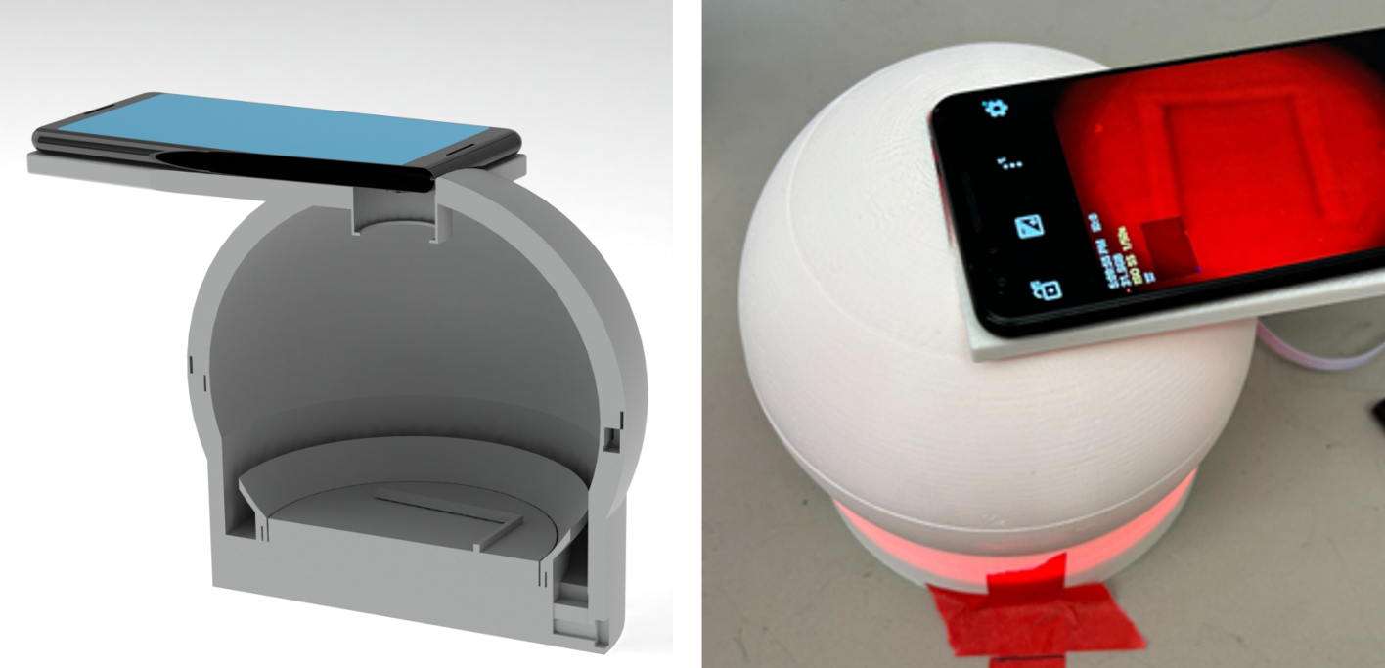
Figure 1. Imaging platform. Left: Cutaway model of the low-cost, 3D-printed diffuse-illumination chamber. A ring of LEDs is housed in a recessed trough at the base, and the overhanging flange blocks direct line-of-sight between the LEDs and the smartphone camera. Half of the locating rails for the paper-based pH sensor is shown at the base of the cutaway model. Right: Fully assembled system illuminated by AlInGaP LEDs. The smartphone display shows the internal mounts used to position the paper-based pH sensor.

2.2.2 Image Acquisition Software

The camera used on the Pixel 3 has a 12.2-megapixel imaging sensor. The platform on top of the light fixture was designed to accommodate the Pixel 3 camera position. Other smartphones may be used, but may require platform modifications for different camera locations. The Android application Open Camera was used to control exposure time, acquire multiple sequential images for signal averaging, and capture the imaging data in RAW (.dng) format. This format is minimally processed, thus preserving the original 10-bit digital data depth per color channel. The Python module Rawpy was used to import the imaging data for further downstream data processing.

2.2.3 Illumination Uniformity and Sensor Stability

To characterize system-level measurement variability, we quantified the spatial non-uniformity of the imaging platform by imaging a traceable diffuse reflectance reference (Labsphere®) positioned at the location normally occupied by the paper-based pH sensor. RAW images were acquired using the smartphone camera, and a Python-based analysis pipeline was used to quantify spatial non-uniformity in the resulting digital-number maps [10]. Figure 2 shows a representative monochrome RAW image of the reflectance standard acquired at an electronic shutter speed of 1/50 s, while Figure 3 presents the corresponding spatial distribution of digital numbers extracted from this image.
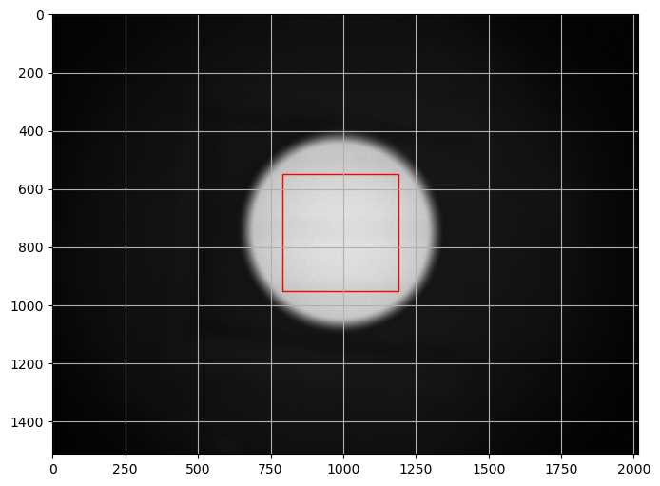
Figure 2: Image of diffuse reflectance standard used to quantify non-uniformities within the imaging platform.
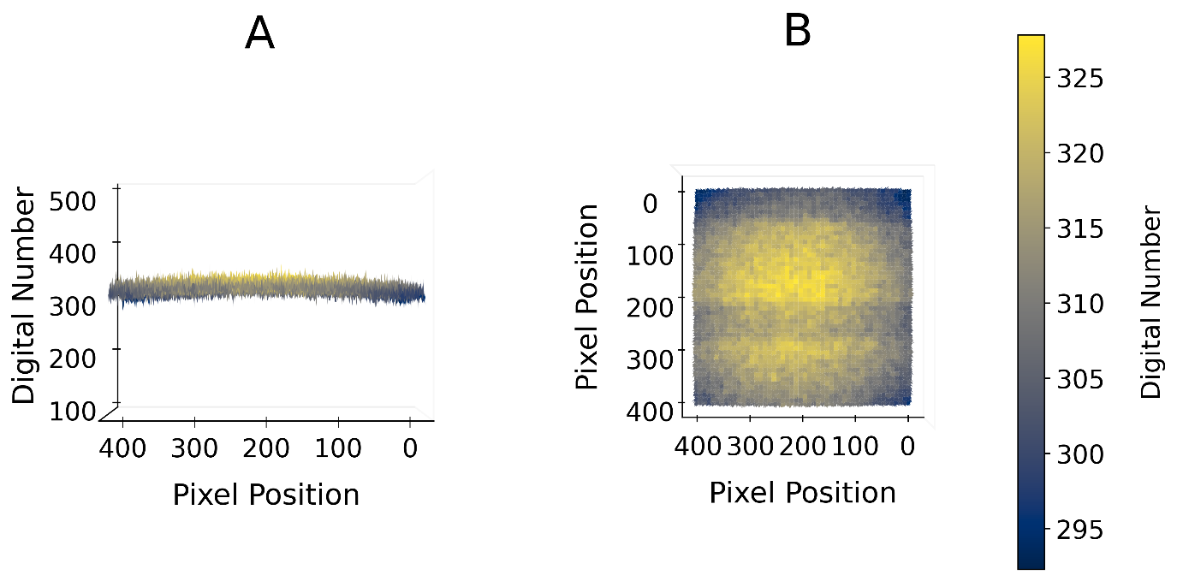
Figure 3: RAW digital number data (single channel) of the diffuse reflectance standard.
This analysis revealed three separable components of non-uniformity:
(1) a high-frequency residual containing deterministic structure from the reference microtexture and sensor fixed-pattern behavior, together with stochastic shot- and read-noise;
(2) a mid-frequency rolling-shutter banding pattern generated by the interaction between CMOS row-wise readout and the pulse-width modulation driving the LED illumination;
(3) a low-frequency illumination curvature arising from the 3D-printed illumination chamber geometry.
The high-frequency variance for this system is modeled as:
$$σ_{HF}^{2}(N)={(σ}_{T}^{2}+σ_{F}^{2})+\frac{\left(σ_{shot}^{2}+σ_{read}^{2}\right)}{N},$$
where the first set of terms ($σ_{T}^{2}$ and $σ_{F}^{2}$) represents deterministic variance from reference texture and sensor fixed-pattern structure. The second set of terms ($σ_{shot}^{2}$and $σ_{read}^{2}$) represent the stochastic variance due to photon shot noise and sensor read noise. Only the stochastic terms are reduced through frame averaging, decreasing with $1/\sqrt{N}$, where $N$ is the number of images to be averaged or stacked.
The second component, the mid-frequency rolling-shutter banding pattern, can also be treated as a stochastic artifact, as the position and amplitude of the band vary between frames depending on the relative timing of sensor readout and LED modulation. As a result, this component is also reduced by stacking. Figure 4 shows the uniformity after averaging 5 consecutive frames. While the impact of stacking on the high-frequency residual is subtle, indicating that a substantial fraction of this variance is deterministic, it is clear that rolling-shutter banding is strongly suppressed by frame averaging. The quantitative non-uniformity values with and without stacking are listed in Table 2.
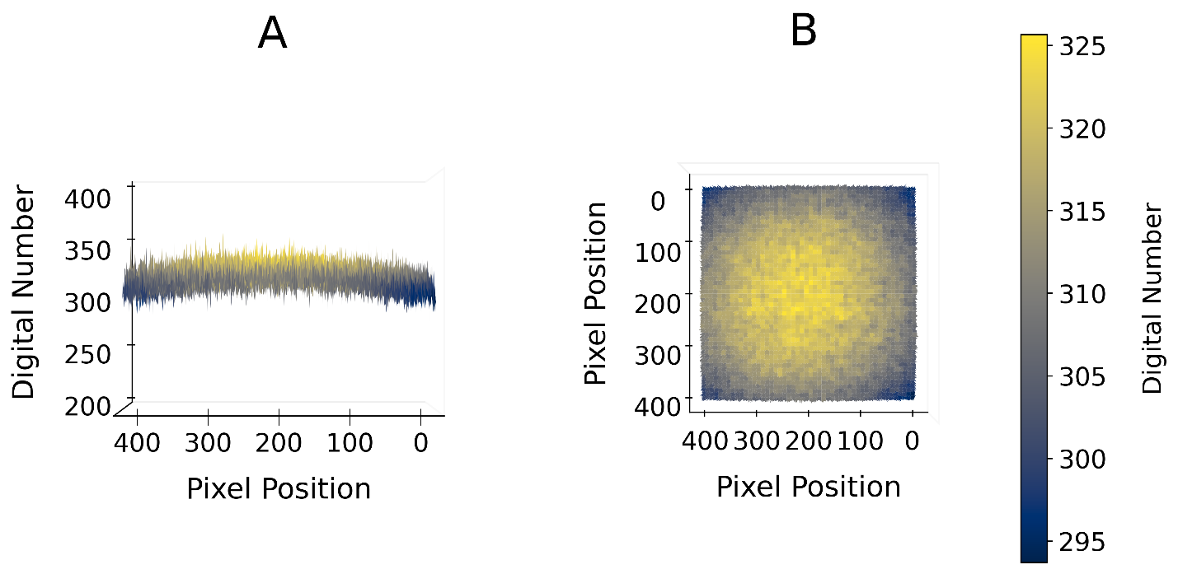
Figure 4: RAW digital number data (single channel) of the diffuse reflectance standard averaged with five frames.
Table 2: Spatial Non-Uniformity Components of the Imaging Platform
Non-uniformity Component | Quantitative Metric (Before Stacking) | Quantitative Metric (After 5-Frame Stack) | Dominant Origin | Mitigation Approach
Low-frequency illumination curvature | 12.37 DN peak–to–trough (3.94% of mean) | 12.35 DN (3.94% of mean) (unchanged) | Chamber geometry | Pixel-wise ratio of unexposed and exposed sensor images (cancels multiplicative shading)
Mid-frequency rolling-shutter banding | 8.86 DN (2.82% of mean) | 3.30 DN (1.05% of mean) (63% reduction) | CMOS readout × LED modulation | Multi-frame stacking; selection of favorable exposure conditions
High-frequency residuals | 9.35 DN (2.98% of mean) | 8.38 DN (2.67% of mean) (~10% reduction) | Microtexture (deterministic) + stochastic shot/read noise | Stacking reduces stochastic component; remaining deterministic texture suitable for light smoothing
The remaining component, a dominant low-frequency curvature, is observed across the measurement region, producing a smooth, symmetric intensity gradient with a maximum near the center of the field of view. Such curvature is consistent with camera-side shading effects, non-ideal diffuse illumination within the cavity, or a combination of both. Regardless of origin, the effect is stable under fixed geometry and illumination, indicating a deterministic, multiplicative non-uniformity rather than stochastic noise, and is therefore well suited to ratiometric normalization. This behavior is consistent with the use of low-cost components such as smartphone optics and a non-optical-grade illumination cavity.
With the optical platform defined, selecting an appropriate pH indicator becomes critical, as the dye’s absorbance spectrum is a key contributor to signal acquisition quality, noise susceptibility, and the achievable measurement accuracy under narrow-band illumination.

2.4 Indicator Dye Selection

We evaluated three commercially available indicators whose absorbance spectra vary with pH across the physiological range: bromothymol blue (absorption peaks at ~427 nm and ~616 nm), [11] phenol red (absorption peaks at ~430 nm and ~558 nm), [12] and neutral red (absorption peaks at ~545 nm and ~450 nm) [13]. Each dye offers favorable attributes such as solubility, moderate-to-low toxicity, and reasonable molar absorptivity, but their spectral properties relative to blood differ significantly.
Hemoglobin introduces substantial complications in reflectance-based physiological pH measurements through its main Soret band (~415 nm) and secondary absorption peaks between 540–580 nm [14]. Capillary samples obtained via heel prick typically contain a mixture of oxyhemoglobin and deoxyhemoglobin, further increasing variability across this spectral region. A systems-level approach, therefore, favors indicators whose pH-responsive absorption features minimize spectral overlap with hemoglobin. Among the dyes evaluated, bromothymol blue provides the most favorable option, with a pH-responsive peak near 616 nm where hemoglobin absorption, although not absent, is substantially reduced compared to the 540–580 nm band.
Accordingly, our design relies on the hyperchromic response of bromothymol blue at 616 nm, with changes in peak intensity captured by the smartphone camera’s red channel under controlled narrow-band red LED illumination.
  - pH Sensor Fabrication

Three grams of PVA is added to 50 mL of de-ionized water. The mixture is stirred and heated to 50 °C until a clear colorless solution is formed. 180 mg of the non-ionic surfactant is added to the solution; this mixture is stirred for 10 minutes at room temperature. 50 mL of the Bromothymol Blue solution is then added to the solution and stirred at 50 °C for 15 minutes, resulting in a dark blue-green uniform solution.
The core pH sensor is made by manually dip-coating a Micro Essential 235 paper approximately 2- inch wide x 3-inch long into the solution containing PVA, Bromothymol Blue, and Tween 20 surfactant. The coated paper is hung-to-dry under ambient conditions for 48 hours, and then left for an additional two weeks to allow atmospheric CO₂ to equilibrate with the hydrated PVA matrix until a stable baseline color is achieved. A. During this prolonged storage period, the coating color reproducibly transitions from dark green to a consistent yellow, after which no further perceptible color change is observed.
Figure 5 shows a typical coated paper after achieving color stability. The reflectance spectrum indicates a slight absorption gradient from top to bottom, consistent with dip-coating deposition. The assembled
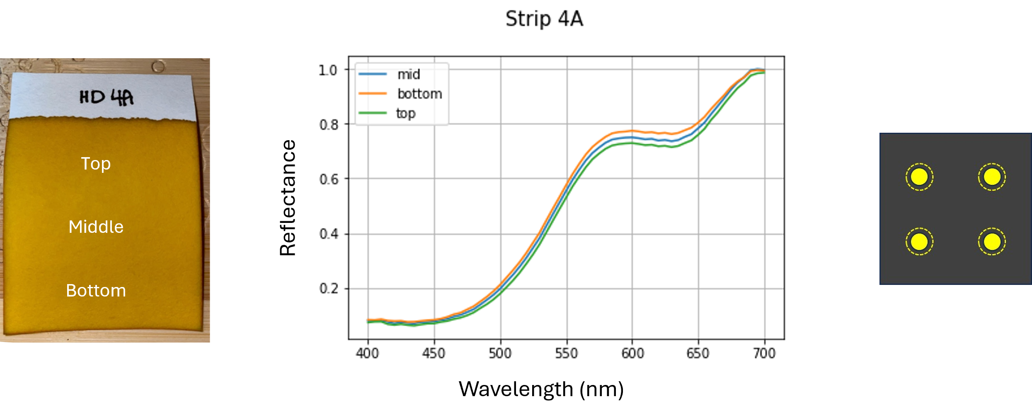
Figure 5 Left) Dip-coated paper after color stabilization under ambient CO₂ equilibration. Middle) Reflectance spectra from top, middle, and bottom lateral positions illustrating a modest but systematic absorption gradient. Right) Fully assembled pH sensor depiction consisting of four matched 3 mm sensing elements mounted on a laser-cut black substrate.

pH sensor, depicted on the right-side of Figure 5, consists of two components; Midnight Black paper laser cut to 1 inch-square with four 2 mm diameter apertures, and four 3 mm diameter pH sensors punch-cut from the coated sensor paper. As a consequence of the absorption gradient, care is taken to obtain sets of 3 mm sensors along the same lateral position. This approach ensures that within-sensor variability is dominated by measurement noise rather than coating non-uniformity. The 3 mm pH sensors from each set are then taped to the black paper, resulting in a final assembly.

- Smartphone-Based Optical Model

The radiometric-based pH measurement used in this work can be expressed as a wavelength-integrated optical model in which the recorded digital number (DN) is proportional to the product of the illumination spectrum, the pH-dependent dye transmittance, and the spectral responsivity of the camera sensor. Under controlled illumination and fixed imaging geometry, the forward model is given by
$$DN∝ \int{S_{LED}}\left(λ\right){ T}_{dye}\left(λ, pH\right){ R}_{cam}\left(λ\right) dλ$$
where $S_{LED}$ represents the LED’s spectral power distribution, $T_{dye}$ the pH-dependent dye transmittance, and $R_{cam}$ the spectral responsivity of the camera’s red channel. The following subsections describe the constituent components of this model, the resulting DN–pH mapping and its associated uncertainty, and the implications of dye concentration on measurement sensitivity.

  - Model Inputs and Spectral Overlaps

Figure 6 illustrates the spectral components in the forward model. The model combines three wavelength-dependent inputs: the pH-dependent transmittance of the indicator dye, the spectral power distribution of the LED illumination source, and the spectral responsivity of the smartphone camera’s red channel. The overlap of these components defines the wavelength weighting that underpins the mapping between pH-dependent transmittance changes and measurable variations in digital number (DN) under controlled illumination and fixed imaging geometry.
The spectral components shown in Fig. 6 were obtained through a combination of modeling, direct measurement, and published characterization data. The pH-dependent absorbance spectra of the indicator dye were generated using a modeled equilibrium response and converted to transmittance for use in the radiometric formulation. The LED spectral power distribution was measured directly under operating conditions using an Ocean Optics spectroradiometer. The spectral responsivity of the camera’s red channel was obtained from published smartphone camera characterization data provided by Ohtera Laboratory and released under a Creative Commons Attribution (CC BY 4.0) license [16]. Together, these independently derived inputs define the wavelength weighting used in the radiometric model.
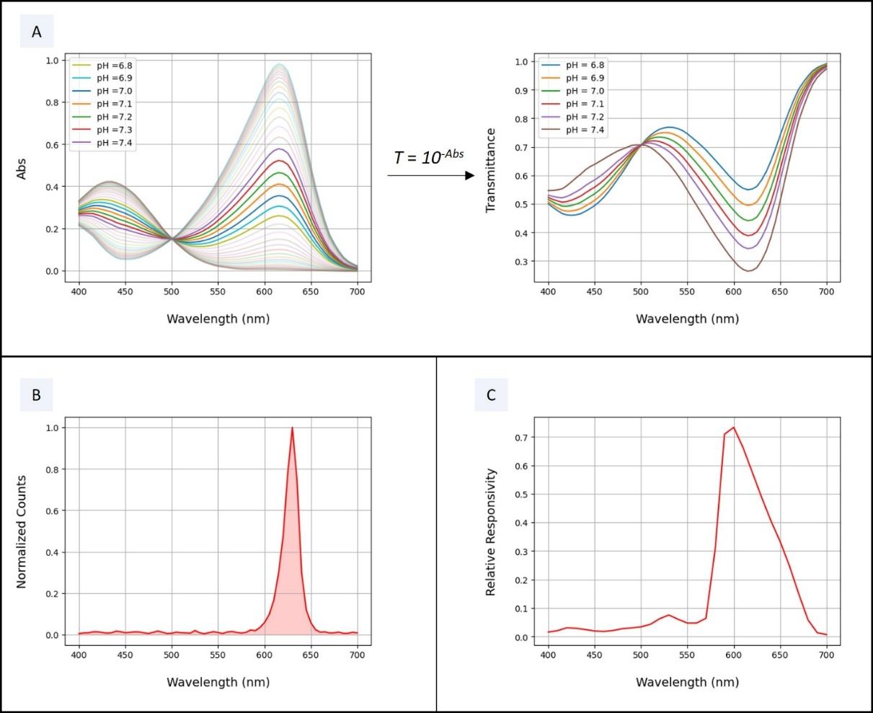
Figure 6: Spectral components of the radiometric measurement model. A) Modeled pH-dependent absorbance spectra of the indicator dye and corresponding transmittance across the physiological pH range [17]. B) Measured spectral power distribution of the LED illumination source, acquired using an Ocean Optics spectroradiometer [18]. C) Spectral responsivity of the Pixel 3 smartphone camera’s red channel [16].
As previously indicated, the radiometric model uses published solution-phase indicator spectra as a first-order representation of bromothymol blue absorbance behavior (Figure 6A). In the fabricated sensor, however, the dye resides in a hydrated polymer–cellulose microenvironment that can induce shifts in effective $λ_{max}$, band shape, and peak amplitude through solid-state and solvatochromic effects. As a result, small systematic offsets between the modeled and measured DN–pH response are expected. Accordingly, the model is treated as a physics-guided approximation that captures sensitivity, slope, and noise propagation, while experimental calibration establishes the final DN–pH mapping.
Although the present implementation uses a Pixel 3 smartphone, prior studies have shown that the spectral responsivities of red channels across a wide range of smartphone cameras are highly similar. In particular, Tominaga reported only modest inter-device variation across twenty different smartphone models, with differences dominated by overall gain rather than wavelength-dependent structure [19]. This observation suggests that the wavelength weighting in the radiometric formulation used by our model may not be specific to a single device.

  - Camera pH Response with Platform Variability

The spatial non-uniformities quantified in Section 2.2.3 define the dominant contributors to measurement uncertainty arising from the imaging platform. In this section, these effects are isolated and interpreted independently of any variability associated with the pH sensor itself, establishing an imaging-only error budget that provides a lower bound on achievable measurement precision under nominal operating conditions. While peak-to-trough metrics as reported in Table 2 are useful for visualizing spatial structure during platform characterization, uncertainty estimates here are expressed using RMS-equivalent measures that are more appropriate for error propagation; full metric definitions and calculations are provided in the accompanying repository [10].
As summarized in Table 3, three principal components contribute to the observed digital-number (DN) variability: a low-frequency illumination curvature driven by chamber geometry, a mid-frequency rolling-shutter banding artifact arising from the interaction between CMOS row-wise readout and LED modulation, and a high-frequency residual composed of target texture, sensor fixed-pattern structure, and stochastic shot and read noise. These components exhibit distinct statistical behavior: the mid-frequency banding term varies between frames and is effectively suppressed through modest multi-frame averaging, while the high-frequency residual is only partially reduced, reflecting a substantial deterministic contribution. In contrast, the low-frequency illumination curvature is stable across frames and is not reduced through stacking. Taken together, these terms yield a bounded residual uncertainty on the order of a few DN prior to any ratio-based normalization. This analysis demonstrates that intrinsic camera noise is not the dominant precision-limiting factor; rather, residual error is governed by structured, repeatable variability introduced by illumination and imaging geometry, motivating subsequent normalization addressed in later sections.
Noise Category | Conservative Metric Used | DN Contribution (RMS) | Basis / Interpretation
Low-frequency curvature | Max p95–p5 curvature span across sampled windows | 4.38 DN | Worst-case spatial curvature observed across the field of view; represents deterministic low-frequency shading over a 30×30 ROI.
Row-correlated banding (mid-frequency) | Stacked profile RMS (Method 2, conservative) | 0.628 DN | Conservative residual row-structured error after stacking; includes baseline ripple and banding overlap without assuming separability.
High-frequency / pixel-scale noise | Reported DN noise across 5 frames | 1.117 DN | Robust frame-to-frame uncertainty of the reported 30×30 masked mean after detrending and debanding.
Total combined DN uncertainty | Quadrature sum of independent components | ≈ 4.6 DN | Overall conservative uncertainty in reported DN, dominated by low-frequency curvature.
Table 3: Pre-Ratio Conservative Noise Budget for Reported DN

3.3 Modeled DN–pH Relationship and Uncertainty Propagation
To establish the relationship between pH and reported digital number (DN), modeled DN values were generated by combining the measured spectral power distribution of the illumination source with the modeled absorbance response of the pH indicator dye. Specifically, the modeled DN at each pH value represents the expected camera response to the illumination spectrum after spectral modification by the indicator dye, independent of camera optics, sensor non-uniformity, or illumination geometry. This modeling framework isolates the spectral and chemical components of the measurement from imaging-system effects.
For consistency with standard calibration practice and to enable straightforward uncertainty propagation, the modeled DN values were fit using a linear model over the physiological pH range of interest (6.8–7.4). The linear fit is intended as a local approximation to the underlying spectral response rather than a complete physical description of dye behavior. As shown in Figure X, the modeled DN values follow an approximately linear trend with small but systematic deviations from the fitted line.
3.3.1 Imaging-System Uncertainty
Uncertainty associated with the imaging platform was quantified independently and reflects the combined contribution of curvature, residual row-correlated banding, and high-frequency pixel-scale noise. These effects arise from the camera sensor, illumination geometry, and acquisition pipeline, and are expressed as an RMS-equivalent DN uncertainty. Under the assumption of fixed geometry, stable illumination, and repeatable camera response, these imaging-system contributions are deterministic in structure and may be substantially mitigated through ratiometric normalization. The resulting imaging-platform uncertainty is shown in Figure 7 as ±2σ error bars about the linear DN–pH model.
3.3.2 Linear-Model Deviation as an Irreducible Uncertainty Term
In addition to imaging-system effects, the modeled DN values exhibit residual deviation from the linear fit. These deviations arise from the intrinsic spectral interaction between the illumination source and the indicator dye and reflect mild nonlinearity in the DN–pH mapping over the selected range. Unlike imaging-system effects, this deviation is not associated with spatial non-uniformity or multiplicative gain variation and therefore persists independent of ratiometric correction.
The deviation from the linear fit was quantified as the root-mean-square (RMS) of the residuals between the modeled DN values and the fitted line. This quantity is treated as a model-mismatch uncertainty term and represents an irreducible contribution to the total DN uncertainty under a linear calibration assumption. The combined effect of imaging-system uncertainty and linear-model deviation is shown in Figure 7 as a second set of ±2σ error bars.
3.3.3 Combined DN Uncertainty
The total DN uncertainty is computed by combining the imaging-system uncertainty and the linear-model deviation in quadrature:
$$σ_{DN}=\sqrt{σ_{img}^{2}+σ_{fit}^{2}},$$
where $σ_{img}$denotes the RMS imaging-system uncertainty and $σ_{fit}$denotes the RMS deviation from the linear DN–pH fit. Expanded uncertainty bounds are obtained by scaling this quantity by a factor of two to represent a 95% confidence interval.
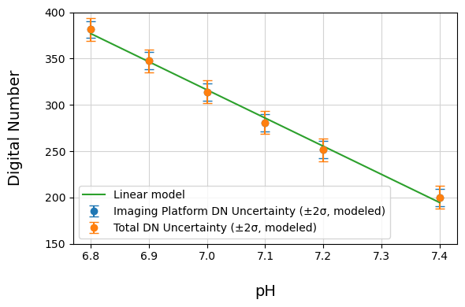
Figure 7: Modeled DN as a function of pH with linear fit. Error bars indicate ±2σ uncertainty from the imaging platform alone and from the combined imaging platform and linear-model deviation. The latter reflects intrinsic spectral-model mismatch that is not mitigated by ratiometric correction.
3.3.4 Mapping DN Uncertainty to pH Uncertainty
To express the resulting uncertainty in units of pH, the DN uncertainty is propagated through the linear calibration slope $m=∣\frac{d DN}{d pH}∣$:
$$Δ{pH}_{2σ}=\frac{2 σ_{DN}}{m}.$$
This mapping provides a direct estimate of pH accuracy under the combined effects of imaging-system noise and linear-model mismatch. Importantly, while ratiometric processing can substantially reduce imaging-system contributions, it does not mitigate deviation from the linear DN–pH model. As a result, the linearization error becomes a dominant contributor to total uncertainty once imaging effects are suppressed.
For context, clinical screening requirements specify a pH accuracy of ±0.04 at the two-standard-deviation (95%) confidence level. The pH uncertainty derived above is therefore evaluated against this criterion. As shown in Figure 7, imaging-system uncertainty alone remains below this threshold, while inclusion of deviation from the linear DN–pH model brings the total uncertainty close to the ±0.04 pH limit. This comparison highlights the importance of suppressing imaging-related contributions and motivates algorithmic strategies that reduce system-level uncertainty.
3.3.5 Implications for Algorithm Design
The uncertainty analysis presented here motivates the use of ratiometric processing to reduce imaging-system contributions to the error budget, ensuring that spatially structured, multiplicative effects do not dominate the reported pH uncertainty. At the same time, the persistence of linear-model deviation highlights the limitations of a purely linear calibration and defines the ultimate accuracy bound achievable under this assumption. Together, these considerations establish a clear framework for interpreting modeled performance and for evaluating algorithmic strategies in subsequent experimental measurements.

4.0 Preliminary Experimental Validation of Quantitative Performance and Error Analysis

Using the imaging platform shown in Figure 1 and the paper-based pH sensor assembly depicted in Figure 5, a limited set of experimental measurements was acquired to assess internal consistency with the modeled DN–pH response and to examine the impact of imaging-system variability under controlled conditions. Buffered aqueous solutions spanning the physiological pH range were sequentially applied to the sensor, with four discrete pH values tested in each experiment. For all measurements, five RAW images were acquired using a Pixel 3 smartphone and averaged to suppress stochastic noise and rolling-shutter banding, consistent with the platform characterization described in Section 2.2.3.

These measurements are not intended to demonstrate final device-level accuracy or establish population-level performance across devices, sensors, or operating environments. Rather, they provide constrained experimental validation in which imaging-related effects are isolated while sensor fabrication, illumination geometry, and acquisition parameters are held fixed. The experiments described below are designed to test specific predictions of the radiometric model regarding error structure and noise mitigation, rather than to establish a calibrated pH measurement.

4.1 Non-Ratiometric Measurements and Model Consistency

The radiometric model predicts that multi-frame stacking substantially suppresses stochastic noise sources, leaving residual variability dominated by deterministic, spatially structured effects associated with illumination geometry and sensor fixed-pattern behavior. To examine this regime experimentally, a first set of measurements was acquired without ratiometric normalization using a limited set of buffered pH solutions.

Figure 8 summarizes the resulting non-ratiometric measurements. Reported digital numbers (DN) were extracted from a fixed 30×30 pixel region of interest (ROI), indicated in the inset, and plotted as a function of pH. As anticipated from the imaging-system analysis in Section 3, the observed DN variability is bounded by the conservative pre-ratio imaging-only error budget summarized in Table 3 and remains dominated by fixed, multiplicative non-uniformities such as low-frequency illumination curvature.

When the DN variability observed in Figure 8 is propagated through the modeled DN–pH slope, the resulting equivalent pH uncertainty is consistent with the conservative imaging-only error budget. This agreement indicates internal consistency between the experiment and the radiometric framework under fixed geometry and illumination, while also confirming that deterministic imaging artifacts remain the dominant contributors prior to normalization.

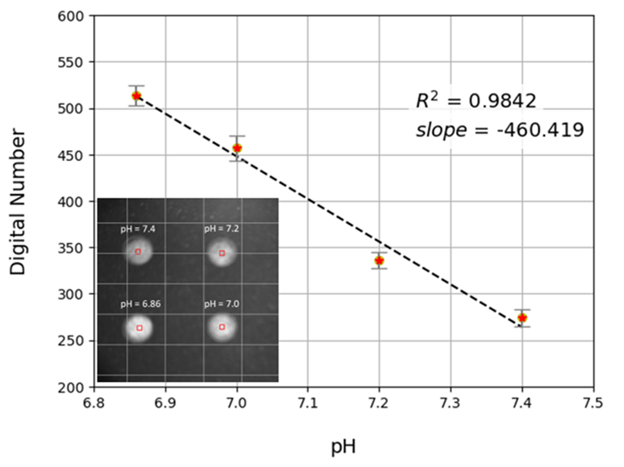
Figure 8: Non-ratiometric DN–pH measurements obtained under fixed geometry and illumination using five-frame stacking. Variability is bounded by the conservative pre-ratio imaging-only error budget and remains dominated by deterministic multiplicative effects. Inset shows the paper based pH sensor and the 30×30 pixel ROI (red square) used for DN extraction.

4.2 Ratiometric Measurements and Suppression of Fixed-Pattern Error

Because the non-ratiometric measurements in Figure 8 remain dominated by deterministic multiplicative effects, a second, separate experiment was conducted to explicitly test the model-predicted mitigation strategy based on ratiometric normalization. This experiment employed a different set of buffered pH solutions and a modified acquisition protocol.
For each pH condition in this ratiometric experiment, the unexposed pH sensor was first imaged under identical geometry and illumination, with five-frame stacking used to reduce stochastic noise. The sensor was then exposed to the buffered solution and imaged again under the same conditions. Pixel-wise ratios of the exposed and unexposed images were computed over the same 30×30 pixel ROI, effectively canceling stable multiplicative effects such as low-frequency illumination curvature and spatial texture associated with the sensor and illumination cavity.
The results of this ratiometric experiment are shown in Figure 9. Following ratio normalization, the remaining variability exhibited no persistent spatial structure and was treated as stochastic residue. Under these conditions, uncertainty was quantified using the standard error of the mean (SEM), reflecting repeatability after normalization rather than device-level accuracy or calibrated pH performance. The substantially reduced dispersion observed in Figure 9 is consistent with model predictions, confirming that fixed-pattern contributions dominate raw measurements and can be effectively mitigated through ratio-based processing.
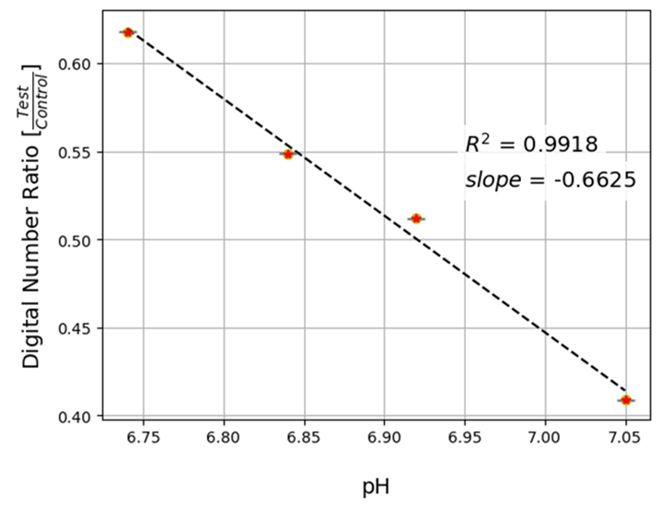
Figure 9: Ratiometric measurements obtained by ratioing exposed and unexposed stacked sensor images acquired under identical conditions. Ratio normalization suppresses deterministic multiplicative artifacts, leaving predominantly stochastic residual variability quantified using SEM. Results reflect repeatability after normalization rather than calibrated pH accuracy.
5.0 Conclusion
The objective of this work was to evaluate whether a commodity smartphone camera can support low-noise optical data acquisition for physiologically demanding pH measurements, where accuracy and precision requirements approach those of clinical screening tools. Through a radiometric modeling framework and independent characterization of imaging-system variability, we found that the smartphone camera itself is not intrinsically limited by sensor noise, particularly when multi-frame stacking is used to suppress stochastic contributions such as shot noise and rolling-shutter artifacts. Instead, under fixed geometry and illumination, the dominant sources of residual error arise from deterministic, fixed-pattern effects associated with illumination non-uniformity, sensor spatial response, and substrate texture.
Importantly, we further show that mitigation strategies grounded in physical modeling, specifically, multi-frame stacking combined with ratiometric normalization using an unexposed reference, substantially suppress these fixed-pattern contributions. As a result, the remaining variability behaves predominantly as stochastic residue and can be meaningfully reduced through protocol design rather than hardware substitution. Together, these findings indicate that, with appropriate acquisition and normalization strategies, a smartphone camera is fundamentally capable of supporting quantitative pH measurements for demanding physiological screening applications, with remaining limitations governed primarily by experimental scope and dataset breadth rather than by intrinsic sensor performance.
A broader implication of this analysis is that the dominant barriers to quantitative pH measurement using paper-based sensors and smartphone imaging arise upstream of algorithmic inference. The results show that, once stochastic noise is suppressed through stacking and deterministic, multiplicative artifacts are mitigated through ratiometric normalization, the remaining measurement uncertainty is both limited and well structured. Under these conditions, the mapping between measured intensity and pH becomes sufficiently constrained that complex machine-learning models may not be necessary to compensate for uncontrolled variability. Instead, performance is governed primarily by acquisition protocol, normalization strategy, and sensor fabrication consistency. This perspective suggests that, for physiologically demanding screening applications, careful physical modeling and experimental design can reduce the problem to one that is analytically tractable, interpretable, and compatible with low-cost deployment—positioning machine learning as an optional refinement rather than a prerequisite for meaningful performance.

6.0 Bibliography

[1] Tiwari, R., & Mahalpure, G. S. (2025). A Detailed Review of pH and its Applications. Journal of Pharmaceutical and Biopharmaceutical Research, 6(2), 492-505. https://doi.org/10.25082/JPBR.2024.02.001

[2] Wiora A, Wiora J. Over One-Year Long-Term Laboratory Tests of pH Electrodes in Terms of Industrial Applications Checking Stabilities of Their Parameters and Their Influence on Uncertainties of Measurements. Sensors (Basel). 2018 Nov 23;18(12):4102. doi: 10.3390/s18124102. PMID: 30477133; PMCID: PMC6308704.

[3] Monaghan MT, Brogan K, Lockington D, Rotchford AP, Ramaesh K. Variability in measuring pH using litmus paper and the relevance in ocular chemical injury. Eye (Lond). 2020 Nov;34(11):2133-2134. doi: 10.1038/s41433-019-0737-z. Epub 2019 Dec 17. PMID: 31848458; PMCID: PMC7784915.

[4] Yuto Nakamura, Masahiro Nagao, Machine learning-based pH quantification from test strip images using multiple color spaces, Chemistry Letters, Volume 54, Issue 2, February 2025, upaf018, https://doi.org/10.1093/chemle/upaf018

[5] Lawn JE, Cousens S, Zupan J. 4 million neonatal deaths: When? Where? Why? The Lancet. 2005 Mar; 365(9462):891–900. https://doi.org/10.1016/S0140-6736(05)71048-5

[6] Westgard QC. 2025 CLIA Acceptance Limits for Proficiency Testing. Westgard Quality Control, 2024, https://westgard.com/clia-a-quality/quality-requirements/2024-clia-requirements.html

[7] Kirby, R., & Palamountain, K. (2020). pH monitor: Target product profile (1st ed., v1.2). Northwestern University for NEST360° and UNICEF, https://www.unicef.org/supply/media/2921/file/ph-monitor-TPP.pdf
[8] Gui, C., Wang, K., Li, C. et al. A CCD-based reader combined with CdS quantum dot-labeled lateral flow strips for ultrasensitive quantitative detection of CagA. Nanoscale Res Lett 9, 57 (2014). https://doi.org/10.1186/1556-276X-9-57
[9] Roda, A., Michelini, E., Zangheri, M., Di Fusco, M., Calabria, D., & Simoni, P. (2016). Smartphone-based biosensors: A critical review and perspectives. Trends in Analytical Chemistry, 79, 317–325. https://doi.org/10.1016/j.trac.2015.10.019
[10] https://github.com/pHastCam/IS-Uniformity-Test
[11] Witschi, A.; Peters, C. A pH Determination Method Suitable for High-Throughput Approaches Based on Spectral Absorbance; Application Note AN 334; BMG Labtech: Cary, NC, 2019. Available at: https://www.bmglabtech.com/en/application-notes/a-ph-determination-method-suitable-for-high-throughput-approaches-based-on-spectral-absorbance/
[12] Westland, S. (2020). colorSpec: Color Spectral Data Handling (Vignette).
Retrieved from https://cran.r-project.org/web/packages/colorSpec/vignettes/colorSpec.pdf
[14] Khosravi, M.; Shamsipur, M.; Hashemi, P. Determination of the Acidity Constants of Neutral Red and Bromocresol Green by Solution Scanometric Method and Comparison with Spectrophotometric Results. J. Chem. Eng. Data 2010, 55 (12), 5650–5654. https://doi.org/10.1021/je100655u
[14] S. Prahl. Optical Absorption of Hemoglobin. OMLC, 1999. https://omlc.org/spectra/hemoglobin/
[16] https://ohlab.kic.ac.jp/index/mobilespec_database
[17] https://github.com/pHastCam/Dye-Indicator-Model
[18] https://github.com/pHastCam/LED_Measurement
[19] Tominaga S, Nishi S, Ohtera R. Measurement and Estimation of Spectral Sensitivity Functions for Mobile Phone Cameras. Sensors (Basel). 2021 Jul 22;21(15):4985. doi: 10.3390/s21154985. PMID: 34372223; PMCID: PMC8347217.

