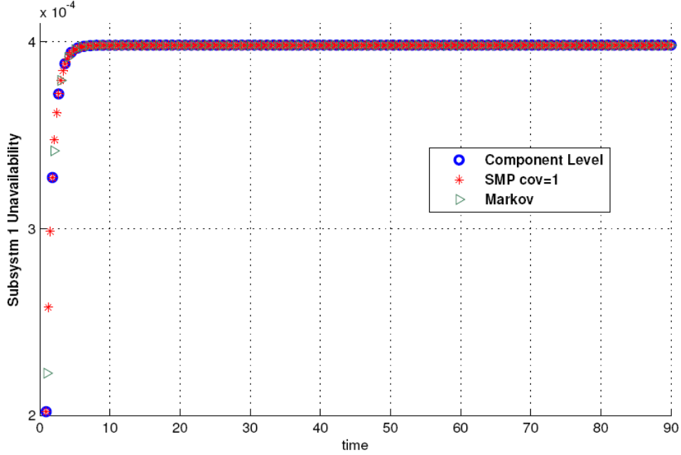
Figure 1.Subsystem 1 unavailability for cov=1
For assumed cov, for t=90:
 | Subsystem 1 Unavailability
Difference: 2.0161e-4,  Ratio: 2.0806 | Component Level | 3.8819e-4
Difference: 2.0161e-4,  Ratio: 2.0806 | Subsystem Level | 1.8658e-4
 | Subsystem 2 Unavailability
Difference: 4.2412e-4,  Ratio: 2.1201 | Component Level | 8.0276e-4
Difference: 4.2412e-4,  Ratio: 2.1201 | Subsystem Level | 3.7864e-4
 | System Unavailability
Difference: 0.62549e-3,  Ratio: 2.1068 | Component Level | 1.1906e-3
Difference: 0.62549e-3,  Ratio: 2.1068 | Subsystem Level | 0.56515e-3

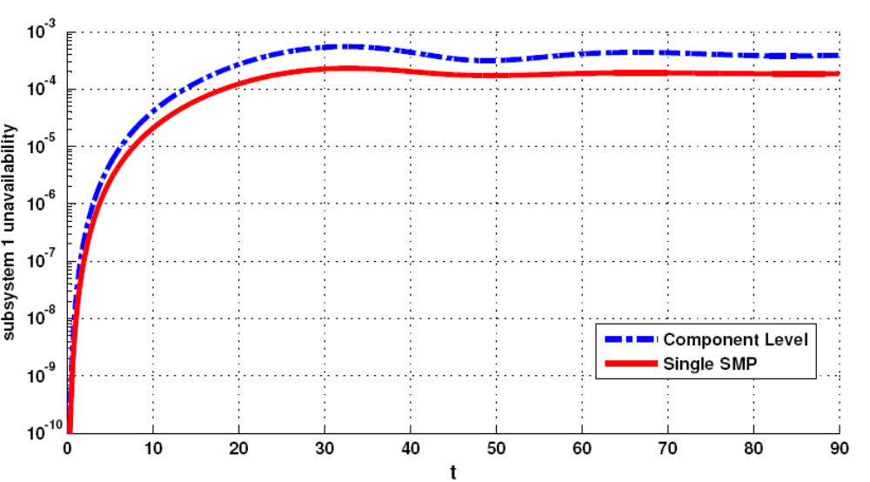
Figure 2.Log-scale plot– subsystem 1 unavailability
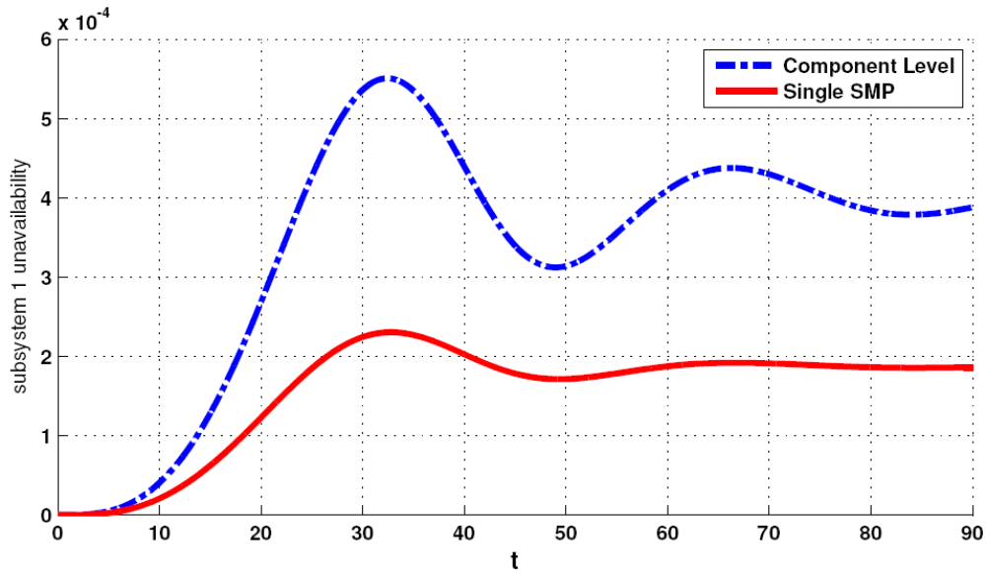
Figure 3.Linear-scale plot– subsystem 1 unavailability
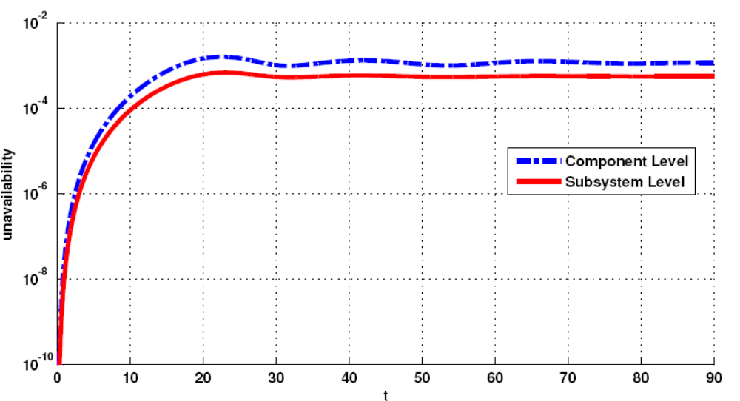
Figure 4.log-scale plot - system unavailability
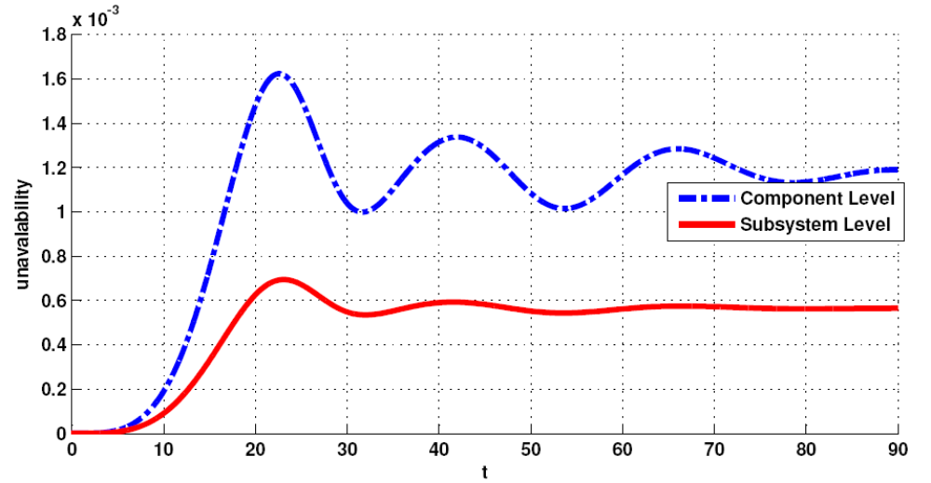
Figure 5.linear scale - system unavailability

