Projekt: Cache Controller für ARM Cortex M0 auf Xilinx Spartan 6
Table of Contents
Motivation 2
Aufbau der Arbeit 2
Grundlagen 2
ARM 2
AHB 2
Performance Indikatoren 2
Cache 2
Implementierung 2
Performance ohne Cache 2
Cache Implementierung 2
Designentscheidungen 2
Anbindung 2
Performance mit Cache 2
Fazit 2

Motivation
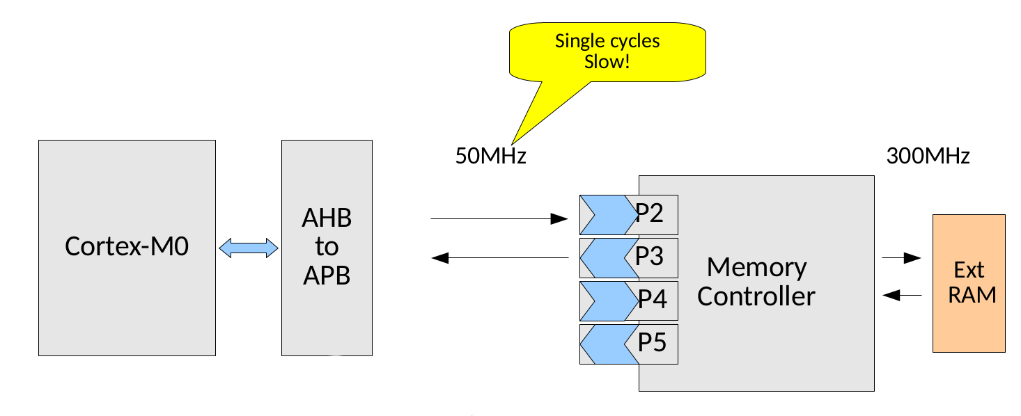
The performance of processors and microcontrollers is heavily depending on the memory performance, especially how fast we can load instructions ans data from the memory. The figure shows the current architecture of the system. It has no Cache and the memory is connect to the APB Interface of the Cortex M0. This results is multiple cycles of delay for each read/write operation we perform in which the processor stalls completely. The first cycle we loose is the AHB to APB bridge, then each DRAM access internally needs ~9 cycles at 300MHz to fetch or write the data, which translates to ~2 additional CPU cycles at 50MHz and finally another APB to AHB cycle. So in total we have at least 4 cycles of delay for each read or write operation. This also accounts for instructions, which inflicts a huge performance penalty, even if we only work on registers in the uC.
To improve performance we add a Cache that is connected to the AHB interface and the memory controller. This reduces the number of stall cycles and thus increases the overall performance.

Structure
In the next Chapter, some basics concerning the used technology will be explained. Chapter 3 is giving a brief introduction to caching strategies and technologies. Chapter 4 presents the created design and chapter 5 gives some final remarks.

Basics

ARM Cortex M0
The ARM Cortex M0 is the smallest available ARM Cortex model. It is classified as a 32bit Micro controller with a RISC instruction set and a 3-stage pipeline. < MORE HERE! >

AHB-Lite
The AHB-Lite stands for “Advanced Highperformance Bus” and is a protocol and interface that is used on the ARM AMBA bus-system to provide high-bandwidth operations for the participators.
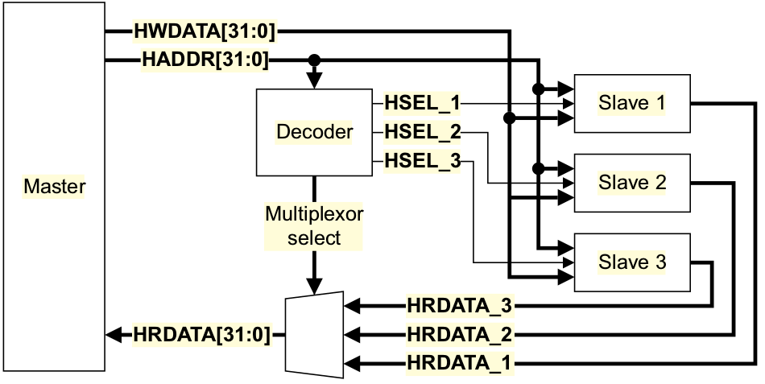
It is a Master/Slave split phase transaction bus-system, where the master request reads/writes from/to slaves, that is implemented as a memory mapped interface. The two phases are address phase and data phase.
- Address Phase: The master writes the desired address to HADDR. The decoder snoops it and notifies the responsible slave with the HSEL signal.
- Data Phase: The Slave is then reading/writing the data. If the action that needs to be performed takes longer than one bus cycle, the slave signals this with the HREADYOUT signal. It can stretch the data phase until it can deliver the data or secured the read. The slaves write is multiplexed back to the master.
Actually, there is number of additional signals and interactions that can occur during a bus transaction, but for the understanding of the project, the given description is sufficient. For more information see UG388.

Performance Indicators
Since the project aims to improve the memory throughput most significant performance indicators are the memory access latency and the available read and read/write bandwidth. These metrics can be used to benchmark applications that are heavily bound to memory operations. However, operations the are calculation bound, we still can achieve a speedup by reducing the instruction fetch latency.
However, they can only be used to indicate the overall application performance development and tells us nothing about the cache controller. To check how well out cache is actually performing, the most important metric would be the hitrate. It is the percentage of memory reads that actually result in a successful cache lookup. The higher this number is, the better.

Cache

Implementation

Performance without Cache

Cache implementation

Design choices

Integration

Performance with Cache

Fazit

