User Desktop Guide
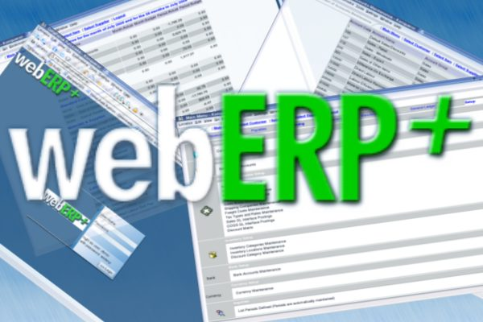
Customer Order Management
Version 0.2
Table of Contents

Introduction 3
Getting started – Logging In 4
Customer Orders 5
New Customers 8
Customer Branch Maintenance 10
Customer Invoicing 11
Customer Credit Notes 13
Money Receipts 16
Conclusion 18
License 18
Contributors 18

Introduction
This manual aims to arm a user of webERP with sufficient knowledge to be effective in administration of sales order entry and accounts receivable. It is not intended to be an in depth study of detail of each area, the focus is on practical instruction on how to use the features.

Getting started – Logging In
Make sure you have been provided with a user name and password by your system administrator. You should also have an WebERP icon on your desktop if it is missing please ask your administrator.

Open a browser connection by clicking on the WebERP icon on your desktop. A browser should open and connect you to WebERP which should be located on a web-server on a network accessible by you. If all went well you should be faced with a login screen which should look something like this :

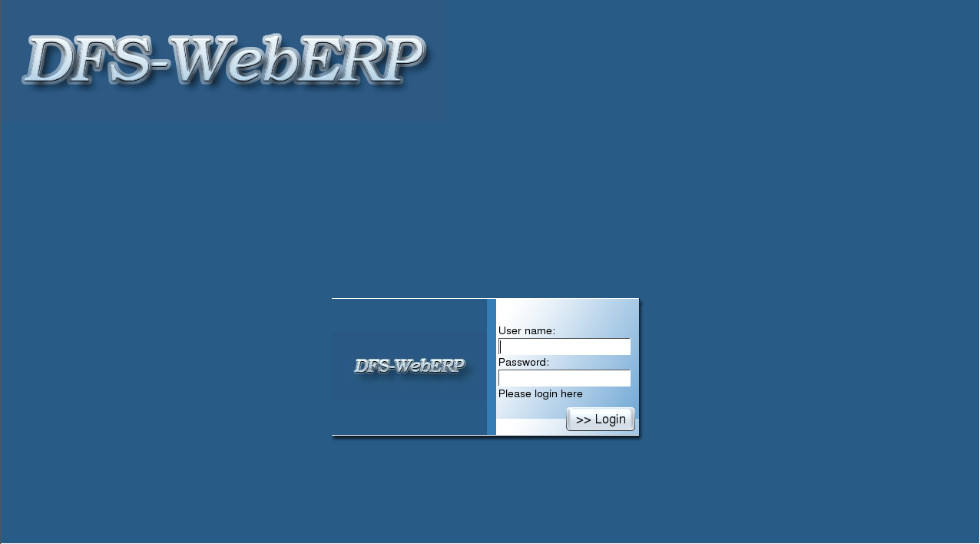
If the screen looks nothing like this or it displays error information please contact your system administrator, he is probably still busy setting up the software. It is important to wait until the setup process is completed before you use it. The logo is more likely to be that of your company.

Now enter the user name and password provided by your systems administrator. If your login fails more than two times contact your system administrator to verify your user name and password. If you try to many times the system will lock your user name and refuse access.

A successful login will provide you with the WebERP main menu screen. Please keep in mind, that it might not look exactly like below. The system caters for different user levels and some functional may not be accessible by you.

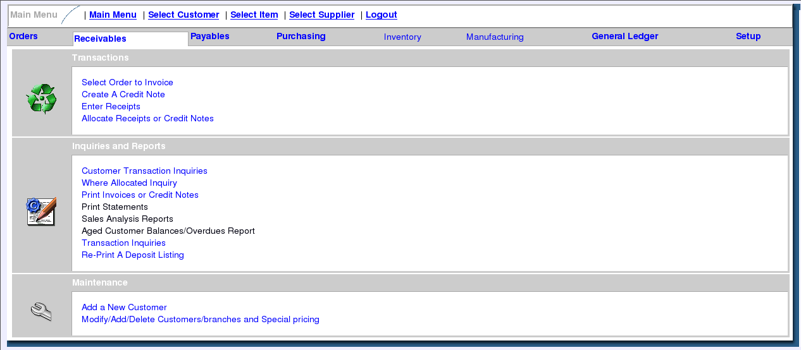

Customer Orders
To enter a new customer order click on the Orders main menu item. The menu screen should change to allow you to click on the Sales Order Entry menu in the section called Transactions, which you should click now.

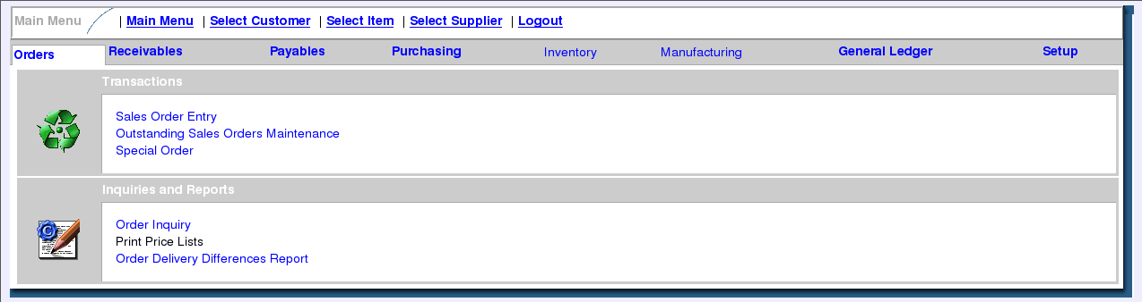
You should now be faced with the Customer Selection screen. Two options for finding an existing customer is available, you can either enter a portion of the customers company name in the first text field, called name, or his branch reference number in the second text field, called code, which he should be able to provide. Once the information has been entered click on the Search Now button.

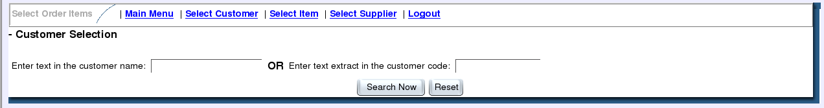
If only one customer in the database fits the search parameters provided the next page will show the Quick Entry screen. A list of possible customers fitting the search parameters will be shown in the event that there are more than one customer fitting the search parameters. Simply select the required customer by clicking on the button in the line with the correct customer information that will take you to the Quick Entry screen.

If the customer is not found and you have verified the information with the customer and you are sure the customer should be in the system contact your system administrator. If however the customer is a new customer click on Add New Customer and then please read the section called New Customers.

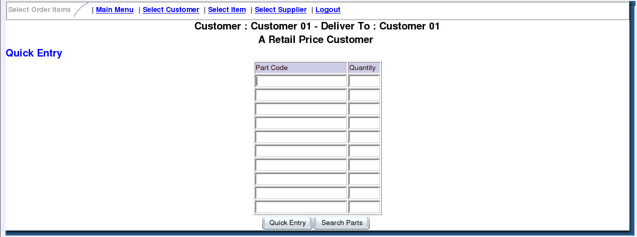
A familiarity with the inventory part numbers will allow you to capture an order quickly, using this screen. Simply enter the part number and quantity required the customer request. Finding an unknown part is easy, click on the Search Parts button and the Select Order Items screen should appear. In order to find the part your customer is looking for you simply enter part of the description for that item or the stock code. It is possible to find all part number by entering %, match anything, into the description section. Remember to click on Search Now to tell the system you would like it to search for information. You may restrict the search to stock category type to reduce the number of items. If only one item matches the search parameters, it will automatically be added to the order. When more than one part matches the search parameters you will be provided with a list of parts. Find the part the customer want and click on the order some reference provided in the right hand column. Remember to change the part quantities on the order.

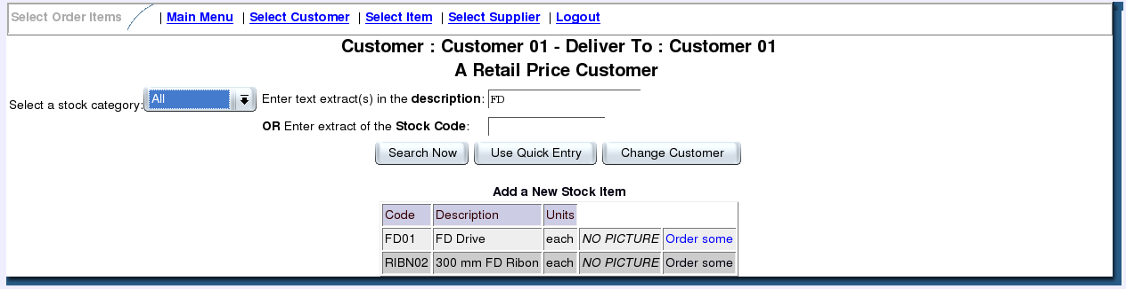

Once all the parts the customer wants have been added, make sure you verify the part quantities. Click the Re-Calculate button after you made changes to the quantities, it will update the Total fields. Once the customer agrees with the order and totals you should click on Enter Delivery Details and Confirm Order to accept the order. You should see the Order Delivery Details screen.

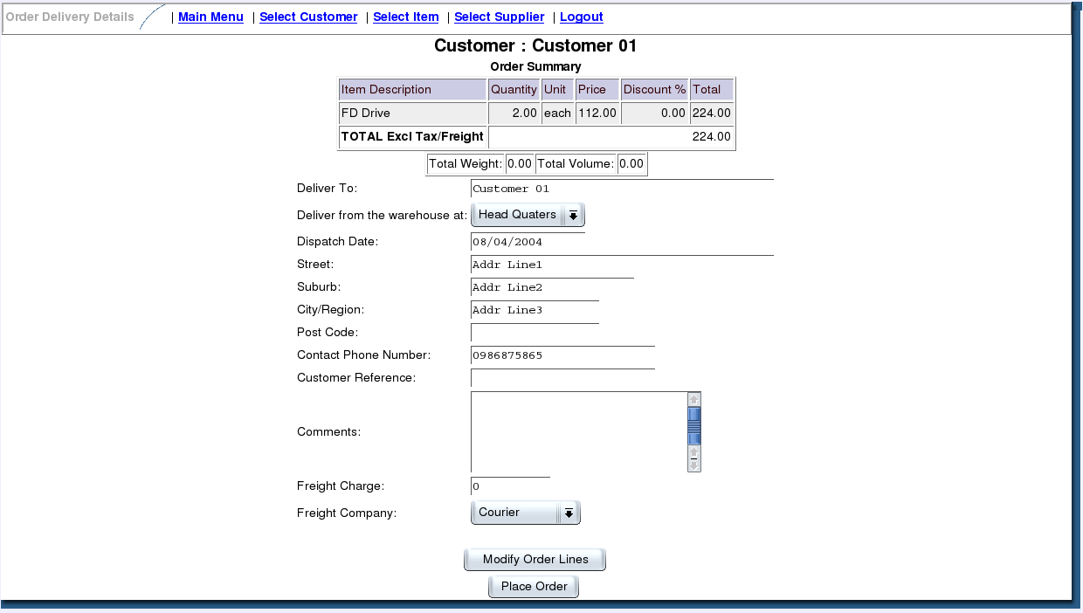

Confirm the customers delivery details. Also remember to choose the correct warehouse from which the order will be shipped and enter the freight charge and company to be used. Clicking on the Place Order will place the order and provide you with some options to print the packing slips and invoices. Please see Customer Invoicing for more details in regards to printing packing slips and invoices.

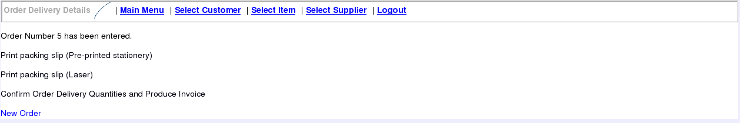

New Customers
To add a new customer click on the Receivables main menu item. The menu screen should change to allow you to click on the Add a New Customer menu in the section called Maintenance, which you should click now.

You should now be faced with the Customer Maintenance screen, which will allow you to enter a new customer. One should note the power the user entering the data has and make sure this level of access is only grated to those with sufficient knowledge and privilege. Concerns of note are the granting of the following to the customer :
  - A price-list which may grant a customer privileged purchasing options not intended.
  - Discount percentage where it may not be reasonable
  - Discount code for which the customer may not qualify.
  - Payment discount percentage for which the customer may not qualify.
  - Credit limit which may effect cash flow and turnaround in your company.
  - Payment terms intended to encourage loyalty.
  - Credit Status which may not reflect customers real credibility.
  - Customer currency which the system should use.
Information which should be requested from the customer :
  - The customer code may be provided by you or your customer. It is important to note that the system also require you to enter branch information through the following screens for which a branch code must be supplied as well.
  - Customer Name. It is suggested to use the Company Name or Surname, First name, Initials.
  - Address information may be entered in the Address Line fields. Suggested order of entry is :
    - Line 1 : Street No or Unit No, Office Block followed by Street Name
    - Line 2 : Suburb, City
    - Line 3 : Postal Code
    - Line 4 : Province, Country
  - Customer's Currency. It is important to realise that currency information should be maintained regularly in order to use any but the default currency.
  - Invoice Addressing. Customers may request that invoices be sent to the branches that place the order, however it should be remembered that in general a central point for invoicing is preferable unless the payment terms is cash only.

Rules should have been established beforehand and must now be used to complete the following information when adding a new customer.
  - Price List.
  - Discount Percentage, Discount Code and Payment Discount Percentage.
  - Credit Limit, Payment Terms and Credit Status.

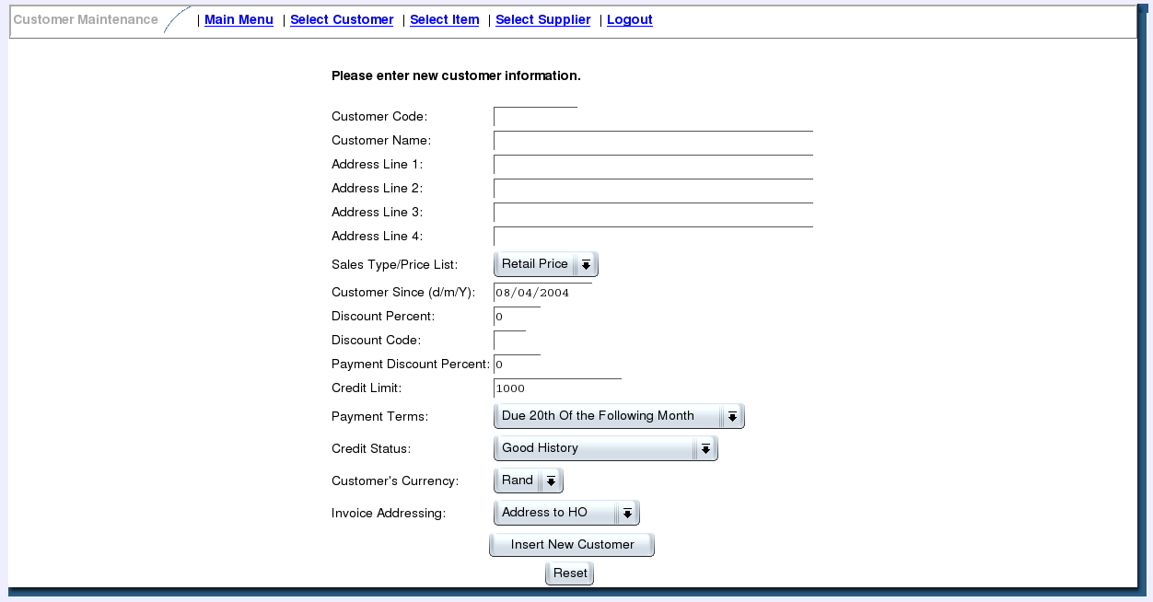
Once all the customer information pertaining to the company and head office was captured you may click on the Insert New Customer button to submit the information to the system. You will now be presented with a screen allowing you to select the option to for entering branch details. It should be noted that company information is intended for prospect reference information. Therefore although the system does not enforce the entry of branch information, it is required before orders can be placed for the customer. To do so click on Enter Branch Details. For more information on entering branch details see Customer Branch Maintenance.

Customer Branch Maintenance
One of two methods of accessing this functionality is available. You can either create a new customer and then precede further by selecting enter branch information or you could use the Select Customer search functionality, located in the menu at the top of the screen. Once the customer is located select Add/Edit/Delete Customer Branch Information which will allow you to maintain the branch information. You will be faced with the Customer Branches screen.

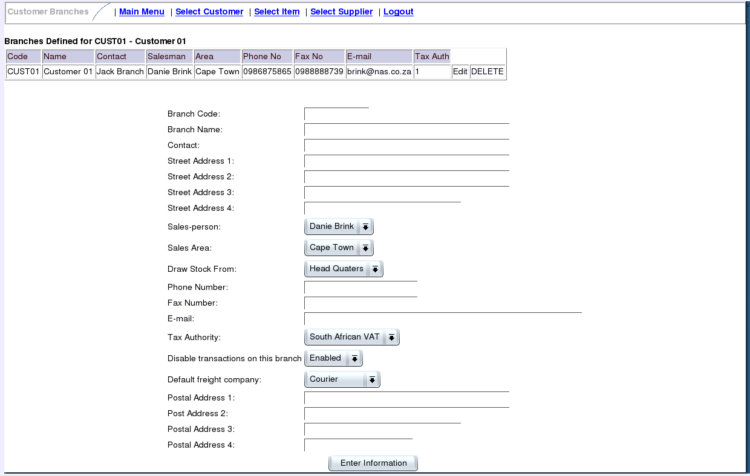

Please keep in mind that a branch is required to take orders from customers.

If you would like to modify or delete an existing branch use the table at the top and click on either Edit or DELETE depending on your requirement. Should you choose to modify the branch details the information will appear in the form below. If you would like to create a new branch simply start entering information as directed below. After an update you will be faced with a blank form again which will allow you to add another branch if required.

The following information should be entered into the form before submition :
- Branch Code – It should be provided by the customer.
- Branch Name – The name of the branch.
- Contact – The name of the contact person.
- Street Address – Please use the same format as indicated in the New Customer section.
- Sales Person – Select the sales person responsible for this customer.
- Sales Area – Select the sales aria in which this customer is located.
- Draw Stock From – Select the location from which orders will be shipped to this customer.
- Phone Number – The contact phone number of Contact.
- Fax Number – The fax number of Contact.
- E-mail – The e-mail address of Contact.
- Tax Authority – Select with care, as it could cause negatively impact on your accounting practices, not to mention that it is difficult to correct once the customer is invoiced. Check with your customer.
- Disable transactions on this branch – will block new customer orders.
- Default freight company – the default courier company to use, the customer or your company might have a preference.
- Postal Address Should be entered in the same format as indicated with Street address except use the PO Box instead of the street address when applicable.

By clicking on Enter Information button the information will be entered into the system.

Customer Invoicing
To invoice a customer order click on the Orders main menu item. The menu screen should change to allow you to click on the Outstanding Sales Orders Maintenance menu in the section called Transactions, which you should click now. This should provide you with the Search Outstanding Sales Orders screen.
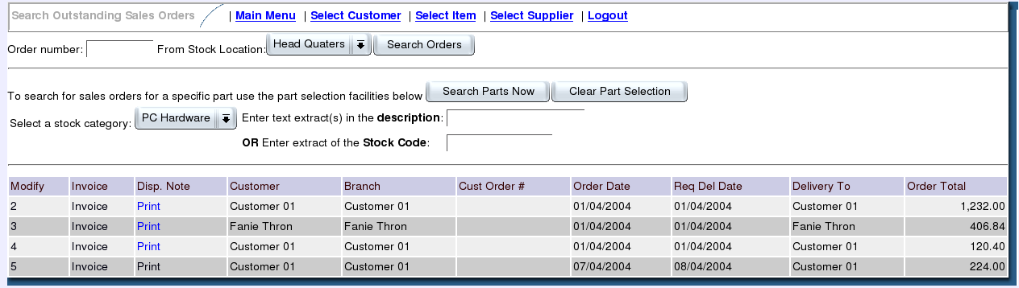
The fastest way to find outstanding orders is simply to select the correct From Location and click on the Search Orders button. This should present you with a list of outstanding orders in a table below the search section.
In the left hand column with the heading Modify you will find a list of system order numbers. You may click on these numbers to modify the orders. To print an invoice click on the Invoice link provided in the second column with the heading Invoice. To print a dispatch not click on the Print link in the column with the heading Disp. Note.

When the Invoice button is clicked the Confirm Dispatch and Invoice An Order screen will appear.
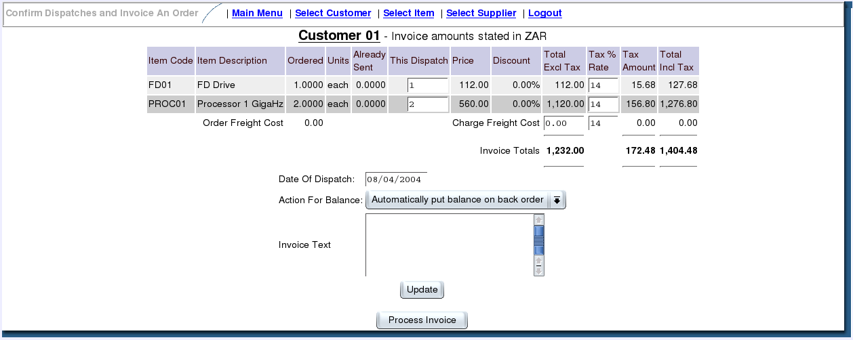
Enter the dispatch totals. These are the items that will be send to the customer and theoretically has already been packed. Below the order item break down you must enter the following information.
- Date Of Dispatch - This should be the date the package or orders will or has been picked up by the couriers.
- Action For Balance - If not all items can be delivered then you could select either “Automatically put balance on back order” where the remaining will be placed on backorder or the alternative is “Cancel any quantities not delivered” which will cancel the order for the rest of the goods requested.
- Invoice Text - Is a note area provided to notify the customer of abnormal action taken or to just add a general invoice message.
Use the Update button to request recalculation from the system if modifications were made. Once you are sure the information displayed is accurate click on the Process Invoice button which will request invoicing form the system. You should now be faced with the processed information that will allow you to print the invoice through the link Print this Invoice. The invoice will be presented in PDF format ( Portable Document Format) and can be printed to a printer of your choice.

Customer Credit Notes
When a customer returns goods purchased or you have overcharged a customer, the correct method of correcting the accounts it to issue a credit note. To do this click on the Receivables main menu item. The menu screen should change to allow you to click on the Create A Credit Note menu in the section called Transactions, which you should click now. Select a customer by entering search criteria into the provided fields and select the customer from the displayed result.
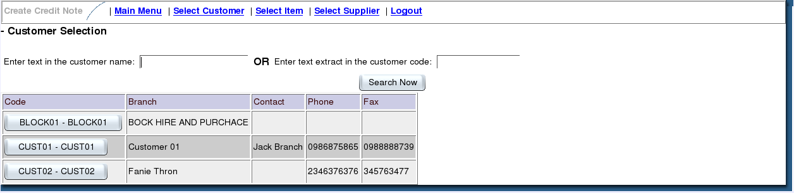
This should provide you with the Create Credit Note screen.
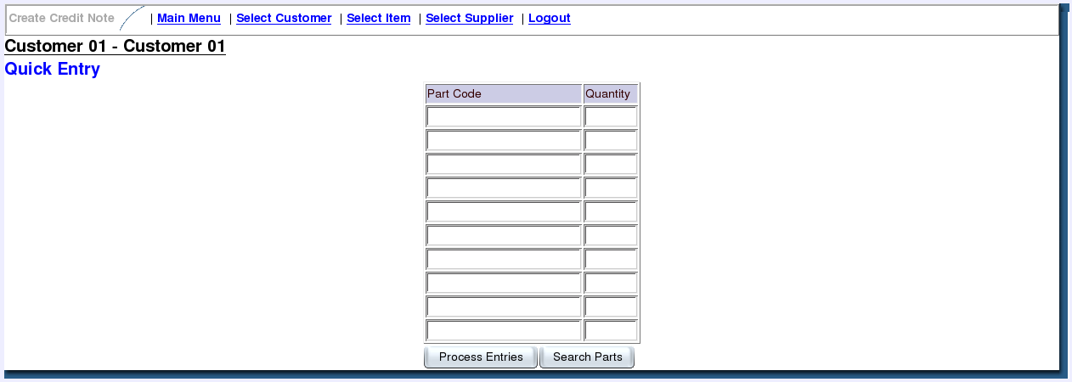
Use the part search functionality by clicking on the Search Parts button to add items to the credit note.
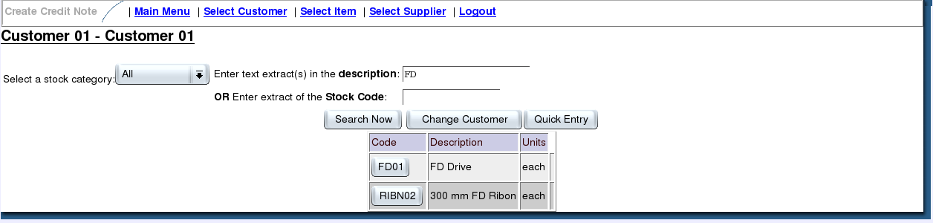
Update the Quantity, Price the customer was charged whether it was the gross price the discount applied at the time and the tax rate applied at the time. When the stock is returned what should be done with it? The selection of the credit note type determines how the credit note will be processed. A credit note of the type Overcharge will have no impact on stock quantities or stock movements, it will reduce the sales analysis sales value amount and make a credit note on the customers account. Selecting a credit note type, to write off the stock, allows (required - if AR general ledger integration is turned on) the user to enter a general ledger account as to where the cost of the goods should be written off to - in the case of say promotional display products or damaged goods in transit.
Select to which location the goods were returned and add a Note to indicate the reason for the action taken. Use the Update button to recalculate totals after changes were made. Once the information is correct in all respects click on Process Credit Note button to let the server process this information.

Note, that an overcharge could also be rectified by crediting the whole invoice using the credit invoice option and re-charging at the correct prices. If the whole invoice is to be credited there is a short cut, the invoice can be selected from the customer inquiry and the undo button allows a user with the appropriate privileges to credit it. The credit note can also be modified to remove those lines which are not to be credited. This can save considerable work where there are many lines on the invoice.

Once processed click on Print this Credit Note to provide the customer with proof of credit.
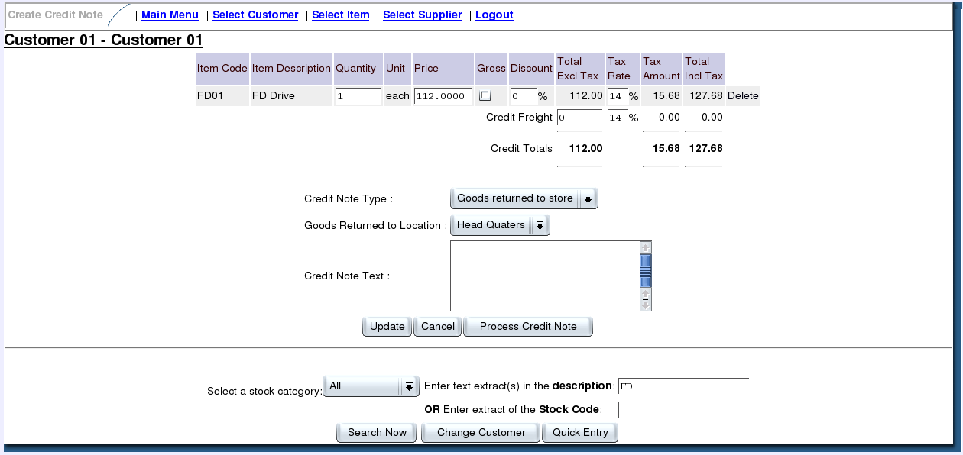
The final step is to associate a credit note to an invoice. In order to do this go back to the Main Menu and click on Allocate Receipts or Credit Notes. You should be presented with the Customer Receipt/Credit Note Allocation screen.
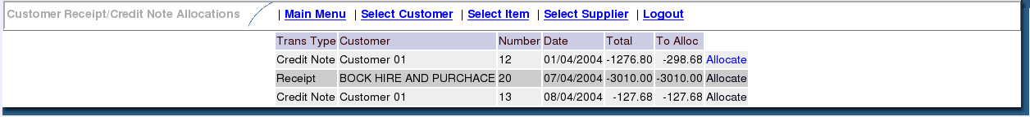
Select the customers credit note by clicking on the Allocate link in the right most column of the table.

Now select the sales invoices for which the customer was credited by checking the boxes next to the sales invoices. If the credit note is meant to reverse the whole amount of the invoice, then checking the box is all that is required. However, if the credit note is only partially related to the invoice this is reflected by entering the amount of money to be allocated against the invoice. Once a change has been made press Recalculate Total To Allocate button and make sure the Credit note line's Yet to Allocate Column is 0 (Zero) and the total Left to allocate is also 0 (Zero) before pressing the Process Allocation button. This will associate the credit note with all the invoices for which it has been issued.
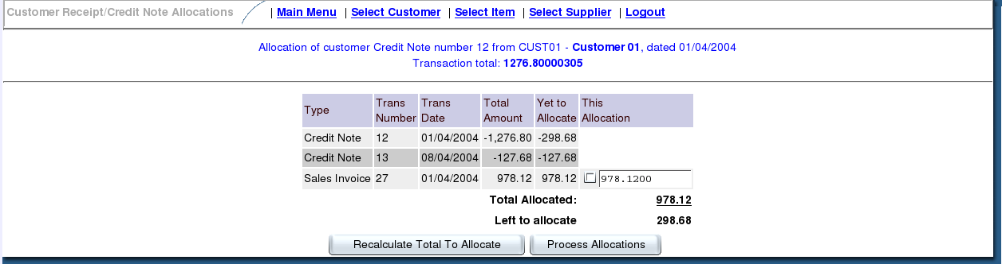
User: In some rare occasions the Left to allocate value will not be 0 (Zero), call your accounts manager and have him/her solve the problem.
( Accounts Manager: If the credit note was entered incorrectly the solution is to finalize the credit note allocation and then make a journal entry to correct the respective accounts. - not yet supported)

Money Receipts
To enter a money receipt click on the Receivables main menu item. The menu screen should change to allow you to click on the Enter Receipts menu in the section called Transactions, which you should click now. This should provide you with the Receipt Entry screen.
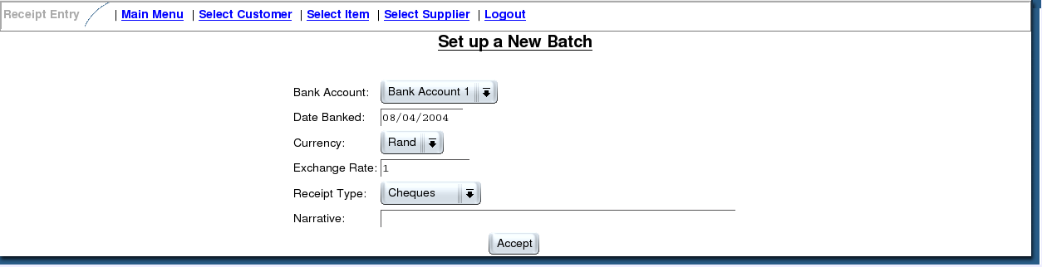
This screen allows for the creation of a new batch of entries. Entry of this screen is straight forward, however be very careful to enter all information correctly. Note if you are reconciling your petty cash you should select the Petty Cash bank account. Information to be entered are as follows:
- Back account – into which the money was paid / transferred
- Date Banked – should correspond to date on bank statement
- Currency – the currency used to make the deposit
- Exchange Rate – the deposit currency's ruling exchange rate on date of transaction
- Receipt Type – Select from the list the type of transaction made. Cheque, Cash, Credit Card, etc.
- Narrative – A description field is provided – the date of the bank statement should be entered here along with the short bank name and filing reference.
- Click on the Accept button when all information is correct to start with this batch.
You should see the following screen with the description Receipt Entry.
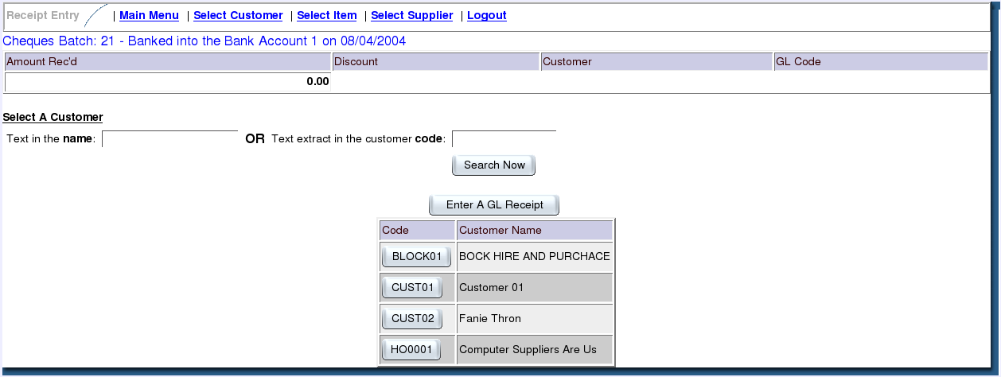
You may either enter a General Ledger(GL) receipt or a customer receipt. To enter a GL receipt click on the Enter A GL Receipt button. Alternatively select a customer by entering a portion of his name or his customer code into corresponding fields and click on Search Now, alternatively enter the '%' sign into the name field and click on Search Now. Select from the list the required customer by clicking on the button in the Code column next to the customers name in the Customer Name column. It should be noted that once an entry has been made you will be allowed to create more entries for this batch.
For General Ledger Entries enter the following information carefully
- GL Account - Select from the list the correct account.
- Amount of Receipt – Enter the monetary value carefully and confirm
- Payee Bank Details – the bank details of the depositor, when none is available you may use his VAT Number or his Name
- Narrative – an explanation of the reason for this transaction, what did he pay for.
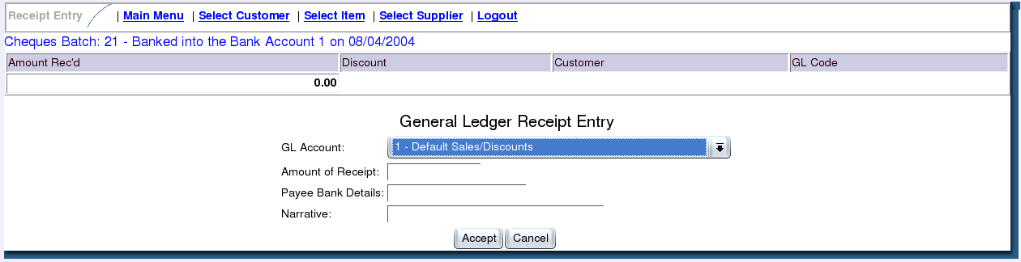
For Customer Entries enter the following information carefully
- Amount of Receipt – Enter the monetary value carefully and confirm
- Amount of Discount – Only if customer has a prompt payment discount
- Payee Bank Details – the bank details of the depositor, when none is available you may use his VAT Number or his Name
- Narrative – The Customer Code or Invoice Numbers being paid.
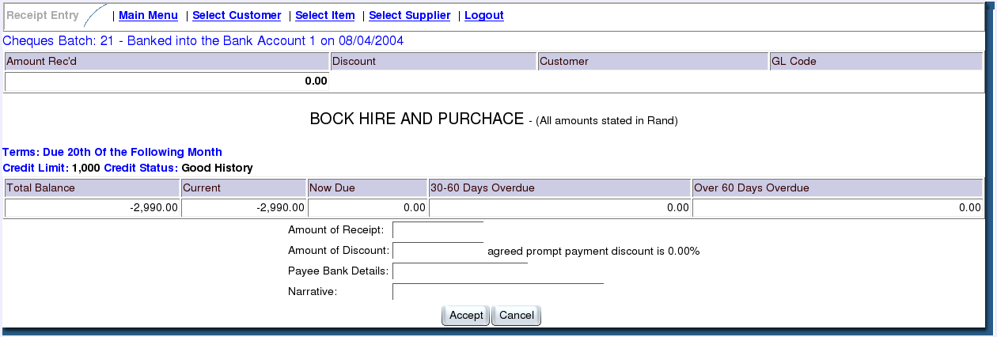
Please verify all batch entries before posting the batch with the Accept and Process Batch button. Once Completed you may print a batch summery by clicking on the Print PDF Batch Summary link. Please see the section called Customer Credit Notes for the allocation of receipts to invoices.
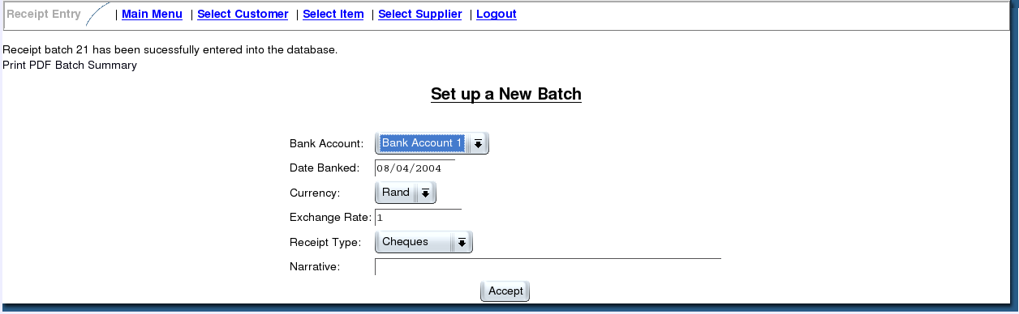

Conclusion
This desktop manual is a simple and non-complicated set of instructions to get your order handling staff working as fast as possible. It will also reduce the amount of training required.

License
This manual is distributed as part of the WebERP system and may be reproduced or modified as required. The document is distributed under the GPL license with the exception that any modifications made, must also be send to Danie Brink brink@b2brus.co.za or Phil Daintree p.daintree@paradise.net.nz in order to keep the original contents of this document as accurate as possible.

Contributors
Phil Daintree – New Zealand
Danie Brink – DataForce Solutions – South Africa
Shane Barnaby – Canada
Sherif Omar - Eygpt
Dick Stins – Holland
Jesse Peterson – USA

