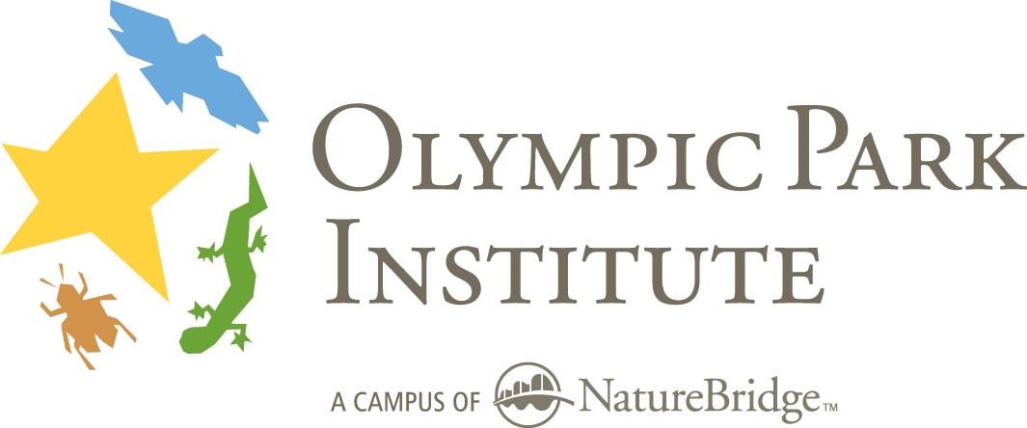Field Science Educator Application

Name ____________________________________ Today’s date _________________
Address ___________________________________ Phone (day) __________________
__________________________________________ (evening) __________________
__________________________________________ E-mail address ________________

Please consider me for (check all that apply):

❒ Full Time Field Science Educator position
❒ Part-time/Substitute Educator position
- Spring Semester start date
- Fall Semester start date
- School year only (not available summers)

My experience includes (indicate approximate number of months):
___ Months of paid employment in residential outdoor environmental education working with schools.
___ Months of paid employment with other non-formal education institutions (parks, zoos, aquariums).
___ Months of volunteer employment with education institutions.
___ Months of paid employment as a classroom teacher for grades: ______.
___ Months involved with scientific field research with [name(s) of institution(s)] __________________.

I have current certification in the following first aid/medical trainings:
- Wilderness First Responder Expires: __________________
- Wilderness First Aid Expires: _______________________
- Adult/Child CPR Expires: ________________________
- Other: ____________________________________________________

Please provide us with the following information and return by mail, fax or email to the address below:

- This Form, Completed
- Cover Letter
- Résumé
- List of Professional References

We will contact you with a request for additional application materials if we decide to move forward with your application process. We determine this by the number of positions available as well as the degree to which your application is competitive with other applications. Additional materials include copies of your medical training certifications, three completed reference forms, and responses to additional written application questions. You may submit these without our request if you like (available on our website).

Field Science Educator Hiring Committee
Olympic Park Institute 111 Barnes Point Road Port Angeles, WA 98363
tel. 360.928.3720 ext. 12 fax 360.928.3046 opi-fse-search@naturebridge.org

Thank you for your interest in working with Olympic Park Institute!

