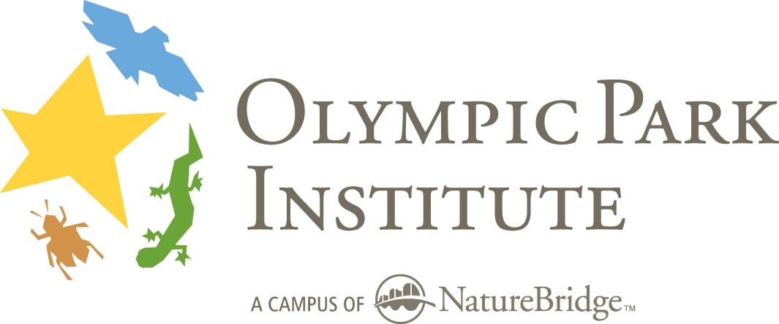
Field Science Educator
Reference Form

Applicant Name: ____________________________________________

Your Name (please print) __________________________________________

Position or Title_____________________________ Email _____________________

Organization_______________________________ Phone _______________________

Number of years known applicant: ___ Relationship to applicant: _________________

Signature__________________________________ Date ___________

Olympic Park Institute is a campus of NatureBridge, a private, non-profit organization dedicated to teaching science and environmental education in nature’s classroom to inspire personal connections to the natural world and responsible actions to sustain it. Olympic Park Institute runs a residential Field Science School, in-school day programs and other outdoor programs.

Educators for OPI deliver safe, quality, inquiry-based education programs to Olympic Park Institute program participants. Classes take place in the out-of-doors and may involve overnight camping and strenuous activity over rugged terrain. Successful applicants excel at teaching youth and adults, leading outdoor groups, and communicating science, natural history and environmental topics effectively.

Your appraisal of the above-named applicant to Olympic Park Institute will assist us in making the most effective hiring decisions. Please fill out this form and return in a sealed envelope, or email directly to the address below.

Field Science Educator Hiring Committee tel. 360.928.3720 ext 12
Olympic Park Institute fax 360.928.3046
111 Barnes Point Road opi-fse-search@yni.org
Port Angeles, WA 98363 www.OlympicParkInstitute.org

Please rate your impression of the applicant in the following areas using the five-point scale provided. Five indicates expert level, can train others; four indicates solidly experienced and widely competent; three indicates some experience and adequate in most situations; two indicates understanding of the basics; one indicates minimal or no experience. Please also provide written comments as needed.

a. Knowledge of natural history and field science
___5:Expert ___4:Solid ___3:Some experience ___2:Basics ___1:Minimal experience
Comments:

b. Risk Management and Safety Awareness
___5:Expert ___4:Solid ___3:Some experience ___2:Basics ___1:Minimal experience
Comments:

c. Outdoor Group Leadership
___5:Expert ___4:Solid ___3:Some experience ___2:Basics ___1:Minimal experience
Comments:

d. Interpersonal and Group Facilitation Skills
___5:Expert ___4:Solid ___3:Some experience ___2:Basics ___1:Minimal experience
Comments:

e. Outdoor skills (camping, hiking, paddling, etc)
___5:Expert ___4:Solid ___3:Some experience ___2:Basics ___1:Minimal experience
Comments:

f. Ability to teach youth and adults (preparation/organization, delivery)
___5:Expert ___4:Solid ___3:Some experience ___2:Basics ___1:Minimal experience
Comments:

g. Competency in Environmental Education
___5:Expert ___4:Solid ___3:Some experience ___2:Basics ___1:Minimal experience
Comments:

How do you recommend the applicant for the position as you understand it?
___Very highly ___Highly ___Somewhat Highly ___Unsure ___Not at all

Overall comments on the applicant:

