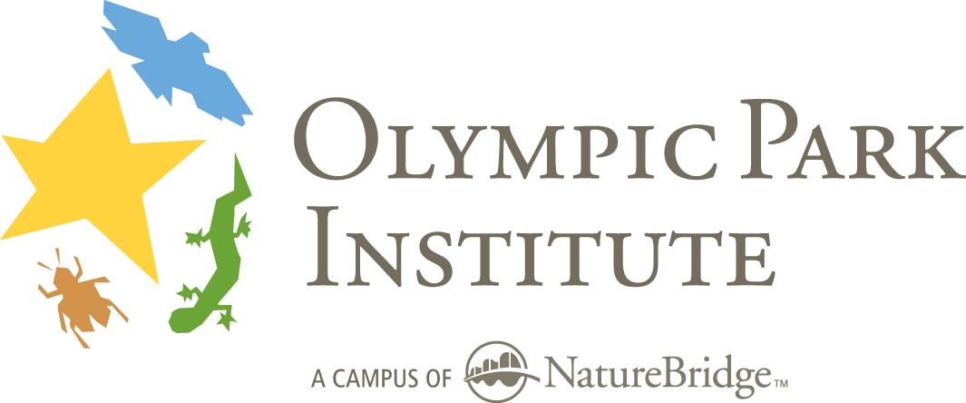
Field Science Educator
Requested Additional Application Materials

Name __________________________________________ Today’s date ______________
Phone _________________________________________
E-mail address:
Please submit responses to the following questions by mail, fax or email with:
- Copies of your current medical certifications
- Three completed OPI recommendation forms from professional references in sealed, signed envelopes, or mailed, faxed or emailed directly from the individual

Return additional application materials to:
Field Science Educator Hiring Committee
Olympic Park Institute 111 Barnes Point Road Port Angeles, WA 98363
tel. 360.928.3720 ext. 12 fax 360.928.3046 opi-fse-search@naturebridge.org

1) How did you learn about Olympic Park Institute?
2) Why do you want to work for OPI? How would work here serve your personal and professional goals?
3) What do you consider to be the goal of field science education?
4) With what age groups and audiences are you most comfortable working? Which is your favorite, and why?
5) Please describe your previous experience working with children. Describe a particularly challenging moment and how you dealt with it.
6) What are the qualities of a great educator?
7) What do you feel is important for students to learn from an Olympic Park Institute program? How would you ensure that they gain what you intend for them to experience?
8) What is your background in natural history and field science topics? What subjects are your strengths?
9) With regard to being a Field Science Educator at Olympic Park Institute, what do you consider to be your greatest strengths and your greatest areas for growth?
10) Describe any particular outdoor skills or backcountry experience you may have.
11) Describe any experience with scientific research you may have.
12) How do you feel about living in a close-knit community?
13) Describe a hypothetical teaching day in a favorite outdoor place, with twelve elementary/middle school students and a parent chaperone. In your description, please:
- Outline your theme, goals and objectives.
- Describe a sequence of activities that help convey your theme through the day.
- Discuss the most important outcomes of the day and how those might be measured.

