115 ½ 18TH Street
Pacific Grove, CA 93950
October 1, 2011

Arin Trook
Yosemite Institute
PO Box 487
Yosemite, CA 95389

Dear Mr. Trook,

My career goal is to inspire children to care for our world’s natural resources. This is why I am an ideal applicant for a Field Educator position with Yosemite Institute! The opportunity that this position offers is uniquely appealing to me because it combines two activities that I am passionate about: working with youth, and providing environmental education in a habitat that I cherish. My desire is to work in a positive team environment in which I can excel in leading outdoor educational activities with diverse groups of students in Yosemite.

Throughout my varied experiences teaching youth, I have been able to witness the daily developmental breakthroughs that occur in children while learning in an outdoor setting, and am thrilled to have been a part of their progress. My teaching style is geared toward reaching the highest standards and preparing students to achieve their life's aspirations.

As you can see from my resume, much of my post-college experience involves wildlife conservation and education. Having decided to pursue a career that combines my love of the outdoors with my passion for promoting self and guided-discovery opportunities in children, I am well qualified for a Field Educator position with Yosemite Institute. Furthermore, I am in a unique position to provide children with varied, effective teaching methods. My strengths include:

- Developing inquiry based science curriculum for use in outdoor settings
- Leadership skills and behavior management
- Working efficiently with team members to present outdoor educational activities
- Maintaining safety of youth in a wide variety of settings
- A range of personal experiences including backpacking/hiking/snorkeling/rock climbing/kayaking, etc.
- Creating a fun and comfortable atmosphere in often stressful and demanding situations in the field

I would very much like an interview at your earliest convenience. I am enthusiastic about the opportunity to work with Yosemite Institute! Thank you for your consideration and I look forward to hearing from you soon.

Sincerely,
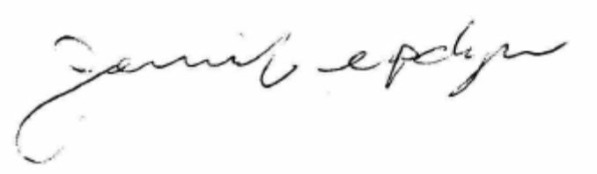
Jennifer Updyke

