IoT-Based SmartWarga Citizen Reporting Platform: Design Thinking and AI-Powered Civic Service Management
Timothy Sebastian Darmawan¹, Rezya Indy Saputra¹, Marvel Nicolas Gunawan¹, Nathan Jeremy Alexander Kurniawan¹
¹Cyber Security, School of Computer Science, Bina Nusantara University, Jakarta, 11480, Indonesia
*Corresponding author: timothy.darmawan@binus.ac.id,
Abstract. Rapid urbanization and the growth of Indonesian smart cities have accelerated the adoption of digital platforms for citizen reporting and civic engagement. However, the increasing volume and heterogeneity of citizen reports at neighborhood (RT/RW) level can overwhelm local administrators and slow down follow-up actions. This paper presents the design of AI-enhanced features for SmartWarga, a web-based citizen reporting platform, using a Design Thinking approach. The proposed system integrates natural language processing (NLP) for automatic text classification and urgency scoring into the existing SmartWarga backend, aiming to assist RT/RW administrators in organizing, prioritizing, and routing citizen reports more effectively. The study is structured around the five Design Thinking phases (Empathize, Define, Ideate, Prototype, Test) and informed by literature on Jakarta Smart City’s complaint ecosystem and prior work on NLP-based civic complaint analysis. In addition, the paper outlines a practical funding scheme, project timeline, and documentation strategy using code and interface screenshots to demonstrate the implemented system.^{[1][2][3][4][5][6]}
Keywords: SmartWarga, citizen reporting, artificial intelligence, natural language processing, Design Thinking, smart city
1. Introduction
Digital citizen reporting platforms have become a core component of smart city strategies, enabling residents to directly report issues such as uncollected waste, damaged infrastructure, or public safety concerns to local authorities. In Jakarta, the JAKI (Jakarta Kini) super-app consolidates various public services and provides a Citizen Report feature that connects reports to a centralized Citizen Relation Management (CRM) system for follow-up by relevant agencies. Public communications from Jakarta Smart City indicate that tens of thousands of reports can be processed annually through this integrated complaint ecosystem, illustrating both the demand for and the complexity of managing civic feedback at scale.^{[1][3][5][7]}
Despite these advances, many neighborhoods at the RT/RW level still rely on informal channels such as messaging groups or ad-hoc communication to coordinate responses to local issues. Such practices lead to unstructured data, limited traceability, and inconsistent prioritization when multiple incidents occur simultaneously. SmartWarga is proposed as a web-based platform that targets neighborhood contexts by providing structured reporting forms, dashboards for RT/RW administrators, and integration points for data analysis.
To address information overload and improve decision-making, the project focuses on embedding artificial intelligence (AI) into SmartWarga. Specifically, natural language processing (NLP) and machine learning are used to automatically classify citizen reports into categories and estimate their urgency based on textual features and context. By integrating AI components into the existing backend, SmartWarga can evolve from a simple reporting channel into a decision-support tool that helps local leaders manage limited resources more effectively.^{[2]}4][^8]
2. Related Work
2.1 Smart City Platforms and Citizen Reporting in Jakarta
Jakarta Smart City acts as a catalyst in creating a smart city ecosystem by integrating government applications and connecting citizens (co-creators) with government (collaborators). JAKI serves as a "super-app" that aggregates more than fifty government services, including Citizen Report, where residents can submit geotagged reports accompanied by photos or videos. The reports are forwarded to a CRM system that routes them to relevant agencies and provides status updates to users, increasing transparency and accountability in public service delivery.^{[1][3][5][7]}
The success of JAKI’s complaint handling demonstrates the potential of centralized digital platforms, but it also reveals challenges in triaging large numbers of reports and balancing responsiveness with resource constraints. Moreover, while city-level platforms are well resourced, neighborhood-level governance often lacks dedicated tools and analytical capabilities, highlighting an opportunity for lightweight, context-aware systems such as SmartWarga.
2.2 NLP and AI for Civic Complaint Analysis
Recent research has applied NLP and machine learning to civic complaints, focusing on tasks like automatic classification, topic modeling, and decision support. Some studies propose complaint analyzers that use text mining techniques to identify complaint categories like road, garbage, and street light and support municipal decision-making. Other work introduces AI-based platforms that apply advanced NLP models to identify, rank, and summarize large volumes of citizen reports, helping governments prioritize interventions and allocate resources more efficiently.^{[2][4][9]}8][^10]
In Indonesia, work on automatic classification of public complaints using algorithms such as Naive Bayes shows that text-based models can achieve promising accuracy when distinguishing complaint categories across sectors like economy, education, health, and social services. These studies provide a foundation for designing AI modules that can process Bahasa Indonesia complaints in platforms like SmartWarga, especially when combined with domain-specific label sets and pre-processing pipelines tailored to local reporting styles.[^6]
2.3 Design Thinking in Digital Service and AI System Development
Design Thinking has become a widely adopted methodology in digital product and service development, emphasizing human-centered, iterative problem-solving. Common frameworks describe five key stages: Empathize, Define, Ideate, Prototype, and Test. In the context of AI and IoT systems, Design Thinking helps teams link technical capabilities with real user needs by encouraging deep user research, creative ideation, and iterative prototyping informed by feedback.^{[11][12]}
Applying Design Thinking to SmartWarga ensures that AI features are not built in isolation but instead respond to concrete problems faced by RT/RW administrators and residents. It also provides a clear narrative structure for communicating the research and development process in academic and technology transfer settings.
3. Methods
3.1 Research Approach
This study employs a qualitative research approach grounded in the Design Thinking framework to explore and prototype AI-enhanced features in the SmartWarga platform. Qualitative methods are appropriate because the primary aim is to understand user needs, pain points, and contextual factors that influence the adoption and effectiveness of AI tools at neighborhood level, rather than solely optimizing numerical performance metrics.
Data sources for the research include: (1) public documentation and online articles about Jakarta Smart City, JAKI, and the Citizen Report feature; (2) prior academic work on NLP-based civic complaint classification and decision support; and (3) technical analysis of the SmartWarga codebase and architecture to identify suitable integration points for AI services. Interviews and observations with RT/RW administrators and engaged residents are planned to enrich understanding of current practices and expectations.^{[1][2][3][4][5]}8][^6]
3.2 Design Thinking Phases
A typical Design Thinking process consists of a cycle of (1) Empathize, (2) Define, (3) Ideate, (4) Prototype, and (5) Test.[^{11][12]}
3.2.1 Empathize
In the Empathize phase, the research team builds a deep understanding of RT/RW administrators and residents as primary users of SmartWarga. This involves observing how local leaders currently receive and manage complaints, how they prioritize issues, and how they coordinate responses through existing channels such as messaging applications or offline meetings. Interviews explore perceived bottlenecks, such as information overload or difficulty tracking recurring issues.
3.2.2 Define
Insights from the Empathize phase are synthesized into specific problem statements. For example, administrators may report that they struggle to categorize and prioritize heterogeneous reports, leading to delayed responses to critical incidents. These observations are translated into design challenges such as: "How might SmartWarga automatically categorize and prioritize citizen reports to reduce administrative workload while maintaining fairness and transparency?" The Define phase clarifies functional requirements for AI modules, including multi-class text classification, urgency scoring, and explainable outputs that administrators can review and override.
3.2.3 Ideate
During the Ideate phase, the team generates a wide range of possible solutions for AI-enhanced SmartWarga. Ideas include implementing supervised text classification models (e.g. Naive Bayes or transformer-based models) trained on labeled citizen reports, designing urgency scoring mechanisms based on keywords and historical patterns, and building decision-support interfaces that recommend routing to appropriate administrative levels. The brainstorm also considers infrastructure constraints and deployment strategies, such as containerized AI microservices accessible via REST APIs.^{[4][6]}
3.2.4 Prototype
In the Prototype phase, selected AI features are implemented in minimal yet functional form and integrated into the SmartWarga platform. The existing web-based client–server architecture of SmartWarga is extended through new components in the backend, including API endpoints for AI prediction requests, modules for handling responses, and database fields for storing AI outputs. User interface elements are adapted to display AI-generated labels and priority indicators on administrator dashboards.
3.2.5 Test
The Test phase focuses on gathering feedback about the AI-enhanced SmartWarga prototype from target users. Initial tests may use synthetic or anonymized report data to evaluate model performance and usability. Administrators are invited to use the prototype to triage batches of reports, and their interactions and comments are recorded. Evaluation metrics include standard classification performance (accuracy, precision, recall, F1-score) and qualitative assessments of perceived usefulness, clarity, and trustworthiness of AI outputs.^{[6][4]}
4. System Design and Implementation
4.1 Overall Architecture
The conceptual architecture of AI-enhanced SmartWarga consists of three main parts: a web-based frontend interface, core backend services, and AI microservices. The frontend provides residents with forms to submit reports and allows RT/RW administrators to monitor and manage issues. The backend, built using a modern web framework and connected to a relational database, handles user authentication, report storage, and coordination with external services. AI microservices implement text classification and urgency scoring logic, exposing prediction endpoints to the backend.^{[2][4]}
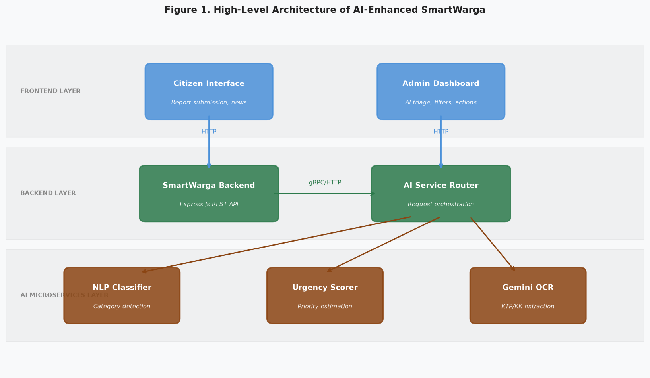
Figure 1. High-level architecture diagram showing interactions among the frontend, SmartWarga backend, and AI microservices layers.
4.2 Data Flow for Citizen Reports
When a citizen submits a report through SmartWarga, the backend stores the raw text and metadata (such as timestamp and location) in the database and sends the text to the AI microservice. The AI service returns predicted category labels and urgency scores, which are stored as additional attributes. Administrator dashboards display these attributes alongside each report, supporting filtering and sorting by category or priority.
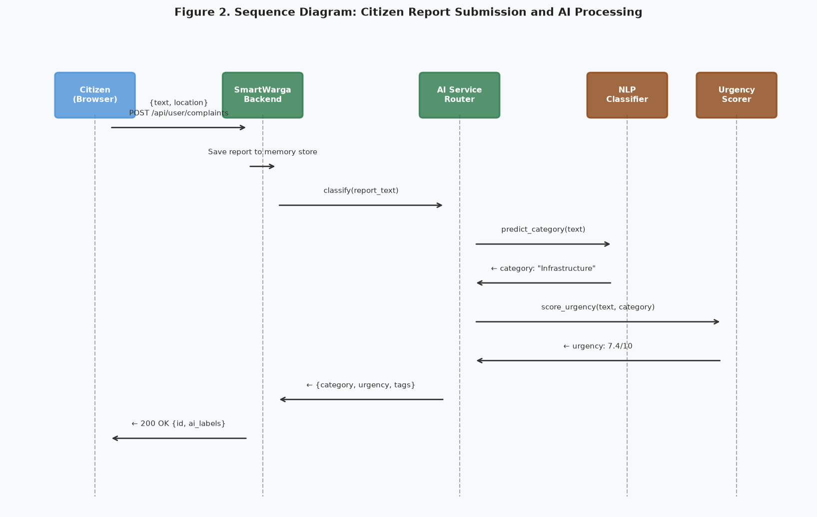
Figure 2. Sequence diagram illustrating the flow from citizen report submission through backend processing, AI classification, urgency scoring, and response.
4.3 Backend Integration and Code Structure
Integration of AI services into the backend involves adding API endpoints, service modules, and data models. For example, an Express.js route may accept report submissions, validate inputs, store initial data, and then call an AI prediction service.
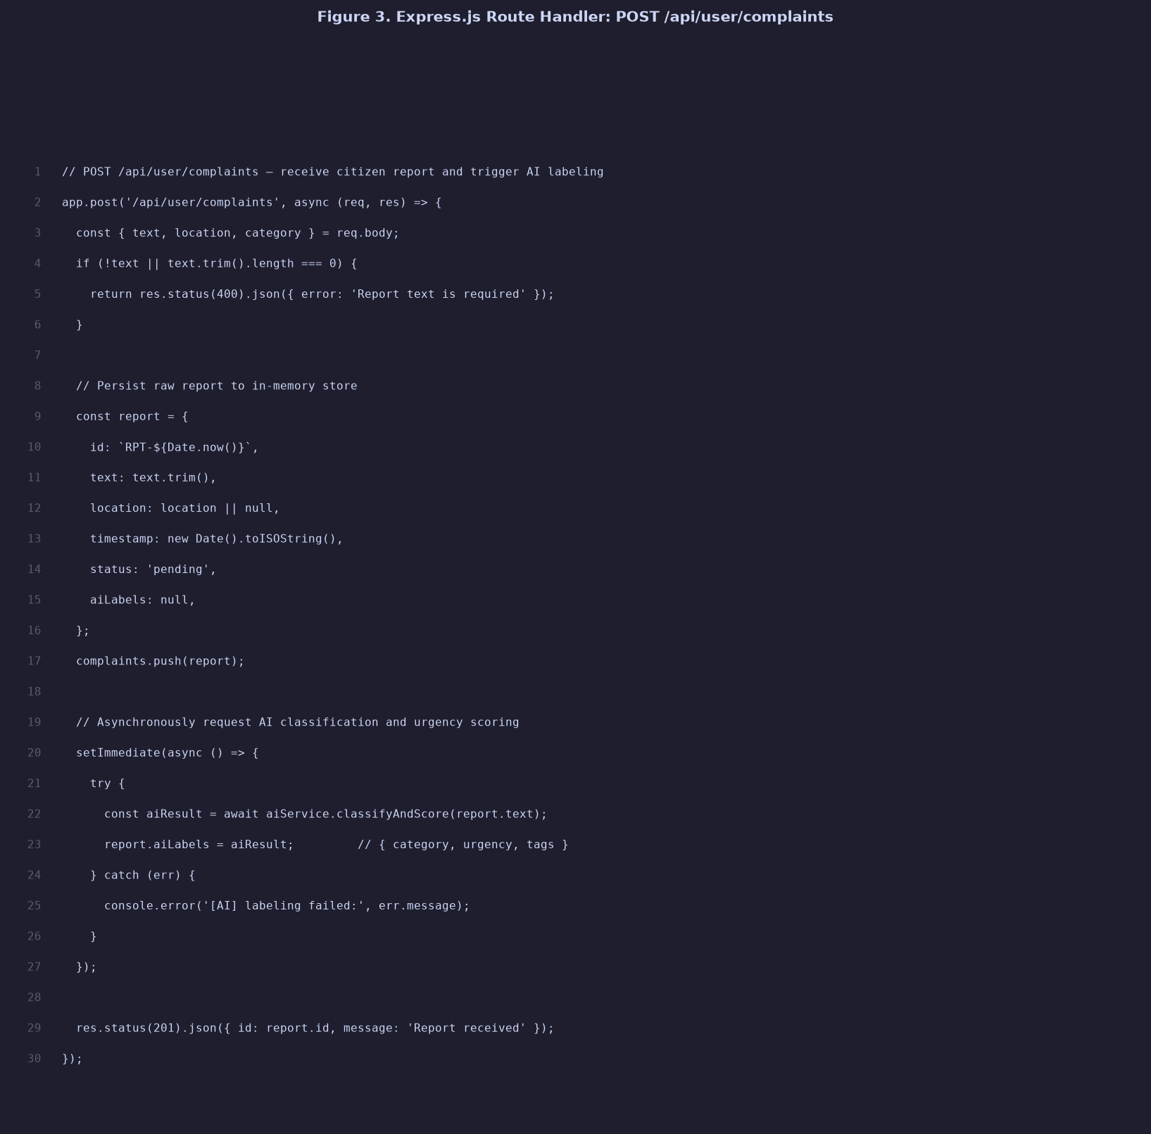
Figure 3. Express.js route handler (POST /api/user/complaints) that receives report data and asynchronously triggers AI labeling via the service module.
A separate integration module manages communication with the AI microservice, including request construction, error handling, and parsing of prediction responses. This module encapsulates external dependencies and provides a clean interface to other parts of the backend.
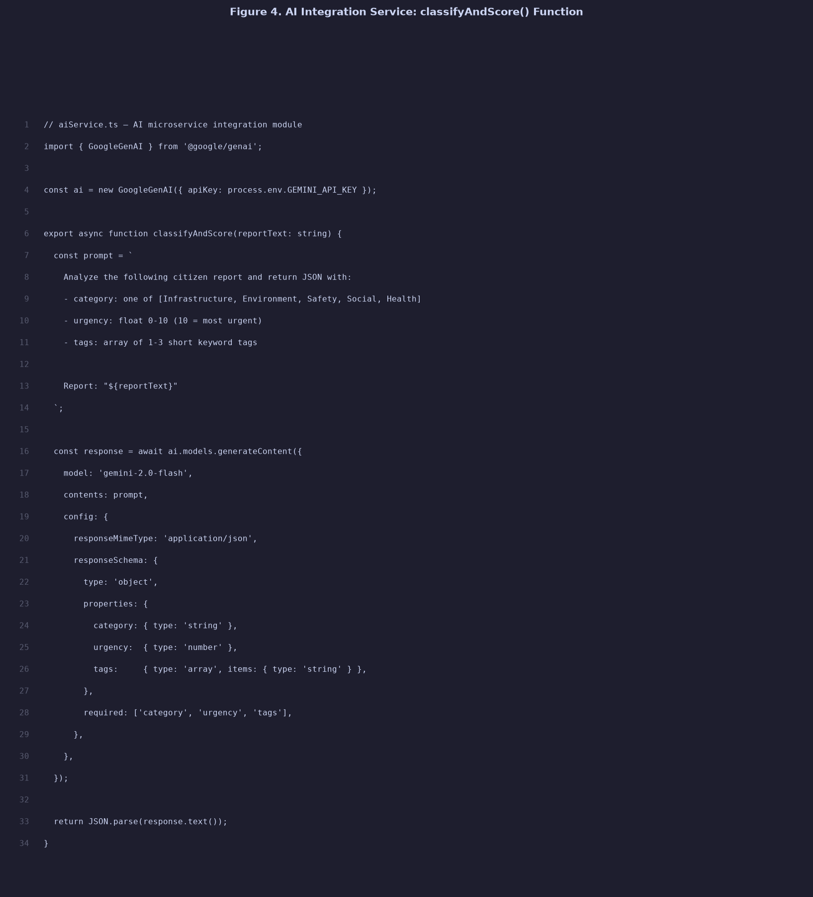
Figure 4. Backend AI integration service (classifyAndScore) that calls the Gemini API to classify report category, estimate urgency, and extract tags.
4.4 User Interface Elements
Administrator dashboards are updated to display AI-generated information in a clear and actionable way. For example, list views include columns for predicted category and urgency score, and detail views present explanations or highlighted keywords to help users understand why a report is considered urgent.
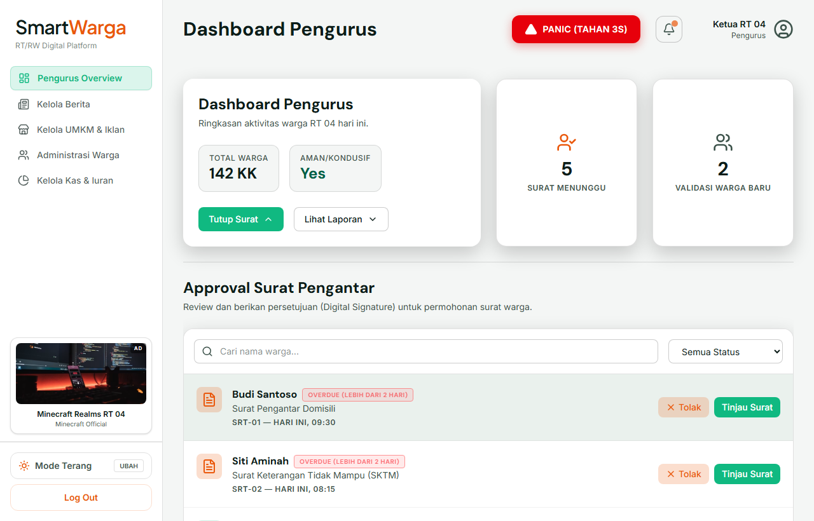
Figure 5. RT/RW administrator dashboard in SmartWarga showing pending letter requests with status filters and approval workflow.
A detail page for each report may show the original text, AI predictions, and controls for confirming or correcting labels. User feedback on predictions can be recorded as additional data to support future model refinement.
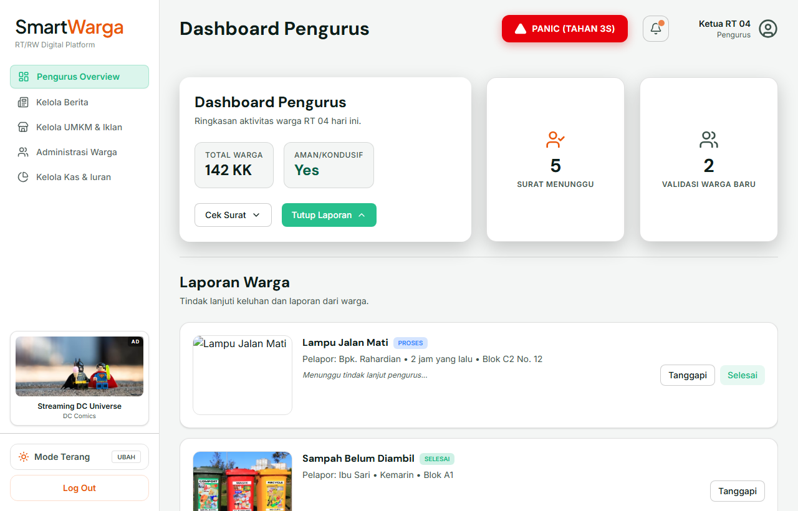
Figure 6. Citizen report triage panel displaying submitted reports with category tags, urgency indicators, and administrator action controls.
4.5 AI Chatbot Integration (WargaAI)
SmartWarga integrates a conversational AI assistant named WargaAI, powered by Google Gemini, to provide residents with instant, natural-language access to RT data. The chatbot is accessible via a floating widget on the user dashboard and responds to queries about RT finances, dues, letters, news, UMKM directory, and community events.
On every request, the backend injects a real-time context object—containing current news, UMKM listings, donation progress, and pending letter counts from in-memory data—into Gemini's system instruction. This enables accurate, data-grounded answers without a database call at query time. The system instruction enforces a warm, formal Indonesian communication style appropriate for a neighborhood platform.
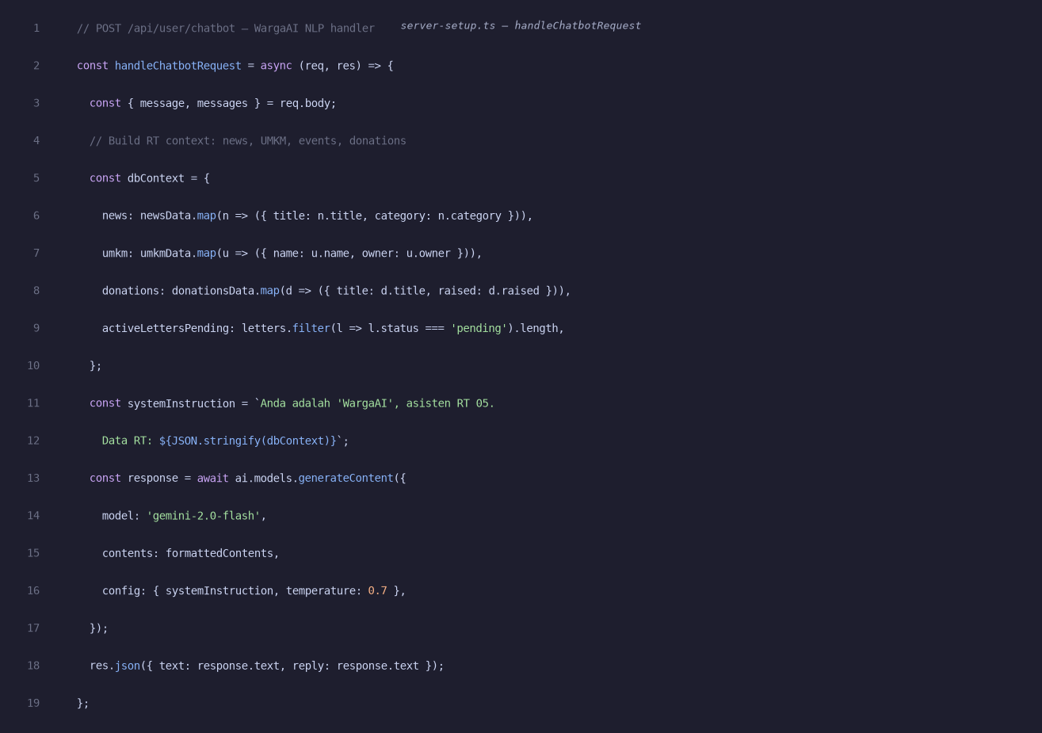
Figure 7. Backend handler (handleChatbotRequest) in server-setup.ts: injects RT context into Gemini system instruction and returns the AI-generated natural language reply.
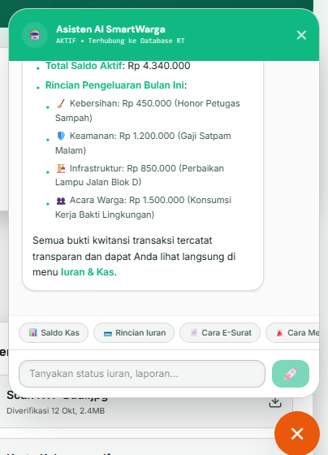
Figure 8. WargaAI floating chatbot panel open on the user dashboard, showing a real-time response to a query about the RT cash balance (saldo kas).
4.6 AI-Powered Report Submission
The E-Reporting module leverages Gemini's multimodal Vision capability to automate the citizen report submission workflow. When a resident uploads a photo of an infrastructure problem, environmental hazard, or safety issue, the image is sent to the Gemini Vision API for analysis.
The model returns a structured JSON response containing a concise report title, one of four predefined categories (Infrastruktur, Kebersihan, Keamanan, or Lainnya), and a formal damage description. These values are automatically populated into the corresponding form fields, reducing manual data entry and improving report quality and consistency across submissions.
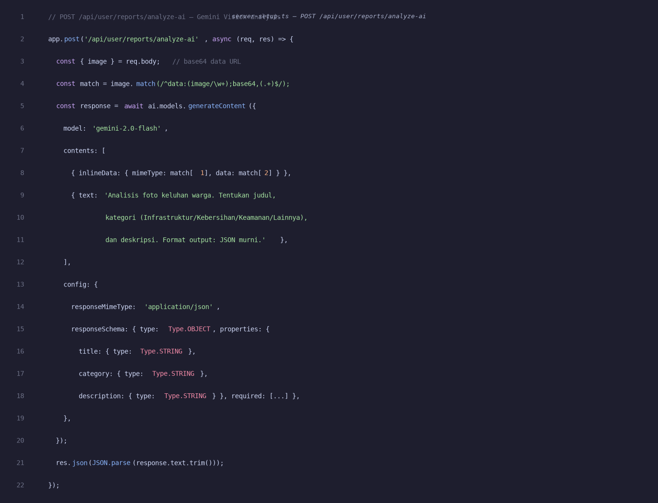
Figure 9. The POST /api/user/reports/analyze-ai endpoint in server-setup.ts: sends the uploaded photo as a base64-encoded inline image to Gemini Vision with a structured JSON response schema, receiving title, category, and description automatically.
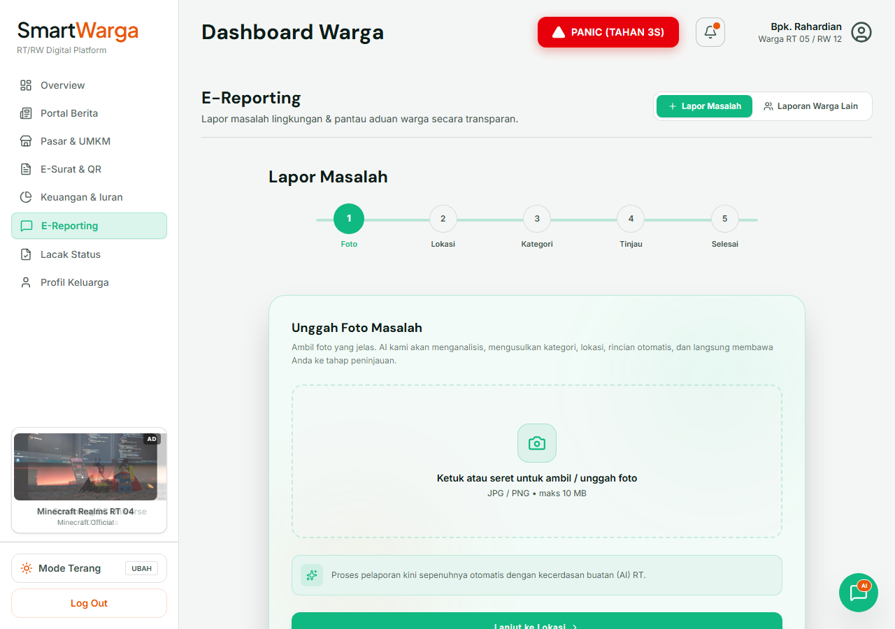
Figure 10. E-Reporting upload interface: the citizen taps to upload a photo of the problem, after which AI Vision analyzes the image and automatically fills the report title, category, and description fields before submission.
4.7 AI OCR for Resident Registration (KTP/KK)
New resident registration in SmartWarga uses Gemini Vision's document understanding capability to automatically extract identity data from uploaded KTP (national ID) or Kartu Keluarga (family card) images. This eliminates the need for manual data entry and reduces transcription errors during onboarding.
When a registrant uploads a photo of their KTP, the frontend converts it to a base64 data URL and calls the POST /api/ocr-ktp endpoint. Gemini Vision reads the document and returns a structured JSON object containing the 16-digit NIK, full name, and address. The registration form fields are populated instantly, and the extracted NIK is cross-validated against the RT's registered resident database before allowing account creation.
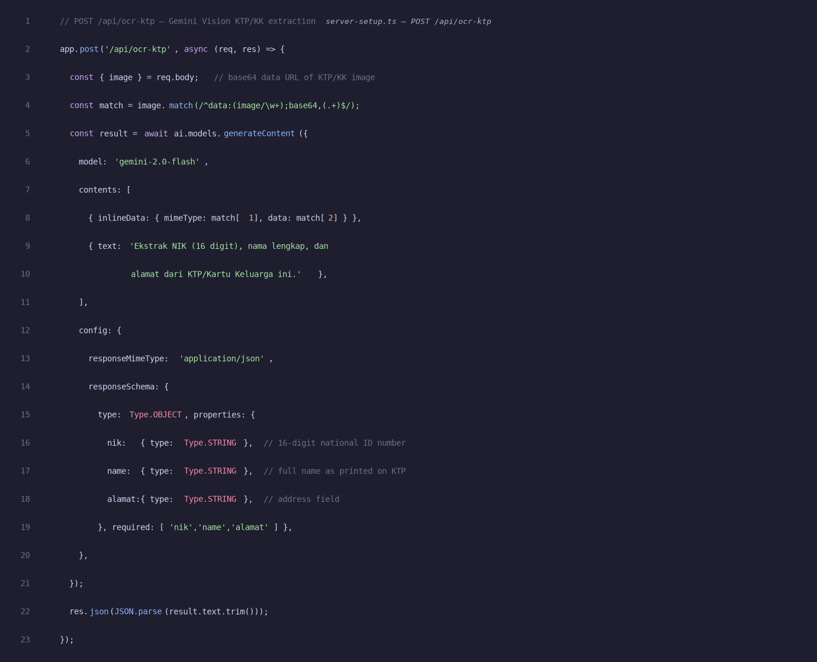
Figure 11. The POST /api/ocr-ktp endpoint in server-setup.ts: receives the KTP image as base64, passes it to Gemini Vision with a structured output schema, and returns nik, name, and alamat fields for auto-filling the registration form.
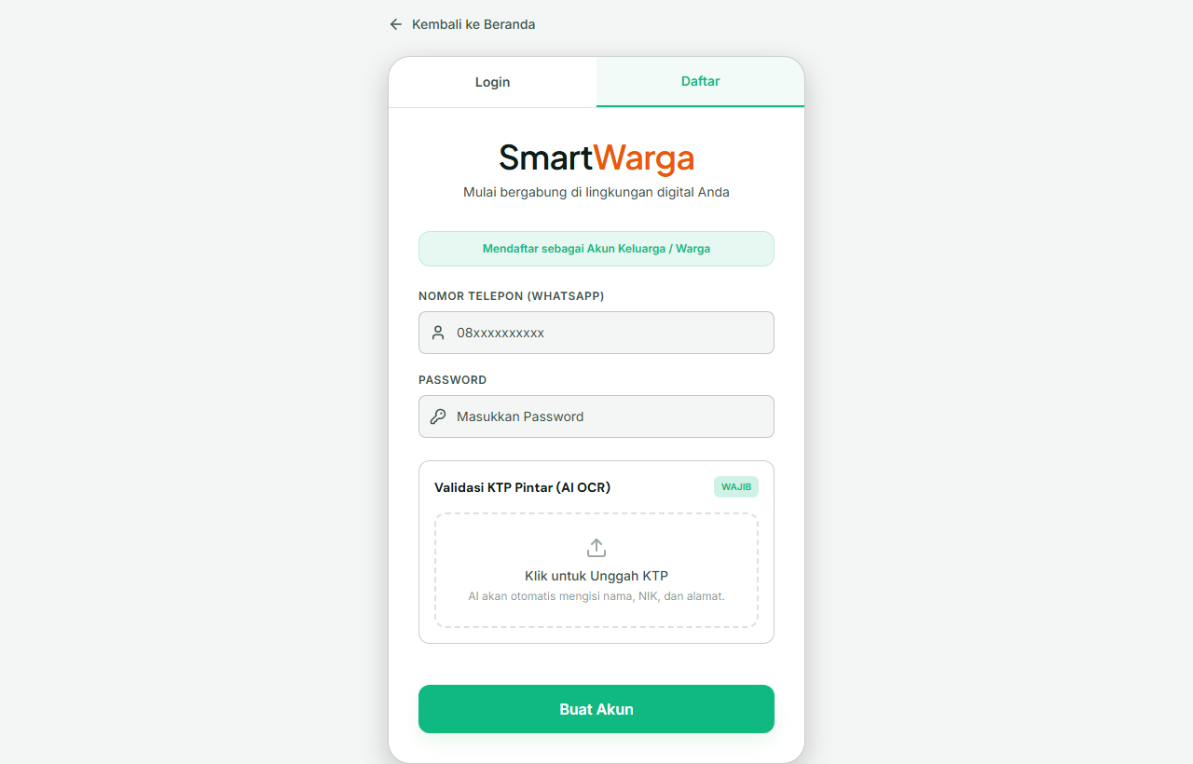
Figure 12. Registration form showing the 'Validasi KTP Pintar (AI OCR)' upload widget — upon document upload, AI Vision populates the NIK, name, and address fields automatically.
4.8 Admin NLP Triage Dashboard
The NLP Triage Dashboard is a new admin-facing panel that applies Natural Language Processing to automatically classify and prioritize incoming citizen reports. Each report submission triggers an asynchronous Gemini call that assigns three AI-generated labels: a category (Infrastruktur, Kebersihan, Keamanan, Sosial, or Lainnya), a numeric urgency score from 0 to 10, and a set of keyword tags summarizing the report content.
The classification runs asynchronously (non-blocking) after the report is saved, so the citizen receives an immediate response while the AI processes the content in the background. The admin triage view, accessible from the 'AI Triage Laporan' sidebar item, displays all reports sorted by urgency descending by default. Administrators can filter by category, sort by urgency or submission date, expand individual reports to view urgency bars and AI tags, and either confirm the AI-generated labels or manually override them—closing the human-in-the-loop validation cycle.
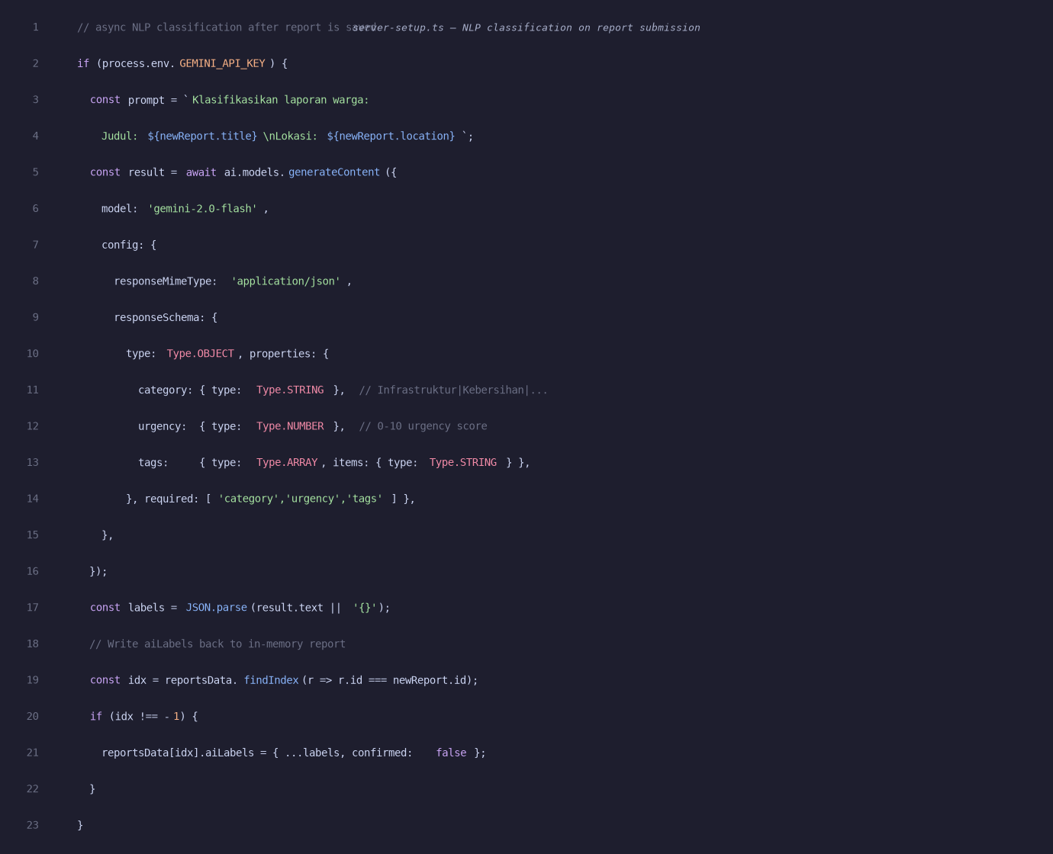
Figure 13. NLP classification in server-setup.ts: called asynchronously after each report submission, it queries Gemini with a structured JSON schema to obtain category, urgency score (0–10), and keyword tags, which are stored as aiLabels on the report object.
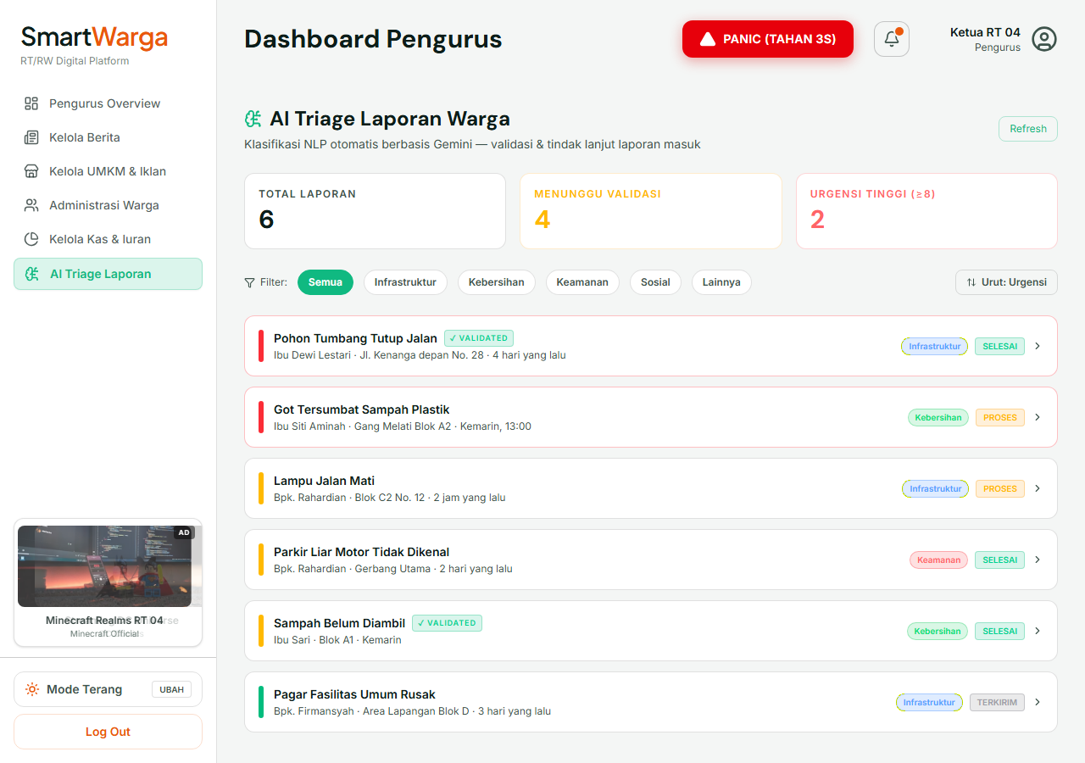
Figure 14. Admin AI Triage Laporan dashboard: reports sorted by urgency score with color-coded category badges (Infrastruktur, Kebersihan, Keamanan), urgency indicators, and VALIDATED status. Admins can filter, expand, confirm labels, or override AI predictions.
5. Planned Evaluation and Discussion
Evaluation of AI-enhanced SmartWarga has two dimensions: technical performance of the models and impact on administrative workflows. On the technical side, text classification models will be assessed using labeled datasets of citizen reports and metrics such as accuracy, precision, recall, and F1-score per category. Baseline approaches, such as simple keyword rules, will be implemented to quantify the added value of machine learning.^{[4][6]}
From a user perspective, qualitative studies will examine whether AI features reduce the time required for RT/RW administrators to triage reports, improve consistency in prioritization, and are perceived as trustworthy and helpful. Interviews and usability tests will explore how administrators interpret AI outputs and where they feel human judgment remains essential. Potential limitations include data sparsity, domain shift across neighborhoods, and risks of bias or unfair prioritization if models are not carefully designed and monitored.^{[8][10]}
These findings will inform iterative improvements to both models and interfaces, as well as guidelines for responsible AI deployment in neighborhood-level governance.
6. Funding Scheme and Project Timeline
The SmartWarga AI project is supported by a funding scheme with a maximum budget of IDR 4,000,000. The allocation is structured as follows:
- IDR 2,000,000 for honoraria to four student research assistants (IDR 500,000 each), payable upon successful publication of the article or receipt of a Letter of Acceptance (LOA) from an academic conference.
- IDR 2,000,000 for product development costs, including domain registration and hosting/server fees for prototype deployment, potential AI service or cloud computing expenses, and supporting equipment such as storage devices or software licenses.
The project timeline spans approximately one year, starting in September after the end-of-semester examinations. Major phases include:
- Months 1–2: Empathize and Define – user research, literature review, and problem formulation.
- Months 3–4: Ideate – design of AI feature set and system architecture.
- Months 5–7: Prototype – implementation of AI microservices, backend integration, and interface adaptations.
- Months 8–10: Test – technical evaluation and user testing with RT/RW administrators, followed by iterative refinement.
- Months 11–12: Completion – preparation of the research article, documentation of code and interfaces, production of demonstration videos, and submission to RTTO and conferences.
7. Additional Outputs
Beyond the academic paper and functional prototype, the project aims to produce several additional outputs that support dissemination and educational use:
- An intellectual property (IP) oriented video that explains the novelty of AI features in SmartWarga and their potential contribution to citizen reporting technologies.
- A product demonstration video that showcases end-to-end use of SmartWarga from both citizen and administrator perspectives, with emphasis on how AI assistance changes the handling of reports.
- Teaching materials and syllabus components for courses related to smart city systems, web application development, and introductory NLP for public administration contexts, incorporating examples from SmartWarga.
These outputs help bridge research, practice, and education, aligning with the goals of technology transfer and capacity building at Bina Nusantara University.^{[5][7]}
8. Conclusions
This paper presents the design and planned implementation of AI-powered features in SmartWarga, a neighborhood-scale citizen reporting platform aimed at RT/RW contexts in Indonesia. Using a Design Thinking framework, the study connects user-centered problem exploration with AI solution design, ensuring that technical additions such as text classification and urgency scoring respond to real challenges faced by local administrators.^{[11][12]}
Related work on smart city complaint systems and NLP-based civic complaint analysis demonstrates the feasibility of applying machine learning to citizen reports, while also highlighting gaps in tools available at neighborhood level. The proposed architecture leverages AI microservices integrated with a web backend to provide structured, prioritizable views of citizen reports without overhauling existing workflows.^{[2]}4][^6]
Future work will involve building labeled datasets from SmartWarga usage, rigorously evaluating model performance, and studying long-term impacts on responsiveness, transparency, and citizen satisfaction. As Indonesia’s smart city ecosystem continues to evolve, platforms like SmartWarga enriched with AI capabilities can play an important role in making local governance more data-informed and citizen-centric.^{[3]}5][^7]

References
- JAKI - Jakarta Kini – Apps on Google Play - One Super App for your various needs in Jakarta!
- [PDF] Smart Civic Complaint Analyzer Using Natural Language Processing - The platform incorporates Natural Language Processing (NLP) to identify complaints made in simple te...
- Take a Peek at Citizen Report on JAKI 3.0 || Jakarta Smart City - Reporting is easier now using Citizen Report on the new version of JAKI. Take a peek here!
- [PDF] Citizen Grievance Classification and Decision Support Using NLP ...
- Profile - Jakarta Smart City - Jakarta Smart City is a catalyst in creating smart city ecosystem, an innovation lab, and a connecto...
- Automatic Classification of Public Complaints Using Naive Bayes - This study develops an automatic classification model for public complaints in eight categories econ...
- Profil - Jakarta Smart City - Pemprov DKI Jakarta - Jakarta Smart City adalah katalisator ekosistem kota cerdas 4.0, laboratorium inovasi, dan penghubun...
- [PDF] CivicSense: AI-Based Citizen Complaint Analyzer - Atlantis Press - CivicSense, an AIbased platform that applies Generative AI and sophisticated Natural Language Proces...
- Civic Complaint Priority Management System
- [PDF] multilingual ai-guided civic issue reporting and government service ...
- The Process of DESIGN THINKING - The document outlines the design thinking process which includes five steps: empathize, define, idea...
- The Design Thinking Process - The document outlines the 5 key stages in the design thinking process: empathize, define, ideate, pr...

