TIMOTHY SEBASTIAN  DARMAWAN | 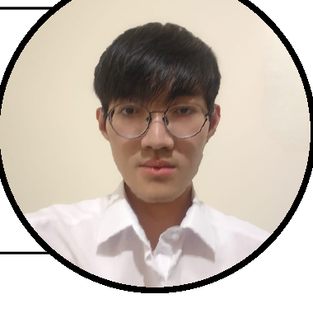

ABOUT ME  Cyber Security student at Bina Nusantara University combining practical depth in AppSec, DevSecOps, and Linux infrastructure with advanced hands-on expertise in LLM agent harnesses, prompt caching economics, and AI orchestration. Experienced in building full-stack B2B SaaS platforms (ReviewTap), developing threat detection engines (Nolen), operating self-hosted cloud systems (Noema), engineering production corporate web systems (Terang Darma Jaya), and leading technical teams.  EXPERIENCES & PROJECTS  2025 — 2026 Featured Engineering Platforms  - ReviewTap (B2B SaaS): Architected NFC/QR Google review platform with sub-second (<1s) dynamic redirect engine, merchant dashboards, and Supabase PostgreSQL (RLS).  - Nolen Lead: Authored threat model, telemetry security requirements, detection rules (MITRE ATT&CK), SSH correlation engine; passed 52 tests and 6 offline scenarios.  - Terang Darma Jaya: Designed and built production corporate website (terangdarmajaya.com), custom UI animations, and Google Tag Manager telemetry.  - Noema & LifeOS: Self-hosted workspace (Next.js PWA, SQLite, background jobs, Bubblewrap sandbox, Tailscale mesh).  - SmartWarga & GuruAI: RT/RW governance platform with dues verification queue (Next.js); Kurikulum Merdeka pedagogical AI co-pilot.  - CTF Competition & Sentinel: Autonomous CTF orchestration agent skill with compaction recovery; developer-oriented vulnerability & secret scanner.  Organizational & Leadership Experience  - Head of Committee / PIC (BNCC HRD): Led a 6-person team managing the 3-week ADP Adobe After Effects Program (Jul—Aug 2026).  - Backend Dev (BNCC TPM Final Project): Engineered auth, dashboard, and Prisma ORM services for a hackathon platform (Feb 2026).  - Activist of BNCC (R&D / HRD): Backend practice, technical program planning, SWOT analysis, and member development.  - Media Partner Staff (BNCC CSR 2026): Coordinated external media partnerships and promotional touchpoints, awarded Certificate of Appreciation.  - Activist of PO: Small group leadership, weekly progress tracking, and internal accountability.  CONTACT  📞 +62 877 7717 9775  ✉️ td522637@gmail.com  📸 @timsurreal  🌐 github.com/timsurrealedu  📍 Jakarta, Indonesia | EDUCATION  • 2025 ~ Expected 2029  Bina Nusantara University  B.Sc. in Cyber Security (Specialization in AppSec, Systems & AI Tooling)  • 2022 - 2025  SMAK 1 BPK Penabur Jakarta  High School Diploma, Science Major (IELTS Band 8.0)  SKILLS & CAPABILITIES  - AI Engineering & Agent Harnesses: Reasonix, Claude Code, Codex, prompt caching optimization, token economics, custom agent skills, model evaluation across Western & Chinese frontier models.  - Full-Stack & Web Platforms: TypeScript, Next.js 15, TailwindCSS v4, Node.js, Express, Prisma ORM, Supabase PostgreSQL (RLS), dynamic redirect engines, Google Tag Manager.  - Security & DevSecOps: AppSec threat modeling, MITRE ATT&CK, detection engineering, secret scanning, Trivy, SonarCloud, GitHub Actions CI/CD.  - Systems & Self-Hosting: Linux (Arch Linux, NixOS, Fedora), system admin, Oracle Cloud (OCI), Tailscale mesh, Syncthing, Bubblewrap sandbox.  - Leadership & Communication: Team management, program planning, technical workshops, public speaking, SWOT analysis.  - Languages: English (IELTS Band 8.0 — Professional), Indonesian (Native), Mandarin (Basic).  - Certifications: BNCC CSR 2026 Certificate of Appreciation (2026), CTF Meta4sec 3.0 Competition (2026), ISACA ARISE IT Audit (2026), BNCC TPM Back-End (2026), IT FAIR XIV UI/UX Competition (2026).

