The graphs below show the distribution of velocities of the more active mouse when it is stimulated and when it is not stimulated.

For each graph, the maximum velocity plotted is set to 100cm/s, as larger velocities are likely measurement values (the correct threshold is unclear).

Each bar represents the percent of total velocities that fall in a given range.

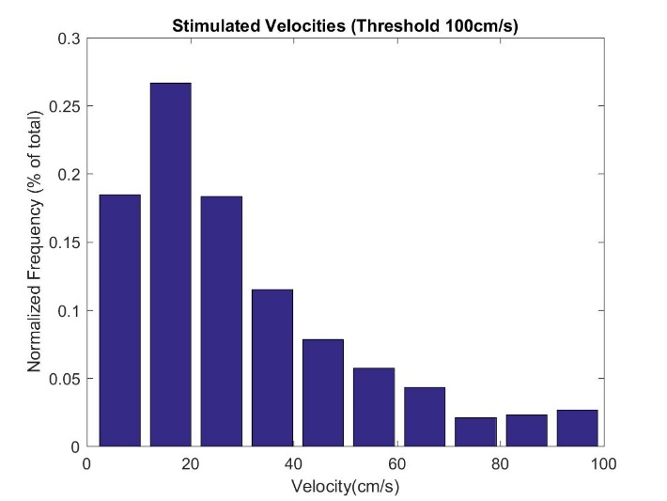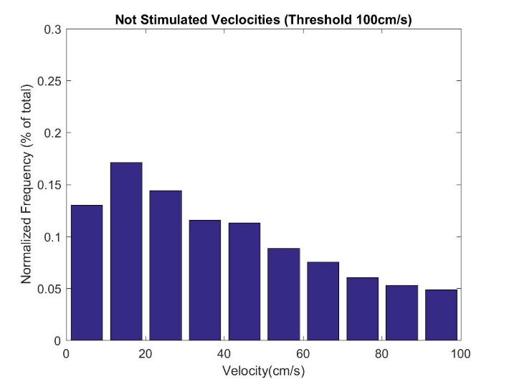

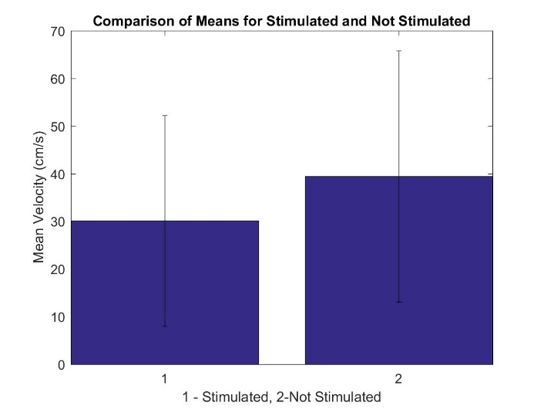

The graph below compares the mean velocities for the mouse when stimulated and when not. The error bars are one standard deviation. The variation may be large due to measurement errors (threshold may be incorrect or another method should be used to preprocess the data?).

Summary of day

Observed surgery of implanting nvista hd device

Tutored by Mollee Jain on Mosaic software (and EthoVision XT)

Observed optogenetic experiment

Analyzed data from previous optogenetic experiment