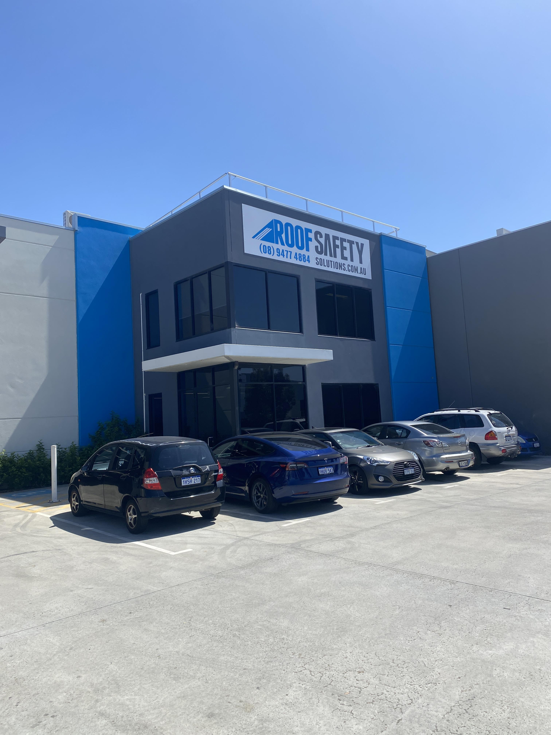

**Height and Safety Audit Report for House of sin**

Roof Safety Solutions Pty Ltd

38 Raduis Loop, Bayswater WA 6053

p: 08 9477 4884

f: 08 9277 3009

e: admin@roofsafetysolutions.com.au

**Contents**

Evaluation Only. Created with Aspose.HTML. Copyright 2013-2023 Aspose Pty Ltd.

1.

Version History

2

2.

Executive Summary

2

3.

Inspection Details

3

4.

Introduction

3

5.

Risk Assessment

4

6.

Inspection Report

5

7.

Summary

15

8.

Conclusion

16

9.

Disclaimer

17

**1. Version History**

**Version**

**Description**

**Author**

**Information**

**2. Executive Summary**

Roof Safety Solutions were contracted to perform the routine audit of House of sin.

The following existing height safety equipment is installed on site:

•

Surface Mount Anchor Points

•

Walkway

•

Horizontal lifeline.

•

Purlin Mount Anchor Points

•

Surface Mount Anchor Points

•

Hatch

•

Signage

•

Platform / Landing

•

Froglink Anchor

The inspection was carried out on the Wednesday, 11 October 2023 by height safety inspectors from Roof Safety

Solutions Pty Ltd. The inspection identifies any risks and reports on compliance in relation to the Australian Standards,

Acts and Regulations that form the basis for height safety in Australia.

This report contains:

•

An inventory of installed height safety equipment,

•

Compliant items,

•

Non-compliant items,

•

Recommendations to rectify any non-compliant issues.

All recommendations have been made in the report to reduce risk of injury as outlined and required by:

•

Work Health & Safety Act 2020 (WA).

•

Work Health & Safety Regulations 2022 (WA) relevant to Fall Prevention.

•

Code of Practice – Prevention of Falls at Workplaces 2020 (WA).

•

AS 1657:2018 - Fixed platforms, walkways, stairways and ladders.

•

AS/NZS 1891.4:2009 - Industrial fall-arrest systems and devices –selection, use and maintenance.

•

AS/NZS 4488.2:1997 – Industrial rope access systems – selection use and maintenance.

**3. Inspection Details**

**Inspection Date:**

11-Oct-2023

**Areas Inspected:**

**Inspector:**

**Testing Instrument:**

Evaluation Only. Created with Aspose.HTML. Copyright 2013-2023 Aspose Pty Ltd.

**4. Introduction**

Roof Safety Solutions has been commissioned to:

1. Supply an inventory of all height safety equipment installed on site.

2. Carry out an inspection of all existing assets, in accordance with:

• Work Health & Safety Act 2020 (WA).

• Work Health & Safety Regulations 2022 (WA)

• Code of Practice – Prevention of Falls at Workplaces 2020 (WA).

• AS 1657:2018 - Fixed platforms, walkways, stairways and ladders.

• AS/NZS 1891.4:2009 - Industrial fall-arrest systems and devices –selection, use and maintenance.

• AS/NZS 4488.2:1997 – Industrial rope access systems – selection use and maintenance.

• AS/NZS 1891.4:2009 - Industrial fall-arrest systems and devices –selection, use and maintenance.

3. Report on findings, identify existing hazards and provide suitable recommendations in cases of non-compliance.

**5.Risk Assessment Matrix**

This report will use the following risk assessment matrix to show the severity of any identified hazards.

**Consequence**

Injuries not

requiring First

Aid

First Aid

Treatment

Case.

Serious injury, medical

treatment or

hospitalisation.

Multiple serious

injuries causing

hospitalisation.

Death or multiple

life threatening

injuries.

Likelihood

**Negligible**

**Minor**

**Moderate**

Major.

Catastrophic

Almost

Certain

5

10

15

20

25

Likely

4

8

12

16

20

Occassionally

3

6

9

12

15

Unlikely

2

4

6

8

10

Rare

1

2

3

4

5

Extreme (15-

25)

Immediate Management Action is required

High (8-14)

Management attention is required with the implementation of formal controls

Medium (4-7)

Requires active monitoring or action

Low (1-3)

Does not require active management

**6. Inspection Report**

**Item 1.1**

**Risk:**

**Maintained**

**Description:**

Surface Mount Anchor Points

**Location:**

**Result:**

**☑**

**Compliant**

**Explanation:**

nn

Compliant

The Anchor Points have been inspected in accordance with manufacturers recommendations, AS1891

and legislative requirements. The anchors are in good operational condition and is fit for use.

Evaluation Only. Created with Aspose.HTML. Copyright 2013-2023 Aspose Pty Ltd.

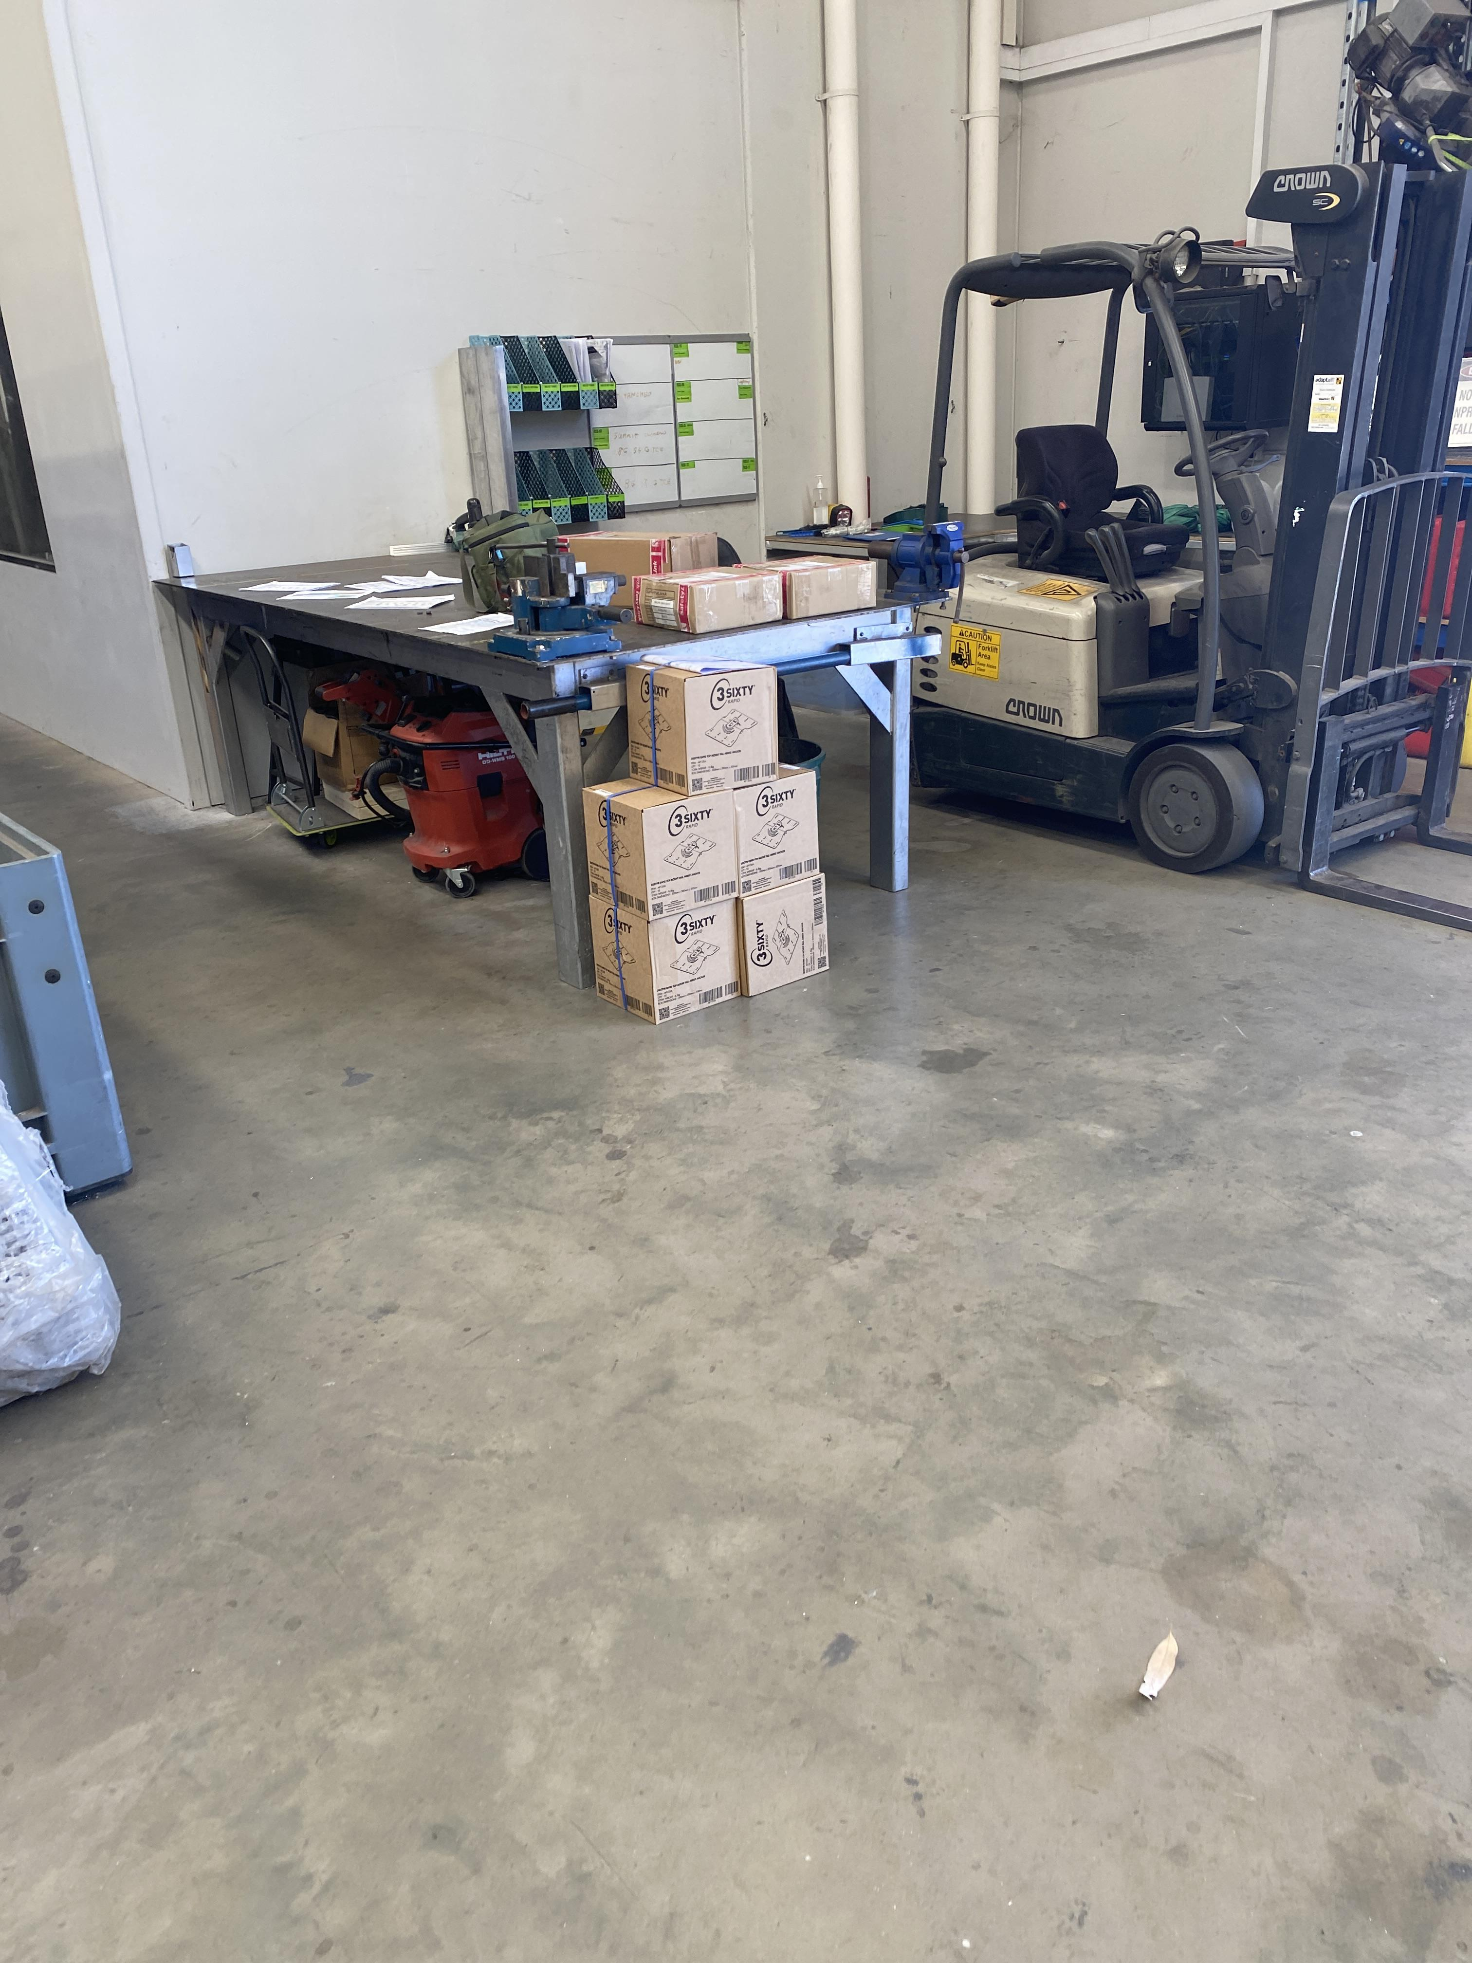

**Item 1.2**

**Risk:**

**Risk 9**

**Description:**

Walkway

**Location:**

Factory Floor

**Result:**

**☐**

**Non-Compliant**

**Explanation:**

**No edge protection on walkway narrower than 600mm.**

*AS 1657:2018 Clause 5.1.3,A 123*

Evaluation Only. Created with Aspose.HTML. Copyright 2013-2023 Aspose Pty Ltd.