Create scene from stargate atlantis

Screenshots from the scene

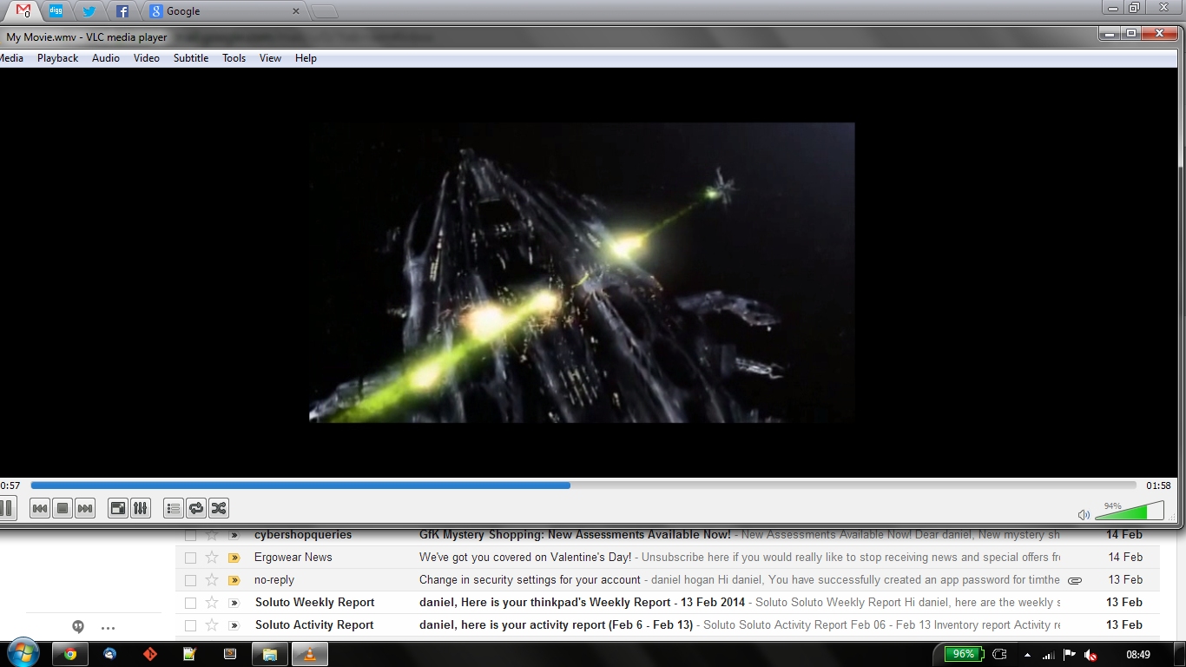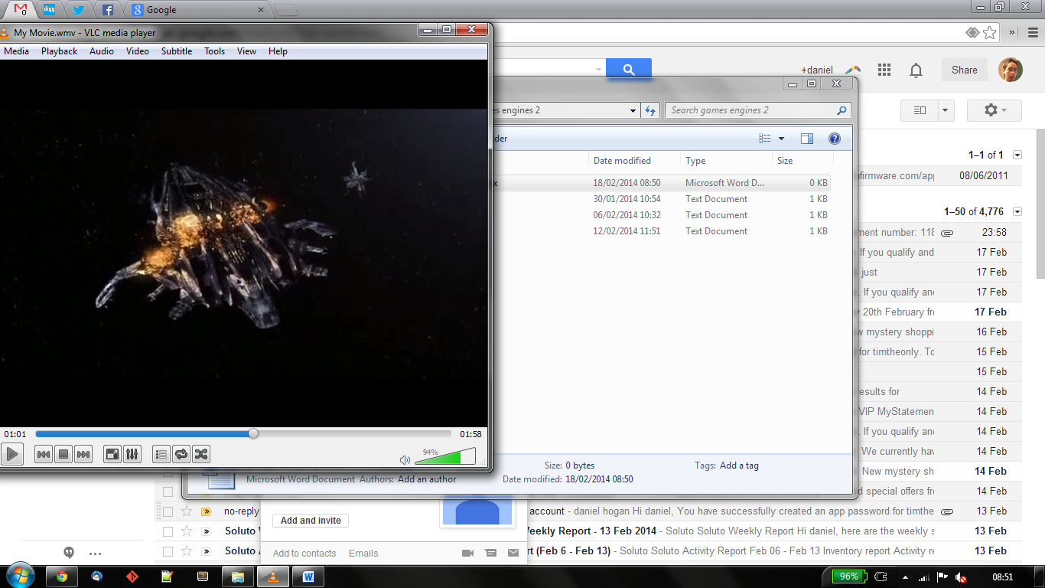

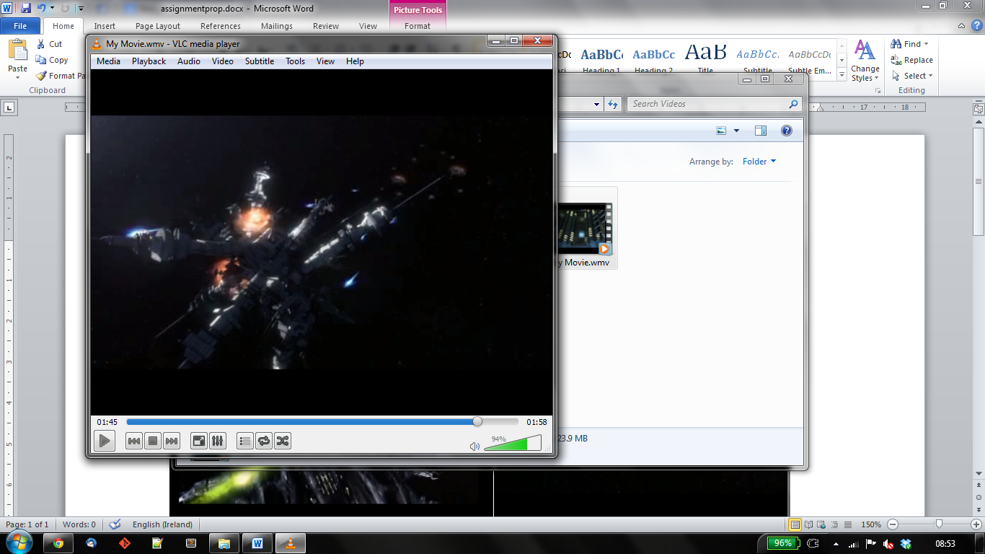

Github repo:

<https://github.com/timtheonly/UnitySteeringBehaviours/tree/assign>