Puddle jumper flees from the defence satellite and cloaks while flying.

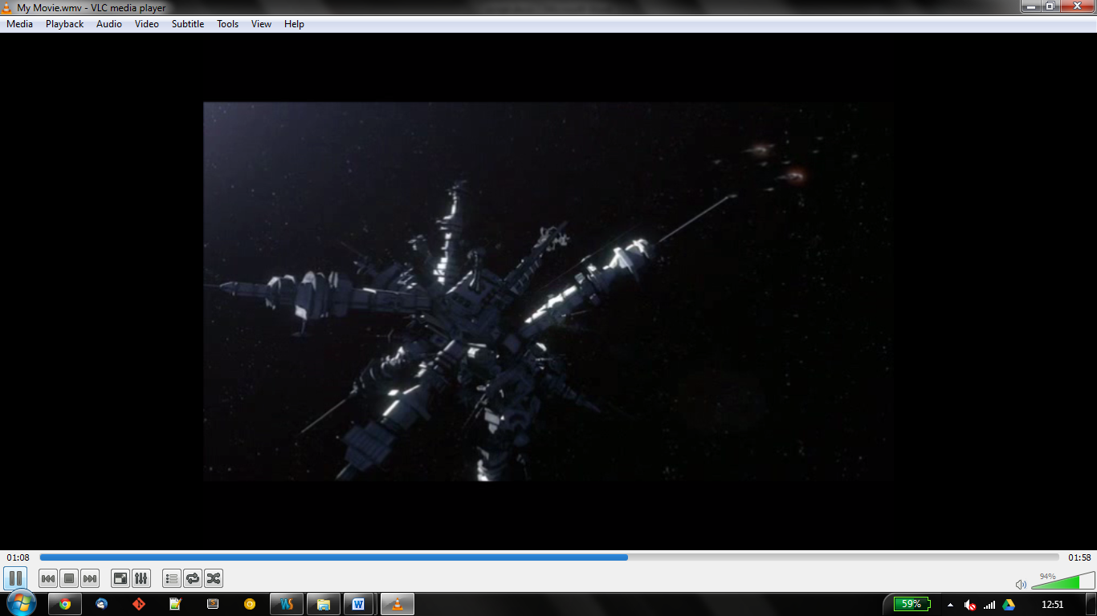

Three wraith hive ships and cruisers exit hyperspace in the vicinity of the defence satellite as the wraith vessels pass by the defence satellite, it powers up unnoticed by the wraith vessels.

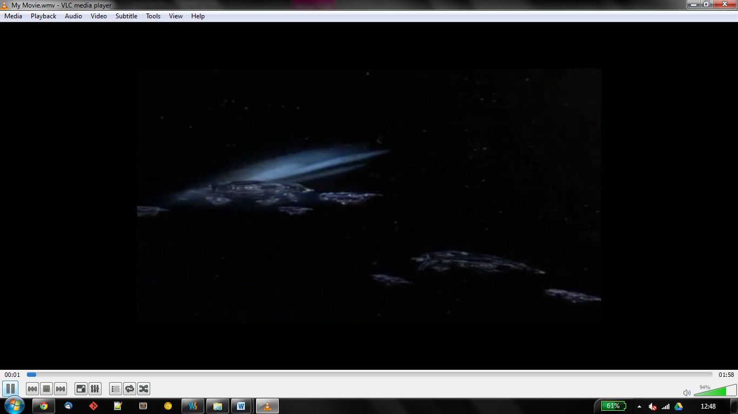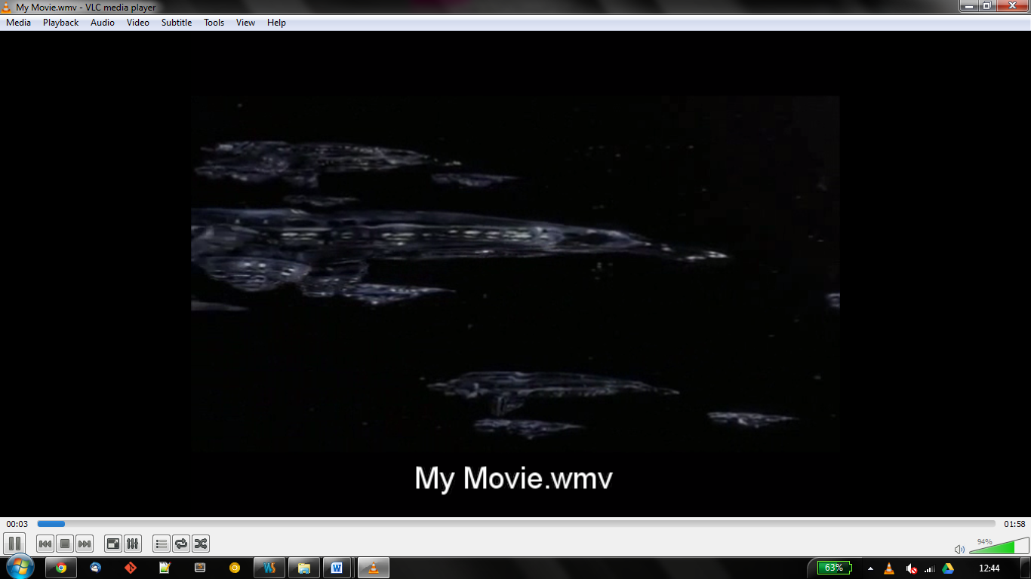

Once the defence satellite is charged it fires an energy weapon and destroys one of the wraith hive ships. The remaining wraith vessels then converge on the defence satellite.

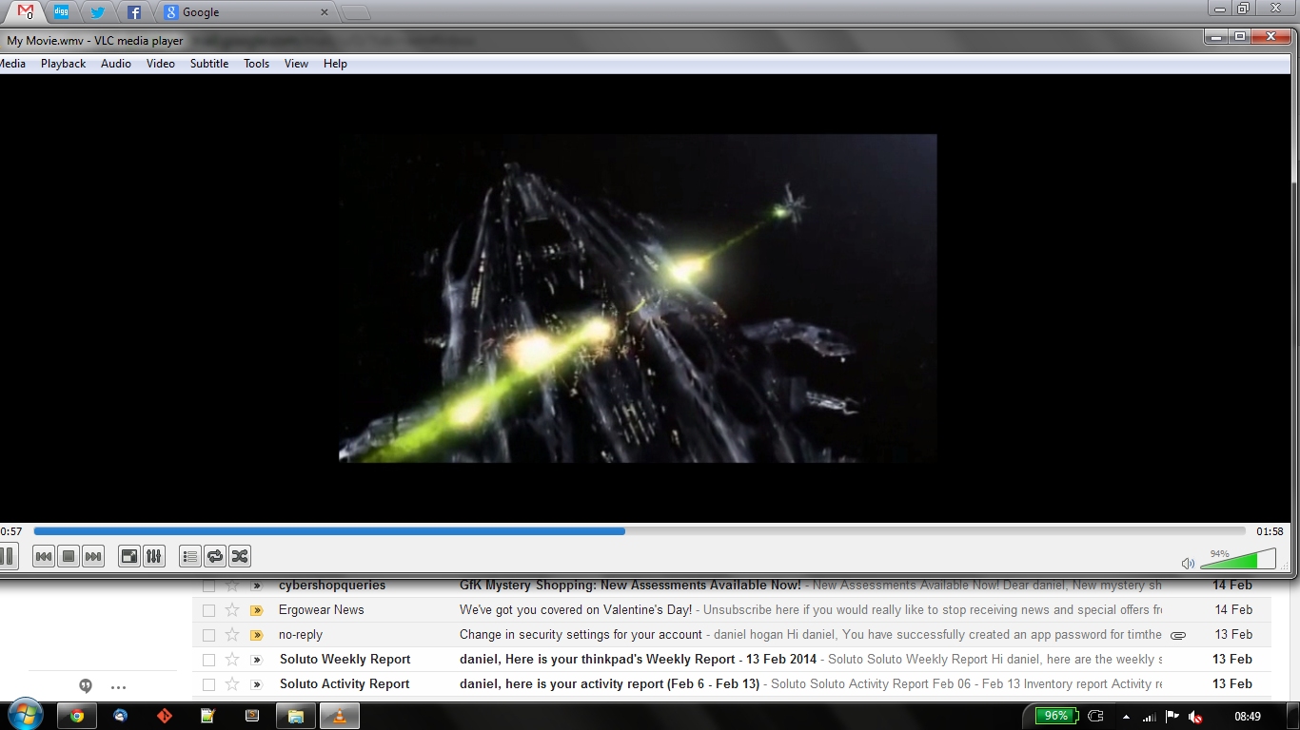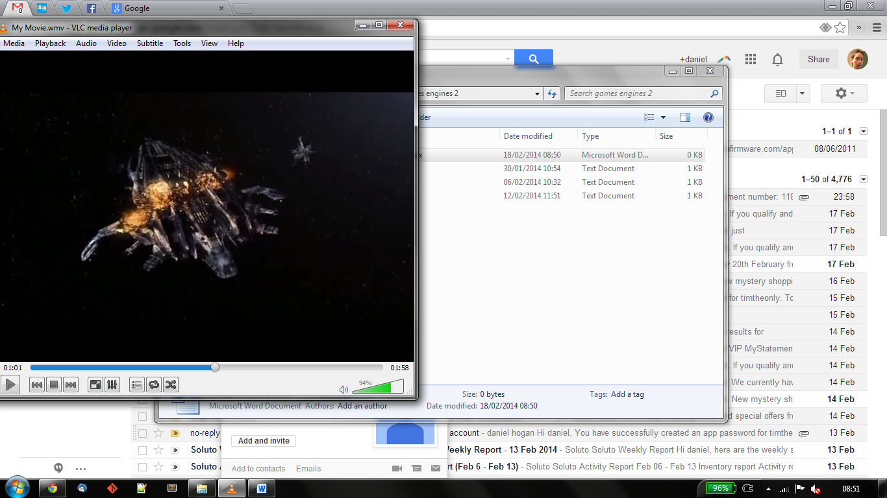

The defence satellite suffers from a catastrophic failure and fails to fire a second time. The crew on the puddle jumper argue to go back and fix the satellite, but decide it would be futile as it would mean un-cloaking the puddle jumper and revealing their position.

The wraith vessels are now in firing range of the defence satellite and begin to fire on it, once the defence satellite has been destroyed the wraith ships enter a hyperspace window.

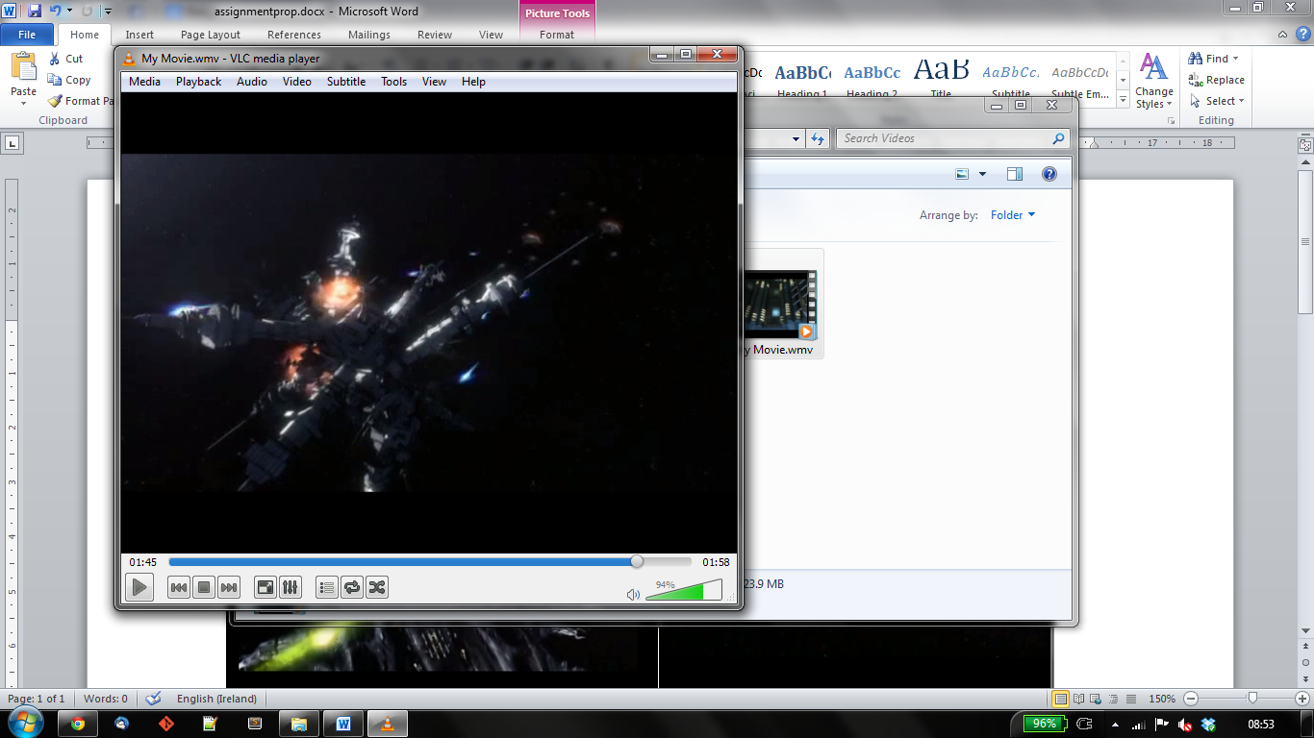

The puddle jumper then uncloaks and disappears from the scene.