Game Description
A 3d tank game that pits the user against three increasingly difficult tanks.
Controlling the game
Using Xbox controller

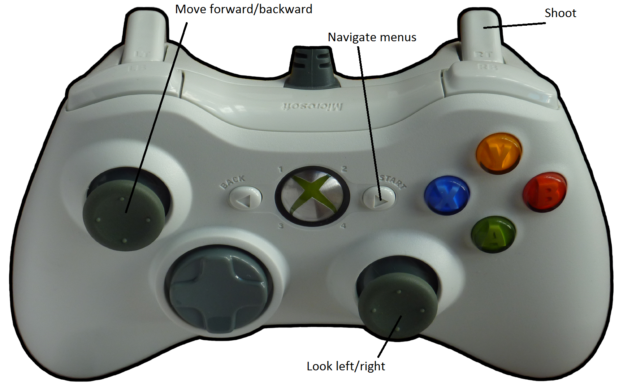

Using the Keyboard

