Prior First- and Fifth-Runner Times as Predictors of Championship Team Place in District of Columbia High School Cross Country
Timothy Tran
St. Albans School
12th grade
Washington, DC, USA
timotran27@gmail.com

Abstract
High school cross country awards team titles by summing the finishing places of five scorers, which raises the question of whether next championship team place is better anticipated by a program’s fastest runner or by its fifth scorer. Prior work on packing looks at how tightly teammates cluster during a race, while sports-forecasting studies rate teams from repeated game outcomes. Neither literature compares lagged first- versus fifth-runner summaries under a five-scorer rule. This paper tests that comparison using public varsity championship results from the District of Columbia State Athletic Association, all contested at five kilometers on a single course. Next championship team place is the primary outcome. Models adjust for school enrollment and sector and are evaluated on a later championship that was not used to choose the specification. Prior fifth-runner relative time was more strongly associated with subsequent boys’ team place than prior first-runner relative time, and it reduced holdout error relative to school characteristics alone. Models that included both runners or conference membership had even lower error on that later meet, though the two runner summaries were highly collinear. An exploratory girls’ panel did not reproduce the same in-sample ranking. The result is a local ranking of public summaries, not a causal account of pack depth or a forecasting model that should be expected to travel.
Introduction
Team scoring in high school cross country is not the same as individual placing. Under National Federation rules, team place is determined by summing the finishing places of a school’s first five runners, and sixth and seventh finishers do not add to their own team’s score even though they displace opposing scorers who finish behind them (National Federation of State High School Associations, 2025). A program can have the meet’s fastest individual and still lose the team title if its fifth scorer is far back in the field.
That scoring rule leaves two competing summaries of prior performance. One is the lead runner, whose time usually corresponds to a high place and is often treated as the program’s ceiling. The other is the fifth scorer, who sits at the margin of the scoring five. The question here is which of those lagged championship summaries, if either, better predicts the next team result after adjustment for school size and sector.
The packing literature is related, but it asks a different question. Falk, Larson, and DeBeliso (2022) measured how often NCAA women’s teammates ran within one second of one another at race checkpoints and found that greater packing was associated with faster combined team times in the same race. If that within-race construct were interchangeable with a lagged fifth-runner time, the spread between a team’s first and fifth times (“pack gap”) should be the more informative predictor of next championship place. This paper tests that implication directly. Finley and Fountain (2023) likewise remain inside a single championship, classifying NCAA teams by opening pace and subsequent movement through the field relative to pre-meet rankings. Hanley (2015, 2016) documented packing and pacing in world-level half marathons and championship marathons, including sex differences in elite fields that are deeper and more homogeneous than a District of Columbia high-school championship. Those papers describe what happens during a race. They do not compare last championship’s first runner with last championship’s fifth runner as forecasts of next team place.
Sports-forecasting research is more useful here as an evaluation standard than as a model to copy. Stefani (1980) constructed least-squares ratings from game results. Kvam and Sokol (2006) combined logistic regression with a Markov chain using a season of NCAA basketball outcomes. Pasteur and Janning (2011) simulated remaining high-school football schedules to project playoff seeds. Those designs rely on repeated contests against identified opponents. A District of Columbia cross country championship is a single annual race scored by five internal places, so applying a full rating system to this file would overstate the available information. What those studies motivate is out-of-sample evaluation: a predictor should be judged on meets that were not used to select it.
School resources are also a plausible confounder. Johnson, Manwell, and Scott (2019) found that private schools win a disproportionate share of high-school football state titles and that the public–private distinction outweighed several other structural variables. The District of Columbia championship is an open meet mixing independent, public, and charter schools, several of which also compete in the Washington Catholic Athletic Conference. Comparing first- and fifth-runner times without enrollment and sector would risk attributing to “depth” what is partly a school-type difference, so those controls belong in the confirmatory specification.
The District of Columbia State Athletic Association contests a single open championship. In the parseable Kenilworth Park years, the race was held at five kilometers with a usual seven-runner cap (District of Columbia State Athletic Association, 2025). The fixed venue makes within-meet standardization possible without converting times across courses. The contribution of this paper is a site-specific ranking of two lagged public summaries as predictors of next boys’ varsity team place among schools with an eligible prior championship, after enrollment and sector adjustment. Accuracy is defined as lower error on a reserved later championship. The paper does not propose a general forecasting system, and it does not treat fifth-runner relative time as a causal measure of pack depth.
Methods
Data Sources and Sample
This paper uses public championship archives rather than invitational results so that every predictor is known before the outcome race and is measured on the same course. Meet listings were taken from the MileSplit championship index and, for 2025, from M&D Timing (District of Columbia State Athletic Association, 2025; MileSplit, 2026; M&D Timing, 2025). Local copies of result pages are stored with the analysis code. When a posted team-score table and a reconstructed table both existed, the posted table was treated as authoritative.
Where posted and reconstructed scores overlapped (n = 67), exact place agreement was 82.1% and exact score agreement was 38.8%. Reconstructed scores were used only when a posted team table was missing.
School names were mapped through a directory that records sector (private, public, or charter), Washington Catholic Athletic Conference membership, and grades 9–12 enrollment. Public-school enrollment was taken from the official fall audit for the school year containing the championship (District of Columbia Public Schools, 2026). Private and charter enrollment used a static directory estimate when year-specific audits were unavailable, and unmatched names were dropped. Table 1 summarizes the championship-year files.
Table 1. Championship-year data audit. All parsed years were contested at Kenilworth Park. Lagged rows enter the estimation sample except 2025, which was held out.
Season | File | Finishers parsed | Scoring teams | Lagged rows | Notes
2016 | dcsaa_2016.txt | 0 | 0 | 0 | Times without school names
2018 | dcsaa_2018.txt | 75 | 11 | 0 | Pacers varsity dump
2019 | dcsaa_2019.txt | 73 | 7 | 7 | Lag from 2018
2020 | — | 0 | 0 | 0 | No championship
2021 | dcsaa_2021.txt | 71 | 8 | 6 | Lag from 2019
2022 | dcsaa_2022.txt | 84 | 12 | 8 | Lag and outcome
2023 | dcsaa_2023.txt | 93 | 14 | 10 | Collapsed HY-TEK recovered
2024 | dcsaa_2024.txt | 98 | 13 | 12 | Lag and outcome
2025 | dcsaa_2025.txt | 102 | 14 | 12 holdout | Temporal holdout

Only varsity five-kilometer championship finishers entered the panel. Models include only schools with five recorded finishers, so a fifth-runner summary exists by construction. When grade was labeled, finishers outside grades 9–12 were dropped before standardization. Times outside 14–45 minutes were dropped, and extras were capped at seven per school. Within each championship, retained varsity boys were converted to z-scores relative to that year’s field, with higher values indicating slower relative time. Predictors came from the prior available Kenilworth championship for the same school. Lag gaps were capped at two years so that 2021 could lag 2019 after the omitted 2020 meet, and longer skips were excluded. A recovered 2018 varsity dump allows 2019 to lag 2018. The 2025 championship was reserved as a temporal holdout and was not used for specification choice.
The estimation sample comprises 43 team-seasons from 15 schools (2019 and 2021–2024). Of 14 scoring teams in 2025, 12 retained a usable prior championship (Figure 1, Table 2). Prior first- and fifth-runner z-scores were strongly collinear (r = 0.85), so later tests distinguish overlapping summaries rather than independent constructs.
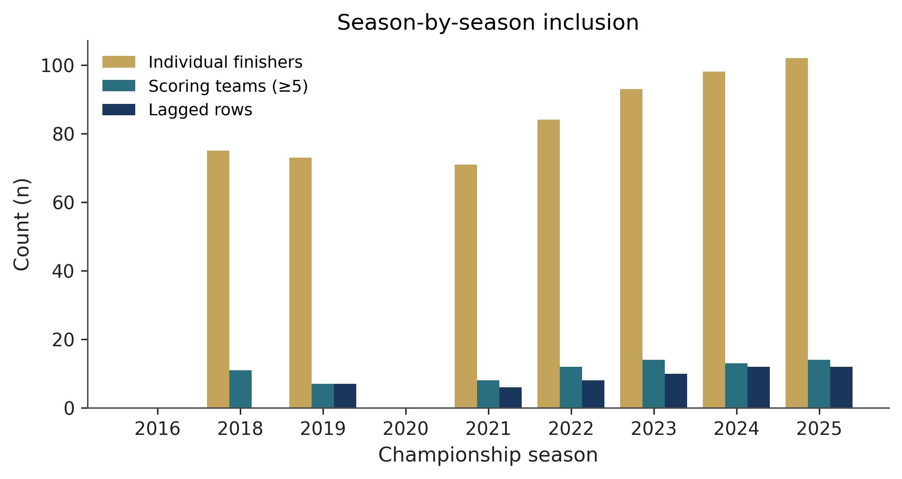
Figure 1. Season-by-season counts of parsed varsity finishers, scoring teams (five or more finishers), and lagged analytic rows.
Table 2. Characteristics of the boys’ estimation sample (fit rows with five or more finishers). Pack gap is fifth-runner z minus first-runner z.
Characteristic | Value
Estimation team-seasons (N) | 43
Schools (clusters) | 15
Seasons in estimation | 2019, 2021–2024
Sector mix (private / public / charter) | 29 / 7 / 7
WCAC school-seasons | 10 (23.3%)
Mean (SD) enrollment grades 9–12 | 822 (523)
Mean (SD) prior first-runner z | -0.85 (0.52)
Mean (SD) prior fifth-runner z | -0.06 (0.74)
Mean (SD) next-year team place | 5.26 (3.25)
Mean (SD) next-year team score | 146 (93)
2025 holdout scoring teams | 12

Statistical Analysis
Because the same schools appear in several years, models were estimated by ordinary least squares with school-clustered standard errors. With 15 clusters, those intervals are treated as exploratory descriptors (Cameron & Miller, 2015). Nested models of team place, and of team score as a continuous check on the scoring rule, added lagged first-runner z, lagged fifth-runner z, lagged pack gap, both z-scores, and conference membership as an exploratory term. Pack gap is a linear transform of the two z-scores, so a first-runner-plus-pack-gap specification was not estimated separately. Ordered logit models of place were used to check that treating place as continuous did not drive the ranking. Akaike information criterion (AIC) differences below about 2 were not treated as decisive (Akaike, 1974).
The confirmatory comparison is 2025 holdout root-mean-square error (RMSE) and mean absolute error (MAE) for fifth-runner versus first-runner relative time, and versus enrollment and sector alone. Rank correlation is secondary. Expanding-window rolling-origin error and leave-one-school-out prediction error provide additional out-of-sample checks. A wild cluster bootstrap that flips residual signs by school (999 draws) provides a small-sample interval for the fifth-runner coefficient. A permutation test reassigns lagged fifth-runner z across team-seasons to test whether the in-sample association is consistent with noise. A within-team swap test exchanges first- and fifth-runner labels and asks whether those labels are exchangeable under collinearity; it is not a test of causal superiority. Sensitivities dropped enrollment, restricted the sample to one-year lags, or replaced z-scores with raw prior times. An exploratory girls’ panel used the same construction, with 2024 held out because 2025 had no girls rows with a prior fifth-runner z. Analyses were conducted in Python 3.11.9 with pandas, NumPy, and statsmodels.
Results
Holdout Evaluation
On the reserved 2025 championship (12 of 14 scoring teams with a usable prior result), prior fifth-runner relative time reduced place error relative to enrollment and sector alone and relative to prior first-runner relative time. It was not the lowest-error specification among all nested models. The fifth-runner model achieved Spearman ρ = 0.85 and RMSE = 2.28 places (Figure 2), compared with control RMSE of 3.07 and first-runner RMSE of 2.48 (Table 3).
Pack-gap RMSE was 2.89. Both z-scores reduced error to 2.22, and adding conference membership reduced it further to 2.14. A paired bootstrap interval for the fifth-minus-first RMSE difference was -0.19 (95% CI -0.58 to 0.61), and the interval versus controls was -0.78 (95% CI -0.96 to 0.74). Across 4 rolling-origin test seasons, mean place RMSE was 2.00 for fifth-runner z and 2.58 for first-runner z, with fifth-runner error lower in 4 of 4 years. Team-score holdout errors ranked similarly. A single later championship cannot separate RMSE differences of a few tenths of a place with much precision, and the paired interval for fifth-versus-first error included zero.
Table 3. Reserved 2025 holdout for team place (n = 12). RMSE and MAE are in places.
Model | Holdout RMSE | Holdout MAE | Spearman ρ
Controls (baseline) | 3.07 | 2.48 | 0.68
First-runner z | 2.48 | 2.05 | 0.78
Pack gap | 2.89 | 2.21 | 0.71
Fifth-runner z | 2.28 | 1.77 | 0.85
Both z-scores | 2.22 | 1.73 | 0.83
+ WCAC | 2.14 | 1.56 | 0.91

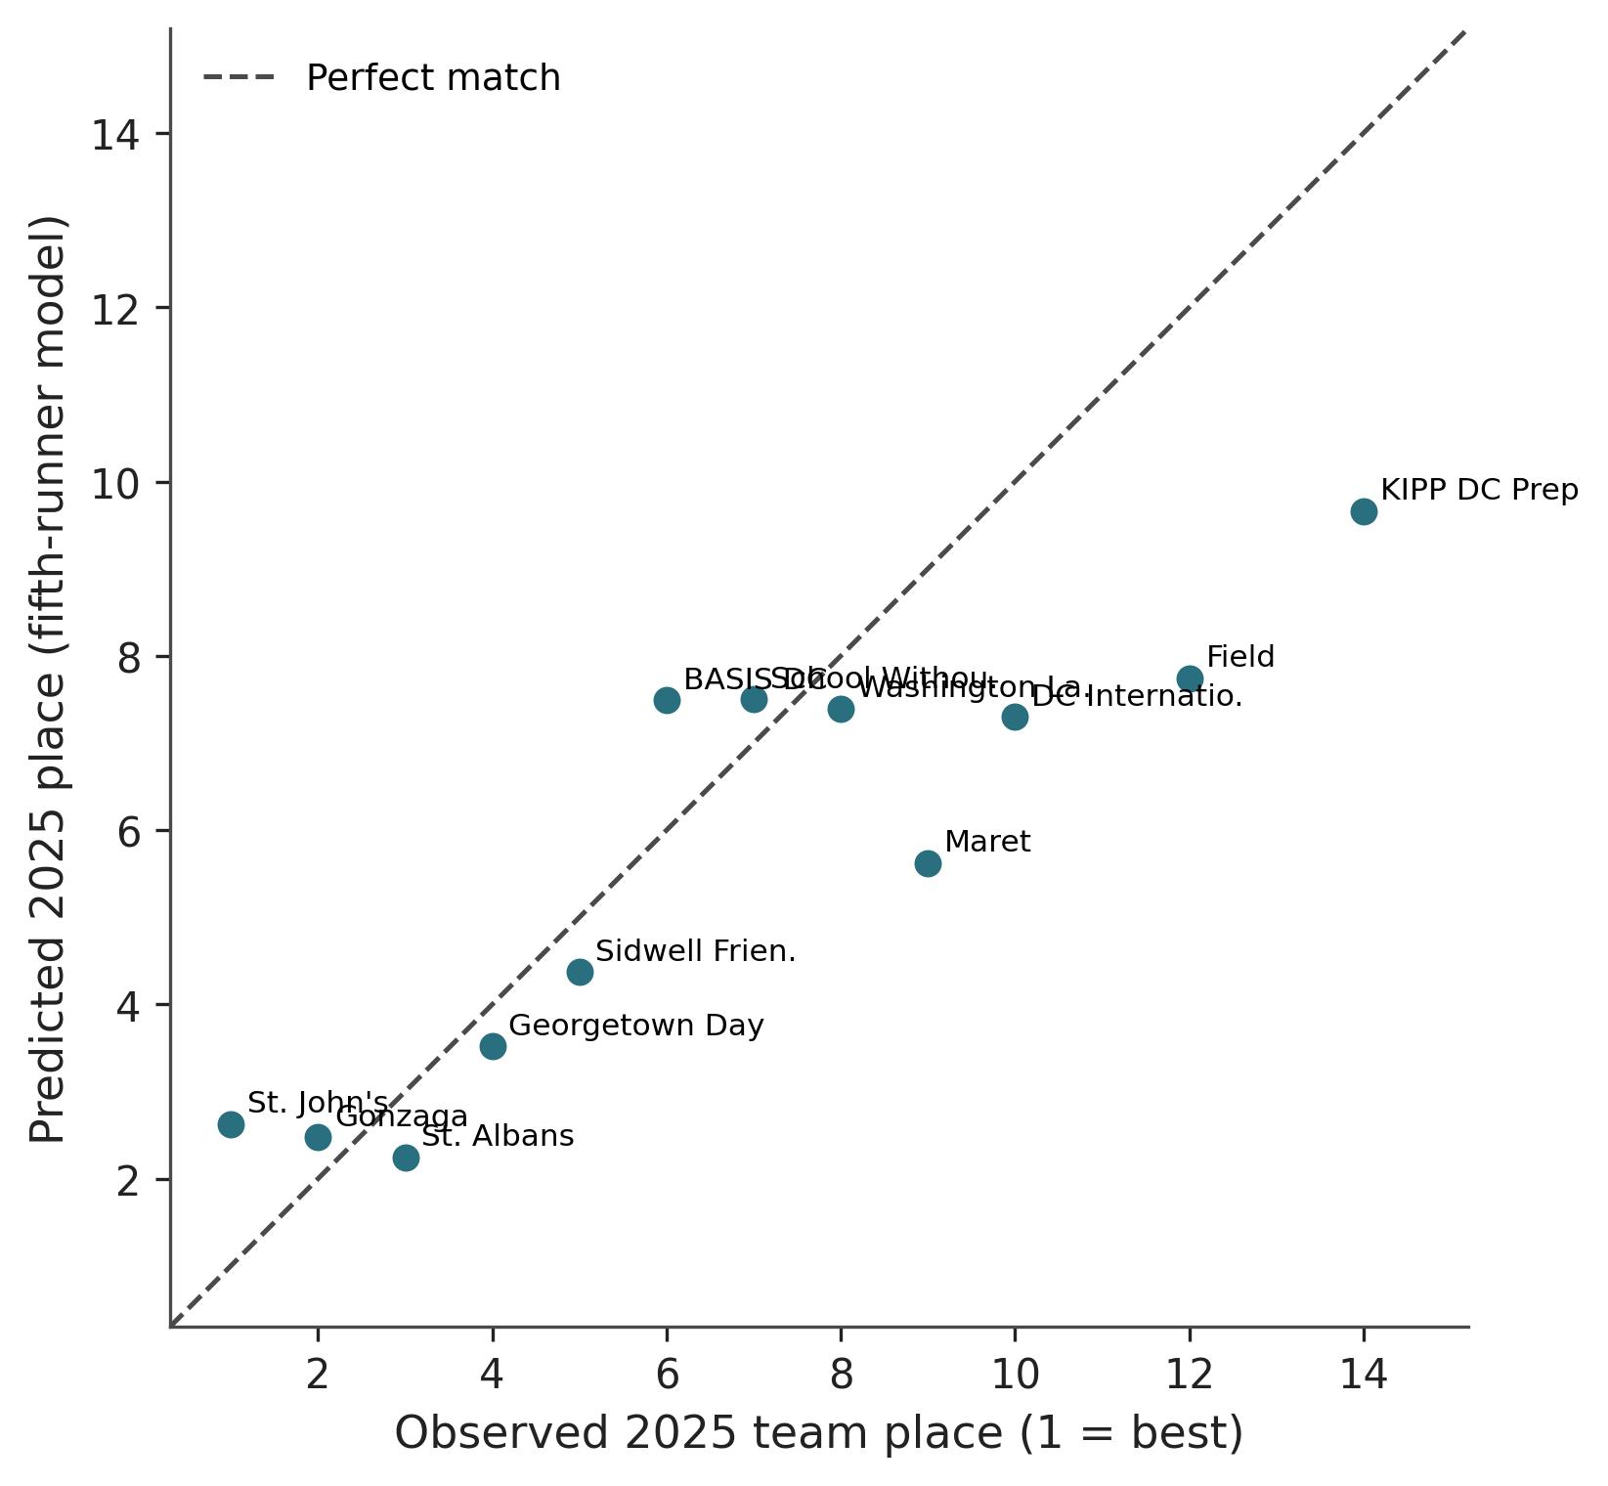
Figure 2. Observed versus predicted 2025 team place from the fifth-runner model. The dashed line marks a perfect numeric match. Lower place is better.
In-Sample Associations
In the estimation sample, the fifth-runner model also showed higher fit for team place (Table 4). Enrollment and sector alone explained 57.7% of place variation. Relative to charter schools, private-school team-seasons were associated with a 6.37-place improvement (lower place is better, 95% CI -8.64 to -4.10), which is consistent in direction with the private-school advantage reported by Johnson et al. (2019) in high-school football. Adding first-runner z raised R² to 0.74, while adding fifth-runner z raised R² to 0.82 and produced the lowest place-model AIC. Each one-standard-deviation slower fifth runner was associated with 3.20 worse places (cluster 95% CI 2.38 to 4.01, wild-cluster interval 2.42 to 3.93). Pack gap added substantially less (R² = 0.64, Figure 3), so Falk et al.’s (2022) within-race packing construct does not appear here as lagged spread. Variance inflation in the joint model was high (variance inflation factor [VIF] ≈ 4.5 for fifth-runner z, and partial correlation after controls was ≈ 0.72), so the two coefficients should not be read as separable pack-depth and star-power effects.
In the joint place model, the fifth-runner coefficient remained larger (2.70) than the first-runner coefficient (0.88), but the predictors were highly collinear (r = 0.85). The AIC gap between the fifth-runner-only model and the two-predictor model was 0.6, which is not decisive under Akaike’s (1974) criterion. Ordered logit ranked those two specifications together and ahead of first-runner z. Figure 4 shows both z-scores against next championship place. Leave-one-school-out prediction RMSE for the fifth-runner place model was 1.66 places.
Table 4. Ordinary least squares models of next championship boys’ team place with school-clustered standard errors (15 schools). ΔAIC is relative to the fifth-runner model.
Model | N | R² | Adj. R² | AIC | ΔAIC | Focal coef (SE) | 95% CI
Controls | 43 | 0.577 | 0.545 | 193.4 | 35.6 | Private -6.37 (1.16) | -8.64, -4.10
+ first-runner z | 43 | 0.744 | 0.718 | 173.8 | 16.0 | 3.38 (0.71) | 1.98, 4.78
+ fifth-runner z | 43 | 0.824 | 0.805 | 157.8 | 0.0 | 3.20 (0.42) | 2.38, 4.01
+ pack gap | 43 | 0.642 | 0.605 | 188.2 | 30.4 | 2.36 (1.13) | 0.14, 4.58
Both z-scores | 43 | 0.829 | 0.806 | 158.4 | 0.6 | Fifth 2.70 (0.44) | 1.85, 3.56
+ WCAC (exploratory) | 43 | 0.836 | 0.808 | 158.8 | 1.0 | WCAC -1.05 (0.79) | -2.59, 0.49

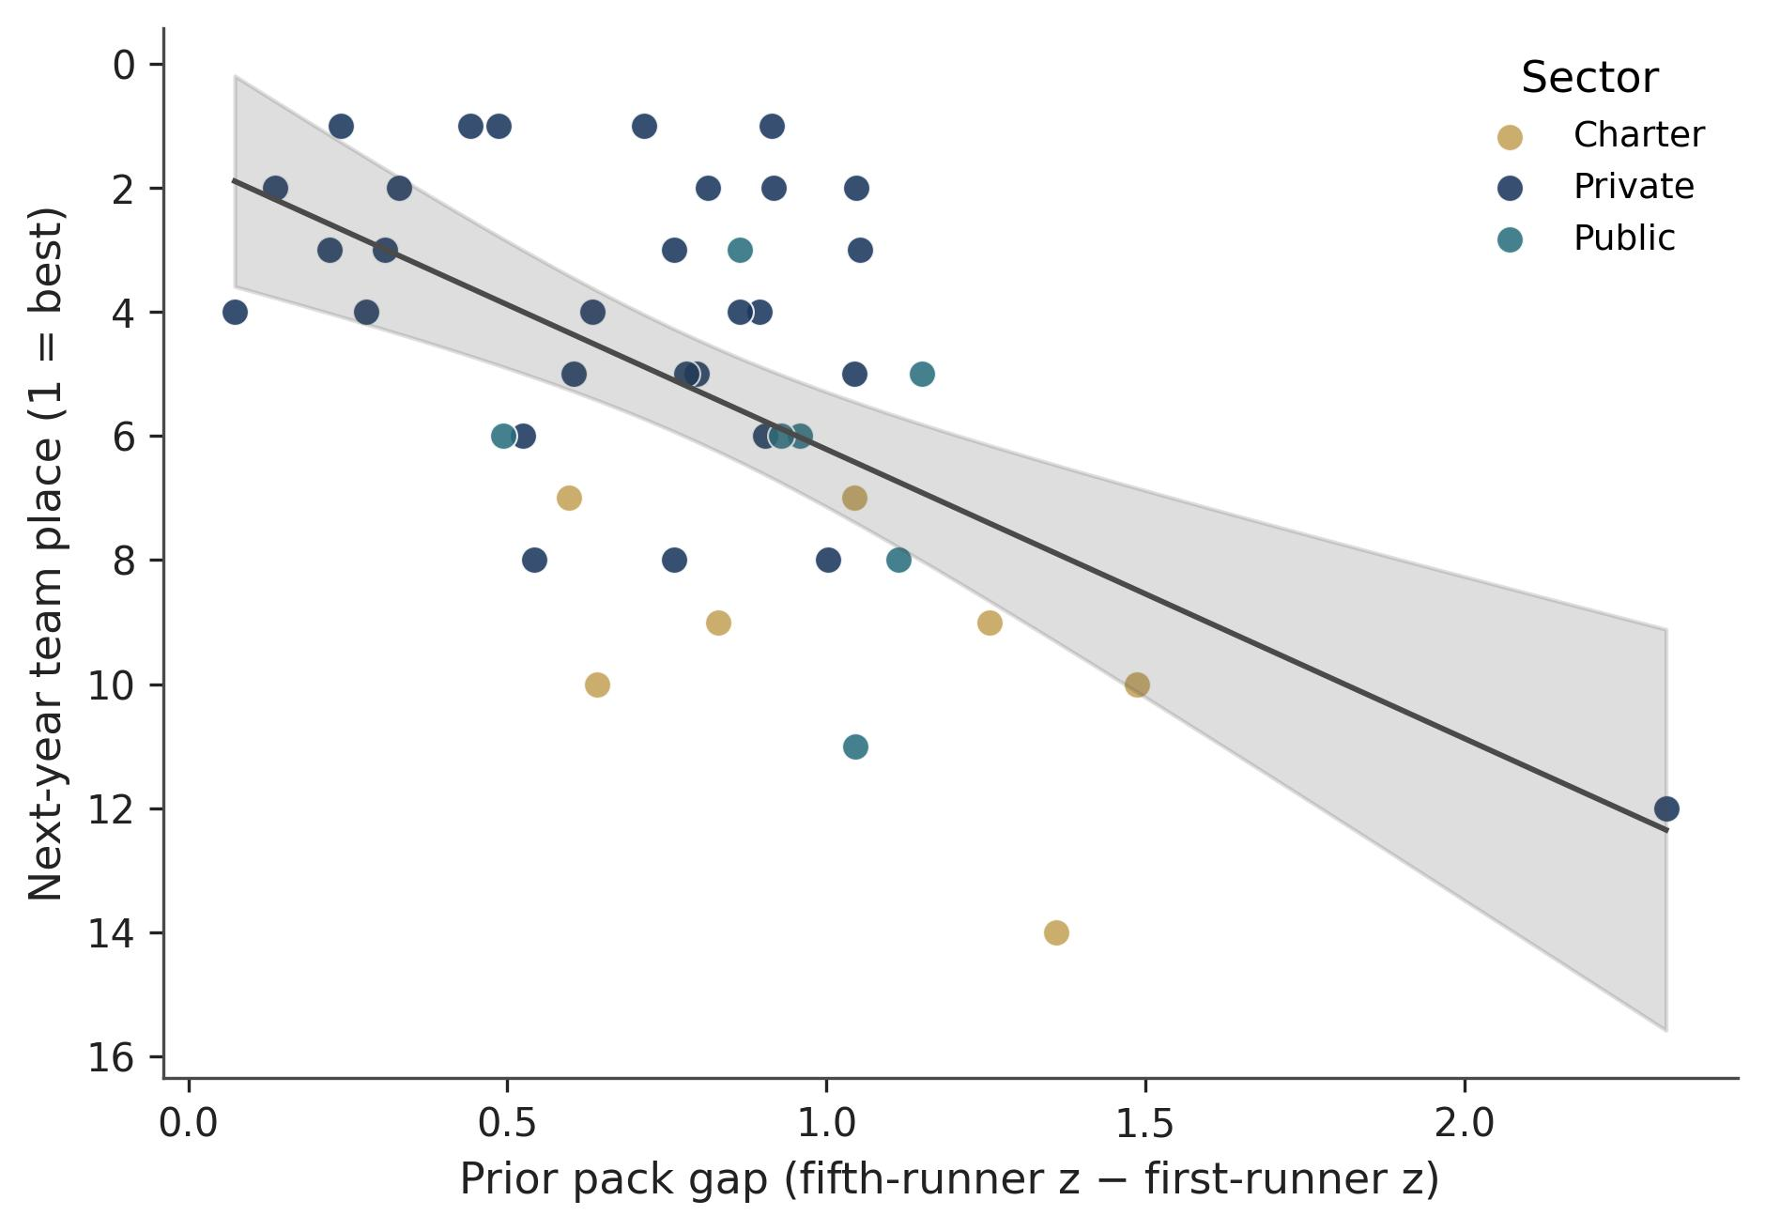
Figure 3. Prior pack gap versus next championship team place in the estimation sample, with an ordinary least squares fit. Lower place is better.
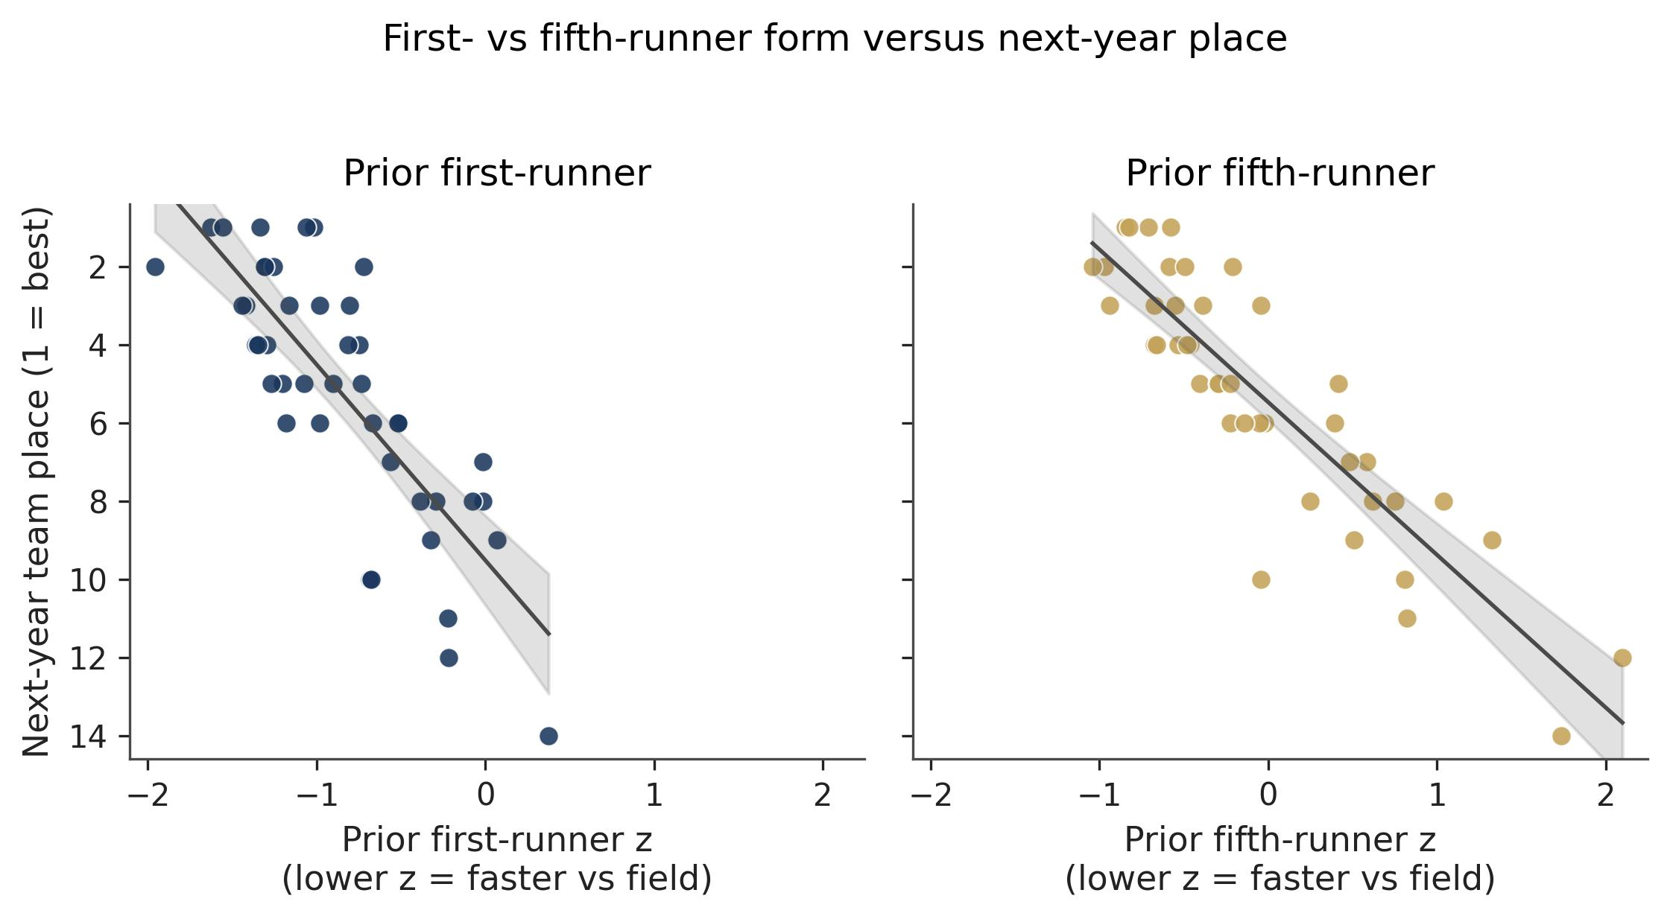
Figure 4. Prior first-runner z (left) and fifth-runner z (right) versus next championship team place. Lower z-scores indicate faster relative time against the year’s field.
Team score, the championship total of five places, produced the same qualitative ranking. Fifth-runner relative time raised in-sample fit more than first-runner relative time (R² = 0.81 versus 0.76), while controls explained 60.2%. In the joint score model, the fifth-runner interval excluded zero and the first-runner interval did not. Leave-one-school-out fifth-runner coefficients stayed in a narrow band (2.69 to 3.37). A permutation test of the fifth-runner place model was inconsistent with noise alone (p = 0.001), but the within-team swap test did not separate the two labels (p = 0.25). Conference membership was not distinguishable from zero in the estimation sample, even though it entered the lowest-error 2025 forecast. An exploratory girls’ panel (14 team-seasons, 2024 holdout n = 7) ranked first-runner z higher in sample (R² = 0.53 versus 0.32), while fifth-runner z retained slightly lower holdout error. That sample is too small to establish effect modification by sex.
Discussion
The confirmatory comparison is whether prior fifth-runner relative time predicts next championship boys’ team place more accurately than prior first-runner relative time after enrollment and sector adjustment. In this Kenilworth panel it does, both in the estimation years and on the reserved 2025 championship. That ranking fits the five-scorer rule, because the fifth finisher is the last place that enters the team total, but it is not evidence that pack depth has been isolated from overall team speed. First- and fifth-runner z-scores were highly collinear, variance inflation in the joint model was high, and the within-team swap test did not distinguish the two labels once both times were known. School size and sector already accounted for a large share of place variation, which matches the private-school advantage Johnson, Manwell, and Scott (2019) reported in another interscholastic setting. Adding the fifth runner still improved the fit and reduced holdout error relative to those controls.
The same collinearity also limits how far the packing literature can be applied here. Falk, Larson, and DeBeliso (2022) measured packing as within-race clustering among NCAA teammates, and Hanley (2015, 2016) and Finley and Fountain (2023) likewise analyze behavior after the gun: pacing, packing, and movement through a championship field. If those within-race constructs were interchangeable with two lagged finish times, the spread between first and fifth times should have been the more informative predictor of next place. Pack gap was not, while the level of the fifth runner was. A lagged finish time could mean a thin roster, a poor championship day, or a deeper opposing field, and without checkpoint splits those mechanisms cannot be separated. Falk et al. (2022) imply that last year’s packing, proxied by spread, should travel, and the data do not support that implication. Fast programs in this association tend to be fast at both ends of the scoring five, so collinearity of about 0.85 is an empirical fact rather than a software warning.
The sports-forecasting literature supplies the evaluation design rather than a competing model. Stefani (1980), Kvam and Sokol (2006), and Pasteur and Janning (2011) rate teams from repeated contests against identified opponents. A District of Columbia championship supplies one race per year, so holding out 2025 follows from that literature’s insistence on out-of-sample judgment rather than from an attempt to build a comparable rating system on two lagged times. Nested specifications that used both z-scores, or conference membership, reduced 2025 error further. Extra predictors can improve a one-meet forecast without changing the confirmatory question. The paired bootstrap interval for fifth-versus-first RMSE included zero, so the holdout should be read as leaning the same way as the estimation sample, not as a precise ranking of nested models.
The exploratory girls’ panel should not be treated as a test of Hanley’s (2016) sex differences in elite packing. That study concerns world-level marathon fields, while the girls’ sample here is a small set of schools and seasons, with 2024 held out because 2025 did not yield lagged fifth-runner rows. First-runner z ranked higher in sample, and fifth-runner z retained slightly lower holdout error. Either pattern is consistent with sampling variation. The panel does not support a claim that fifth-runner form is generally better, or that the boys’ ranking is sex-specific.
Most of the limits come from the sample. Parseable listings come from one district and one course (43 lagged team-seasons, 15 schools). Schools that do not field five finishers in consecutive available championships never enter, so stable programs are over-represented. Some lags skip a year. Z-scores shift when the opposing field shifts. Private and charter enrollment is mostly a constant. Place is an ordered rank treated as continuous, though ordered logit and team score produced the same qualitative ranking. Conference membership is a binary schedule proxy. Only the holdout fifth-versus-first error comparison was locked before inspection of the 2025 results. The design is observational and does not identify causal effects of roster construction.
Within those bounds, the implication is local. For District of Columbia boys’ championships at Kenilworth, last year’s fifth-runner relative time is the better of the two public individual summaries for next team place once school size and sector are in the model. The same results page does not show that packing caused that place, and the ranking need not travel to a classified state meet on a different course. Repeating the same first-versus-fifth comparison in an association that uses classifications would test whether the fifth-scorer advantage is a feature of the scoring rule or of this particular open field.
Conclusion
Among schools with an eligible prior Kenilworth championship, prior fifth-runner relative time predicted subsequent District of Columbia boys’ team place and team score more closely than prior first-runner relative time after adjustment for enrollment and sector, and it produced smaller errors on a reserved later championship than either school characteristics or the first runner. Specifications that used both runners, or conference membership, were still more accurate on that later meet, but the two runner summaries were too collinear to support a separable pack-depth interpretation. The ranking applies to this association and course, and it does not establish that the fifth scorer is always the statistic that matters.
Data Availability
Replication code, cleaned team-season files, the season audit, and the 43-row analytic sample are available at https://github.com/timtran7/ts-jhss. The underlying listings are public championship results from the District of Columbia State Athletic Association, MileSplit, and M&D Timing.
References
Akaike, H. (1974). A new look at the statistical model identification. IEEE Transactions on Automatic Control, 19(6), 716–723. https://doi.org/10.1109/TAC.1974.1100705
Cameron, A. C., & Miller, D. L. (2015). A practitioner’s guide to cluster-robust inference. Journal of Human Resources, 50(2), 317–372. https://doi.org/10.3368/jhr.50.2.317
District of Columbia Public Schools. (2026). DCPS data set – enrollment (audit files). https://dcps.dc.gov/node/1018342
District of Columbia State Athletic Association. (2025). 2025 cross country bulletin. https://www.dcsaasports.com/boys-cross-country/
Falk, J., Larson, A., & DeBeliso, M. (2022). Pack running among female NCAA collegiate cross country teams. European Journal of Physical Education and Sport Science, 9(1). https://doi.org/10.46827/ejpe.v9i1.4484
Finley, P. S., & Fountain, J. J. (2023). An examination of race strategies in NCAA cross country championship events. Journal of Coaching and Sports Science, 2(1), 1–11. https://doi.org/10.58524/jcss.v2i1.210
Hanley, B. (2015). Pacing profiles and pack running at the IAAF World Half Marathon Championships. Journal of Sports Sciences, 33(11), 1189–1195. https://doi.org/10.1080/02640414.2014.988743
Hanley, B. (2016). Pacing, packing and sex-based differences in Olympic and IAAF World Championship marathons. Journal of Sports Sciences, 34(18), 1675–1681. https://doi.org/10.1080/02640414.2015.1132841
Johnson, J. E., Manwell, A. K., & Scott, B. F. (2019). An examination of competitive balance within interscholastic football. Journal of Amateur Sport, 5(1), 21–49. https://doi.org/10.17161/jas.v5i1.6708
Kvam, P., & Sokol, J. S. (2006). A logistic regression/Markov chain model for NCAA basketball. Naval Research Logistics, 53(8), 788–803. https://doi.org/10.1002/nav.20165
M&D Timing. (2025). DCSAA Cross Country Championships 2025 results. https://results.mdtimingllc.com/meets/58668
MileSplit. (2026). DCSAA Cross Country Championships results index. https://dc.milesplit.com/
National Federation of State High School Associations. (2025). 2025–26 NFHS track and field and cross country rules book. NFHS.
Pasteur, R. D., & Janning, M. C. (2011). Monte Carlo simulation for high school football playoff seed projection. Journal of Quantitative Analysis in Sports, 7(2), Article 11. https://doi.org/10.2202/1559-0410.1330
Stefani, R. T. (1980). Improved least squares football, basketball, and soccer ratings. IEEE Transactions on Systems, Man, and Cybernetics, 10(2), 116–123. https://doi.org/10.1109/TSMC.1980.4308442

