## Process base

During the project, a simple order-to-cash process was designed in BPMN-format. The order-to-cash process encompasses all steps from when a customer order is placed up until the business is paid (the cash). Those steps include order management and order fulfillment, through to credit management, then invoicing and ultimately payment collection. Since the project does not focus on developing a complex process, a simplified process was used.

A variety of sources were consulted for this purpose and finally the process from the following source was used:

*Dumas, Marlon; La Rosa, Marcello; Mendling, Jan; Reijers, Hajo A. (2018): Fundamentals of Business Process Management. Berlin, Heidelberg: Springer Berlin Heidelberg, Page 373.*

Other processes were under consideration, but were discarded as the project progressed:

*Fahland, Dirk; Ghidini, Chiara; Becker, Jörg; Dumas, Marlon (2020): Business Process Management Forum. Cham: Springer International Publishing (392), Page 251.*

*Dubois, Eric; Pohl, Klaus (2017): Advanced Information Systems Engineering. Cham: Springer International Publishing (10253), Page 353.*

The BPMN process shows the process from ordering a product to delivery. The example company works with two suppliers. The three roles of the ERP system, a warehouse employee and a sales employee are represented by swin lanes. When a customer orders a product, it is checked whether it is already in stock. If it is, the product is ordered from the warehouse and confirmed after the order is received. If the product is not in stock, the raw materials are ordered from the two suppliers and then the product is manufactured. If the product is then available, the product is shipped to the customer's delivery address. At the same time, an invoice is sent to the customer. When the amount is received and the product has been delivered, the order is archived, and the process is finished.

The process is considered the basis for the project. For this purpose, a second similar process will be developed, in which the first process will be modified.

The BPMN process can be found on the next page.

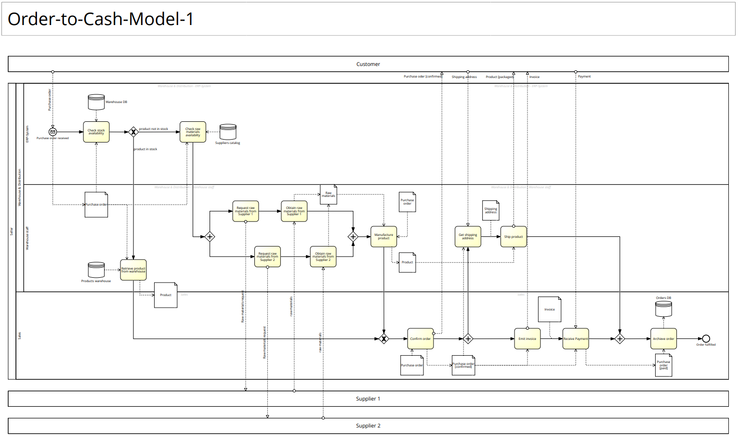

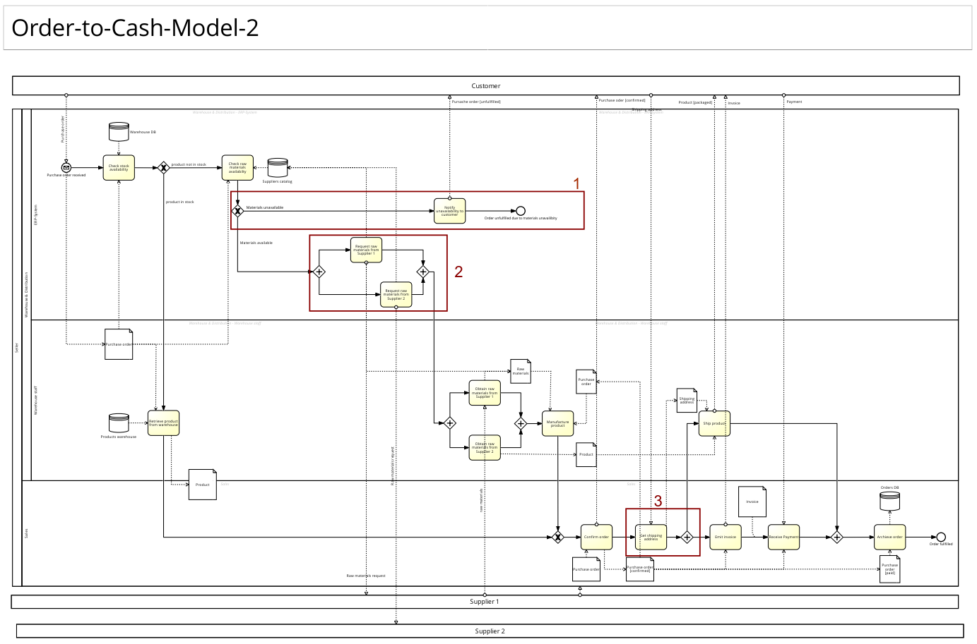

## Process changes

In the previous page you can see the customized process. The markers show the changes.

The following adjustments were applied:

1. A new gateway was integrated. Here it is checked whether the raw materials are available at the suppliers. If this is not the case, a new end is reached and the customer is informed that the product is not available.
2. Orders for raw materials have now been automated by the ERP system. A warehouse employee no longer must do this manually. For this purpose, the suppliers' databases were connected and automatic processes were started.
3. The customer's delivery address is now entered directly by the sales staff, who also confirm the order. In addition, this changed the sequence and parallelism of the process steps.