Mixology From Home
Griffin Witt, Louie Finder, Ryan Grant, Timur Bashpanov
Point of contact email: addresses: gwitt1@vt.edu, louiefinder@vt.edu, ryangrant@vt.edu, timur23@vt.edu
CS 4604, Dr. Nizamani
Spring 2026

Table of Contents
1. Introduction to the Mini-verse 3
1.1 Background 3
1.2 Motivation 3
1.3 Overview of the Mini-verse 3
2. User Support 4
2.1 User Roles and Entities 4
2.2 Authentication (Login System) 4
2.3 Security Measures 4
3. Database Connection & Setup 5
3.1 System Connection 5
3.2 Setup Instructions 5
3.3 Database Initialization 5
3.4 Challenges & Lessons Learned 5
4. System Design & Functionality 6
4.1 Schema Design 6
4.2 ER Diagram 6
4.3 Tables & Keys 6
5. Reporting 7
6. GUI / Interface 8
6.1 CRUD Operations 8
7. Reflection 9
7.1 Individual Contributions 9
7.2 Team Reflection 9
8. Appendix 10

1. Introduction to the Mini-verse
This section introduces your project, its purpose, and the overall system you have designed.

1.1 Background
Many people at home struggle to manage the cocktail ingredients they have and figure out what drinks they can make with them. The typical alternative is to manually search the web for recipes, which is time-consuming because you must cross-reference each recipe against what you own. Paid bartending courses exist but are expensive and impractical for casual home use. There is no widely available tool that connects a personal ingredient inventory to a recipe database in real time.
The cocktail and home bartending space lack a centralized, structured system that can answer a simple question: given what I already have in my kitchen, what can I make tonight? This gap motivates the need for a database-driven application that model users, ingredients, recipes, and their relationships.

1.2 Motivation
Mixology From Home was built to give everyday users a fast, organized way to discover cocktail recipes based on what they already own. The system is intended for three types of users: casual drinkers who want to try something new after work, event hosts who need to plan drinks for a gathering without overbuying, and mixology enthusiasts who want to track and refine their craft.
The key actions users perform include maintaining an ingredient inventory, browsing and searching drink recipes, saving favorites for quick access, logging drinks they have made with personal ratings, and building shopping lists for missing ingredients. These actions are important because they transform an unstructured, manual process into a streamlined, data-driven workflow.

1.3 Overview of the Mini-verse
The system is built around the following main entities:
- User: Individual accounts with authentication, roles, and profile information.
- Ingredient: Master list of cocktail components (spirits, mixers, garnishes, syrups, bitters) with category and unit of measurement.
- Drink: Cocktail recipes with name, instructions, flavor profile, glassware type, difficulty level, and category.
- Drink_Ingredient: Bridge table linking each drink to its required ingredients with quantities and preparation notes.
- User_Inventory: Tracks which ingredients each user currently has at home.
- Favorite: Records which drinks each user has bookmarked.
- User_Drink_History: Logs drinks users have made with timestamps, ratings, and notes.
- Shopping_List / Shopping_List_Item: Named shopping lists with individual ingredient items and purchase tracking.
Users interact with the system through a web interface that provides navigation across all entity views, modal forms for data entry, and dynamic table rendering. The key relationships are: users own inventories of ingredients, drinks require specific ingredients, users favorite and log drinks, and users create shopping lists containing ingredient items.

2. User Support
This section describes how your system supports different users and ensures secure access.

2.1 User Roles and Entities
The system implements two user roles:
Regular User (role: user): Can browse all drink recipes, manage their personal ingredient inventory (My Pantry), save drinks to favorites, log drinks they have made with personal ratings in Drinking History, and create and manage shopping lists with individual items. Regular users can perform full CRUD operations on their own data across all non-admin sections of the application.
Admin User (role: admin): Inherits all regular user privileges and additionally gains access to the Manage Users panel in the sidebar. Admins can view all user accounts, create new accounts, edit existing user details, and delete user records. The admin panel is hidden from non-admin users through conditional rendering in the frontend.
The User entity stores the following attributes: UserID (PK, auto-increment), first_name, last_name, email (unique), password (hashed), phone, role (enum: admin/user), status, bio, and created_date (auto-timestamp).
The three conceptual personas from the project proposal (Casual Drinker, Event Host, Professional Mixologist) are all served by the Regular User role. The Admin role was added to support system administration.

2.2 Authentication (Login System)
The authentication system is implemented in api/auth.php and supports the following operations:
Account Creation (Sign Up): Users provide first name, last name, email, and password. The frontend validates that all fields are filled, passwords match the confirmation field, and the minimum password length is 6 characters. The backend checks for email uniqueness against the database before inserting. Passwords are hashed using PHP's password_hash() with the PASSWORD_DEFAULT algorithm (bcrypt) before storage. New accounts are automatically assigned the 'user' role and 'active' status. After successful creation, the user is automatically logged in.
Login (Sign In): Users enter their email and password. The backend retrieves the matching user record by email using a prepared statement, then calls password_verify() to compare the submitted password against the stored bcrypt hash. On success, a PHP session is created storing user_id, user_name, and role.
Logout: Calls session_destroy() on the server and returns the user to the login screen. All session data is cleared.
Session Persistence: On page load, the frontend calls auth.php?action=check. If a valid session exists, the user is automatically directed to the application view without re-entering credentials.
Screenshots here

2.3 Security Measures
SQL Injection Prevention: All database queries use MySQLi prepared statements with parameterized bindings. The BaseController's upsert() method builds parameterized INSERT and UPDATE queries dynamically, and the delete() method uses bind_param() for the ID parameter. No user input is ever concatenated directly into SQL strings.
Password Security: All passwords created through the application are hashed with bcrypt via password_hash(PASSWORD_DEFAULT). The admin seed account in init.sql uses a pre-computed bcrypt hash. The 20 sample user accounts use non-functional placeholder values in the password field and cannot be used to log in; they exist solely to populate relational data for testing. New accounts created through Sign Up are always properly hashed.
Session Handling: PHP sessions are started with session_start() in both auth.php and BaseController.php. Every API endpoint (except auth) checks for a valid session before executing any database operation. Unauthorized requests receive a JSON error response.
No Sensitive Data in URLs: Authentication data is transmitted via POST request bodies (FormData), not URL parameters. The only URL parameter used is the record ID for DELETE operations.

3. Database Connection & Setup
This section explains how your system connects to the database and how it can be set up and reproduced.

3.1 System Connection
The system uses a three-tier architecture:
- Frontend (HTML/CSS/JS) sends asynchronous HTTP requests via the Fetch API to PHP endpoints.
- Backend (PHP 8) receives requests, instantiates the BaseController, executes parameterized SQL queries via the MySQLi extension, and returns JSON responses.
- Database (MySQL 8) stores all persistent data with enforced foreign key constraints and referential integrity.
The connection is established in db_connect.php, which creates a MySQLi connection using the Docker service hostname, database name, and credentials. The connection is configured with UTF-8 (utf8mb4) character encoding. Every API endpoint includes this file to obtain the shared connection object.
Screenshot here

3.2 Setup Instructions
To run the application from scratch:
- Install Docker Desktop (available at docker.com for Windows, macOS, and Linux).
- Clone the repository: git clone https://github.com/timurB27/MixologyFromHome.git
- Navigate to the project root: cd MixologyFromHome
- Start the containers: docker-compose up -d
- Verify both containers are running: docker-compose ps (you should see mfh-db-1 and mfh-web-1 in the running state).
- Open a browser and navigate to http://localhost:8080
- Log in with the admin account (admin@mfh.com / password) or create a new account via Sign Up.
To stop the application: docker-compose stop. To completely remove containers and volumes: docker-compose down -v.

3.3 Database Initialization
- 3.3 Database Initialization
- The database schema and sample data are defined in docker/mysql/init.sql. This file is mounted to /docker-entrypoint-initdb.d/ in the MySQL container, which causes MySQL to automatically execute it on first startup.
- The init.sql script performs the following in order:
- Creates 9 tables with all primary keys, foreign keys, and constraints (UNIQUE, DEFAULT, AUTO_INCREMENT, ON UPDATE CURRENT_TIMESTAMP).
- Inserts 20 sample User records with non-functional placeholder password values (these accounts cannot log in), plus 1 admin account with a real bcrypt hash.
- Inserts 20 Ingredient records covering spirits, mixers, juices, syrups, liqueurs, and bitters.
- Inserts 20 Drink records referencing real cocktail recipes with proper base_spirit_ID and created_by_userID foreign keys.
- Inserts sample data into User_Inventory (20 rows), Favorite (20 rows), User_Drink_History (20 rows), and Shopping_List (20 rows).
- The Drink_Ingredient and Shopping_List_Item bridge tables do not have seed data in init.sql. Records for these tables are created through the application interface.

3.4 Challenges & Lessons Learned
Docker Networking: Initially, the PHP container could not resolve the MySQL hostname. We learned that Docker Compose creates a shared network between services and that the service name in docker-compose.yml (db) must match the hostname used in db_connect.php.
Case Sensitivity on Linux: Our development machines ran macOS and Windows, where file names are case-insensitive. When deployed in the Linux Docker container, references to Users.php vs users.php caused 404 errors. We standardized all file names to lowercase.
Foreign Key Ordering in init.sql: Tables with foreign key dependencies had to be created in the correct order. Attempting to create Drink before Ingredient caused errors because the base_spirit_ID foreign key references Ingredient.
Composite Primary Keys: Bridge tables like Drink_Ingredient and Favorite use composite primary keys. We learned that the frontend edit/delete logic needed to handle multi-column keys differently than auto-increment single-column keys, which required adjustments to both the JavaScript schema map and the PHP controller.

4. System Design & Functionality
This section describes your database design and how it supports your application.

4.1 Schema Design
The schema evolved across three phases of the project:
Phase 1 (Conceptual): Identified real-world entities including User, Ingredient, Drink, Favorites, Shopping List, and History. Defined attributes at a high level without formal constraints.
Phase 2 (ER Diagram): Formalized entity attributes, identified primary keys, and mapped relationships with cardinality. Included a conceptual ER diagram with entities like User_Inventory and Drink_Ingredient as associative entities resolving many-to-many relationships.
Phase 3 (Logical Design): Converted the conceptual ER diagram to a logical design. Key changes included: splitting the composite Name attribute into first_name and last_name; correcting cardinalities to 1:M for all foreign key relationships; removing the redundant recorded_in relationship between Ingredient and User_Drink_History; reversing the base_spirit arrow to flow from Ingredient to Drink (since the FK lives on Drink); removing invalid relationships like USER_INVENTORY → SHOPPING_LIST_ITEM and DRINK_INGREDIENT → FAVORITE that implied non-existent foreign keys.
Phase 4 (Implementation): The logical schema was implemented in MySQL via init.sql. All tables are in Third Normal Form (3NF): every non-key attribute depends on the whole key and nothing but the key. There are no transitive dependencies or partial key dependencies. The bridge tables (Drink_Ingredient, User_Inventory, Favorite, Shopping_List_Item) each use composite primary keys consisting of the two foreign keys they join.

4.2 ER Diagram
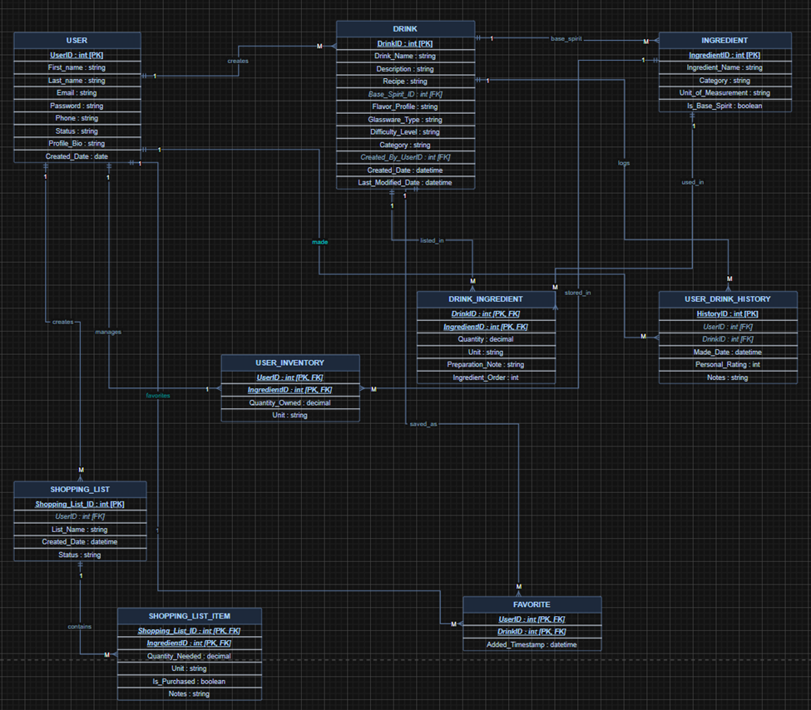
Key relationships:
- User 1:M Drink (creates) — A user can author many drink recipes; each drink has one creator.
- User 1:M User_Inventory (manages) — A user can stock many ingredients; each inventory entry belongs to one user.
- User 1:M Favorite (favorites) — A user can favorite many drinks; each favorite record belongs to one user.
- User 1:M User_Drink_History (made) — A user can log many drinks made; each history entry belongs to one user.
- User 1:M Shopping_List (creates) — A user can create many shopping lists; each list belongs to one user.
- Drink 1:M Drink_Ingredient (listed_in) — A drink can have many ingredients; each bridge row belongs to one drink.
- Drink 1:M Favorite (saved_as) — A drink can be favorited by many users; each favorite row references one drink.
- Drink 1:M User_Drink_History (logs) — A drink can appear in many history records; each history entry references one drink.
- Ingredient 1:M Drink_Ingredient (used_in) — An ingredient can appear in many drinks.
- Ingredient 1:M Drink (base_spirit) — One ingredient can be the base spirit for many drinks.
- Ingredient 1:M User_Inventory (stored_in) — An ingredient can appear in many users' inventories; each inventory row references one ingredient.
- Ingredient 1:M Shopping_List_Item (listed_in) — An ingredient can appear on many shopping lists; each item row references one ingredient.
- Shopping_List 1:M Shopping_List_Item (contains) — A list can have many items; each item belongs to one list.

4.3 Tables & Keys
- Present each table with:
  - attributes
  - primary keys
  - foreign keys
Use clear tables (not screenshots of DB UI).
The following tables define the relational schema for the Mixology From Home system. All tables are normalized to Third Normal Form (3NF) to ensure data integrity and minimize redundancy.

Table: User
Stores personal information, authentication credentials, and system roles.
Attribute | Key Type | Description
UserID | Primary Key | Unique identifier (auto-increment)
first_name |  | User's first name
last_name |  | User's last name
email |  | Unique account email
password |  | Bcrypt-hashed password
phone |  | Contact number
role |  | 'admin' or 'user' (enum)
status |  | Account status (e.g., 'active')
bio |  | Optional user biography
created_date |  | Automatic timestamp of creation

Table: Ingredient
The master catalog of spirits, mixers, and garnishes used in recipes.
Attribute | Key Type | Description
IngredientID | Primary Key | Unique identifier (auto-increment)
Ingredient_name |  | Name of the component
category |  | Type (Spirit, Mixer, Garnish, etc.)
unit_of_measurement |  | Standard unit (oz, ml, dash)
is_base_spirit |  | Boolean flag for core alcoholic bases

Table: Drink
Maintains cocktail recipes, metadata, and attribution.
Attribute | Key Type | Description
DrinkID | Primary Key | Unique identifier (auto-increment)
name |  | Cocktail name
description |  | Narrative overview of the drink
recipe |  | Step-by-step preparation steps
base_spirit_ID | Foreign Key | References Ingredient.IngredientID
flavor_profile |  | Taste notes (e.g., bitter, sweet)
glassware_type |  | Recommended serving glass
difficulty |  | Complexity level (e.g., Easy, Expert)
category |  | Classification (e.g., Classic)
created_by_userID | Foreign Key | References User.UserID

Table: Drink_Ingredient (Bridge)
Resolves the many-to-many relationship between recipes and ingredients.
Attribute | Key Type | Description
DrinkID | Composite PK / FK | References Drink.DrinkID
IngredientID | Composite PK / FK | References Ingredient.IngredientID
quantity |  | Amount required for the recipe
preparation_note |  | Specific notes (e.g., "chilled," "shaken")

Table: User_Inventory (Bridge)
Tracks which ingredients a specific user currently has available at home.
Attribute | Key Type | Description
UserID | Composite PK / FK | References User.UserID
IngredientID | Composite PK / FK | References Ingredient.IngredientID

Table: Favorite (Bridge)
Manages the drinks bookmarked by users for quick access.
Attribute | Key Type | Description
UserID | Composite PK / FK | References User.UserID
DrinkID | Composite PK / FK | References Drink.DrinkID

Table: User_Drink_History
Logs individual drinks prepared by users along with personal metrics.
Attribute | Key Type | Description
HistoryID | Primary Key | Unique identifier (auto-increment)
UserID | Foreign Key | References User.UserID
DrinkID | Foreign Key | References Drink.DrinkID
personal_rating |  | Numerical rating given by the user
notes |  | Personal tasting or variation notes
timestamp |  | Date and time the entry was logged

Table: Shopping_List
Allows users to create and name lists for missing supplies.
Attribute | Key Type | Description
ShoppinglistID | Primary Key | Unique identifier (auto-increment)
UserID | Foreign Key | References User.UserID
list_name |  | Name of the list (e.g., "Friday Party")

Table: Shopping_List_Item (Bridge)
Contains individual ingredients assigned to a specific shopping list.
Attribute | Key Type | Description
ShoppinglistID | Composite PK / FK | References Shopping_List.ShoppinglistID
IngredientID | Composite PK / FK | References Ingredient.IngredientID
is_purchased |  | Boolean flag for tracking completion

5. Reporting
Note: This section is in progress. Reporting features will be fully implemented and documented for the final submission.
The system is designed to support reports that use joins and aggregation to provide meaningful insights from the data. The following reports are planned:
Report 1: Drinks You Can Make (JOIN + subquery)
This report identifies all cocktail recipes that a user can prepare given their current inventory. It joins User_Inventory with Drink_Ingredient to find drinks where every required ingredient is present in the user's pantry. This is the core value proposition of the application.
SELECT d.name FROM Drink d
WHERE NOT EXISTS (
SELECT 1 FROM Drink_Ingredient di
WHERE di.DrinkID = d.DrinkID
AND di.IngredientID NOT IN (
SELECT IngredientID FROM User_Inventory WHERE UserID = ?));
Report 2: Most Popular Drinks (JOIN + GROUP BY + ORDER BY)
This report ranks drinks by the number of times they have been favorited across all users. It helps surface community favorites and supports a discovery/recommendation feature.
SELECT d.name, COUNT(f.UserID) AS fav_count
FROM Drink d JOIN Favorite f ON d.DrinkID = f.DrinkID
GROUP BY d.DrinkID ORDER BY fav_count DESC LIMIT 10;
Report 3: Average Drink Ratings (JOIN + GROUP BY + aggregate function)
This report calculates the average personal rating for each drink based on all users' history entries. It allows users to see which drinks are rated highest by the community.
SELECT d.name, ROUND(AVG(h.personal_rating), 1) AS avg_rating,
COUNT(h.HistoryID) AS times_made
FROM Drink d JOIN User_Drink_History h ON d.DrinkID = h.DrinkID
GROUP BY d.DrinkID ORDER BY avg_rating DESC;
[Report output screenshots will be added for final submission]

6. GUI / Interface
Describe and demonstrate your user interface.
- Your interface should be:
  - user-friendly
  - designed for non-expert users
  - all database interactions must occur through the application (no direct table access)
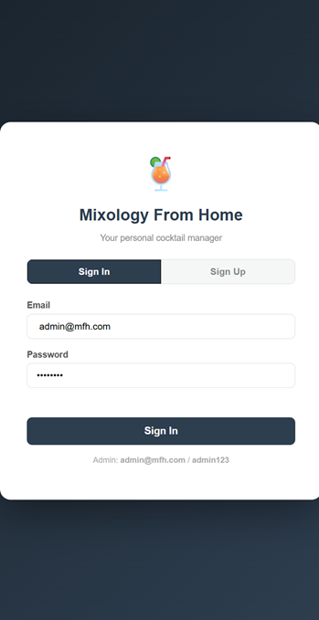
Overview
The Mixology From Home application utilizes a Model-View-Controller (MVC) inspired architecture. The front-end interface communicates with the database exclusively through an asynchronous API layer written in PHP. This ensures that no raw SQL queries are ever exposed to the client-side, fulfilling the project requirement for mediated database access.
Design Principles
- User-Friendly Simplicity: The UI utilizes a clean, high-contrast color palette to reduce cognitive load. Actions are clearly defined with large, tactile buttons and standardized form fields.
- Designed for Non-Expert Users: Rather than requiring knowledge of database queries, the interface uses natural language and visual cues. The sign-in process provides clear feedback and helpful hints.
- Controlled Database Access: All interactions are abstracted. Users never interact with the underlying MySQL/MariaDB tables directly.
Back-End Mediation: The BaseController
To maintain consistency, all database interactions are governed by a central engine called the BaseController. This class acts as the gatekeeper for the following operations:
- Dynamic Routing: The controller automatically detects the HTTP method (GET, POST, or DELETE) and routes the request to the appropriate database function.
- Automated CRUD Operations: Instead of writing manual SQL for every table, the BaseController uses a "Field Whitelist," allowing data to be written only to pre-defined columns.
- Upsert Logic: The interface supports a seamless experience where the same form can either "Update" an existing record or "Insert" a new one depending on whether a unique ID is present.
Security & Authentication
The interface is wrapped in a secure session-management layer:
- Session Protection: All API routes check for a valid user_id before processing requests. Unauthorized access attempts return a 401 Unauthorized JSON error.
- Password Hashing: User security is prioritized by using password_hash during signup and password_verify during login, ensuring credentials are never stored as plain text.
- Prepared Statements: To protect against SQL Injection, every interaction in the application uses SQL Prepared Statements ($conn->prepare).
Module Mapping
Interface Module | API File | Target Database Table
Ingredient Library | ingredients.php | Ingredient
Drink Recipes | drinks.php | Drink
Recipe Ingredients | drink_ingredients.php | Drink_Ingredient
Drinking History | history.php | User_Drink_History
Favorites | favorites.php | Favorite
My Pantry (User Inventory) | inventory.php | User_Inventory
Shopping Lists | shopping_lists.php | Shopping_List
Shopping Items | shopping_items.php | Shopping_List_Item
Manage Users (Admin only) | users.php | User
User Interaction Flow
- GUI Trigger: The user enters data in the interface (e.g., a cocktail rating) and clicks "Save."
- API Request: The front-end sends an asynchronous request (e.g., POST) to the relevant PHP API file.
- Controller Processing: The BaseController validates the request and executes the necessary database operation using prepared statements.
- Feedback: The system returns a success status in JSON format, which the GUI uses to display a confirmation to the user.

6.1 CRUD Operations

Create (Insert)
To add a new record, the user clicks the + Add New button displayed above any data table. A modal dialog opens with input fields generated dynamically from the table's schema definition. For example, adding a new drink recipe presents fields for Drink Name, Description, Recipe Text, Flavor, Glass, Difficulty, Category, and Base Spirit ID. After filling in the fields and clicking Save, the frontend sends an HTTP POST request (without an ID) to the relevant PHP endpoint. The BaseController detects the absence of an ID and executes an INSERT statement. The modal closes and the table refreshes to display the new record.
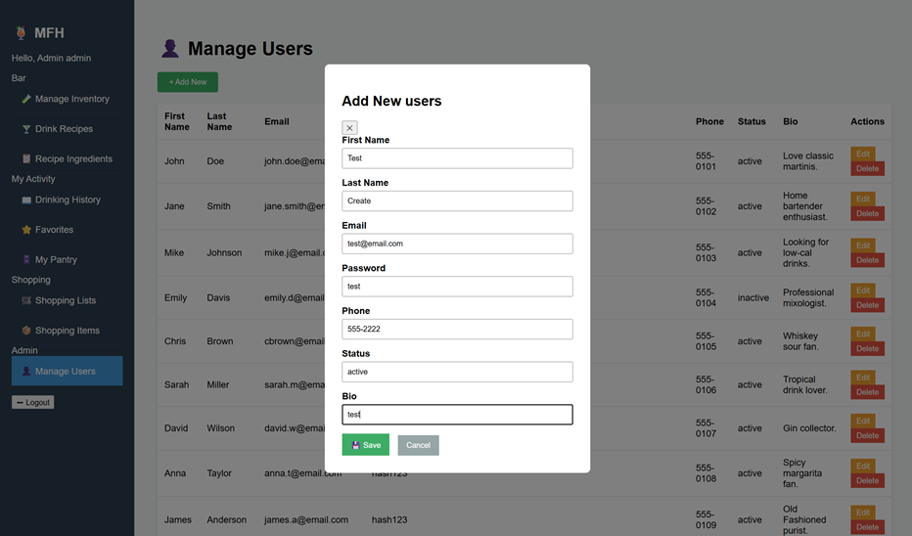

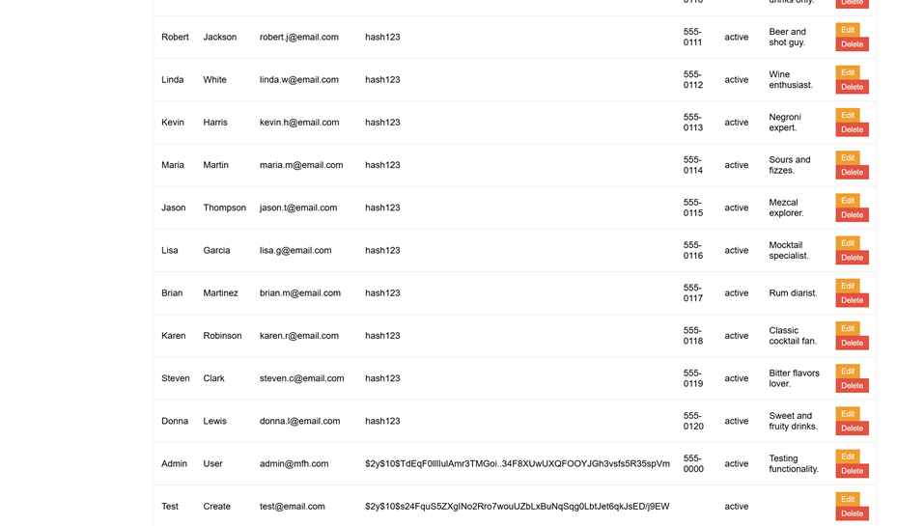

Read (Display)
All records for a given entity are loaded automatically when the user selects a sidebar navigation item. The frontend sends an HTTP GET request to the corresponding PHP endpoint. The backend executes a SELECT * query and returns all rows as a JSON array. The JavaScript renderTable() function iterates over the response and builds an HTML table with one column per schema-defined field plus an Actions column. No page reload occurs — only the content area updates in place.

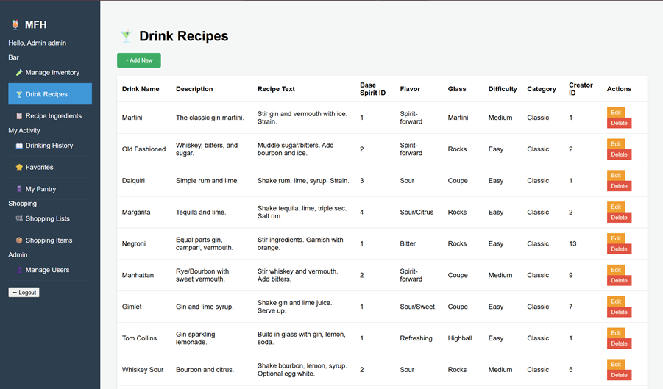

Update (Edit)
Each row in every data table has an Edit button in the Actions column. Clicking it calls editRow(), which fetches the current record from the API and pre-populates the modal form with the existing values. The user modifies any fields and clicks Save. Because the record's primary key is stored in a hidden form field, the POST request carries an id parameter. The BaseController detects the ID and executes an UPDATE statement targeting that specific row. The table re-renders to reflect the change.
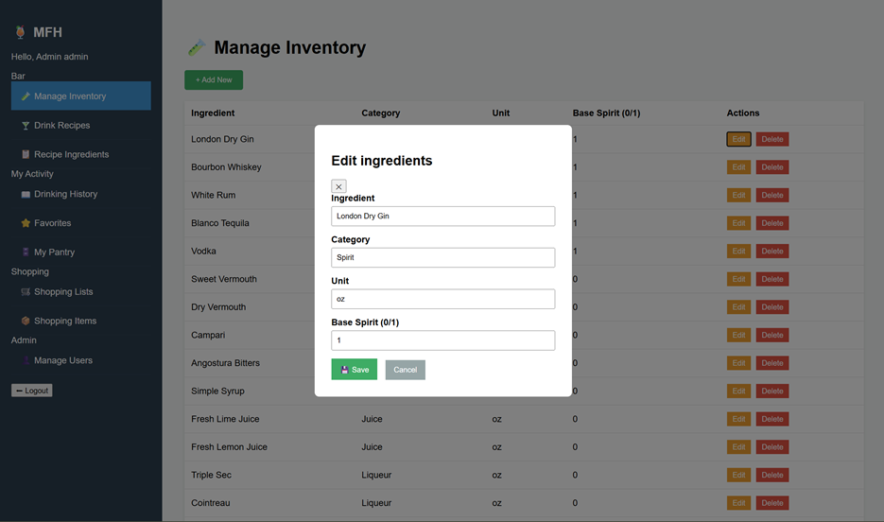

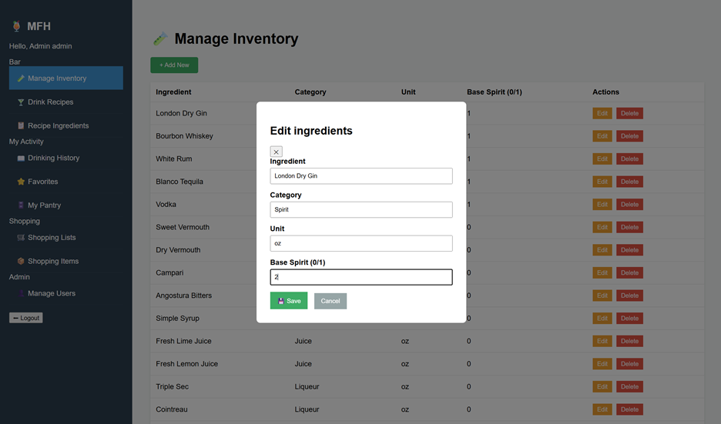
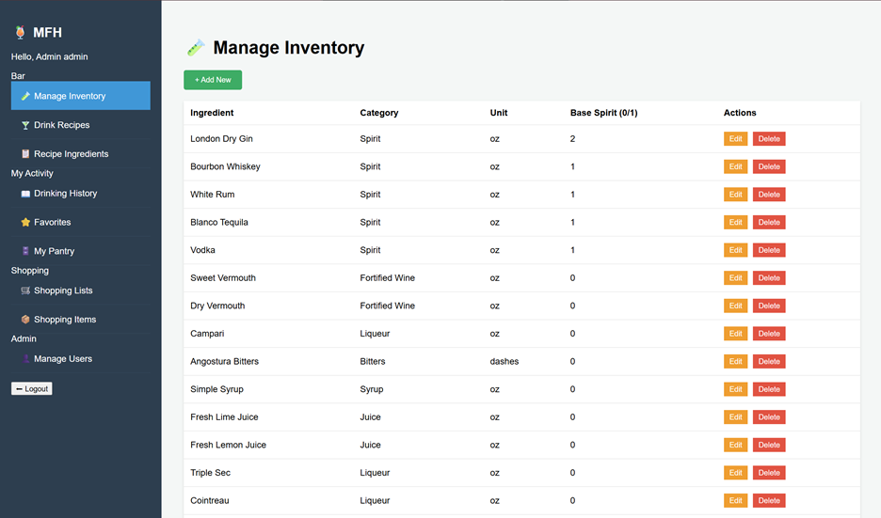

Delete
Each row in every data table has a Delete button in the Actions column. Clicking it triggers a browser confirmation dialog. If confirmed, the frontend sends an HTTP DELETE request with the record's primary key as a URL parameter (?id=<value>). The BaseController executes a DELETE statement for that record. If a foreign key constraint exists (for example, deleting an ingredient that is referenced by a drink recipe), the database rejects the operation and the backend returns an error response. The table refreshes to confirm the removal.
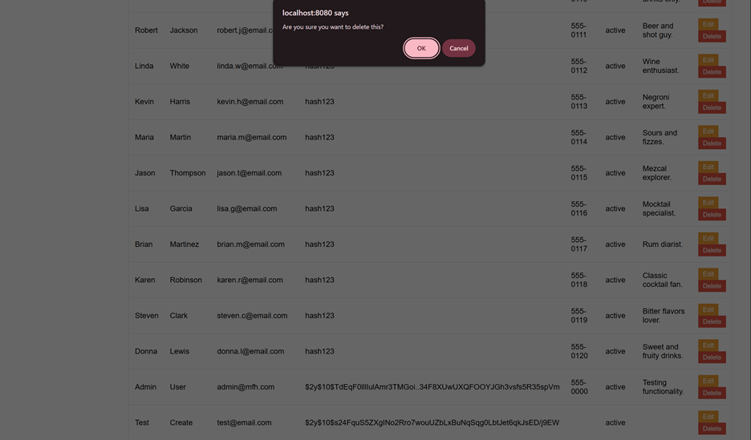
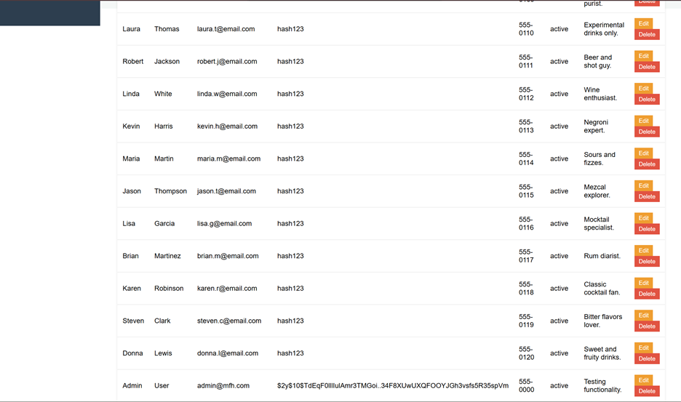

7. Reflection

7.1 Individual Contributions
- Each team member must write one paragraph describing:
  - their role
  - their contributions

7.2 Team Reflection
- Write paragraphs describing:
  - one feature your team is proud of or
  - an alternative approach you could have taken
- Reflect on challenges, decisions, or improvements

8. Appendix
Include:
- Link: GitHub/GitLab Repository
Ensure link is working and accessible.

Important Notes
- All figures, tables, and screenshots must:
  - be numbered
  - include captions
  - be referenced in the text
- Ensure your report is:
  - clear and well-organized
  - complete according to all sections above
- Submit your final report as a PDF

Disclaimer
This template provides structure and guidance. Students are responsible for ensuring their report fully meets the assignment rubric and requirements.

