**Change**

A project change. One of the developers has been taken off your project and put onto one with a higher priority. You have been asked to consider the options of extending your project by 2 weeks or spending €15k. Make a recommendation for the course of action and draft the related change request form.

**Response**

Agile – If project is on time and depending on the time of change a project delay of 2 weeks might be acceptable. Otherwise –if budget allows- spend additional 15k Euro to ensure quality and time scope of project.

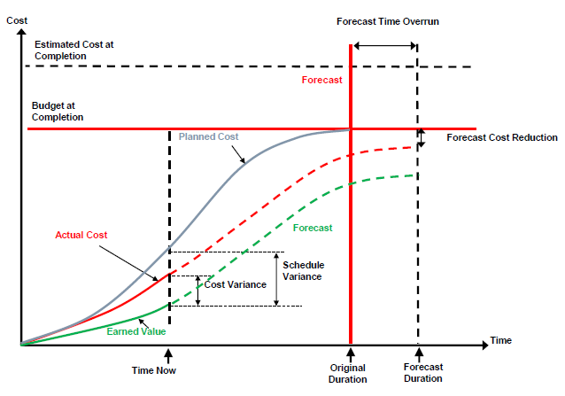

**Change Request Form**

|  |  |  |  |  |  |
| --- | --- | --- | --- | --- | --- |
| **1.) SUBMITTER - GENERAL INFORMATION** | | | | | |
| **CR#** | *[CR001]* | | | | |
| **Type of CR** | Enhancement | Defect |  | | |
| **Project/Program/Initiative** |  | | | | |
| **Submitter Name** | *[John Doe]* | | | | |
| **Brief Description of Request** | *[Enter a detailed description of the change being requested]* | | | | |
| **Date Submitted** | *[mm/dd/yyyy]* | | | | |
| **Date Required** | *[mm/dd/yyyy]* | | | | |
| **Priority** | Low | Medium | High | | Mandatory |
| **Reason for Change** | *[Enter a detailed description of why the change is being requested]* | | | | |
| **Other Artifacts Impacted** | *[List other artifacts affected by this change]* | | | | |
| **Assumptions and Notes** | *[Document assumptions or comments regarding the requested change]* | | | | |
| **Comments** | *[Enter additional comments]* | | | | |
| **Attachments or References** | Yes | No |  | | |
| **Link:** | | | | |
| **Approval Signature** | *[Approval Signature]* | | **Date Signed** | *[mm/dd/yyyy]* | |

|  |  |  |  |  |  |
| --- | --- | --- | --- | --- | --- |
| **2.) PROJECT MANAGER - INITIAL ANALYSIS** | | | | | |
| **Hour Impact** | *[#hrs]* | | *[Enter the hour impact of the requested change]* | | |
| **Duration Impact** | *[#dys]* | | *[Enter the duration impact of the requested change]* | | |
| **Schedule Impact** | *[WBS]* | | *[Detail the impact this change may have on schedules]* | | |
| **Cost Impact** | *[Cost]* | | *[Detail the impact this change may have on cost]* | | |
| **Comments** | *[Enter additional comments]* | | | | |
| **Recommendations** | *[Enter recommendations regarding the requested change]* | | | | |
| **Approval Signature** | | *[Approval Signature]* | | **Date Signed** | *[mm/dd/yyyy]* |

|  |  |  |  |  |  |  |  |
| --- | --- | --- | --- | --- | --- | --- | --- |
| **3.) CHANGE CONTROL BOARD – DECISION** | | | | | | | |
| **Decision** | | Approved | Approved with Conditions | | Rejected | | More Info |
| **Decision Date** | | *[mm/dd/yyyy]* | | | | | |
| **Decision Explanation** | | *[Document the CCB’s decision]* | | | | | |
| **Conditions** | | *[Document and conditions imposed by the CCB]* | | | | | |
| **Approval Signature** | *[Approval Signature]* | | | **Date Signed** | | *[mm/dd/yyyy]* | |