Software Architecture & DevOps — Laboratory Work
Week 8 · Lab 4
GitOps Delivery Architecture & Helm Package Design
Environment configuration management, declarative package abstraction and Git-driven continuous delivery for ShopLite
Student: Timur
Repository: https://github.com/timurdll/devops-labs
Branch: week8-gitops-helm
Chart / GitOps: charts/shoplite · environments/ · gitops/
Date: 4 November 2026

Contents
1. Objective and deliverables
2. Requirements and design decisions
3. GitOps state reconciliation
3.1 State machine of one Application
3.2 Reconciliation loop between Git, Argo CD and the Kubernetes API server
4. Helm package design
4.1 Chart hierarchy
4.2 Multi-environment configuration tree and variable inheritance
4.3 Parameter schema
5. GitOps delivery on the cluster
6. Observed reconciliation (Argo CD sync evidence)
6.1 Design vs runtime: 31 / 31 checks passed
7. Issues found during verification
8. Architecture Decision Records (summary)
9. Conclusions and limitations
Appendix A. Evidence files
Appendix B. Key manifests

(Right-click → Update Field in Word if the page numbers are not shown.)

1. Objective and deliverables
The goal of this lab is to design how ShopLite is configured for several environments and delivered from git. The static Week 7 manifests become one reusable Helm chart with a typed parameter contract. Each environment (dev, staging, prod) gets a values file that holds only its differences. Argo CD continuously reconciles the cluster with the repository. After the one-time bootstrap, the only way to change ShopLite is a commit.
System: ShopLite from Week 7 (web, catalog, orders + PostgreSQL) on the same kind cluster (Kubernetes v1.37, 1 control-plane and 2 worker nodes). Controller: Argo CD v3.5.6. Package: Helm 4.3.1, chart shoplite 0.1.1.
Table 1. Deliverables map
Assignment deliverable | Where it is
GitOps State Reconciliation Diagram (FSM) | Figure 2, Table 3 · docs/week8/diagrams/gitops-state-machine.mmd
GitOps Reconciliation Sequence Diagram (Git ↔ Argo CD ↔ API server) | Figure 3 · gitops-reconciliation-sequence.mmd
Helm Chart hierarchy scheme | Figure 4 · helm-chart-structure.mmd
Multi-environment configuration tree, variable inheritance | Figure 5, Table 4 · values-inheritance.mmd
Parameter schema (values.yaml) | §4.3 · charts/shoplite/values.yaml + values.schema.json, Appendix B
Static YAML parameterized into a reusable Helm chart | §4 · charts/shoplite/
Argo CD deployed, pointed at the repo, sync on commit | §5, §6 · gitops/
Argo CD sync screenshot / log | Figure 6, §6 · docs/week8/evidence/

2. Requirements and design decisions
Table 2. Requirements mapped to design decisions
Requirement | Design decision
Environment configuration management | Three environments = three namespaces (shop-dev, shop-staging, shop-prod), each with Pod Security Admission “restricted”, its own Secret and its own database. One values file per environment contains only the differences (ADR-W8-02).
Declarative package abstraction | One chart. Services are a map rendered by a single template. Hardening is fixed, not configurable. A strict values.schema.json is the contract.
Git-driven continuous delivery | Argo CD app of apps: root → AppProjects + platform + ApplicationSet shoplite → shoplite-dev / -staging / -prod (ADR-W8-01).
Safe production | prod is not auto-synced. Drift from git is reported as OutOfSync, and an operator approves the sync after reviewing the diff (ADR-W8-04).
Least privilege for the controller | AppProject shoplite: no cluster-scoped kinds, 7 namespaced kinds, 3 namespaces. AppProject platform: Namespace, IngressClass, ClusterRole(Binding) only.
Secrets | Never in git. The chart references database.existingSecret. Sealed Secrets or External Secrets Operator is the production path (ADR-W8-03).
Change detection | Polling every 30 s instead of the default 120 s, because GitHub cannot send webhooks into a local kind cluster (ADR-W8-05).

Figure 1 shows where every piece lives. Git holds the desired state. Argo CD objects in the argocd namespace pull it. The kind cluster namespaces hold the actual state.
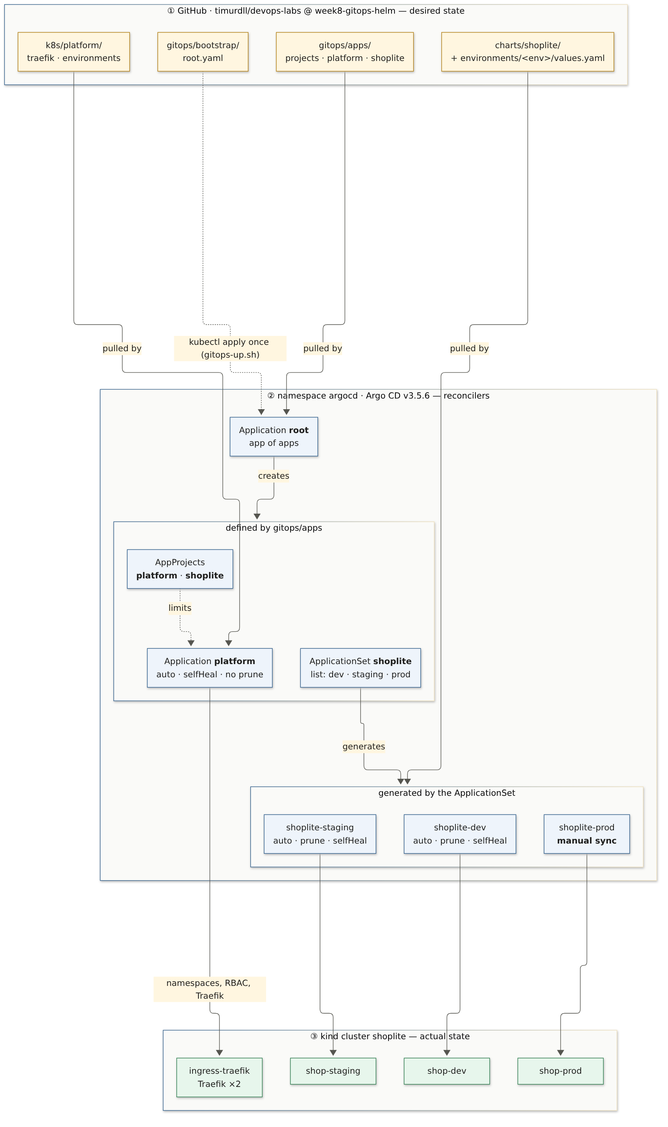
Figure 1. GitOps architecture: repository → Argo CD → cluster (source: gitops-architecture.mmd)

3. GitOps state reconciliation

3.1 State machine of one Application
Git holds the desired state: a commit SHA rendered through Helm. The cluster holds the actual state. Argo CD tracks two orthogonal axes: *sync status* (does live equal desired?) and *health* (is it working?). The state machine below models one Application. Every transition except SyncFailed was observed in this lab (§6).
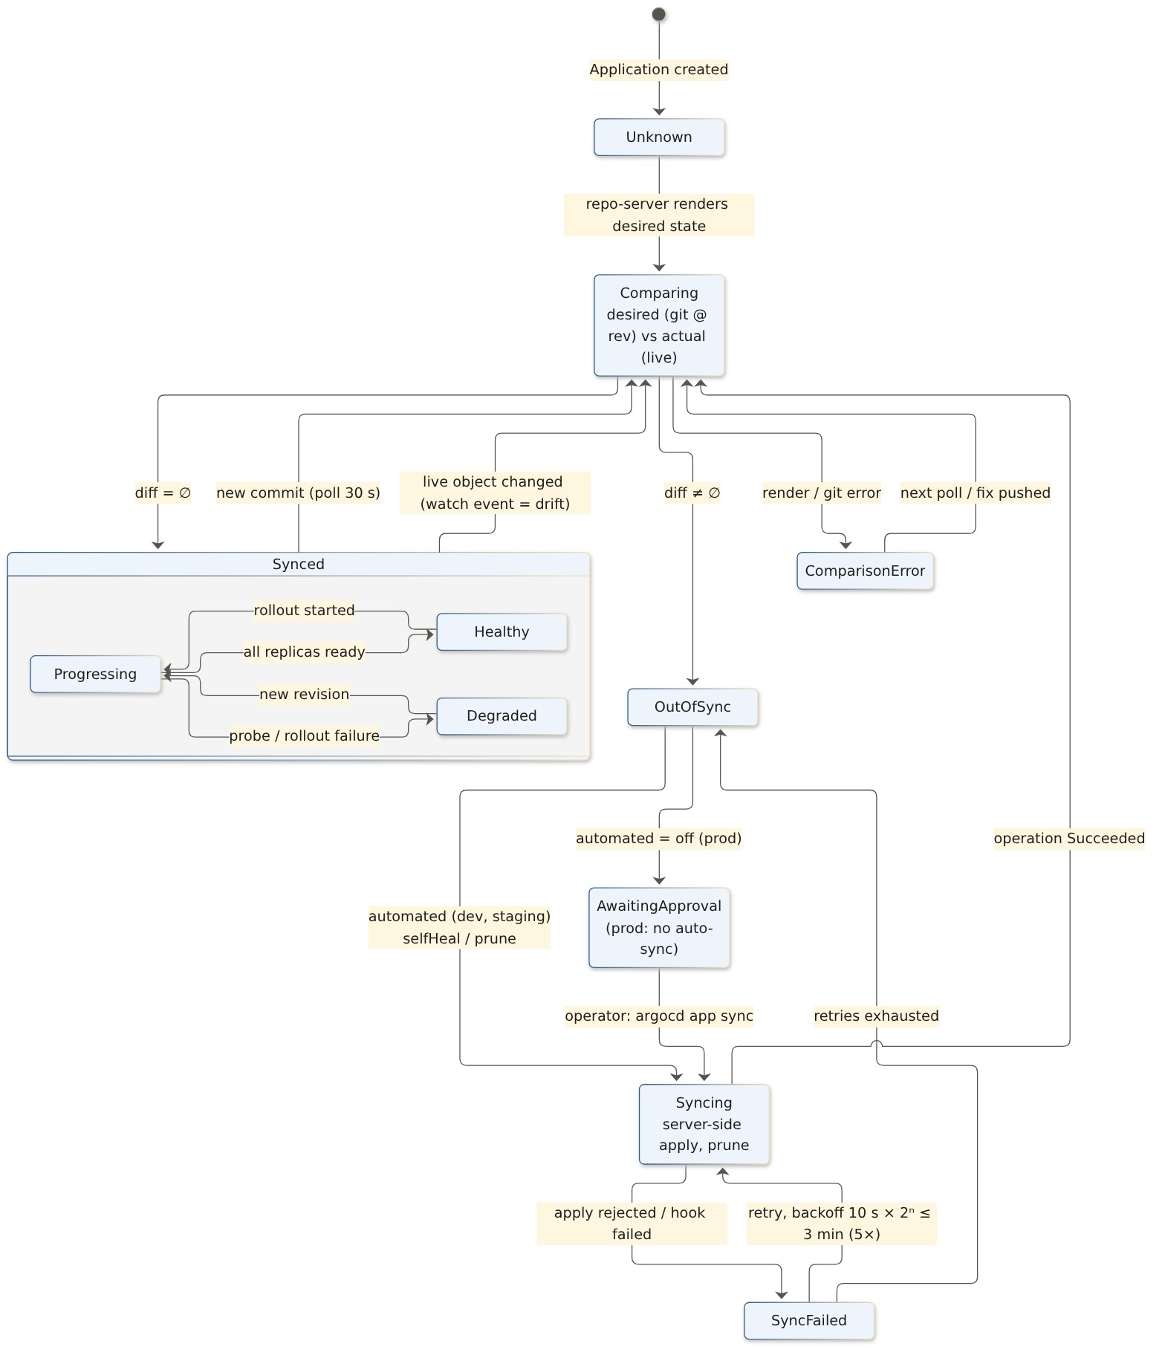
Figure 2. GitOps state reconciliation as a finite state machine (source: gitops-state-machine.mmd)
Table 3. Transitions and where they were observed
From → To | Trigger | Observed in
Synced → Comparing → OutOfSync | new commit, picked up by the 30 s poll | 03, 05
Synced → OutOfSync (drift) | kubectl scale on a live Deployment (watch event) | 04
OutOfSync → Syncing → Synced | automated sync (dev, staging) | 03, 03b
OutOfSync → AwaitingApproval → Syncing | prod: automated off, operator runs gitops-sync-prod.sh | 02, 05
Synced(Progressing) → Synced(Healthy) | rolling update finished, all replicas ready | 03
ComparisonError / Unknown | git unreachable: no comparison, no self-heal | 09

3.2 Reconciliation loop between Git, Argo CD and the Kubernetes API server
Argo CD uses a pull model, so nothing outside the cluster needs cluster credentials. The repo-server renders helm template with the three value layers and caches the result per commit SHA. The application controller compares that render with live objects from its watch cache and server-side-applies the difference. Drift is detected immediately from watch events. New commits are detected by polling every 30 s.
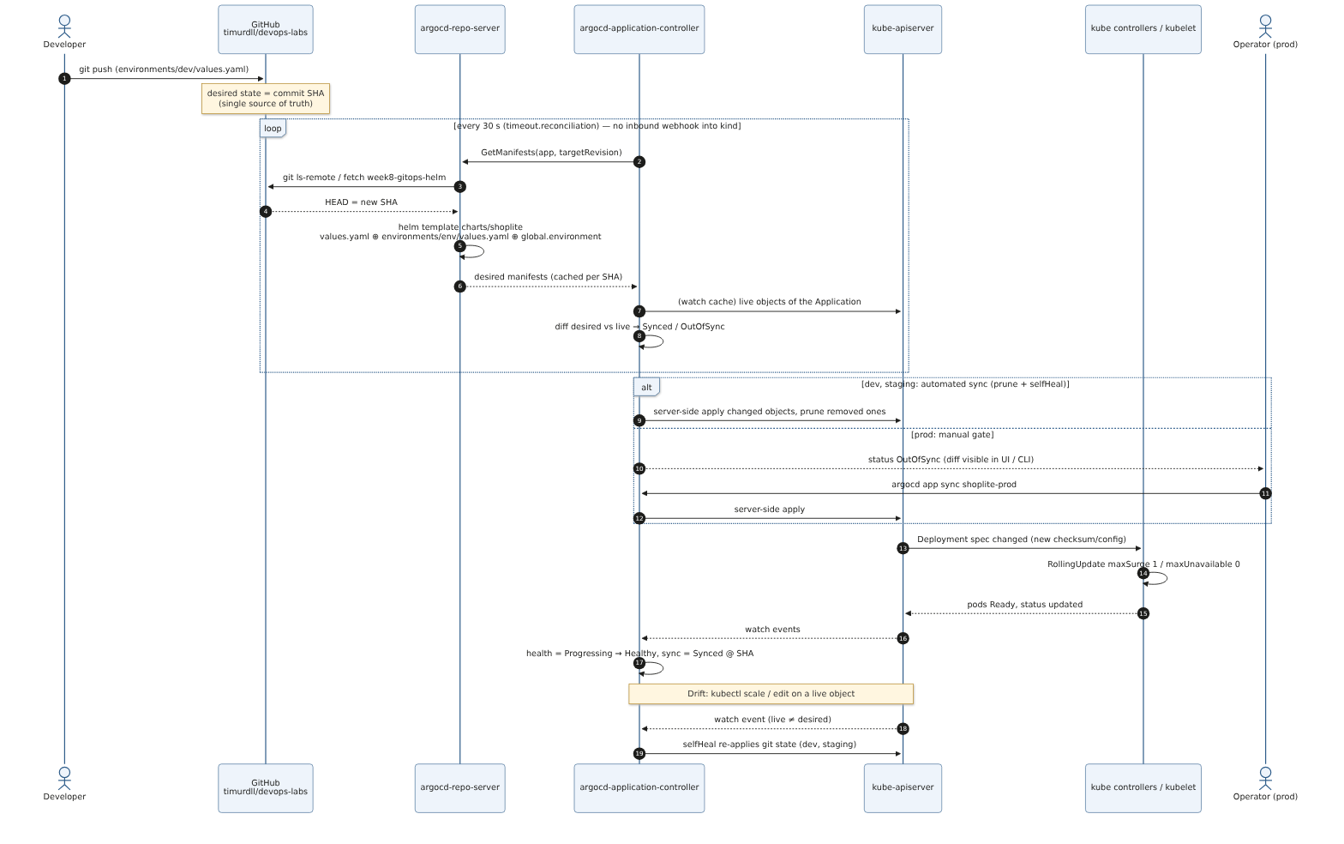
Figure 3. GitOps reconciliation sequence: Git ↔ Argo CD ↔ kube-apiserver (source: gitops-reconciliation-sequence.mmd)

4. Helm package design

4.1 Chart hierarchy
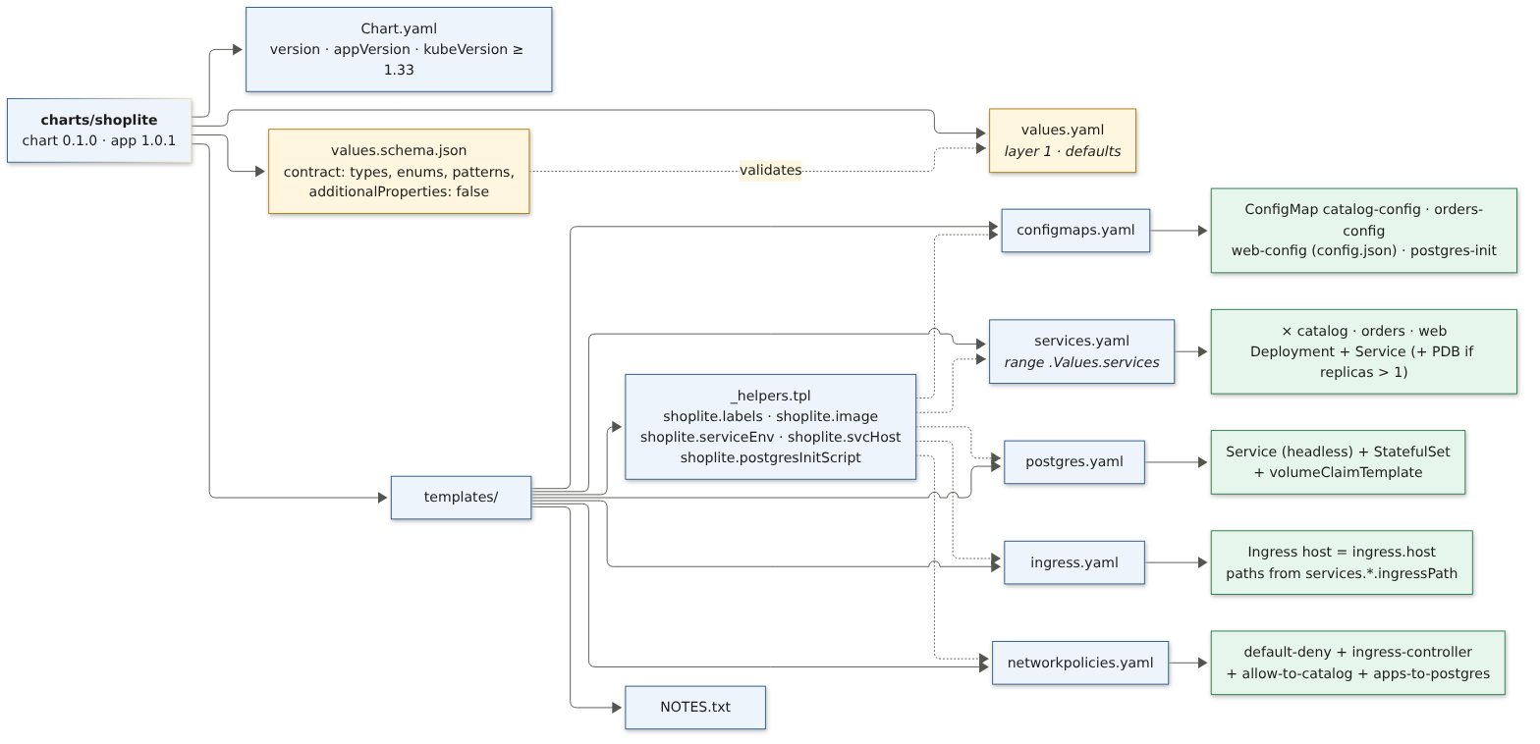
Figure 4. Hierarchical decomposition of charts/shoplite (source: helm-chart-structure.mmd)
charts/shoplite/
Chart.yaml version 0.1.1 · appVersion 1.0.1 · kubeVersion >= 1.33
values.yaml layer 1: defaults (the parameter schema, documented inline)
values.schema.json contract: types, enums, patterns, additionalProperties: false
templates/
_helpers.tpl labels · image ref (tag precedence) · service env · svc DNS · DB init script
configmaps.yaml <svc>-config (envFrom) · web-config (config.json) · postgres-init
services.yaml range .Values.services → Deployment + Service (+ PDB)
postgres.yaml headless Service + StatefulSet + volumeClaimTemplate
ingress.yaml host from ingress.host, paths from services.*.ingressPath (longest first)
networkpolicies.yaml default-deny + ingress controller + allowFrom + DB clients
NOTES.txt
Parameterisation choices
- Parameters: replicas, resources, image registry and tag, ingress host, extra env, UI config, storage, PDB and topology spread on/off. Not parameters: security context, automountServiceAccountToken, enableServiceLinks, probe ports. If those were configurable, one values file could switch off the Week 6/7 controls. Trivy (gate G7) scans the chart rendered for each environment to prove the controls hold.
- Derived, not duplicated: PGHOST, CATALOG_URL, the DB init script and the NetworkPolicy peer lists are computed from services.* and .Release.Namespace. Adding a database-backed service is one map entry.
- Config changes roll pods: a checksum/config annotation replaces kustomize’s hash-suffixed names from Week 7. The mounted web-config is hot-reloaded, so it has no checksum.
- Selectors unchanged (app.kubernetes.io/name only). Deployment selectors are immutable, so moving from the Week 7 manifests needs no object recreation.

4.2 Multi-environment configuration tree and variable inheritance
charts/shoplite/values.yaml ← layer 1 (shared defaults)
environments/
dev/values.yaml ← layer 2 (replicas 1, small requests, dev host, banner)
staging/values.yaml ← layer 2 (production shape: PDBs, staging host)
prod/values.yaml ← layer 2 (3 API replicas, bigger requests, 2 Gi DB)
gitops/apps/shoplite.yaml ← layer 3 (global.environment = ApplicationSet generator element)
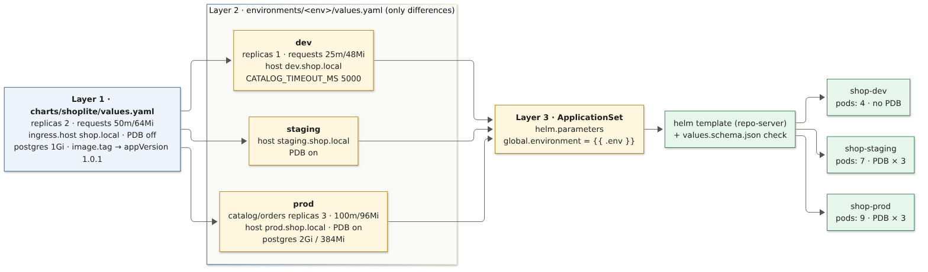
Figure 5. Environment-specific variable inheritance, deep-merged left to right (source: values-inheritance.mmd)
Table 4. Effective values per environment (bold = overridden)
Key | Chart default | dev | staging | prod
services.catalog.replicas | 2 | 1 → 2 (demo) | 2 | 3
services.orders.replicas | 2 | 1 | 2 | 3
services.web.replicas | 2 | 1 → 2 (demo) | 2 | 2
services.*.resources.requests | 50m / 64Mi | 25m / 48Mi | 50m / 64Mi | 100m / 96Mi
ingress.host | shop.local | dev.shop.local | staging.shop.local | prod.shop.local
podDisruptionBudget.enabled | false | false | true | true
orders.env.CATALOG_TIMEOUT_MS | 2000 | 5000 | 2000 | 2000
postgres.storage.size | 1Gi | 1Gi | 1Gi | 2Gi
global.environment | "" (required) | dev | staging | prod

Maps merge deeply and scalars and lists are replaced, so an environment file never repeats a default. The environment name is injected by the ApplicationSet from the same generator element that sets the namespace, so the two cannot diverge.

4.3 Parameter schema
values.yaml documents the parameters inline (Appendix B). values.schema.json turns them into a contract: helm lint/template and Argo CD’s repo-server reject an invalid file before anything reaches the API server. Negative tests:
--set global.environment=qa → '/global/environment': value must be one of 'dev', 'staging', 'prod'
--set image.tag=latest → '/image/tag': 'not' failed (mutable tags are forbidden)
--set services.web.replicas=0 → '/services/web/replicas': minimum: got 0, want 1
--set services.web.replica=3 → '/services/web': additional properties 'replica' not allowed (typo)
--set services.catalog.env.DB_PASSWORD=x → invalid propertyName 'DB_PASSWORD' (no secrets in values)
postgres.image without @sha256:… → pattern mismatch (third-party images digest-pinned)
CI gates extended (Week 6): G2 runs helm lint --strict and a kubeconform -strict render for each environment (57 objects, all valid), and validates the Argo CD custom resources against the datree CRD catalog. G7 runs trivy config on the chart rendered for each environment. The original root scan silently skipped the chart, because it cannot render without global.environment. That gap was found and closed here.

5. GitOps delivery on the cluster
./scripts/gitops-up.sh # install Argo CD (pinned), env namespaces + secrets, apply root app
./scripts/gitops-sync-prod.sh # prod approval gate: shows the diff, then syncs
./scripts/gitops-verify.sh # evidence 01, 06, 07, 08 (31 design-vs-runtime checks)
./scripts/gitops-demo.sh # scenarios A / B / C (pushes demo commits)
./scripts/gitops-watch.sh <app> <seconds> # print every state transition of one Application
Table 5. Argo CD objects
Object | Kind | Source in git | Sync policy
root | Application | gitops/apps | auto · prune · self-heal
platform, shoplite | AppProject | gitops/apps/projects.yaml | —
platform | Application (wave −1) | k8s/platform: Traefik, env namespaces, RBAC | auto · self-heal · no prune
shoplite | ApplicationSet (list generator) | gitops/apps/shoplite.yaml | —
shoplite-dev, shoplite-staging | Application | charts/shoplite + environments/<env> | auto · prune · self-heal · retry 5× backoff
shoplite-prod | Application | charts/shoplite + environments/prod | manual

Bootstrap steps (gitops-up.sh):
- Apply the pinned Argo CD install with server-side apply. The ApplicationSet CRD exceeds the client-side last-applied annotation limit.
- Create the environment namespaces and one db-credentials Secret per namespace from git-ignored random values.
- Apply gitops/bootstrap/root.yaml. From then on every AppProject, Application and ApplicationSet comes from git.
Traefik now also watches the three environment namespaces. Access is granted through one ClusterRole traefik-ingress-namespaced bound by a RoleBinding per namespace, which is still namespace-scoped. The Week 7 shop namespace keeps working unchanged.

6. Observed reconciliation (Argo CD sync evidence)
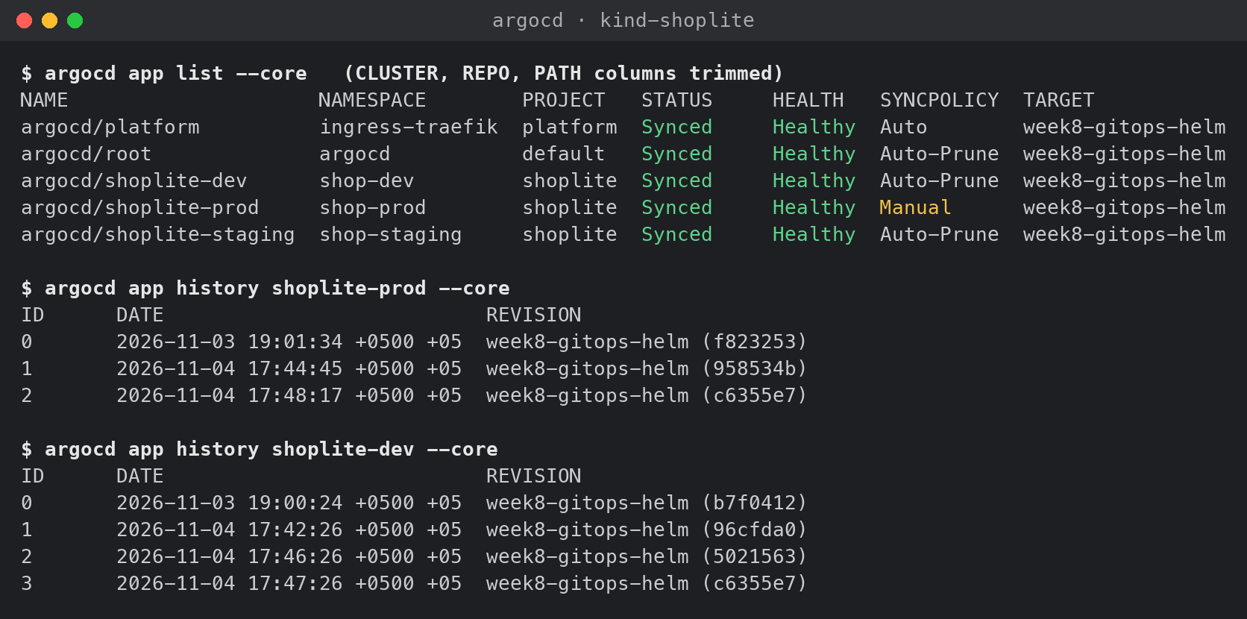
Figure 6. Argo CD sync status and sync history of the environments (argocd --core, evidence/argocd-sync-cli.txt)
Table 6. Scenarios
# | Scenario | Observed | Evidence
0 | Bootstrap fix via git: platform showed InvalidSpecError; fix pushed (98636da) | push → Synced/Progressing +15 s → Healthy +28 s | 00-bootstrap
1 | First prod release needs approval | OutOfSync/Missing until gitops-sync-prod.sh → 20 objects created | 02-prod-first-sync
A | Commit to dev (catalog 1→2, new banner) | OutOfSync +5 s → Progressing +6 s → Healthy +8 s | 03-scenario-a
A2 | Scale through git after the chart fix (web 1→2) | OutOfSync +46 s → Healthy +48 s; running pod survived | 03b-scenario-a2
B | Drift: kubectl scale orders → 5 in staging | self-heal < 1 s, partial sync of Deployment/orders only | 04-scenario-b
C | Commit to prod (release banner) | OutOfSync +47 s, stays until approval → Synced/Healthy | 05-scenario-c

Scenario A: a commit is the deployment. Nobody runs kubectl or helm. The cluster follows git:
17:42:18 git push commit 017a7f4 (environments/dev/values.yaml: catalog 1→2, banner)
17:42:21 + 0s shoplite-dev sync=Synced health=Healthy operation=Succeeded revision=06da9ad
17:42:26 + 5s shoplite-dev sync=OutOfSync health=Healthy operation=Running revision=017a7f4
17:42:27 + 6s shoplite-dev sync=Synced health=Progressing operation=Succeeded revision=017a7f4
17:42:29 + 8s shoplite-dev sync=Synced health=Healthy operation=Succeeded revision=017a7f4
Scenario B: drift is reverted. A manual edit of a live object is undone within the same second, and only the drifted object is re-applied:
17:42:29 kubectl -n shop-staging scale deploy/orders --replicas=5
12:42:29Z Initiated automated sync to '017a7f4…' (application-controller log, UTC)
12:42:29Z Initialized new operation: resources=[Deployment/orders] selfHealAttemptsCount=2
12:42:30Z Partial sync operation to 017a7f4… succeeded
ReplicaSet orders-56f46b7ddc: 3 pods created and the same 3 pods deleted within 1 s → orders 2/2
Scenario C: production waits for a human. The prod Application reports the difference but does not act until an operator approves:
17:42:35 git push commit 4ba6625 (environments/prod/values.yaml: release banner)
17:42:39 + 0s shoplite-prod sync=Synced health=Healthy revision=017a7f4
17:43:26 + 47s shoplite-prod sync=OutOfSync health=Healthy revision=4ba6625 ← waits, prod serves old config
17:44:40 operator: ./scripts/gitops-sync-prod.sh --yes (diff reviewed: web-config banner)
17:44:46 + 0s shoplite-prod sync=Synced health=Healthy revision=4ba6625
12:45:32Z first response with the new banner (+47 s after the ConfigMap update, kubelet volume sync)
Commit-to-detection took 5–47 s, within the designed bound of one 30 s poll plus the repo-server’s revision cache.

6.1 Design vs runtime: 31 / 31 checks passed
The oracle is helm template of the current git commit. For every environment, gitops-verify.sh compares it with the live cluster:
Table 7. Design (git) vs runtime state (scripts/gitops-verify.sh)
Check | Expected | Actual | Result
app shoplite-dev | Synced/Healthy | Synced/Healthy | PASS
app shoplite-dev revision = git HEAD | 4f8ad1b | 4f8ad1b | PASS
shop-dev deploy/catalog ready/desired | 2/2 | 2/2 | PASS
shop-dev deploy/orders ready/desired | 1/1 | 1/1 | PASS
shop-dev deploy/web ready/desired | 2/2 | 2/2 | PASS
shop-dev ingress host | dev.shop.local | dev.shop.local | PASS
shop-dev PodDisruptionBudgets | 0 | 0 | PASS
shop-dev pvc/data-postgres-0 | Bound:1Gi | Bound:1Gi | PASS
shop-dev PSA enforce | restricted | restricted | PASS
shop-dev HTTP GET /api/catalog/products | 200 | 200 | PASS
app shoplite-staging | Synced/Healthy | Synced/Healthy | PASS
app shoplite-staging revision = git HEAD | 4f8ad1b | 4f8ad1b | PASS
shop-staging deploy/catalog ready/desired | 2/2 | 2/2 | PASS
shop-staging deploy/orders ready/desired | 2/2 | 2/2 | PASS
shop-staging deploy/web ready/desired | 2/2 | 2/2 | PASS
shop-staging ingress host | staging.shop.local | staging.shop.local | PASS
shop-staging PodDisruptionBudgets | 3 | 3 | PASS
shop-staging pvc/data-postgres-0 | Bound:1Gi | Bound:1Gi | PASS
shop-staging PSA enforce | restricted | restricted | PASS
shop-staging HTTP GET /api/catalog/products | 200 | 200 | PASS
app shoplite-prod | Synced/Healthy | Synced/Healthy | PASS
app shoplite-prod revision = git HEAD | 4f8ad1b | 4f8ad1b | PASS
shop-prod deploy/catalog ready/desired | 3/3 | 3/3 | PASS
shop-prod deploy/orders ready/desired | 3/3 | 3/3 | PASS
shop-prod deploy/web ready/desired | 2/2 | 2/2 | PASS
shop-prod ingress host | prod.shop.local | prod.shop.local | PASS
shop-prod PodDisruptionBudgets | 3 | 3 | PASS
shop-prod pvc/data-postgres-0 | Bound:2Gi | Bound:2Gi | PASS
shop-prod PSA enforce | restricted | restricted | PASS
shop-prod HTTP GET /api/catalog/products | 200 | 200 | PASS
Secret db-credentials tracked by Argo CD | no | no | PASS

Orders were placed successfully through each environment’s host (HTTP 201, 07-traffic-tests.txt). An isolation probe carrying the orders label could reach postgres.shop-dev. It was BLOCKED from postgres.shop-staging and postgres.shop-prod, so the environments are isolated even though they share a cluster.

7. Issues found during verification
Table 8. Defects found by comparing runtime behaviour against the design
# | Symptom | Root cause | Fix
1 | platform Application Unknown, InvalidSpecError | Destination namespace "" is not in AppProject platform’s destinations | destination.namespace: ingress-traefik, fixed through git (scenario 0)
2 | Trivy G7 reported 0 findings for the chart, because it never scanned it | The chart fails to render without global.environment, and Trivy silently skips it | G7 scans once per environment with --helm-values
3 | Scaling catalog 1→2 restarted the running pod | topologySpreadConstraints was rendered only for replicas > 1, which changed the pod template | Always rendered (chart 0.1.1). Scenario A2: scaling adds pods, restarts none
4 | Argo CD Synced while prod served the old banner for 47 s | config.json is a mounted ConfigMap, refreshed by kubelet on its sync period (eventual consistency) | Documented. Config that must switch atomically uses checksum/config (pod roll), as the env-var services do
5 | GitHub unreachable for ~30 min during the first demo run | Network outage on the host (SSH :22 and HTTPS :443 refused) | Apps went Unknown and self-heal stopped. Injected drift stayed until GitHub returned, then healed by itself (09). Production: HA git mirror or OCI charts, alert on ComparisonError. Demo now aborts on a failed push
6 | Argo CD image pull took > 25 min | Slow uplink, three parallel pulls of a 211 MB image | Documented: pre-load with kind load docker-image or use a pull-through cache

8. Architecture Decision Records (summary)
Table 9. ADRs (full text: docs/week8/adr.md)
ADR | Decision | Main reason / trade-off
W8-01 | Argo CD (not Flux) as GitOps controller | ApplicationSet + AppProject RBAC + first-class sync/health status. Costs about 7 pods / 600 MiB, where Flux would be lighter.
W8-02 | One chart + directory per environment on one branch; namespace per environment | Promotion = a PR that changes one file. No long-lived environment branches that drift.
W8-03 | Secrets out of git (existingSecret) for the lab | No plaintext in git. Production: Sealed Secrets or External Secrets Operator restores “git = full desired state”.
W8-04 | dev/staging automated (prune + self-heal), prod manual, platform no prune | Human approval gate for production. Pruning a Namespace would delete a whole environment.
W8-05 | 30 s polling instead of webhooks | kind is not reachable from GitHub. Production: webhook for immediate refresh, poll as fallback.

9. Conclusions and limitations
- The nine hand-written Week 7 manifest files of the shop are now one chart with a schema-checked parameter contract. The three environments differ only in 13–29 lines of values.
- Git is the single source of truth in practice, not only on paper. Commits deployed themselves (5–48 s). Manual drift was reverted in under a second. Production waited for approval, and a bootstrap bug was fixed by a commit.
- Verification found three defects in this work: an AppProject destination, a skipped security scan, and a pod restart on scale. It also surfaced two operational facts: “Synced” is not yet “serving”, and git is a runtime dependency of reconciliation.
- Limitations: the Applications track the branch week8-gitops-helm (switch targetRevision to main after merging). Secrets are created out-of-band. Images are loaded into kind locally instead of pulled from the signed Week 6 registry. Argo CD is the non-HA install.
- Next steps: image promotion by PR (CI bumps image.tag in environments/dev), Sealed Secrets, a GitHub webhook, and Argo CD notifications on ComparisonError and SyncFailed. These connect to Week 9 (observability) and Week 12 (progressive delivery).

Appendix A. Evidence files
File (docs/week8/evidence/) | Content
00-bootstrap.txt | gitops-up.sh output, platform fix timeline
01-argocd-applications.txt | Argo CD pods, AppProjects, ApplicationSet, Applications
02-prod-first-sync.txt | first prod release and chart 0.1.1 promotion (diff + sync result)
03-scenario-a-commit-to-dev.txt | commit → dev auto-sync timeline
03b-scenario-a2-scale-without-restart.txt | scale through git after the chart fix
04-scenario-b-drift-self-heal.txt | drift → self-heal, ReplicaSet events, controller log
05-scenario-c-prod-manual-gate.txt | prod waits for approval, ConfigMap propagation delay
06-environments-runtime.txt | Deployments, StatefulSets, PDBs, Ingresses, NetworkPolicies, PVCs, pods per env
07-traffic-tests.txt | requests through each env host, orders, cross-env isolation probe
08-design-vs-runtime.txt | 31 checks: git (helm template) vs cluster
09-observation-git-unreachable.txt | behaviour while GitHub was unreachable
10-argocd-cli-sync-log.txt, argocd-sync-cli.png | argocd app list / get / history

Appendix B. Key manifests
ApplicationSet (gitops/apps/shoplite.yaml)
# One chart, three environments. The list generator is the environment matrix; the template
# turns each element into an Application "shoplite-<env>" rendering charts/shoplite with
# layer 1 charts/shoplite/values.yaml (implicit)
# layer 2 environments/<env>/values.yaml
# layer 3 global.environment = <env> (from the generator: name ≡ namespace)
apiVersion: argoproj.io/v1alpha1
kind: ApplicationSet
metadata:
name: shoplite
namespace: argocd
spec:
goTemplate: true
goTemplateOptions: ["missingkey=error"]
generators:
- list:
elements:
- env: dev
autoSync: true
- env: staging
autoSync: true
- env: prod
autoSync: false # human approval: OutOfSync is reported, the sync is a manual action
template:
metadata:
name: "shoplite-{{ .env }}"
labels:
shoplite.io/environment: "{{ .env }}"
finalizers:
- resources-finalizer.argocd.argoproj.io
spec:
project: shoplite
source:
repoURL: https://github.com/timurdll/devops-labs.git
targetRevision: week8-gitops-helm
path: charts/shoplite
helm:
releaseName: shoplite
valueFiles:
- "../../environments/{{ .env }}/values.yaml"
parameters:
- name: global.environment
value: "{{ .env }}"
destination:
server: https://kubernetes.default.svc
namespace: "shop-{{ .env }}"
# Replica counts are owned by git, but kubectl rollout restart stamps an annotation that
# should not show up as drift.
ignoreDifferences:
- group: apps
kind: Deployment
jsonPointers:
- /spec/template/metadata/annotations/kubectl.kubernetes.io~1restartedAt
syncPolicy:
syncOptions:
- CreateNamespace=false # namespaces come from the platform Application
- PruneLast=true
- RespectIgnoreDifferences=true
retry:
limit: 5
backoff:
duration: 10s
factor: 2
maxDuration: 3m
templatePatch: |
{{- if .autoSync }}
spec:
syncPolicy:
automated:
prune: true
selfHeal: true
{{- end }}
Parameter schema: chart defaults (charts/shoplite/values.yaml)
# ShopLite chart — parameter schema, layer 1 of 3 (chart defaults).
#
# Values are merged in this order; a later layer overrides an earlier one key by key
# (maps merge deeply, lists and scalars are replaced):
# 1. charts/shoplite/values.yaml this file: safe baseline shared by every environment
# 2. environments/<env>/values.yaml what differs per environment (replicas, host, sizing…)
# 3. ApplicationSet helm.parameters only global.environment, injected from the generator,
# so the environment name and the namespace cannot diverge
# The contract is enforced by values.schema.json: helm lint / helm template / Argo CD reject
# unknown keys and out-of-range values before anything reaches the API server.

global:
# dev | staging | prod. Required; set by the ApplicationSet (layer 3).
environment: ""

# Applied to every application image unless a service overrides it.
image:
# Empty → local images loaded into kind (shoplite/<service>:<tag>).
# For a real registry: ghcr.io/timurdll/devops-labs (pushed and signed by the Week 6 pipeline).
registry: ""
# Empty → Chart.appVersion. Promotion between environments = changing this value in git.
tag: ""
pullPolicy: IfNotPresent

# North-south entry point (Traefik, Week 7). One host per environment.
ingress:
enabled: true
className: traefik
host: shop.local

# Pod-level defaults shared by all stateless services (Week 7 hardening, unchanged).
podDefaults:
terminationGracePeriodSeconds: 30
# Seconds the pod keeps serving after it is removed from the endpoints (rolling-update drain).
preStopSleepSeconds: 5
revisionHistoryLimit: 3
# Hard spread of the replicas of one revision across worker nodes.
topologySpread:
enabled: true
whenUnsatisfiable: DoNotSchedule

# PodDisruptionBudget (minAvailable: 1) for every service with replicas > 1.
podDisruptionBudget:
enabled: false

# Stateless services. The key is the Kubernetes name (Deployment, Service, DNS name).
services:
catalog:
enabled: true
component: api
tier: backend
replicas: 2
image:
repository: shoplite/catalog
tag: "" # empty → image.tag → Chart.appVersion
runAsUser: 65532 # distroless "nonroot"
probes:
readinessPath: /readyz
livenessPath: /healthz
resources:
requests: { cpu: 50m, memory: 64Mi }
limits: { cpu: 500m, memory: 256Mi }
# Exposed through the Ingress under this path prefix ("" → not exposed).
ingressPath: /api/catalog
# Gets its own database + login role; the password is read from database.existingSecret.
database:
name: catalog
passwordKey: CATALOG_DB_PASSWORD
# Extra non-secret settings → <service>-config ConfigMap → envFrom.
env: {}
# Other services allowed to call this one (NetworkPolicy).
allowFrom: [orders]

orders:
enabled: true
component: api
tier: backend
replicas: 2
image:
repository: shoplite/orders
tag: ""
runAsUser: 65532
probes:
readinessPath: /readyz
livenessPath: /healthz
resources:
requests: { cpu: 50m, memory: 64Mi }
limits: { cpu: 500m, memory: 256Mi }
ingressPath: /api/orders
database:
name: orders
passwordKey: ORDERS_DB_PASSWORD
env:
# CATALOG_URL is derived from the release namespace by the chart.
CATALOG_TIMEOUT_MS: "2000"
allowFrom: []

web:
enabled: true
component: frontend
tier: frontend
replicas: 2
image:
repository: shoplite/web
tag: ""
runAsUser: 101 # "nginx" in nginx-unprivileged
probes:
readinessPath: /healthz
livenessPath: /healthz
resources:
requests: { cpu: 20m, memory: 32Mi }
limits: { cpu: 200m, memory: 128Mi }
ingressPath: /
env: {}
allowFrom: []
# Rendered into config.json and mounted as a file (hot-reloaded by the kubelet).
uiConfig:
shopName: ShopLite
currency: USD
banner: ""

# Stateful tier: PostgreSQL StatefulSet with one PVC.
postgres:
enabled: true
image: postgres:17-alpine@sha256:b0f9560a2de083e2cc7382e75f808c7381a32852a7ec49117deedb300e552b24
runAsUser: 70
storage:
size: 1Gi
storageClassName: standard
resources:
requests: { cpu: 100m, memory: 256Mi }
limits: { cpu: "1", memory: 512Mi }

database:
# Secret holding POSTGRES_PASSWORD and one <SERVICE>_DB_PASSWORD per service. It is NOT part of
# the chart: values never enter git (created by scripts/gitops-up.sh; ADR in docs/week8).
existingSecret: db-credentials

networkPolicies:
enabled: true
# Namespace + pod label of the ingress controller allowed to reach the services.
ingressController:
namespace: ingress-traefik
podName: traefik
Environment overrides (environments/prod/values.yaml)
# Layer 2 · prod — highest availability. Argo CD detects the difference between git and the cluster
# (OutOfSync) but does NOT sync on its own: an operator approves every sync (manual gate).
ingress:
host: prod.shop.local

podDisruptionBudget:
enabled: true

services:
catalog:
replicas: 3
resources:
requests: { cpu: 100m, memory: 96Mi }
limits: { cpu: "1", memory: 384Mi }
orders:
replicas: 3
resources:
requests: { cpu: 100m, memory: 96Mi }
limits: { cpu: "1", memory: 384Mi }
web:
uiConfig:
shopName: ShopLite
banner: "Release 2026.11 approved for production"

postgres:
storage:
size: 2Gi
resources:
requests: { cpu: 250m, memory: 384Mi }

