Software Architecture & DevOps — Laboratory Work
Week 10 · Lab 6
Service Mesh Architecture & Inter-Service Communication
Decentralized traffic management, zero-trust mTLS with ServiceAccount identities, and a 90/10 canary with Istio and Envoy sidecars for ShopLite
Student: Timur
Repository: https://github.com/timurdll/devops-labs
Branch: week10-service-mesh
Stack: Istio 1.31.4 (sidecar mode, istio-cni) · Envoy · Argo CD · Kubernetes 1.37 (kind)
Date: 11 November 2026

Contents
1. Objective and deliverables
2. Requirements and design decisions
3. Mesh topology: control plane vs data plane
4. Istio resources and traffic rules
4.1 The custom resources
4.2 Traffic-shifting rules (canary 90/10)
5. Zero-trust transport: mutual TLS
5.1 Identity and certificates
5.2 On the wire: PERMISSIVE vs STRICT
6. Identity-based authorization
7. Validation
7.1 Traffic distribution
7.2 istioctl diagnostics
7.3 One trace through the mesh
8. GitOps rollout and CI
9. Evaluation: design vs. observed
9.1 What the rollout revealed
10. Architecture decisions
11. Conclusions and limitations
Appendix A. Files and evidence
Appendix B. Istio manifests (shop-staging, rendered)

(Right-click → Update Field in Word if the page numbers are not shown.)

1. Objective and deliverables
The goal of this lab is to move inter-service communication out of the application code and into a service mesh. Routing, load balancing, retries and timeouts run in an Envoy proxy next to every service and are configured centrally. Every hop is encrypted and mutually authenticated with a workload identity. Access is decided by that identity, and a new version can receive an exact share of the traffic.
System: ShopLite from Weeks 7–9 (Traefik → web, catalog, orders → PostgreSQL, plus the Week 9 telemetry pipeline) in dev, staging and prod, delivered by Argo CD on the kind cluster. New in Week 10: the Istio 1.31.4 control plane (installed by Argo CD), chart 0.3.0 with a mesh section, catalog 1.2.0 as the canary, and four probe and diagnostic scripts.
Table 1. Deliverables map
Assignment deliverable | Where it is
Control/Data Plane Architecture Diagram | Figure 1, Table 3 · docs/week10/diagrams/mesh-topology.mmd
mTLS Handshake Sequence Diagram (ServiceAccount identities, PeerAuthentication) | Figure 2 · mtls-handshake-sequence.mmd
Istio CRD manifest files (VirtualService, DestinationRule, Gateway, PeerAuthentication) | §4, Appendix B · docs/week10/manifests/ (rendered from charts/shoplite/templates/mesh.yaml and k8s/mesh/)
Mesh topology: service discovery, traffic splitting, encrypted transport | §3–§5
Explicit traffic-shifting rules, canary 90 % v1 / 10 % v2 | §4.2 · §7.1 (Table 7)
mTLS and traffic distribution validated with istioctl | §7.2 (Table 8) · docs/week10/evidence/

2. Requirements and design decisions
Table 2. Requirements mapped to design decisions
Requirement | Design decision
Decentralized traffic management | An Envoy sidecar in every pod (native sidecar, injected by istiod). Routing and load balancing run in the caller's proxy, configured by istiod over xDS. Apps keep calling plain http://catalog (ADR-W10-01).
Service discovery | istiod turns Kubernetes Services and EndpointSlices into Envoy clusters (CDS) and endpoints (EDS), pushing ready endpoints only. outboundTrafficPolicy REGISTRY_ONLY: unknown hosts are unreachable.
North-south entry | One Envoy gateway per environment behind Traefik: Gateway + VirtualService shop-edge, scoped to its namespace (ADR-W10-02).
Encrypted transport, zero trust | PeerAuthentication STRICT (mesh-wide default and per namespace), DestinationRule ISTIO_MUTUAL. istiod-signed certificates carry the ServiceAccount as a SPIFFE ID and are valid for 24 h.
Least privilege between services | AuthorizationPolicy default-deny + ALLOW per call-graph edge by SPIFFE principal. NetworkPolicies remain as an independent L3/L4 layer (ADR-W10-05).
Canary 90 / 10 | DestinationRule subsets v1/v2 (pod label version) and VirtualService weights, both at the edge and east-west. Independent of replica counts (ADR-W10-06).
Resilience at the proxy | connectTimeout 1 s (fixes the Week 9 10-second TCP connect hang) and outlierDetection (5 consecutive 5xx → ejected for 30 s).
Observable mesh | App + Envoy metrics merged on istio-agent :15020. Envoy spans go to the Week 9 Collector. Gateway access log (ADR-W10-07).
PSA restricted, GitOps, approval gate | istio-cni instead of a NET_ADMIN init container (ADR-W10-03). Phases PERMISSIVE → STRICT → canary, one commit each; prod only through the manual sync (ADR-W10-04).

3. Mesh topology: control plane vs data plane
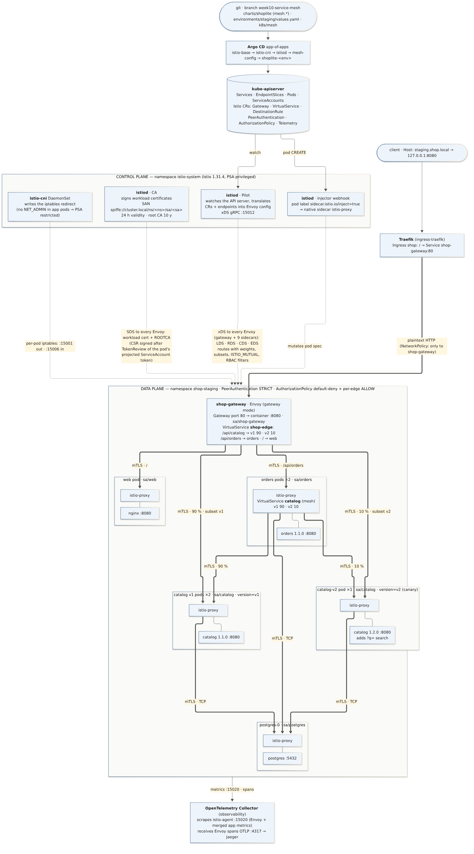
Figure 1. Control plane (istio-system) and data plane (shop-staging). Thick: request path with mTLS between Envoys and the 90/10 split. Dotted: configuration pushed by the control plane (xDS, SDS, injection, CNI redirect).

Table 3. Components of the two planes
Plane | Component | Role
Control | istiod · Pilot | Watches Services, EndpointSlices, Pods and the Istio CRs. Translates them into Envoy listeners, routes, clusters and endpoints and streams them over xDS (gRPC :15012). Changes reach proxies in seconds without restarts.
Control | istiod · CA | Validates the pod's projected ServiceAccount token (TokenReview), signs a certificate with SAN spiffe://cluster.local/ns/<ns>/sa/<sa> and delivers it over SDS. Rotated before its 24 h expiry.
Control | istiod · injector | Mutating webhook. A pod with label sidecar.istio.io/inject=true gets istio-validation + istio-proxy as native sidecars. shop-gateway gets the gateway template.
Control | istio-cni DaemonSet | Writes each pod's iptables redirect: outbound → :15001, inbound → :15006. No NET_ADMIN in app pods.
Data | shop-gateway (Envoy) | Edge of each environment: Gateway port 80, VirtualService shop-edge (/api/catalog 90/10, /api/orders, /).
Data | istio-proxy sidecars | Outbound: route, canary split, mTLS origination (verifies the server SAN). Inbound: mTLS termination with a required client certificate, RBAC filter (AuthorizationPolicy), telemetry.

Argo CD installs the control plane from the official charts in sync waves: istio-base (CRDs) → istio-cni and istiod → mesh-config (k8s/mesh) → the environment apps. The ShopLite chart renders each environment's mesh objects, so prod changes only with prod's approved sync.

4. Istio resources and traffic rules

4.1 The custom resources
scripts/mesh-export-manifests.sh renders the resources that git produces into docs/week10/manifests/, one file per environment. The files contain exactly what Argo CD applies.
Table 4. Istio resources per environment
File | Resources
00-mesh-wide.yaml (istio-system) | PeerAuthentication default STRICT (secure default for any namespace) · Telemetry mesh-default (Envoy tracing → Collector, 100 %)
shop-staging.yaml (15) | Gateway shop-gateway · VirtualService shop-edge, catalog · DestinationRule catalog (subsets v1/v2), orders, web, postgres · PeerAuthentication STRICT · AuthorizationPolicy default-deny, allow-to-{shop-gateway, web, orders, catalog, postgres} · Telemetry gateway-access-log
shop-dev.yaml (14) | Same as staging, without the canary
shop-prod.yaml (8) | Phase 1: Gateway, VirtualService, DestinationRules, PeerAuthentication PERMISSIVE, no authorization yet. Not applied: waits for approval.

4.2 Traffic-shifting rules (canary 90/10)
The weight comes from services.catalog.canary.weight: 10 in environments/staging/values.yaml. The chart helper shoplite.meshRoute renders 100 − w and w. The split is applied at the edge and east-west, so the canary sees the same share of external and internal traffic. It does not depend on replica counts: 2 v1 pods and 1 v2 pod still give 90/10.
# DestinationRule catalog: which pods are v1 and v2 (pod label "version", set by the chart)
spec:
host: catalog.shop-staging.svc.cluster.local
trafficPolicy:
tls: { mode: ISTIO_MUTUAL }
connectionPool: { tcp: { connectTimeout: 1s } }
outlierDetection: { consecutive5xxErrors: 5, interval: 10s, baseEjectionTime: 30s, maxEjectionPercent: 50 }
subsets:
- { name: v1, labels: { version: v1 } } # Deployment catalog 1.1.0 × 2
- { name: v2, labels: { version: v2 } } # Deployment catalog-v2 1.2.0 × 1
---
# VirtualService catalog (gateways: [mesh]): every sidecar that calls catalog, e.g. orders
spec:
hosts: [catalog.shop-staging.svc.cluster.local]
gateways: [mesh]
http:
- name: catalog-canary
route:
- destination: { host: catalog.shop-staging.svc.cluster.local, subset: v1, port: { number: 80 } }
weight: 90
- destination: { host: catalog.shop-staging.svc.cluster.local, subset: v2, port: { number: 80 } }
weight: 10
---
# VirtualService shop-edge (gateways: [shop-gateway]): the same split for /api/catalog at the edge,
# /api/orders → orders, / → web
Promotion and rollback are value changes, reviewed and synced like any other commit, with no pod restarts:
- promote: weight: 50, then 100, then 1.2.0 becomes the stable image.tag;
- roll back: canary.enabled: false.

5. Zero-trust transport: mutual TLS
Figure 2 shows the full sequence for one orders → catalog call. Every value in it was observed in the cluster: SNI, ALPN, SANs, validity and the RST/403 outcomes.
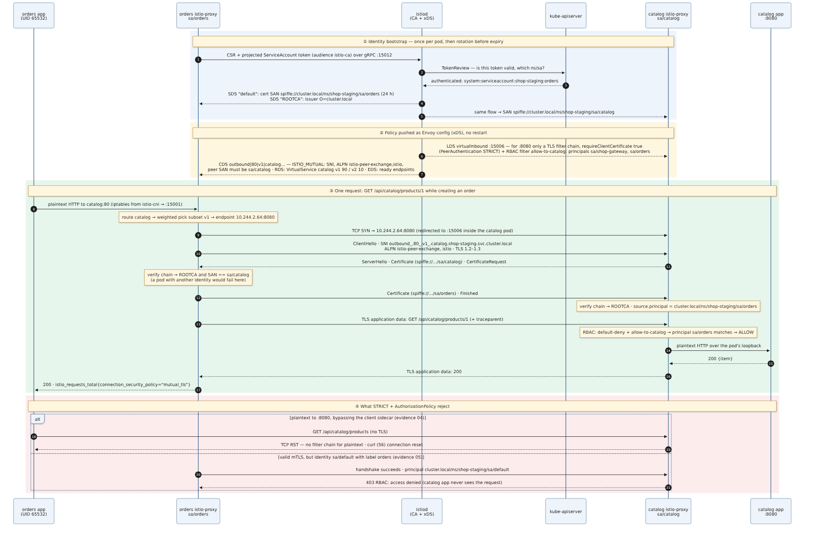
Figure 2. mTLS handshake sequence: ① identity bootstrap (CSR + projected ServiceAccount token → TokenReview → SPIFFE certificate over SDS), ② policy as xDS (PeerAuthentication STRICT → client certificate required; DestinationRule ISTIO_MUTUAL → SNI, ALPN, expected peer SAN), ③ one authorized request, ④ what is rejected

5.1 Identity and certificates
- Each workload has its own ServiceAccount (catalog, orders, web, postgres, shop-gateway) with automountServiceAccountToken: false. The sidecar uses its own projected token, audience istio-ca.
- Certificate of a catalog pod (istioctl proxy-config secret): SAN URI:spiffe://cluster.local/ns/shop-staging/sa/catalog, issuer O=cluster.local, valid 11 Nov 10:53:29 → 12 Nov 10:55:29 (24 h). ROOTCA valid until 2036.
- Client side (orders → catalog v1): SNI outbound_.80_.v1_.catalog.shop-staging.svc.cluster.local, ALPN istio-peer-exchange, istio; the peer must be spiffe://cluster.local/ns/shop-staging/sa/catalog; TLS 1.2–1.3.
- Server side (inbound listener :15006, port 8080): under STRICT only a TLS filter chain with requireClientCertificate = true exists. A plaintext connection matches no chain and is reset.

5.2 On the wire: PERMISSIVE vs STRICT
scripts/mesh-mtls-probe.sh runs tcpdump in the network namespace of a catalog pod, from a throwaway container outside the cluster objects. During the capture it sends 30 parallel requests through the gateway, one order (orders → catalog), and a plaintext GET from an orders pod. The plaintext GET bypasses that pod's own sidecar by running as UID 1337, the UID Istio exempts from redirection.
Table 5. Packet capture on catalog :8080
 | PERMISSIVE (phase 1, evidence 03) | STRICT (phase 2, evidence 04)
Mesh traffic | ClientHello (SNI outbound_.80_._.catalog…, ALPN istio-http/1.1, istio, http/1.1) → handshake → ChangeCipherSpec → encrypted data | identical
Plaintext GET to :8080 | readable on the wire: GET /api/catalog/products → HTTP/1.1 200 OK | RST from the catalog sidecar, curl (56) connection reset
Segments | 28 appdata · 24 handshake · 12 CCS · 2 PLAINTEXT | 20 appdata · 10 handshake · 5 CCS · 1 plaintext request · 1 RST

# 2026-11-11T17:39:28Z namespace shop-staging PeerAuthentication default: STRICT
...
curl: (56) Recv failure: Connection reset by peer
17:39:33.989637 10.244.2.61.43432 > 10.244.2.64.8080 309 B TLS handshake (ClientHello, SNI outbound_.80_._.catalog.shop-staging.svc.cluster.local, ALPN istio-http/1.1,istio,http/1.1)
17:39:34.002266 10.244.2.61.43390 > 10.244.2.64.8080 309 B TLS handshake (ClientHello, SNI outbound_.80_._.catalog.shop-staging.svc.cluster.local, ALPN istio-http/1.1,istio,http/1.1)
17:39:34.008629 10.244.2.61.43406 > 10.244.2.64.8080 309 B TLS handshake (ClientHello, SNI outbound_.80_._.catalog.shop-staging.svc.cluster.local, ALPN istio-http/1.1,istio,http/1.1)
17:39:34.008672 10.244.2.61.43418 > 10.244.2.64.8080 309 B TLS handshake (ClientHello, SNI outbound_.80_._.catalog.shop-staging.svc.cluster.local, ALPN istio-http/1.1,istio,http/1.1)
17:39:34.009067 10.244.2.61.43442 > 10.244.2.64.8080 309 B TLS handshake (ClientHello, SNI outbound_.80_._.catalog.shop-staging.svc.cluster.local, ALPN istio-http/1.1,istio,http/1.1)
17:39:35.086261 10.244.1.58.59146 > 10.244.2.64.8080 100 B PLAINTEXT HTTP: GET /api/catalog/products HTTP/1.1
The captures were taken before the canary existed, so the SNI has no subset (_._). After phase 3 the SNI includes it (…_.v1_.…).

6. Identity-based authorization
default-deny (an ALLOW policy that matches nothing) switches every workload to deny-by-default. One ALLOW per edge then names the callers by SPIFFE principal:
- gateway → web, orders, catalog;
- orders → catalog;
- catalog and orders → postgres (TCP).
scripts/mesh-authz-probe.sh shows that a pod label is a claim, not an identity:
Table 6. Label vs identity (evidence 05)
Caller | NetworkPolicy (labels) | Certificate SAN | Result
Impostor pod labelled app.kubernetes.io/name=orders, ServiceAccount default | allowed | spiffe://cluster.local/ns/shop-staging/sa/default | 403 RBAC: access denied (the app never sees it)
Real orders pod | allowed | spiffe://cluster.local/ns/shop-staging/sa/orders | 200

The catalog sidecar's own request metrics by peer identity (istio_requests_total, evidence 07):
spiffe://cluster.local/ns/shop-staging/sa/default code 403 mutual_tls 1 requests
spiffe://cluster.local/ns/shop-staging/sa/orders code 200 mutual_tls 304 requests
spiffe://cluster.local/ns/shop-staging/sa/shop-gateway code 200 mutual_tls 1884 requests
unknown code 200 none 4 requests (PERMISSIVE-phase probes)

7. Validation

7.1 Traffic distribution
scripts/mesh-canary-check.sh staging 1000 400 counts the split in three independent ways. To tell the versions apart from the response alone, the probe uses a real behaviour difference: catalog 1.2.0 adds ?q= search and 1.1.0 ignores the parameter. GET /api/catalog/products?q=zzz-canary-probe therefore returns all products from v1 and [] from v2.
Table 7. Canary split, target 10 % (evidence 06)
Count | v1 | v2 | v2 share
1. Client: 1000 × GET through Traefik → gateway | 881 | 119 | 11.9 % (95 % Wilson 10.0–14.1 %)
2. Gateway access log, upstream cluster per request | 881 | 119 | 11.9 %
3a. Envoy metrics (Prometheus): gateway → catalog | 1194 | 161 | 11.9 % · all mutual_tls
3b. Envoy metrics: orders → catalog (400 orders, east-west) | 491 | 52 | 9.5 % · all mutual_tls

All 1000 GETs returned 200 and all 400 orders 201. Envoy chooses a weighted cluster per request at random, so a deviation of about 2 points at N = 1000 is sampling noise. The 95 % interval contains 10 %.

7.2 istioctl diagnostics
Table 8. istioctl checks (scripts/mesh-diagnose.sh, evidence 07)
Check | Command | Result
Proxies in sync | istioctl proxy-status | 16 proxies (14 pods + 2 gateways), all 1.31.4, CDS/LDS/EDS/RDS
Configuration valid | istioctl analyze -n shop-staging | No errors or warnings. Info IST0102 (injection by pod label: intentional). The first run found IST0144 and IST0162; both fixed.
Injection | istioctl x check-inject deployment/<d> | ✔ catalog, orders, web, shop-gateway
Policy on the canary pod | istioctl x describe pod catalog-v2-… | subset v2 · route weight 10 % · workload mTLS STRICT
mTLS origination | istioctl proxy-config cluster --fqdn catalog… | SNI per subset, ALPN istio-peer-exchange/istio, peer SAN sa/catalog, TLS 1.2–1.3, connectTimeout 1 s, outlier detection
Endpoints per subset | istioctl proxy-config endpoint --cluster … | v1: 2 HEALTHY · v2: 1 HEALTHY
Certificates | istioctl proxy-config secret | default (24 h) + ROOTCA ACTIVE · SAN spiffe://…/sa/catalog
Inbound requires client cert | istioctl proxy-config listener --port 15006 | port 8080: transport tls only, requireClientCertificate True
Gateway routes | istioctl proxy-config route --name http.8080 | /api/orders*, /api/catalog* (v1 90 / v2 10), /* from shop-edge
Authorization | istioctl x authz check catalog-… | default-deny + allow-to-catalog attached

7.3 One trace through the mesh
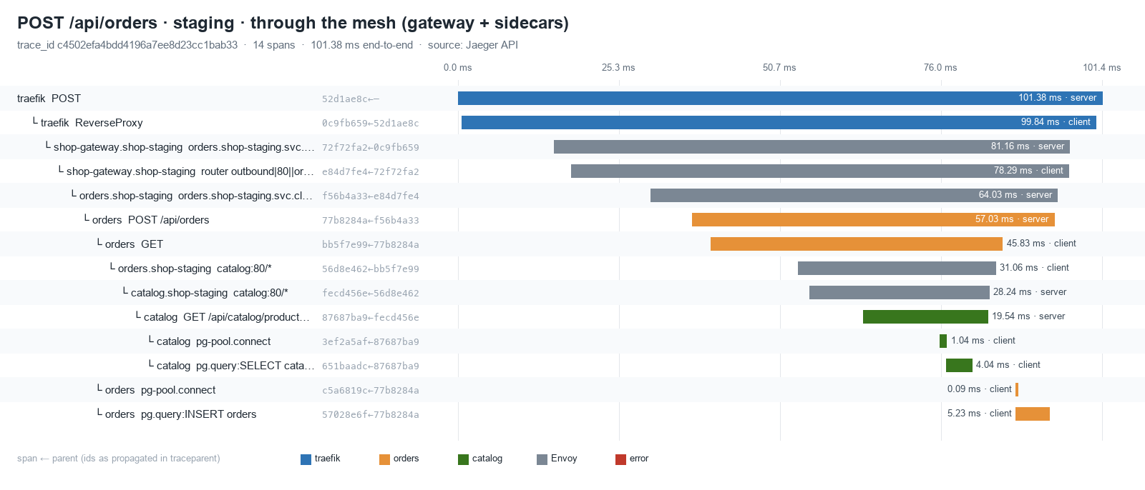
Figure 3. POST /api/orders in staging from Jaeger: Traefik → shop-gateway → orders sidecar → orders → orders sidecar (outbound|80|v1|catalog) → catalog sidecar → catalog → pg. 14 spans, one trace id (evidence 08)
Envoy continues the W3C traceparent that Traefik starts, so the gateway and sidecar spans (grey) join the app spans in one trace. The Week 9 telemetry checks still pass with the mesh in place: 51/53, and the two failures are expected (prod waiting for approval; a panel that needs errors). Evidence 10.

8. GitOps rollout and CI
Table 9. Rollout phases
Phase | Commit | Result
0 · Control plane | 894da3c: istio-base/cni/istiod/mesh-config, AppProject mesh, Application health check, chart 0.3.0 (mesh off), Collector scrapes pod IP + annotated port | Healthy in 36 s (evidence 01)
1 · Into the mesh, PERMISSIVE | 128048e: mesh.enabled in dev, staging and prod (prod: PERMISSIVE, no authz, 2 gateway replicas) | dev, staging rolled with sidecars. prod OutOfSync, waits for approval (evidence 02)
2 · STRICT + authorization | 5a17706: dev, staging | through xDS in about 40 s, no restarts (evidence 04, 05)
3 · Canary | d6be3fc: staging, catalog 1.2.0 at 10 % | evidence 06
4 · Fixes from istioctl | e1d83c2: Gateway port 80 → 8080, UID 1337 on the container only | analyze clean (evidence 07)

prod: in this session the prod sync was not approved, so prod still runs the Week 9 release without sidecars. The operator approves it with scripts/gitops-sync-prod.sh (diff, then sync). Phase 2 and a possible canary for prod follow as separate commits behind the same gate.
CI (evidence 09):
- With the mesh, the chart renders Istio CRs that plain kubeconform has no schemas for (37 errors). G2 now validates them against the datree CRD catalog (123/123 valid) and adds a step for k8s/mesh.
- G7 trivy config passes for the repo and all three rendered environments, with no new ignore entries.

9. Evaluation: design vs. observed
Table 10. Design expectations and observations
Design expectation | Observed | ✓
All service-to-service traffic is mTLS under STRICT | Only TLS records on catalog :8080. All requests to catalog are mutual_tls. | ✓
Plaintext refused under STRICT, accepted under PERMISSIVE | 200 and readable → RST | ✓
Identity, not labels, decides access | Label-forging pod gets 403, real orders gets 200 | ✓
90/10 at the edge and east-west | 11.9 % (CI contains 10 %) and 9.5 % | ✓
Policy changes need no restarts | phase 1 → 2 in about 40 s, no restarts | ✓
One trace through gateway, sidecars and apps | 14-span trace, 0 orphans | ✓
Week 9 observability unaffected; PSA restricted kept | 51/53 checks (2 expected); namespaces still restricted | ✓

9.1 What the rollout revealed
- istioctl analyze found two real errors in the first gateway version. IST0162: the Gateway port was not a Service port. IST0144: UID 1337, reserved for Envoy, was set at pod level. Both were fixed in e1d83c2.
- The Week 9 scrape broke by design under STRICT. A plaintext scrape of :8080 is exactly the plaintext probe and gets reset. The Collector now scrapes istio-agent's merged endpoint :15020, using pod IP + annotated port.
- App-of-apps sync waves did not wait until the Application health check was restored in argocd-cm. Without it, istiod raced the CRDs.
- The data plane costs more memory than the apps (evidence 11): 16 proxies use 616 MiB (34–52 MiB each) against 473 MiB for the 14 app containers. This is the main cost of the sidecar pattern on a small cluster.
- Latency per hop: in the recorded trace, orders → catalog takes 31 ms in the orders sidecar against 19.5 ms inside catalog. One trace on kind with 100 % tracing: an indication, not a benchmark.
- Canary queries must group by destination_canonical_service + destination_version; destination_workload is catalog / catalog-v2.

10. Architecture decisions
Table 11. ADR summary (full text: docs/week10/adr.md)
ADR | Decision | Main consequence
W10-01 | Istio 1.31.4, sidecar mode, official charts via Argo CD, pinned | Envoy everywhere, full istioctl tooling; 616 MiB of proxies; health check for app-of-apps waves
W10-02 | One Envoy gateway per environment behind Traefik, namespace-scoped | prod gateway changes only with prod sync; one extra edge hop
W10-03 | istio-cni instead of istio-init | App namespaces stay PSA restricted; one privileged DaemonSet
W10-04 | PERMISSIVE → STRICT → canary, one commit each; prod gated | Observable, reversible steps; prod at phase 1 awaiting approval
W10-05 | NetworkPolicy (labels) + AuthorizationPolicy (SPIFFE identity), REGISTRY_ONLY | Label forging fails (403); every new edge needs a policy change
W10-06 | Canary by VirtualService weights + DestinationRule subsets | Exact split independent of replicas; promotion is a values commit
W10-07 | Mesh telemetry into the Week 9 pipeline (:15020, Envoy spans, gateway access log) | Dashboards unchanged; queries by canonical service

11. Conclusions and limitations
- Inter-service communication in ShopLite is now managed by the mesh. istiod configures every Envoy from git-declared resources. Service discovery, the 90/10 split and the timeouts and outlier detection work without application changes.
- Zero trust is enforced and measured. Plaintext is reset under STRICT. Every request carries a verified SPIFFE identity. A pod with forged labels but the wrong identity is refused with 403.
- Each claim was checked in at least two independent ways: the packet capture and istioctl for mTLS, client responses and the access log and Envoy metrics for the split, the probe and the RBAC counters and the metrics for authorization.
- Limitations: prod is not yet meshed (waits for approval). Single istiod replica. Self-signed mesh root CA (production: intermediate CA from cert-manager or Vault). No egress gateway. The Collector is outside the mesh. Canary promotion is manual.
- Next steps: approve the prod phases; automated canary analysis (Argo Rollouts or Flagger with the Table 7 Prometheus query as the success metric); an external CA; evaluate ambient mode to cut the proxy memory.

Appendix A. Files and evidence
File (docs/week10/) | Content
manifests/00-mesh-wide.yaml, shop-{dev,staging,prod}.yaml | Istio custom resources as applied (rendered by scripts/mesh-export-manifests.sh)
diagrams/*.mmd, *.png, *.svg | Mesh topology, mTLS sequence, trace waterfall
exports/traces/order-through-mesh.json | The trace of Figure 3 (Jaeger JSON)
evidence/01-control-plane-up.txt | Control plane delivered by Argo CD
evidence/02-rollout-phases.txt | Per-environment state; prod OutOfSync with its pending diff
evidence/03, 04 -mtls-capture-*.txt | Packet captures under PERMISSIVE and STRICT
evidence/05-authz-identity-probe.txt | Impostor (sa/default) 403 vs orders 200
evidence/06-canary-traffic-split.txt | Three independent counts of the 90/10 split
evidence/07-istioctl-diagnostics.txt | proxy-status, analyze, check-inject, describe, proxy-config, authz check
evidence/08-trace-through-mesh.txt | Span tree of one order through gateway and sidecars
evidence/09-ci-gates.txt | kubeconform with Istio CRD schemas, trivy config
evidence/10-week9-telemetry-regression.txt | Week 9 checks with the mesh in place
evidence/11-sidecar-overhead.txt | Memory of proxies vs apps

Appendix B. Istio manifests (shop-staging, rendered)
# Rendered from k8s/mesh (Argo CD Application mesh-config, namespace istio-system). Do not edit.
apiVersion: security.istio.io/v1
kind: PeerAuthentication
metadata:
name: default
namespace: istio-system
spec:
mtls:
mode: STRICT
---
apiVersion: telemetry.istio.io/v1
kind: Telemetry
metadata:
name: mesh-default
namespace: istio-system
spec:
tracing:
- providers:
- name: otel-collector
randomSamplingPercentage: 100
# Istio custom resources rendered by charts/shoplite for shop-staging (helm template, values from
# environments/staging/values.yaml). Do not edit — change the chart or the values and re-run
# scripts/mesh-export-manifests.sh. 15 resources: Gateway, VirtualService, DestinationRule, PeerAuthentication, AuthorizationPolicy, Telemetry
---
# Source: shoplite/templates/mesh.yaml
apiVersion: networking.istio.io/v1
kind: Gateway
metadata:
name: shop-gateway
labels:
helm.sh/chart: shoplite-0.3.0
spec:
# Matches only gateway pods in this namespace (PILOT_SCOPE_GATEWAY_TO_NAMESPACE in istiod).
selector:
istio: shop-gateway
servers:
- port:
# The Service port; Envoy listens on its targetPort 8080 (unprivileged). istioctl analyze
# IST0162 flags a Gateway port that no Service of the gateway pods exposes.
number: 80
name: http
protocol: HTTP
# TLS terminates at Traefik, the cluster edge (Week 7); Traefik → gateway stays in-cluster.
hosts:
- "staging.shop.local"
---
# Source: shoplite/templates/mesh.yaml
# North-south routing: the path table of the Week 8 Ingress, now executed by Envoy. A service
# with a canary gets a weighted split right here, so browser traffic is shifted too.
apiVersion: networking.istio.io/v1
kind: VirtualService
metadata:
name: shop-edge
labels:
helm.sh/chart: shoplite-0.3.0
spec:
hosts:
- "staging.shop.local"
gateways:
- shop-gateway
http:
- name: orders
match:
- uri:
prefix: /api/orders
route:
- destination:
host: orders.shop-staging.svc.cluster.local
port:
number: 80
- name: catalog
match:
- uri:
prefix: /api/catalog
route:
- destination:
host: catalog.shop-staging.svc.cluster.local
subset: v1
port:
number: 80
weight: 90
- destination:
host: catalog.shop-staging.svc.cluster.local
subset: v2
port:
number: 80
weight: 10
- name: web
match:
- uri:
prefix: /
route:
- destination:
host: web.shop-staging.svc.cluster.local
port:
number: 80
---
# Source: shoplite/templates/mesh.yaml
# East-west canary: every sidecar that calls catalog (e.g. orders → catalog) applies the same
# split, so the canary sees the same share of internal and external traffic.
apiVersion: networking.istio.io/v1
kind: VirtualService
metadata:
name: catalog
labels:
helm.sh/chart: shoplite-0.3.0
spec:
hosts:
- catalog.shop-staging.svc.cluster.local
gateways:
- mesh
http:
- name: catalog-canary
route:
- destination:
host: catalog.shop-staging.svc.cluster.local
subset: v1
port:
number: 80
weight: 90
- destination:
host: catalog.shop-staging.svc.cluster.local
subset: v2
port:
number: 80
weight: 10
---
# Source: shoplite/templates/mesh.yaml
apiVersion: networking.istio.io/v1
kind: DestinationRule
metadata:
name: catalog
labels:
helm.sh/chart: shoplite-0.3.0
spec:
host: catalog.shop-staging.svc.cluster.local
trafficPolicy:
tls:
mode: ISTIO_MUTUAL # originate mTLS with the workload certificate (explicit; auto-mTLS would too)
connectionPool:
tcp:
# Week 9 finding: a fetch to a missing catalog hung in TCP connect for 10 s. Envoy fails the
# connect after this timeout instead and answers 503 (no healthy upstream).
connectTimeout: 1s
outlierDetection:
# Passive health checking: eject an endpoint that keeps failing, so one bad pod (e.g. a broken
# canary replica) stops receiving traffic until it recovers.
consecutive5xxErrors: 5
interval: 10s
baseEjectionTime: 30s
maxEjectionPercent: 50
subsets:
- name: v1
labels:
version: v1
- name: v2
labels:
version: v2
---
# Source: shoplite/templates/mesh.yaml
apiVersion: networking.istio.io/v1
kind: DestinationRule
metadata:
name: orders
labels:
helm.sh/chart: shoplite-0.3.0
spec:
host: orders.shop-staging.svc.cluster.local
trafficPolicy:
tls:
mode: ISTIO_MUTUAL # originate mTLS with the workload certificate (explicit; auto-mTLS would too)
connectionPool:
tcp:
# Week 9 finding: a fetch to a missing catalog hung in TCP connect for 10 s. Envoy fails the
# connect after this timeout instead and answers 503 (no healthy upstream).
connectTimeout: 1s
outlierDetection:
# Passive health checking: eject an endpoint that keeps failing, so one bad pod (e.g. a broken
# canary replica) stops receiving traffic until it recovers.
consecutive5xxErrors: 5
interval: 10s
baseEjectionTime: 30s
maxEjectionPercent: 50
---
# Source: shoplite/templates/mesh.yaml
apiVersion: networking.istio.io/v1
kind: DestinationRule
metadata:
name: web
labels:
helm.sh/chart: shoplite-0.3.0
spec:
host: web.shop-staging.svc.cluster.local
trafficPolicy:
tls:
mode: ISTIO_MUTUAL # originate mTLS with the workload certificate (explicit; auto-mTLS would too)
connectionPool:
tcp:
# Week 9 finding: a fetch to a missing catalog hung in TCP connect for 10 s. Envoy fails the
# connect after this timeout instead and answers 503 (no healthy upstream).
connectTimeout: 1s
outlierDetection:
# Passive health checking: eject an endpoint that keeps failing, so one bad pod (e.g. a broken
# canary replica) stops receiving traffic until it recovers.
consecutive5xxErrors: 5
interval: 10s
baseEjectionTime: 30s
maxEjectionPercent: 50
---
# Source: shoplite/templates/mesh.yaml
apiVersion: networking.istio.io/v1
kind: DestinationRule
metadata:
name: postgres
labels:
helm.sh/chart: shoplite-0.3.0
spec:
host: postgres.shop-staging.svc.cluster.local
trafficPolicy:
tls:
mode: ISTIO_MUTUAL
connectionPool:
tcp:
connectTimeout: 1s
---
# Source: shoplite/templates/mesh.yaml
# Transport security of every sidecar in this namespace. Overrides the mesh-wide STRICT default
# only while mesh.mtlsMode is PERMISSIVE (migration window, ADR-W10-04).
apiVersion: security.istio.io/v1
kind: PeerAuthentication
metadata:
name: default
labels:
helm.sh/chart: shoplite-0.3.0
spec:
mtls:
mode: STRICT
---
# Source: shoplite/templates/mesh.yaml
# Zero trust: an ALLOW policy without rules denies every request to every workload of the
# namespace. The policies below re-open exactly the edges of the call graph, by SPIFFE identity
# (the ServiceAccount in the peer's mTLS certificate), not by IP.
apiVersion: security.istio.io/v1
kind: AuthorizationPolicy
metadata:
name: default-deny
labels:
helm.sh/chart: shoplite-0.3.0
spec: {}
---
# Source: shoplite/templates/mesh.yaml
# The gateway is the entry point: it accepts plaintext HTTP from Traefik (NetworkPolicy limits the
# source to the Traefik pods).
apiVersion: security.istio.io/v1
kind: AuthorizationPolicy
metadata:
name: allow-to-shop-gateway
labels:
helm.sh/chart: shoplite-0.3.0
spec:
selector:
matchLabels:
app.kubernetes.io/name: shop-gateway
action: ALLOW
rules:
- to:
- operation:
ports: ["8080"]
---
# Source: shoplite/templates/mesh.yaml
apiVersion: security.istio.io/v1
kind: AuthorizationPolicy
metadata:
name: allow-to-catalog
labels:
helm.sh/chart: shoplite-0.3.0
spec:
selector:
matchLabels:
app.kubernetes.io/name: catalog
action: ALLOW
rules:
- from:
- source:
principals:
- cluster.local/ns/shop-staging/sa/shop-gateway
- cluster.local/ns/shop-staging/sa/orders
to:
- operation:
ports: ["8080"]
---
# Source: shoplite/templates/mesh.yaml
apiVersion: security.istio.io/v1
kind: AuthorizationPolicy
metadata:
name: allow-to-orders
labels:
helm.sh/chart: shoplite-0.3.0
spec:
selector:
matchLabels:
app.kubernetes.io/name: orders
action: ALLOW
rules:
- from:
- source:
principals:
- cluster.local/ns/shop-staging/sa/shop-gateway
to:
- operation:
ports: ["8080"]
---
# Source: shoplite/templates/mesh.yaml
apiVersion: security.istio.io/v1
kind: AuthorizationPolicy
metadata:
name: allow-to-web
labels:
helm.sh/chart: shoplite-0.3.0
spec:
selector:
matchLabels:
app.kubernetes.io/name: web
action: ALLOW
rules:
- from:
- source:
principals:
- cluster.local/ns/shop-staging/sa/shop-gateway
to:
- operation:
ports: ["8080"]
---
# Source: shoplite/templates/mesh.yaml
apiVersion: security.istio.io/v1
kind: AuthorizationPolicy
metadata:
name: allow-to-postgres
labels:
helm.sh/chart: shoplite-0.3.0
spec:
selector:
matchLabels:
app.kubernetes.io/name: postgres
action: ALLOW
rules:
- from:
- source:
principals:
- cluster.local/ns/shop-staging/sa/catalog
- cluster.local/ns/shop-staging/sa/orders
to:
- operation:
ports: ["5432"]
---
# Source: shoplite/templates/mesh.yaml
# Gateway access log (Envoy → stdout): one line per request with the upstream cluster, e.g.
# outbound|80|v2|catalog.shop-prod.svc.cluster.local — the subset that served the request.
apiVersion: telemetry.istio.io/v1
kind: Telemetry
metadata:
name: gateway-access-log
labels:
helm.sh/chart: shoplite-0.3.0
spec:
selector:
matchLabels:
istio: shop-gateway
accessLogging:
- providers:
- name: envoy

