Software Architecture & DevOps — Laboratory Work
Week 9 · Lab 5
Distributed Observability & Telemetry Data Flow Design
End-to-end telemetry architecture, RED dashboard design, Prometheus and OpenTelemetry instrumentation, and evaluation of the collected telemetry for ShopLite
Student: Timur
Repository: https://github.com/timurdll/devops-labs
Branch: week9-observability
Stack: OpenTelemetry Collector 0.163 · Prometheus 3.15 · Jaeger 2.20 · Grafana 13.2
Date: 10 November 2026

Contents
1. Objective and deliverables
2. Telemetry architecture
3. Instrumentation
3.1 Metrics: Prometheus client SDK on /metrics
3.2 Tracing: OpenTelemetry SDK and W3C traceparent
3.3 Trace propagation across services
4. Grafana dashboard design (RED first)
5. Delivery and fault experiment
6. Evaluation: design vs observed
6.1 Automated verification: 49 / 49 checks passed
6.2 What the telemetry revealed
7. Architecture Decision Records (summary)
8. Conclusions and limitations
Appendix A. Exported configuration and evidence
Appendix B. Key configuration

(Right-click → Update Field in Word if the page numbers are not shown.)

1. Objective and deliverables
The goal of this lab is to design and build how ShopLite reports on itself. Every request should be measurable as RED metrics (Rate, Errors, Duration) and traceable across services. Both signals travel through one pipeline to stores that a single Grafana dashboard reads. The telemetry is then used in a fault experiment to check whether it shows what the design promises.
System: ShopLite from Weeks 7–8 (Traefik → web, catalog, orders → PostgreSQL) in the dev, staging and prod environments delivered by Argo CD on the kind cluster. New in Week 9: services 1.1.0 with prom-client and the OpenTelemetry Node SDK, chart 0.2.0 with telemetry values, and the Argo CD Application observability (Collector, Prometheus, Jaeger, Grafana).
Table 1. Deliverables map
Assignment deliverable | Where it is
Telemetry Data Flow Diagram (App → Collector → Prometheus/Jaeger → Grafana) | Figure 1, Table 3 · docs/week9/diagrams/telemetry-data-flow.mmd
Distributed Trace Sequence diagram (traceparent across microservices) | Figure 2 · trace-propagation-sequence.mmd
Trace Waterfall diagram | Figures 3–4 · trace-waterfall-ok.png / -error.png (from real traces)
Grafana dashboard wireframe prioritising RED | Figure 5, Table 4 · grafana-wireframe.png
APIs instrumented: Prometheus client SDK (/metrics) + OTel tracing headers | §3 · services/*/src/telemetry/
Telemetry collected in Grafana/Jaeger and evaluated against the design | §5–§6 · Figures 6–8 · docs/week9/evidence/
Exported JSON configuration files | Appendix A · docs/week9/exports/

2. Telemetry architecture
Table 2. Requirements mapped to design decisions
Requirement | Design decision
One path for every signal | Apps know one endpoint, the OpenTelemetry Collector. It receives OTLP spans, scrapes /metrics and routes both to their stores (ADR-W9-02).
RED via the Prometheus client SDK | Histogram http_server_request_duration_seconds{http_request_method, http_route, http_response_status_code}. Names follow the OTel HTTP semantic conventions (ADR-W9-01).
Distributed tracing with standard headers | W3C traceparent, extracted by the http instrumentation and injected by undici (fetch). Traefik starts the trace and decides sampling (ADR-W9-06).
Metrics ↔ traces correlation | Every latency observation carries the active trace_id as an OpenMetrics exemplar. Grafana links the exemplar to Jaeger.
Bounded cardinality | http_route is a template (/api/catalog/products/:id), and unknown paths become “unmatched”. No ids appear in labels.
Probes are not traffic | /healthz, /readyz and /metrics are not traced. Dashboard queries filter http_route=~"/api/.*".
Same delivery model as Week 8 | Chart 0.2.0 enables telemetry per environment. The Argo CD Application observability deploys k8s/observability. prod went through the manual approval gate.
Secure by default | Default-deny NetworkPolicies. Only the Collector may scrape app pods. Grafana has no anonymous access and no Ingress, and its admin Secret is not in git. All images are digest-pinned.

Labels added at scrape time are namespace, pod, app and environment (from the pod label shoplite.io/environment; Traefik gets environment="edge"). One dashboard therefore serves all three environments through its $env variable.
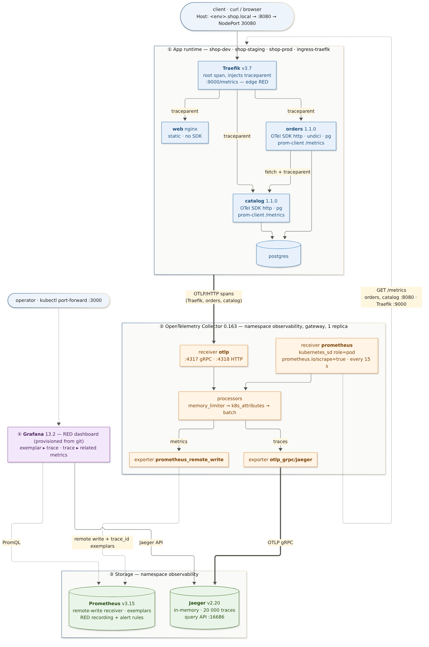
Figure 1. Telemetry data flow: app runtime → OTel Collector → Prometheus / Jaeger → Grafana (source: telemetry-data-flow.mmd)
Table 3. Signals, transport and storage
Signal | Produced by | Transport | Stored in | Read by
Server RED metrics | catalog, orders (prom-client, OpenMetrics) | pull: Collector prometheus receiver, kubernetes_sd pods, 15 s → push: prometheus_remote_write | Prometheus 3.15 (TSDB + exemplars) | Grafana, alert rules
Client RED (orders → catalog) | orders http_client_request_duration_seconds | same | Prometheus | panel “orders → catalog”
Edge RED | Traefik :9000/metrics | same | Prometheus | panel “Edge (Traefik)”
Spans | Traefik, orders, catalog (OTel SDK) | push: OTLP/HTTP :4318 → Collector (k8s_attributes) → OTLP gRPC | Jaeger 2.20 (memory) | Jaeger UI, Grafana
Collector health | Collector :8888 | self-scrape | Prometheus | telemetry-verify.py

3. Instrumentation

3.1 Metrics: Prometheus client SDK on /metrics
Each service has its own prom-client registry in OpenMetrics format. A request is timed from arrival to the response’s finish event. The route label is computed by routeOf(). Excerpt of GET /metrics from orders during the fault:
# Content-Type: application/openmetrics-text; version=1.0.0
http_server_request_duration_seconds_bucket{le="2.5",service="orders",http_request_method="POST",
http_route="/api/orders",http_response_status_code="502"} 53 # {trace_id="491dddc7…",span_id="0c96e20b…"} 2.0017
http_server_active_requests{http_request_method="POST",service="orders"} 0
http_client_request_duration_seconds_count{service="orders",
server_address="catalog.shop-prod.svc.cluster.local",http_response_status_code="timeout"} 43
- Buckets: 5 ms to 5 s, matching the 500 ms SLO and the 2 s / 5 s client timeouts. The Node.js default process metrics (CPU, heap, event-loop lag) are also exported.
- Exemplars: the # {trace_id=…} suffix links this bucket to the exact trace that produced it.
- Tests: unit tests cover exemplar on/off, the in-flight gauge and the client histogram. The CI coverage gate includes metrics.js and catalog-client.js. Current results: catalog 11 and orders 13 tests passing, 100 % lines.

3.2 Tracing: OpenTelemetry SDK and W3C traceparent
require('./telemetry/tracing') is the first line of server.js, so the http, pg and undici instrumentations patch those modules before they are loaded. The configuration is the standard OTEL_* environment rendered by the chart:
OTEL_SERVICE_NAME=orders
OTEL_EXPORTER_OTLP_ENDPOINT=http://otel-collector.observability.svc.cluster.local:4318 (http/protobuf)
OTEL_TRACES_SAMPLER=parentbased_traceidratio OTEL_TRACES_SAMPLER_ARG=1.0
OTEL_PROPAGATORS=tracecontext,baggage
OTEL_RESOURCE_ATTRIBUTES=deployment.environment.name=prod,service.namespace=shoplite,service.version=1.1.0
- Server spans: renamed to METHOD route-template with http.route set. Exceptions are recorded with status ERROR, and error log lines carry trace_id.
- Privacy: SQL parameters are never recorded (enhancedDatabaseReporting: false).
- Failure isolation: if the Collector is unreachable, spans are dropped and requests never wait.

3.3 Trace propagation across services
Every id in Figure 2 comes from one real trace (exports/traces/order-ok.json). Traefik creates the root span and sends traceparent: 00-<trace-id>-<span-id>-01 to orders. orders continues the trace and forwards a new parent span id to catalog through fetch. catalog’s database spans complete the tree.
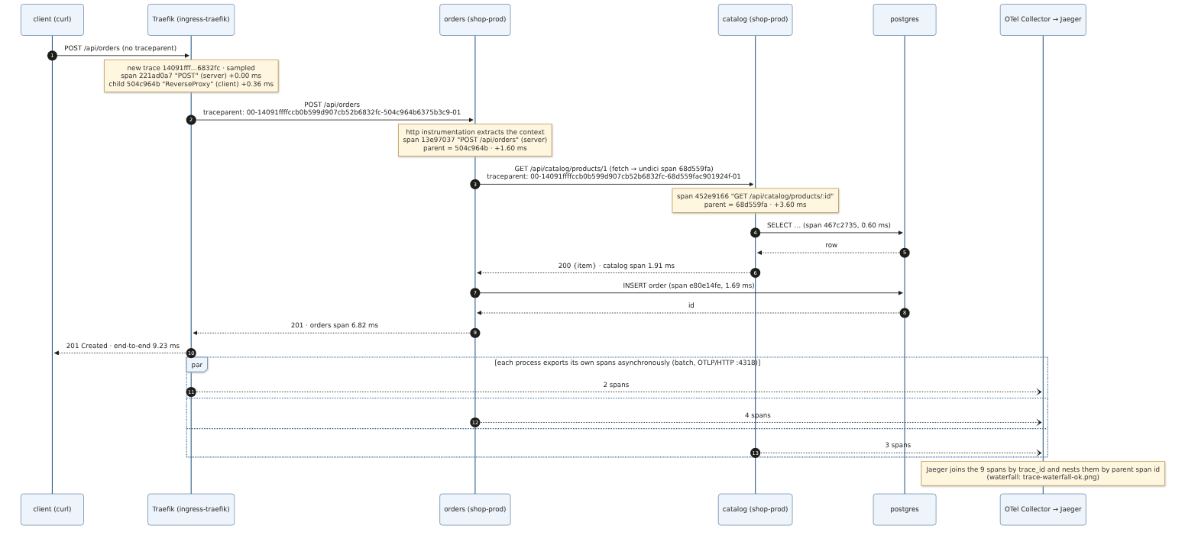
Figure 2. Distributed trace sequence: traceparent from the edge through orders and catalog to PostgreSQL (source: trace-propagation-sequence.mmd)
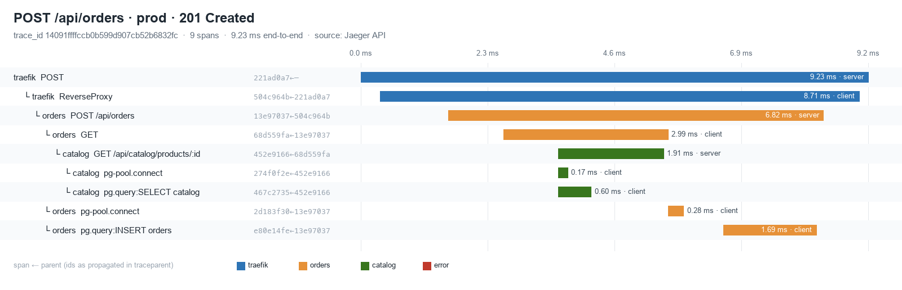
Figure 3. Trace waterfall of a successful POST /api/orders: 9 spans, 9.23 ms, each row “span ← parent” (rendered from Jaeger JSON by trace_waterfall.py)
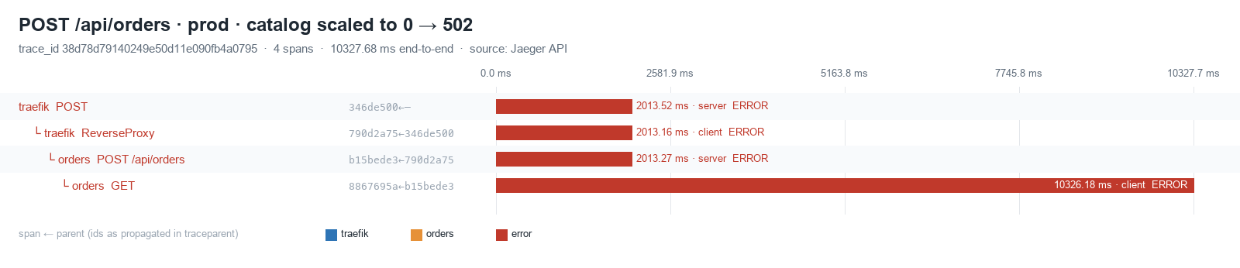
Figure 4. The same request during the catalog outage: the response ended at 2.0 s, but the fetch span ran for 10.3 s (connect timeout)
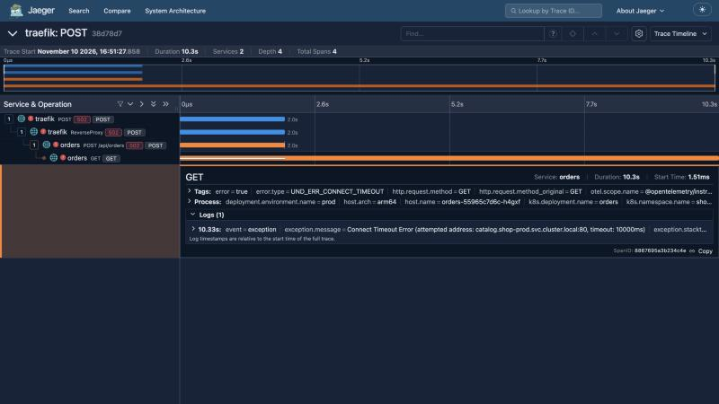
Figure 5. Jaeger UI: the failed trace with the exception event and the k8s.* attributes added by the Collector

4. Grafana dashboard design (RED first)
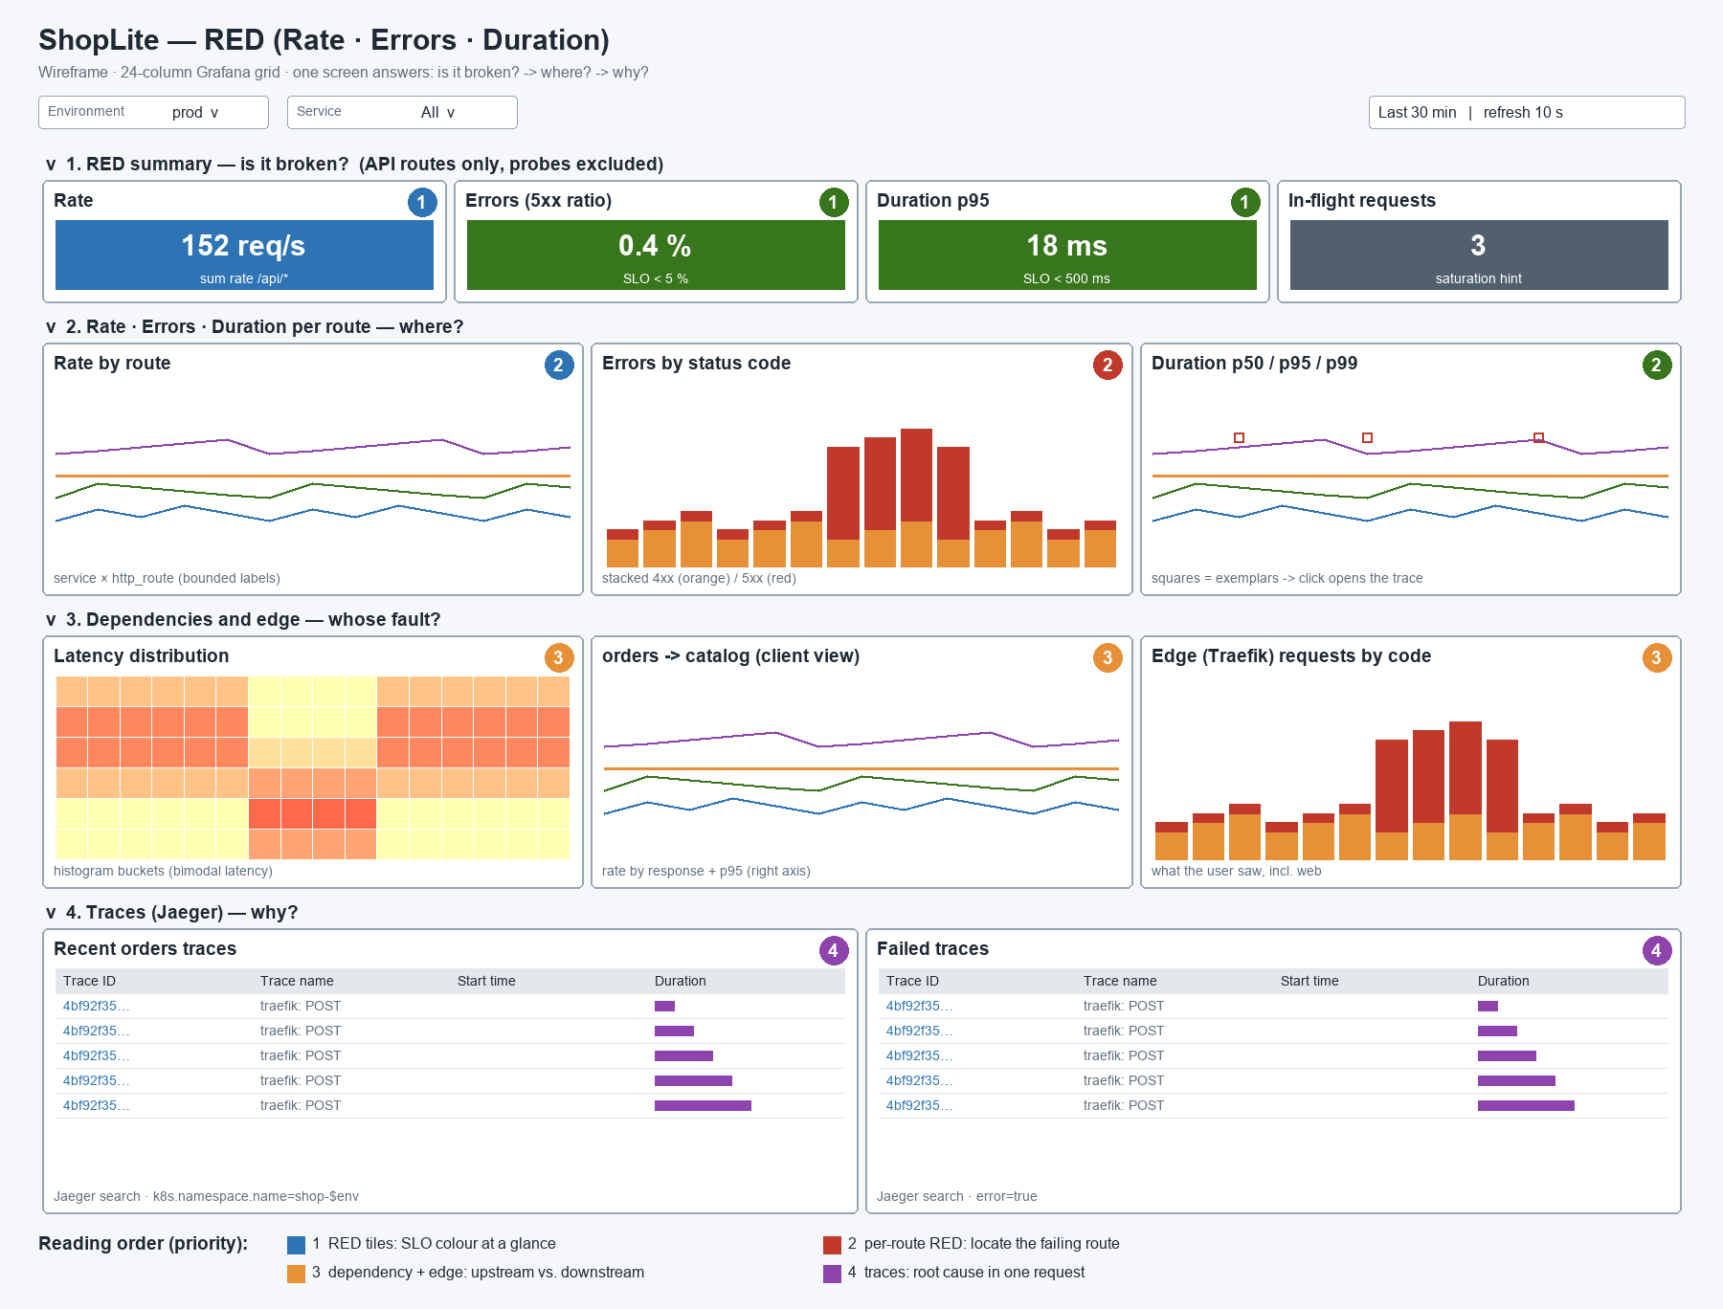
Figure 6. Wireframe of the ShopLite RED dashboard (grafana_wireframe.py)
The layout answers three questions in reading order: is it broken → where → why. SLO thresholds colour the top row, so it reads at a glance. Each row below narrows the scope.
Table 4. Panel rows, priority and queries
Row | Panels | Priority | Query (environment = $env)
1 · RED summary | Rate · Errors (5xx ratio) · Duration p95 · In-flight | 1: SLO at a glance | sum(rate(…_count{http_route=~"/api/.*"}[$__rate_interval])); 5xx ratio uses “or vector(0)”, so 0 % is shown as 0, not “no data”
2 · per route | Rate by route · Errors by status code · p50/p95/p99 with exemplars | 2: localise | sum by (service, http_route) · sum by (service, http_response_status_code) · histogram_quantile
3 · dependencies | Latency heatmap · orders → catalog (client view) · Edge (Traefik) by code | 3: upstream vs downstream | http_client_request_duration_seconds · traefik_router_requests_total{router=~"shop-$env-.*"}
4 · traces | Recent orders traces · Failed traces | 4: root cause | Jaeger search: service orders, tags k8s.namespace.name=shop-$env [error=true]

The dashboard JSON lives in git (k8s/observability/dashboards/shoplite-red.json, 16 panels including rows). It is provisioned read-only (allowUiUpdates: false), so a change is a commit, like everything else since Week 8. Prometheus also evaluates the SLOs as rules: ShopLiteHighErrorRate (5xx > 5 % for 1 min), ShopLiteSlowRequests (p95 > 500 ms for 2 min) and, after this experiment, ShopLiteServiceNoTargets (§6.2).

5. Delivery and fault experiment
Table 5. GitOps rollout of Week 9
Step | Change in git | Result (evidence)
1 | Services 1.1.0, chart 0.2.0, k8s/observability, Traefik tracing/metrics flags, Application observability; apps → branch week9-observability | dev and staging auto-synced. observability Healthy. prod OutOfSync, waiting for approval (01)
2 | Traefik RBAC as namespaced Roles | Old ClusterRole and RoleBindings pruned with a targeted manual sync, because platform has prune off (02)
3 | — | prod approved with gitops-sync-prod.sh: diff reviewed, then synced (03)
4 | Jaeger 2.22.0 → 2.20.0 | Grafana’s Jaeger data source works (ADR-W9-05)
5 | Alert ShopLiteServiceNoTargets + promtool unit test | Rule loaded, test runs in CI

Experiment. scripts/telemetry-experiment.sh ran synthetic users against all three environments for 7 minutes. The traffic mixes reads, 404s, 409/422 validation errors and orders. In prod, catalog was scaled to 0 from 11:50:03 to 11:52:03 UTC. prod has no self-heal, so Argo CD leaves that drift in place.
11:47:33Z load start: dev, staging, prod for 420 s
11:50:03Z FAULT kubectl -n shop-prod scale deploy/catalog --replicas=0 (was 3)
11:50:41Z alert ShopLiteHighErrorRate pending (orders, prod) → firing 1 min later at 51 %
11:52:03Z RECOVER kubectl -n shop-prod scale deploy/catalog --replicas=3
11:52:10Z catalog ready again
11:54:34Z load done prod: 7370 requests, 168 × 502 and 159 × 503 during the fault; dev/staging: 0 × 5xx
Table 6. RED in prod from Prometheus (evidence 08)
prod | catalog: rate · 5xx · p95 | orders: rate · 5xx · p95 | edge 5xx
baseline 11:49:30 | 13.2 req/s · 0 % · 7 ms | 8.8 req/s · 0 % · 22 ms | 0 %
fault 11:51:30 | no data (0 pods, nothing to scrape) | 2.3 req/s · 49 % · 2 347 ms | 19.5 %
recovered 11:54:00 | 13.8 req/s · 0 % · 9 ms | 9.3 req/s · 0 % · 22 ms | 0 %

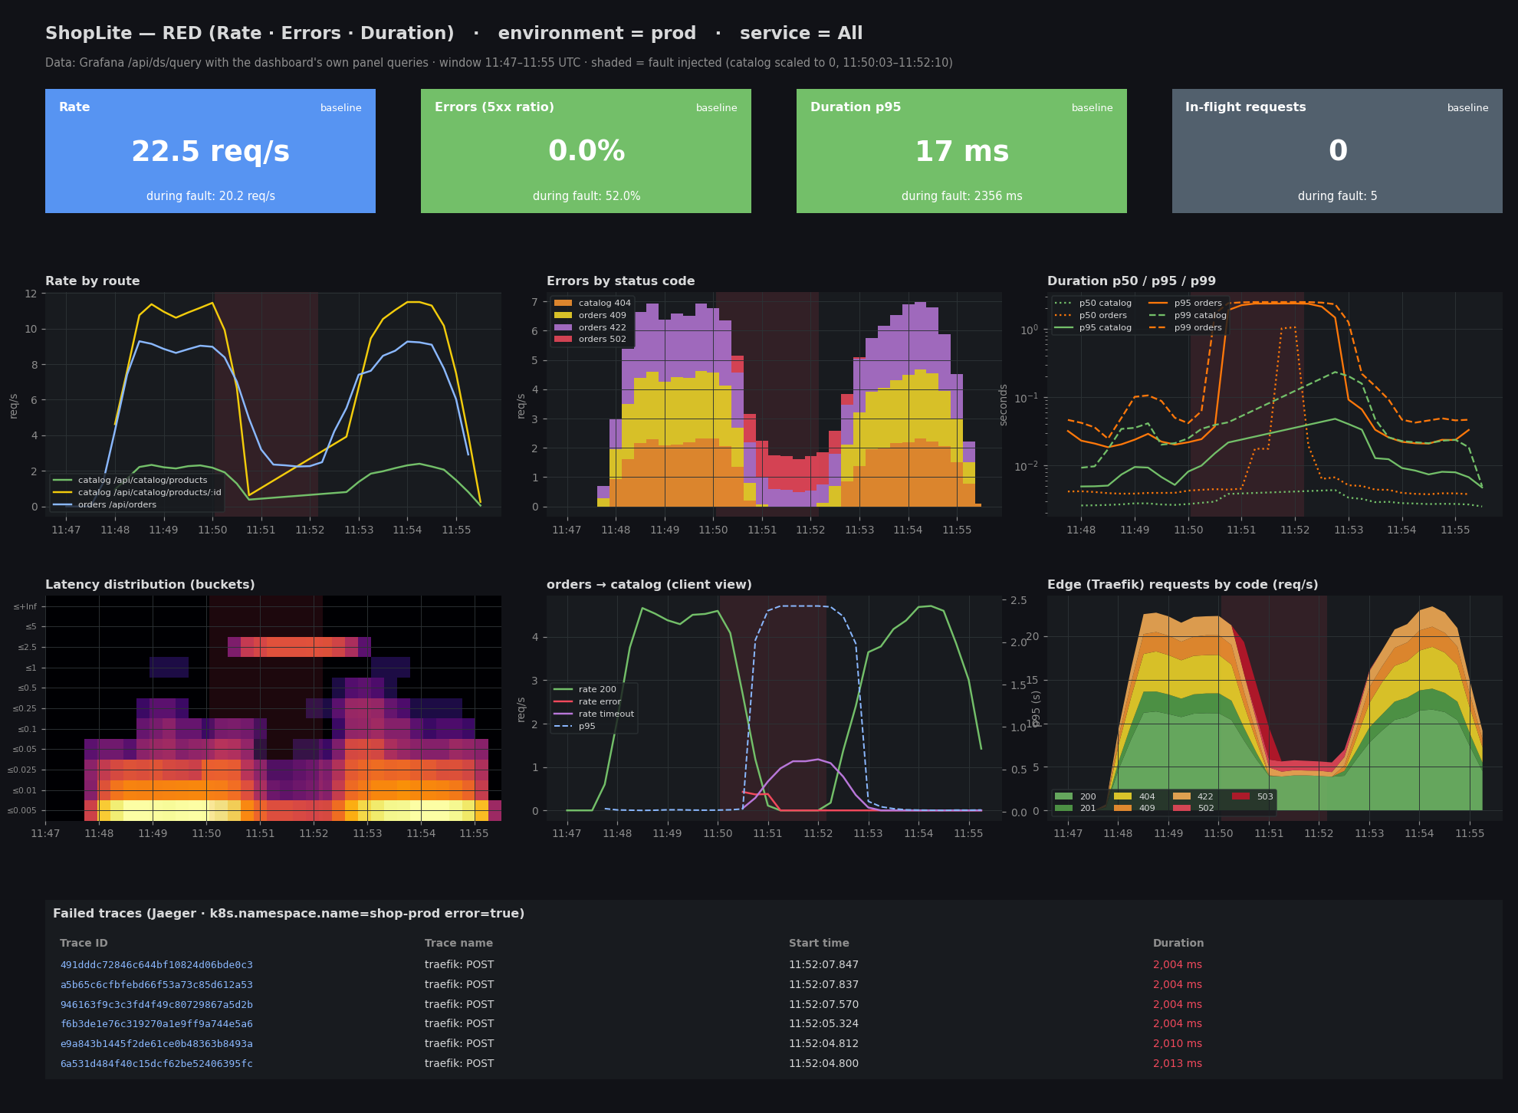
Figure 7. The dashboard’s panel queries for prod, executed through Grafana’s /api/ds/query and drawn in the dashboard layout. Shaded = fault window
Figure 7 is drawn from Grafana’s own query results (exports/grafana-panel-results.json). It is not a browser screenshot of the Grafana UI: signing in requires the admin password from the git-ignored Secret, and this session was not permitted to read it. The live dashboard is available through kubectl -n observability port-forward svc/grafana 3000.

6. Evaluation: design vs observed

6.1 Automated verification: 49 / 49 checks passed
scripts/telemetry-verify.py follows the data-flow diagram arrow by arrow, from the GitOps state, through app → Collector, Collector → Prometheus and Collector → Jaeger, to Grafana. It ends with the NetworkPolicy probe.
Table 7. Design vs runtime (scripts/telemetry-verify.py, evidence 06)
Check | Observed | Result
Argo CD app observability Synced/Healthy | Synced/Healthy @ 72db3e8 | PASS
Argo CD app platform Synced/Healthy | Synced/Healthy @ 72db3e8 | PASS
Argo CD app root Synced/Healthy | Synced/Healthy @ 72db3e8 | PASS
Argo CD app shoplite-dev Synced/Healthy | Synced/Healthy @ 72db3e8 | PASS
Argo CD app shoplite-prod Synced/Healthy | Synced/Healthy @ 72db3e8 | PASS
Argo CD app shoplite-staging Synced/Healthy | Synced/Healthy @ 72db3e8 | PASS
observability pod grafana ready | grafana/grafana:13.2.5 | PASS
observability pod jaeger ready | jaegertracing/jaeger:2.20.0 | PASS
observability pod otel-collector ready | otel/opentelemetry-collector-contrib:0.163.2 | PASS
observability pod prometheus ready | prom/prometheus:v3.15.1 | PASS
scrape target shop-dev/catalog up | 2 pod(s) | PASS
scrape target shop-dev/orders up | 1 pod(s) | PASS
scrape target shop-staging/catalog up | 2 pod(s) | PASS
scrape target shop-staging/orders up | 2 pod(s) | PASS
scrape target shop-prod/catalog up | 3 pod(s) | PASS
scrape target shop-prod/orders up | 3 pod(s) | PASS
scrape target ingress-traefik/traefik up |  | PASS
web (nginx, not instrumented) is NOT scraped |  | PASS
Collector receives OTLP spans, refuses none | 206.5 spans/s accepted, 0.0 refused | PASS
RED series for dev: catalog + orders | catalog 8.6 req/s, orders 5.8 req/s | PASS
RED series for staging: catalog + orders | catalog 8.7 req/s, orders 5.8 req/s | PASS
RED series for prod: catalog + orders | catalog 6.4 req/s, orders 5.8 req/s | PASS
http_route is a bounded template (no raw ids) | /api/catalog/products, /api/catalog/products/:id, /api/orders, /healthz, /readyz, unmatched | PASS
trace_id exemplars stored on duration buckets | 2974 exemplars | PASS
Traefik edge metrics present |  | PASS
client-side histogram orders → catalog present |  | PASS
RED recording + alert rules loaded | 5 rules | PASS
Jaeger has traefik, orders, catalog | catalog, jaeger, orders, traefik | PASS
POST /api/orders traces span traefik → orders → catalog | 50/50 traces cross 3 services | PASS
traceparent propagation: one trace id, every parent span present | trace 79081985e4b61dc1…, 9 spans, 0 orphans | PASS
spans enriched with k8s.* by the Collector |  | PASS
no SQL parameters recorded (enhancedDatabaseReporting off) |  | PASS
probes and scrapes are not traced (/healthz, /readyz, /metrics) | 0 traces found | PASS
Grafana data source prometheus healthy | Successfully queried the Prometheus API. | PASS
Grafana data source jaeger healthy | Data source is working | PASS
RED dashboard provisioned from git | ShopLite — RED (Rate · Errors · Duration) · 12 panels | PASS
panel “Rate” returns data (prod) | 1 series/frames | PASS
panel “Errors (5xx ratio)” returns data (prod) | 1 series/frames | PASS
panel “Duration p95” returns data (prod) | 1 series/frames | PASS
panel “In-flight requests” returns data (prod) | 1 series/frames | PASS
panel “Rate by route” returns data (prod) | 3 series/frames | PASS
panel “Errors by status code” returns data (prod) | 4 series/frames | PASS
panel “Duration p50 / p95 / p99” returns data (prod) | 7 series/frames | PASS
panel “Latency distribution (all API requests)” returns data (prod) | 11 series/frames | PASS
panel “orders → catalog (client view)” returns data (prod) | 4 series/frames | PASS
panel “Edge (Traefik) requests by code” returns data (prod) | 7 series/frames | PASS
panel “Recent orders traces” returns data (prod) | 1 series/frames | PASS
panel “Failed traces” returns data (prod) | 1 series/frames | PASS
pod in shop-prod (not the Collector) cannot read orders /metrics | BLOCKED | PASS

Table 8. Design expectations checked by the fault experiment
Design expectation | Observed | ✓
One trace per request from the edge to the database, joined by traceparent | 9-span trace Traefik → orders → catalog → pg. 50/50 sampled orders traces cross 3 services, 0 orphan spans | ✓
RED per environment from one dashboard | $env switches dev/staging/prod, and all 12 data panels return data | ✓
Exemplars link metrics to traces | 2 974 exemplars. The exemplar on the 502 bucket is a trace in the Failed-traces table | ✓
A dependency failure shows up in the caller | orders 5xx 0 → 49 %, p95 22 ms → 2.35 s (the 2 s client timeout) | ✓
The SLO alert fires about 1 min after the breach | Pending after 38 s, firing 60 s later | ✓
The edge view catches what app metrics cannot | Traefik 502/503 visible while catalog had no pods | ✓
Telemetry never blocks traffic | Jaeger restart (Recreate) during the version switch: the Collector retried and requests were unaffected | ✓

6.2 What the telemetry revealed
Table 9. Findings and changes
# | Observation | Cause | Change
1 | With 0 pods, catalog had no RED series, so its error-rate alert could not fire | “No data” is not “no errors”: a service without targets produces no series at all | New alert ShopLiteServiceNoTargets (target set present 5 min ago is gone) + promtool test that replays the outage, run in CI
2 | orders → catalog fetch span lasted 10.3 s, the request was answered with 502 after 2.0 s | AbortSignal.timeout aborts the request, not undici’s TCP connect (10 s default) | Recommended for the next release: undici Agent with connect.timeout = CATALOG_TIMEOUT_MS + circuit breaker
3 | Grafana’s Jaeger data source: 404 on health and search | The plugin uses the legacy /api/traces route that Jaeger 2.21+ removed (proved with a logging proxy) | Jaeger pinned to 2.20.0 after a local compatibility test (ADR-W9-05)
4 | First run: request rate fell to 0 in all environments | Load workers exited on the first curl error under set -e. The telemetry showed missing traffic, not errors | Loader tolerates failures and paces requests
5 | Trivy KSV-0041 (CRITICAL) on the Week 8 ClusterRole | A ClusterRole that can read Secrets, bound per namespace | Namespaced Role + RoleBinding per environment (ADR-W9-07)

7. Architecture Decision Records (summary)
Table 10. ADRs (full text: docs/week9/adr.md)
ADR | Decision | Main reason / trade-off
W9-01 | OpenTelemetry for traces, Prometheus exposition for metrics, linked by exemplars | curl-able /metrics as required by the lab. OTel names keep the queries portable. Costs two libraries per service.
W9-02 | One Collector as the telemetry gateway | Apps know one address. Policy (memory_limiter, k8s enrichment, future tail sampling) lives in one place.
W9-03 | Collector: one replica | The prometheus receiver does not shard. Production: Target Allocator + agent DaemonSet.
W9-04 | Prometheus (remote-write receiver) + Jaeger (memory) | Lab-sized and ephemeral. Production: PVC + Thanos/Mimir, Jaeger/Tempo on durable storage, mTLS, SSO.
W9-05 | Jaeger pinned to 2.20.0 | Grafana’s Jaeger plugin still searches through the legacy API. Revisit when upstream is fixed.
W9-06 | 100 % head sampling, decided at the edge | Services follow the parent’s flag. Metrics are never sampled. Production: tail sampling (all errors, slow requests, 5 % of the rest).
W9-07 | Traefik RBAC as namespaced Roles | Fixes the Week 8 KSV-0041 finding.

8. Conclusions and limitations
- ShopLite now has one telemetry path. Instrumented services and the edge feed one Collector, which feeds Prometheus and Jaeger, which feed one RED dashboard. All of it is deployed through git and Argo CD like the rest of the system.
- The design held under a real fault. Errors and latency appeared in the caller within one scrape interval, the SLO alert fired after its 1-minute hold, and every failed request had a trace that explained it.
- The telemetry also found gaps in the design and in the code. A dead service is silent, which led to the new NoTargets alert. A client timeout does not end the connection attempt. The Grafana and Jaeger versions had an API mismatch.
- Limitations: Prometheus (emptyDir) and Jaeger (memory) lose data on restart, so results were exported first. The Collector is a single replica. There is no Alertmanager. Grafana UI evidence is the panel query results, not a screenshot.
- Next steps: the undici connect timeout and circuit breaker, tail sampling in the Collector, durable storage, and Alertmanager routing. SLO burn-rate alerts connect to Week 12 (progressive delivery with automated analysis).

Appendix A. Exported configuration and evidence
File (docs/week9/) | Content
exports/grafana-dashboard-shoplite-red.json | RED dashboard as stored by Grafana (API export)
exports/grafana-datasources.json | Prometheus + Jaeger data sources with exemplar → trace links
exports/otel-collector-config.json | Collector pipelines: receivers, processors, exporters
exports/prometheus-config.json, prometheus-rules.json | Prometheus runtime config, recording and alert rules with their state
exports/jaeger-config.json | Jaeger v2 configuration
exports/grafana-panel-results.json | Every panel query result for prod in the experiment window
exports/traces/order-ok.json, order-catalog-down.json | The two traces of Figures 2–4 (Jaeger JSON)
evidence/01 … 03 | Observability rollout, RBAC prune, prod release 1.1.0
evidence/04, 05, 08 | Experiment timeline, alerts during the outage, RED baseline vs fault
evidence/06-telemetry-verify.txt | 49 design-vs-runtime checks
evidence/07-metrics-endpoint-sample.txt | Raw /metrics output with exemplars
evidence/jaeger-ui-*.jpg, grafana-dashboard-data-prod.png | Jaeger UI screenshots, dashboard data render

Appendix B. Key configuration
Collector pipeline (k8s/observability/config/otel-collector.yaml)
# OpenTelemetry Collector (contrib 0.163) — the single telemetry gateway of the cluster.
# Apps only know one address (OTEL_EXPORTER_OTLP_ENDPOINT); backends can be swapped here
# without touching the services. `$$` escapes `$` from the Collector's env-var expansion.
extensions:
health_check:
endpoint: 0.0.0.0:13133

receivers:
# Push: spans from catalog/orders (OTel SDK) and Traefik.
otlp:
protocols:
grpc:
endpoint: 0.0.0.0:4317
http:
endpoint: 0.0.0.0:4318
# Pull: Prometheus-compatible scraping of every pod annotated prometheus.io/scrape=true.
prometheus:
config:
global:
scrape_interval: 15s
scrape_timeout: 5s
scrape_configs:
- job_name: kubernetes-pods
kubernetes_sd_configs:
- role: pod
namespaces:
names: [shop-dev, shop-staging, shop-prod, ingress-traefik]
relabel_configs:
- source_labels: [__meta_kubernetes_pod_annotation_prometheus_io_scrape]
regex: "true"
action: keep
- source_labels: [__meta_kubernetes_pod_phase]
regex: Running
action: keep
# role: pod yields one target per declared container port; keep the annotated one.
- source_labels: [__meta_kubernetes_pod_container_port_number]
target_label: __meta_kubernetes_pod_annotation_prometheus_io_port
action: keepequal
- source_labels: [__meta_kubernetes_pod_annotation_prometheus_io_path]
regex: (.+)
target_label: __metrics_path__
- source_labels: [__meta_kubernetes_namespace]
target_label: namespace
- source_labels: [__meta_kubernetes_pod_name]
target_label: pod
- source_labels: [__meta_kubernetes_pod_label_app_kubernetes_io_name]
target_label: app
- source_labels: [__meta_kubernetes_pod_label_shoplite_io_environment]
target_label: environment
# Traefik is shared by all environments: its series get environment="edge".
- source_labels: [__meta_kubernetes_namespace]
regex: ingress-traefik
replacement: edge
target_label: environment
- job_name: otel-collector # self-monitoring: queue sizes, refused/dropped spans
static_configs:
- targets: [localhost:8888]

processors:
# First in every pipeline: refuse data instead of being OOM-killed under a burst.
memory_limiter:
check_interval: 1s
limit_percentage: 80
spike_limit_percentage: 25
# Adds k8s.namespace.name / k8s.pod.name / k8s.deployment.name to spans, looked up by the
# source IP of the OTLP connection, so the apps don't have to know where they run.
k8s_attributes:
auth_type: serviceAccount
passthrough: false
extract:
metadata: [k8s.namespace.name, k8s.pod.name, k8s.deployment.name, k8s.node.name]
pod_association:
- sources:
- from: connection
batch:
send_batch_size: 1024
timeout: 2s

exporters:
otlp_grpc/jaeger:
endpoint: jaeger.observability.svc.cluster.local:4317
tls:
insecure: true # in-cluster, NetworkPolicy-restricted; mTLS is the production step (ADR-W9-04)
prometheus_remote_write:
endpoint: http://prometheus.observability.svc.cluster.local:9090/api/v1/write
tls:
insecure: true
resource_to_telemetry_conversion:
enabled: false # target labels above are enough; avoids a label explosion
send_metadata: true

service:
extensions: [health_check]
telemetry:
metrics:
level: normal
readers:
- pull:
exporter:
prometheus:
host: 0.0.0.0
port: 8888
pipelines:
traces:
receivers: [otlp]
processors: [memory_limiter, k8s_attributes, batch]
exporters: [otlp_grpc/jaeger]
metrics:
receivers: [prometheus]
processors: [memory_limiter, batch]
exporters: [prometheus_remote_write]
RED rules (k8s/observability/config/shoplite-red.rules.yml)
# RED recording rules (the dashboard's stat tiles) and SLO alerts. No Alertmanager in the lab:
# firing alerts are visible in Prometheus /alerts and in Grafana.
groups:
- name: shoplite-red
interval: 15s
rules:
- record: shoplite:http_requests:rate1m
expr: >-
sum by (environment, service, http_route) (
rate(http_server_request_duration_seconds_count{http_route=~"/api/.*"}[1m]))
- record: shoplite:http_errors:ratio_rate1m
expr: >-
sum by (environment, service) (
rate(http_server_request_duration_seconds_count{http_route=~"/api/.*",http_response_status_code=~"5.."}[1m]))
/
sum by (environment, service) (
rate(http_server_request_duration_seconds_count{http_route=~"/api/.*"}[1m]))
- record: shoplite:http_request_duration_seconds:p95_1m
expr: >-
histogram_quantile(0.95, sum by (environment, service, le) (
rate(http_server_request_duration_seconds_bucket{http_route=~"/api/.*"}[1m])))
- alert: ShopLiteHighErrorRate
expr: shoplite:http_errors:ratio_rate1m > 0.05
for: 1m
labels:
severity: page
annotations:
summary: "{{ $labels.service }} in {{ $labels.environment }}: {{ $value | humanizePercentage }} of API requests fail (SLO: < 5 %)"
- alert: ShopLiteSlowRequests
expr: shoplite:http_request_duration_seconds:p95_1m > 0.5
for: 2m
labels:
severity: ticket
annotations:
summary: "{{ $labels.service }} in {{ $labels.environment }}: p95 latency {{ $value | humanizeDuration }} (SLO: < 500 ms)"
# Found in the Week 9 outage experiment: with 0 pods a service has no RED series at all, so the
# error-ratio alert above stays silent for it ("no data" is not "0 % errors"). This fires when
# a service that was scraped 5 minutes ago has no healthy target now.
- alert: ShopLiteServiceNoTargets
expr: >-
count by (namespace, app) (up{job="kubernetes-pods",app=~"catalog|orders"} offset 5m)
unless
count by (namespace, app) (up{job="kubernetes-pods",app=~"catalog|orders"} == 1)
for: 1m
labels:
severity: page
annotations:
summary: "{{ $labels.app }} in {{ $labels.namespace }} has no healthy scrape target (scaled to 0 or crash-looping)"
Metrics module (services/orders/src/telemetry/metrics.js)
'use strict';

const client = require('prom-client');
const { trace, isSpanContextValid } = require('@opentelemetry/api');

// RED metrics, named after the OpenTelemetry HTTP semantic conventions
// (http.server.request.duration → http_server_request_duration_seconds). One histogram gives all
// three signals: Rate = rate(…_count)
// Errors = rate(…_count{http_response_status_code=~"5.."})
// Duration = histogram_quantile(0.95, rate(…_bucket))
const DURATION_BUCKETS = [0.005, 0.01, 0.025, 0.05, 0.1, 0.25, 0.5, 1, 2.5, 5];

function activeSpanContext() {
const span = trace.getActiveSpan();
return span ? span.spanContext() : undefined;
}

function createMetrics({ service, collectDefaults = true } = {}) {
const registry = new client.Registry();
// Exemplars (a trace_id attached to a histogram sample) only exist in the OpenMetrics format.
registry.setContentType(client.Registry.OPENMETRICS_CONTENT_TYPE);
registry.setDefaultLabels({ service });
if (collectDefaults) client.collectDefaultMetrics({ register: registry });

const duration = new client.Histogram({
name: 'http_server_request_duration_seconds',
help: 'Duration of inbound HTTP requests.',
labelNames: ['http_request_method', 'http_route', 'http_response_status_code'],
buckets: DURATION_BUCKETS,
enableExemplars: true,
registers: [registry],
});
const active = new client.Gauge({
name: 'http_server_active_requests',
help: 'Inbound HTTP requests currently being served.',
labelNames: ['http_request_method'],
registers: [registry],
});

// Outbound calls to dependencies (orders → catalog): the same RED view one hop further.
const clientDuration = new client.Histogram({
name: 'http_client_request_duration_seconds',
help: 'Duration of outbound HTTP requests to dependencies.',
labelNames: ['server_address', 'http_response_status_code'],
buckets: DURATION_BUCKETS,
registers: [registry],
});

function observeClient(serverAddress, statusCode, seconds) {
clientDuration.observe(
{ server_address: serverAddress, http_response_status_code: String(statusCode) },
seconds,
);
}

/**
* Call when a request arrives; call the returned function when it has been answered.
* `http_route` must be a route template (/products/:id), never the raw path, to keep the
* number of series bounded.
*/
function startRequest(method, spanContext = activeSpanContext()) {
const started = process.hrtime.bigint();
active.inc({ http_request_method: method });
return function end(route, statusCode) {
active.dec({ http_request_method: method });
const labels = {
http_request_method: method,
http_route: route,
http_response_status_code: String(statusCode),
};
const value = Number(process.hrtime.bigint() - started) / 1e9;
const exemplarLabels =
spanContext && isSpanContextValid(spanContext)
? { trace_id: spanContext.traceId, span_id: spanContext.spanId }
: {};
duration.observe({ labels, value, exemplarLabels });
};
}

return { registry, startRequest, observeClient, contentType: registry.contentType };
}

module.exports = { createMetrics, DURATION_BUCKETS };

