Software Architecture & DevOps — Laboratory Work
Week 6 · Lab 2
CI/CD Architecture & DevSecOps Threat Modeling
Automated supply-chain pipeline, quality gates and STRIDE threat model for ShopLite
Student: Timur
Group: ____________
Repository: https://github.com/timurdll/devops-labs
Pipeline: .github/workflows/ci.yml
Date: 15 October 2026

Contents
1. Objective and deliverables
2. Pipeline architecture
3. STRIDE threat model of the pipeline
4. Implementation
5. Trivy execution report
6. Verification
7. Conclusions and limitations
Appendix A. Full workflow file (ci.yml)

1. Objective and deliverables
The goal of this lab is to design an automated software-delivery pipeline with explicit quality gates, to threat-model the delivery channel itself with STRIDE, and to implement the design as a working CI workflow with an automated container vulnerability scanner (Trivy) that enforces a severity threshold.
System under delivery — ShopLite. A small microservice shop built for these labs: catalog and orders (Node.js 24 REST APIs backed by PostgreSQL) and web (static UI on nginx). The same images are deployed to Kubernetes in Week 7.
Table 1. Deliverables map
Assignment deliverable | Where it is in this report / repository
Pipeline Sequence Diagram (UML) with pass/fail criteria per gate | Figure 1, Table 2 · docs/week6/diagrams/ci-pipeline-sequence.mmd
CI/CD pipeline flowchart | Figure 2 · docs/week6/diagrams/ci-pipeline-flow.mmd
Pipeline Threat Model diagram (STRIDE) | Figure 3 · docs/week6/diagrams/threat-model-dfd.mmd
STRIDE matrix with security mitigations | Table 5, Table 6
Functional CI workflow enforcing the quality gates | .github/workflows/ci.yml (§4, Appendix A)
Trivy integration with vulnerability thresholds + execution report | §5 · docs/week6/evidence/trivy/

1.1 Design goals
- Every change passes the same gates. No pull request can be merged and no image can be published unless all gates pass.
- Fail fast, fail cheap. Static checks run as parallel jobs and finish in seconds; the expensive image build starts only after all of them are green.
- The pipeline itself is attack surface. Third-party actions, registries, the runner token and the workflow file are threat-modelled (§3), not only the application code.
- What is scanned is what is shipped. The image that passed Trivy is the exact image that is pushed and signed — there is no rebuild in between.

2. Pipeline architecture

2.1 UML sequence diagram
Figure 1 models the end-to-end lifecycle: a developer opens a pull request, six static gates run in parallel, the image job builds and scans each service, and — only after a merge to main — the publish stage pushes and signs the scanned image. Every reply message states the pass/fail criterion of its gate.
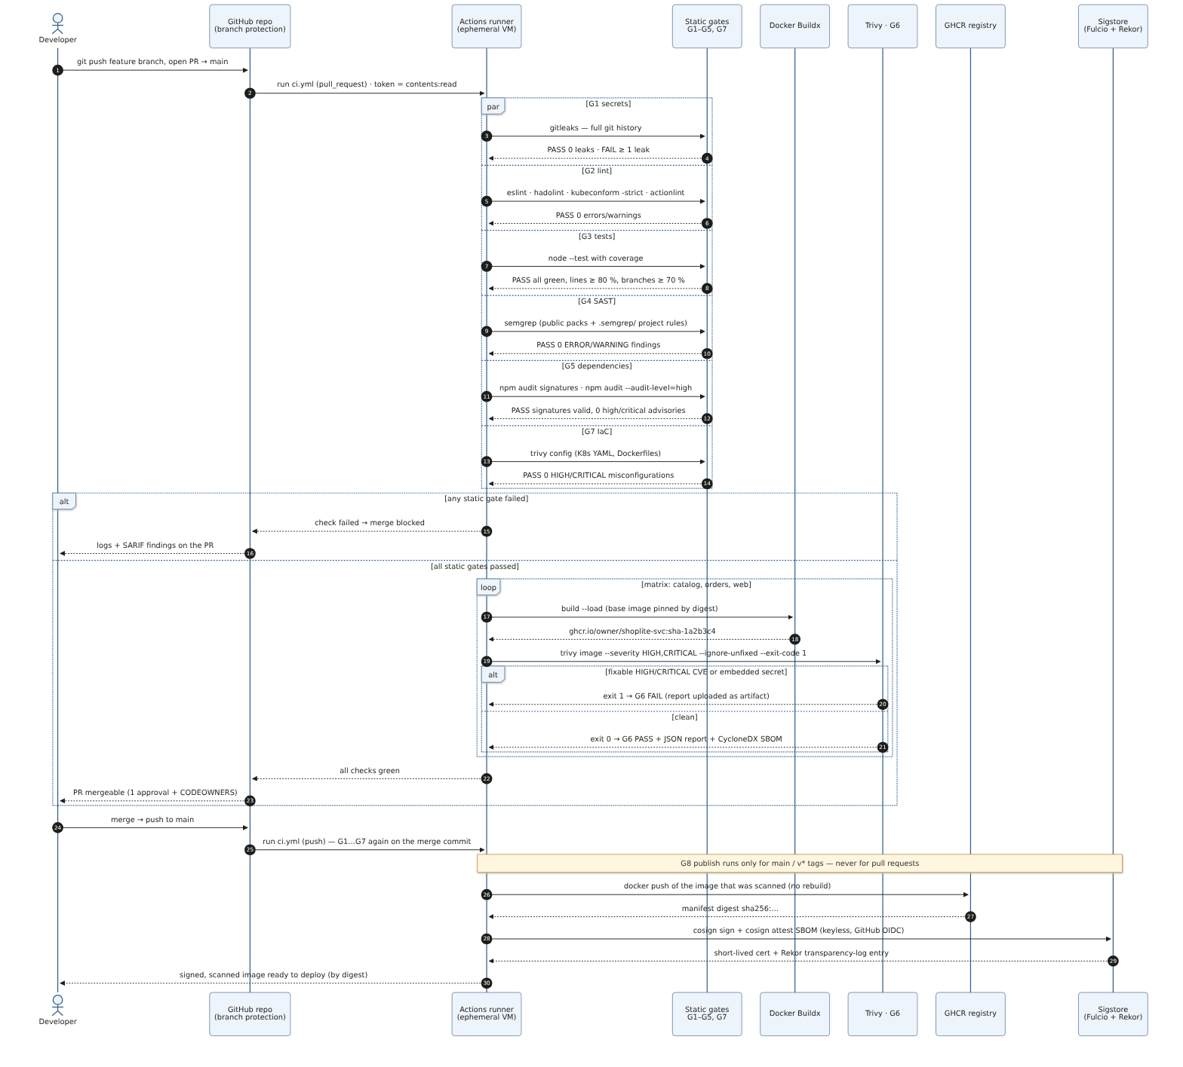
Figure 1. UML sequence diagram of the delivery pipeline (source: ci-pipeline-sequence.mmd)

2.2 Pipeline flowchart
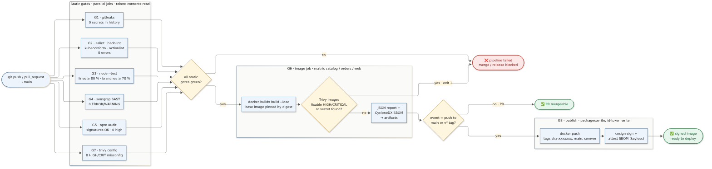
Figure 2. Pipeline flowchart: jobs of ci.yml as quality gates with pass/fail branches

2.3 Quality gates and pass/fail criteria
Table 2. Quality gates with pass/fail criteria
Gate | Job | Tool (pinned) | PASS when | FAIL when (job exit ≠ 0)
G1 Secrets | secret-scan | gitleaks v8.30.1 | 0 findings in the full git history | ≥ 1 secret-like string (output redacted)
G2 Lint — code | lint ×2 | ESLint 10 | 0 errors (eqeqeq, no-eval, no-implied-eval, …) | any ESLint error
G2 Lint — infra | lint-infra | hadolint v2.15.1, kubeconform v0.8.0, actionlint 1.7.12 | Dockerfiles without warnings; every rendered K8s object valid (-strict, K8s 1.37 schema); workflow passes actionlint + shellcheck | any warning, invalid object or workflow error
G3 Unit tests | test ×2 | node --test | all tests pass and line coverage ≥ 80 %, branch coverage ≥ 70 % | failing test or coverage below threshold
G4 SAST | sast | Semgrep 1.180.0: p/javascript, p/nodejs, p/secrets, p/dockerfile, p/kubernetes, p/github-actions + .semgrep/ project rules | 0 findings of severity ERROR/WARNING | any blocking finding (--error)
G5 Dependencies (SCA) | deps-audit ×2 | npm audit signatures, npm audit | registry signatures valid; 0 HIGH/CRITICAL advisories in production deps | invalid signature or HIGH/CRITICAL advisory
G6 Image scan | image ×3 | Trivy v0.75.0 (vuln + secret scanners) | 0 fixable HIGH/CRITICAL CVEs and 0 secrets in image layers | any fixable HIGH/CRITICAL CVE or embedded secret
G7 IaC scan | iac-scan | Trivy v0.75.0 config | 0 HIGH/CRITICAL misconfigurations in K8s YAML and Dockerfiles (except scoped entries in .trivyignore.yaml) | any HIGH/CRITICAL misconfiguration
G8 Publish | image (conditional steps) | docker push, cosign (keyless) via sigstore/cosign-installer v4.1.2 | runs only on push to main or a v*.*.* tag, after G1–G7 passed | never runs for pull requests

Why “fixable” HIGH/CRITICAL as the G6 threshold. A CVE that has no fixed version cannot be remediated by the team; blocking on it would only teach people to bypass the gate. Unfixed CVEs are still listed in the full JSON report (§5) and are re-evaluated on every run, so the gate starts failing automatically as soon as an upstream fix ships.

2.4 Architecture decisions
Table 3. Architecture decisions of the pipeline
Decision | Rationale
Actions pinned to full commit SHA; container tools pinned to tag + digest | Tags are mutable. In March 2026, 76 of 77 aquasecurity/trivy-action tags were force-pushed to credential-stealing code (CVE-2026-33634); tj-actions/changed-files was hijacked the same way in March 2025 (CVE-2025-30066). A SHA or digest cannot be re-pointed.
Trivy v0.75.0 rather than v0.76.0 | v0.76.0 was one day old. The pipeline follows a 7-day cooldown for tools and dependencies (also enforced through Dependabot’s cooldown) — most hijacked releases are detected within days.
permissions: {} at workflow level, grants per job | A compromised lint step only holds contents: read; packages: write and id-token: write exist only in the publish-capable job.
pull_request, never pull_request_target | Fork PRs run with a read-only token and no secrets — prevents “pwn request” attacks.
persist-credentials: false on every checkout | The token is not left in .git/config where artifacts or later steps could leak it.
Build once → scan → push the same image | No drift between the scanned and the shipped artifact (TOCTOU); also saves a rebuild.
npm ci --ignore-scripts | Lifecycle scripts are the payload channel of npm worms such as Shai-Hulud (September 2025).
Distroless runtime for the Node.js services | No shell, no package manager: 30 SBOM components and 0 HIGH/CRITICAL CVEs (§5).
Keyless cosign signature + CycloneDX SBOM attestation | Binds the image digest to the workflow identity (OIDC) and records it in the Rekor transparency log — non-repudiation.

3. STRIDE threat model of the pipeline

3.1 Data-flow diagram with trust boundaries
The pipeline was decomposed into external entities, processes, data stores and flows (F1–F13). Dashed boxes are trust boundaries (TB-1…TB-6); every flow is annotated with the IDs of the threats that apply to it (Table 5).
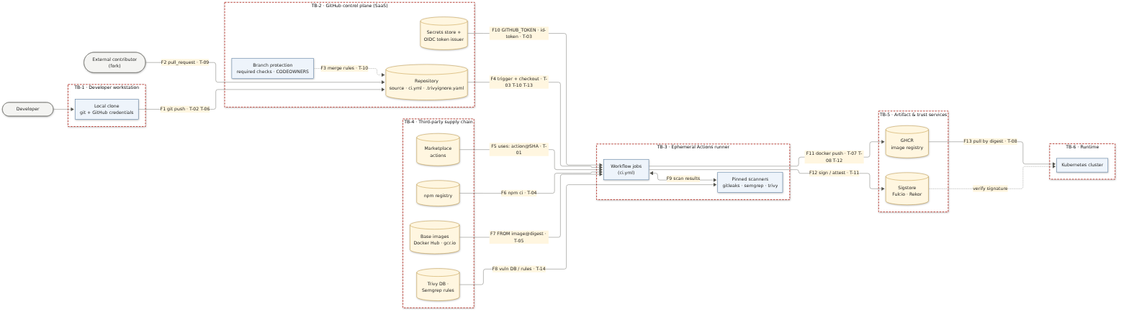
Figure 3. STRIDE threat model of the delivery pipeline as a data-flow diagram
Table 4. Trust boundaries
Trust boundary | What crosses it | Why it matters
TB-1 Developer workstation → GitHub | commits (F1) | workstation credentials can be stolen and used to push code as a trusted identity
External contributor → GitHub | fork pull requests (F2) | untrusted code is executed by our CI
TB-2 GitHub → TB-3 runner | workflow definition, source, token (F4, F10) | the runner holds credentials while executing code from the repository
TB-4 Third-party supply chain → runner | actions, npm packages, base images, vulnerability DB (F5–F8) | code we did not write runs with our token
Runner → TB-5 registry / Sigstore | images, signatures (F11, F12) | whatever is published here gets deployed
TB-5 registry → TB-6 runtime | image pulls (F13) | the cluster trusts what it pulls

3.2 STRIDE matrix
Rating: Likelihood (L) and Impact (I) as High/Medium/Low; Risk is the higher of both, raised to Critical when both are High.
Table 5. STRIDE matrix of the CI/CD pipeline
ID | STRIDE | Flow | Threat & attack scenario | L | I | Risk | Mitigations implemented (where) | Residual risk
T-01 | Tampering | F5 actions | Maintainer account or tag hijacked; uses: x@v1 now runs malware that dumps runner memory and secrets (tj-actions 2025, trivy-action 2026). | H | H | Critical | All actions pinned to 40-char SHA; Dependabot (github-actions, 7-day cooldown) bumps pins; least-privilege token per job; no long-lived secrets in CI (ci.yml, dependabot.yml). | Malicious commit pinned after cooldown — review Dependabot diffs.
T-02 | Info disclosure | F1 source | Developer commits a token/password; it stays in history forever. | H | H | Critical | G1 gitleaks scans the full history and blocks the PR; secret values live in a git-ignored db.env and reach the cluster via kustomize secretGenerator. | Formats unknown to gitleaks — enable GitHub push protection.
T-03 | Info disclosure | F4/F10 token | GITHUB_TOKEN / OIDC token exfiltrated by a malicious step or leaked via .git/config in an artifact (ArtiPACKED). | M | H | High | permissions: {} default; packages:write + id-token:write only in the image job; persist-credentials: false; only reports uploaded as artifacts. | A compromised step in the image job on main still has push rights for that run.
T-04 | Tampering | F6 npm | Dependency poisoning: typosquat, hijacked maintainer, malicious postinstall (event-stream 2018, Shai-Hulud 2025). | H | H | Critical | Lockfile integrity (npm ci); --ignore-scripts; G5 npm audit signatures + audit-level=high; Dependabot cooldown; single runtime dependency (pg). | Zero-day malicious package not yet in advisories.
T-05 | Tampering | F7 base images | Outdated base with known CVEs or re-tagged malicious image. | H | M | High | Bases pinned by digest; G6 Trivy gate; minimal bases; Dependabot docker updates. Demonstrated: G6 blocked nginx 1.29-alpine with 43 fixable HIGH CVEs. | Unfixed CVEs — tracked in full report.
T-06 | Spoofing | F1 identity | Stolen PAT/SSH key pushes malicious code as a trusted developer. | M | H | High | CODEOWNERS on .github/, k8s/, .trivyignore.yaml; branch protection (PR + review + required checks) and 2FA as repository settings. | Compromised reviewer — add signed-commit requirement.
T-07 | Spoofing | F11 registry | Look-alike or unauthorised image pushed under our name; registry credential reused. | M | H | High | Push only from CI with the ephemeral GITHUB_TOKEN (no stored password); keyless signatures let consumers verify the signer is this repo’s workflow. | Admission-time signature enforcement (Kyverno / policy-controller) — Week 8+.
T-08 | Tampering | F11/F13 artifacts | Image replaced between scan and deploy (TOCTOU) or mutable tag :main overwritten. | M | H | High | Scanned image pushed as-is; immutable sha-<commit> tags; deploy by digest; signature bound to digest. | Enable GHCR tag immutability.
T-09 | Elevation of privilege | F2 fork PR | “Pwn request”: fork PR changes the build to run with a write token and secrets. | M | H | High | pull_request trigger (read-only, no secrets for forks); no pull_request_target; publish steps guarded by event == push && ref == main/tag. | First-time contributor approval is a repo setting.
T-10 | Tampering | F3/F4 pipeline | Insider edits ci.yml or adds a broad .trivyignore entry to silence a gate. | M | H | High | Workflow + ignore file are code-owned; ignore entries must be path-scoped, justified, expiring; actionlint validates the workflow. | Reviewer fatigue — keep the list short.
T-11 | Repudiation | F12 provenance | Nobody can prove which commit/workflow produced a running image. | M | M | Medium | cosign keyless signature + CycloneDX SBOM attestation in Rekor; OCI labels; sha-<commit> tag; run logs. | Run logs expire after 90 days; Rekor entries do not.
T-12 | Info disclosure | F11 image layers | .env or key file copied into the image and published. | M | H | High | .dockerignore excludes .env*; multi-stage build copies only node_modules + src; G6 runs Trivy --scanners vuln,secret. | Secrets in exotic formats.
T-13 | Denial of service | F4 runner | PR with infinite loop or crypto-miner exhausts minutes and blocks the queue. | M | L | Medium | timeout-minutes on every job (5–20); concurrency with cancel-in-progress; fork workflows need approval. | Minutes consumed until timeout.
T-14 | Tampering / DoS | F8 scanner & feeds | Scanner or its DB compromised (Trivy v0.69.4, March 2026) or unavailable — gate skipped or lies. | L | H | High | Scanner pinned (action SHA + version + image digest); cooldown before upgrades; Trivy fails closed when the DB cannot be downloaded. | Trust in the DB provider; a second scanner (Grype) could be added.

Coverage: Spoofing (T-06, T-07) · Tampering (T-01, T-04, T-05, T-08, T-10, T-14) · Repudiation (T-11) · Information disclosure (T-02, T-03, T-12) · Denial of service (T-13, T-14) · Elevation of privilege (T-09).
Table 6. Mitigation map: control → threats → gate
Security control | Threats addressed | Implemented in
Linting (ESLint, hadolint, kubeconform, actionlint) | T-05, T-10 | G2
SAST (Semgrep public packs + project rules) | injection flaws in own code, T-10 | G4
CVE scanning (npm audit, Trivy image) | T-04, T-05 | G5, G6
Secret masking & detection (gitleaks --redact, Trivy secret scanner, GitHub log masking) | T-02, T-12 | G1, G6
IaC misconfiguration scanning (Trivy config) | insecure Kubernetes / Docker configuration | G7
SHA/digest pinning + Dependabot cooldown | T-01, T-04, T-05, T-14 | ci.yml, Dockerfiles, dependabot.yml
Least-privilege token, no pull_request_target | T-03, T-09 | ci.yml
Branch protection + CODEOWNERS | T-06, T-10 | CODEOWNERS + repository settings
Keyless signing + SBOM attestation | T-07, T-08, T-11 | G8

4. Implementation
The design is implemented in .github/workflows/ci.yml (full listing in Appendix A). Supporting files:
Table 7. Files supporting the pipeline
File | Purpose
.semgrep/shoplite.yml | Three project SAST rules: eval/Function, child_process with a non-literal command, SQL built by string concatenation — added after the public rule packs produced a false negative (§6.2).
.trivyignore.yaml | The only risk acceptance: KSV-0109 false positive on ConfigMap postgres-init (the word PASSWORD is an SQL keyword, not a value). Path-scoped, justified, expires 2027-03-31.
.github/dependabot.yml | Weekly updates for actions, npm and Docker with a 7-day cooldown.
.github/CODEOWNERS | Mandatory review for the pipeline, security policy and cluster configuration.
scripts/ci-local.sh | Runs the same gates locally with the same pinned tool images (read from ci.yml, so they cannot drift).
scripts/negative-tests.sh | Plants a fake token and injectable code to prove that G1 and G4 really fail.

Key excerpt — the G6 gate:
- name: G6 · Trivy image gate (fail on fixable HIGH/CRITICAL, any embedded secret)
uses: aquasecurity/trivy-action@ed142fd0673e97e23eac54620cfb913e5ce36c25 # v0.36.0
with:
version: ${{ env.TRIVY_VERSION }} # v0.75.0
image-ref: ${{ fromJSON(steps.meta.outputs.json).tags[0] }}
scanners: vuln,secret
severity: ${{ env.TRIVY_GATE_SEVERITY }} # HIGH,CRITICAL
ignore-unfixed: true
exit-code: '1'

5. Trivy execution report
Executed with Trivy v0.75.0 (aquasec/trivy:0.75.0, pinned by digest) against images built from this repository. Raw reports: docs/week6/evidence/trivy/ — *-gate.txt (gate output), *-full.json|txt (all severities), *-sbom.cdx.json (CycloneDX SBOM).

5.1 Final run — gate passed
Table 8. Trivy results of the final run
Image | Base image (pinned by digest) | OS | Gate: fixable HIGH/CRIT | All findings (informational) | SBOM | Result
shoplite/catalog:1.0.1 | gcr.io/distroless/nodejs24-debian13:nonroot | Debian 13.7 | 0 | 23 MEDIUM, 8 LOW (none fixable) | 30 | PASS
shoplite/orders:1.0.1 | gcr.io/distroless/nodejs24-debian13:nonroot | Debian 13.7 | 0 | 23 MEDIUM, 8 LOW (none fixable) | 30 | PASS
shoplite/web:1.0.1 | nginxinc/nginx-unprivileged:1.30.6-alpine3.24 | Alpine 3.24.2 | 0 | 1 MEDIUM (fixable, below threshold) | 71 | PASS
npm dependencies (pg tree) | — | — | 0 | 0 | — | PASS
IaC: 9 K8s manifests + 3 Dockerfiles | — | — | 0 misconfig | 1 accepted false positive | — | PASS

5.2 Blocked run — the gate doing its job
The first version of services/web was based on nginxinc/nginx-unprivileged:1.29-alpine. Gate G6 failed the pipeline (evidence: docs/week6/evidence/trivy/blocked-run/).
Table 9. Trivy result of the blocked run
Image | OS | HIGH | MEDIUM | LOW | Fixable HIGH | Gate
shoplite/web:1.0.0 on nginx 1.29-alpine | Alpine 3.23.4 | 43 | 81 | 50 | 43 | FAIL (exit 1)

The 43 HIGH findings came from 10 Alpine packages: curl/libcurl 8.17.0 (20), libuuid (6), libexpat (6), pcre2 (4), libssl3/libcrypto3 3.5.6 (4), c-ares, libxml2 and tiff. Excerpt of the gate output:
$ trivy image --severity HIGH,CRITICAL --ignore-unfixed --exit-code 1 shoplite/web:1.0.0
shoplite/web:1.0.0 (alpine 3.23.4)
Total: 43 (HIGH: 43, CRITICAL: 0)

LIBRARY VULNERABILITY SEVERITY INSTALLED FIXED
curl CVE-2026-11352 HIGH 8.17.0-r1 8.22.0-r0
libcrypto3 CVE-2026-14456 HIGH 3.5.6-r0 3.5.8-r0
libexpat CVE-2026-45186 HIGH 2.7.5-r0 2.8.1-r0
c-ares CVE-2026-33630 HIGH 1.34.6-r0 1.34.8-r0
pcre2 CVE-2026-103111 HIGH 10.47-r0 10.49-r0
… 38 more

>>> exit code 1 — job "G6/G8 · image (web)" failed

Root cause: 1.29 is a closed nginx mainline branch, so the tag no longer receives Alpine package rebuilds. Remediation: moved to the maintained stable branch 1.30.6-alpine3.24 (pinned by digest) and re-scanned → 0 HIGH/CRITICAL, gate passed. Dependabot (docker ecosystem) now proposes such bumps automatically.

6. Verification

6.1 Pipeline runs
The workflow is committed to the repository and was triggered by the push of commit 0091d67 — run 38738427951. No job of that run was started: GitHub reported “The job was not started because your account is locked due to a billing issue”. This is an account-level restriction of GitHub Actions, not a result of the pipeline — none of the gates executed. Once the lock is cleared the run can be repeated with gh run rerun 38738427951.
The workflow was validated with actionlint, and every gate was executed locally by scripts/ci-local.sh with the identical pinned tool images (log: docs/week6/evidence/ci-local-run.log):
━━━ SUMMARY ━━━
PASS G1 secret scan (gitleaks) (3s)
PASS G2 lint code (eslint) (2s)
PASS G2 lint infra (hadolint/kubeconform/actionlint) (5s)
PASS G3 unit tests + coverage (1s)
PASS G4 SAST (semgrep) (7s)
PASS G5 dependency audit (npm audit) (7s)
PASS G7 IaC misconfiguration (trivy config) (1s)
PASS G6 build + image scan (trivy image) (18s)

G2: 28/28 Kubernetes objects valid · G3: catalog 6/6, orders 5/5 tests, lines 100 %, branches ≥ 95 %
G4: 136 rules, 0 findings · G5: 93 packages with verified registry signatures, 0 vulnerabilities

6.2 Negative tests — proving that gates block
scripts/negative-tests.sh plants defects in a throw-away repository (log: docs/week6/evidence/negative-tests.log):
Table 10. Negative tests of the security gates
Test | Planted defect | Expected | Observed
T1 · G1 | random ghp_… GitHub token in src/config.js | fail | gitleaks rule github-pat, exit 1 ✔
T2 · G4, public packs only | eval(query param), exec("ls " + header), SQL via template string | fail | exit 0, 0 findings — FALSE NEGATIVE
T3 · G4, public packs + .semgrep/ | same code | fail | 3 blocking findings, exit 1 ✔
G6 (real, §5.2) | outdated nginx base image | fail | 43 HIGH, exit 1 ✔

Lesson from T2: the public Semgrep JavaScript/Node rules model Express/Koa request sources and therefore missed the same dangerous sinks in a plain node:http service. A SAST gate is only as good as its rules — the pipeline now ships project rules for the sinks this code base could reach, and the negative test keeps them honest.

7. Conclusions and limitations
The pipeline enforces eight gates with explicit pass/fail criteria; it was shown to block a vulnerable base image (43 HIGH CVEs), a committed secret and injectable code. The STRIDE analysis identified 14 threats to the delivery channel — four of them Critical — and each has at least one implemented control.
- Branch protection, GHCR tag immutability and first-time-contributor approval are repository settings rather than code; they are documented here and must be enabled in the GitHub repository settings (Settings → Branches / Packages).
- Signature verification at deploy time (Kyverno verifyImages or sigstore policy-controller) belongs to the GitOps lab (Week 8).
- The local gate run used macOS/arm64 while GitHub runners are linux/amd64 — versions and digests are identical, but CVE counts of multi-arch base images may differ slightly per architecture.

References
- CVE-2026-33634 — Trivy / trivy-action supply-chain compromise: https://cveawg.mitre.org/api/cve/CVE-2026-33634
- CVE-2025-30066 — tj-actions/changed-files compromise (GitHub Advisory Database).
- OWASP Top 10 CI/CD Security Risks; Microsoft STRIDE threat-modelling methodology.

Appendix A. Full workflow file (.github/workflows/ci.yml)
# ShopLite CI — Week 6 (Lab 2): CI/CD architecture with DevSecOps quality gates.
#
# G1 secret-scan ─┐
# G2 lint ────────┤
# G2 lint-infra ──┤
# G3 test ────────┼──► G6 image (build → Trivy gate → SBOM) ──► G8 publish (push + cosign sign)
# G4 sast ────────┤ only on push to main / v* tags
# G5 deps-audit ──┤
# G7 iac-scan ────┘
#
# Supply-chain hardening applied to this file itself (see docs/week6/README.md, STRIDE T-01/T-04):
# * every third-party action is pinned to a full commit SHA (tags are mutable — cf. trivy-action, March 2026)
# * every container tool is pinned to tag + digest
# * default GITHUB_TOKEN permissions are empty; each job asks only for what it needs
# * checkout never persists credentials; no pull_request_target trigger

name: ci

on:
push:
branches: [main]
tags: ['v*.*.*']
pull_request:
branches: [main]
workflow_dispatch:

permissions: {}

concurrency:
group: ci-${{ github.workflow }}-${{ github.ref }}
cancel-in-progress: true

env:
NODE_VERSION: '24'
TRIVY_VERSION: v0.75.0
# Fail threshold for the image gate. Unfixed CVEs are reported but do not block (nothing to upgrade to).
TRIVY_GATE_SEVERITY: HIGH,CRITICAL
GITLEAKS_IMAGE: ghcr.io/gitleaks/gitleaks:v8.30.1@sha256:c00b6bd0aeb3071cbcb79009cb16a60dd9e0a7c60e2be9ab65d25e6bc8abbb7f
SEMGREP_IMAGE: semgrep/semgrep:1.180.0@sha256:529ee8a277ec8adc5b534d7c74eea0a47e9de21d62852b6ba7ac6ba9566845c3
HADOLINT_IMAGE: hadolint/hadolint:v2.15.1@sha256:32dac94127fd60b7b7e3fbfc65e1383b9b5e25c9bfd7b8536de7a539fe68a12d
KUBECONFORM_IMAGE: ghcr.io/yannh/kubeconform:v0.8.0@sha256:faffaf43f95aa6425306e1ab8d6fcad72acb9049158f38e574c085ea1ec0f64e
ACTIONLINT_IMAGE: rhysd/actionlint:1.7.12@sha256:b1934ee5f1c509618f2508e6eb47ee0d3520686341fec936f3b79331f9315667

jobs:
# ── G1 · Secret scanning ─────────────────────────────────────────────────────
# Pass: 0 leaks in the full git history. Fail: any finding (exit 1).
secret-scan:
name: G1 · secrets (gitleaks)
runs-on: ubuntu-24.04
timeout-minutes: 5
permissions:
contents: read
steps:
- uses: actions/checkout@3d3c42e5aac5ba805825da76410c181273ba90b1 # v7.0.1
with:
fetch-depth: 0
persist-credentials: false
- name: Scan git history for secrets
run: |
docker run --rm -v "$PWD:/repo" -w /repo "$GITLEAKS_IMAGE" \
git /repo --redact --verbose --exit-code 1 --log-opts="--all"

# ── G2 · Lint (code) ─────────────────────────────────────────────────────────
# Pass: 0 ESLint errors. Fail: any error.
lint:
name: G2 · lint (${{ matrix.service }})
runs-on: ubuntu-24.04
timeout-minutes: 5
permissions:
contents: read
strategy:
fail-fast: false
matrix:
service: [catalog, orders]
defaults:
run:
working-directory: services/${{ matrix.service }}
steps:
- uses: actions/checkout@3d3c42e5aac5ba805825da76410c181273ba90b1 # v7.0.1
with:
persist-credentials: false
- uses: actions/setup-node@949feb2413d6458794dcd2491c4babbbce0c15c1 # v7.1.0
with:
node-version: ${{ env.NODE_VERSION }}
cache: npm
cache-dependency-path: services/${{ matrix.service }}/package-lock.json
- run: npm ci --ignore-scripts --no-audit --no-fund
- run: npm run lint

# ── G2 · Lint (infrastructure) ───────────────────────────────────────────────
# Pass: Dockerfiles have no hadolint warnings, every K8s object validates against
# the Kubernetes 1.37 schema, and this workflow passes actionlint. Fail: any finding.
lint-infra:
name: G2 · lint (Dockerfile, K8s, workflow)
runs-on: ubuntu-24.04
timeout-minutes: 5
permissions:
contents: read
steps:
- uses: actions/checkout@3d3c42e5aac5ba805825da76410c181273ba90b1 # v7.0.1
with:
persist-credentials: false
- name: hadolint
run: |
for f in services/*/Dockerfile; do
echo "::group::$f"
docker run --rm -i "$HADOLINT_IMAGE" hadolint --failure-threshold warning - < "$f"
echo "::endgroup::"
done
- name: kubeconform (strict schema validation)
run: |
cp k8s/shop/secrets/db.env.example k8s/shop/secrets/db.env # placeholder values for rendering only
kubectl kustomize k8s/ > /tmp/rendered.yaml
docker run --rm -v /tmp:/work "$KUBECONFORM_IMAGE" \
-strict -summary -kubernetes-version 1.37.0 /work/rendered.yaml
- name: actionlint
run: docker run --rm -v "$PWD:/repo" -w /repo "$ACTIONLINT_IMAGE" -color

# ── G3 · Unit tests + coverage ───────────────────────────────────────────────
# Pass: all tests green AND line coverage ≥ 80 %, branch coverage ≥ 70 % (enforced by node --test).
test:
name: G3 · test (${{ matrix.service }})
runs-on: ubuntu-24.04
timeout-minutes: 10
permissions:
contents: read
strategy:
fail-fast: false
matrix:
service: [catalog, orders]
defaults:
run:
working-directory: services/${{ matrix.service }}
steps:
- uses: actions/checkout@3d3c42e5aac5ba805825da76410c181273ba90b1 # v7.0.1
with:
persist-credentials: false
- uses: actions/setup-node@949feb2413d6458794dcd2491c4babbbce0c15c1 # v7.1.0
with:
node-version: ${{ env.NODE_VERSION }}
cache: npm
cache-dependency-path: services/${{ matrix.service }}/package-lock.json
- run: npm ci --ignore-scripts --no-audit --no-fund
- run: npm test

# ── G4 · SAST ────────────────────────────────────────────────────────────────
# Pass: 0 Semgrep findings at ERROR/WARNING severity. Fail: any blocking finding (--error).
sast:
name: G4 · SAST (semgrep)
runs-on: ubuntu-24.04
timeout-minutes: 10
permissions:
contents: read
security-events: write # upload SARIF to the Security tab
steps:
- uses: actions/checkout@3d3c42e5aac5ba805825da76410c181273ba90b1 # v7.0.1
with:
persist-credentials: false
- name: Semgrep scan
run: |
docker run --rm -v "$PWD:/src" -w /src "$SEMGREP_IMAGE" semgrep scan \
--config p/javascript --config p/nodejs --config p/secrets \
--config p/dockerfile --config p/kubernetes --config p/github-actions --config .semgrep/ \
--severity ERROR --severity WARNING \
--metrics off --error --sarif-output semgrep.sarif --text
- name: Upload SARIF
if: always() && github.event.pull_request.head.repo.fork != true
uses: github/codeql-action/upload-sarif@cee97f86b972a3ded3c58d04148362b193ddc518 # v4.38.3
with:
sarif_file: semgrep.sarif
category: semgrep

# ── G5 · Dependency audit (SCA) ──────────────────────────────────────────────
# Pass: no known HIGH/CRITICAL advisory in production dependencies. Fail: npm audit exit ≠ 0.
deps-audit:
name: G5 · deps (${{ matrix.service }})
runs-on: ubuntu-24.04
timeout-minutes: 5
permissions:
contents: read
strategy:
fail-fast: false
matrix:
service: [catalog, orders]
defaults:
run:
working-directory: services/${{ matrix.service }}
steps:
- uses: actions/checkout@3d3c42e5aac5ba805825da76410c181273ba90b1 # v7.0.1
with:
persist-credentials: false
- uses: actions/setup-node@949feb2413d6458794dcd2491c4babbbce0c15c1 # v7.1.0
with:
node-version: ${{ env.NODE_VERSION }}
- name: Verify lockfile integrity & registry signatures
run: |
npm ci --ignore-scripts --no-audit --no-fund
npm audit signatures
- run: npm audit --omit=dev --audit-level=high

# ── G7 · IaC misconfiguration scan ───────────────────────────────────────────
# Pass: 0 HIGH/CRITICAL misconfigurations in Dockerfiles and K8s manifests. Fail: exit 1.
iac-scan:
name: G7 · IaC scan (trivy config)
runs-on: ubuntu-24.04
timeout-minutes: 5
permissions:
contents: read
steps:
- uses: actions/checkout@3d3c42e5aac5ba805825da76410c181273ba90b1 # v7.0.1
with:
persist-credentials: false
- uses: aquasecurity/trivy-action@ed142fd0673e97e23eac54620cfb913e5ce36c25 # v0.36.0
env:
TRIVY_IGNOREFILE: .trivyignore.yaml # scoped, justified, expiring risk acceptances only
with:
version: ${{ env.TRIVY_VERSION }}
scan-type: config
scan-ref: .
skip-dirs: docs
severity: ${{ env.TRIVY_GATE_SEVERITY }}
exit-code: '1'
format: table

# ── G6 · Build + image scan, then G8 · publish ───────────────────────────────
# The image that is pushed is byte-for-byte the image that was scanned (no rebuild between scan and push).
image:
name: G6/G8 · image (${{ matrix.service }})
needs: [secret-scan, lint, lint-infra, test, sast, deps-audit, iac-scan]
runs-on: ubuntu-24.04
timeout-minutes: 20
permissions:
contents: read
packages: write # push to ghcr.io (only used on main / tags)
id-token: write # keyless cosign signing via GitHub OIDC
strategy:
fail-fast: false
matrix:
service: [catalog, orders, web]
env:
PUBLISH: ${{ github.event_name == 'push' && (github.ref == 'refs/heads/main' || startsWith(github.ref, 'refs/tags/v')) }}
steps:
- uses: actions/checkout@3d3c42e5aac5ba805825da76410c181273ba90b1 # v7.0.1
with:
persist-credentials: false

- id: meta
uses: docker/metadata-action@dc802804100637a589fabce1cb79ff13a1411302 # v6.2.0
with:
images: ghcr.io/${{ github.repository_owner }}/shoplite-${{ matrix.service }}
tags: |
type=sha,format=short,prefix=sha-
type=ref,event=branch
type=ref,event=pr
type=semver,pattern={{version}}
type=semver,pattern={{major}}.{{minor}}

- uses: docker/setup-buildx-action@f87e5991a6d7451dcb8d9637bfbc97413f497069 # v4.4.1

- name: Build (load into local daemon, do not push yet)
uses: docker/build-push-action@c3c9e263c25d99ce0380d002d59b67737d91b0dc # v7.4.0
with:
context: services/${{ matrix.service }}
load: true
push: false
tags: ${{ steps.meta.outputs.tags }}
labels: ${{ steps.meta.outputs.labels }}
cache-from: type=gha,scope=${{ matrix.service }}
cache-to: type=gha,mode=max,scope=${{ matrix.service }}

- name: G6 · Trivy image gate (fail on fixable HIGH/CRITICAL, any embedded secret)
uses: aquasecurity/trivy-action@ed142fd0673e97e23eac54620cfb913e5ce36c25 # v0.36.0
with:
version: ${{ env.TRIVY_VERSION }}
image-ref: ${{ fromJSON(steps.meta.outputs.json).tags[0] }}
scanners: vuln,secret
severity: ${{ env.TRIVY_GATE_SEVERITY }}
ignore-unfixed: true
exit-code: '1'
format: table
output: trivy-${{ matrix.service }}.txt

- name: Trivy full report (all severities, JSON)
if: always()
uses: aquasecurity/trivy-action@ed142fd0673e97e23eac54620cfb913e5ce36c25 # v0.36.0
with:
skip-setup-trivy: true
image-ref: ${{ fromJSON(steps.meta.outputs.json).tags[0] }}
format: json
output: trivy-${{ matrix.service }}.json

- name: CycloneDX SBOM
if: always()
uses: aquasecurity/trivy-action@ed142fd0673e97e23eac54620cfb913e5ce36c25 # v0.36.0
with:
skip-setup-trivy: true
image-ref: ${{ fromJSON(steps.meta.outputs.json).tags[0] }}
format: cyclonedx
output: sbom-${{ matrix.service }}.cdx.json

- name: Publish gate result to the job summary
if: always()
run: |
{
echo "### Trivy gate — ${{ matrix.service }}"
echo '```'
cat trivy-${{ matrix.service }}.txt
echo '```'
} >> "$GITHUB_STEP_SUMMARY"
cat trivy-${{ matrix.service }}.txt

- name: Upload scan reports
if: always()
uses: actions/upload-artifact@cf430e030ddbb5b0abf93d22962f4752f3646cd9 # v7.0.2
with:
name: security-reports-${{ matrix.service }}
path: |
trivy-${{ matrix.service }}.txt
trivy-${{ matrix.service }}.json
sbom-${{ matrix.service }}.cdx.json
retention-days: 30

# ── G8 · Publish: only for trusted refs, never for pull requests ──────────
- name: Log in to GHCR
if: env.PUBLISH == 'true'
uses: docker/login-action@dbcb813823bdd20940b903addbd779551569679f # v4.6.0
with:
registry: ghcr.io
username: ${{ github.actor }}
password: ${{ secrets.GITHUB_TOKEN }}

- name: Push the scanned image
id: push
if: env.PUBLISH == 'true'
env:
TAGS: ${{ steps.meta.outputs.tags }}
run: |
for t in $TAGS; do docker push "$t"; done
first=$(echo "$TAGS" | head -n1)
echo "ref=$(docker image inspect --format '{{index .RepoDigests 0}}' "$first")" >> "$GITHUB_OUTPUT"

- uses: sigstore/cosign-installer@6f9f17788090df1f26f669e9d70d6ae9567deba6 # v4.1.2
if: env.PUBLISH == 'true'

- name: Sign image and attach SBOM attestation (keyless, Sigstore)
if: env.PUBLISH == 'true'
env:
REF: ${{ steps.push.outputs.ref }}
run: |
cosign sign --yes "$REF"
cosign attest --yes --type cyclonedx --predicate sbom-${{ matrix.service }}.cdx.json "$REF"
echo "Signed $REF" >> "$GITHUB_STEP_SUMMARY"

