Software Architecture & DevOps — Laboratory Work
Week 7 · Lab 3
Kubernetes Cluster Topology & Microservices Architecture
Container orchestration topology, workload isolation, state management and request routing for ShopLite
Student: Timur
Group: ____________
Repository: https://github.com/timurdll/devops-labs
Manifests: k8s/
Date: 15 October 2026

Contents
1. Objective and deliverables
2. Requirements and design decisions
3. Cluster topology
4. Request traffic flow
5. Configuration injection: ConfigMaps vs Secrets
6. Manifest suite
7. Deployment and runtime verification
8. Conclusions and limitations
Appendix A. kubectl cluster status outputs
Appendix B. Key manifests

1. Objective and deliverables
The goal of this lab is to architect a multi-microservice Kubernetes deployment, map its traffic routes and configuration-injection mechanisms, express it as declarative manifests, deploy it to a local cluster and verify that the runtime state matches the designed topology.
System — ShopLite: three microservices — web (nginx, static UI), catalog (Node.js, product API), orders (Node.js, order API that calls catalog) — and PostgreSQL. The images are the ones produced by the Week 6 pipeline. Target: a local kind cluster (Kubernetes v1.37, one control-plane and two worker nodes).
Table 1. Deliverables map
Assignment deliverable | Where it is
K8s Cluster Architecture / Topology Diagram | Figure 1, Table 3 · docs/week7/diagrams/k8s_topology.py
Ingress Request Flow Diagram | Figures 2–3 · ingress-routing-rules.mmd, ingress-request-flow.mmd
Traffic routes and configuration injection (ConfigMaps vs Secrets) | §4, §5, Figure 4
Clean Kubernetes YAML manifest suite | k8s/ (§6, Appendix B)
kubectl cluster status outputs | §7, Appendix A · docs/week7/evidence/

2. Requirements and design decisions
Table 2. Requirements mapped to design decisions
Requirement | Design decision
2–3 microservices + database | web, catalog, orders (orders → catalog for pricing) + postgres StatefulSet.
Workload isolation | Separate namespaces for the edge (ingress-traefik) and the application (shop); Pod Security Admission “restricted” on both; default-deny NetworkPolicies plus three allow rules; database-per-service (two databases and login roles); no ServiceAccount token in app pods.
State management | PostgreSQL as a StatefulSet with volumeClaimTemplates: stable identity postgres-0 and a PVC bound to a dynamically provisioned PV (local-path). Stateless tiers are Deployments.
Request routing | One Ingress (Host shop.local + path prefixes) → ClusterIP Services → pods; east-west calls via Service DNS; the database behind a headless Service.
Configuration | Non-sensitive settings in ConfigMaps (in git); credentials in a Secret generated from a git-ignored file; both environment-variable and volume injection are used.
Availability | 2 replicas per stateless service with a hard topology spread (one per worker), readiness/liveness probes, maxUnavailable: 0, preStop drain.

Ingress controller choice. The Kubernetes project retired ingress-nginx in March 2026 (repository archived, no further security patches) — running it would contradict the DevSecOps practices of Week 6. Traefik v3.7 implements the same networking.k8s.io/v1 Ingress API and is installed from plain YAML (k8s/platform/traefik.yaml) with least-privilege RBAC: it watches only namespace shop through a namespaced Role, and its ClusterRole is limited to the cluster-scoped IngressClass and Node kinds.

3. Cluster topology
Figure 1 maps every object of the manifest suite: namespaces, Deployments → ReplicaSets → Pods with their node placement, Services, the Ingress, ConfigMaps, the Secret, NetworkPolicies, the StatefulSet with its PVC/PV and the StorageClass.
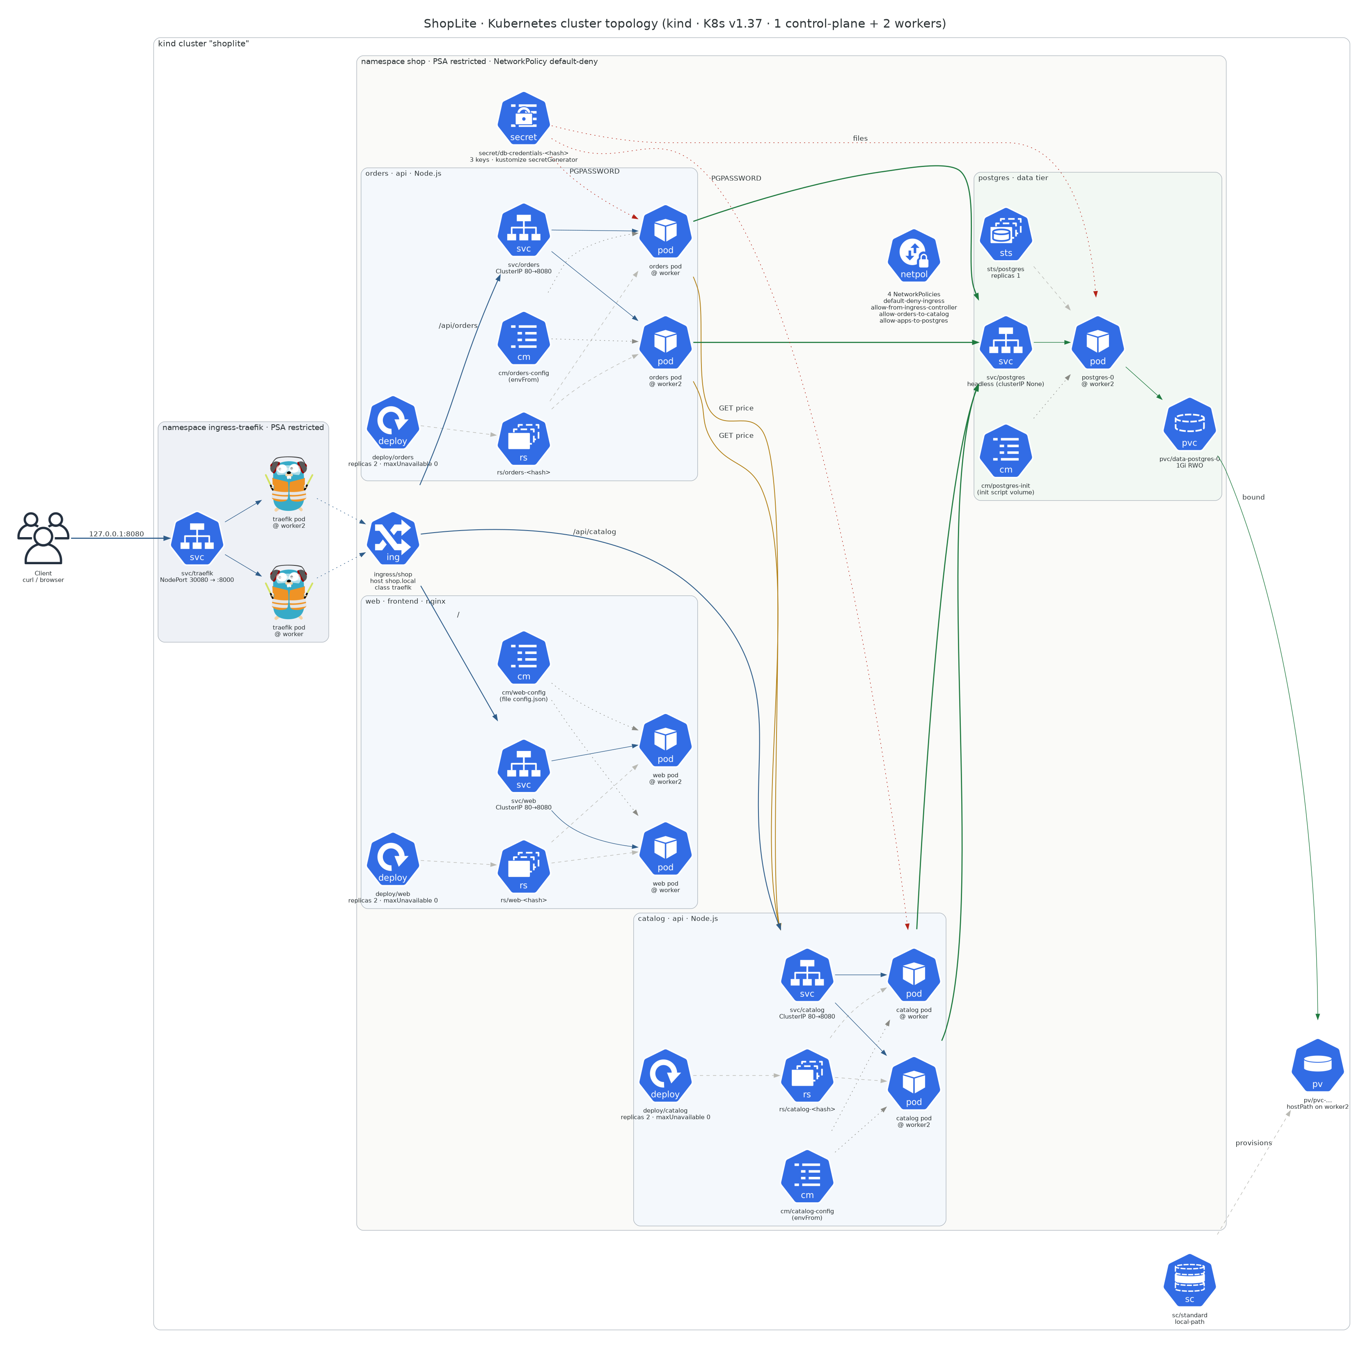
Figure 1. Kubernetes cluster topology of ShopLite (source: k8s_topology.py, Python Diagrams)
Table 3. Topology components
Namespace | Object | Kind | Replicas / size | Port(s) | Placement (verified)
ingress-traefik | traefik | Deployment → ReplicaSet → Pods | 2 | Service NodePort 30080 → 8000 | worker, worker2
(cluster) | traefik | IngressClass | — | controller traefik.io/ingress-controller | —
shop | shop | Ingress | 3 paths | host shop.local | status address 127.0.0.1
shop | web | Deployment → RS → Pods + ClusterIP Service | 2 | 80 → 8080 | worker, worker2
shop | catalog | Deployment → RS → Pods + ClusterIP Service | 2 | 80 → 8080 | worker, worker2
shop | orders | Deployment → RS → Pods + ClusterIP Service | 2 | 80 → 8080 | worker, worker2
shop | postgres | StatefulSet + headless Service | 1 | 5432 | worker2
shop | data-postgres-0 | PVC → PV (StorageClass standard / local-path) | 1 Gi RWO | — | hostPath on worker2
shop | catalog-config, orders-config, web-config, postgres-init | ConfigMap | 4 | — | —
shop | db-credentials-<hash> | Secret (Opaque, 3 keys) | 1 | — | —
shop | default-deny-ingress, allow-from-ingress-controller, allow-orders-to-catalog, allow-apps-to-postgres | NetworkPolicy | 4 | — | enforced by kindnet

Nodes: shoplite-control-plane (tainted; runs no application pods; receives host traffic on :30080), shoplite-worker and shoplite-worker2 (run all workloads).

4. Request traffic flow

4.1 Host/Path matching → Ingress → ClusterIP Service → Pod endpoint
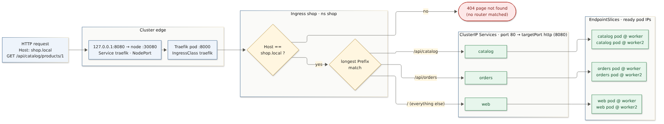
Figure 2. Translation of an HTTP request across cluster boundaries
Table 4. Request translation steps
Step | Boundary crossed | What happens | Evidence
1 | host → cluster | 127.0.0.1:8080 is a kind port mapping to the control-plane container port 30080. | kind/cluster.yaml
2 | node → edge pod | NodePort Service traefik: kube-proxy DNATs the connection to one of the two Traefik pods (L4). | 03-services-endpoints.txt
3 | edge → routing table | Traefik matches the Host header shop.local, then the longest Prefix path: /api/catalog, /api/orders, /. No match → 404. | 07-traffic-tests.txt (Host other.local → 404)
4 | routing → Service → endpoints | The Ingress backend names Service + port “http”; Traefik resolves it through the EndpointSlice to ready pod IPs and proxies directly to a pod (L7 round-robin, no extra ClusterIP hop). The access log shows http://10.244.x.x:8080. | 07-traffic-tests.txt (Traefik access log)
5 | namespace boundary | NetworkPolicy allow-from-ingress-controller admits only Traefik pods from namespace ingress-traefik on port 8080. | 08-network-policies.txt

4.2 End-to-end sequence (north-south and east-west)
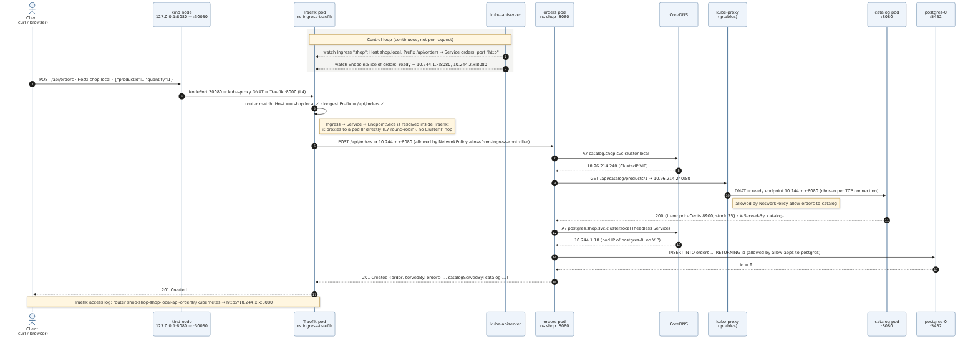
Figure 3. Ingress request flow of POST /api/orders down to the database
Observed behaviour versus design:
- North-south balancing is per request. 8 calls to /api/catalog/products were split 4 / 4 across the two catalog pods (X-Served-By header).
- East-west balancing is per connection. orders reaches catalog through the ClusterIP catalog.shop.svc.cluster.local (CoreDNS → virtual IP → kube-proxy iptables DNAT). Because Node’s fetch keeps the TCP connection alive, each orders pod kept talking to one catalog pod (orders-…zk82g → catalog-…5xz7n, orders-…p9vzn → catalog-…cntbb). This is expected L4 behaviour; per-request L7 balancing between services is the service-mesh topic of Week 10.
- Headless Service. postgres.shop.svc.cluster.local resolves to the pod IP 10.244.1.10 rather than a virtual IP, whereas the ClusterIP Services resolve to 10.96.x.x addresses.

5. Configuration injection: ConfigMaps vs Secrets
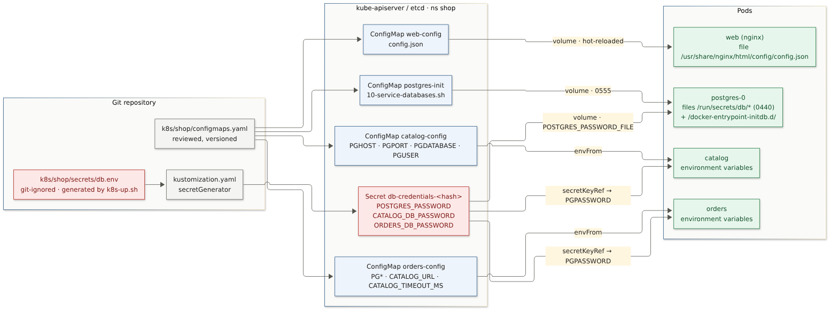
Figure 4. Configuration injection: ConfigMaps (in git) vs Secrets (never in git)
Table 5. ConfigMaps vs Secrets in ShopLite
 | ConfigMap | Secret
Contents | DB host/port/name/user, CATALOG_URL, timeouts, UI config.json, DB init script | Three passwords: postgres superuser, catalog role, orders role
Stored in git? | Yes — reviewed like code (k8s/shop/configmaps.yaml) | No — secrets/db.env is git-ignored and generated with 32 random characters by k8s-up.sh; only db.env.example is committed
How it is created | Plain YAML | kustomize secretGenerator — a content hash is appended to the name, so rotating a password rolls every consumer automatically
Environment injection | envFrom: configMapRef (catalog, orders) | env.valueFrom.secretKeyRef → PGPASSWORD (catalog, orders)
File injection | web-config mounted as config.json (hot-reloaded by the kubelet); postgres-init mounted as an executable init script | db-credentials mounted at /run/secrets/db with mode 0440 (group 70) and read through POSTGRES_PASSWORD_FILE — the postgres container has 0 password environment variables
Verified in | 05-config-injection.txt | 05-config-injection.txt (values masked: PGPASSWORD=******** (32 chars, from Secret))

Rule applied: files are preferred for secrets because environment variables leak into crash dumps, /proc/<pid>/environ and child processes; the Node.js services read PGPASSWORD from the environment only because that is how the pg driver consumes it. A Secret is merely base64-encoded in etcd, so production additionally needs encryption at rest and an external secret store (Sealed Secrets, External Secrets Operator or SOPS).

6. Manifest suite
kind/cluster.yaml 3 nodes, host :8080 → NodePort 30080, registry mirror hook
k8s/kustomization.yaml kubectl apply -k k8s/ (platform + shop)
k8s/platform/traefik.yaml Namespace, ServiceAccount, ClusterRole(+Binding), Role(+Binding)
in shop, IngressClass, Deployment (×2), Service NodePort
k8s/shop/kustomization.yaml namespace, secretGenerator, common labels
k8s/shop/namespace.yaml Namespace shop (Pod Security Admission: restricted)
k8s/shop/configmaps.yaml 4 ConfigMaps
k8s/shop/postgres.yaml headless Service + StatefulSet + volumeClaimTemplate
k8s/shop/catalog.yaml Deployment + ClusterIP Service
k8s/shop/orders.yaml Deployment + ClusterIP Service
k8s/shop/web.yaml Deployment + ClusterIP Service
k8s/shop/ingress.yaml Ingress shop.local → /api/catalog, /api/orders, /
k8s/shop/networkpolicies.yaml default-deny + 3 allow rules
k8s/shop/secrets/db.env.example template for the git-ignored Secret source

Every pod carries the same hardening, enforced by the Week 6 gates G2 (kubeconform -strict) and G7 (trivy config): runAsNonRoot with a fixed non-root UID · allowPrivilegeEscalation: false · readOnlyRootFilesystem: true (emptyDir only where a path must be writable) · capabilities.drop: [ALL] · seccompProfile: RuntimeDefault · CPU/memory requests and limits · automountServiceAccountToken: false (except Traefik, which needs its token to watch the API) · enableServiceLinks: false · images pinned by tag (application) or digest (third-party).

7. Deployment and runtime verification
./scripts/k8s-up.sh # kind cluster, registry mirror, random secrets, build + kind load, kubectl apply -k k8s/
./scripts/k8s-verify.sh # captures evidence/00…09 and compares design vs runtime
./scripts/k8s-rollout-test.sh # rolling restart of every stateless tier under load

7.1 Designed topology vs runtime state
Table 6. Topology verification (scripts/k8s-verify.sh) — 30 passed, 0 failed
Check | Expected | Actual | Result
nodes Ready | 3 | 3 | PASS
deploy/catalog ready replicas | 2/2 | 2/2 | PASS
deploy/catalog pods on distinct nodes | 2 | 2 | PASS
svc/catalog type:port→targetPort | ClusterIP:80→http | ClusterIP:80→http | PASS
svc/catalog ready endpoints | 2 | 2 | PASS
deploy/orders ready replicas | 2/2 | 2/2 | PASS
deploy/orders pods on distinct nodes | 2 | 2 | PASS
svc/orders type:port→targetPort | ClusterIP:80→http | ClusterIP:80→http | PASS
svc/orders ready endpoints | 2 | 2 | PASS
deploy/web ready replicas | 2/2 | 2/2 | PASS
deploy/web pods on distinct nodes | 2 | 2 | PASS
svc/web type:port→targetPort | ClusterIP:80→http | ClusterIP:80→http | PASS
svc/web ready endpoints | 2 | 2 | PASS
statefulset/postgres ready | 1/1 | 1/1 | PASS
svc/postgres headless | None | None | PASS
pvc/data-postgres-0 | Bound:1Gi | Bound:1Gi | PASS
deploy/traefik ready | 2/2 | 2/2 | PASS
deploy/traefik pods on distinct nodes | 2 | 2 | PASS
svc/traefik NodePort | NodePort:30080 | NodePort:30080 | PASS
ingress/shop class | traefik | traefik | PASS
ingress/shop host | shop.local | shop.local | PASS
ingress/shop paths | /api/catalog,/api/orders,/ | /api/catalog,/api/orders,/ | PASS
ingress/shop status address | 127.0.0.1 | 127.0.0.1 | PASS
configmaps (app) | 4 | 4 | PASS
secret db-credentials-<hash> keys | 3 | 3 | PASS
networkpolicies | 4 | 4 | PASS
namespace shop PSA enforce | restricted | restricted | PASS
HTTP GET / via ingress | 200 | 200 | PASS
HTTP GET /api/catalog/products | 200 | 200 | PASS
HTTP GET /api/orders | 200 | 200 | PASS

7.2 Workload isolation — NetworkPolicy reachability matrix
Table 7. NetworkPolicy reachability (08-network-policies.txt)
From → To | Intended | Observed
orders → catalog :80 | allow | CONNECTED
catalog → postgres :5432 | allow | CONNECTED
web → catalog :80 | deny | BLOCKED (timeout)
web → postgres :5432 | deny | BLOCKED (timeout)
catalog → orders :80 | deny | BLOCKED (timeout)
pod in default namespace → catalog.shop :80 | deny | BLOCKED (timeout)
control: pod in default namespace → Traefik → web | allow | CONNECTED (probe works, so the block is real)

7.3 Issues found during verification
Comparing the runtime against the design surfaced six real defects; each was fixed in the manifests or code (not by hand in the cluster):
Table 8. Defects found by verification and their fixes
# | Symptom (evidence) | Root cause | Fix
1 | First deploy: GET /api/catalog/products → 500 “relation products does not exist” | /readyz only pinged the DB, so pods became Ready before their schema migration finished | Readiness = migration done AND DB reachable (repo.js)
2 | “duplicate key … pg_type_typname_nsp_index” in Postgres logs | Two replicas ran CREATE TABLE IF NOT EXISTS concurrently — a known Postgres race | Migration inside a transaction holding pg_advisory_xact_lock
3 | Pods received CATALOG_SERVICE_HOST, CATALOG_PORT=tcp://… env vars | Legacy Docker-link service variables are injected by default and can collide with application config | enableServiceLinks: false on every pod
4 | Rolling update under load: 87 of 834 requests failed (55×502, 31 timeouts, 1×500) — 10a | Pods stopped listening before Traefik/EndpointSlices removed them; single Traefik replica; single-replica Postgres restarted | preStop sleep 5 s (native sleep action — distroless has no /bin/sleep); Traefik ×2 with requestAcceptGraceTimeout=5s → 0 of 3 440 failed — 10b
5 | Two replicas of orders and web on the same node | ScheduleAnyway is only a preference; surge pods of the old ReplicaSet skewed the count | DoNotSchedule + matchLabelKeys [pod-template-hash] + nodeTaintsPolicy Honor → 30/30
6 | Traefik replica stuck in ImagePullBackOff | Docker Hub 429 Too Many Requests (anonymous pull limit) | containerd hosts.toml routes docker.io pulls through mirror.gcr.io — safe because every third-party image is pinned by digest

7.4 Zero-downtime rollout
Table 9. Client-observed errors during rolling updates
Run | Change | Requests | Non-2xx | Evidence
Before fix | template change of all workloads incl. single-replica Postgres | 834 | 87 (10.4 %) | 10a-rolling-update-before-fix.txt
After fix | rolling restart of traefik, catalog, orders, web | 3 440 | 0 | 10b-rolling-update-after-fix.txt

8. Conclusions and limitations
The designed topology — three microservices and a stateful database, isolated by namespaces, Pod Security Admission and NetworkPolicies, routed through an Ingress — was implemented as a declarative manifest suite, deployed to a three-node kind cluster and verified automatically: 30 of 30 design checks pass, the reachability matrix matches the intended policy, and stateless tiers roll without a single failed request.
- PostgreSQL is a single replica: changing its pod template restarts it and causes a few seconds of API errors. Zero-downtime database changes need an HA operator (e.g. CloudNativePG) and the expand/contract strategy of Week 13.
- A Secret is only base64-encoded; production requires etcd encryption at rest and an external secret manager.
- The local kubectl client is v1.34 while the server is v1.37 (skew warning in 01-cluster.txt); all commands used are stable APIs.

Appendix A. kubectl cluster status outputs
Captured by scripts/k8s-verify.sh from the running cluster (docs/week7/evidence/00-kubectl-status.txt). The remaining evidence files contain the detailed outputs (describe ingress, EndpointSlices, DNS lookups, configuration injection, storage, traffic tests).
# kubectl cluster status — captured 2026-10-15 11:57 UTC

$ kubectl get nodes -o wide
NAME STATUS ROLES AGE VERSION INTERNAL-IP EXTERNAL-IP OS-IMAGE KERNEL-VERSION CONTAINER-RUNTIME
shoplite-control-plane Ready control-plane 101m v1.37.0 172.27.0.3 <none> Debian GNU/Linux 13 (trixie) 6.11.11-linuxkit (arm64) containerd://2.3.4
shoplite-worker Ready <none> 101m v1.37.0 172.27.0.2 <none> Debian GNU/Linux 13 (trixie) 6.11.11-linuxkit (arm64) containerd://2.3.4
shoplite-worker2 Ready <none> 101m v1.37.0 172.27.0.4 <none> Debian GNU/Linux 13 (trixie) 6.11.11-linuxkit (arm64) containerd://2.3.4

$ kubectl get all -n ingress-traefik -o wide
NAME READY STATUS RESTARTS AGE IP NODE NOMINATED NODE READINESS GATES
pod/traefik-6bb9986886-7lt2z 1/1 Running 0 81m 10.244.2.40 shoplite-worker <none> <none>
pod/traefik-6bb9986886-m2zbl 1/1 Running 0 81m 10.244.1.25 shoplite-worker2 <none> <none>

NAME TYPE CLUSTER-IP EXTERNAL-IP PORT(S) AGE SELECTOR
service/traefik NodePort 10.96.168.124 <none> 80:30080/TCP 95m app.kubernetes.io/name=traefik

NAME READY UP-TO-DATE AVAILABLE AGE CONTAINERS IMAGES SELECTOR
deployment.apps/traefik 2/2 2 2 95m traefik traefik:v3.7.14@sha256:575fa15b135078fe5e50aa847987d96dbddd7b093c172429618404df73f3fa7c app.kubernetes.io/name=traefik

NAME DESIRED CURRENT READY AGE CONTAINERS IMAGES SELECTOR
replicaset.apps/traefik-66dbcdcf68 0 0 0 88m traefik traefik:v3.7.14@sha256:575fa15b135078fe5e50aa847987d96dbddd7b093c172429618404df73f3fa7c app.kubernetes.io/name=traefik,pod-template-hash=66dbcdcf68
replicaset.apps/traefik-6bb6d7b5db 0 0 0 83m traefik traefik:v3.7.14@sha256:575fa15b135078fe5e50aa847987d96dbddd7b093c172429618404df73f3fa7c app.kubernetes.io/name=traefik,pod-template-hash=6bb6d7b5db
replicaset.apps/traefik-6bb9986886 2 2 2 81m traefik traefik:v3.7.14@sha256:575fa15b135078fe5e50aa847987d96dbddd7b093c172429618404df73f3fa7c app.kubernetes.io/name=traefik,pod-template-hash=6bb9986886
replicaset.apps/traefik-79489d666b 0 0 0 82m traefik traefik:v3.7.14@sha256:575fa15b135078fe5e50aa847987d96dbddd7b093c172429618404df73f3fa7c app.kubernetes.io/name=traefik,pod-template-hash=79489d666b

$ kubectl get all -n shop -o wide
NAME READY STATUS RESTARTS AGE IP NODE NOMINATED NODE READINESS GATES
pod/catalog-865f56b9d7-5xz7n 1/1 Running 0 81m 10.244.2.41 shoplite-worker <none> <none>
pod/catalog-865f56b9d7-cntbb 1/1 Running 0 81m 10.244.1.26 shoplite-worker2 <none> <none>
pod/orders-7bf64477d6-p9vzn 1/1 Running 0 81m 10.244.2.42 shoplite-worker <none> <none>
pod/orders-7bf64477d6-zk82g 1/1 Running 0 81m 10.244.1.27 shoplite-worker2 <none> <none>
pod/postgres-0 1/1 Running 0 89m 10.244.1.10 shoplite-worker2 <none> <none>
pod/web-5bc5f9b587-7nww7 1/1 Running 0 81m 10.244.2.43 shoplite-worker <none> <none>
pod/web-5bc5f9b587-fvr7j 1/1 Running 0 81m 10.244.1.28 shoplite-worker2 <none> <none>

NAME TYPE CLUSTER-IP EXTERNAL-IP PORT(S) AGE SELECTOR
service/catalog ClusterIP 10.96.214.240 <none> 80/TCP 93m app.kubernetes.io/name=catalog
service/orders ClusterIP 10.96.251.142 <none> 80/TCP 93m app.kubernetes.io/name=orders
service/postgres ClusterIP None <none> 5432/TCP 93m app.kubernetes.io/name=postgres
service/web ClusterIP 10.96.125.85 <none> 80/TCP 93m app.kubernetes.io/name=web

NAME READY UP-TO-DATE AVAILABLE AGE CONTAINERS IMAGES SELECTOR
deployment.apps/catalog 2/2 2 2 93m catalog shoplite/catalog:1.0.1 app.kubernetes.io/name=catalog
deployment.apps/orders 2/2 2 2 93m orders shoplite/orders:1.0.1 app.kubernetes.io/name=orders
deployment.apps/web 2/2 2 2 93m web shoplite/web:1.0.1 app.kubernetes.io/name=web

NAME DESIRED CURRENT READY AGE CONTAINERS IMAGES SELECTOR
replicaset.apps/catalog-548f7f457d 0 0 0 88m catalog shoplite/catalog:1.0.1 app.kubernetes.io/name=catalog,pod-template-hash=548f7f457d
replicaset.apps/catalog-59f58775f4 0 0 0 83m catalog shoplite/catalog:1.0.1 app.kubernetes.io/name=catalog,pod-template-hash=59f58775f4
replicaset.apps/catalog-6c59676d 0 0 0 82m catalog shoplite/catalog:1.0.1 app.kubernetes.io/name=catalog,pod-template-hash=6c59676d
replicaset.apps/catalog-865f56b9d7 2 2 2 81m catalog shoplite/catalog:1.0.1 app.kubernetes.io/name=catalog,pod-template-hash=865f56b9d7
replicaset.apps/orders-689596c68c 0 0 0 82m orders shoplite/orders:1.0.1 app.kubernetes.io/name=orders,pod-template-hash=689596c68c
replicaset.apps/orders-7bf64477d6 2 2 2 81m orders shoplite/orders:1.0.1 app.kubernetes.io/name=orders,pod-template-hash=7bf64477d6
replicaset.apps/orders-7c8978645 0 0 0 83m orders shoplite/orders:1.0.1 app.kubernetes.io/name=orders,pod-template-hash=7c8978645
replicaset.apps/orders-7fbc9b4fdd 0 0 0 88m orders shoplite/orders:1.0.1 app.kubernetes.io/name=orders,pod-template-hash=7fbc9b4fdd
replicaset.apps/web-595fbfb9fd 0 0 0 83m web shoplite/web:1.0.1 app.kubernetes.io/name=web,pod-template-hash=595fbfb9fd
replicaset.apps/web-5bc5f9b587 2 2 2 81m web shoplite/web:1.0.1 app.kubernetes.io/name=web,pod-template-hash=5bc5f9b587
replicaset.apps/web-77b98f58 0 0 0 82m web shoplite/web:1.0.1 app.kubernetes.io/name=web,pod-template-hash=77b98f58
replicaset.apps/web-fc865db75 0 0 0 88m web shoplite/web:1.0.1 app.kubernetes.io/name=web,pod-template-hash=fc865db75

NAME READY AGE CONTAINERS IMAGES
statefulset.apps/postgres 1/1 93m postgres postgres:17-alpine@sha256:b0f9560a2de083e2cc7382e75f808c7381a32852a7ec49117deedb300e552b24

$ kubectl get ingressclass,ingress -A
NAME CONTROLLER PARAMETERS AGE
ingressclass.networking.k8s.io/traefik traefik.io/ingress-controller <none> 95m

NAMESPACE NAME CLASS HOSTS ADDRESS PORTS AGE
shop ingress.networking.k8s.io/shop traefik shop.local 127.0.0.1 80 93m

$ kubectl get configmap,secret,pvc,networkpolicy -n shop
NAME DATA AGE
configmap/catalog-config 4 93m
configmap/kube-root-ca.crt 1 93m
configmap/orders-config 6 93m
configmap/postgres-init 1 93m
configmap/web-config 1 93m

NAME TYPE DATA AGE
secret/db-credentials-d72dg62d64 Opaque 3 93m

NAME STATUS VOLUME CAPACITY ACCESS MODES STORAGECLASS VOLUMEATTRIBUTESCLASS AGE
persistentvolumeclaim/data-postgres-0 Bound pvc-06806ee8-ed08-4f11-b8f3-5ca5bccfbfb7 1Gi RWO standard <unset> 93m

NAME POD-SELECTOR AGE
networkpolicy.networking.k8s.io/allow-apps-to-postgres app.kubernetes.io/name=postgres 93m
networkpolicy.networking.k8s.io/allow-from-ingress-controller app.kubernetes.io/name in (catalog,orders,web) 93m
networkpolicy.networking.k8s.io/allow-orders-to-catalog app.kubernetes.io/name=catalog 93m
networkpolicy.networking.k8s.io/default-deny-ingress <none> 93m

$ kubectl get pv,storageclass
NAME CAPACITY ACCESS MODES RECLAIM POLICY STATUS CLAIM STORAGECLASS VOLUMEATTRIBUTESCLASS REASON AGE
persistentvolume/pvc-06806ee8-ed08-4f11-b8f3-5ca5bccfbfb7 1Gi RWO Delete Bound shop/data-postgres-0 standard <unset> 93m

NAME PROVISIONER RECLAIMPOLICY VOLUMEBINDINGMODE ALLOWVOLUMEEXPANSION AGE
storageclass.storage.k8s.io/standard (default) rancher.io/local-path Delete WaitForFirstConsumer false 101m

$ kubectl get endpointslices -n shop
NAME ADDRESSTYPE PORTS ENDPOINTS AGE
catalog-fjwl2 IPv4 8080 10.244.2.41,10.244.1.26 93m
orders-9ln7n IPv4 8080 10.244.2.42,10.244.1.27 93m
postgres-pjrqd IPv4 5432 10.244.1.10 93m
web-nvlfm IPv4 8080 10.244.2.43,10.244.1.28 93m

A.2 Ingress description
$ kubectl -n shop describe ingress shop
Name: shop
Labels: app.kubernetes.io/name=shop-ingress
app.kubernetes.io/part-of=shoplite
Namespace: shop
Address: 127.0.0.1
Ingress Class: traefik
Default backend: <default>
Rules:
Host Path Backends
---- ---- --------
shop.local
/api/catalog catalog:http (10.244.2.41:8080,10.244.1.26:8080)
/api/orders orders:http (10.244.2.42:8080,10.244.1.27:8080)
/ web:http (10.244.2.43:8080,10.244.1.28:8080)
Annotations: <none>
Events: <none>

Appendix B. Key manifests

B.1 k8s/shop/ingress.yaml
# North-south entry point. Traefik matches Host + longest path prefix:
# shop.local/api/catalog/* → Service catalog:80 → pod :8080
# shop.local/api/orders/* → Service orders:80 → pod :8080
# shop.local/* → Service web:80 → pod :8080
apiVersion: networking.k8s.io/v1
kind: Ingress
metadata:
name: shop
labels:
app.kubernetes.io/name: shop-ingress
spec:
ingressClassName: traefik
rules:
- host: shop.local
http:
paths:
- path: /api/catalog
pathType: Prefix
backend:
service:
name: catalog
port:
name: http
- path: /api/orders
pathType: Prefix
backend:
service:
name: orders
port:
name: http
- path: /
pathType: Prefix
backend:
service:
name: web
port:
name: http

B.2 k8s/shop/catalog.yaml (orders.yaml and web.yaml follow the same pattern)
apiVersion: apps/v1
kind: Deployment
metadata:
name: catalog
labels:
app.kubernetes.io/name: catalog
app.kubernetes.io/component: api
spec:
replicas: 2
revisionHistoryLimit: 3
strategy:
type: RollingUpdate
rollingUpdate:
maxSurge: 1
maxUnavailable: 0
selector:
matchLabels:
app.kubernetes.io/name: catalog
template:
metadata:
labels:
app.kubernetes.io/name: catalog
app.kubernetes.io/component: api
tier: backend
spec:
automountServiceAccountToken: false
terminationGracePeriodSeconds: 30
enableServiceLinks: false # no legacy <SVC>_SERVICE_HOST/_PORT env vars; use DNS
securityContext:
runAsNonRoot: true
runAsUser: 65532
runAsGroup: 65532
seccompProfile:
type: RuntimeDefault
topologySpreadConstraints:
# Hard rule: replicas of one revision on different nodes. matchLabelKeys scopes the
# skew to the current ReplicaSet (old pods during a rollout don't count); Honor skips
# the tainted control-plane node as a placement domain.
- maxSkew: 1
topologyKey: kubernetes.io/hostname
whenUnsatisfiable: DoNotSchedule
nodeTaintsPolicy: Honor
matchLabelKeys: ["pod-template-hash"]
labelSelector:
matchLabels:
app.kubernetes.io/name: catalog
containers:
- name: catalog
image: shoplite/catalog:1.0.1
imagePullPolicy: IfNotPresent
ports:
- name: http
containerPort: 8080
envFrom:
- configMapRef:
name: catalog-config
env:
- name: POD_NAME
valueFrom:
fieldRef:
fieldPath: metadata.name
- name: PGPASSWORD
valueFrom:
secretKeyRef:
name: db-credentials
key: CATALOG_DB_PASSWORD
lifecycle:
preStop:
sleep: # native sleep action — distroless images have no /bin/sleep
seconds: 5
readinessProbe:
httpGet:
path: /readyz
port: http
periodSeconds: 5
livenessProbe:
httpGet:
path: /healthz
port: http
periodSeconds: 10
resources:
requests:
cpu: 50m
memory: 64Mi
limits:
cpu: 500m
memory: 256Mi
securityContext:
allowPrivilegeEscalation: false
readOnlyRootFilesystem: true
capabilities:
drop: ["ALL"]
---
apiVersion: v1
kind: Service
metadata:
name: catalog
labels:
app.kubernetes.io/name: catalog
spec:
type: ClusterIP
selector:
app.kubernetes.io/name: catalog
ports:
- name: http
port: 80
targetPort: http

B.3 k8s/shop/networkpolicies.yaml
# Workload isolation inside the `shop` namespace (ingress direction):
# 1. deny everything by default
# 2. Traefik (namespace ingress-traefik) → web, catalog, orders on :8080
# 3. orders → catalog on :8080 (east-west price lookup)
# 4. catalog, orders → postgres on :5432 (nothing else can reach the database)
apiVersion: networking.k8s.io/v1
kind: NetworkPolicy
metadata:
name: default-deny-ingress
spec:
podSelector: {}
policyTypes: ["Ingress"]
---
apiVersion: networking.k8s.io/v1
kind: NetworkPolicy
metadata:
name: allow-from-ingress-controller
spec:
podSelector:
matchExpressions:
- key: app.kubernetes.io/name
operator: In
values: ["web", "catalog", "orders"]
policyTypes: ["Ingress"]
ingress:
- from:
- namespaceSelector:
matchLabels:
kubernetes.io/metadata.name: ingress-traefik
podSelector:
matchLabels:
app.kubernetes.io/name: traefik
ports:
- port: 8080
protocol: TCP
---
apiVersion: networking.k8s.io/v1
kind: NetworkPolicy
metadata:
name: allow-orders-to-catalog
spec:
podSelector:
matchLabels:
app.kubernetes.io/name: catalog
policyTypes: ["Ingress"]
ingress:
- from:
- podSelector:
matchLabels:
app.kubernetes.io/name: orders
ports:
- port: 8080
protocol: TCP
---
apiVersion: networking.k8s.io/v1
kind: NetworkPolicy
metadata:
name: allow-apps-to-postgres
spec:
podSelector:
matchLabels:
app.kubernetes.io/name: postgres
policyTypes: ["Ingress"]
ingress:
- from:
- podSelector:
matchExpressions:
- key: app.kubernetes.io/name
operator: In
values: ["catalog", "orders"]
ports:
- port: 5432
protocol: TCP

B.4 k8s/shop/postgres.yaml
# Stateful tier: PostgreSQL as a single-replica StatefulSet with a PersistentVolumeClaim.
# Headless Service → stable DNS name postgres-0.postgres.shop.svc.cluster.local and
# postgres.shop.svc.cluster.local resolving straight to the pod IP (no kube-proxy VIP).
apiVersion: v1
kind: Service
metadata:
name: postgres
labels:
app.kubernetes.io/name: postgres
app.kubernetes.io/component: database
spec:
clusterIP: None
selector:
app.kubernetes.io/name: postgres
ports:
- name: postgres
port: 5432
targetPort: postgres
---
apiVersion: apps/v1
kind: StatefulSet
metadata:
name: postgres
labels:
app.kubernetes.io/name: postgres
app.kubernetes.io/component: database
spec:
serviceName: postgres
replicas: 1
selector:
matchLabels:
app.kubernetes.io/name: postgres
template:
metadata:
labels:
app.kubernetes.io/name: postgres
app.kubernetes.io/component: database
tier: data
spec:
automountServiceAccountToken: false
enableServiceLinks: false # no legacy <SVC>_SERVICE_HOST/_PORT env vars; use DNS
terminationGracePeriodSeconds: 30
securityContext:
runAsNonRoot: true
runAsUser: 70 # "postgres" user in the alpine image
runAsGroup: 70
fsGroup: 70
seccompProfile:
type: RuntimeDefault
containers:
- name: postgres
image: postgres:17-alpine@sha256:b0f9560a2de083e2cc7382e75f808c7381a32852a7ec49117deedb300e552b24
imagePullPolicy: IfNotPresent
env:
- name: POSTGRES_USER
value: postgres
- name: POSTGRES_PASSWORD_FILE
value: /run/secrets/db/POSTGRES_PASSWORD
- name: PGDATA
value: /var/lib/postgresql/data/pgdata
ports:
- name: postgres
containerPort: 5432
readinessProbe:
exec:
command: ["pg_isready", "-U", "postgres", "-h", "127.0.0.1"]
periodSeconds: 5
livenessProbe:
exec:
command: ["pg_isready", "-U", "postgres", "-h", "127.0.0.1"]
initialDelaySeconds: 30
periodSeconds: 10
resources:
requests:
cpu: 100m
memory: 256Mi
limits:
cpu: "1"
memory: 512Mi
securityContext:
allowPrivilegeEscalation: false
readOnlyRootFilesystem: true
capabilities:
drop: ["ALL"]
volumeMounts:
- name: data
mountPath: /var/lib/postgresql/data
- name: db-credentials
mountPath: /run/secrets/db
readOnly: true
- name: init-scripts
mountPath: /docker-entrypoint-initdb.d
readOnly: true
- name: run
mountPath: /var/run/postgresql
- name: tmp
mountPath: /tmp
volumes:
- name: db-credentials
secret:
secretName: db-credentials
defaultMode: 0440 # readable by fsGroup 70 only
- name: init-scripts
configMap:
name: postgres-init
defaultMode: 0555
- name: run
emptyDir:
medium: Memory
sizeLimit: 16Mi
- name: tmp
emptyDir:
sizeLimit: 64Mi
volumeClaimTemplates:
- metadata:
name: data
spec:
accessModes: ["ReadWriteOnce"]
storageClassName: standard
resources:
requests:
storage: 1Gi

B.5 k8s/shop/kustomization.yaml
apiVersion: kustomize.config.k8s.io/v1beta1
kind: Kustomization
namespace: shop

resources:
- namespace.yaml
- configmaps.yaml
- postgres.yaml
- catalog.yaml
- orders.yaml
- web.yaml
- ingress.yaml
- networkpolicies.yaml

# The Secret is declared here but its values live in secrets/db.env, which is git-ignored
# (see secrets/db.env.example). Kustomize appends a content hash to the name, so rotating a
# password produces a new Secret name and triggers a rolling update of every consumer.
secretGenerator:
- name: db-credentials
type: Opaque
envs:
- secrets/db.env

labels:
- pairs:
app.kubernetes.io/part-of: shoplite
includeSelectors: false

