Development and debugging MEX-Functions with Eclipse IDE and GDB.

This document describes the setup of Eclipse IDE for the development and debugging of mex-functions.

Demo project contains C source code of the exemplar mex-function,make script and MATLAB script which invokes the mex-function. These exhibit a complete workflow using the standard and available utilities and interfaces.

Prerequisites:
Matlab (R2018b in this demo)
Eclipse CDT (Mars-2 in this demo)
GCC (4.8.5 in this demo)
GDB (7.11 in this demo)
make (3.82 in this demo)

Environment variables:
$MATLAB points to Matlab home
export CC=$(command -v gcc)
export GCC=$(command -v gcc)
export CXX=$(command -v g++)

Close MATLAB session
Close Eclipse
Unzip demo.
Start Eclipse. Specify workspace directory. Workspace will contain the reference to the project. Open two perspectives: C/C++ and Debug. Set C/C++ as an active perspective. Import the sample project: File → Import → C/C++ → Existing Code as Makefile Project

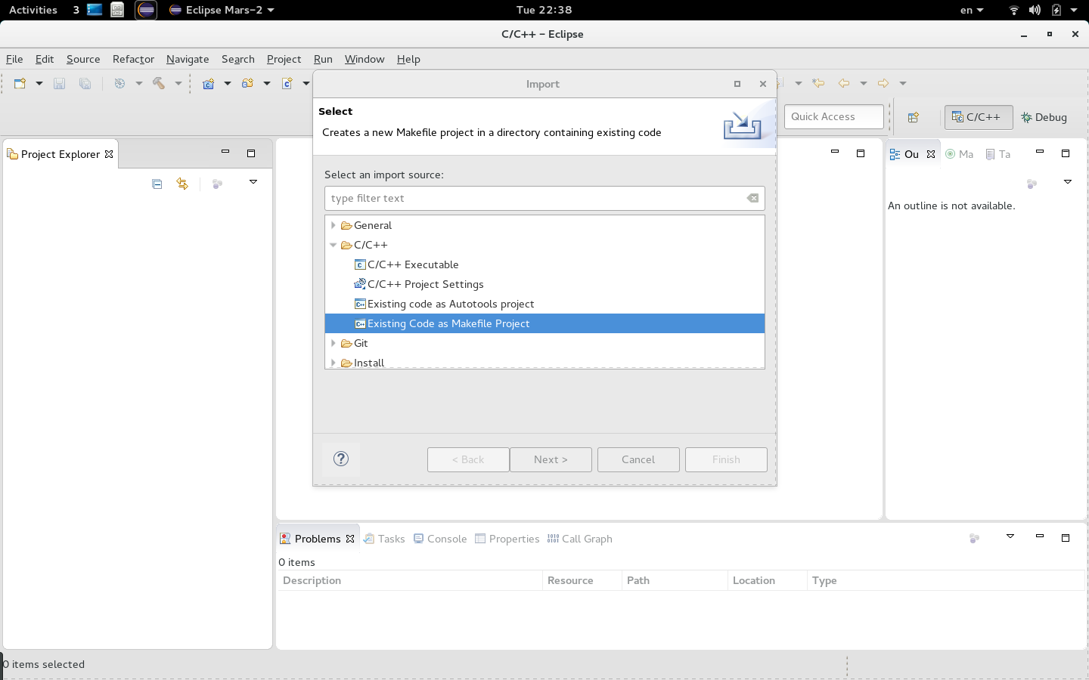

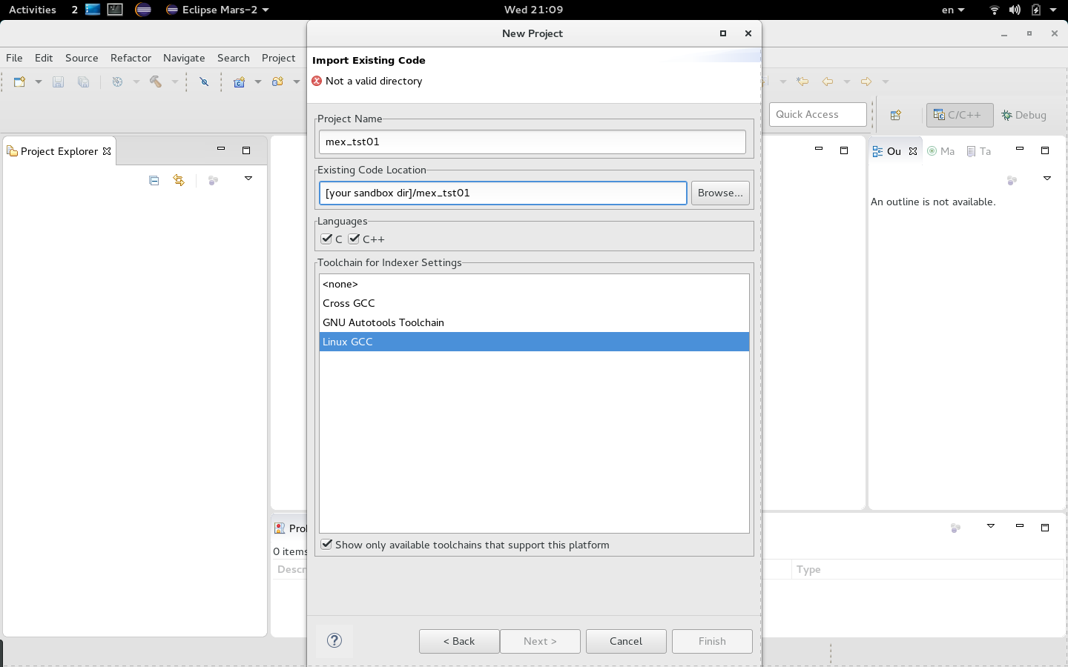
Create two build configurations: Debug and Release.
When the Debug configuration is active, the project is built with no optimization and the mex-file includes debug information.
Release configuration is for the “end product”. Compile optimization is enabled and no debug information is present in the mex-file.
This set of configurations is supported by makefile. Now we need Eclipse to know about them.
Project → Build Configurations → Manage

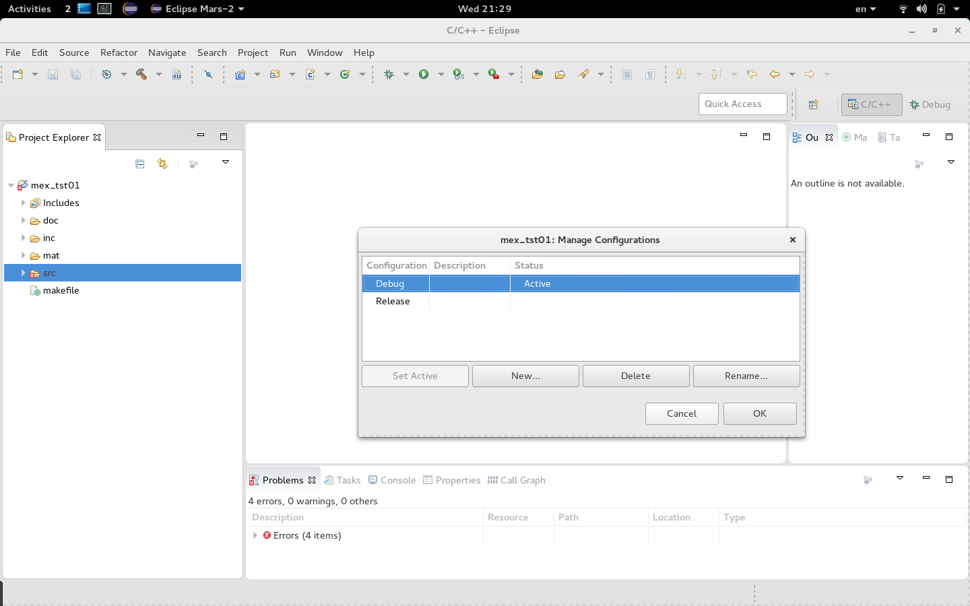
Edit Debug Build Configuration
Project → Properties → C/C++ Build

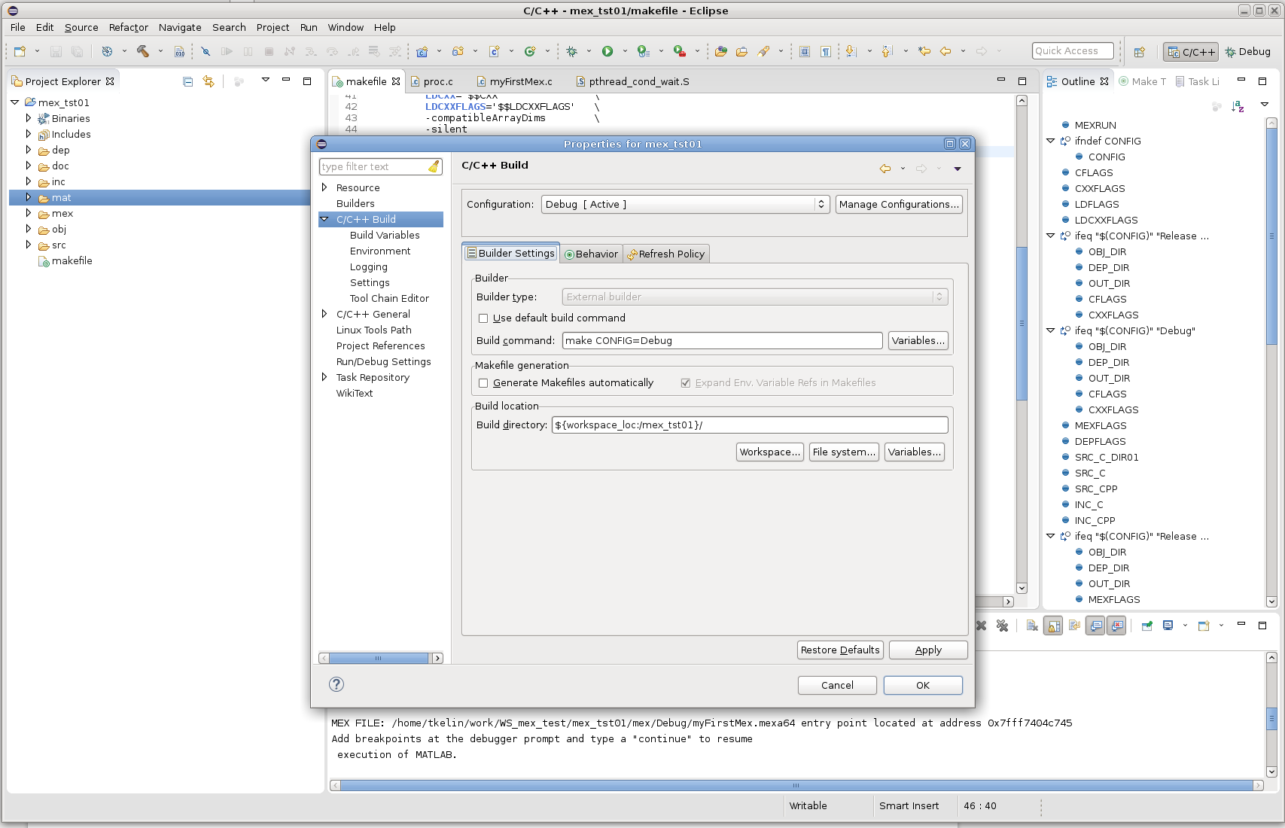
Edit Release Build Configuration

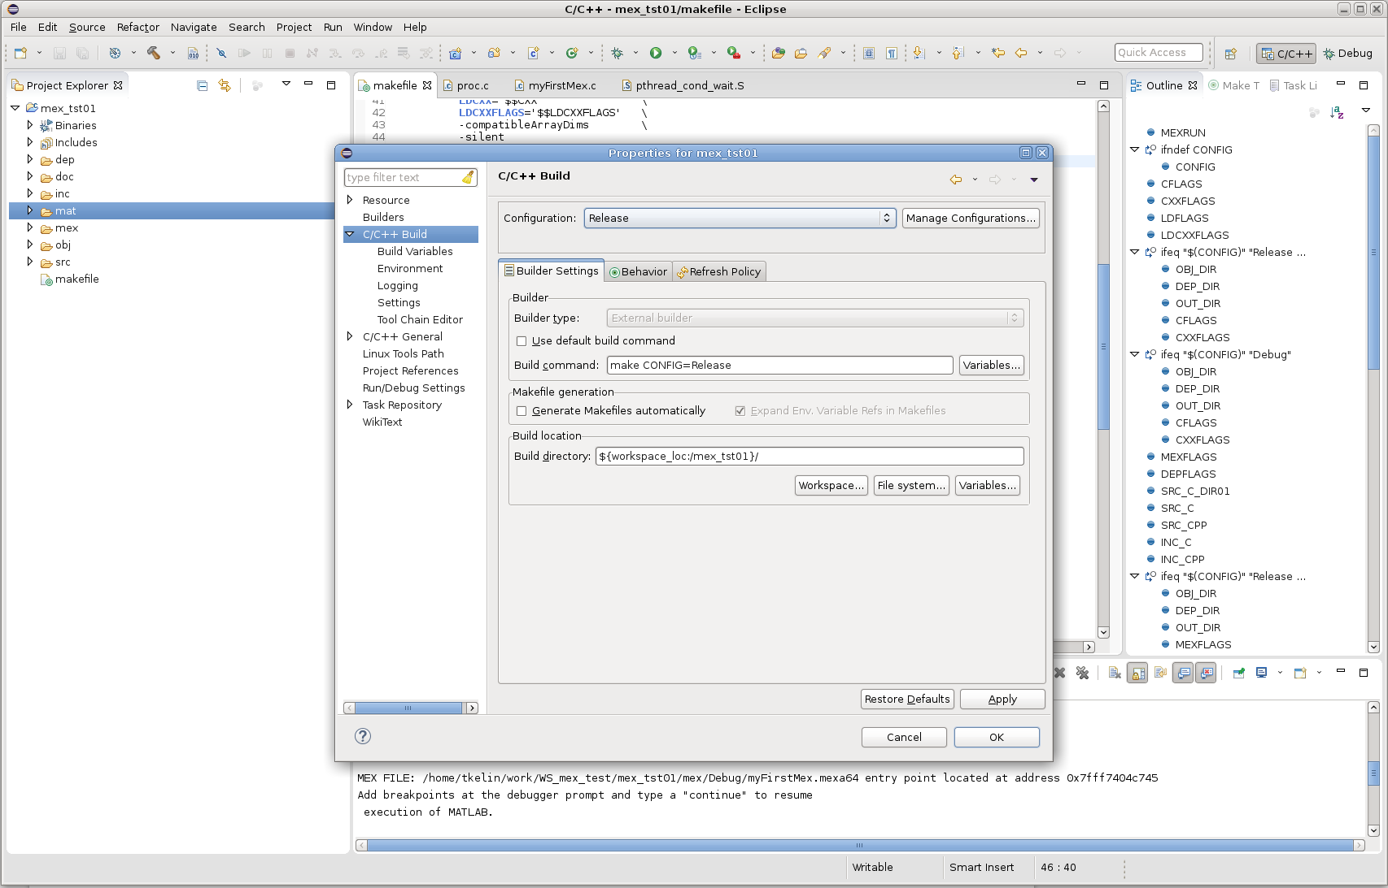
Project Explorer shows the directory tree. It is the same as the project tree.
Open any source file, there are red underlines for unknown macros and data types.

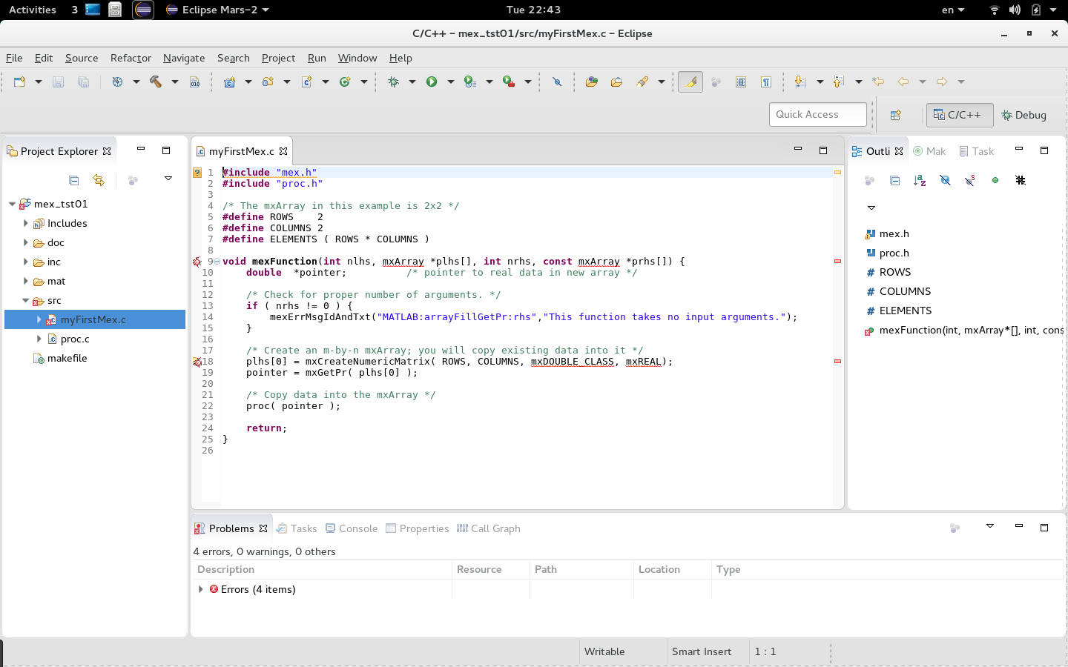
Edit the project properties.
Project → Properties → C/C++ General → Paths and Symbols → GNU C

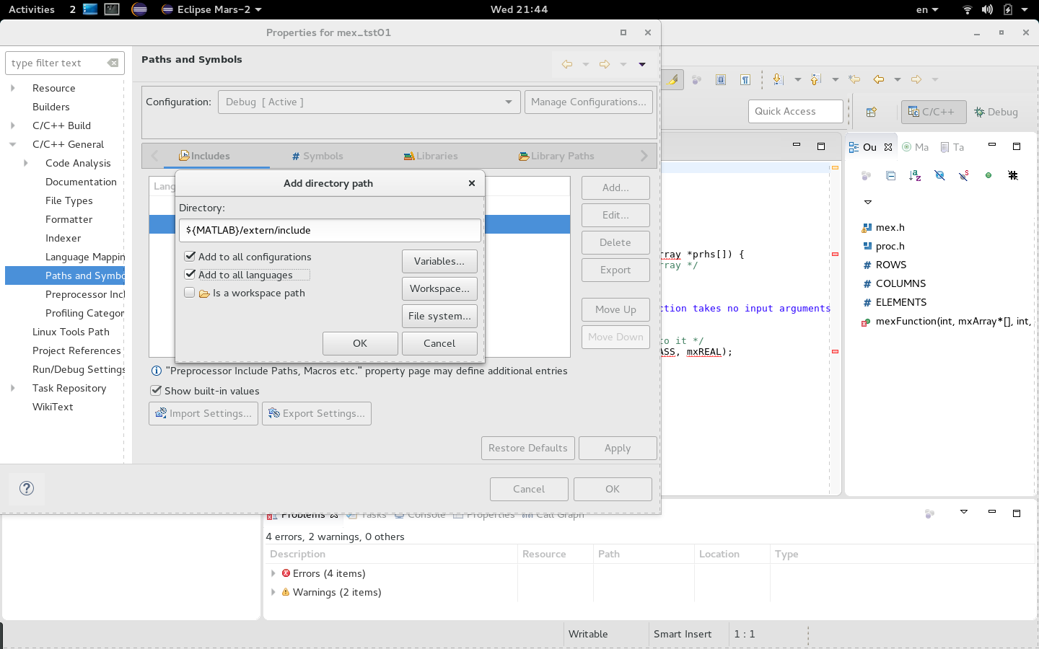
Add MATLAB directories which contain include files corresponding to mex development. We also specify local inc folder with .h-files.
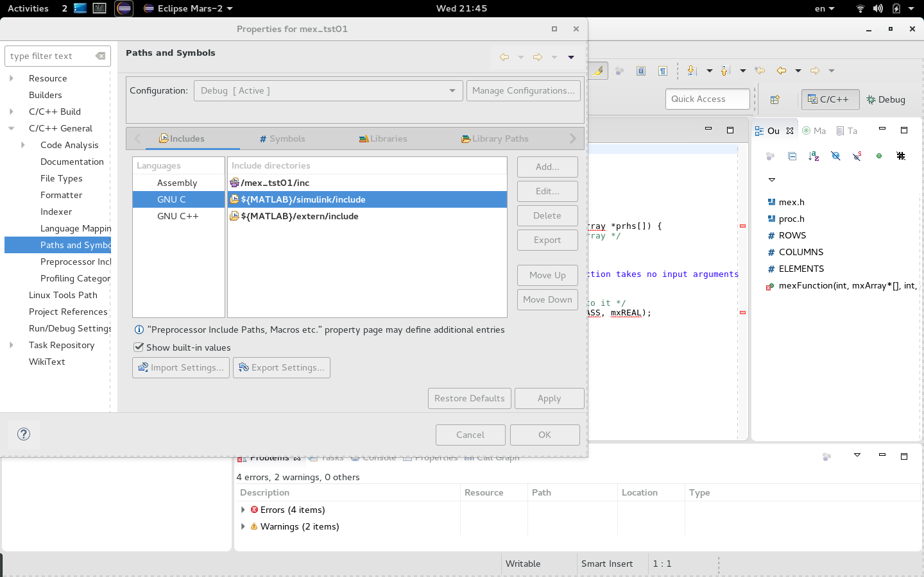
Project → C/C++ Index → Rebuild. The project is now indexed with no missing specifications and all the red underlines disappeared.

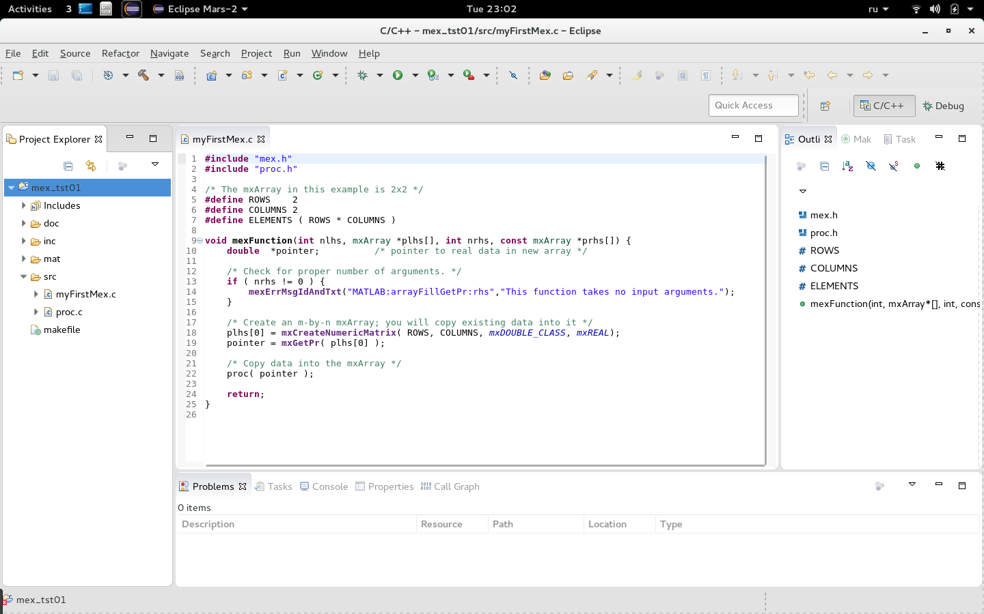
Now we are going to try building the project in the Debug configuration:
Project → Build Configurations → Set Active → Debug
Project → Build Project
In the Console output window we see no build errors. New build specific folders were created in the Project Explorer. Mex-function executable was also created. We will be running and debugging it.

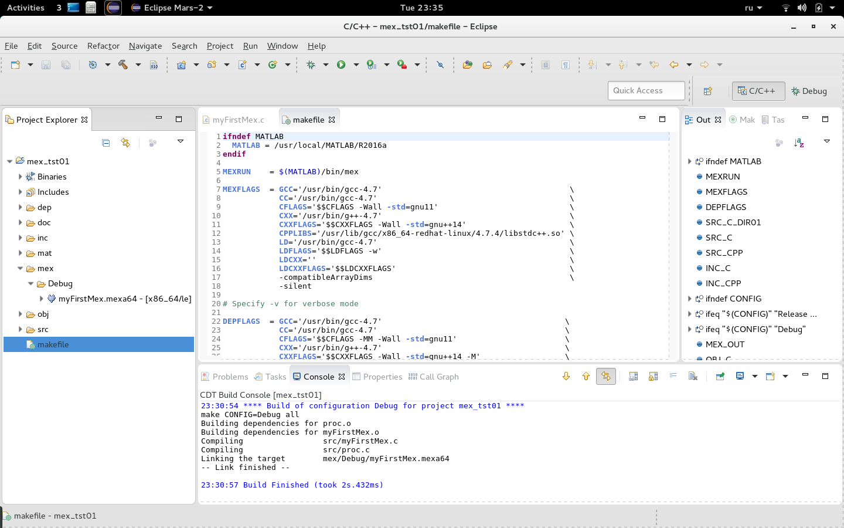

At this stage we need to set up Eclipse IDE so it calls GDB for debugging.

When debug process starts the sequence of the calls is the following:
- Eclipse starts GDB
- GDB runs MATLAB session with JVM disabled (-nojvm option)
- MATLAB runs script (mat/mex_dbg01.m) with the calls to the mex-function which we are going to debug.
- As soon as the execution of the script comes to the point when the mex-file is loaded, MATLAB stops the execution and passes the control to GDB presumably via the JIT Compilation Interface. At this stage we have full source-level visibility of the mex-function execution process and its internals for debugging purposes.

Passing the control to GDB can be enabled and disabled from within MATLAB script and we can specify which function call or calls are required to be debugged. In the sample script the mex-function is called 3 times but the debugger is enabled only for the second call.
Run→ Debug Configurations → C/C++ Application→ Double Click → Main
As “С/С++ Application” we specify the full path to MATLAB binary executable.

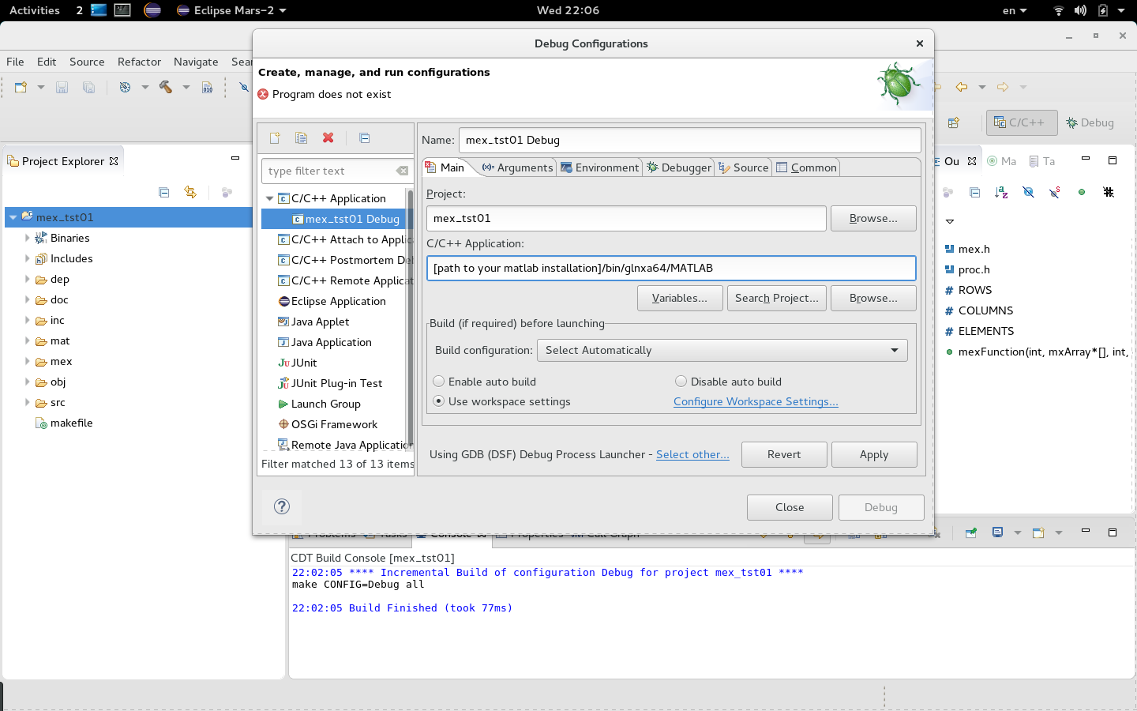
Specify command line options for MATLAB executable:
-nojvm – start without Java
-r mex_dbg01 – run script mex_dbg01.m at MATLAB start. This script adds path to the mex-file to MATLAB path list and calls our mex function.
We also specify the directory where the script mex_dbg01.m is located.

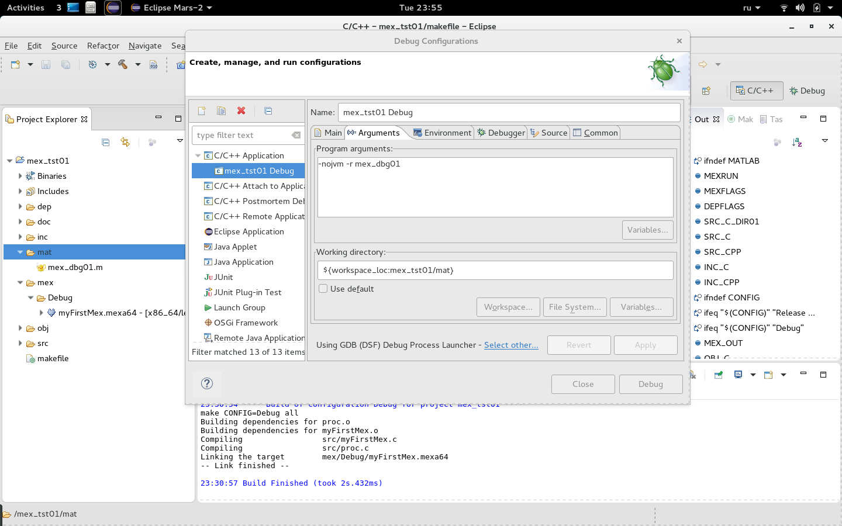
Set the environment variable which tells MATLAB that it is executed under gdb, and that it needs to pass the control to the debugger in response to the corresponding commands in the script.

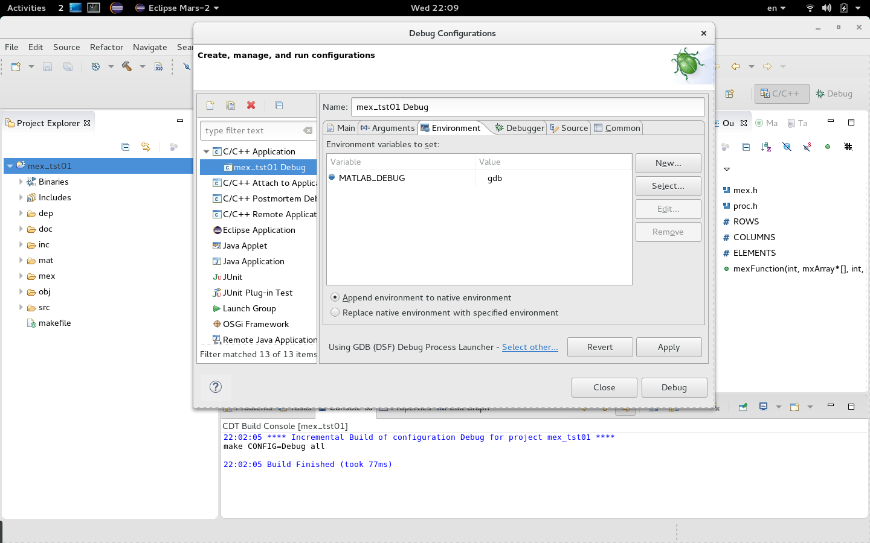
We don't set the breakpoint on main(). We are not interested in MATLAB's main().

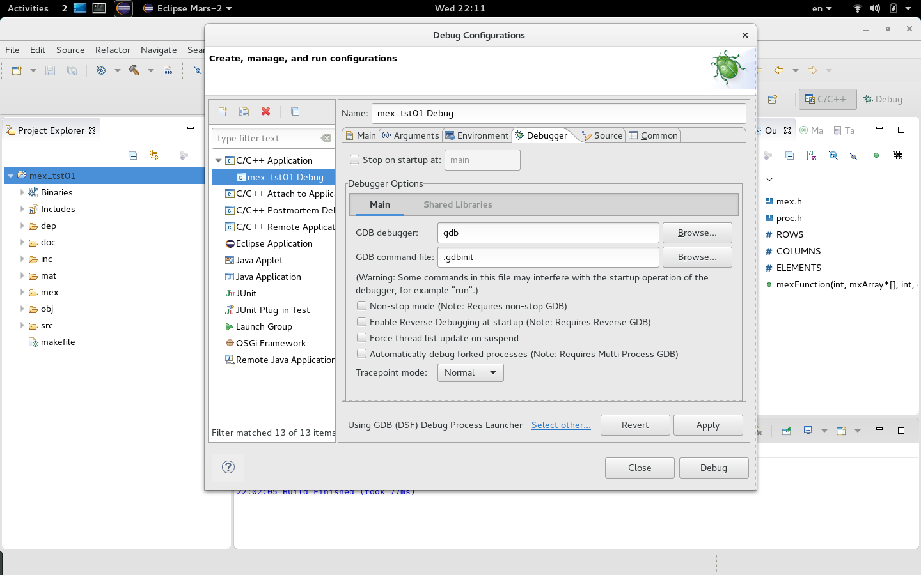
Start MATLAB from under gdb: Run → Debug. Wait until gdb stops and then switch the active perspective to Debug. In the Console output window we can see the result of the first call to the mex-function for which the control wasn't passed to gdb. The execution stops when MATLAB loads mex function second time and is about to call it.

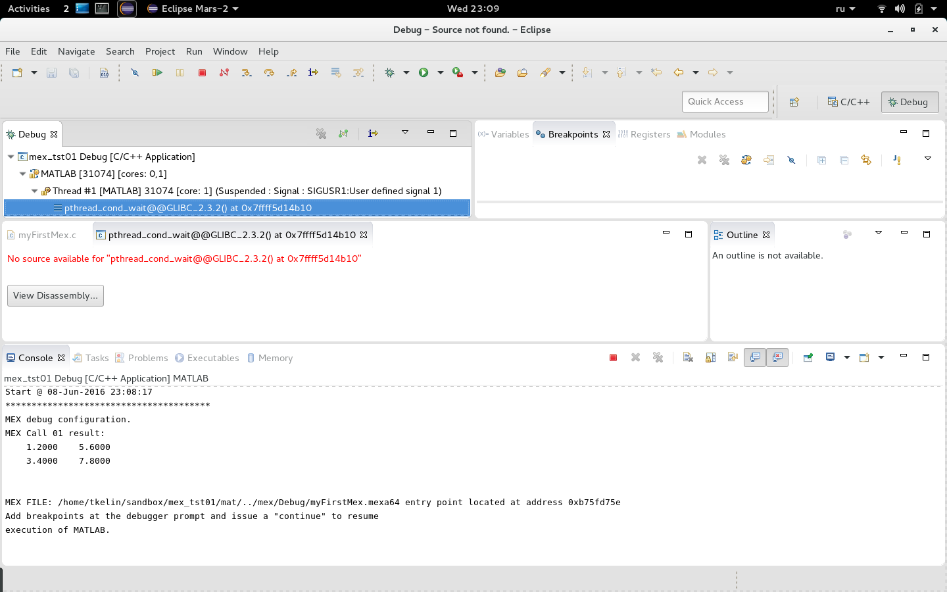

Set breakpoint to our mex-function mexFunction(). Continue execution: Run → Resume.

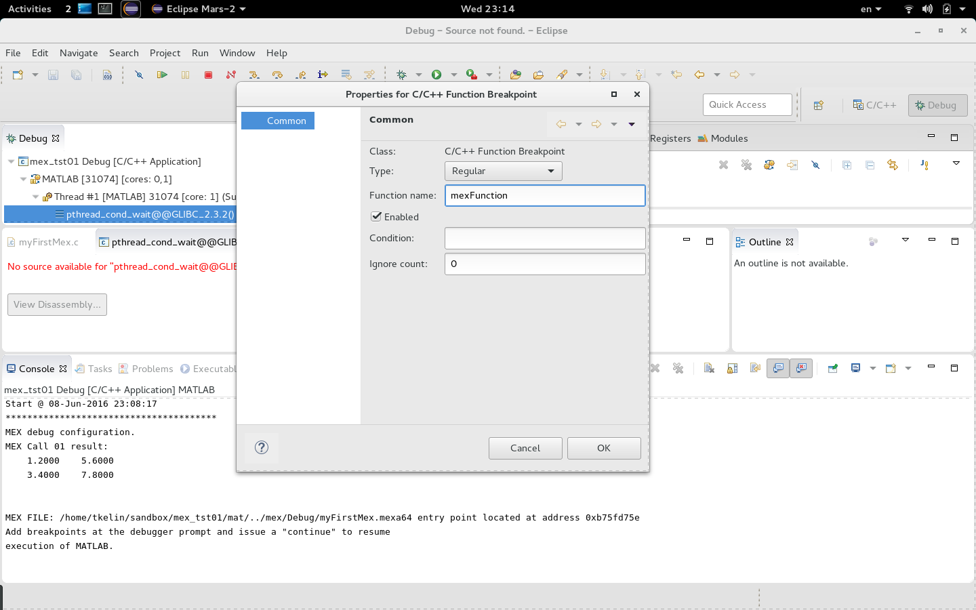
GDB stops at the first executable line of out mex-function. Now we have access to all the features of the source-level debugger.

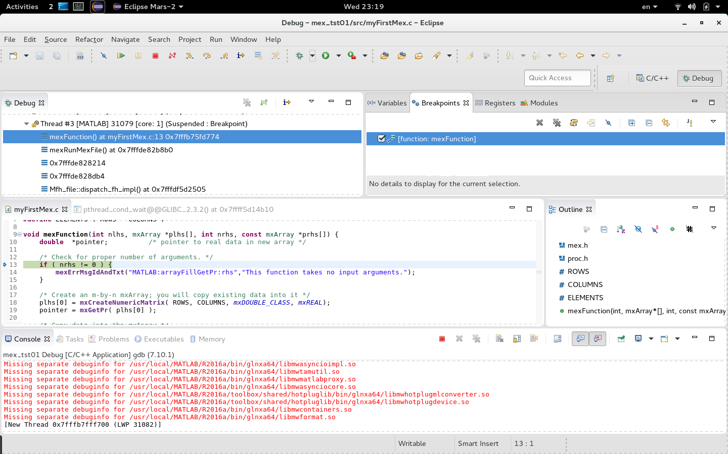
After debugging the source we deactivate the breakpoint at the start of mexFunction() and continue: Run → Resume. In the Console output window we can see the result of the script execution.

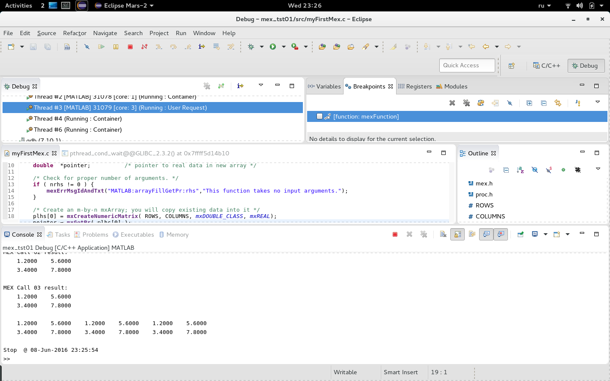
Note:
During the debug session MATLAB runs without JVM. This is why the functions which use Java become unavailable, for example plotting functions. Avoid using these functions while debugging by testing MATLAB_DEBUG environment variable in the script.

T.K. June 2016

