Changes needed:
1)
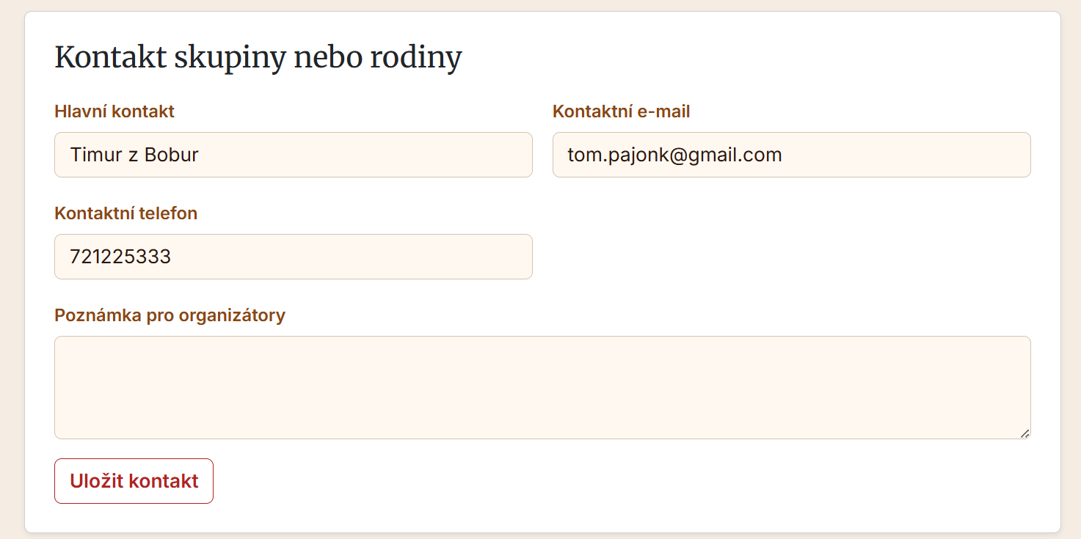
The headers should say:
**Přihlašovatel / registrátor - hlavní kontakt skupiny nebo rodiny.**
2)
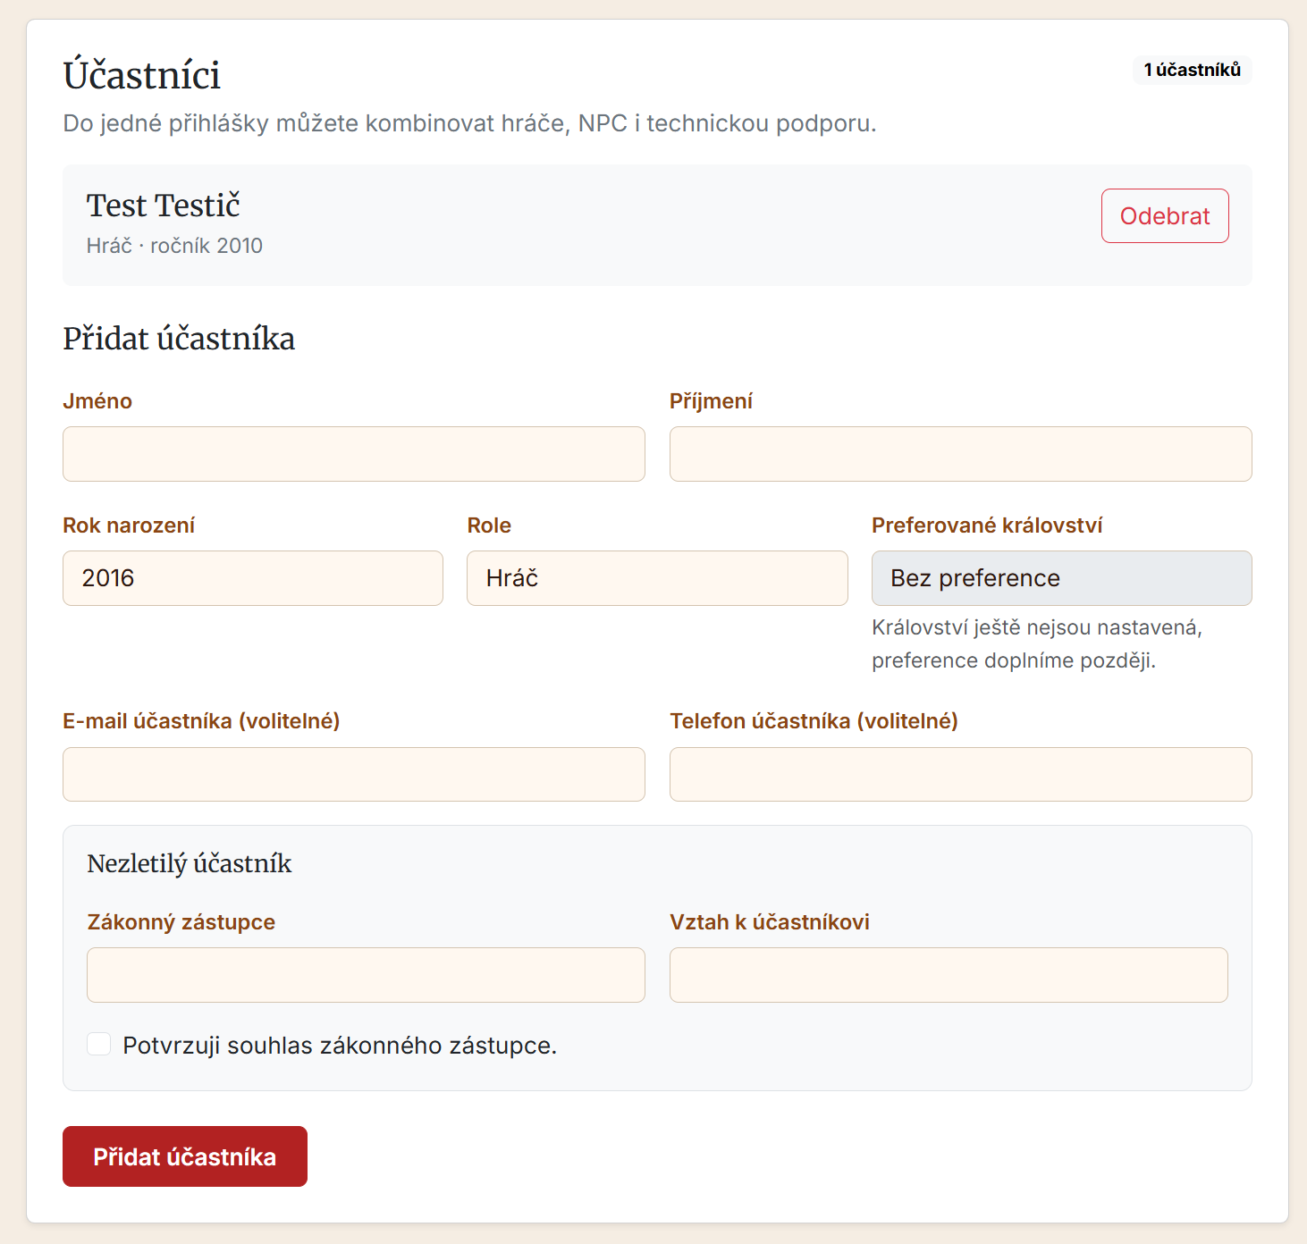
We should be allowed to edit the attendee as well here.
We need to add the character name.
We need to highlight which fields are mandatory with an asterisk.
Add some validation if you try to add the user and we don't have a name and surname.
And the date of year of birth as well.
Character name is not required.
We need to think about the role a little bit. Basically there are two branches:
- a player
Here are the options for a player 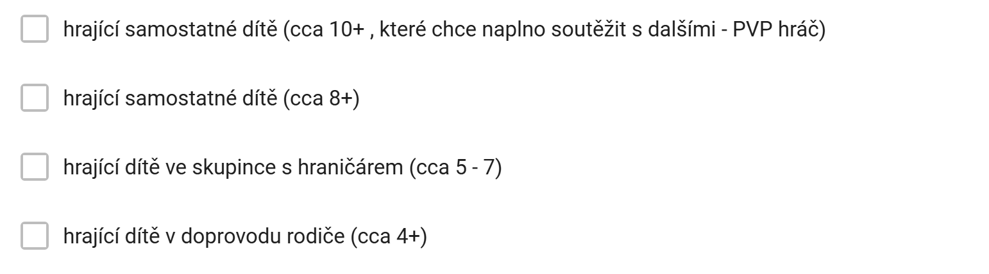
2) and an adult
Adult can multiple select. The player can only select one of the boxes.
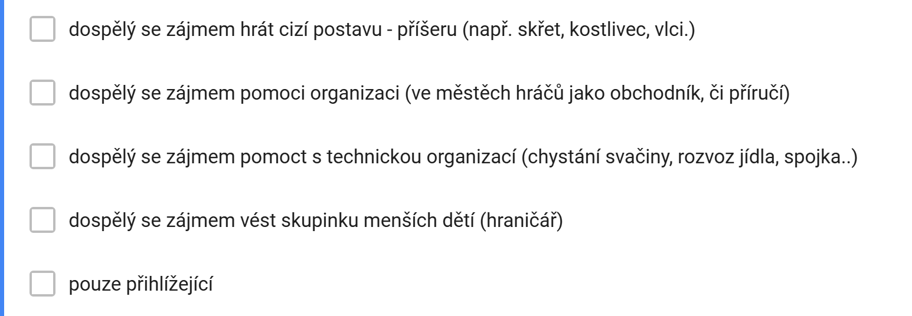

We will also add a note field here.
This is the czech heading for the note field.
„Poznámka pro organizátory - zejména v jaké skupině a národu děti chtějí nebo naopak nechtějí být. Napište i pokud je vám to jedno - velmi nám to usnadní třídění, aby byly národy vyrovnané.“
3) 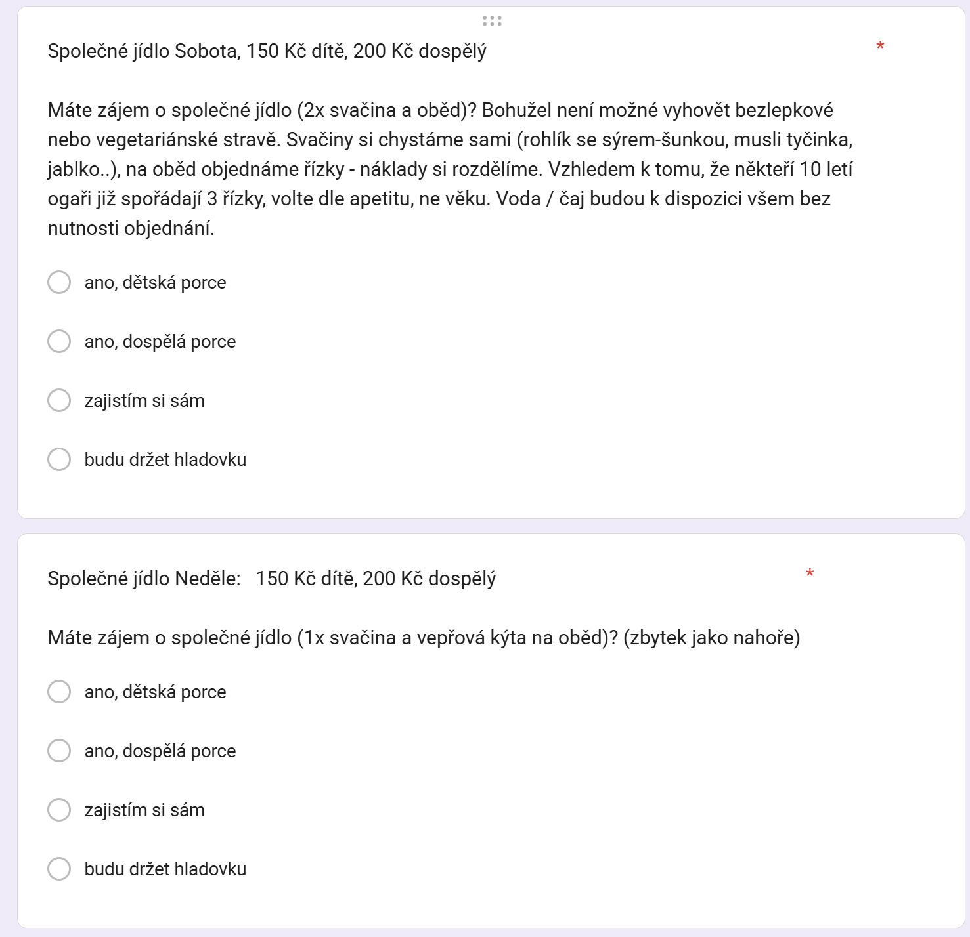
This is how the food registration looked last time but we will design this now differently. Bear in mind that we need to keep this capability intact so we will need to tell the user. There is only generally one type of food on the day but the user can select a small or big portion for himself.
4)
We are also missing lodging requirements where we basically want to ask the user if he wants to stay inside or he has a tent or he can camp or he is not planning to stay in for the night.

