COMP 4770: Team Project
Iteration 0: Requirements Gathering

Team "C"omputer
Science
Students
Taking
Computer
Science
4770:
Team
Project
As
Part of
Their
2016
Winter
Semester
At
Memorial
University of
Newfounland,
Winter 2016.

aka Team CSSTCS4770TPAPT2016WSAMUN Winter2016:

Tim Murray
Shane Butt
Dean Massecar
Philip St.Croix
Iteration 0:

Outlined below is the first iteration of the CodeDrop (name pending) project from our team. This iteration comprises of a selection of User Stories and Use Cases, some wireframe sketches which showcase a potential UI for the system, and a UML State Chart describing the logical flow of the program.
Before continuing here is a quick run down of the technologies that we have put into consideration for use with CodeDrop (all pending approval):

The project will be coded primarily -- if not fully -- in Java on the server side, with Javascript/HTML on the front end.

Tomcat will be used as our application server.

Spring is in consideration as a Java web framework.

PostgreSQL will be used for our database needs.

CodeMirror has been suggested, for use as the in-browser text editor that the Users would interact with.

Docker provides functionality to sandbox our compilation and testing environments as we will be running arbitrary code on the server side.
Wireframes
Below are wireframe diagrams of the individual screens that users will encounter in the system.

Universal Login page (left) [universal-login]
This is the page encountered by all users when they first enter the system.

Student Main Page: (right) [student-assignments]
This is the first page the Student sees when they log in, which allows them to select assignments to work on from a list of assignments and courses.
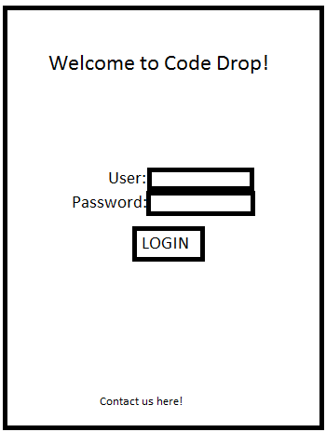
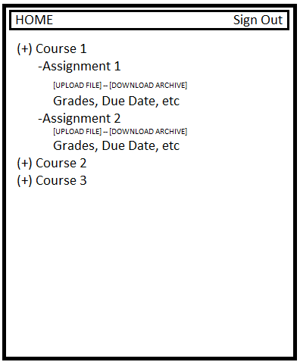
Student Coding Page: (left) [student-coding]
This is the page on which the Student writes/uploads code. It has a coding window as well as a File browser and console window.
Student Testing Page: (right) [student-testing]
This page allows a student to run the tests for their assignments after they have written code.
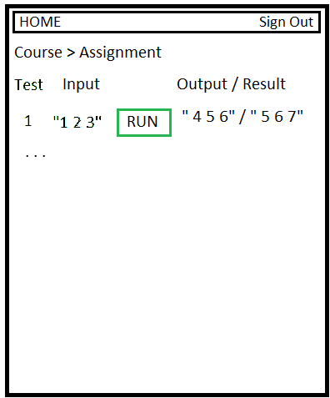
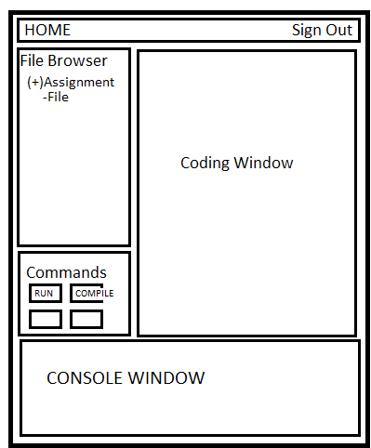

Instructor/Marker Course Management (left) [instructor-management, marker-management]
Allows Instructors or Markers to view and navigate through all of their courses/ assignments and view all students assigned. Instructors can add assignments.

Instructor/Marker Student Management: (right) [instructor-studentmanagement]
Allows the Instructor or Marker to view assignment submissions for the Students registered in a particular course. Opening an assignment here opens up the Instructor Assignment View page.

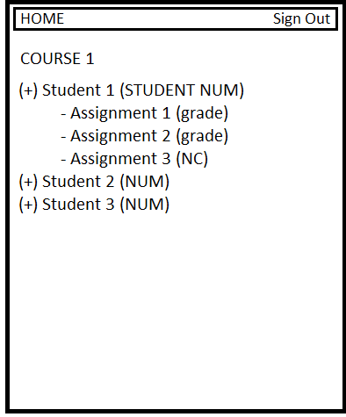
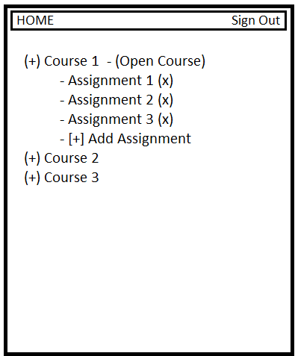

Instructor Assignment Edit Page: (right) [instructor-assignmentedit]
Where the instructor edits assignments. This allows the user to add in multiple tests, as well as descriptions, and start/end dates.

Assignment Viewing Page: (right) [instructor-assignmentview]
This page shows the instructor/marker details about an individual assignment submission from a student, and allows them to run tests on it/ leave comments and grade.
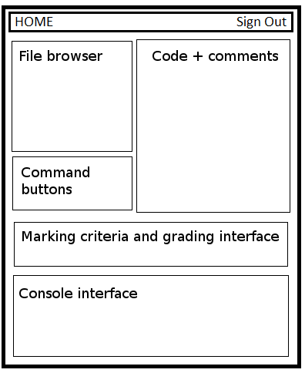
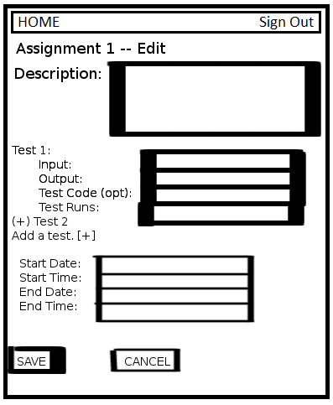

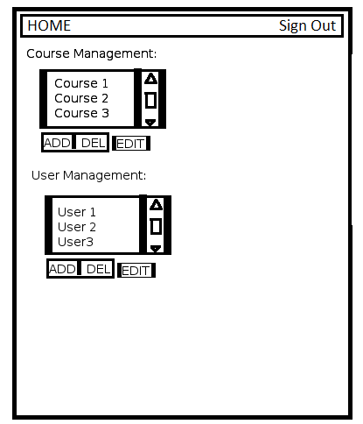
Admin Management Page:
[administrator-management]

This page shows the Administrative user a list of courses and of Users in the system. It provides links for addition, deletion and editing of these entities.

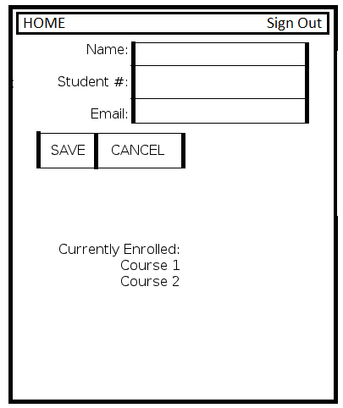
Admin User Management Screen:
[administrator-usermanagement]

This page lets an Admin user change details about system users, such as their names, emails, and permissions.

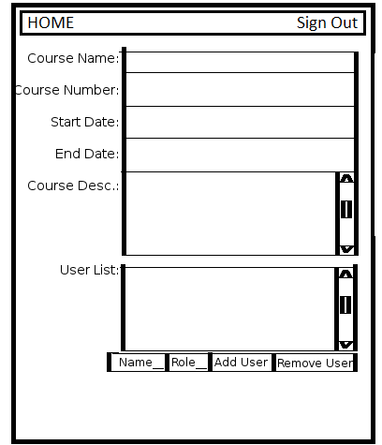

Admin Course Management Screen:
[administator-coursemanagement]

This page allows Administrators to set the details of courses, such as name, number, and also to add individual students, and instructors to the course being edited..
State Chart: This chart provides a view of the states of the CodeDrop system, and the actions which Users can take to transition between them.

