PHY453 Computational Physics | Assignment 5
Sumit Ghosh | Roll no: 20201222

Q1.(a) For V=1, b=2 what is the energy?

Ans : For V=1, b=2, the first three energy eigenvalues are: (-0.521007, 1.191738, 1.240160)
(computed with a=5, n=5)
- The first eigenvalue corresponds to the single bound state (ground state) for the system
whereas the other two smallest eigenvalues represent the first scattering states. These
values change when the parameters (a: periodicity, n: no of plane waves) are modified.

Q1.(b) Plot the energy as a function of ‘a’. Explain what you observe.

Ans :
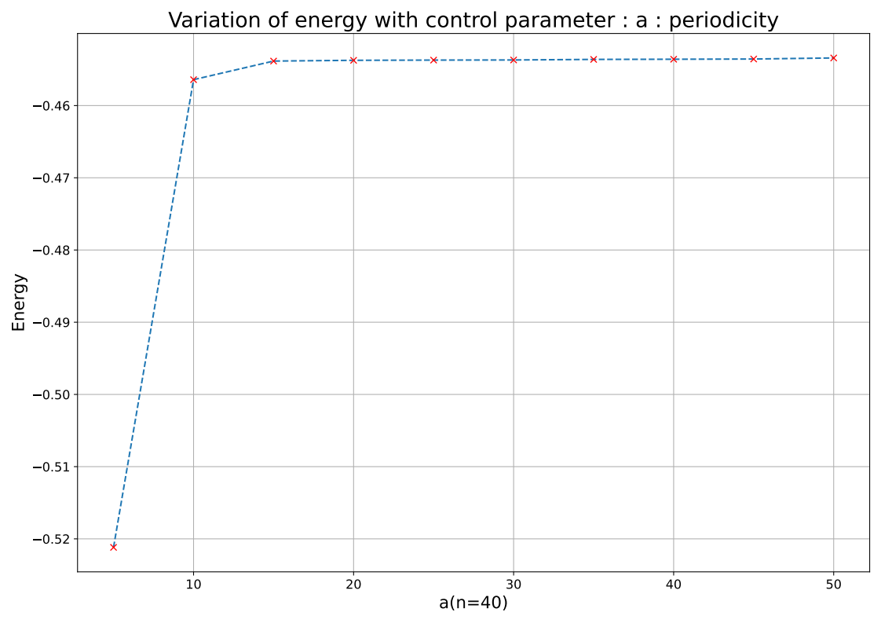
Physical interpreation:
Effect of changing ‘a’ on energy (au):

The parameter ‘a’ is used as a measure of distance between neighbouring potential wells when we
consider perioidic boundry conditions (PBC). For small ‘a’ values, successive wells are strongly
coupled and this leads to reduced overall energy of the system (as seen in the above figure). When
the periodicity of the plane waves increases, aliter, when ‘a’ is infinitely large, only then do we
simulate the actual well. As we increase the value of ‘a’, the periodic potentials move farther away,
interact less, the energy of the system increases, and this signals that the interaction between
successive attractive square well potentials decreases. We notice that after a > 15, the energy of the
system remains constant. Hence a=15 can be chosen to be a suitable value for PBC.

Q1.(b) Plot the energy as a function of no. of plane waves. What do you observe? Explain
your observation.

Ans : Number of plane waves = 2*n+1

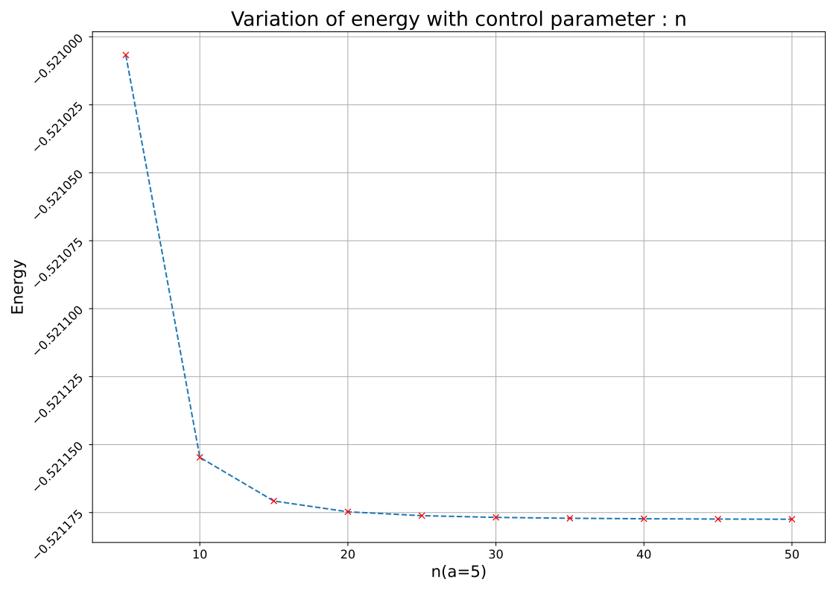
Physical interpreation:
Effect of changing ‘n’ on energy:

The parameter ‘n’ represents the number of plane waves used or the size of the basis set used for
the simulation. As ‘n’ increases, energy goes down and gradually converges to a particular value.
From the variational principle, we know that, the higher the number of wave functions we use in the
expansion of unknown wave function, the closer we approach the ground state of the system. Since
the value of energy obtained from this method is always higher than the actual ground state of the
system, when we increase the size of the basis, we approach the ground state energy from the right.
From the figure n=30, seems to be an ideal size to achive convergence.

