#WEEK 1
——Understanding the Basics

- Cloud Computing
-> is the delivery of computing resources (servers, storage, databases, networking, etc.) over the internet instead of owning and maintaining physical hardware yourself.
One pays on a subscription basis for what they use.
- Traditional servers: are dedicated physical machine that runs applications, hosts websites, or stores data.
- On-Premise Infrastructure*: the company owns, hosts, and manages all its IT infrastructure in its own physical location.
- Pros: Full control, data never leaves your building, no dependency on a third-party provider.
- Cons: High upfront capital cost, scaling means buying and installing new hardware (slow).
- Cloud Infrastructure: a third party provider (AWS, Microsoft Azure, Google Cloud) owns and runs massive data centers and one can rent the resources remotely over the internet.
- Pros: No upfront hardware cost, scale up/down in minutes, provider handles physical maintenance.
- Cons: Ongoing cost can exceed on-prem* at scale, less direct control, dependent on internet connectivity and a vendor.
- Virtualization: is the technology that makes cloud computing possible. A hypervisor (e.g., VMware, KVM, Hyper-V) lets one physical server be split into multiple isolated virtual machines (VMs), each behaving like an independent computer with its own OS, even though they share the same underlying hardware.
This is the key efficiency unlock: instead of one application per physical server (often <20% utilized), a cloud provider can run dozens of VMs on one machine, driving utilization up and cost down per workload.
- Datacenter: houses thousands of servers, along with cooling, power backup, networking, and physical security. Cloud providers operate datacenters at massive scale across multiple geographic regions, which is why cloud services are highly available and can serve users globally with low latency.

*Essential Characteristics:
- On-demand self-service
- Broad network access
- Resource pooling
- Rapid elasticity
- Measured service

Think of cloud computing like renting an apartment instead of buying a house. You pay only for what you use, the maintenance is handled by the owner, and you can move or scale more easily than owning physical infrastructure.

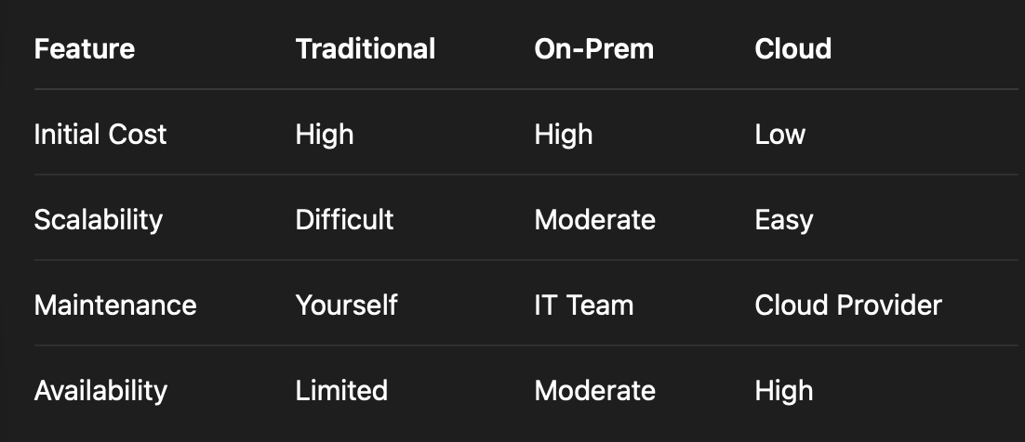
Note: Cloud providers own the data centers. But remember customers still own their data. Customers own the data and are responsible for securing it.

2. Deployment Models
->
a. Public Cloud- Infrastructure is owned by a third-party provider (AWS, Azure, GCP) and shared across multiple customers, though each customer's data is logically isolated.
- Use case: Startups, web apps, scalable workloads with variable demand.
- Trade-off: Lowest cost and fastest to deploy, but less control over the physical environment and shared underlying hardware (with strong isolation guarantees from the provider).
b. Private Cloud- Infrastructure is dedicated to a single organization — either hosted on-premise or by a third party, but never shared with other tenants.
- Use case: Banks, government, healthcare — anyone with strict compliance, security, or data residency requirements.
- Trade-off: Maximum control and security, but higher cost and slower to scale (closer to on-prem economics).
c. Hybrid Cloud- A combination of private/on-prem infrastructure and public cloud, connected so workloads and data can move between them.
- Use case: A company keeps sensitive customer data on a private cloud but bursts extra compute into the public cloud during high-traffic periods (e.g., Black Friday sales).
- Trade-off: Flexibility and optimized cost/control balance, but added complexity in managing two environments and the network connecting them.

3. Service Models:
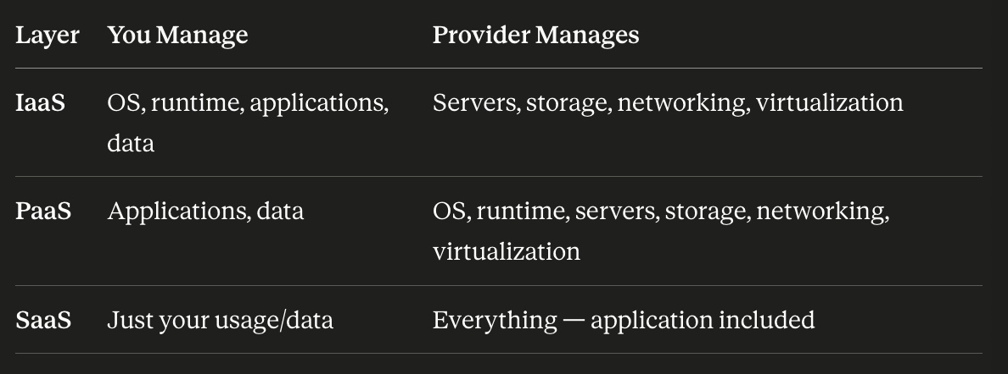
• Infrastructure as a Service (IaaS) : You rent the raw building blocks: virtual machines, storage, and networks. You install and manage the OS, middleware, and applications yourself.
- Examples: AWS EC2, Azure Virtual Machines, Google Compute Engine.

• Platform as a Service (PaaS) : The provider manages the OS, runtime, and infrastructure; you just write and deploy your application code. No need to patch servers or configure runtimes.
- Examples: Azure App Service, Google App Engine, Heroku.

• Software as a Service (SaaS) : Fully finished software delivered over the internet. You just use it (no installation, no infrastructure, no code.)
- Examples: Gmail, Salesforce, Microsoft 365, Slack.

4. How AWS is Organized
-> AWS infrastructure has three layers, biggest to smallest:
• Regions— Separate geographic areas (e.g., US East, Europe). Pick one close to your users for speed, or one required by law for data residency. Each Region is fully independent.
• Availability Zones (AZs)— Each Region has multiple AZs (3+), which are physically separate datacenters with their own power and cooling. If one AZ fails, the others keep running.
• Edge Locations— small sites spread globally that cache content close to users for speed (used by AWS's CDN, CloudFront).

5. Core AWS Services
-> There are 5:
- Identity and Access Management (IAM) controls who can access what in your AWS account (users, groups, roles, permissions). The security gatekeeper for everything else in AWS (foundation).
- Elastic Compute Cloud (EC2) virtual servers you rent (IaaS compute building block). Pick an OS, pick a size, run your application.
- Simple Storage Service (S3) storage for files (images, backups, videos, logs). Not a database — just a place to dump and retrieve objects reliably.
- Virtual Private Cloud (VPC) your own private network inside AWS, where you control which resources are public-facing vs private.
• Public subnet - resources reachable from the internet, e.g. a web server
• Private subnet - resources isolated from direct internet access, e.g. a database
- Relational Database Service (RDS) managed relational databases (MySQL, PostgreSQL, etc.) — AWS handles patching and backups (PaaS-style).

IAM controls access → VPC defines the network → EC2 runs your compute → S3 stores your files → RDS holds your structured data. This is the backbone of most basic AWS architectures.

_______________________________________________________________________________________

AWS CLI installed in terminal.

aws —version
aws-cli/2.35.13 Python/3.14.6 Darwin/25.5.0 source/arm64

