TECHNICAL

DESIGN DOCUMENT

**Project Name : “UDAN Flights”**

**BY - Sumeet Patil**

**Introduction**

Udan Flights is created to meet the needs of online Flight reservation system, with 1 actor: ie. User/Customer. The architecture implemented is Spring Boot using Spring boot and Angular framework. The proposed system is a solution for users to book flight tickets, search for tickets, view booking details and many more such features just by sitting at their home. Udan Flights is a specialized computer system that automates a wide variety of in-flight tasks, reducing the workload on the flight crew.

**Services**

The different services in which this project is divided into are:

* **Flight Service:** Performs operations like search flights, book flights, cancel flights and view bookings.
* **User Service:** Registers a new account and login for the customer. It also performs authentication at the time of login.

**Functional Requirements:**

The functional requirements of the project are:

* **Login/Register:** Users should have an account to access features of the Udan Flights, So users should initially register in the system by providing his/her details. Details will consist of name, username, phone number, age and password. If a user has created an account then he has to login into the system with his username and password to use features of Udan Flights.
* **Search Flights :** User has to search flights by entering source and destination details in the text boxes in user Interface then click on the search flights button. The lists of Flights will be displayed for given source and destination and other details like flight Id, date ,time and total fare will also be displayed.
* **Book Flights:** User/Customer can book tickets by clicking on the book now button. Users will be redirected to another page where information about the flight you tried to book will display. Click on the Make payment button and you will get the Flight Booked and Booking Id will be displayed on screen.
* **View Booking Details :** All the Bookings of the users can be seen in this feature. This displays all the tickets booked by a particular user in the past.
* **Cancel Booking :** User/Customer can cancel the book tickets from the tickets displayed by view Booking details. Users just have to click on the cancel button from the list of tickets and selected tickets will be cancelled by deducting cancellation charges.

**Overall Architecture Diagram:**

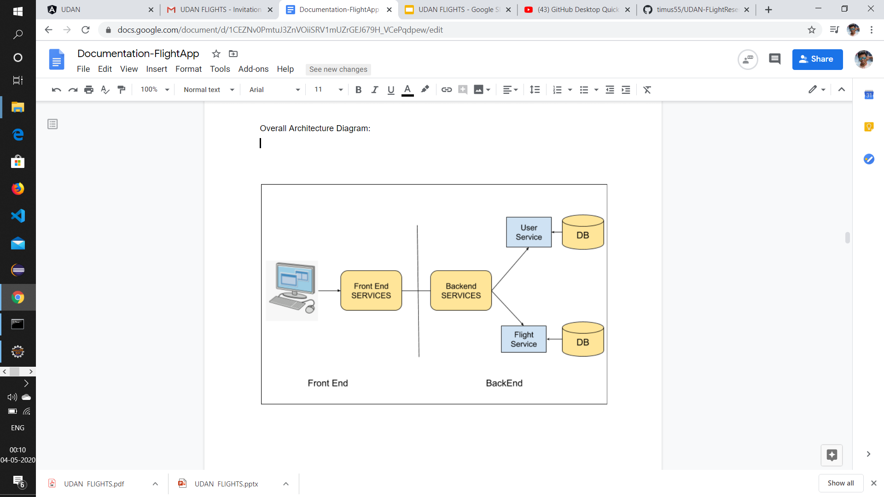

**USE Case Diagram:**

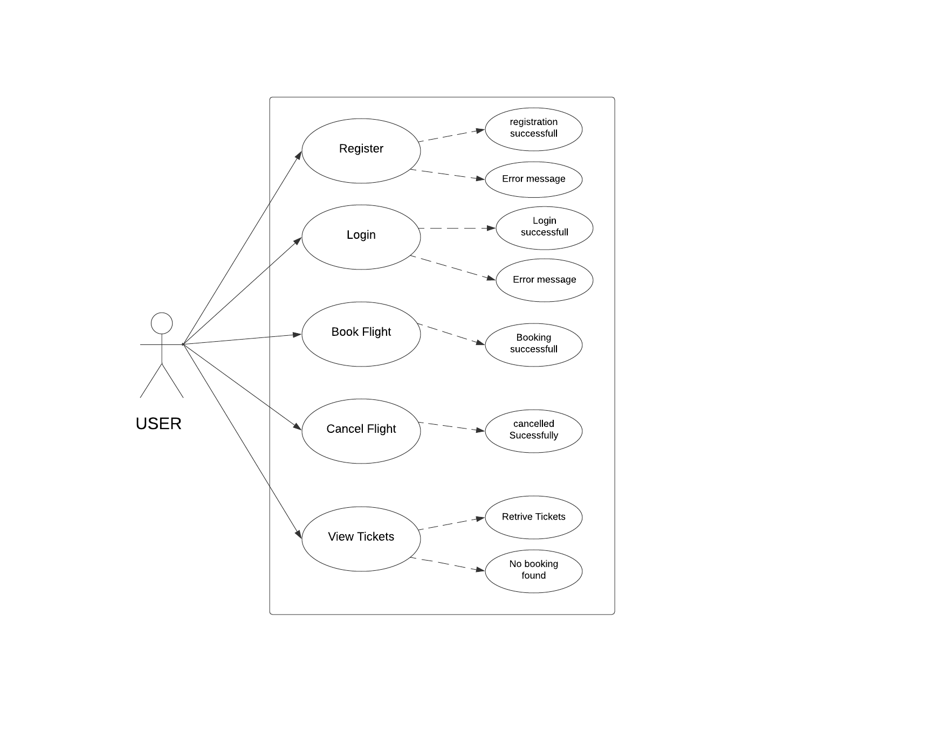

**CLASS Diagram:**

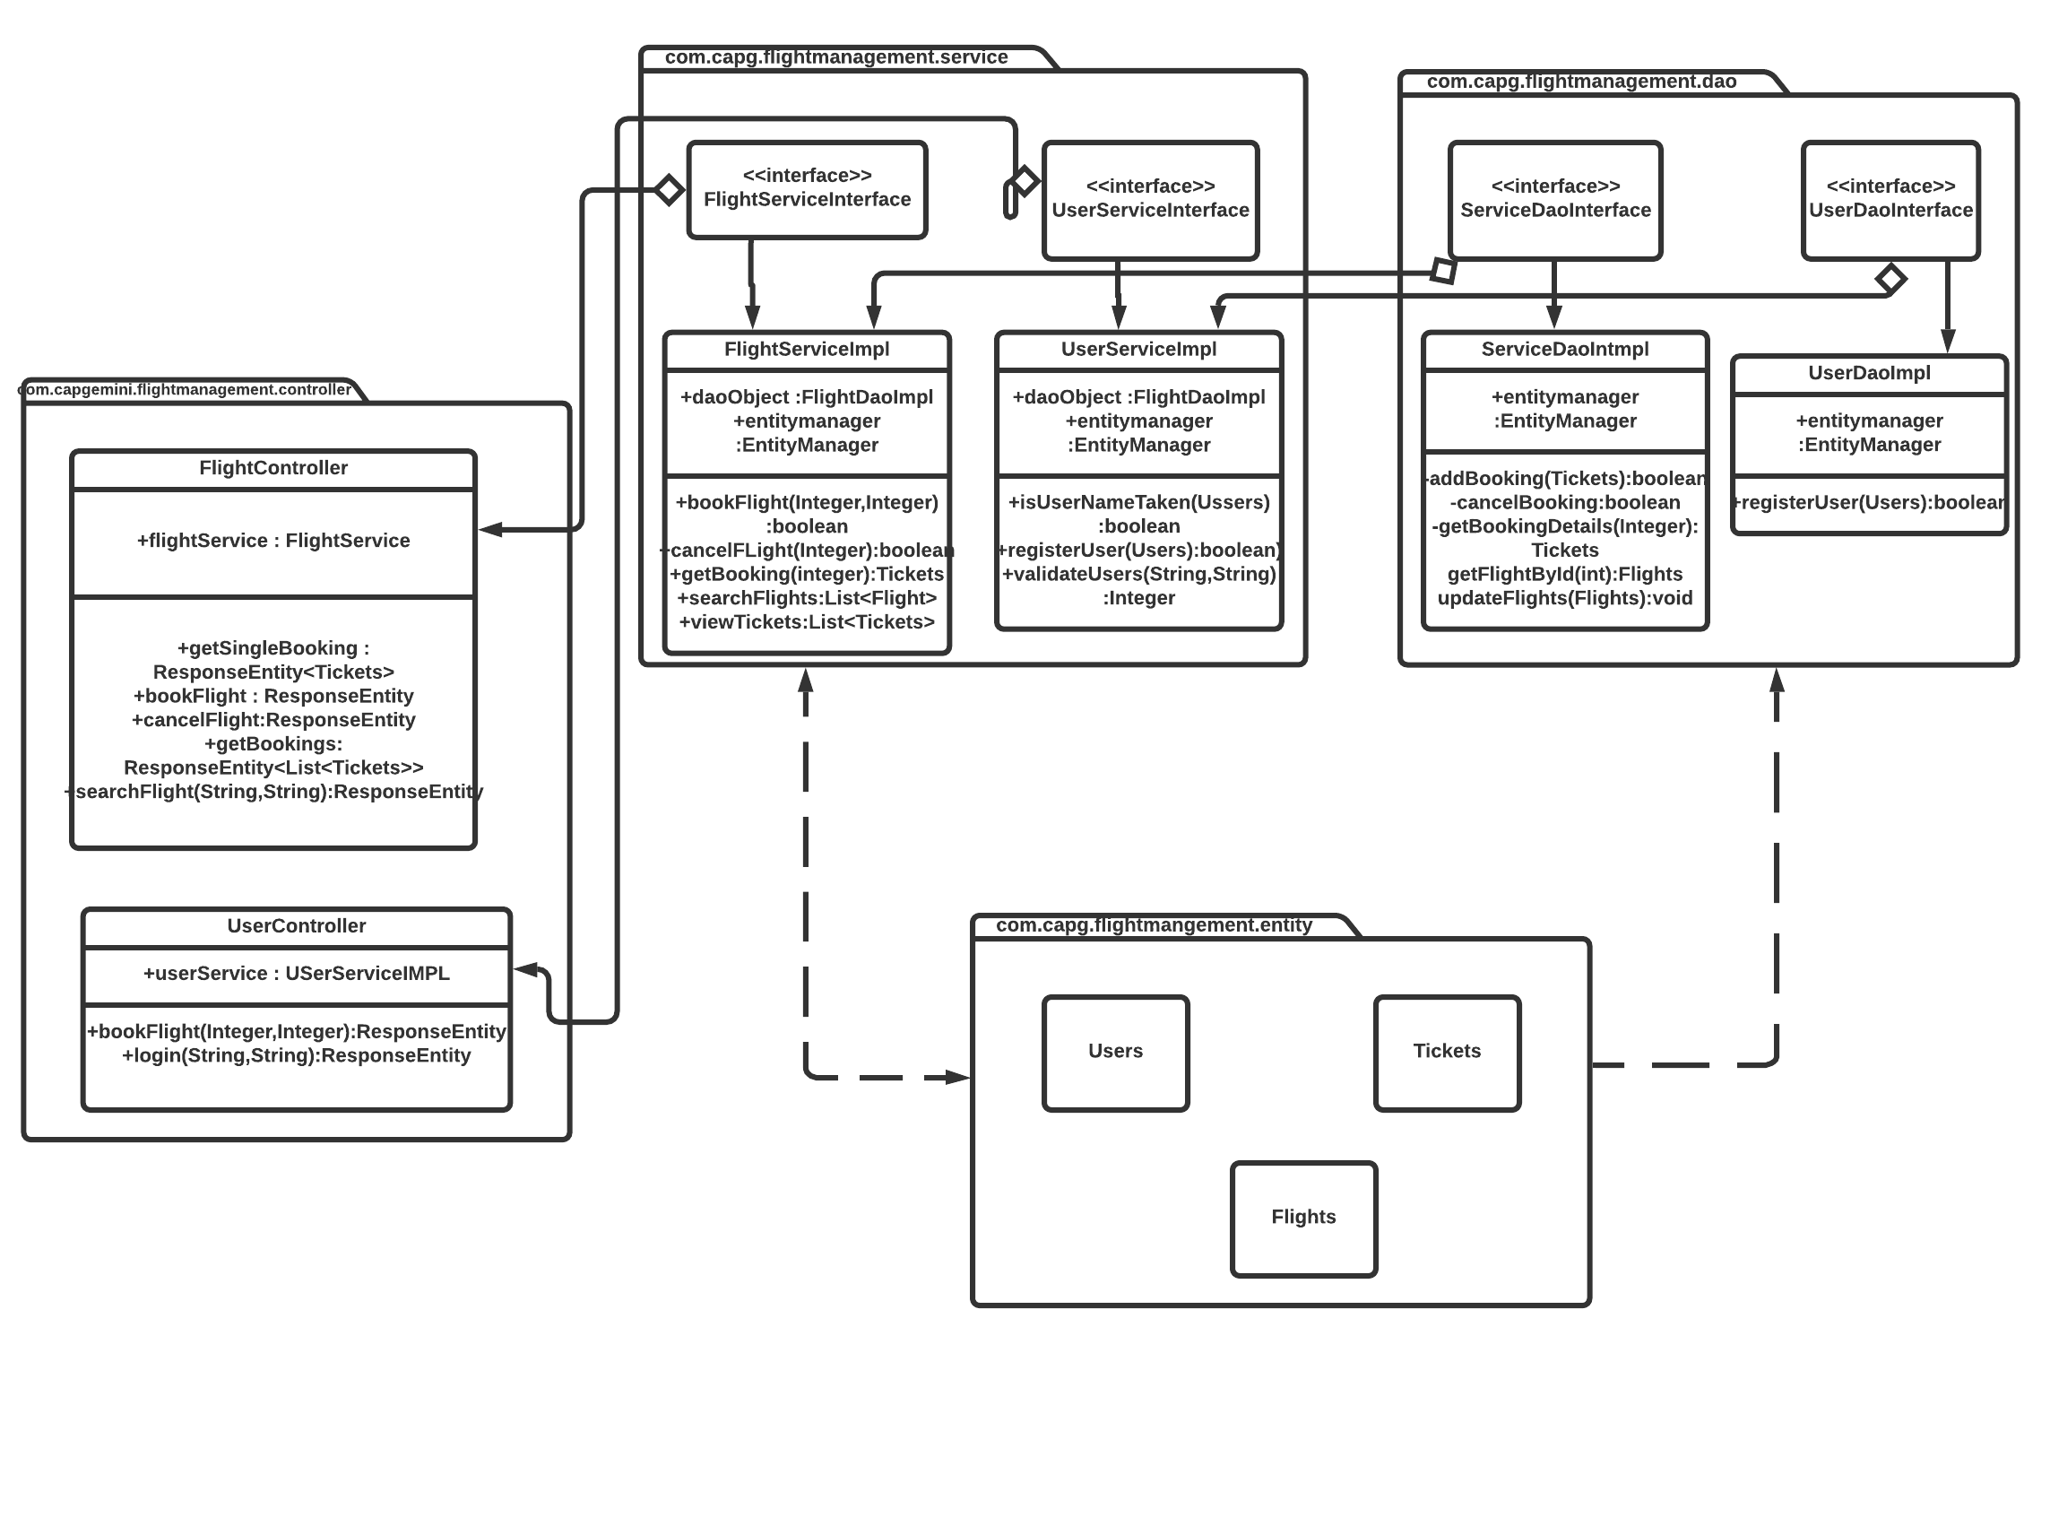

**Sequence Diagram:**

**Login**

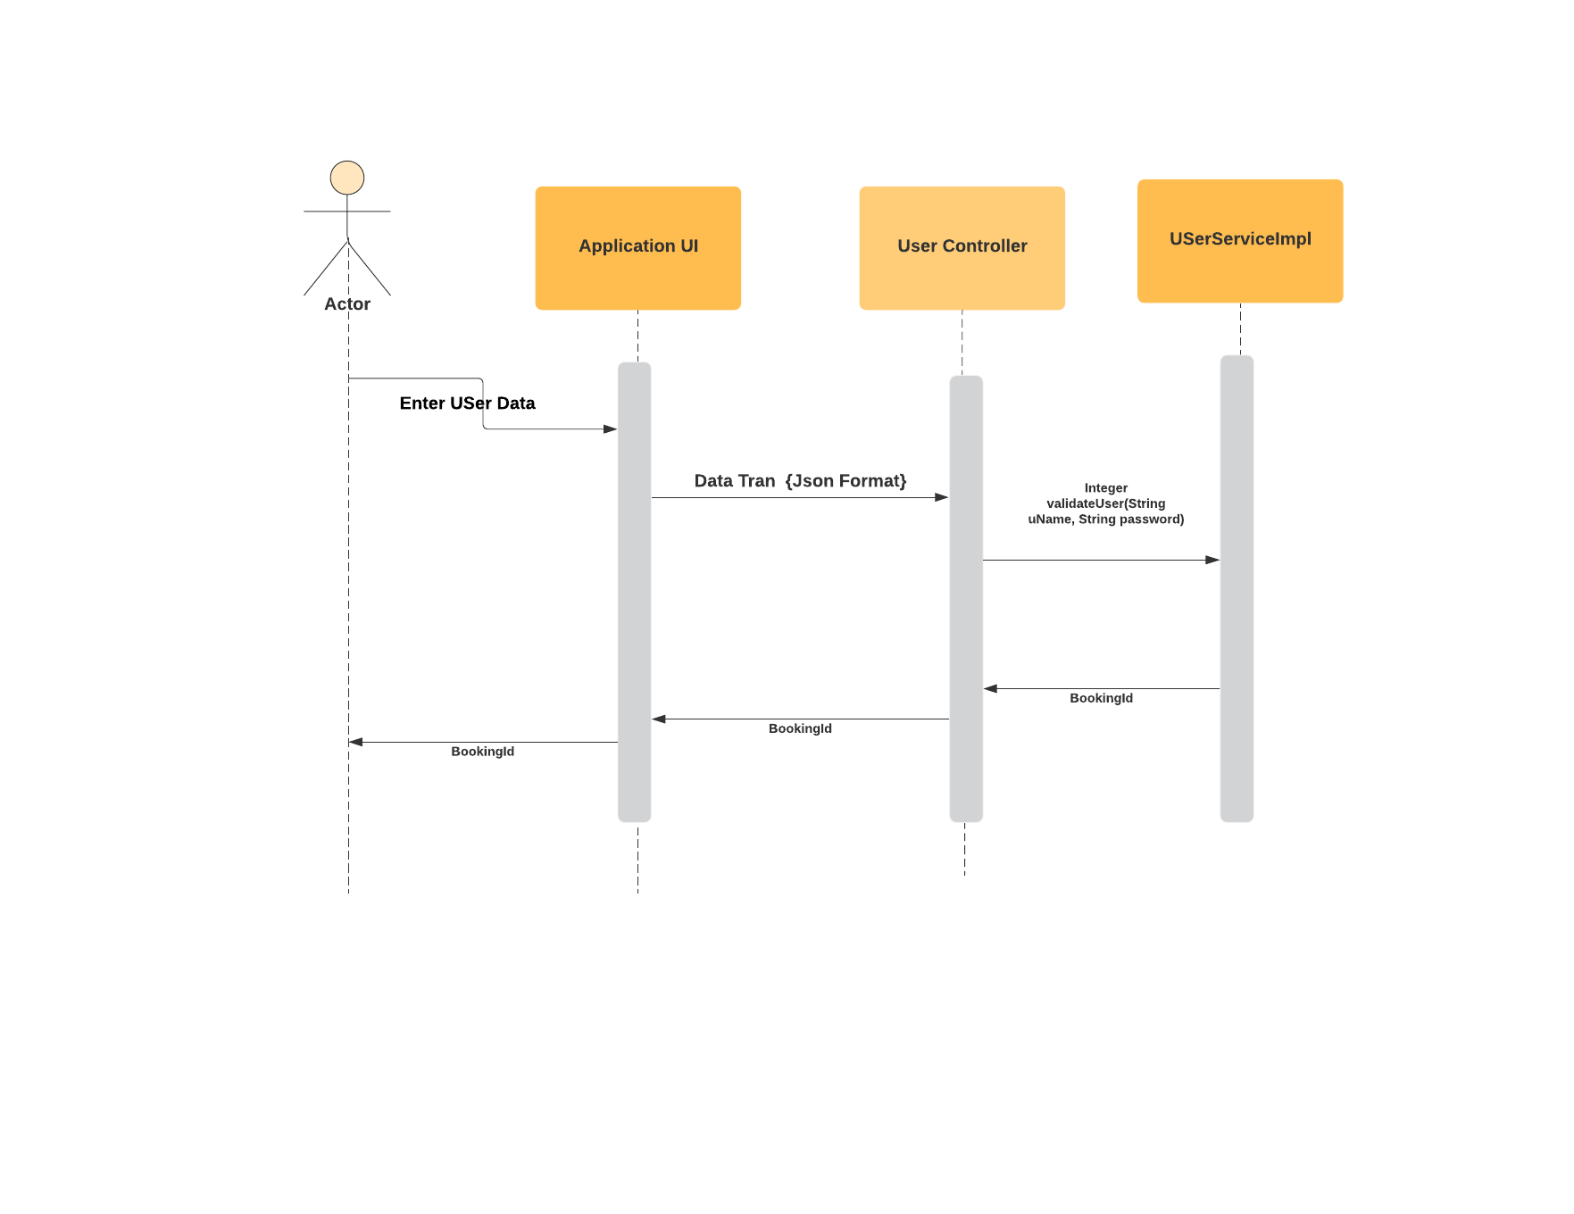

**Register**

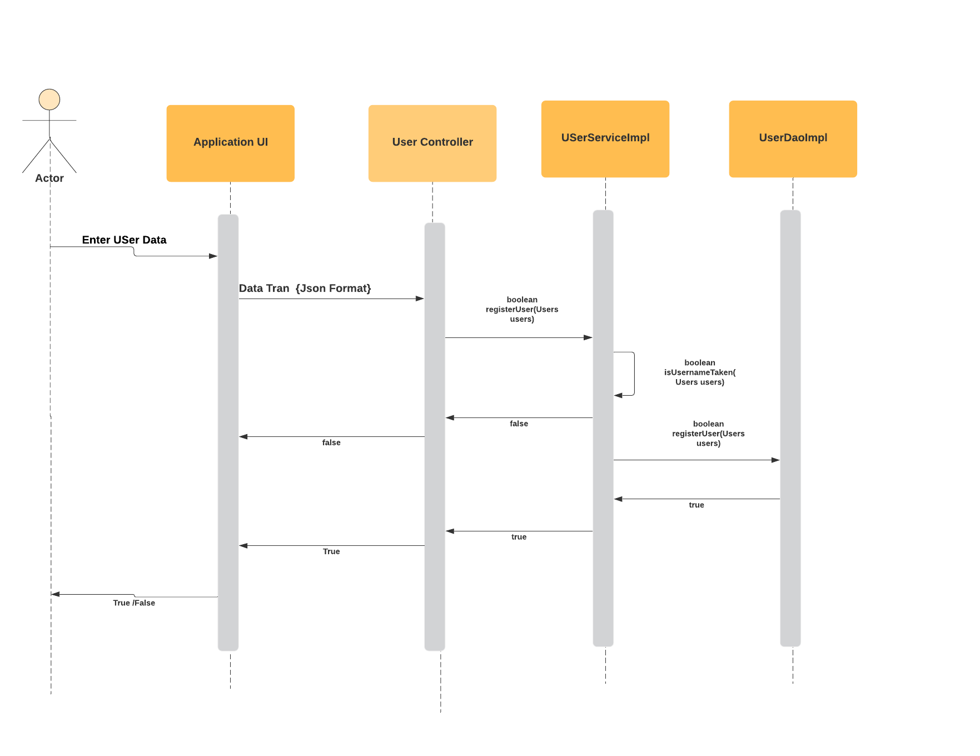

**Book Flight:**

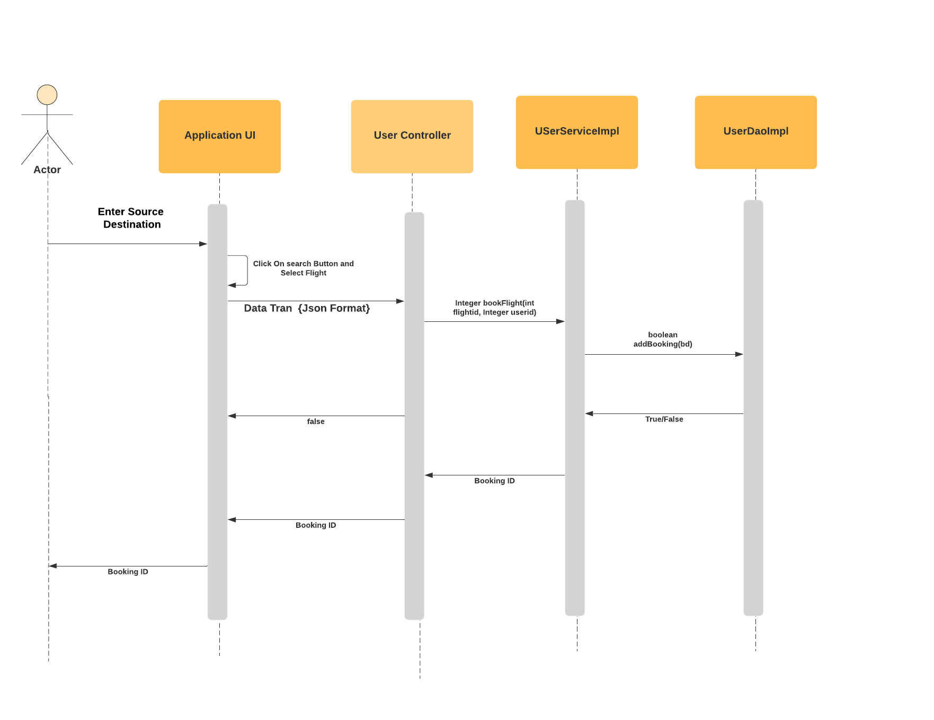

**Activity Diagram:**

**Login:**



**Entity Relationship Diagram**



**WIREFRAMES:**

