
Udacity
Analysis
September 18, 2019

Wrangling the Twitter Account of WeRateDogs

WeRateDogs is a twitter account (they have other social media accounts too) that have popularised “rating dogs”. In short, people upload their photos to Twitter, introduce their pup and give them a rating. From the word cloud below, you can see that most tweet’s introduce their pups, indicate what dog stage they are in and mention a little about their pet.


A word cloud of the most used words in tweets

The rest of this article is devoted to looking at three insights regarding the twitter account. I will also introduce you to their unique approach to identifying the stage of a dog.

What stage is your dog in? | Which dogs were general more popular? | Just how wide is WeRateDogs’ reach?
I wasn’t aware of the 4 stages of a dog. Just in case you are unfamiliar here is a quick list:  - Doggo  - Pupper  - Puppo  - Floof(er)  Don’t feel bad if you have never heard of this before, it’s a new language born from this twitter account.  For detailed definitions of each stage check out this link.  Interestingly, these are stages made popular by the WeRateDogs Twitter account. Surprisingly though, not many of the tweets reference the stage their dog is in.  Only 15% of Tweets had any reference to where dogs were in life. | For this part we looked not at the bread of the dog but the stage the dog was in.  In fact, we only had 285 tweets that identified the breed of the dog with a confidence above 90%.  What we looked at here is the stage a dog was in and what people favoured the most.  No surprise here as people retweeted and favourites Tweets where dogs were in the pupper stage (the puppy phase)  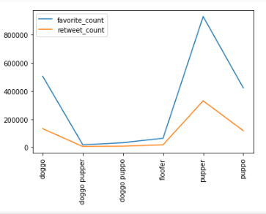 | Given that I only analysed about 1350 original Tweets where a picture of a dog was posted, I was definitely surprised just how wide this Twitter account reaches.  In fact, they have become a brand selling a number of merchandise as well as books.  In addition, they have used their influence to raise money for charities as well as through the platform GoFundMe.  In total, ~1350 Tweets have been:  Favourites:  11,321,150  Retweets:  3,512,094  That is incredible reach

The data analysed is between 2015-11-16 20:01:42 and 2017-08-01 16:23:56
Includes only original tweets with dog pictures

