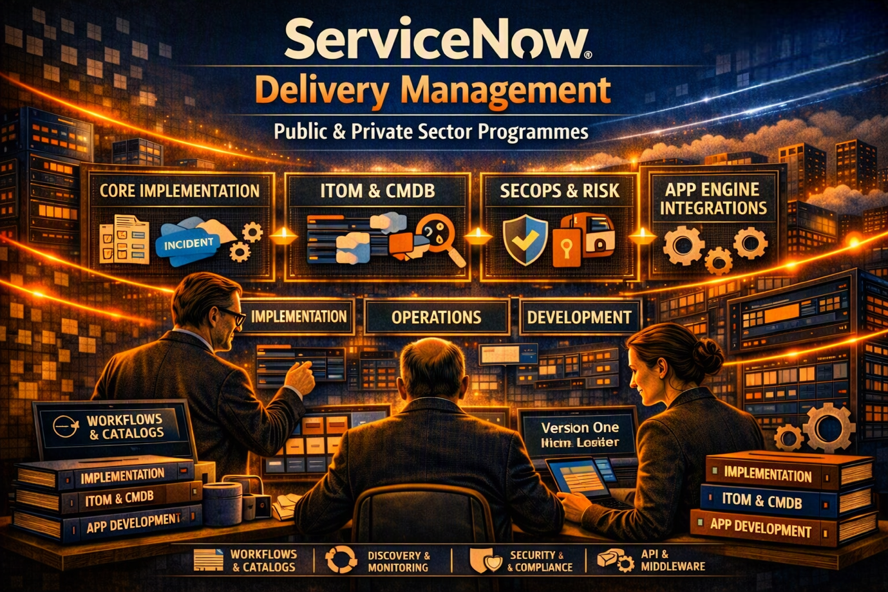

ServiceNow Delivery Management – Enterprise Service Management Transformation

Delivering Secure, Scalable Service Management Across Public and Private Sector Environments

Project Overview
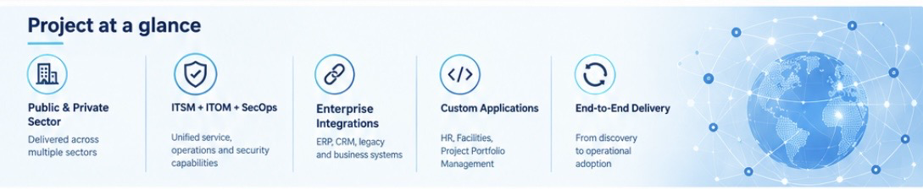

As a ServiceNow Delivery Manager, I directed and governed medium-to-large-scale ServiceNow programmes across public and private sector organisations.
The programmes covered a broad range of transformation activity, including ServiceNow platform implementations, technical infrastructure and operations, cybersecurity and compliance capabilities, and custom application development.
The common objective was to help organisations strengthen service-management maturity while creating secure, integrated and scalable platforms capable of supporting wider digital-transformation goals.
Delivery combined structured programme management with technical leadership, stakeholder governance and disciplined control across the full project lifecycle.

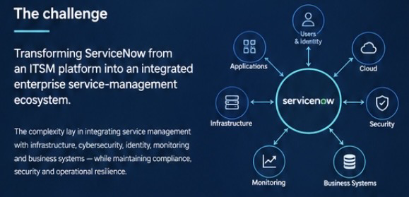
The Programme Challenge

ServiceNow programmes frequently extend well beyond the implementation of individual ITSM modules. For enterprise organisations, the platform needs to integrate with existing technology estates, operational processes, identity platforms, monitoring tools and business applications.
The delivery portfolio therefore required coordinated management across three principal areas:
- Core ServiceNow implementation
- Technical infrastructure and operations
- Custom applications and enterprise integrations
This created a requirement for strong programme governance alongside sufficient technical understanding to coordinate delivery teams, vendors, stakeholders and technology dependencies.

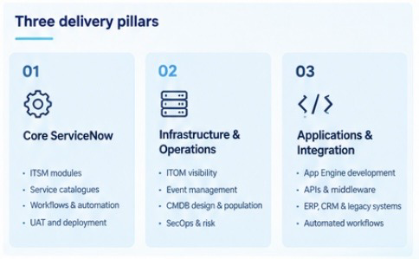
Core ServiceNow Implementations
Multiple ServiceNow implementation programmes were delivered using a combination of standard platform capabilities and tailored extensions.
Key delivery activities included:
- Requirements discovery and solution-design workshops
- ITSM module and service-catalogue configuration
- Workflow automation and UI-policy development
- Integration with identity and access-management platforms
- User acceptance testing coordination
- Deployment and transition into operational support
The delivery approach focused on adopting ServiceNow best practices while ensuring the resulting platform aligned with each client’s operational requirements.
This supported improved adoption, greater process consistency and more efficient service-management operations.

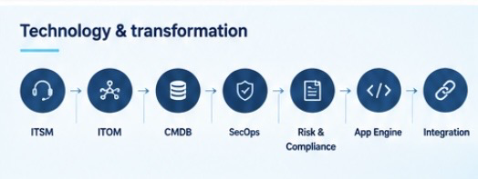
Infrastructure, IT Operations & Cybersecurity

A significant element of the programme portfolio involved extending ServiceNow into infrastructure management, operations and cybersecurity.
Delivery included capabilities across:
ITOM
- IT infrastructure visibility
- Event-management implementation
- Operational monitoring integration
CMDB
- CMDB design and population
- Configuration-data reconciliation
- Improved configuration accuracy and visibility
SecOps & Risk
- Security-operations orchestration
- Vulnerability-response automation
- Risk and compliance dashboards
- Alignment with ISO 27001 and NIST frameworks
- Integration with monitoring and SIEM technologies
These capabilities strengthened cyber resilience, improved the quality of configuration information and supported a more proactive approach to incident and vulnerability response.

Custom Applications & Enterprise Integration
ServiceNow was also used as a platform for delivering applications beyond traditional IT service management.
I directed App Engine development and middleware integrations supporting areas including:
- HR
- Facilities
- Project Portfolio Management
- ERP integration
- CRM integration
- Legacy-system integration
API and middleware design enabled data to move between platforms, while automated workflows supported approvals, notifications and reporting.
Governance and version-control processes were maintained across the development streams to provide appropriate delivery control as the platform evolved.
The resulting applications provided more unified access to enterprise information, improved user experience and supported broader digital-transformation objectives.

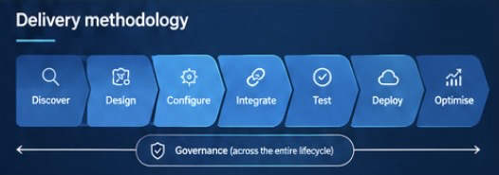
Programme Governance & Delivery Leadership
Effective governance was central to the delivery model.
As Delivery Manager, I maintained oversight across the programme lifecycle, coordinating delivery activity while ensuring that risks, issues, dependencies and changes were actively managed.
Responsibilities included:
- Programme planning and milestone tracking
- RAID and change management
- Vendor coordination and assurance
- Executive reporting
- Stakeholder communication
- Resource management
- Capability development and uplift
- PMO oversight
Governance was supported by established ITIL, ISO 27001 and Agile delivery principles, providing a structured framework for managing delivery quality, risk and stakeholder expectations.

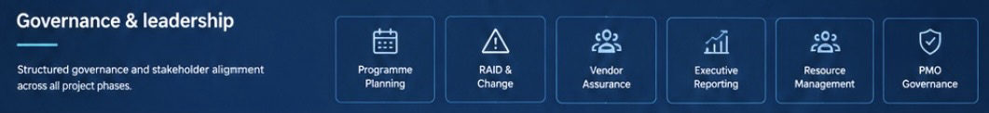

Outcomes & Business Impact
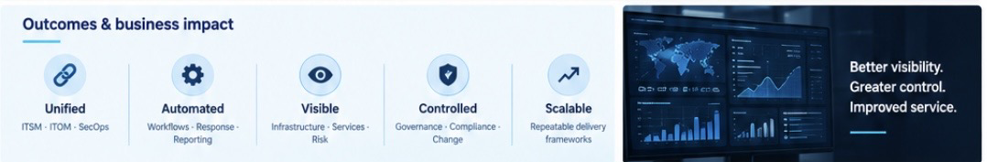
Across the programme portfolio, the delivery approach contributed to:
- Successful delivery of ServiceNow programmes across multiple sectors
- Consolidation of ITSM, ITOM and SecOps capabilities onto a common platform
- Increased automation and operational visibility
- Improved compliance capabilities
- Enhanced service delivery and customer satisfaction
- Repeatable delivery frameworks supporting future ServiceNow implementations
The programmes therefore provided more than individual technology implementations. They established foundations that could be extended as organisational service-management requirements evolved.

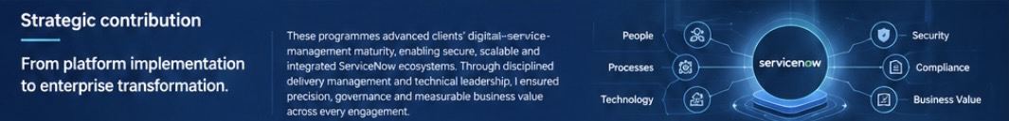
Strategic Contribution

The broader contribution was the development of secure, scalable and integrated ServiceNow ecosystems that supported organisational digital-service-management maturity.
By combining programme governance, stakeholder leadership and technical delivery oversight, I ensured that ServiceNow initiatives remained aligned to operational requirements while providing a controlled route from requirements and design through implementation, integration and operational adoption.
The result was a structured and repeatable delivery model capable of supporting complex enterprise environments and continued platform evolution.

Key Capabilities Demonstrated
Programme & Delivery Management
Programme planning • Governance • RAID management • Change control • Vendor management • Executive reporting
ServiceNow
ITSM • ITOM • CMDB • SecOps • Risk & Compliance • App Engine • Service Catalogue • Workflow Automation
Cyber & Compliance
Security orchestration • Vulnerability response • SIEM integration • ISO 27001 • NIST
Enterprise Integration
APIs • Middleware • ERP • CRM • Legacy platforms • Identity & Access Management
Transformation Leadership
Stakeholder alignment • Operational transformation • Service-management maturity • Capability uplift • Continuous improvement

Conclusion
These ServiceNow programmes demonstrate the value of combining strong delivery governance with practical technical leadership.
Rather than treating ServiceNow as a standalone ITSM implementation, the programmes positioned the platform as an integrated component of wider enterprise transformation—connecting service management, infrastructure operations, cybersecurity, compliance, applications and business processes.

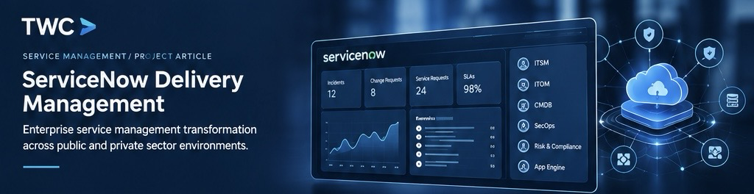
The resulting approach provided clients with a foundation for secure, scalable and increasingly automated service management, while establishing repeatable delivery frameworks for future transformation initiatives.

