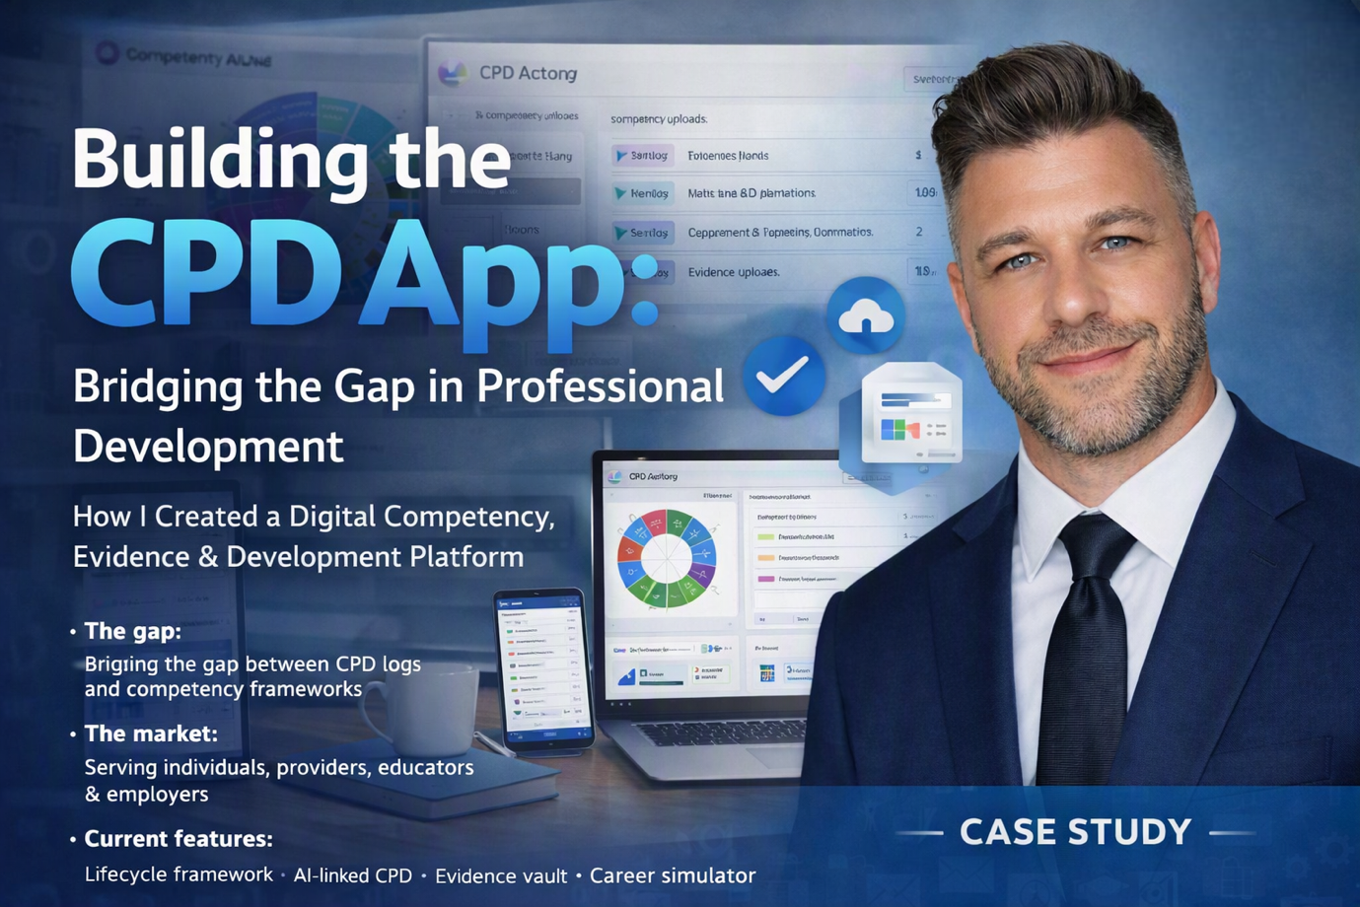

Case Study: Building the CPD App — From Concept to Launch

Overview
Creating a modern CPD (Continuing Professional Development) application is no small task. It requires a deep understanding of professional development, user experience, competency frameworks, and the realities of how people record and evidence their growth. As a Senior IT Programme Manager with 25 years of experience delivering complex digital programmes, I set out to build a CPD platform that solved a universal problem: CPD is essential, but the tools available are outdated, fragmented, and built for HR teams rather than individuals.

The CPD App was designed to change that.

1. Identifying the Problem
Professionals, students, apprentices, and job‑seekers all face the same challenge: evidencing skills and development. Traditional CPD systems are:
• administrative rather than developmental
• rigid and compliance‑driven
• poorly designed for mobile use
• disconnected from competency frameworks
• not built for quick evidence capture

I wanted to create a tool that was:
• simple
• visual
• mobile‑friendly
• competency‑driven
• evidence‑focused
• exportable for employers and educators

Current providers such as APM and BCS only offer:
• No way to provide evidence to support CPD progress or competency ratings
• A static CPD log
• A competency framework and ratings for each competency
• No ability to identify or plan development needs, perform gap analysis, or manage a development plan
• No linkage between the CPD log and competency framework

The CPD App bridges these gaps by integrating all these elements into a single, dynamic ecosystem.

This became the foundation of the CPD App.

2. The Market
The platform serves four key audiences:
- Personal individuals — professionals, students, and apprentices tracking their own development
- CPD providers — such as APM and BCS, seeking modern, integrated tools
- Education sector — colleges and training providers supporting employability and skills evidence
- Employers — enabling performance reviews, appraisals, and career development tracking
3. Designing the Solution
The design phase focused on three pillars:

A. Competency Mapping
I built a visual competency wheel aligned to professional frameworks (APM, BCS, PMI).
Users can instantly see strengths, gaps, and development priorities.

B. CPD Logging
A structured CPD log allows users to record activities quickly, categorise them, and link them to competencies.

C. Evidence Capture
Users can upload documents, notes, links, and proof of learning — creating a complete development portfolio.

These three components work together to create a seamless CPD ecosystem.

4. Current Features
The CPD App delivers a comprehensive suite of features designed for flexibility, automation, and insight:

- Lifecycle framework — visualises development stages
- CPD log — import, reporting, and AI-suggested entries; links to competency, evidence, and development plan
- Competency ratings — import/manual creation, reporting, AI-suggested and manual links to CPD, evidence, and development
- Dashboard — metrics and KPIs for progress tracking
- Awards and badges — automated recognition of milestones
- Gap analysis — identifies competency gaps and suggests tasks
- Evidence vault — securely stores and links evidence to CPD, development plan, and competency
- Development plan — connects goals, CPD, and evidence
- Career simulator — compares current role vs. target role to define development targets
- To-do list — actionable daily tracking
- Full reporting suite — exportable insights for individuals and organisations
- Profile page — personalised summary of achievements
- Link to CV App — integrates professional development with career documentation

5. Building the Application
Using the Base44 platform, I developed:

• the full CPD logging system
• competency wheel visualisation
• evidence repository
• user dashboard
• metrics and progress tracking
• exportable reports
• mobile‑ready interface

The build required careful UX planning, data modelling, and iterative testing to ensure the app was intuitive and fast.

6. Testing & Iteration
I conducted multiple rounds of testing with:
• professionals
• students
• apprenticeship learners
• project managers
• educators

Feedback led to improvements in:
• navigation
• evidence upload flow
• competency scoring
• dashboard clarity
• mobile responsiveness

The app evolved into a clean, modern, user‑friendly tool.

7. Launch & Early Adoption
The CPD App is now being positioned for:
• professionals maintaining CPD
• students evidencing skills
• apprentices tracking workplace learning
• colleges supporting employability
• project managers developing competency portfolios
Early adopters have praised the simplicity, visual design, and structured approach to development.
8. Future Roadmap
Planned enhancements include:
- Corporate and personal packages — tailored pricing and functionality
- LinkedIn integration — sync achievements and competencies
- Badge level display — visible on profile page
- Social sharing — share badge progress on social media
- Light/Dark mode toggle — improved accessibility
- Calendar integration — scan Gmail and Outlook events for automatic CPD logging
- integration with professional bodies
- college and apprenticeship dashboards
- team‑based CPD management
- enterprise licensing

The platform is built to scale with low overheads and strong SaaS potential.

Conclusion
The CPD App transforms how professionals and learners manage their development. It connects competency, evidence, and planning in one intelligent system — something no existing provider offers. It’s scalable, mobile-ready, and designed for both individual and institutional use.

The CPD App represents the culmination of decades of experience in professional development, digital delivery, and user‑centric design. It solves a real problem for real people — helping them track growth, evidence skills, and progress in their careers.

This case study demonstrates the full lifecycle: concept, design, build, testing, launch, and future evolution.

