**Final Report**

*CMSC 495 Week 8*

*By: Shelley Schoppert, Jake Gonzalez, Justin Smith, Timothy Strickland*

*University of Maryland, Global Campus*

*10/11/2022*

# **1. Milestones**

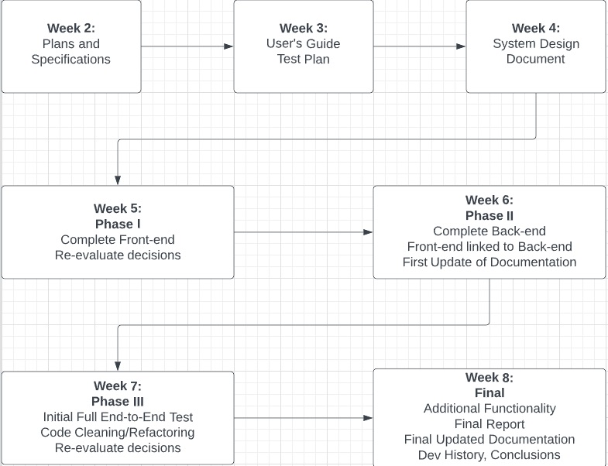This is the final week. This week the final delivery will be posted. All functionality that has been updated in the documentation will be presented, code will be cleaned up and fully tested and the final report delivered with a conclusion statement.

# **2. Schedule**

Fully delivered project will be submitted on 10/11/2022.

# **3. Problems**

# Some functionality could not be included as it required the use of a database. For instance, we initially wanted to store data and search for it. Unfortunately, without a database this is largely impossible.

# **4. Re-Evaluation**

# Not much has changed since our initial evaluation. The idea and concept remain unchanged.

# **5. Updates**

Both the Test Plan, User’s Guide and Software Design to specify what is delivered in the final update.

# **6. Conclusion**

There were some lessons learned in this project. The lack of a database continued to restrict what we could do till the very end. For future projects, a database would be required if we are attempting to store, read and search through information.  
  
The history of changes for the project can be found at our github page here:  
https://github.com/timwstrickland/metadata_analyzation