**Phase 1 Report**

*CMSC 495 Week 5*

*By: Shelley Schoppert, Jake Gonzalez, Justin Smith, Timothy Strickland*

*University of Maryland, Global Campus*

*09/02/2022*

# **1. Milestone**

The objective for this week was to deliver our initial code base, update any documentation if necessary, and submit the project to assignment board.

# **2. Schedule**

Currently I would consider us ahead of schedule. We have both the Test Plan and the Design Doc finished. We have our initial code to handle the front-end and the back-end written.

# **3. Problems**

This week we encountered an issue of trying to connect our back-end to the front-end which was a little more complex than we thought.

Our biggest issue that we have encountered so far on the project is the lack of functionality a database would have provided. We decided not to go this route because not all students learned about databases and we didn’t want to add more layers of complexity to the project. Hindsight being 20-20, this caused some creative thinking on our part to get around these limitations.

# **4. Test Specifications**

## **4.1 User Interface test cases**

These cases are for the testing of the program

### **4.1.1 Select Upload Button**

**Objective**

The purpose of this test is to verify that the upload button allows the user to select an image.

**Input specifications**

1. Upload a photo or image to the GUI. This is done by clicking on the “Upload Button”.

**Output specifications**

1. Opens a window that allows the user to select an image.
2. File path to the image is displayed.

### **4.1.2 Select Submit**

**Objective**

The purpose of this test is to upload the image to the GUI.

**Input Specifications**

1. Select the “Submit” button.

**Output Specifications**

1. Exif data is printed to the screen as seen in the following image (next page):
2. 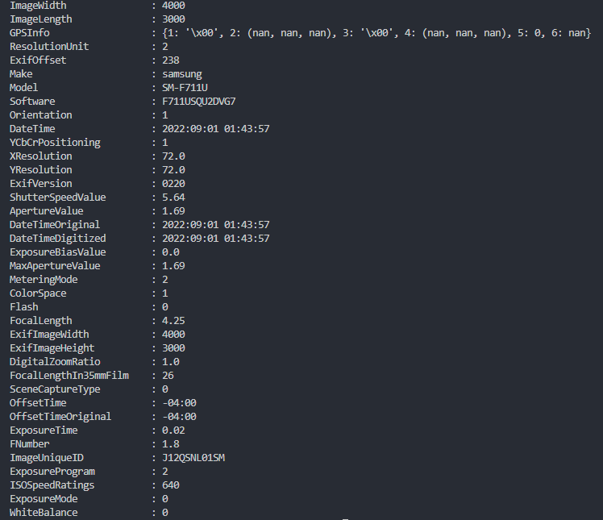

### **4.1.3 Select Export**

**Objective**

The purpose of this test is to export data to a file.

**Input Specifications**

1. Push the Export button.

**Output Specifications**

1. File is created with the exif data inserted.

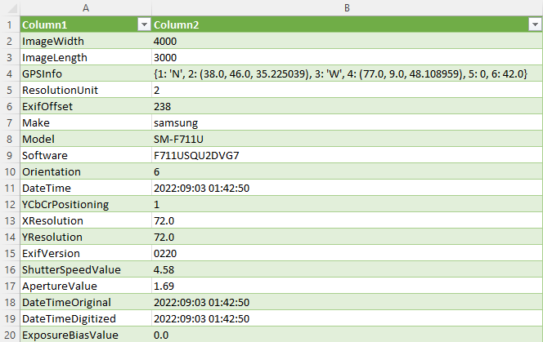

### **4.1.4 Return Button**

**Objective**

The purpose of this test is to return to the home page from the data page.

**Input Specifications**

1. Push the Return button.

**Output Specifications**

1. Return the user to the home page

### **4.1.5 About Button**

**Objective**

The purpose of this test is to present the “About” page to the user.

**Input Specifications**

1. Push the “About” button.

**Output Specifications**

1. User is presented the “About” page.

## **4.2 File Handling**

### **4.2.1 Incorrect file type is presented**

**Objective**

The purpose of this test is to ensure incorrect file types are handled appropriately.

**Input Specifications**

1. Attempt to upload a file that is not jpg or png.

**Output Specifications**

1. The file is rejected and a helpful message is displayed.

### **4.2.2 Requested Data is not Available/Missing**

**Objective**

The purpose of this test is the handling of missing exif data.

**Input Specifications**

1. Upload a valid file that is missing specific exif data.
2. Request the missing data be presented.

**Output Specifications**

1. The output annotates that the requested data could not be found.

# **5. User Guide**

### **5.1 Home Page**

* Add Image Button
  + Users can add an image to retrieve exif data. Takes the user to the data page. Image must be jpg or png.
    - Opens a navigation window so the user can navigate to the file in question
* Search for…
  + User can use drop down to determine what specific data to sort for.
* About Button
  + User is taken to an “about” page to learn about the site and what it is capable of.

### **5.2 Data Page**

* Data pane
  + User is presented the exif data in the pane
* Return Button
  + User is returned to home screen
* Export Button
  + User can export the data to a saved file

Loop through and extract metadata with Python.

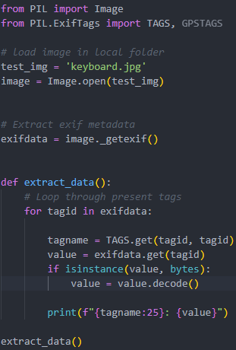

### 

### **5.3 About Page**

* User is presented a guide to show what the site is capable of.
* Return button
  + Returns the user to the home page