**Phase 2 Report**

*CMSC 495 Week 6*

*By: Shelley Schoppert, Jake Gonzalez, Justin Smith, Timothy Strickland*

*University of Maryland, Global Campus*

*09/26/2022*

# **1. Milestones**

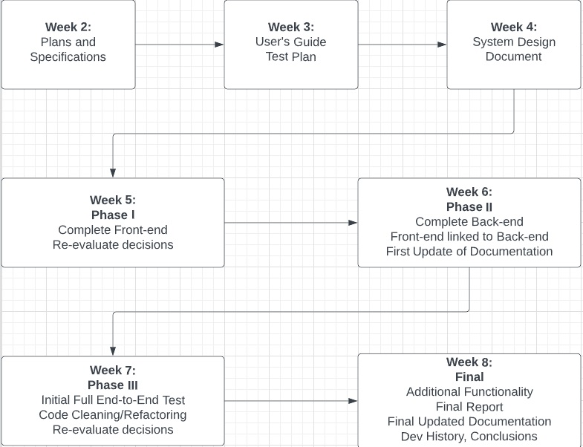This is week 6. Our plan is to deliver the back-end solution and start linking the front-end up with the back-end. We are also going to look at any updates in our documentation thus far,

# **2. Schedule**

Currently the project is on schedule. We have met all milestones up to this point. The front-end includes html, css and python flask. The back-end is written in python using pillow.

# **3. Problems**

# We ran into some issues linking up our front-end and back-end code. This was a lot more complex than we had initially planned. The final solution is not there yet and we still have a lot of work to do. We do have our initial links setup however.

# **4. Re-Evaluation**

# Not much has changed since our initial evaluation. The idea and concept remain unchanged. However, the specifics on how we are doing things have changed slightly. We treated the front-end and back-end almost as separate projects. A lot of the group’s experience has been working with the back-end only, so the front-end was kind of new territory for some of us. The Test Plan and User’s Guide have been updated to reflect slight changes in our design and to add more content to include images and instructions in the User’s Guide.

# **5. Updates**

Both the Test Plan, User’s Guide and Software Design was updated.