**Phase 3 Report**

*CMSC 495 Week 7*

*By: Shelley Schoppert, Jake Gonzalez, Justin Smith, Timothy Strickland*

*University of Maryland, Global Campus*

*10/4/2022*

# **1. Milestones**

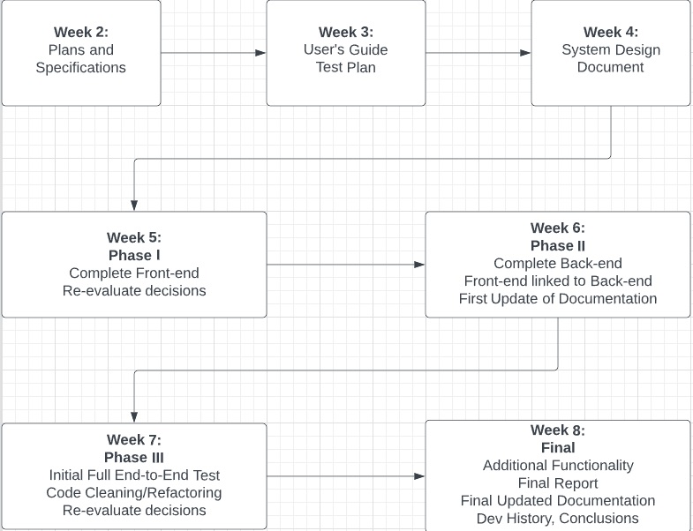This is week 7. Our plan was to deliver a fully functional front and back end with some initial full testing implemented.

# **2. Schedule**

Currently the project is on schedule. We have met all milestones up to this point. The front-end includes html, css and python flask. The back-end is written in python using pillow. The front-end is connected to the back-end.

# **3. Problems**

# We ran into some issues this week with PNG files. After reading a lot of the problems we made the decision to just remove the format from the application. The documentation states that PNG are a known problem with the Pillow Library if used in certain ways. We did not want to re-engineer our code to make it work at this point in the project. We still have a few issues that need to be addressed before the final delivery. In particular some images are kind of quirky and do weird things when submitted through the application. We are in progress of doing more extensive testing to create a smoother experience for the user.

# **4. Re-Evaluation**

# Not much has changed since our initial evaluation. The idea and concept remain unchanged.

# **5. Updates**

Both the Test Plan, User’s Guide and Software Design was updated to exclude PNG file formats.