1. Display unique Jobs FROM EMP table

SELECT unique job FROM scott.emp;

or

SELECT distinct job FROM scott.emp;

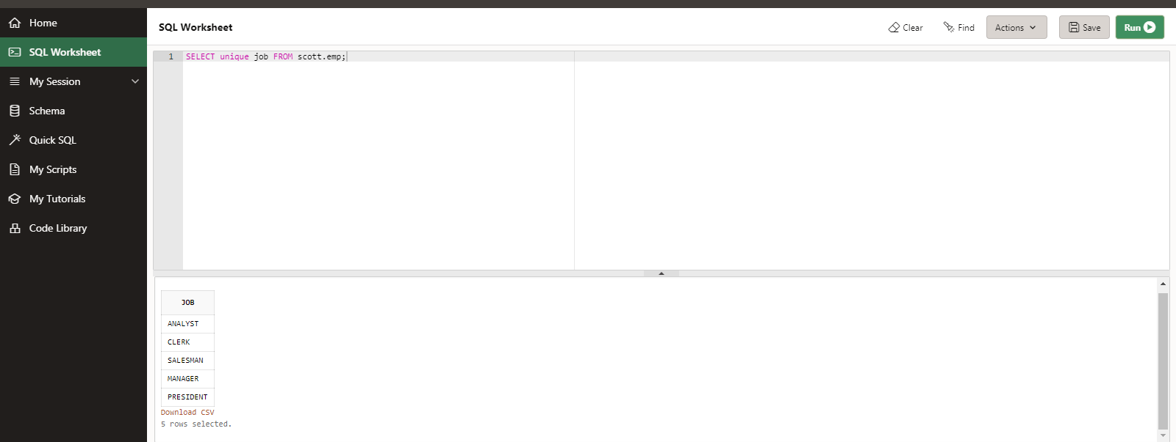

2. List the employees in the ascending order of their salaries

SELECT * FROM scott.emp order by sal asc;

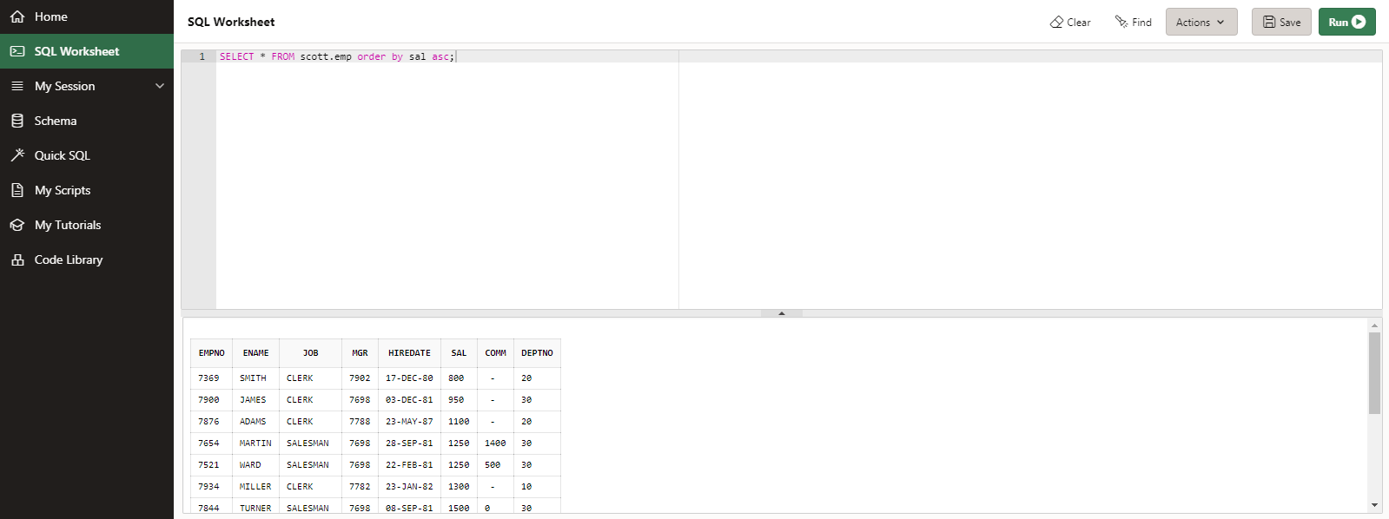

3. List the details of the employees in ascending order of the dept no and descending of Jobs

SELECT * FROM scott.emp order by deptno asc, job desc;

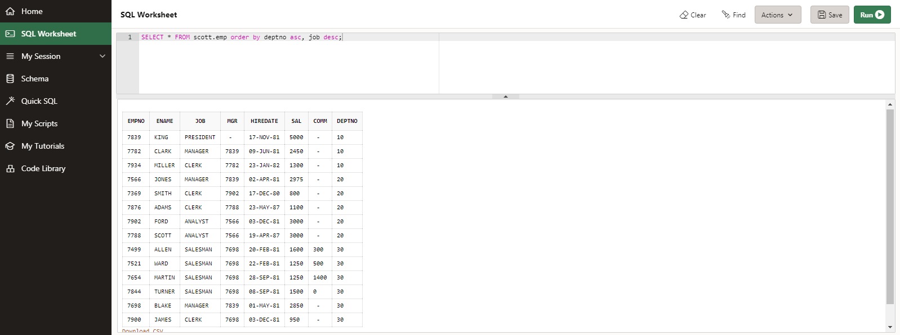

4. Display all the unique job groups in the descending order

SELECT distinct job FROM scott.emp order by job desc;

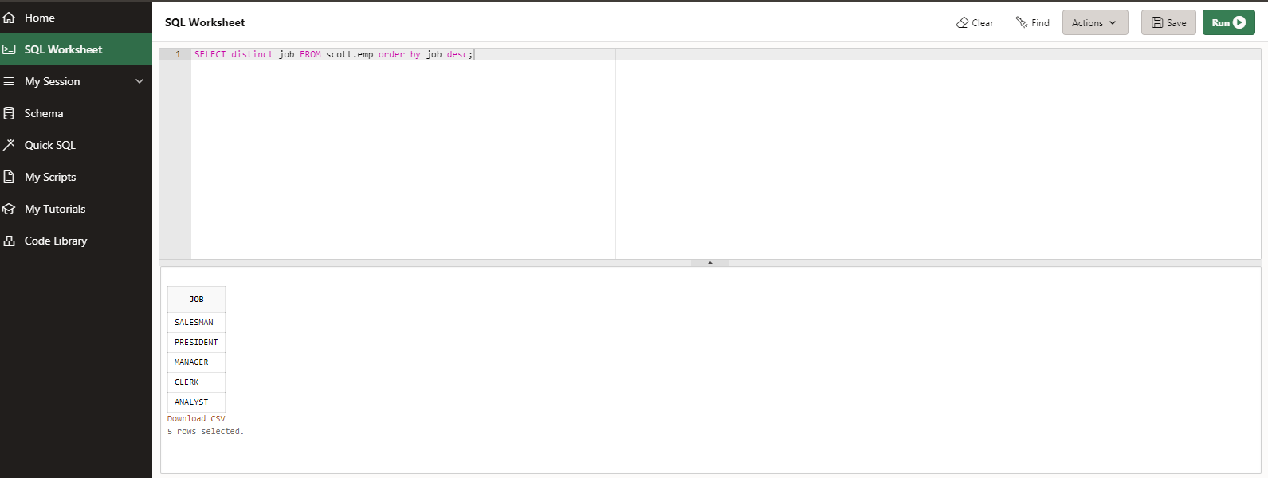

5. Display all the employees who are managers

SELECT * FROM scott.emp WHERE job='MANAGER';

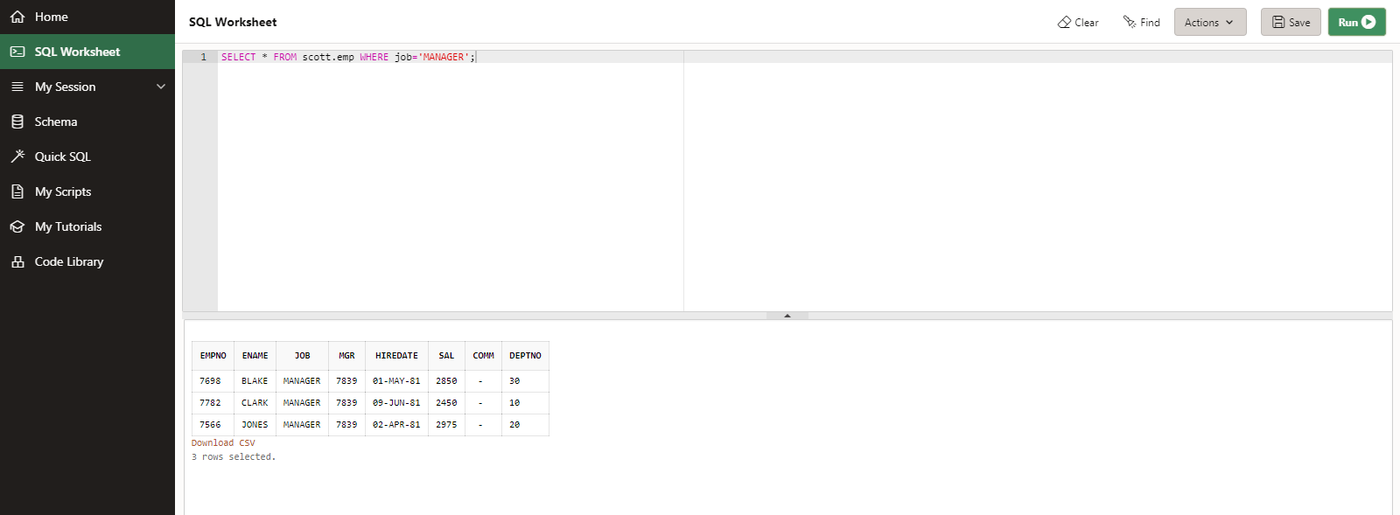

6. List the employees who JOINed before 1981

SELECT * FROM scott.emp WHERE hiredate< ('01-JAN-81');

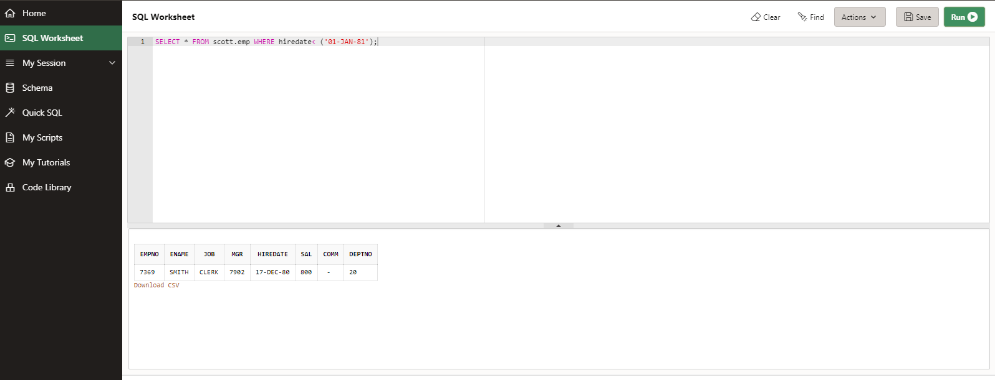

7. List the Empno, Ename, Sal, daily sal of all employees in the ascending order of annual sal

SELECT Empno, Ename, Sal, Sal/30, 12*Sal annsal FROM scott.emp order by annsal asc;

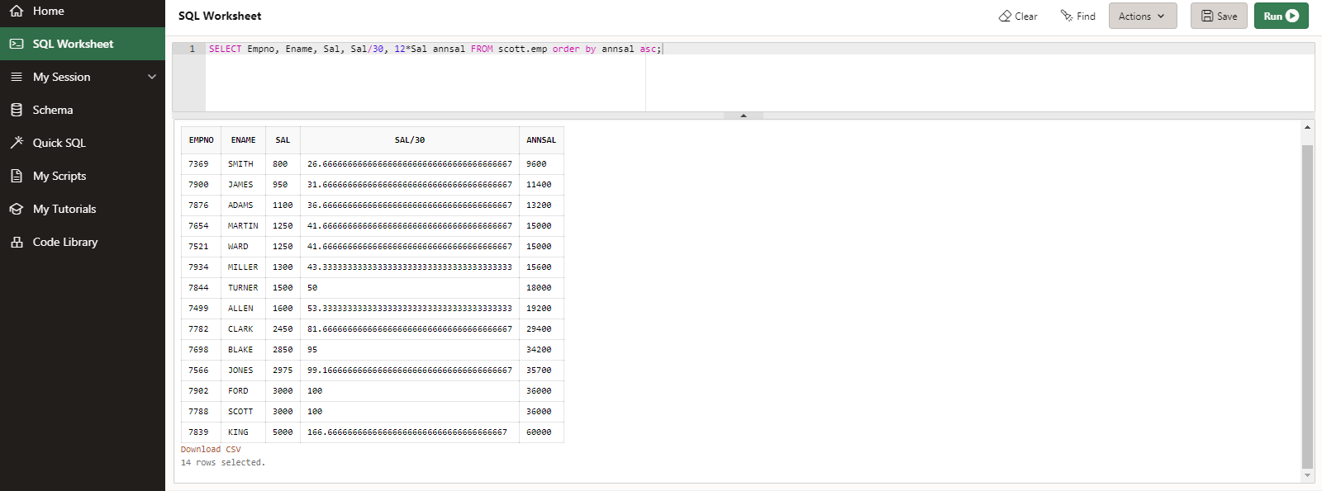

8. Display the Empno, Ename, job, Hiredate, Exp of all Mgrs

SELECT Empno, Ename, job, hiredate, months_between(sysdate,hiredate) exp FROM scott.emp WHERE empno in (SELECT mgr FROM scott.emp);

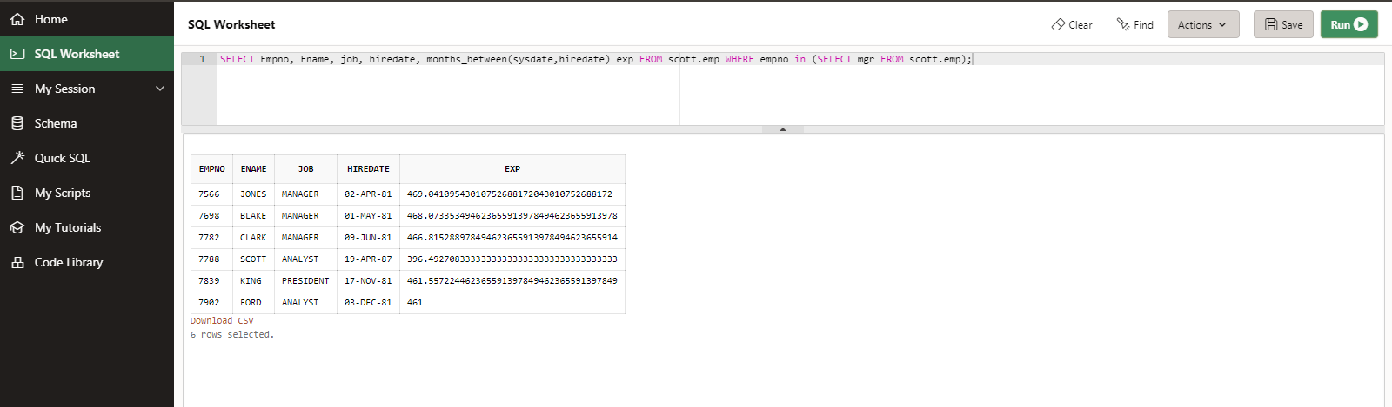

9. List the Empno, Ename, Sal, experience of all employees working for Mgr=7369

SELECT empno,ename,sal, months_between(sysdate,hiredate) exp FROM scott.emp WHERE mgr = 7369;

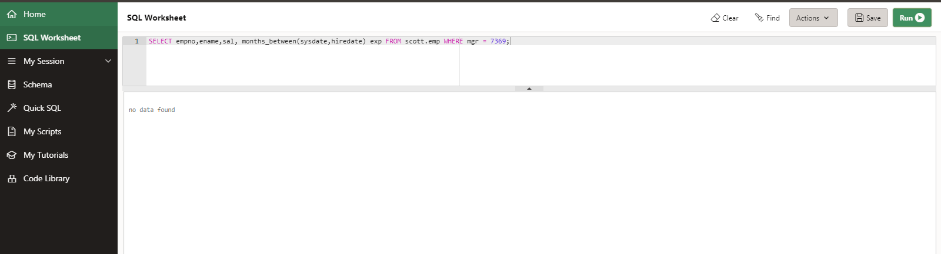

10. Display all the details of the employees whose Comm. Is more than their Sal

SELECT * FROM scott.emp WHERE comm > sal;

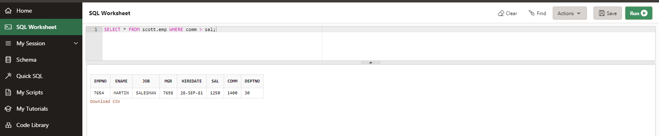

11. List the employees in the asc order of Designations of those JOINed after the second half of 1981

SELECT * FROM scott.emp WHERE hiredate>('30-JUN-1981') and to_char(hiredate,'YYYY')=1981 order by job asc;

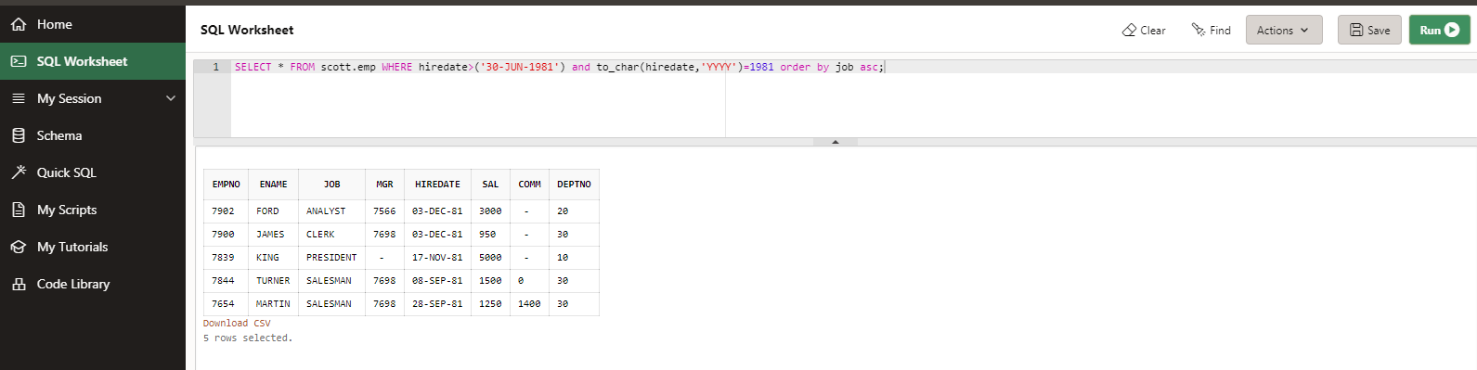

12. List the employees along with their experience and daily salary is more than Rs.100

SELECT * FROM scott.emp WHERE (sal/30) >100;

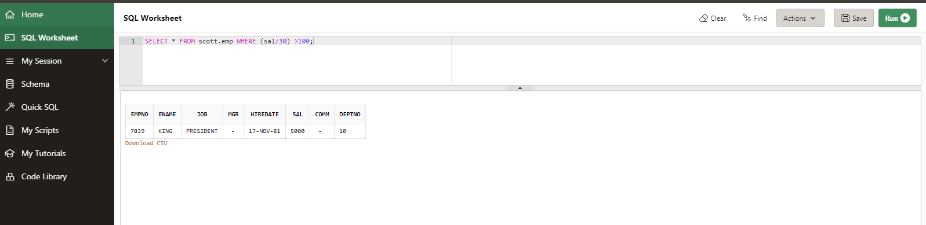

13. List the employees who are either ‘CLERK’ or ‘ANALYST’ in the Desc order

SELECT * FROM scott.emp WHERE job = 'CLERK' or job = 'ANALYST' order by job desc;

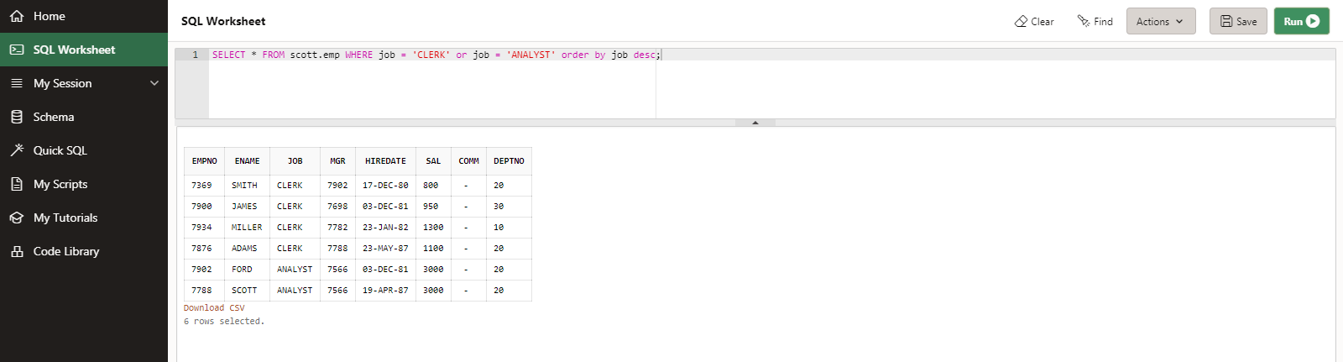

14. List the employees who JOINed on 1-MAY-81,3-DEC-81,17-DEC-81,19-JAN-80 in asc order of seniority

SELECT * FROM scott.emp WHERE hiredate in ('01-may-81','03-dec-81','17-dec-81','19-jan-80') order by hiredate asc;

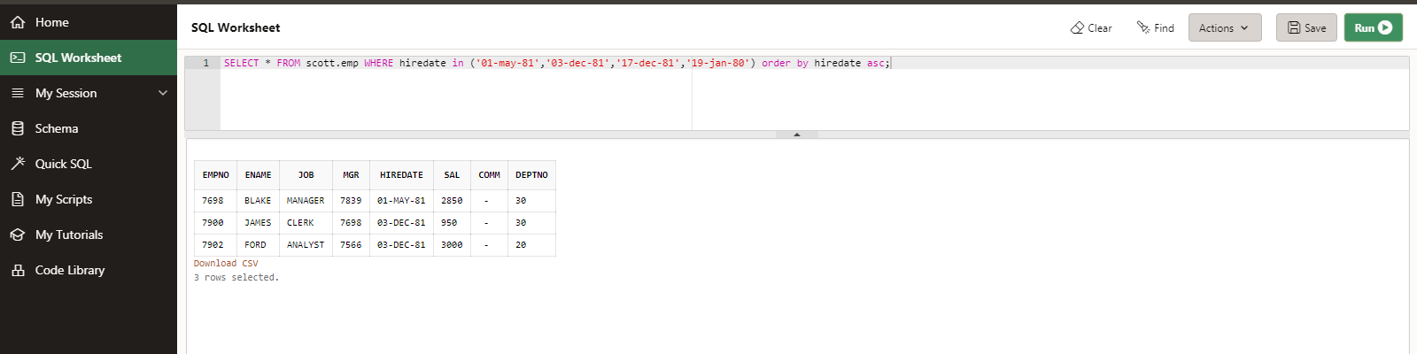

15. List the emp who are working for the Deptno 10 or 20

SELECT * FROM scott.emp WHERE deptno = 10 or deptno = 20;

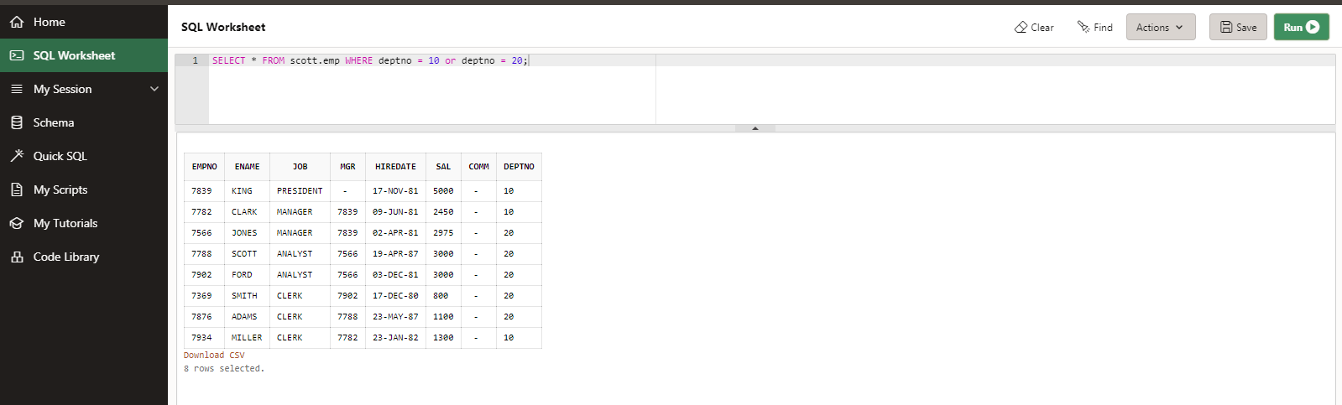

16. List the employees who are JOINed in the year ‘81

SELECT * FROM scott.emp WHERE hiredate between '01-jan-81' and '31-dec-81';

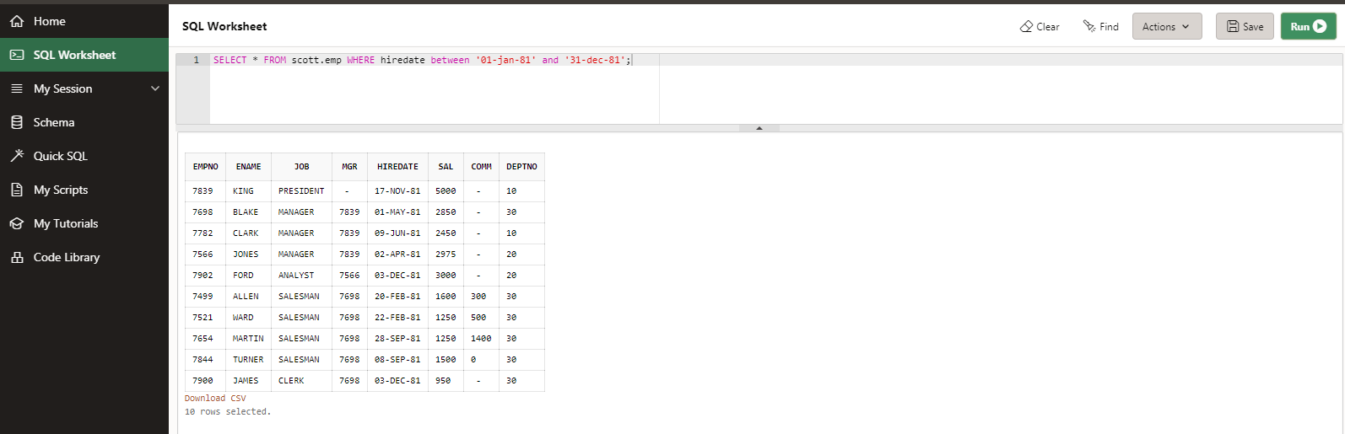

17. List the employees who are JOINed in the month of Aug 1980

SELECT * FROM scott.emp WHERE to_char(hiredate,'mon-yyyy') ='aug-1980';

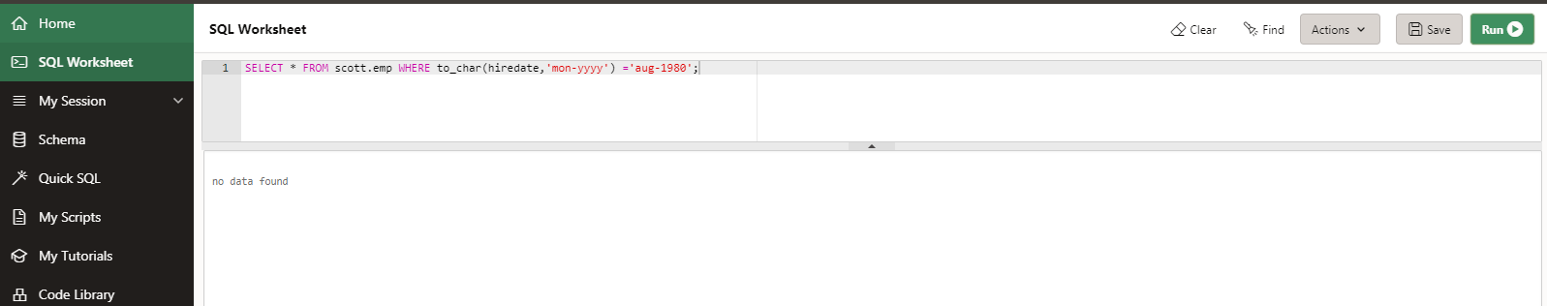

18. List the Enames those are having five characters in their Names

SELECT ename FROM scott.emp WHERE length (ename) = 5;

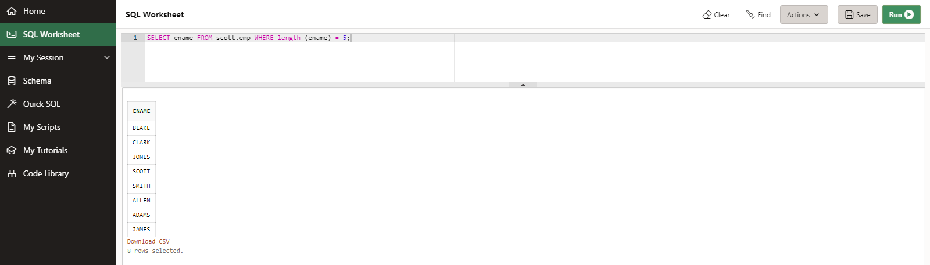

19. List the Enames those are starting with ‘S’ and with five characters

SELECT ename FROM scott.emp WHERE ename like 'S%' and length (ename) = 5;

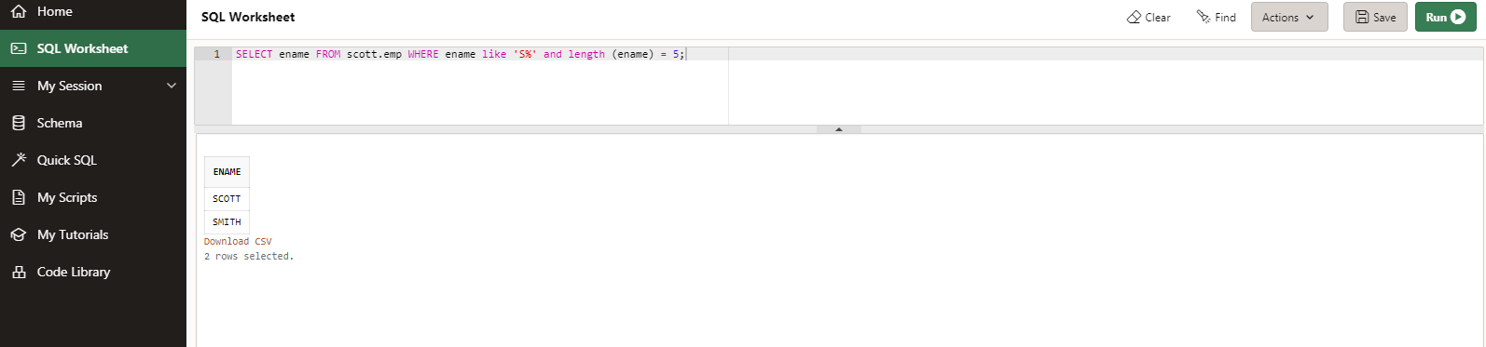

20. List the employees those are having four chars and third character must be ‘r’

SELECT * FROM scott.emp WHERE length(ename) = 4 and ename like '__R%';

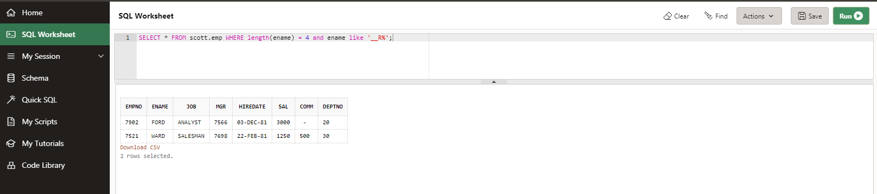

21. List the names of those employees whose employee numbers are 7369, 7521, 7839, 7934, 7788.

SELECT ename FROM scott.emp WHERE empno in (7369, 7521, 7839, 7934, 7788);

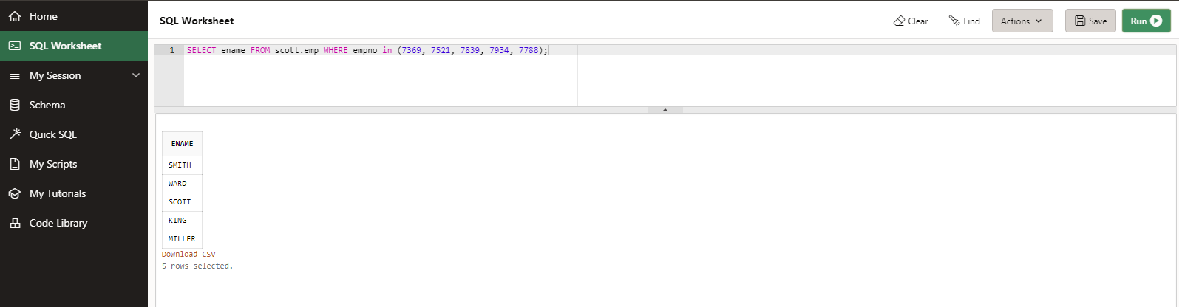

22. List those employees who do not belonging to department 30, 40, or 10.

SELECT * FROM scott.emp WHERE deptno not in (30,40,10);

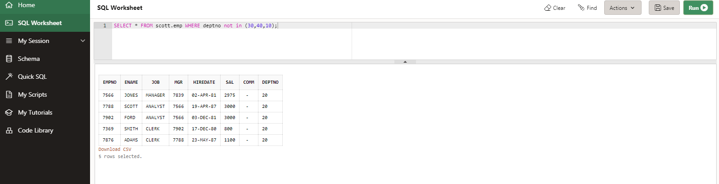

23. List those employee names who have JOINed between 30 June and 31 Dec ‘81.

SELECT ename FROM scott.emp WHERE hiredate between '30-jun-81' and '31-dec-81';

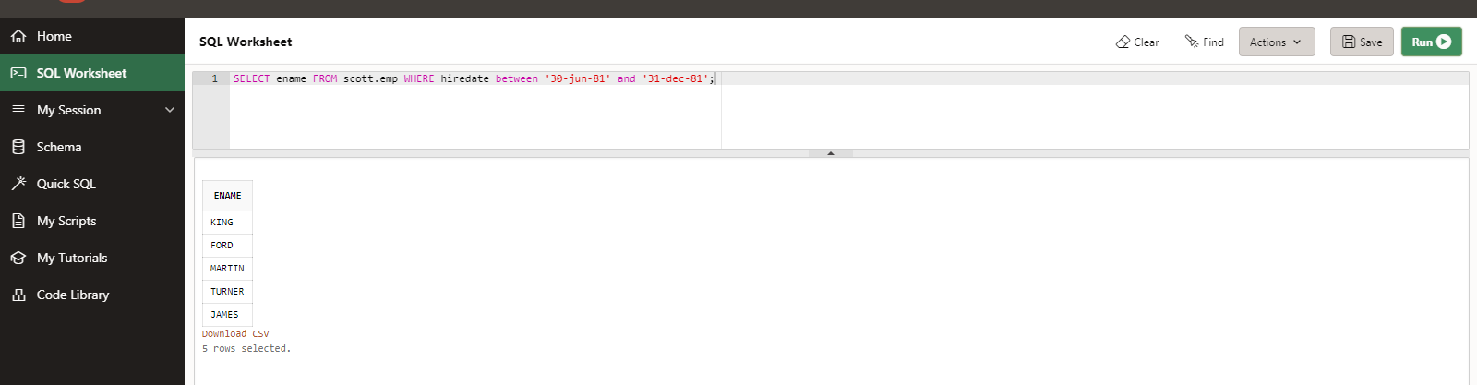

24. List the different designations available in the company

SELECT distinct job FROM scott.emp;

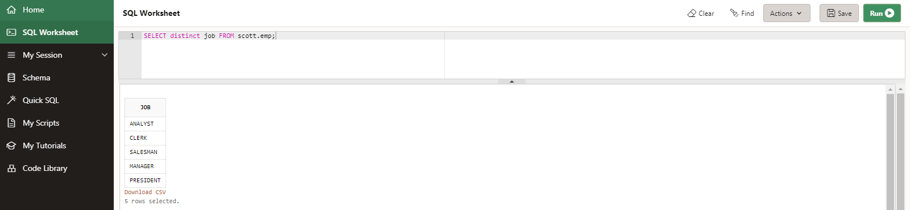

25. List those employees name that are not eligible for commission

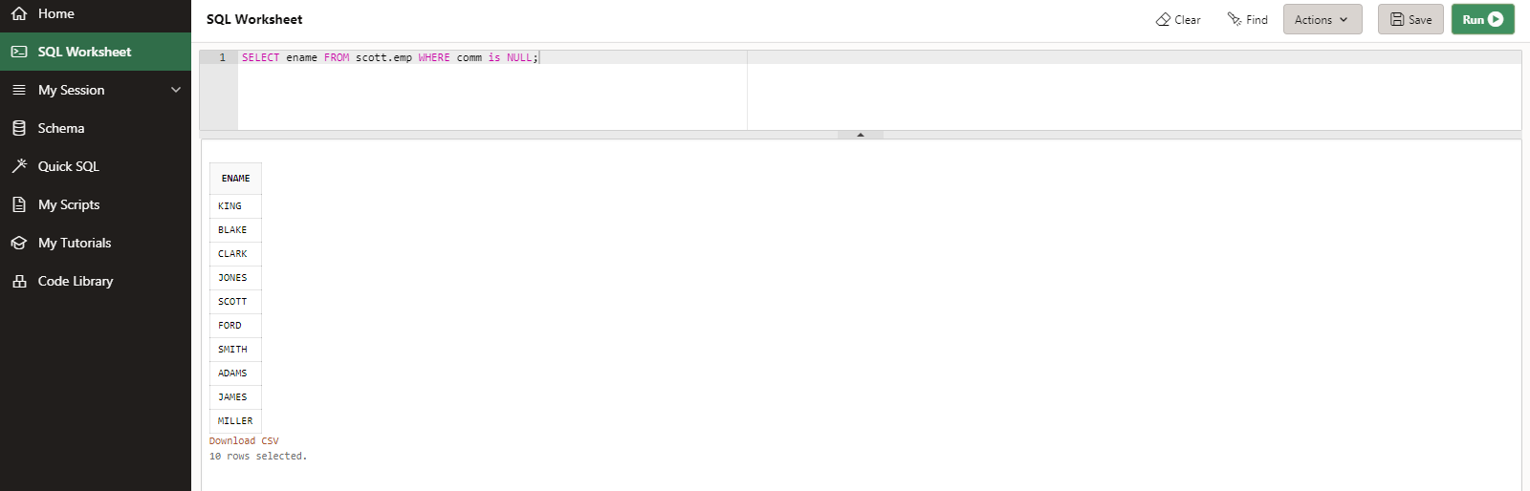

SELECT ename FROM scott.emp WHERE comm is NULL;

26. List the name of the employee and designation of the employee who does not report to anybody

SELECT ename, job FROM scott.emp WHERE job='PRESIDENT';

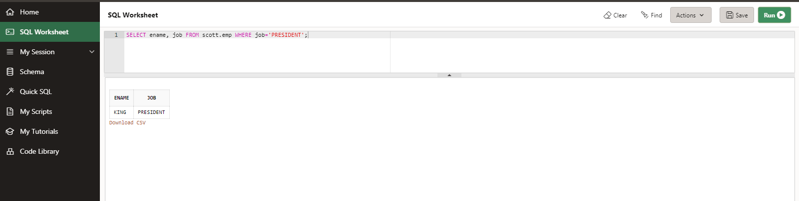

27. List the employees who are eligible for commission

SELECT ename FROM scott.emp WHERE comm is not NULL;

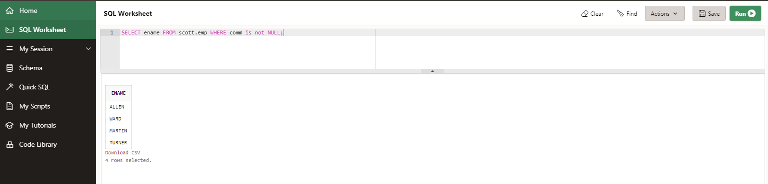

28. List names of employees if the names have “i” as the second character

SELECT ename FROM scott.emp WHERE ename like '_I%';

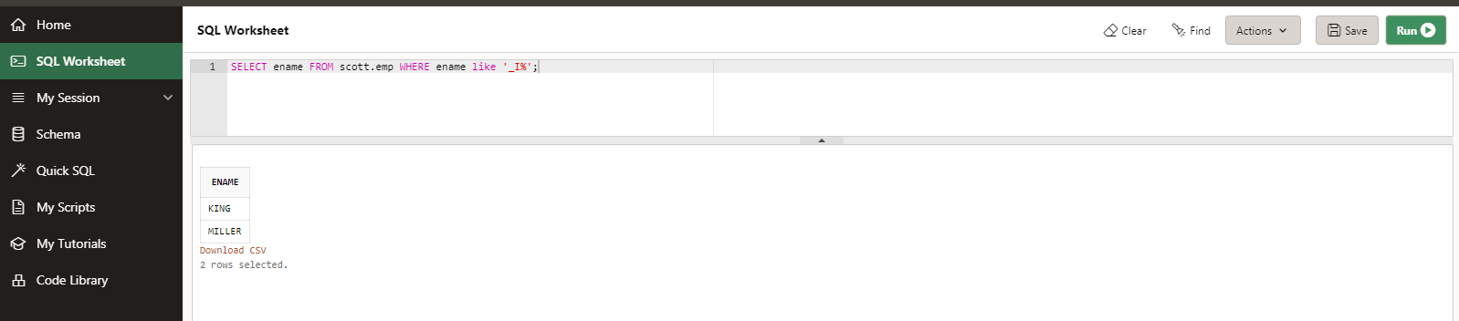

29. Display the names of all employees with their salary and commission earned. Employees with a null commission field should have 0 in the commission column

SELECT ename, sal, COALESCE(comm, 0) FROM scott.emp;

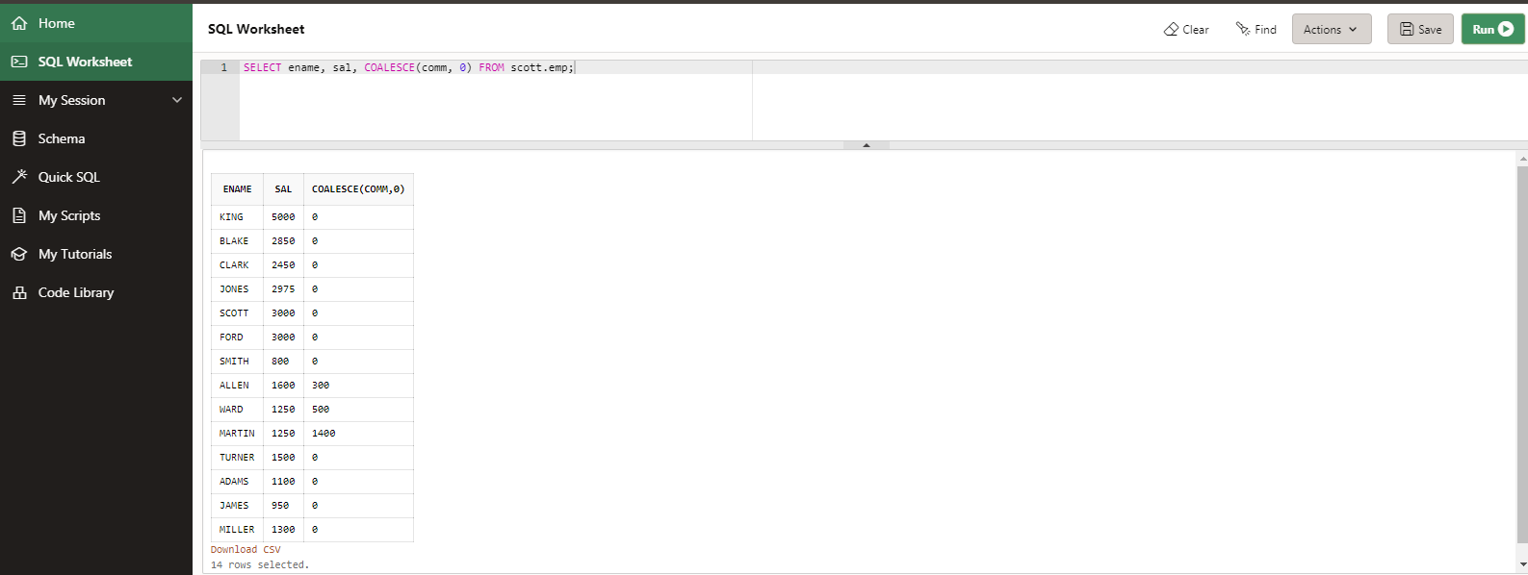

1. List the count and average salary for employees in department 20.

SELECT avg(sal),count(*) FROM scott.emp WHERE deptno=20;

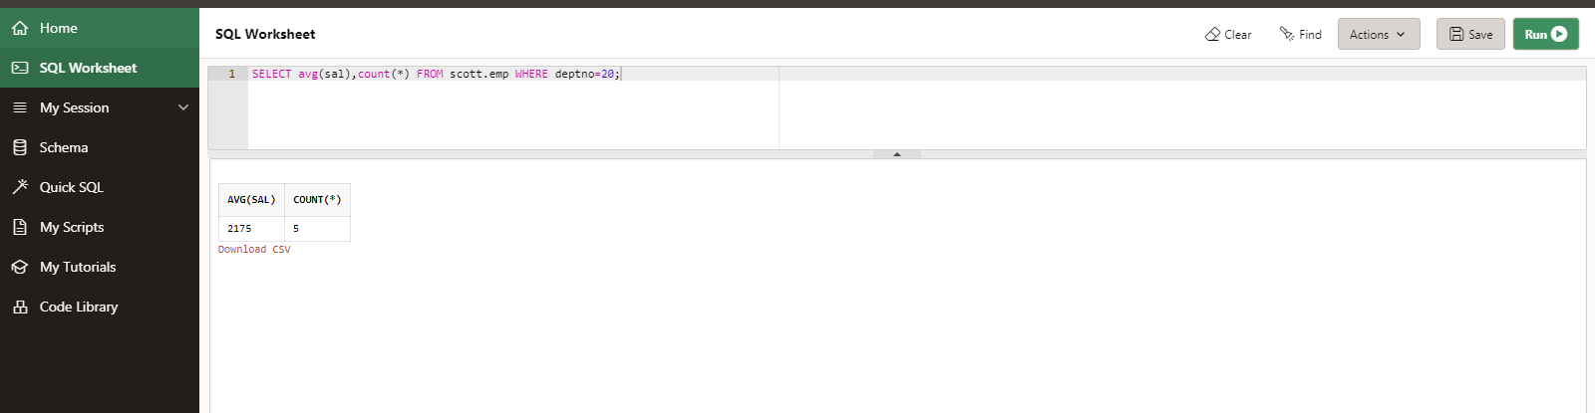

2. List names of employees who are older than 30 years in the company.

SELECT * FROM scott.emp WHERE extract(year FROM hiredate)>30;

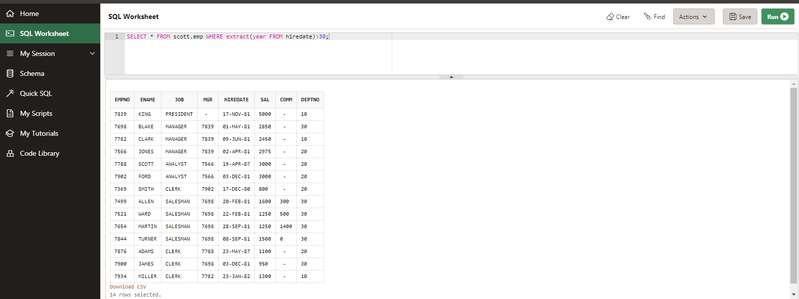

3. List the employee name , hire date in the descending order of the hire date.

SELECT ename,hiredate FROM scott.emp order by hiredate desc;

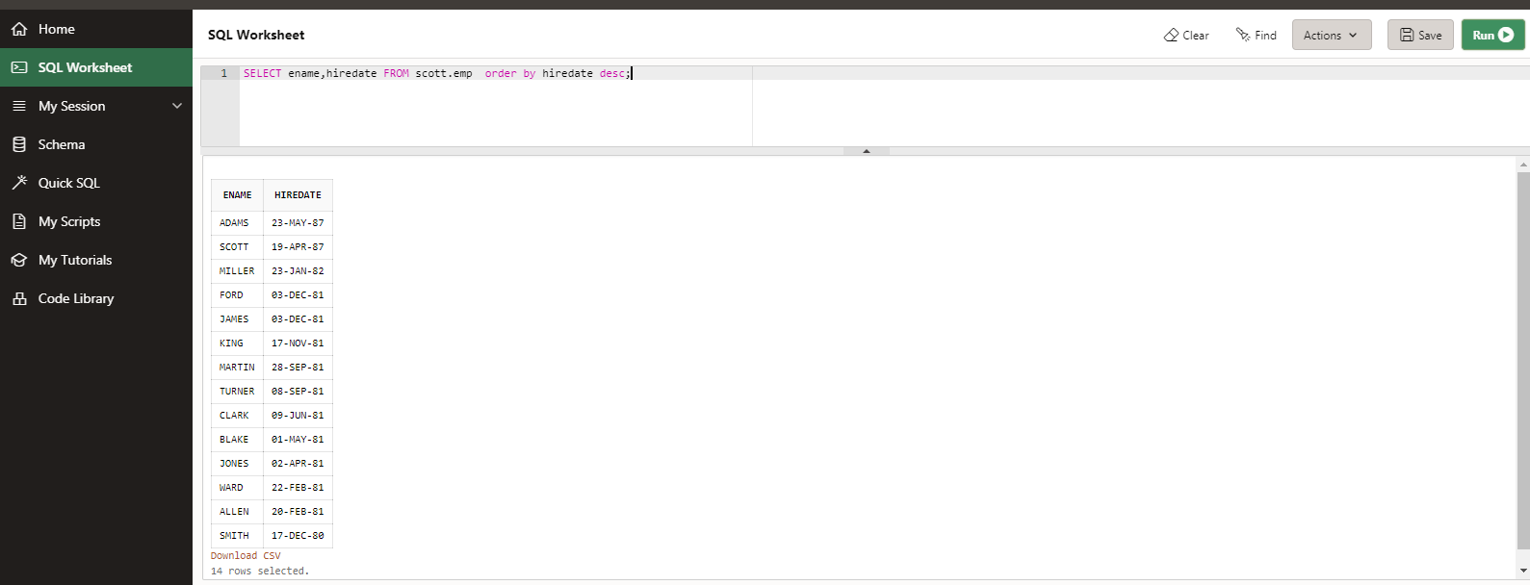

4. List employee name, salary, PF, HRA, DA and gross; order the results in the ascending order of gross. HRA is 50% of the salary and DA is 30% of the salary.

SELECT ename, sal, sal * .1 as PF, sal * .5 as HRA, sal *.3 as DA , sal * .9 as gross

FROM scott.emp order by gross;

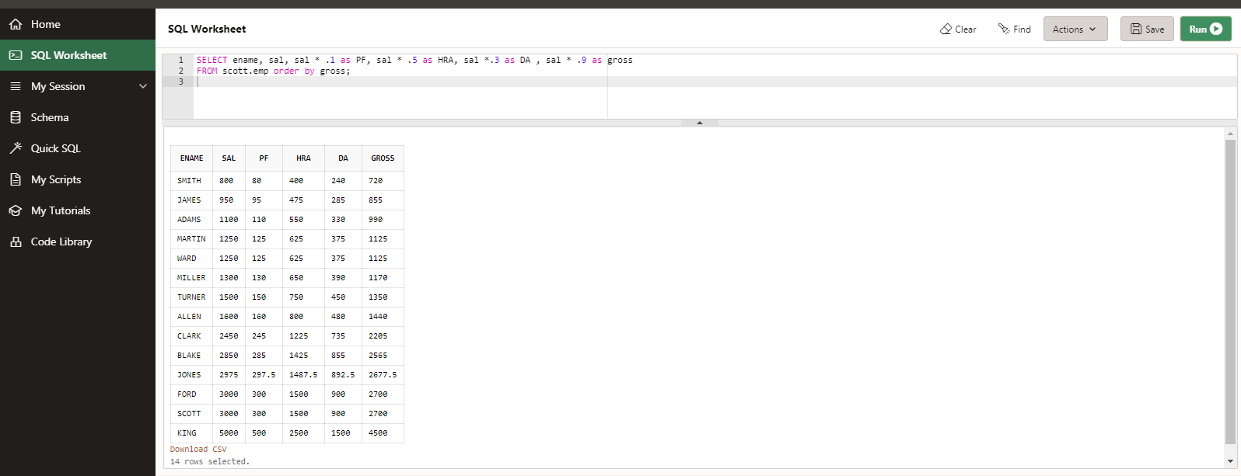

5. List the department numbers and number of employees in each department.

SELECT deptno, count(deptno) as no_of_emp FROM scott.emp group by deptno;

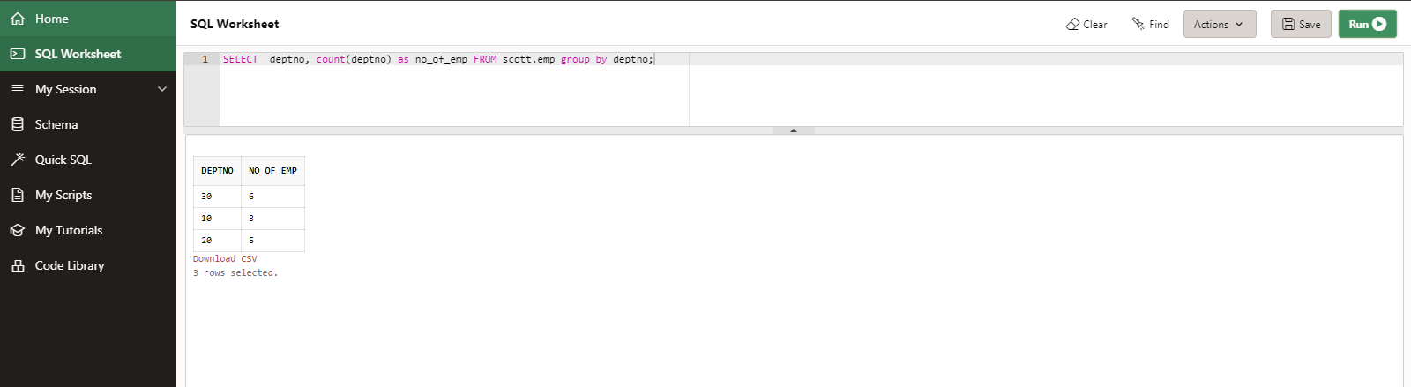

# **Round 3 – SUBQUERIES**

## **Write queries for the following questions**

1. List employees whose job is same as that of Smith

SELECT *

FROM scott.emp

WHERE job =

(SELECT job

FROM scott.emp

WHERE ename ='SMITH');

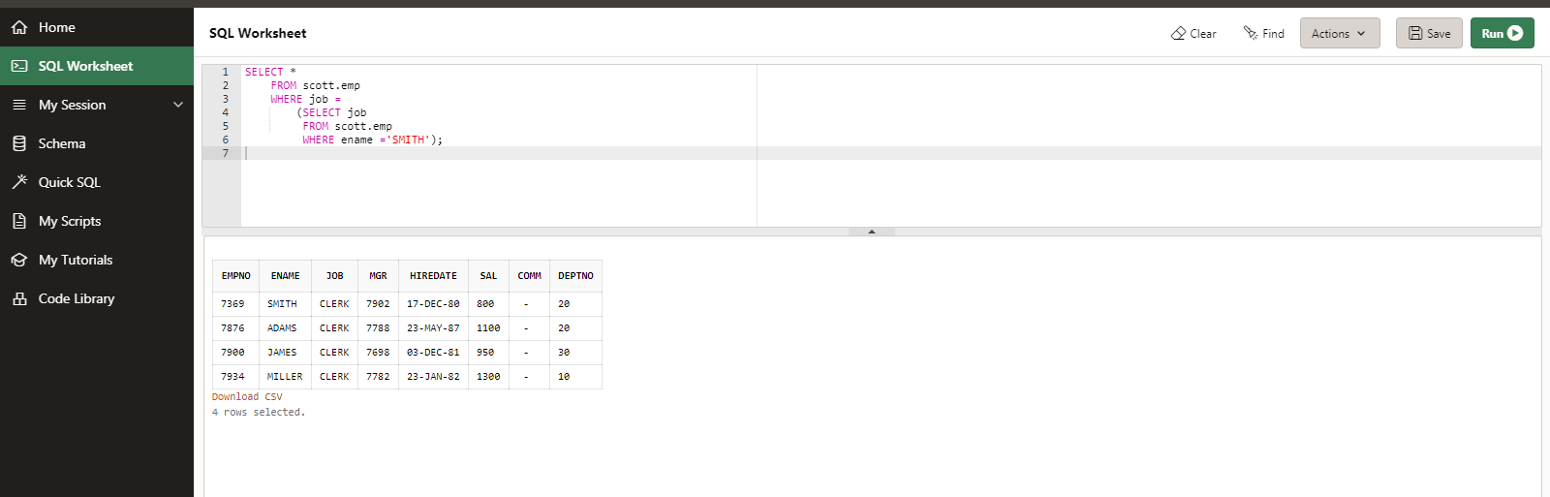

2. List employees who have JOINed after Adam

SELECT *

FROM scott.emp

WHERE hiredate>

(SELECT hiredate

FROM scott.emp

WHERE ename = 'ADAMS');

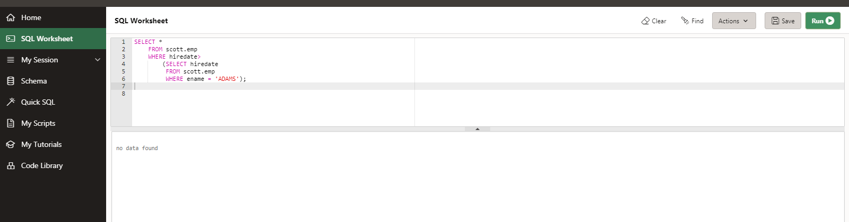

3. List employees who salary us greater than Scott’s salary

SELECT *

FROM scott.EMP

WHERE sal >

( SELECT sal

FROM scott.emp

WHERE ename='SCOTT');

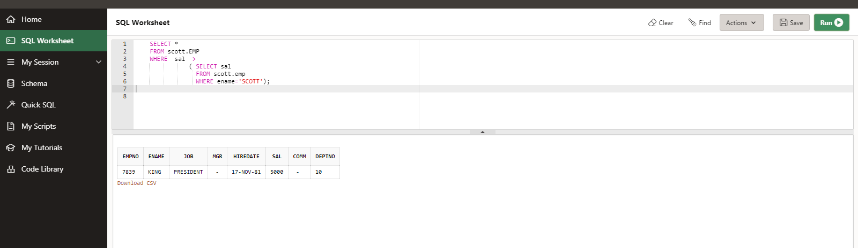

4. List employees getting the max salary

SELECT *

FROM scott.emp

WHERE sal = (

SELECT MAX(Sal)

FROM scott.emp);

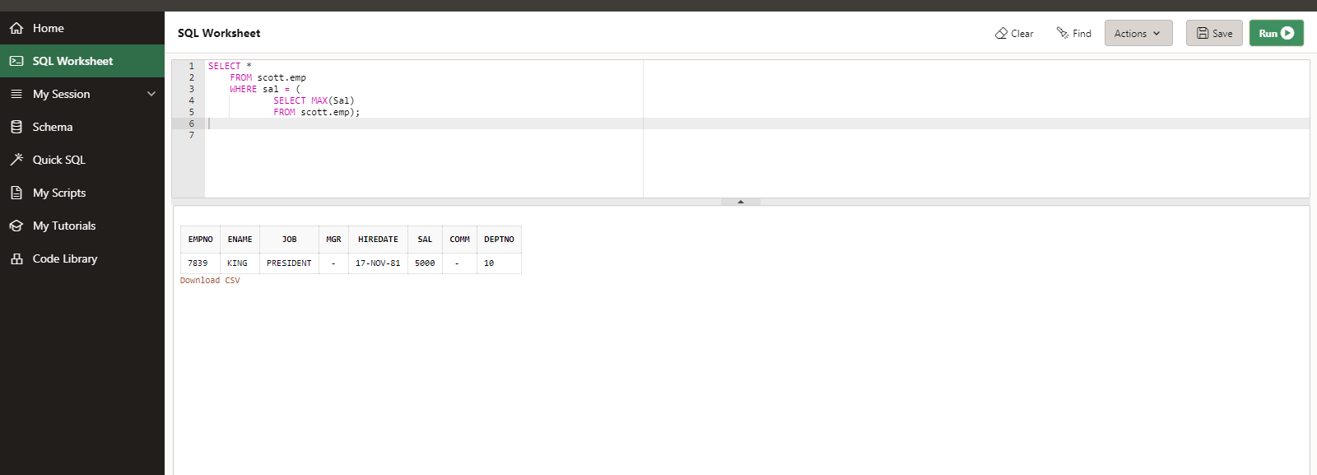

5. List employees show salary is > the max salary in deptno 30

SELECT *

FROM scott.emp

WHERE sal > (

SELECT MAX(Sal)

FROM scott.emp

WHERE deptno='30');

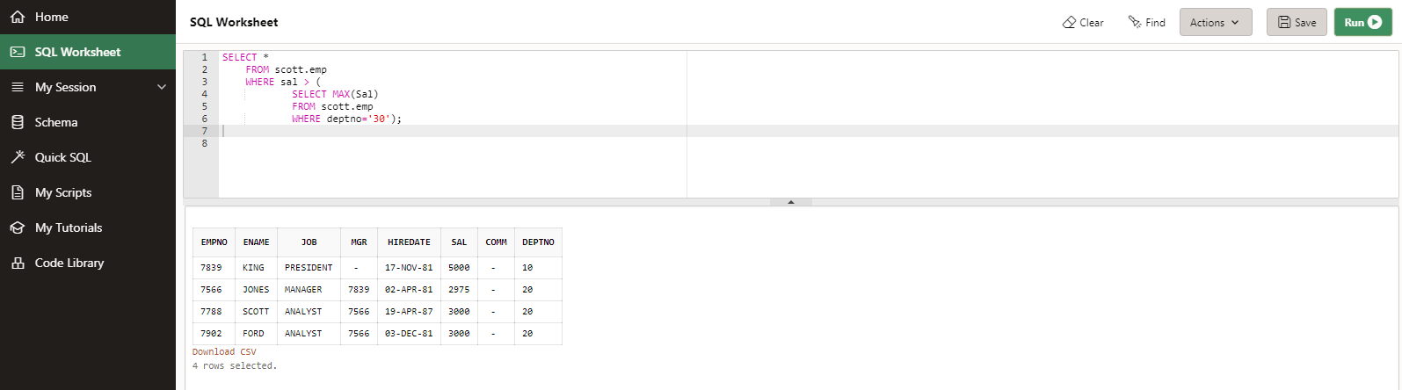

1. List employee name, department number and their corresponding department name.

SELECT

e.ename as Employee_Name,

d.deptno as Department_Number,

d.dname as Department_Name

FROM scott.emp e

left JOIN scott.dept d on e.deptno = d.deptno;

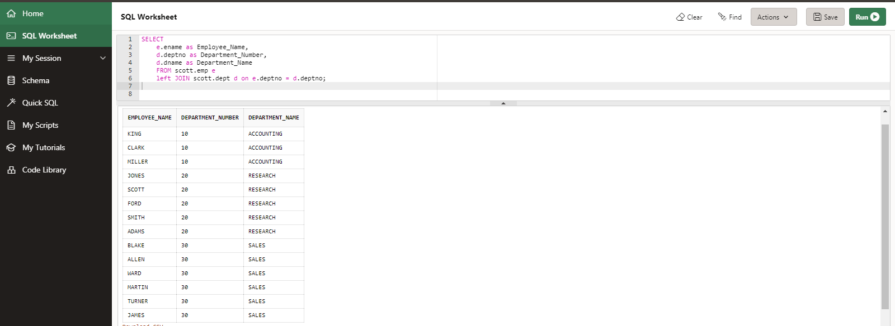

2. List employee name and their manager name

SELECT distinct e.Ename as Employee_Name, m.mgr as reports_to_MGR

FROM scott.emp e

inner JOIN scott.emp m on e.mgr = m.mgr;

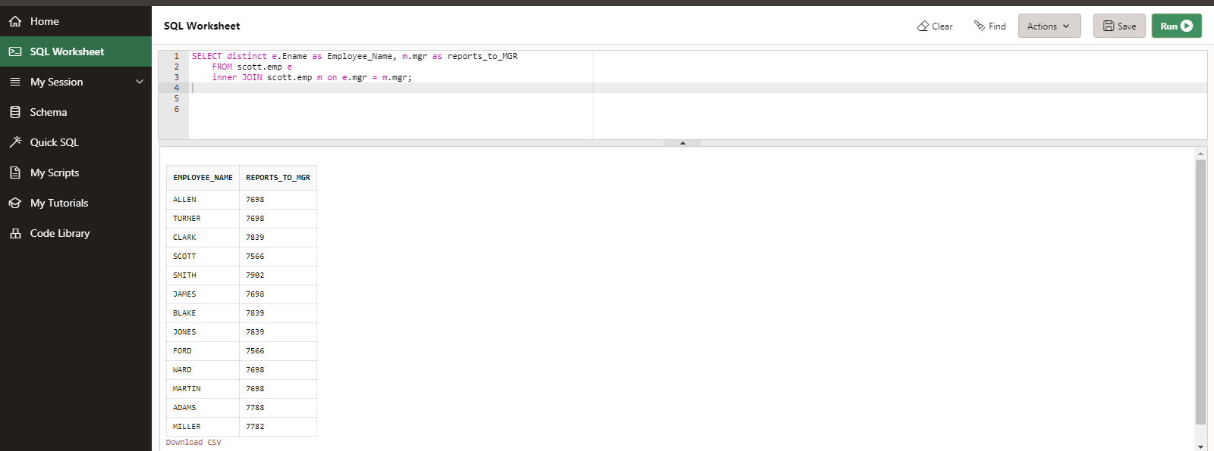

3. List employees who work in Research department

SELECT *

FROM scott.emp e

inner JOIN scott.dept d ON e.deptno = d.deptno

WHERE DNAME = 'RESEARCH';

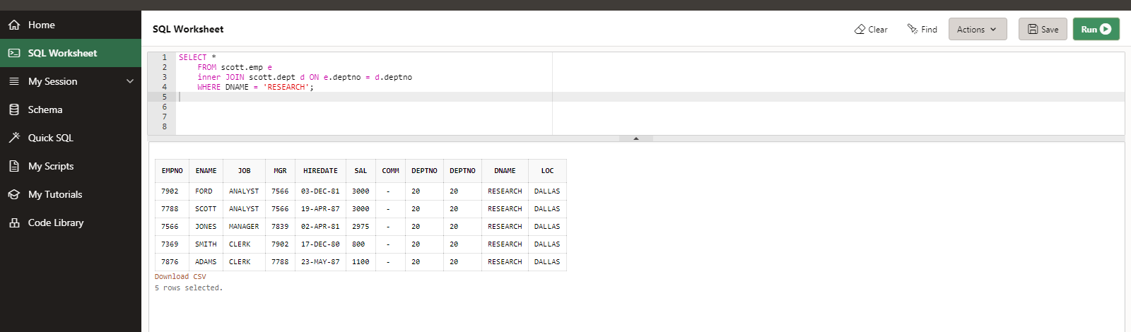

4. List all rows FROM EMP table and only the matching rows FROM DEPT table.

SELECT *

FROM SCOTT.EMP

LEFT OUTER JOIN SCOTT.DEPT ON SCOTT.EMP.DEPTNO=SCOTT.DEPT.DEPTNO;

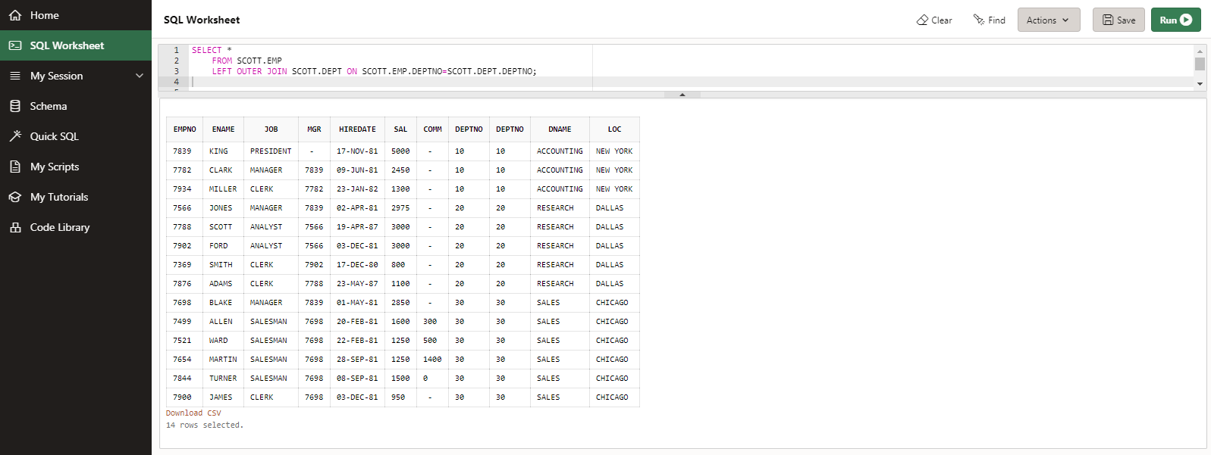

OR

5. List all rows FROM EMP table and only the matching rows FROM DEPT table.

SELECT *

FROM SCOTT.EMP, SCOTT.DEPT

WHERE SCOTT.EMP.DEPTNO=SCOTT.DEPT.DEPTNO(+);

